BAYESIANQC Screenshot Walkthrough
Prepared for Josh Burkhalter from the screenshots sent on July 4, 2026.
Source thread: Gmail subject "Some Screenshots", sent to Joshburkhalter@hotmail.com. The screenshots show a local demo instance; visible localhost URLs are not public service addresses.
Purpose. This document converts the raw screenshots into a short product walkthrough. Each section explains what is visible on screen and why that view matters in the QC workflow.

Quick map
Screenshot | Area | Primary point
1 | Configuration | Create or reuse the objects behind a chartable QC stream.
2 | Backlog / due QC | Technician work queue with due status, method, reference, and bench context.
3 | Dashboard | Supervisor-level live counts for alerts, investigations, and CAPAs.
4 | Kiosk overview | Large-screen monitoring of many QC streams with Bayesian status badges.
5 | Focused chart | Point-level and trend-level evidence behind a rejected FlashCheck stream.

1. Add Datastream setup wizard
What it shows. This shows the Configuration > Add Datastream workflow. The screen is at the Location step of a five-step wizard: Location, Method, Limits, Kiosk, and Review. The form captures the enterprise site, lab bench or area, instrument, manufacturer, and model, and includes a Download XLSX Template option for spreadsheet-based setup.
Why it matters. This is the setup surface for creating or reusing the objects behind one chartable QC stream. It is meant to make a new QC stream reproducible by tying the stream to a site, bench, instrument, method, limits, and kiosk assignment before it is reviewed.

Visible details to call out:
- The app is running as an admin user against the local demo API at http://127.0.0.1:8010.
- The dark overlay at the top is a desktop/editor overlay, not part of the BAYESIANQC application.
Screenshot 1: screenshot-01.png (2116 x 1318).
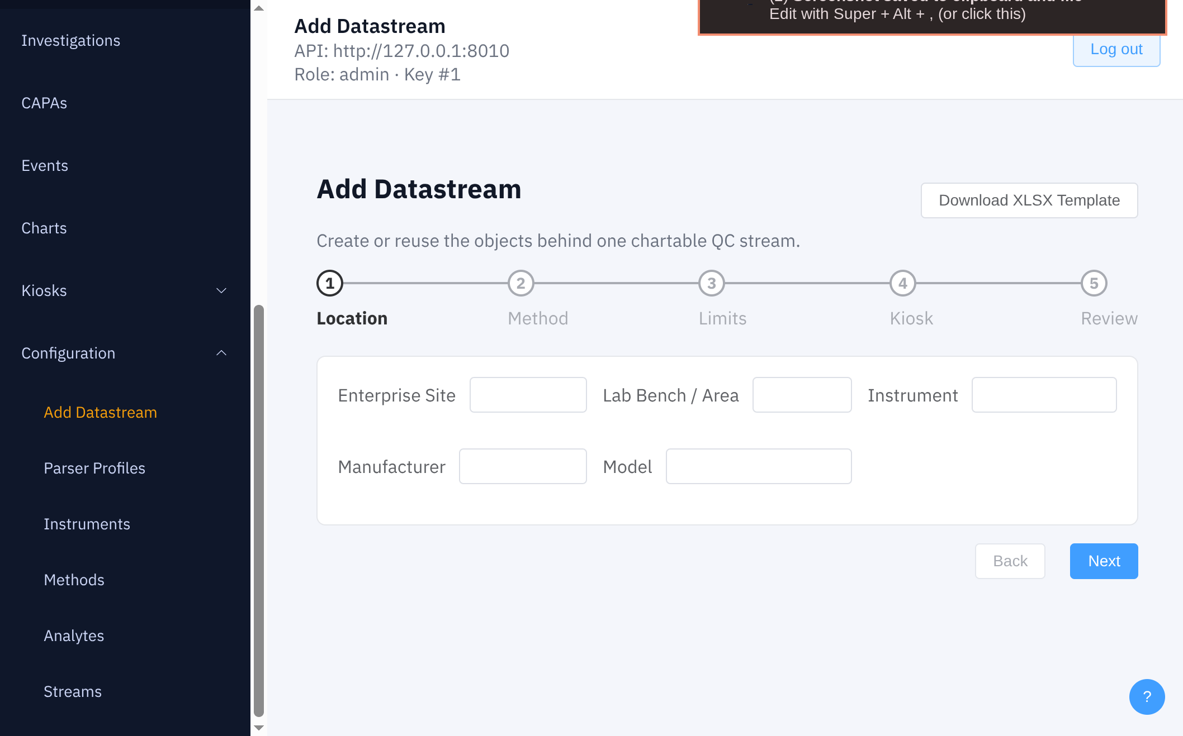

2. Due QC work queue
What it shows. This shows the scheduled QC backlog table. Each row lists a due status and timestamp, the QC task, the associated reference material or lot, and the bench. The visible examples include fuel ASTM streams such as D86 10% recovered and total sulfur, plus medical clinical streams such as creatinine and WBC controls.
Why it matters. This is the technician-facing queue. It turns scheduled or requested QC into actionable work items and keeps the run context visible: which method, instrument, reference material, lot, and bench should be used.

Visible details to call out:
- All visible items are overdue in the demo data, which makes the queue easy to demonstrate.
- The mix of fuel and clinical rows shows that the workflow is domain-flexible rather than tied to one lab specialty.
Screenshot 2: screenshot-02.png (1482 x 1000).
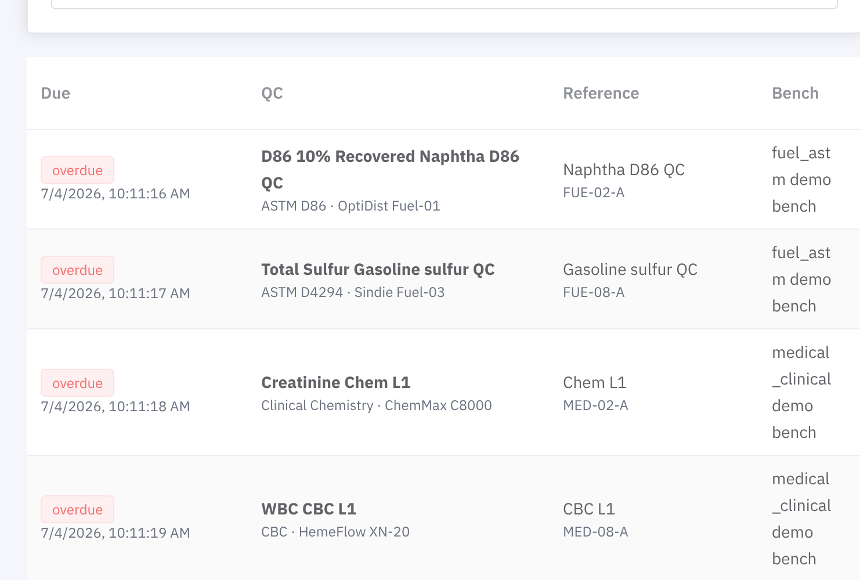

3. Operational dashboard
What it shows. This shows the Dashboard operational summary. The cards summarize workflow counts: Alerts, Investigations, and CAPAs. In this demo state there are 517 total/open alerts, 0 investigations, and 0 CAPAs.
Why it matters. This view gives a supervisor or reviewer a quick triage point for the current QC state. Alerts show the active exception load; investigations and CAPAs show whether issues have been escalated into formal follow-up workflows.

Visible details to call out:
- The Refresh control updates the live counts from the API.
- The screenshot shows a demo backlog with alerts generated, but no investigation or CAPA records opened yet.
Screenshot 3: screenshot-03.png (1614 x 1012).
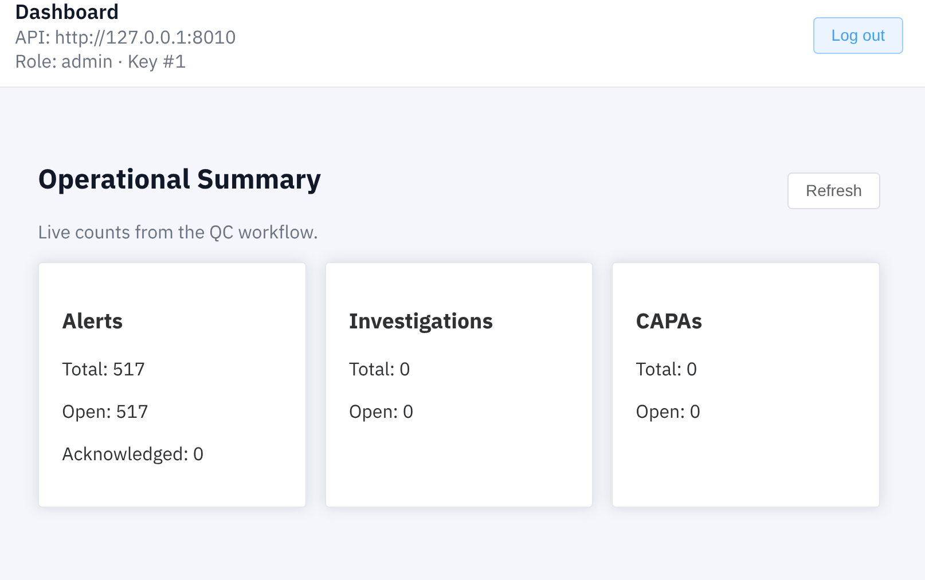

4. Multi-chart demo kiosk overview
What it shows. This shows the BAYESIANQC demo kiosk in multi-chart mode. It displays six streams at once, with page and timer controls in the header. Each tile combines a compact QC chart, a Bayesian status badge, and an Open button for drilling into the full stream view.
Why it matters. This is the large-screen monitoring view. It is designed to rotate through many streams and make the highest-risk items obvious from across the room. Green, amber, and red status treatments distinguish accept, monitor, low-confidence/warn, and reject states.

Visible details to call out:
- The header indicates page 1 of 4, covering streams 1-6 of 24.
- The lower rail in each tile shows Bayesian warning/hold probability over time alongside the standard QC trend chart.
- Visible examples include acceptable OptiDist streams, a monitor state, and rejected FlashCheck streams.
Screenshot 4: screenshot-04.png (2084 x 1298).
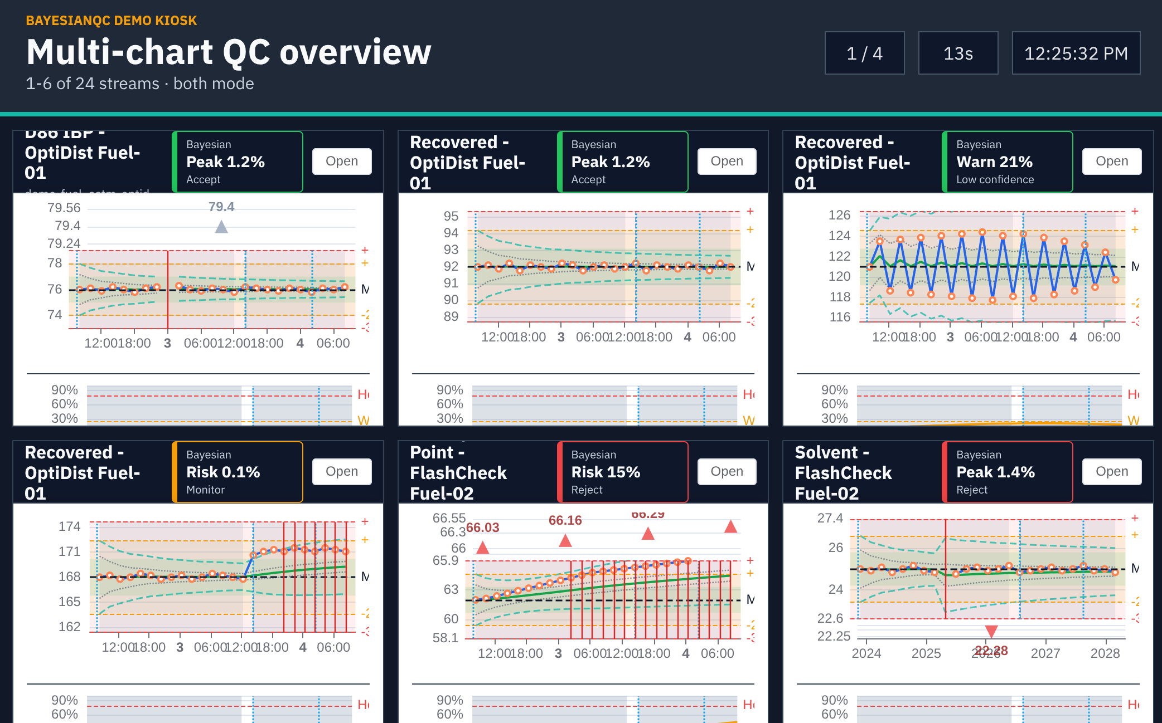

5. Focused Pensky Flash Point chart
What it shows. This shows the focused kiosk view for Pensky Flash Point - FlashCheck Fuel-02 over Feb 2-5, 2026. The stream is flagged with a Bayesian Risk 15% reject badge. The main chart displays QC results against mean and standard-deviation limits, with Bayesian bands and highlighted outlier points above the upper control region.
Why it matters. This detailed view explains why a stream is risky. A reviewer can see the recent upward trend, compare observations against the control bands, and inspect point-level evidence before deciding whether to accept, investigate, or hold/reject the run.

Visible details to call out:
- The visible tooltip for the selected point shows result 63.95, disposition accept, risk 0/100, P warn/action 2.6% / 0.1%, posterior mean 62.8320, and lot FUE-05-A.
- The lower probability rail shows risk accumulating over time, with warn and hold thresholds drawn as reference lines.
- The Grid button returns from the focused stream view to the multi-chart kiosk overview.
Screenshot 5: screenshot-05.png (2072 x 1314).
