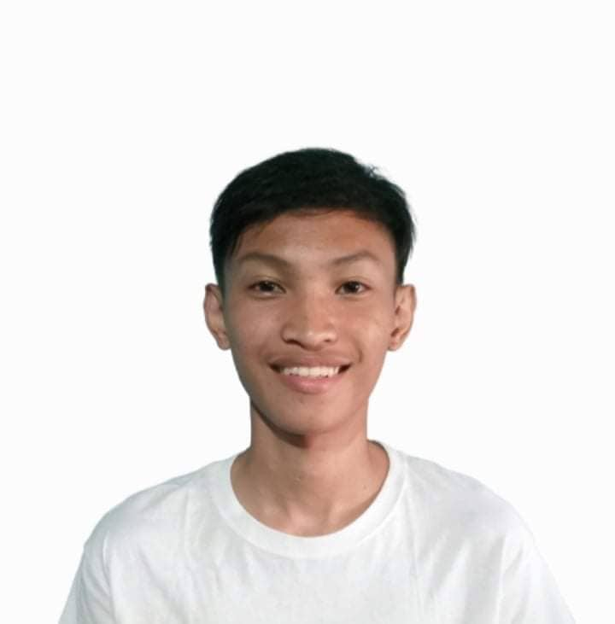

* Coding
* Graphic Art
* Video Editing
* Decission making
* Attentive

I am Kier Patrick Rago a highly motivated and hardworking individual. I would like to utilize my skills and experiences to your reputed company.

**Junior High School**

**Quezon National High School**

Ibabang iyam, Lucena City

2015-2019

**SECONDARY**

**CSTC (Collage of Sciences Technology and Communication)**

**Information Communication and Technology (ICT)**

Purok Camia Brgy 10, Lucena City

2019-2021

**TERTIARY**

**Dalubhasaan ng Lungsod ng Lucena**

Annex Building Brgy Isabang Lucena City

Bachelor of Science in Information and Technology (BSIT)

**AGE** : 20

**DATE OF BIRTH** : January 8, 2003

**PLACE OF BIRTH** : Lucena City

**NATIONALITY** : Filipino

**CIVIL STATUS**  : Single

**RELIGION** : Roman Catholic

**LANGUAGE SPOKEN** : English and Tagalog

***I hereby certify that the above information is true and correct to the best of my knowledge and belief.***

**Kier Patrick Rago**

Applicant

Car Wash

Plant Nursery in Philippine Coconut Authority (PCA)

**Work Experiences**

N/A

**Kier Patrick Rago**

*Purok Maulawin Brgy. Isabang Lucena City*

*09512378910 patrickrago08@gmail.com*

To live in honesty and integrity. To work in a highly challenging competitive environment for the enhancement of my creative abilities and optimum profitability of the organization.

**ACHIEVEMENTS**

**EDUCATIONAL BACKGROUND**

**SKILLS**

**PERSONAL DATA**

**CAREER OBJECTIVES**

**PROFILE**