CM146 Problem Set 1 — Problem 4
Graphs and Written Answers
Name: ______________________________

a) Visualization
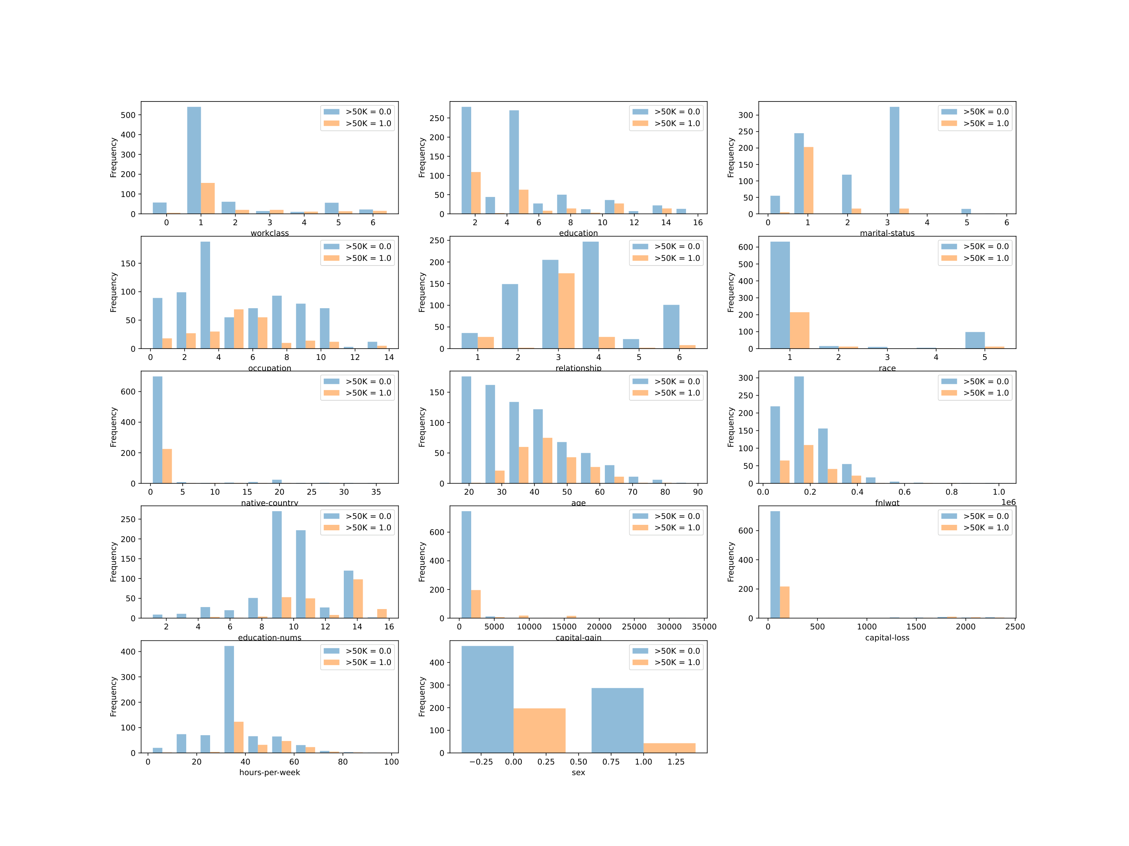
Figure 1. Adult dataset feature histograms separated by income class.
- Workclass: Both classes are concentrated at code 1, although the >50K class is slightly more distributed among higher codes.
- Education: The ≤50K class is concentrated around codes 2 and 4, while the >50K class has a larger proportion at code 1.
- Marital status: The >50K class is strongly concentrated at code 1, whereas the ≤50K class is more commonly code 3.
- Occupation: Lower-income examples are spread across several occupations, while higher-income examples are concentrated around codes 5 and 6.
- Relationship: The >50K class is concentrated at code 3, while the ≤50K class is spread mainly across codes 2, 3, and 4.
- Race: Code 1 is the most common value in both classes. Other categories occur much less frequently, particularly in the >50K class.
- Native country: Code 1 dominates both income classes, so this feature provides limited separation for most examples.
- Age: Higher-income individuals tend to be older; their median age is 42 compared with 34 for the lower-income class.
- fnlwgt: The two classes have heavily overlapping distributions, suggesting that this feature alone does not distinguish income well.
- Education number: Higher-income examples tend to have more years of education, with medians of 13 and 9 for the two classes.
- Capital gain: Most examples have zero capital gain, but nonzero and larger gains occur more frequently among higher-income examples.
- Capital loss: Most examples also have zero capital loss, although positive losses are somewhat more common in the higher-income class.
- Hours per week: Higher-income individuals generally work more hours, averaging about 45 hours versus 38 hours per week.
- Sex: Code 0 is more strongly represented in the >50K class, while code 1 makes up a larger proportion of the ≤50K class.

b) Random Classifier
The Random Classifier produced a training error of 0.374, matching the expected result. It predicts labels according to the class proportions learned from the training data rather than using the features.

c) Decision Tree
The entropy-based Decision Tree achieved a training error of 0.000. This perfect training performance suggests that an unrestricted tree can fit the training data completely, although it may be overfitting.

d) k-Nearest Neighbors
Using raw features, the training errors were 0.153 for k=3, 0.195 for k=5, and 0.213 for k=7. Training error increased with k because larger neighborhoods produce smoother decision boundaries.

e) Cross-validation
Using 100 stratified 80/20 splits on the raw data:
- Majority Vote: training error 0.2400, test error 0.2400, micro-F1 0.7600.
- Random Classifier: training error 0.3748, test error 0.3820, micro-F1 0.6180.
- Decision Tree: training error 0.0000, test error 0.2056, micro-F1 0.7944.
- kNN (k=5): training error 0.2017, test error 0.2591, micro-F1 0.7408.
The unrestricted Decision Tree had zero training error but a much larger test error, indicating overfitting. It nevertheless had the lowest test error of these four raw-feature models.

f) Selecting k
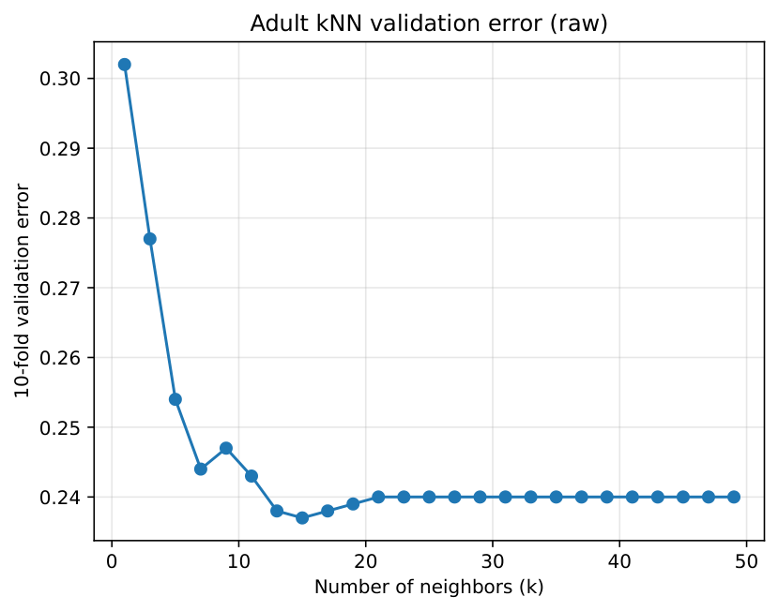
Figure 2. Adult kNN 10-fold validation error using raw features.
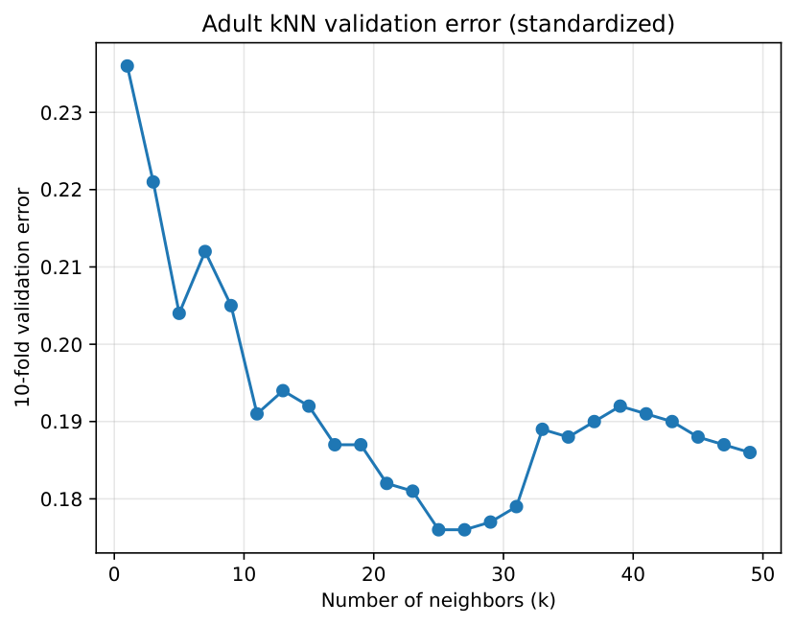
Figure 3. Adult kNN 10-fold validation error using standardized features.
The best raw-feature value was k=15, with a 10-fold validation error of 0.2370. Validation error initially decreased as k increased, reached its minimum at 15, and then stopped improving, showing that an intermediate neighborhood size generalized best.

g) Selecting tree depth
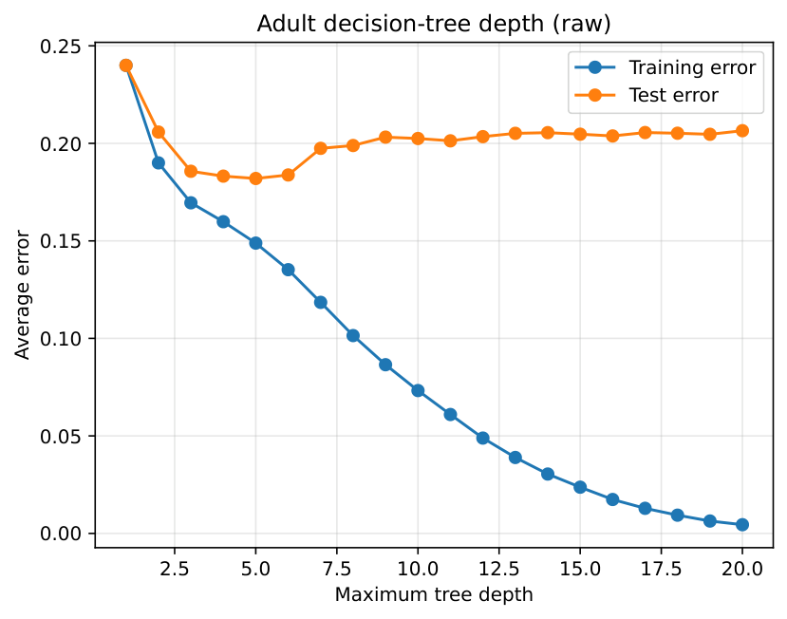
Figure 4. Adult Decision Tree training and test error by depth using raw features.
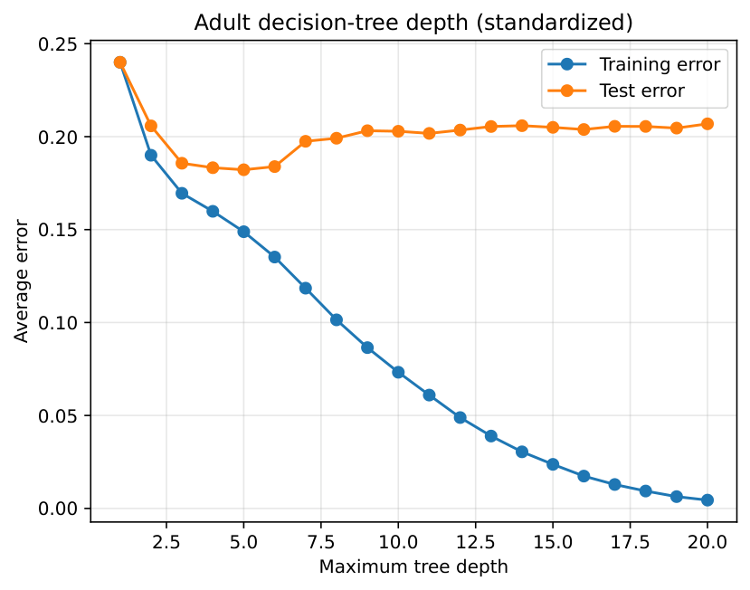
Figure 5. Adult Decision Tree training and test error by depth using standardized features.
The best maximum depth was 5, with an average raw-feature test error of 0.1820. Training error continued to decline as depth increased, while test error began increasing after the minimum, demonstrating overfitting in deeper trees.

h) Learning curves
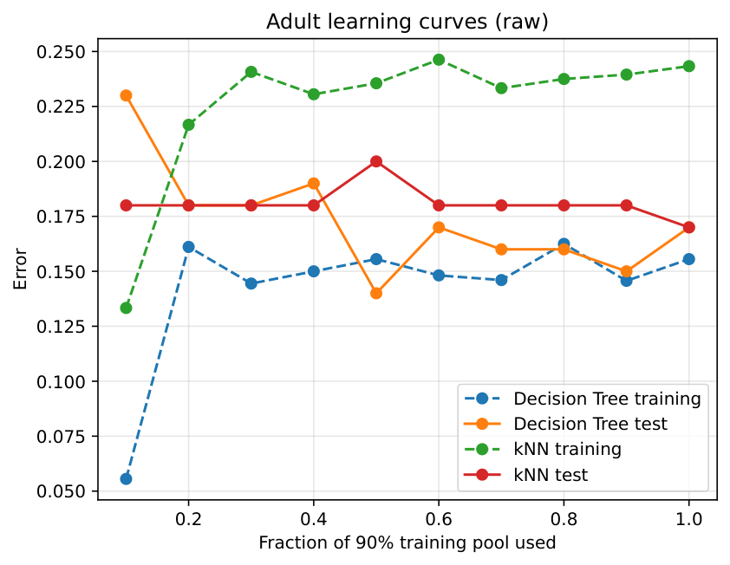
Figure 6. Adult Decision Tree and kNN learning curves using raw features.
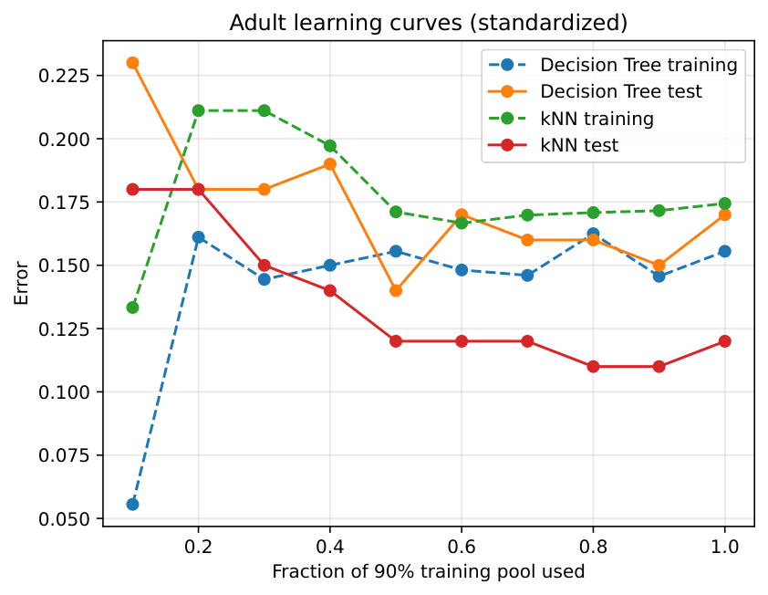
Figure 7. Adult Decision Tree and kNN learning curves using standardized features.
The Decision Tree’s test error generally decreased as more training examples were added, while its training error increased from its unusually low value on the smallest sample and then stabilized. Raw kNN changed less substantially, but its test error decreased slightly from approximately 0.18 to 0.17 when the full training portion was used.

i) Standardization
Standardization had almost no effect on Majority Vote, Random Classifier, or the Decision Tree because these methods do not depend directly on feature distances. The standardized tree again selected depth 5 and had a test error of approximately 0.1822.
Standardization substantially improved kNN. For k=5, its average test error decreased from 0.2591 to 0.2077, while micro-F1 increased from 0.7408 to 0.7923. The selected k changed from 15 to 25, and the minimum validation error decreased from 0.2370 to 0.1760. This improvement occurs because standardization prevents large-scale features such as fnlwgt and capital gain from dominating distance calculations.

Extension to multiclass classification
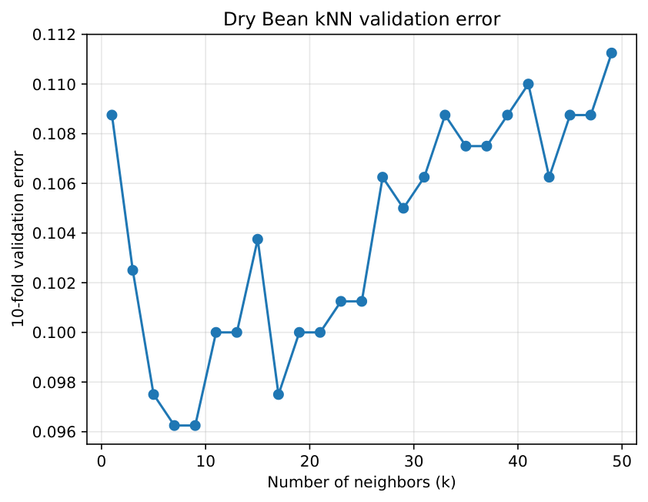
Figure 8. Dry Bean kNN 10-fold validation error by k.
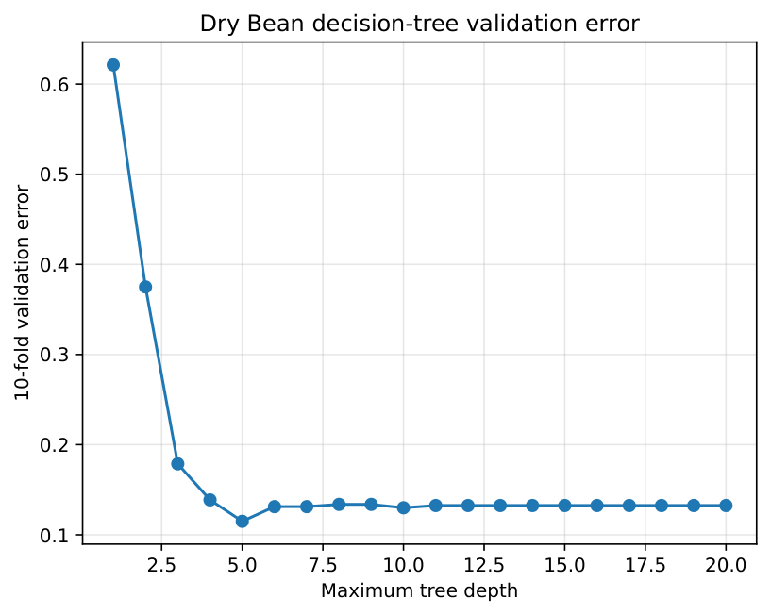
Figure 9. Dry Bean Decision Tree 10-fold validation error by depth.
For the Dry Bean data, 10-fold cross-validation selected k=7 for kNN, with a validation error of 0.0962, and maximum depth 5 for the Decision Tree, with a validation error of 0.1150. The validation plots showed that these values provided the minimum errors before performance flattened or worsened.
On the held-out test set, kNN achieved a test error of 0.0850 and micro-F1 of 0.9150. The Decision Tree achieved a test error of 0.1250 and micro-F1 of 0.8750. Therefore, the selected kNN model performed better on this multiclass task.

