DIPLOMA THESIS
Documentation

Author(s) | Luan Lanzmaier, André Rath, Nikita Schaar
Form, academic year | 5AHWIN, 2025/26
Topic | DigiKicker – Digitalization of a Table Soccer Game
Co-operation partners | HTL Leoben

Assignment of tasks | The creation of a working controller to control a self-made simulation of a table soccer game. This game should have multiplayer functionality and should be playable online and offline.

Realisation | Finalization of uncorrected version until the beginning of January 2026

Results | Schaar: When the project is finalized, there should be a fully functional and neatly designed controller, that is created using CAD software. It should be made using a 3D printed encasing that encapsulates microcontrollers and sensors, which are used for measuring the rotary and translatory movements of the turn stick and transferring them over to the simulation on the PC. A low latency is important here, to ensure a clean and unbroken game experience that is as close to real time as possible.  Rath: In the end, there should be a fully functional, interactive simulation of a table soccer game, that takes input from the controller in real time. There should be a multiplayer mode that works with two teams, each having two players, playing against each other. Additionally, there should be a training mode, where players can improve their skills, as well as a minigame mode, in which players should be able to solve riddles and do some target practice.  Lanzmaier: In the finished version, there should be a stable system with low latency to make a multiplayer mode possible. This allows up to four players to control the table together at a time and play against each other. The network architecture should be based on a peer-to-peer or server-client-model and should have as few delays as possible. Additionally, there should be a uniform, visually pleasing asset design, which lets the whole simulation look clean.

Illustrative graph, photo  (incl. explanation) | 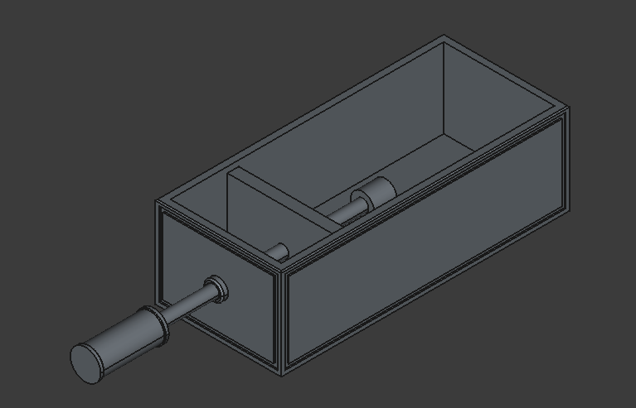  Basic CAD model of the controller hardware

Participation in competitions  Awards | -------

Accessibility of the
Diploma Thesis

Approval  (Date / Signature) | Examiner | Head of College

