DEFECT AUDIT REPORT
EduFAMS Parent Portal — FS-08 Profile & Account Management

Target Module / URL: FS-08 Parent Portal (My Profile: http://localhost:5174/profile)
Specification Reference: FS-08 FSD & TC_R8_Parent_Portal_SingPass_Profile.md (TC-R8-099, TC-R8-103, TC-R8-124)
Test Standard & Schema: AvePoint Enterprise QA Defect Schema / combo-qa Format B
Audit Date & Status: 24-Oct-2026 | Status: OPEN / PENDING RESOLUTION

1. Executive Defect Summary Table
# | Defect Summary | Component | Priority | Status
1 | Mobile Number validation displays raw untranslated i18n key features.parentProfile.validation.mobileInvalid | My Profile (Contact) | High | Pending review
2 | Mandatory Street and Country fields in Mailing Address lack inline validation when empty (violates MSG-0001) | My Profile (Address) | High | Pending review
3 | Mobile Navigation burger button fails to expand navigation drawer on mobile viewports (Responsive UI flaw) | Header Navbar | Medium | Pending review

2. Detailed Defect Records (AvePoint 15-Field Enterprise Format)

Bug #1 — Mobile Number Raw i18n Key Error

Project | EduFAMS E-Service Portal
Issue Type | Bug
Summary | Mobile Number validation displays raw untranslated key features.parentProfile.validation.mobileInvalid
Priority | High
Component | My Profile (Contact Information Form)
Affected Version | Web Client SIT v1.0.0 (Port 5174)
Fix Version | Sprint 1 / Next Hotfix
Assignee | Frontend Engineering Team
Reviewer | / Lead QA
Due Date | 25-Oct-2026
Description | When entering an invalid mobile number (e.g. 12 or less than 8 digits starting with 6, 8, or 9), the form displays the raw i18n localization translation key features.parentProfile.validation.mobileInvalid instead of the localized user-friendly message. This violates end-user usability and reveals internal code identifiers.
Steps to Reproduce | 1. Navigate to http://localhost:5174/profile and authenticate via Mockpass.  2. Click "Update details" to open profile form.  3. In Mobile Number field, input invalid value "12".  4. Observe inline validation message below the input.
Expected Result | System displays localized business validation message per FS-08 MSG-0805: "Enter a mobile number in the correct format, like 9123 4567".
Actual Result | System renders raw developer key: features.parentProfile.validation.mobileInvalid.
Attachment | Figure 1: Form state displaying raw key features.parentProfile.validation.mobileInvalid under Mobile Number field.
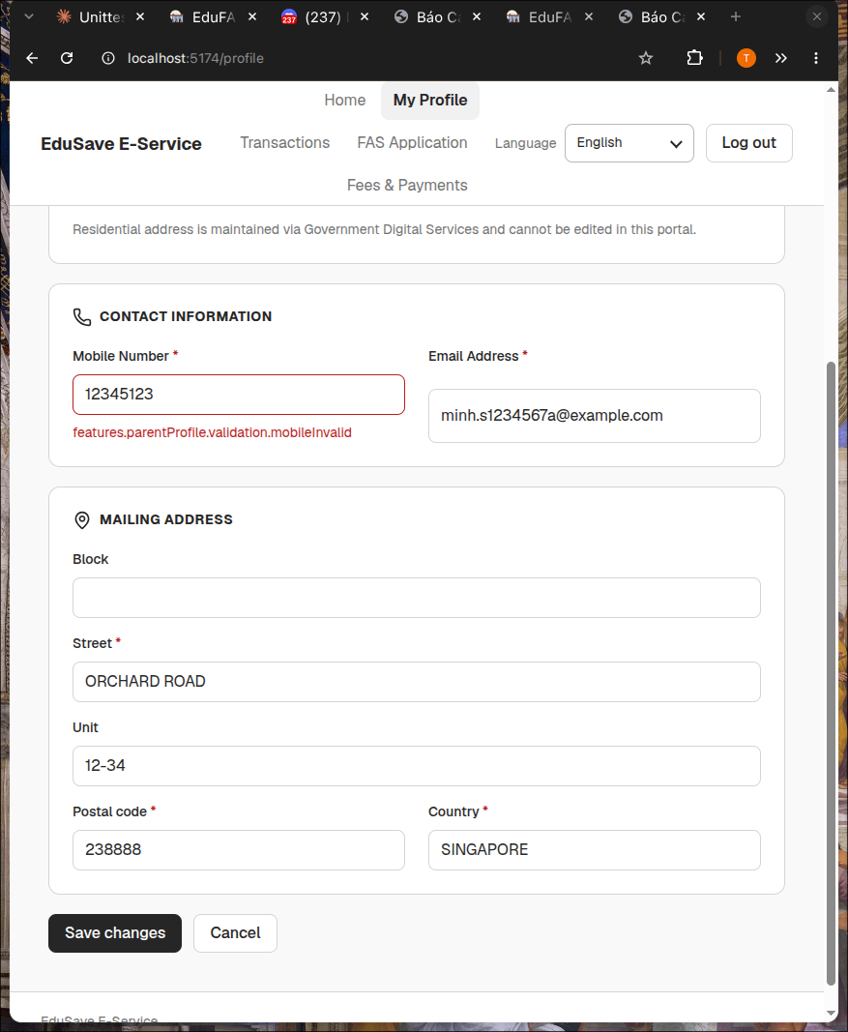

Bug #2 — Missing Mandatory Street & Country Validation

Project | EduFAMS E-Service Portal
Issue Type | Bug
Summary | Mandatory Street and Country fields in Mailing Address lack inline validation when empty
Priority | High
Component | My Profile (Mailing Address Section)
Affected Version | Web Client SIT v1.0.0 (Port 5174)
Fix Version | Sprint 1 / Next Hotfix
Assignee | Frontend Engineering Team
Reviewer | / Lead QA
Due Date | 25-Oct-2026
Description | According to FS-08 Section 5 and TC-R8-103, Street and Country are mandatory fields (Mandatory = Yes), whereas Block and Unit are optional. When a user deletes values in Street and Country leaving them blank, the form fails to show inline required validation warnings (violating MSG-0001).
Steps to Reproduce | 1. Navigate to http://localhost:5174/profile and click "Update details".  2. Clear the "Street" input field completely.  3. Clear the "Country" input field completely.  4. Attempt to save or inspect inline validation feedback.
Expected Result | Inline error alert should immediately appear below Street and Country (e.g. "Street is required", MSG-0001) preventing invalid state.
Actual Result | No validation error alert appears below Street or Country. Only Email and Mobile display error containers.
Attachment | Figure 2: Street and Country inputs cleared without triggering required validation alerts.
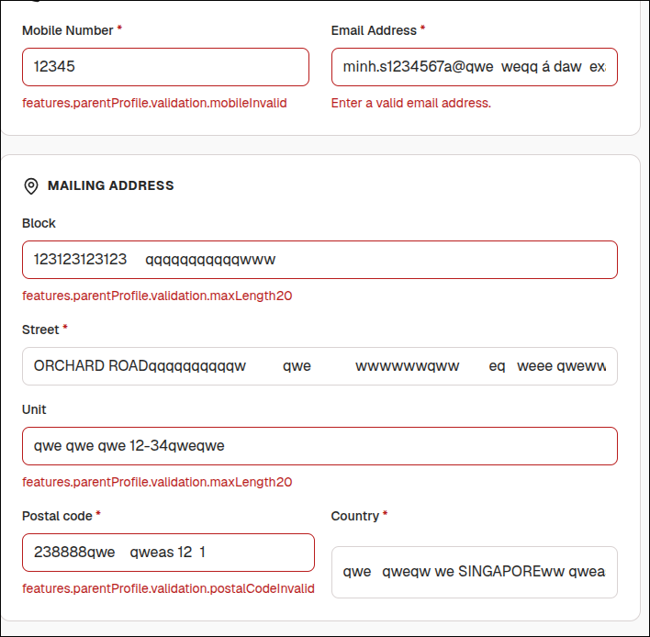

Bug #3 — Mobile Navbar Drawer Expansion Failure

Project | EduFAMS E-Service Portal
Issue Type | Bug
Summary | Mobile Navigation burger button fails to expand navigation drawer on mobile viewports
Priority | Medium
Component | Header Navigation Bar (Responsive Layout)
Affected Version | Web Client SIT v1.0.0 (Port 5174)
Fix Version | Sprint 1 / Responsive Polish
Assignee | Frontend Engineering Team / UI
Reviewer | / Lead QA
Due Date | 27-Oct-2026
Description | On mobile screen widths (<= 500px), the top navigation bar collapses into a hamburger icon "Open navigation". However, tapping or clicking this button fails to open the mobile drawer or slideout menu, preventing users from accessing portal modules (Home, Transactions, FAS, Fees). Violates responsive usability requirements in TC-R8-124.
Steps to Reproduce | 1. Resize browser viewport to mobile width (375px x 700px).  2. Load http://localhost:5174/profile.  3. Tap on the burger button ("Open navigation").  4. Observe navigation drawer state.
Expected Result | Navigation drawer expands smoothly, displaying full portal links with accessible close mechanism.
Actual Result | Burger menu button does not trigger drawer expansion; user remains trapped without navigation links.
Attachment | Figure 3: Mobile viewport 375x700 with non-functioning hamburger navigation button.
