BUG REPORT
SharePoint Site — Test Form & Comments
Prepared by: Kent Tran (Tran Tuan Kiet)

Summary
# | Summary | Component | Priority | Status
1 | Date of Birth field accepts future dates | Test Form | High | Pending review
2 | Age field accepts negative values | Test Form | High | Pending review
3 | Age field accepts decimal values | Test Form | Medium | Pending review
4 | Users can delete comments created by other users | Comments | High | Pending review
5 | Age is not automatically calculated after selecting Date of Birth | Test Form | Medium | Pending review

Bug #1 — Date of Birth field accepts future dates
Project | SharePoint Site
Issue Type | Bug
Summary | Date of Birth field accepts future dates
Priority | High
Component | Test Form
Affected Version | unknown
Fix Version | unknown
Assignee | Unassigned
Reviewer | Una Zheng
Due Date | 27-Aug-2026
Description | The Date of Birth field allows a user to select and save a date later than the current date, resulting in invalid personal information.
Steps to Reproduce | 1. Open the Test Form.  2. Click "New" to create a new item.  3. Enter valid values in all required fields.  4. Select a future date in the Date of Birth field, for example, 22-Aug-2026.  5. Click "Save".
Expected Result | The system should reject a future Date of Birth and display a clear validation message.
Actual Result | The system accepts and saves a Date of Birth that is later than the current date.
Attachment | 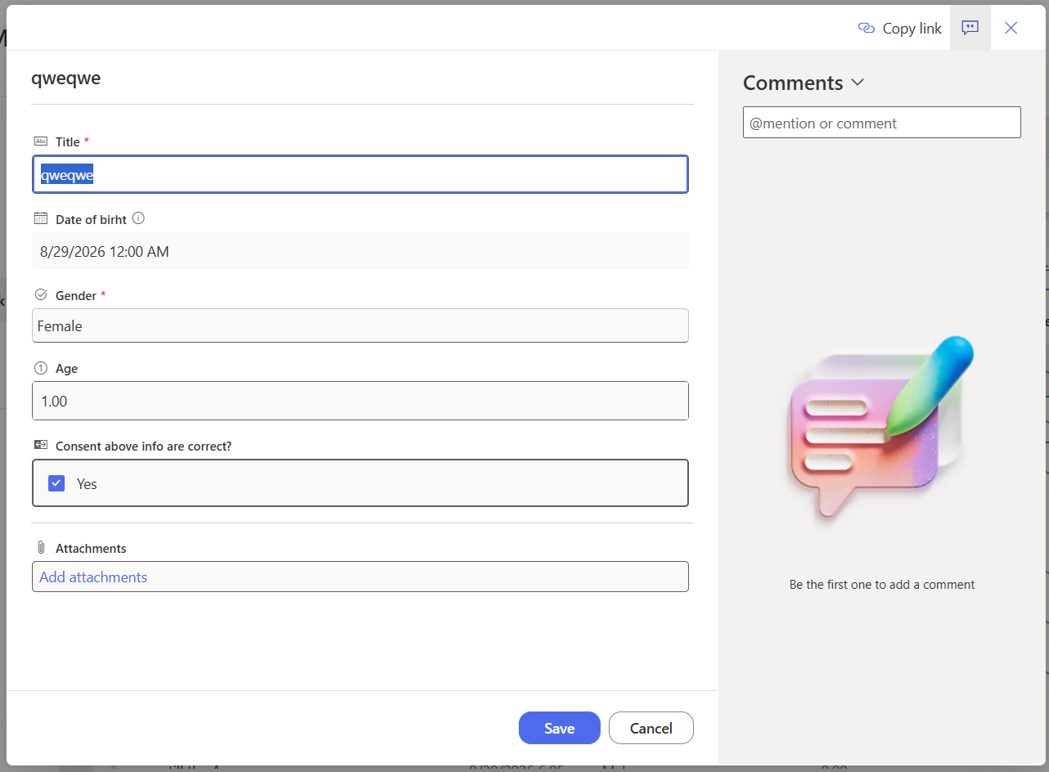  Setting the Date of Birth to a future date (8/29/2026).  The form accepts and saves the future date without validation.

Bug #2 — Age field accepts negative values
Project | SharePoint Site
Issue Type | Bug
Summary | Age field accepts negative values
Priority | High
Component | Test Form
Affected Version | unknown
Fix Version | unknown
Assignee | Unassigned
Reviewer | Una Zheng
Due Date | 27-Aug-2026
Description | The Age field allows manual entry of a negative number, even though age should be automatically calculated from Date of Birth and should never be negative.
Steps to Reproduce | 1. Open the Test Form.  2. Click "New" to create a new item.  3. Enter valid values in all required fields.  4. Enter "-1" in the Age field.  5. Click "Save".
Expected Result | The Age field should be read-only and automatically calculated from Date of Birth. A negative age must not be accepted.
Actual Result | The system allows the user to manually enter and save a negative value in the Age field.
Attachment | 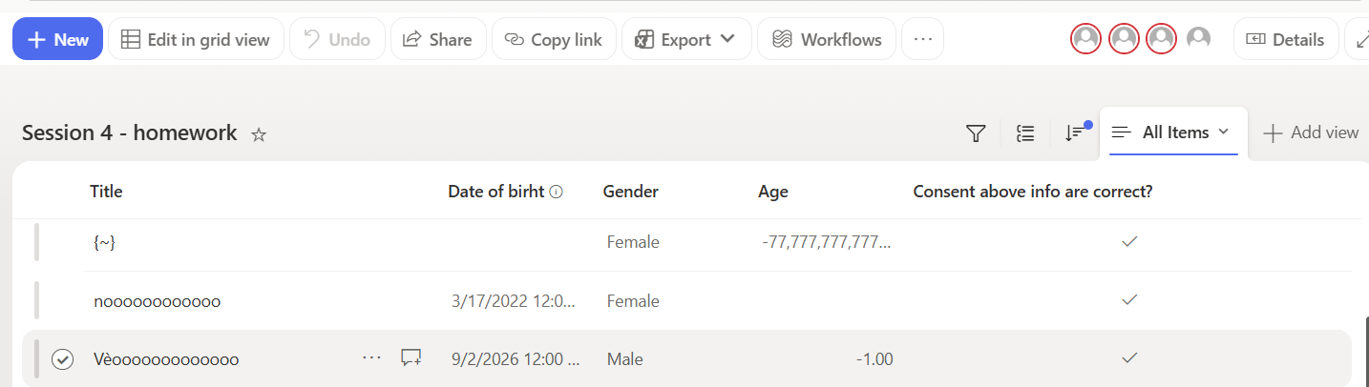  Negative value entered and saved in the Age field.

Bug #3 — Age field accepts decimal values
Project | SharePoint Site
Issue Type | Bug
Summary | Age field accepts decimal values
Priority | Medium
Component | Test Form
Affected Version | unknown
Fix Version | unknown
Assignee | Unassigned
Reviewer | Una Zheng
Due Date | 27-Aug-2026
Description | The Age field allows manual entry of a decimal number even though age should be automatically calculated and displayed as a whole number.
Steps to Reproduce | 1. Open the Test Form.  2. Click "New" to create a new item.  3. Enter valid values in all required fields.  4. Enter "3.14" in the Age field.  5. Click "Save".
Expected Result | The Age field should be read-only and automatically calculated from Date of Birth as a whole number. Decimal values must not be accepted.
Actual Result | The system allows the user to manually enter and save a decimal value in the Age field.
Attachment | 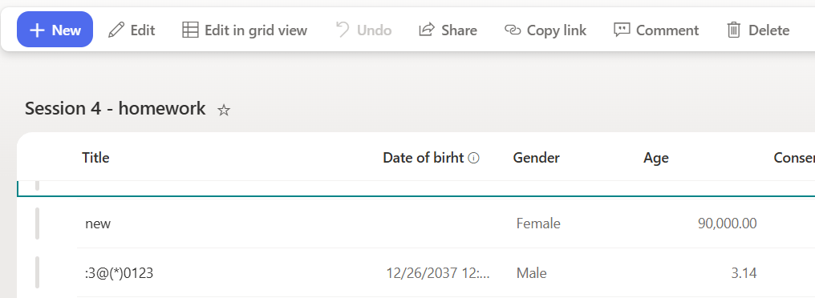  Decimal value entered in the Age field.  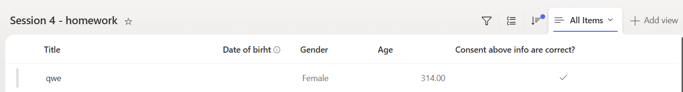  The decimal value is saved without validation.

Bug #4 — Users can delete comments created by other users
Project | SharePoint Site
Issue Type | Bug
Summary | Users can delete comments created by other users
Priority | High
Component | Comments
Affected Version | unknown
Fix Version | unknown
Assignee | Unassigned
Reviewer | Una Zheng
Due Date | 27-Aug-2026
Description | A regular user can delete a comment created by another user, even though the comment does not belong to the current user.
Steps to Reproduce | 1. Sign in as User A and add a comment to an item.  2. Sign out, then sign in as User B using a non-admin account.  3. Open the same item and locate the comment created by User A.  4. Delete User A's comment.  5. Refresh the item or reopen the comments section.
Expected Result | A regular user should only be able to delete comments created by that user. Comments created by other users should not show a delete option.
Actual Result | User B can delete the comment created by User A, and the comment is permanently removed.
Attachment | 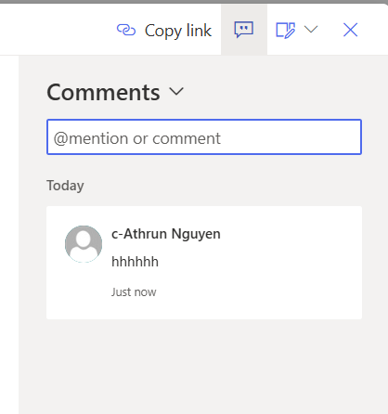  Comment originally created by user Athrun Nguyen.  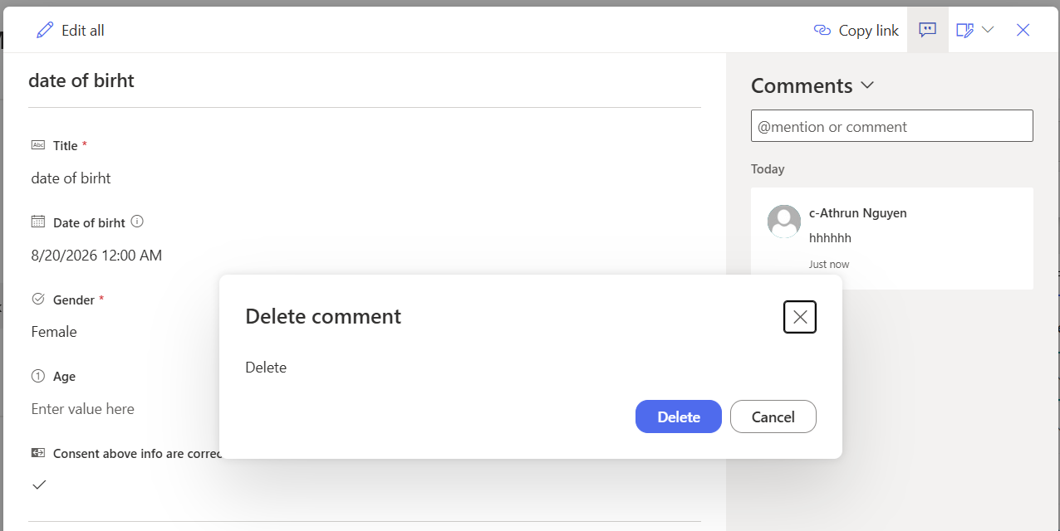  User B is able to delete the comment from their own account.  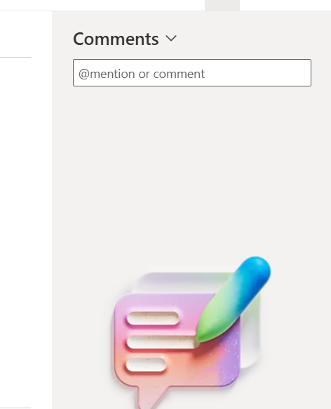  Delete option is shown to a user who does not own the comment (should be disabled).

Bug #5 — Age is not automatically calculated after selecting Date of Birth
Project | SharePoint Site
Issue Type | Bug
Summary | Age is not automatically calculated after selecting Date of Birth
Priority | Medium
Component | Test Form
Affected Version | unknown
Fix Version | unknown
Assignee | Unassigned
Reviewer | Una Zheng
Due Date | 27-Aug-2026
Description | The Age field is not automatically calculated after the user selects a valid Date of Birth.
Steps to Reproduce | 1. Open the Test Form.  2. Click "New" to create a new item.  3. Enter valid values in all required fields.  4. Select a valid date in the Date of Birth field.  5. Check the Age field.
Expected Result | The Age field should be automatically calculated and displayed based on the selected Date of Birth.
Actual Result | The Age field remains empty and is not automatically calculated after a valid Date of Birth is selected.
Attachment | 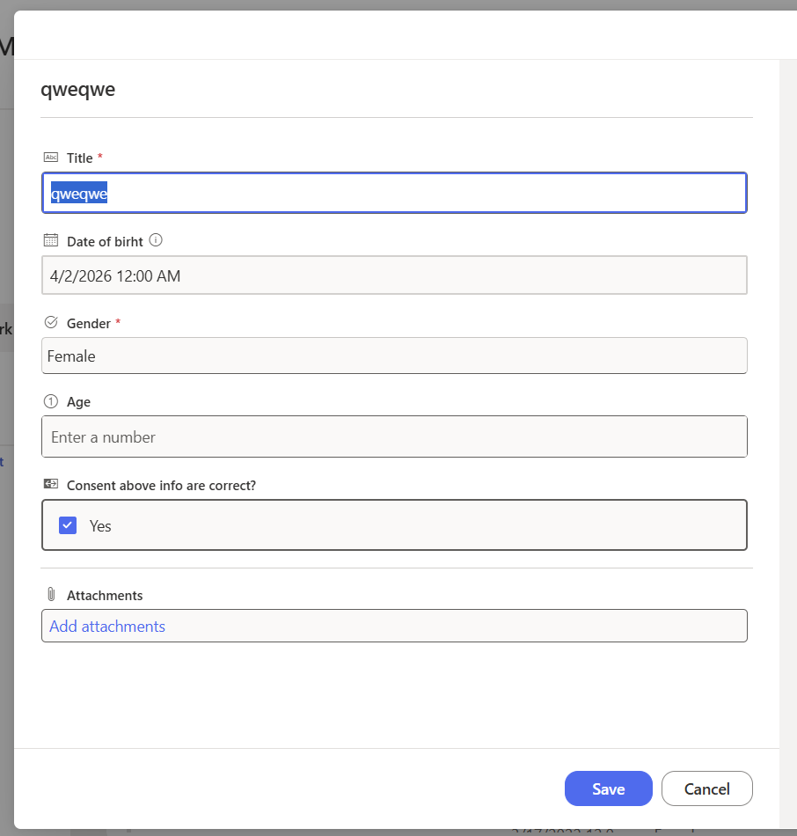  Date of Birth selected on the form.  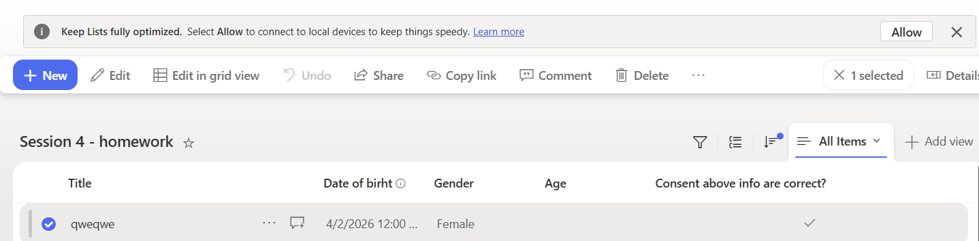  Age field remains empty after selecting the Date of Birth.

