Project Documentation
Mining Massive Data Sets Final Project - Process, Ideas, and Implementation Details
Team members: Chau Pham Tuan Kiet (523K0011), Nguyen Bao Long (523K0014), Nguyen Ba Hung (523K0006)
Lecturer: Hoang Anh
Course: Mining Massive Data Sets
This document explains how our team planned, designed, implemented, and verified the final project. It is written as an official process document rather than a short report. The main goal is to show what was actually built in each task, how the ideas were formed from the rubric, and how the implementation evidence was produced in the notebooks.
The wording is intentionally natural because this document is also meant to help during a discussion with the lecturer. Instead of only presenting final scores, it explains the reasoning behind the design decisions and the concrete work that appears in the submitted files.

1. Overall Project Workflow
At the beginning, the team treated the assignment PDF as the primary specification. Every important bullet in the rubric had to become a notebook section, a class, an output file, a chart, or a statement in the final report. That approach made the work easier to control because the project had many small requirements across three technical tasks.
The implementation style was shared across the tasks. Each notebook starts with dependency setup, imports, configuration, data preparation, algorithm classes, experiment execution, output generation, plots, and Spark cleanup. This structure was chosen so the source code is easy to inspect, easy to re-run, and easier to explain in an interview.
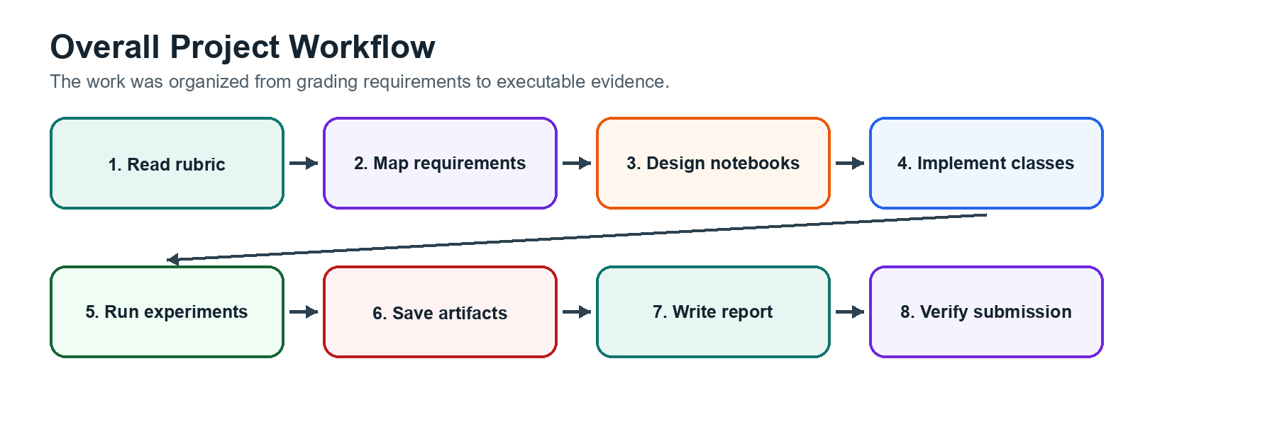
Figure 1. Overall workflow used to move from rubric requirements to final submission evidence.

1.1 What the team built
- A complete submission folder named final_2_523K0011 with Source and Report directories.
- Three executed notebooks: Task01.ipynb, Task02.ipynb, and Task03.ipynb.
- Saved CSV outputs for generated data, experiment metrics, and final results.
- Saved figures for clustering behavior, 3D t-SNE, regression loss curves, RMSE comparisons, and runtime comparisons.
- An IEEE-style PDF report and this separate process documentation file.

1.2 How the rubric was converted into work
The project was planned from the grading categories. Data requirements were implemented first because every algorithm and experiment depends on correct input. Algorithm requirements were then implemented as focused classes. Experiment requirements were handled last by saving plots and CSV summaries. This order kept the notebooks reproducible and helped avoid late changes that could break previous outputs.
Our team also kept the notebooks self-contained. The CSV files needed by Tasks 2 and 3 are copied into the corresponding task folders, and Task 1 exports its generated string dataset. This makes the folder easier to submit and easier for the lecturer to re-run without searching for files in another location.

1.3 Preparation Before Implementation
Before writing the notebooks, the team first prepared the project as a rubric-driven submission rather than a collection of separate experiments. The assignment PDF was read as the main specification, especially the grading tables and the required submission structure. From that reading, the team listed the expected folders, notebooks, CSV files, figures, report files, and preserved notebook outputs that had to appear in the final folder.
The working folder was organized early so each task could be checked independently. The final submission directory uses the required Source and Report structure, and each task has its own subfolder. The given datasets, gold_prices.csv and ratings2k.csv, were copied into the task folders that use them. Task 1 generates its own dataset and exports it to CSV so the generated input can also be inspected by the lecturer.
The environment preparation focused on reproducibility. Each notebook starts with dependency setup, imports, a configuration object, Spark session creation, and fixed random seeds where needed. This made it easier to rerun the notebooks, regenerate outputs, and explain which parameters control the experiments. The same organization also helped the team verify that every chart and CSV in the report came from an executed notebook cell.
The preparation stage also included deciding how to defend the work orally. For each task, the team wrote down the key concept that must be explained: non-Euclidean clustering and Jaccard distance for Task 1, CUR-based dimensionality reduction and regression evaluation for Task 2, and missing-rating interpretation with fast neighbor lookup for Task 3. This made the implementation choices easier to connect back to the assignment requirements.

2. Task 1 - Hierarchical Clustering in Non-Euclidean Spaces
This section follows the same explanation pattern for Task 1: the idea from the rubric, the design decisions, the implementation steps, the output evidence, the alternatives that were considered but not selected, and the final result.
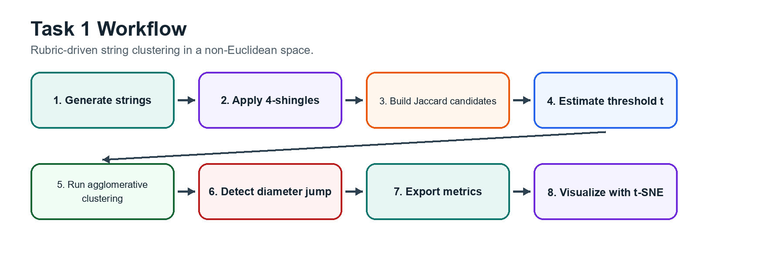
Figure 2. Task 1 pipeline from rubric interpretation to clustering visualization.

2.1 Idea from the rubric
Task 1 started directly from the rubric. The assignment required about 10,000 alphabetical strings, random lengths in the range [32, 64], 4-shingle tokenization, Jaccard distance, a saved CSV file, distributed computation, and an agglomerative clustering algorithm in a non-Euclidean setting. The notebook was therefore designed around these exact points instead of starting from a generic clustering example.
A key idea was that the generated dataset should be valid but also meaningful for clustering. If every string were completely random, most 4-shingle sets would have very little overlap, and the clustering result would be difficult to explain. Because of that, the team generated prototype strings and then created mutations from those prototypes. This still produces alphabetical strings with the required length range, but it also creates local neighborhoods where Jaccard similarity can detect related strings.

2.2 Design decisions
- The string dataset is generated with PySpark so the large data creation step is distributed.
- The shingle extraction step is also handled in Spark before the compact representation is collected for the in-memory clustering stage.
- Every string is converted to lowercase before 4-shingles are created, which satisfies the case-insensitive requirement.
- Jaccard distance is used because the objects are sets of shingles, not numeric vectors in Euclidean space.
- Agglomerative clustering is kept in memory because the assignment explicitly asks for an in-memory algorithm structure.
- The code is organized into classes such as StringDatasetBuilder, OverlapCandidateIndex, DiameterJumpDetector, Cluster, and AgglomerativeClusteringRunner.
Approach 2 from the non-Euclidean hierarchical clustering lecture was interpreted in a practical way. Instead of representing a cluster by a simple numeric centroid, the implementation keeps a cluster as a collection of member strings and measures distance between clusters through pairwise Jaccard behavior among members. This matches the non-Euclidean setting because a centroid is not naturally defined for a set of shingles.

2.3 Implementation process
- Create a reproducible configuration with total string count, prototype count, length range, threshold parameters, and random seed.
- Start a Spark session with local parallelism and fixed shuffle partitions.
- Generate prototype strings and mutate them to create 10,000 valid alphabetical strings.
- Apply 4-shingle tokenization with lowercase normalization and export the dataset to task01_strings.csv with columns index, string, and shingles.
- Build an overlap-based candidate index so the clustering loop does not need to compare every possible string pair from the beginning.
- Estimate the merge threshold t from nearest-neighbor Jaccard distances, then run the agglomerative loop with this threshold.
- Track merged cluster size, merge distance, cluster diameter, and global_avg_dist at each accepted merge.
- Stop the algorithm when the diameter-jump detector identifies an abnormal jump.
- Save task01_metrics.csv, draw the global_avg_dist chart, and create a 3D t-SNE visualization for inspection.

2.4 Threshold and stopping rule
The threshold t is not selected as an arbitrary constant. The notebook estimates it from the nearest-neighbor Jaccard distance distribution and then applies a small padding value while respecting a maximum threshold. This gives the algorithm a data-driven starting point: nearby strings can merge, but far-away strings are blocked.
The diameter-jump rule acts as a quality guard. During normal useful merges, the cluster diameter changes gradually. When a candidate merge would create a cluster whose diameter suddenly becomes much larger than the recent history, the detector stops the process. The idea is simple: a sudden jump usually means the algorithm is about to combine groups that are not really close anymore.

2.5 Output evidence and results
Item | Value
Generated strings | 10,000
CSV columns | index, string, shingles
Recorded merge steps | 116
Active clusters at stop rule | 9884
Last merge distance | 0.3793
Last global_avg_dist | 0.002527

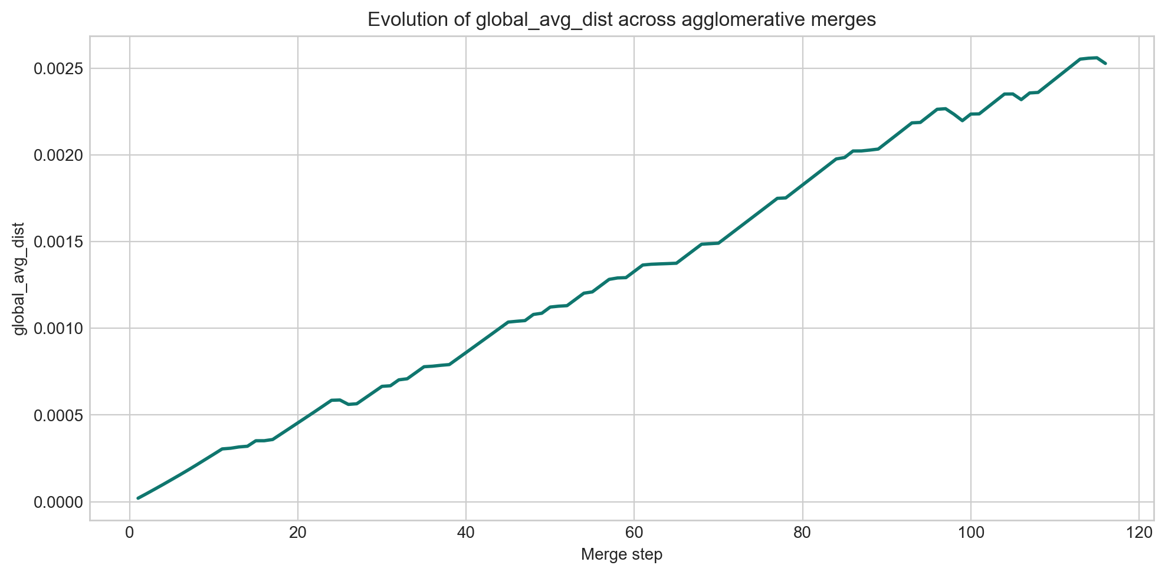
Figure 3. Evolution of global_avg_dist during Task 1 agglomerative merging.
The line chart is used as evidence that the notebook executed iterative clustering steps and recorded global_avg_dist values over time. It also gives the lecturer a quick way to inspect how the internal cluster quality metric changed as merges were accepted.
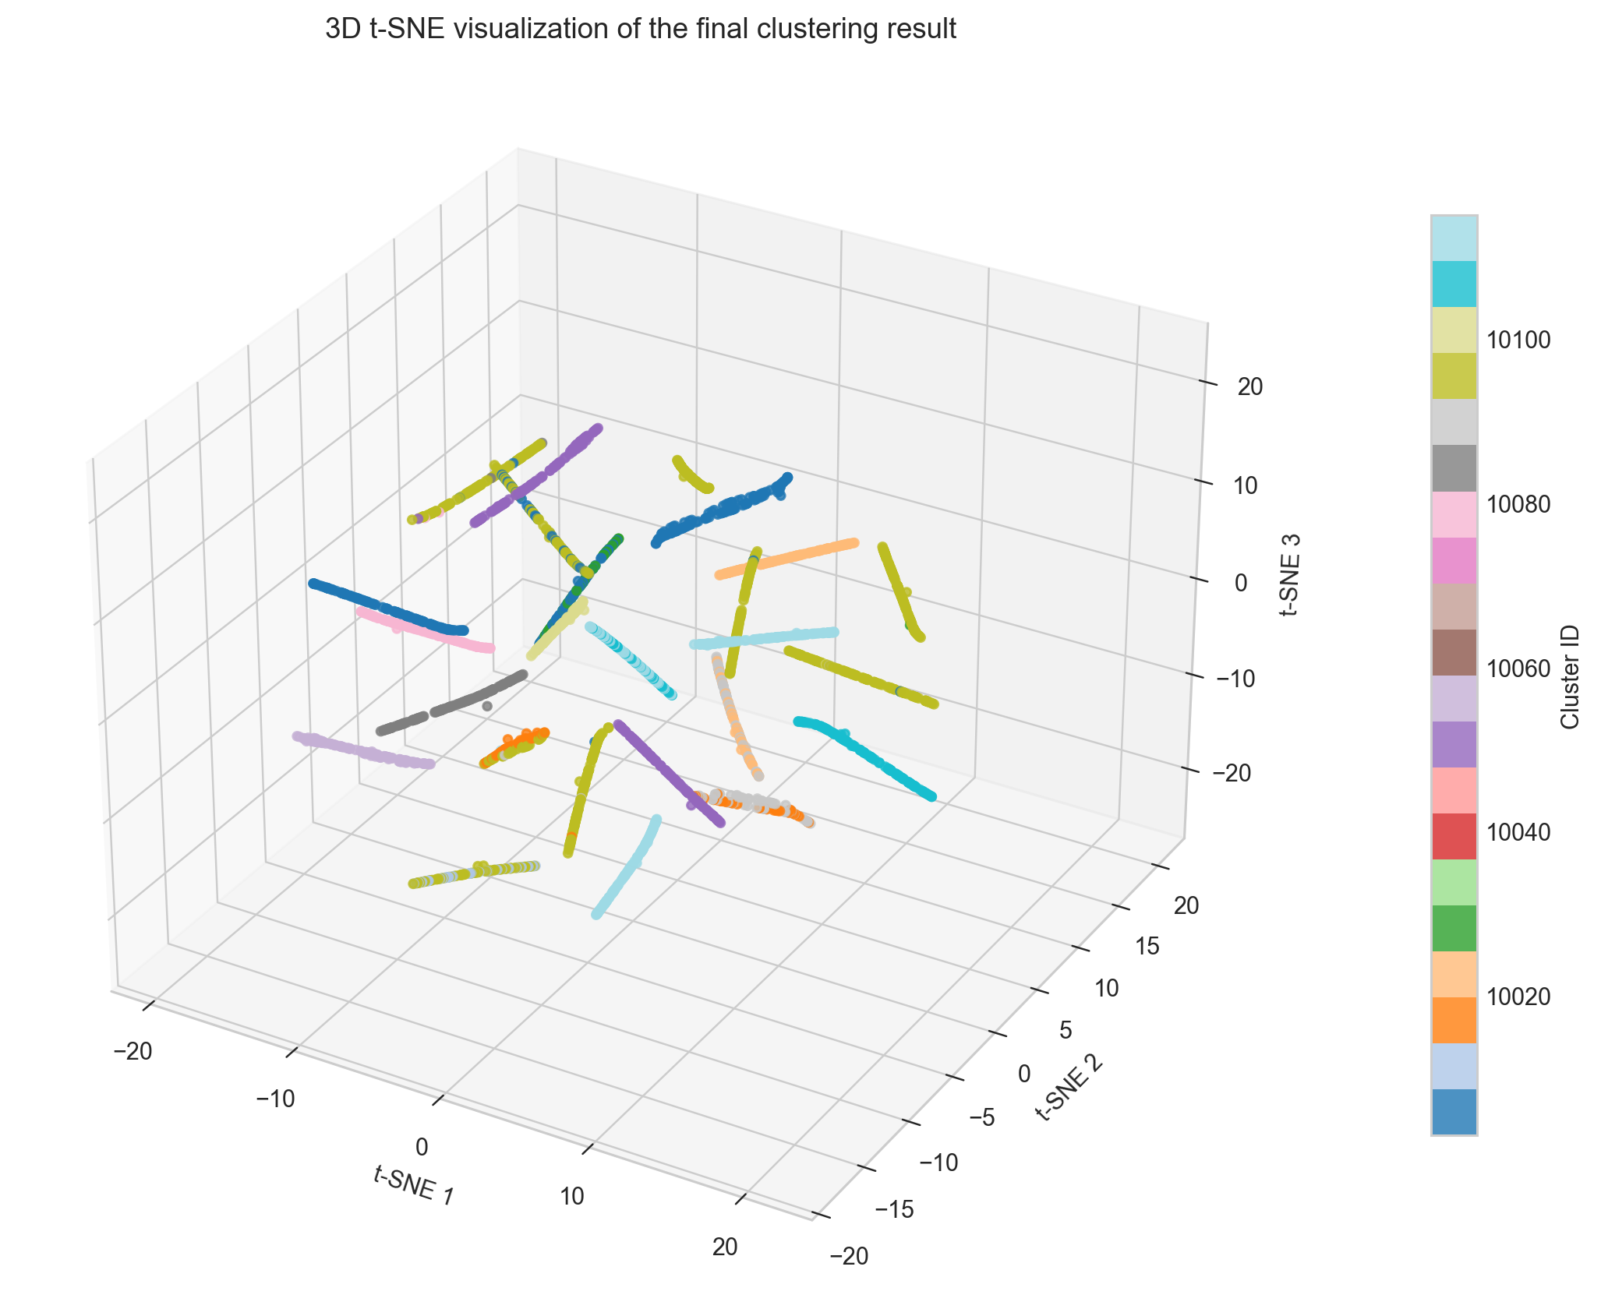
Figure 4. 3D t-SNE visualization of the final Task 1 grouping.
The t-SNE plot is only used for visualization. It is not part of the clustering logic. This separation matters because the assignment asks for hierarchical clustering based on Jaccard distance, while t-SNE is a visual inspection tool that helps present the final grouping in a human-readable form.

2.6 Alternatives considered but not selected
- Completely random strings were considered, but they would produce weak shingle overlap and a less meaningful clustering demonstration.
- A full all-pairs distance matrix was avoided because 10,000 strings would create a very large comparison set for a notebook environment.
- A Euclidean centroid representation was not used because the data objects are shingle sets and the lecture requirement is non-Euclidean.
- A fixed hand-picked threshold was avoided because a data-driven threshold is easier to justify during grading.

2.7 Rubric coverage notes
- The dataset size, length range, 4-shingle representation, Jaccard distance, and CSV export are covered in the data section of the notebook.
- Distributed computation is used for data generation and shingling through PySpark.
- The agglomerative algorithm, in-memory loop, cluster representation, cluster distance, threshold, and diameter jump are implemented as explicit classes and methods.
- The experiment section produces the required global_avg_dist line chart and 3D t-SNE visualization.

3. Task 2 - Linear Regression for Gold Price Prediction
This section follows the same explanation pattern for Task 2: the idea from the rubric, the design decisions, the implementation steps, the output evidence, the alternatives that were considered but not selected, and the final result.
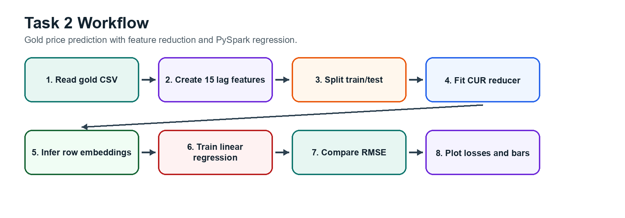
Figure 5. Task 2 pipeline for lag feature construction, CUR reduction, and regression evaluation.

3.1 Idea from the rubric
Task 2 was planned as a supervised time-series prediction task. The rubric gives a gold-price CSV file and asks for features based on the previous 15 dates, with the label being the gold price at date t. In our implementation, the label is the Sell Price column. The dataset is read with PySpark, transformed into feature-label samples, split into training and test sets with a 7:3 ratio, and then evaluated with PySpark linear regression.
The second major requirement is dimensionality reduction from 15 down to 5 using a CUR algorithm implemented as a class. This requirement shaped the design of the notebook. Instead of training only one regression model, the experiment runner trains and evaluates a separate model for every reduced dimension from 15 to 5.

3.2 Design decisions
- The data preparation logic is placed in GoldPriceDatasetBuilder so loading, date sorting, lag generation, and sample creation are grouped together.
- Sell Price is used as the label because it is a clear target column for prediction and appears in the given dataset.
- The 15 previous Sell Price values become lag_1 through lag_15 and are assembled into the feature vector.
- randomSplit with the configured seed is used for the 7:3 training/test split so the run is reproducible.
- CURReducer uses RowMatrix.computeSVD to obtain information about important directions in the feature matrix.
- RegressionExperimentRunner controls the repeated experiments so code is not copied for each dimension.

3.3 Implementation process
- Read gold_prices.csv with Spark using header inference and cast Buy Price and Sell Price to numeric values.
- Convert Date to a date type and sort all rows by date.
- Use a window over the ordered dates to generate 15 lag features from the previous dates.
- Drop rows without enough history, assemble lag columns into a Spark feature vector, and keep the label column.
- Split the samples into training and test DataFrames with the 7:3 ratio required by the assignment.
- Collect the feature matrix into NumPy arrays for the CUR transformation while still using Spark for loading and model training.
- Fit CURReducer on the training features and transform both training and test features into row embeddings for each dimension.
- Train PySpark LinearRegression models for dimensions 15, 14, ..., 5 and record objective history, train RMSE, and test RMSE.
- Save task02_results.csv, draw the training loss curves, and draw the twin-bar RMSE comparison chart.

3.4 CUR and row embedding explained simply
The project does not use CUR as a black-box library call. The notebook implements a CUR-style reducer class. The general idea is to keep informative columns and representative rows so that the original 15-dimensional lag vector can be represented in a smaller space. RowMatrix.computeSVD is used to estimate useful feature directions, and leverage-like scores help select columns for each target dimension.
After the reducer selects columns, the feature vectors are converted into a new compact representation. In the notebook, this new representation is called row_embedding. The same transformation is applied to both the training and test sets, which keeps evaluation consistent.

3.5 Output evidence and results
Dimension | Train RMSE | Test RMSE | Objective iterations
15 | 0.3469 | 0.3237 | 15
14 | 0.3457 | 0.3237 | 43
13 | 0.3449 | 0.3237 | 17
12 | 0.3471 | 0.3239 | 15
11 | 0.3439 | 0.3214 | 20
10 | 0.3427 | 0.3209 | 15
9 | 0.3468 | 0.3205 | 28
8 | 0.3460 | 0.3219 | 14
7 | 0.3480 | 0.3217 | 13
6 | 0.3445 | 0.3169 | 14
5 | 0.3416 | 0.3201 | 12

The best test-time configuration in the executed run is dimension k = 6, with train RMSE = 0.3445 and test RMSE = 0.3169. This result is useful because it shows that reducing the original 15 lag features can keep the prediction quality competitive.
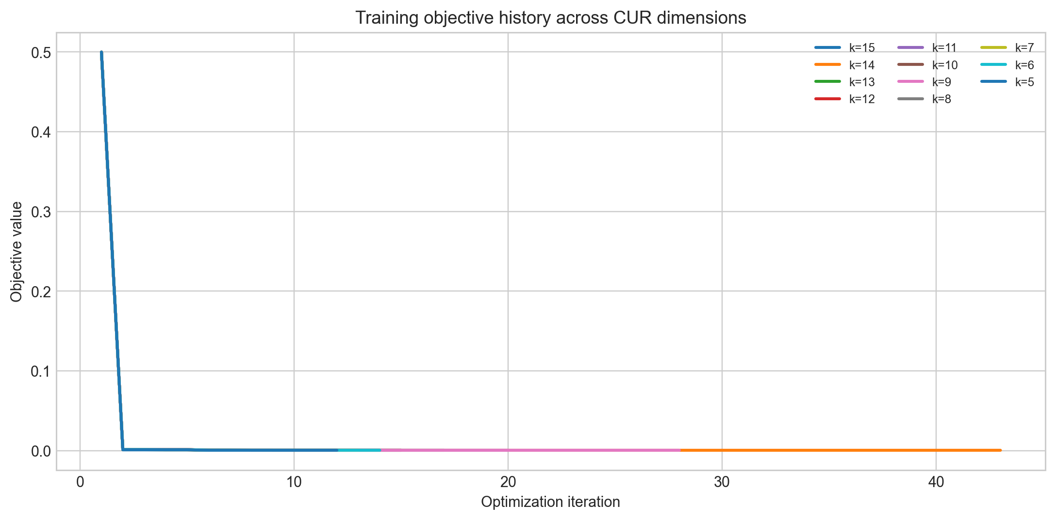
Figure 6. Training objective histories for different CUR-reduced dimensions.
The loss chart is included because the rubric asks for a single chart with multiple loss curves. It also shows that the repeated experiments were actually executed rather than described only in text.
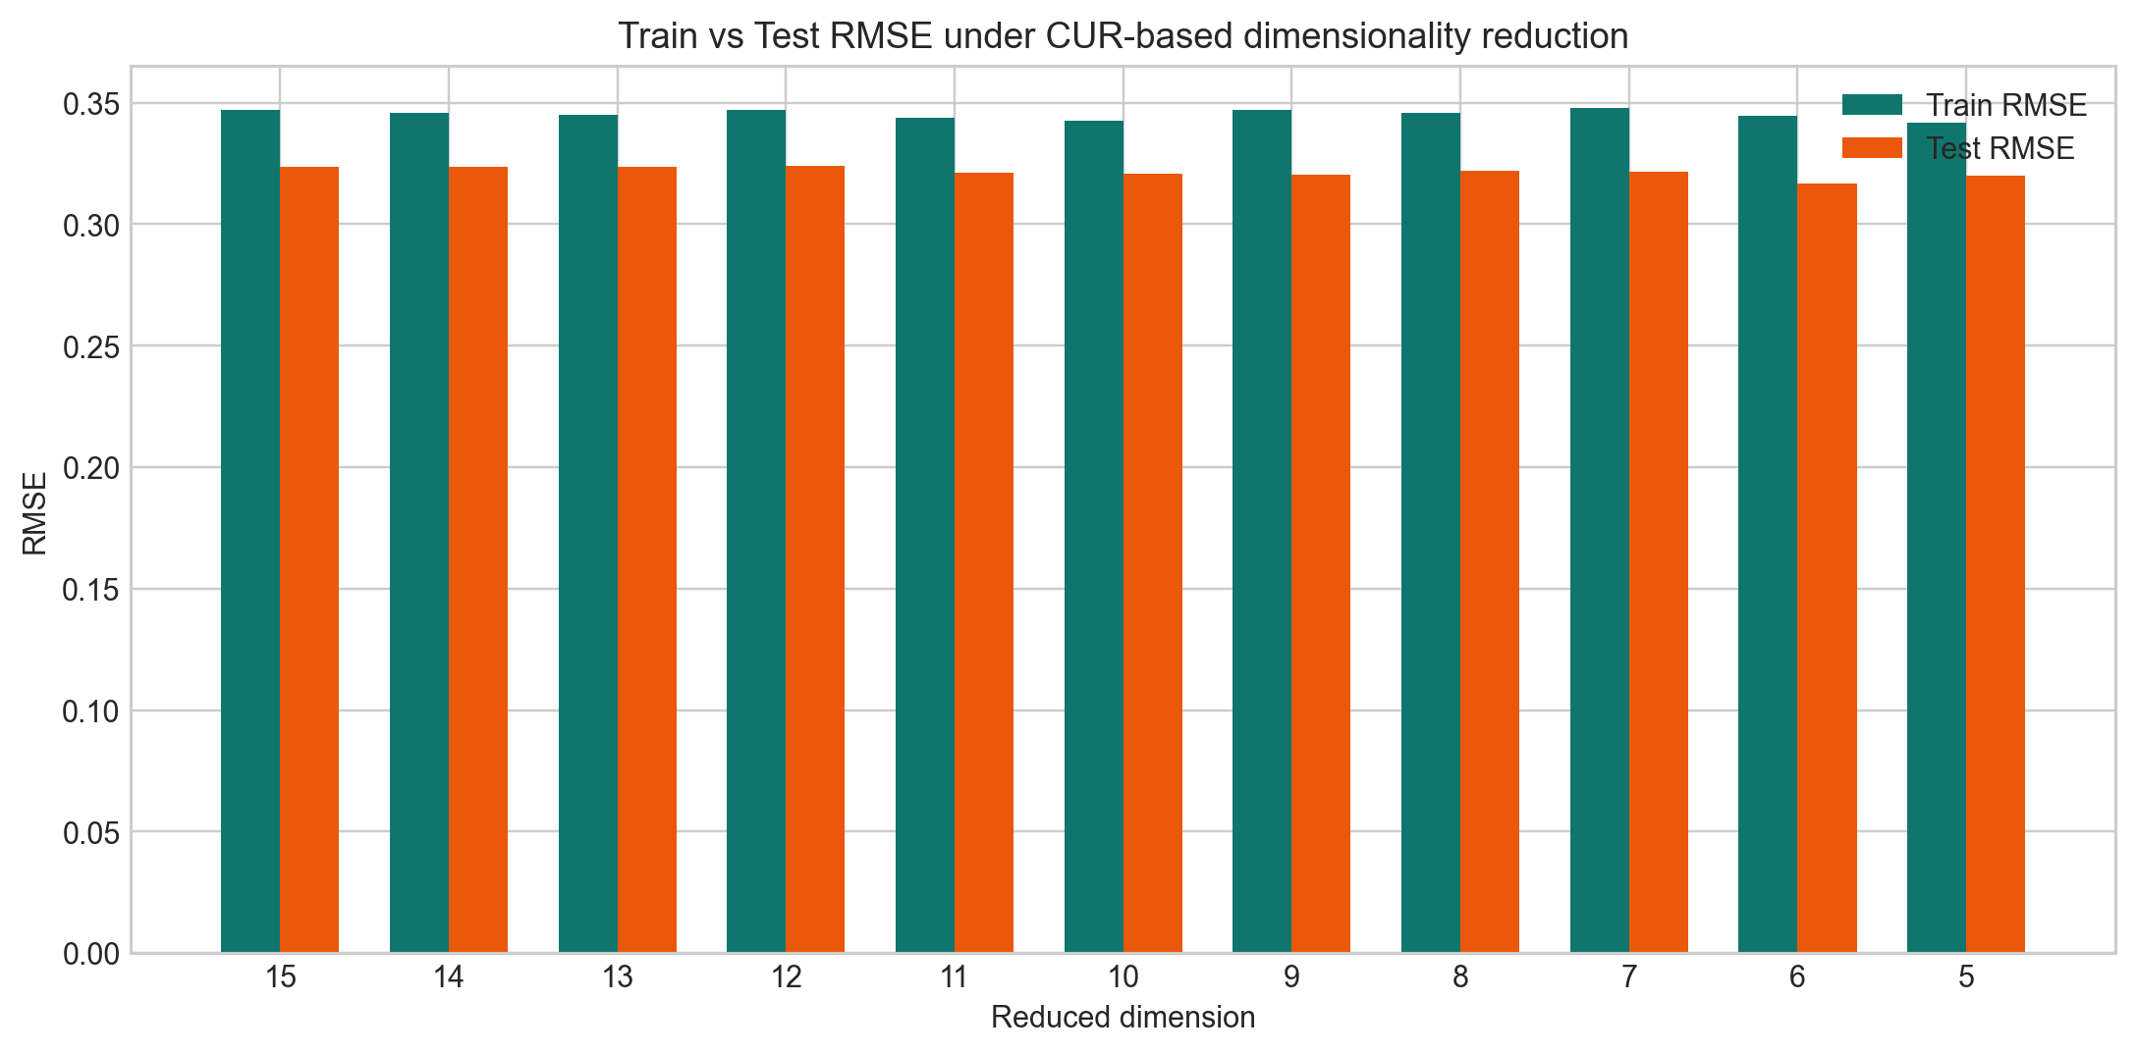
Figure 7. Twin-bar comparison of train and test RMSE across reduced dimensions.

3.6 Execution note
When the notebook is re-executed on Windows, Spark may print LBFGS line-search reset messages while fitting some linear regression models. In our verification runs, these messages did not stop the notebook and did not create error outputs in the .ipynb file. The results CSV and plots were still generated successfully, so the messages were treated as Spark optimizer logs rather than failed project execution.

3.7 Alternatives considered but not selected
- A manual linear regression implementation was not selected because the assignment explicitly allows pyspark.ml.regression.LinearRegression.
- A single fixed reduced dimension was not selected because the rubric asks for reduction from 15 to 5 with step size 1, so every dimension must be evaluated.
- A copy-pasted experiment block for each dimension was avoided because it would be harder to maintain and explain.
- Using only local pandas for the whole task was avoided because distributed computation is required.

3.8 Rubric coverage notes
- The CSV is read with PySpark and transformed into a Spark DataFrame.
- The notebook creates 15-date lag features and labels each sample with the Sell Price at date t.
- The samples are divided into training and test sets with the 7:3 ratio.
- CUR reduction is implemented as a class and uses RowMatrix.computeSVD.
- The experiment runner infers row embeddings, trains linear regression models, saves results, and produces both required charts.

4. Task 3 - Collaborative Filtering for Recommendation
This section follows the same explanation pattern for Task 3: the idea from the rubric, the design decisions, the implementation steps, the output evidence, the alternatives that were considered but not selected, and the final result.
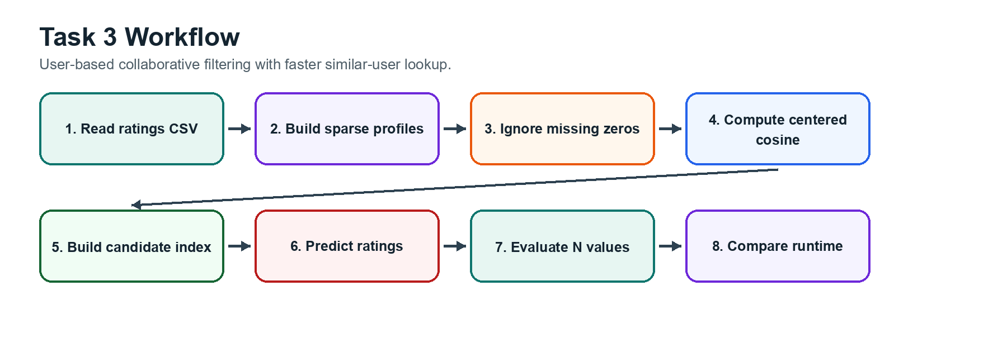
Figure 8. Task 3 pipeline for user-based collaborative filtering and fast lookup evaluation.

4.1 Idea from the rubric
Task 3 required collaborative filtering on ratings2k.csv. The most important data interpretation rule is that a zero in a user profile means the user has not tried or rated an item yet. It does not mean the user dislikes the item. Because of that, the similarity metric and prediction method must avoid treating missing entries as negative preferences.
The rubric also asks for a fast way to determine users that are most similar to a target user without enumerating the whole dataset, with average O(1) behavior expected. The notebook therefore builds a candidate lookup structure before prediction. At prediction time, the model can retrieve a shortlist from a dictionary and then compute exact similarity only on the returned candidates.

4.2 Design decisions
- RatingsDatasetBuilder reads the CSV with Spark, casts user, item, and rating columns, and creates the train/test split.
- Each user profile is stored as a sparse dictionary of rated items rather than a dense vector full of zeros.
- CenteredCosineSimilarity computes similarity only on co-rated items, so missing values do not create false negative signals.
- OverlapHashIndex builds candidate shortlists using shared rated items, which is simple and easy to defend during an interview.
- UserBasedCF performs weighted prediction from similar users who rated the target item.
- CFExperimentRunner evaluates multiple values of N and compares baseline full-scan prediction against indexed lookup.

4.3 Why full-vector cosine was not used
A normal cosine similarity on dense rating vectors would include many zeros. In this dataset, zeros mean missing ratings, not dislikes. If those zeros were included directly, two users could look artificially similar because both have not rated many of the same items, or they could be penalized for missing values that do not represent opinion. The selected mean-centered cosine metric only uses co-rated items and subtracts each local mean, so it better represents agreement on items both users actually rated.

4.4 Implementation process
- Read ratings2k.csv with Spark and split the dataset into training and test sets.
- Collect training rows into sparse user-rating dictionaries and item-user lookup dictionaries.
- Build a preview matrix only for inspection, where missing ratings are displayed as zero.
- Fit OverlapHashIndex by counting how often another user appears with the target user on rated items.
- Store a candidate shortlist for each user in a dictionary, which makes the initial candidate retrieval an average constant-time lookup.
- For each prediction, retrieve either all users for the baseline or the shortlist for the indexed method.
- Compute exact centered cosine similarity only for candidates who rated the target item.
- Predict the rating with a weighted user-user formula based on the top N positive similarities.
- Evaluate RMSE for N values 5, 10, 15, 20, and 25, then benchmark baseline and indexed runtime on the same hardware.

4.5 Output evidence and results
N | RMSE | Baseline seconds | Indexed seconds
5 | 0.9596 | 3.815 | 2.832
10 | 0.9532 | 3.815 | 2.832
15 | 0.9536 | 3.815 | 2.832
20 | 0.9536 | 3.815 | 2.832
25 | 0.9536 | 3.815 | 2.832

The best tested neighbor count is N = 10, with RMSE = 0.9532. The runtime comparison gives baseline = 3.815s and indexed lookup = 2.832s in the latest execution. The dataset is not extremely large, so the speedup is moderate, but the design still demonstrates the required idea: avoid scanning the whole user set for every prediction by using a precomputed candidate lookup.
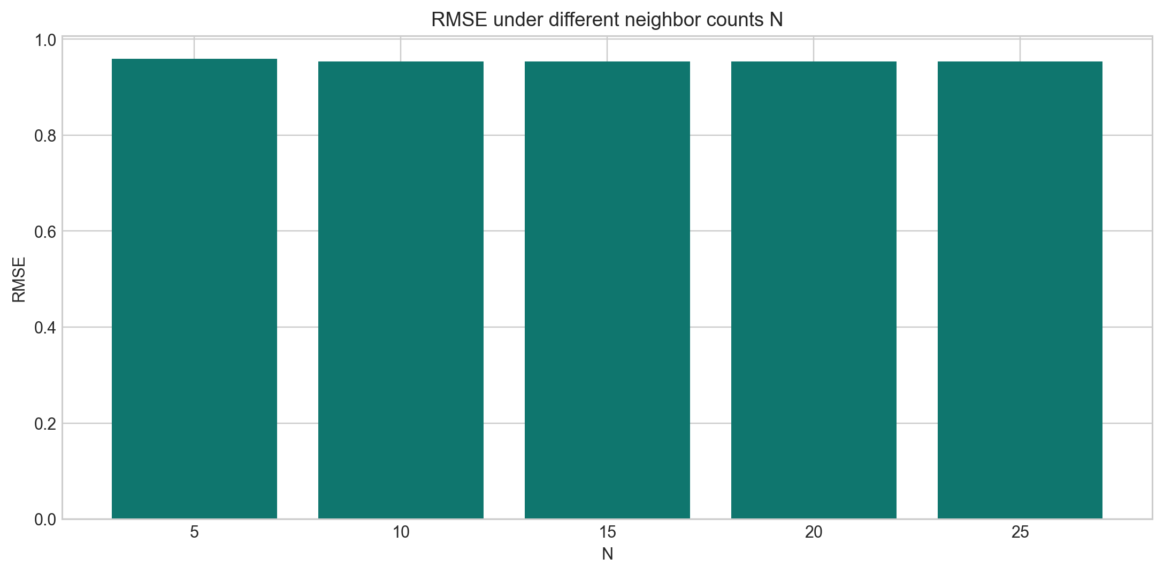
Figure 9. RMSE values for different neighbor counts N in Task 3.
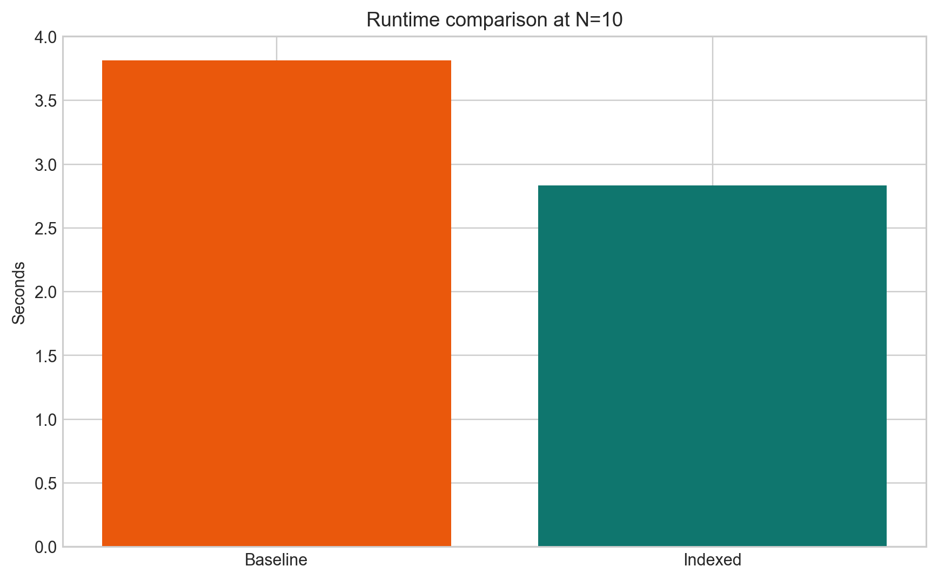
Figure 10. Runtime comparison between baseline full scan and indexed lookup.

4.6 Alternatives considered but not selected
- Dense-vector cosine over all items was not selected because zeros are missing values, not negative ratings.
- A full-scan neighbor search was kept only as a baseline because the rubric asks for a faster lookup approach.
- A very complex model-based recommender was not selected because the assignment focuses on user-user similarity and prediction with similar users.
- A random candidate shortlist was avoided because it would not reflect shared rating behavior and would be difficult to justify.

4.7 Rubric coverage notes
- The notebook reads ratings2k.csv and creates user profiles from the rating records.
- The similarity metric treats zero as missing by using only co-rated items.
- The collaborative-filtering prediction is based on user-user similarity and top N neighbors.
- The quick lookup method is implemented as OverlapHashIndex and integrated into the prediction pipeline.
- The experiments split training/test data, evaluate several N values, plot RMSE, and compare runtime with and without the fast lookup.

5. Difficulties, Fixes, and Understanding

5.1 Task 1: meaningful non-Euclidean clustering
The main difficulty in Task 1 was making the generated string dataset suitable for clustering. If all 10,000 strings were generated independently at random, most strings would share very few shingles and the clustering process would be hard to interpret. The implemented solution mutates controlled prototype strings, so the data remains alphabetical and random-looking while still containing enough local similarity for Jaccard-based clustering to show meaningful behavior.
Another difficulty was avoiding an expensive all-pairs comparison. The notebook uses an overlap-based candidate index to find promising neighbors before the in-memory agglomerative loop. This does not change the required distance definition: the final merge decision still uses Jaccard distance and the explicit threshold t. The team understands Task 1 as a representation problem first: strings become shingle sets, clusters become collections of members, and distances are computed between sets rather than Euclidean points.

5.2 Task 2: CUR reduction and consistent evaluation
The main difficulty in Task 2 was connecting the distributed Spark workflow with the CUR-style dimensionality reduction requirement. Spark is used to read the data, build lag features, split train/test data, and train LinearRegression models. The reducer uses RowMatrix.computeSVD to obtain useful feature directions, then applies the same selected representation to both training and test features. This keeps the evaluation fair because test rows are transformed using the reducer fitted from the training feature matrix.
The team also needed to avoid duplicated experiment code. Instead of writing separate blocks for dimensions 15, 14, ..., 5, the RegressionExperimentRunner loops over configured dimensions, trains models, records objective histories, and saves one results table. The team understands Task 2 as more than a prediction task: it demonstrates how dimensionality reduction can be tested under the same metric and compared against the original feature dimension.

5.3 Task 3: missing ratings and fast lookup
The most important difficulty in Task 3 was interpreting zero correctly. A zero in the displayed user profile means missing or unknown, not a negative rating. Because of that, dense-vector similarity over all items would be misleading. The implemented centered cosine similarity only uses co-rated items, so similarity reflects agreement on items both users actually rated.
The second difficulty was satisfying the fast similar-user lookup requirement without replacing the collaborative-filtering logic. OverlapHashIndex builds candidate shortlists from shared rated items and stores them in a dictionary. Prediction can retrieve a shortlist quickly, then still compute exact similarity and weighted rating prediction on the candidate users. The team understands this as a two-stage method: fast candidate retrieval first, exact user-user scoring second.

5.4 General lessons from the project
Across all three tasks, the team learned that the most important part of the project is matching the data representation to the algorithm. Task 1 needs sets of shingles, Task 2 needs lag-feature vectors and reduced embeddings, and Task 3 needs sparse rating dictionaries. Once the representation is correct, the algorithm and the required plots become easier to explain.
The team also learned to keep evidence close to implementation. Every major claim in the report is backed by a generated CSV, a saved chart, or preserved notebook output. This is why the notebooks are organized into small sections and why the documentation explains not only the final result, but also the preparation, choices, and verification steps behind that result.

6. Verification and Submission Readiness
After the implementation was organized into smaller notebook cells, the notebooks were executed again so the outputs would be preserved in the .ipynb files. This matters because the submission notice asks students to preserve notebook outputs and output files. The latest verification confirmed that the notebooks execute without error outputs and still generate the expected CSV files and figures.
Notebook | Code cells | Main evidence files
Task01.ipynb | 15 | task01_strings.csv, task01_metrics.csv, global_avg_dist chart, 3D t-SNE chart
Task02.ipynb | 12 | task02_results.csv, loss curves, train/test RMSE twin-bar chart
Task03.ipynb | 15 | task03_results.csv, RMSE chart, runtime comparison chart

The report was also rebuilt after the latest runtime values changed in Task 3. This keeps the final PDF consistent with the saved CSV result. The report remains within the required five-page maximum, while this documentation file provides the longer explanation requested by the lecturer.

7. What the Team Can Explain During Evaluation
- Why the project is rubric-first and how each notebook section maps to a requirement.
- Why Task 1 uses prototype mutation, 4-shingles, Jaccard distance, Approach 2, threshold t, and a diameter-jump stop condition.
- Why Task 2 treats Sell Price as the label, how 15 lag features are generated, and how CUR reduction creates row embeddings.
- Why Task 3 treats zeros as missing values, why centered cosine is used, and how the candidate index speeds up neighbor retrieval.
- Where each output file is saved and how the figures in the report and this documentation were generated.

8. Conclusion
The project was completed as a set of reproducible notebook pipelines rather than isolated code fragments. Each task begins with a rubric requirement, turns that requirement into a concrete design, implements the design with focused classes, and produces saved artifacts that can be checked independently. This documentation shows the process behind the final submission and gives a longer explanation of the ideas that could not fit into the five-page report.
Overall, the team built a complete MMDS final project covering non-Euclidean hierarchical clustering, gold-price prediction with CUR-based dimensionality reduction, and collaborative filtering with faster similar-user lookup. The final submission is ready to be read, re-run, and defended section by section.

