Project Work Summary
Mining Massive Data Sets Final Project
Detailed explanation of what we built, how we built it, what we tested, and what results we obtained
Team members:
Chau Pham Tuan Kiet - 523K0011
Nguyen Bao Long - 523K0014
Nguyen Ba Hung - 523K0006
Lecturer: Nguyen Thanh An
In this document, we explain clearly and in detail what we did in our final project. We use the first-person plural voice throughout because the work was completed as a team. Our goal in this summary is not only to list the final deliverables, but also to show our engineering process, the reasoning behind our design choices, the experiments we ran, the outputs we produced, and the level of verification we performed before finalizing the submission.

1. Executive Summary
We completed a three-task project covering hierarchical clustering in non-Euclidean spaces, linear regression for gold price prediction, and collaborative filtering for recommendation. Across all three tasks, we organized the work around a consistent set of principles: distributed computation where the assignment required it, compact class-based organization, reproducible notebook execution, and outputs that are easy to explain in an interview. We also prepared an IEEE-style report and verified that the notebooks can run both on a personal machine and on Google Colab.
- For Task 1, we generated 10,000 strings, tokenized them with 4-shingles, used Jaccard distance, and executed an agglomerative clustering procedure following Approach 2 from the lecture. The executed run used threshold t = 0.7224, recorded 116 merge steps, stopped with 9884 raw clusters, and created 25 visualization buckets for the 3D plot.
- For Task 2, we used PySpark to prepare supervised gold-price samples, reduced feature dimensionality from 15 down to 5 with a CUR-style class, trained PySpark linear regression models for every dimension, and obtained the best test RMSE at k = 6 with value 0.3169.
- For Task 3, we implemented user-based collaborative filtering with a mean-centered similarity metric that does not interpret zero as negative feedback, then accelerated neighbor lookup with a hash-based overlap index. The best RMSE occurred at N = 10 with value 0.9532, while the indexed runtime was faster than the baseline runtime.

2. Team, Scope, and Deliverables
We organized the project so that every required deliverable could be traced to a concrete file in the final submission folder. Each notebook contains preserved outputs, each task has its own output artifacts, and the report uses the generated figures as evidence. The table below summarizes the core deliverables and the purpose of each one.
Deliverable | Location | Purpose
Task 1 notebook | Source/Task01/Task01.ipynb | Generate data, cluster strings, track metrics, and visualize clustering.
Task 2 notebook | Source/Task02/Task02.ipynb | Prepare supervised gold-price samples, run CUR reduction, and train linear regression models.
Task 3 notebook | Source/Task03/Task03.ipynb | Build user-based collaborative filtering with fast candidate lookup and evaluate RMSE/runtime.
Project report | Report/report.tex and Report/report.pdf | Summarize the project in IEEE style with figures and references.
Figures and CSV outputs | Task subfolders and Report folder | Provide executed evidence for results, charts, and visual explanations.

3. How We Approached the Whole Project
We started from the assignment rubric and treated it as the main specification for the project. This helped us avoid building unnecessary features and kept our implementation aligned with the grading criteria.
We separated the work by task, but we also kept a shared engineering style: each task uses a clear notebook pipeline, small classes for the main responsibilities, explicit saved outputs, and comments or headings that make the logic easy to explain later.
We tested the notebooks multiple times on our personal machine. After that, we also verified that the notebooks can run on Google Colab, including the data-loading path for the CSV files in Tasks 2 and 3.
We updated the report and final submission structure several times so that the folder name, file organization, and preserved outputs all matched the submission rules given in the assignment PDF.

4. Task 1 - Hierarchical Clustering in Non-Euclidean Spaces
In Task 1, we had to generate a large synthetic dataset of strings and then cluster those strings with a hierarchical algorithm in a non-Euclidean setting. The key difficulty of this task was that the data are not ordinary numeric vectors, so we could not rely on centroids the same way we would in Euclidean clustering.
We generated approximately 10,000 alphabetical strings with lengths in the required range. Even though some strings were displayed with mixed case in the raw generation step, the shingling logic converted them to lowercase so that the task remained case-insensitive as specified in the assignment. The saved CSV output contains the required columns: index, string, and shingles.
We then applied 4-shingling to convert each string into a set of character shingles. Once each string was represented as a set, we used Jaccard distance to measure dissimilarity between pairs of strings. This made the data suitable for non-Euclidean clustering, because Jaccard naturally works on sets rather than on coordinates in a geometric space.
After re-reading the lecture slides, we aligned our Task 1 implementation with Approach 2 from the non-Euclidean hierarchical clustering lecture. In that approach, a cluster is represented as the collection of points it contains, and the inter-cluster distance is defined through pairwise distances between points from the two clusters. In our implementation, we used the minimum pairwise Jaccard distance between member strings of two clusters when deciding whether they should be merged.
We also implemented a diameter-jump stopping rule. During the agglomerative process, we tracked the merged-cluster diameter and stopped when a sudden abnormal jump appeared. This matched the lecture idea that diameter can serve as a stopping criterion when further merges start to create low-quality clusters.
The executed run estimated the merge threshold as t = 0.7224. The process recorded 116 merge steps before the stop condition was triggered. At the stop rule, the clustering still contained 9884 raw clusters, which means the stopping criterion was conservative and prevented aggressive over-merging. For visualization only, we added a consolidation step that grouped those raw clusters into 25 larger buckets so that the 3D t-SNE plot would be interpretable for human readers.
- We generated the dataset with Spark so the expensive data creation and shingle extraction steps were distributed.
- We exported the generated dataset to CSV to satisfy the required deliverable and to make the result easy to inspect independently from the notebook.
- We ran the agglomerative clustering loop in memory, which is what the assignment asked for in the algorithm section.
- We logged clustering metrics at iterative steps so we could draw the global_avg_dist chart and later explain how the clustering quality changed during merging.
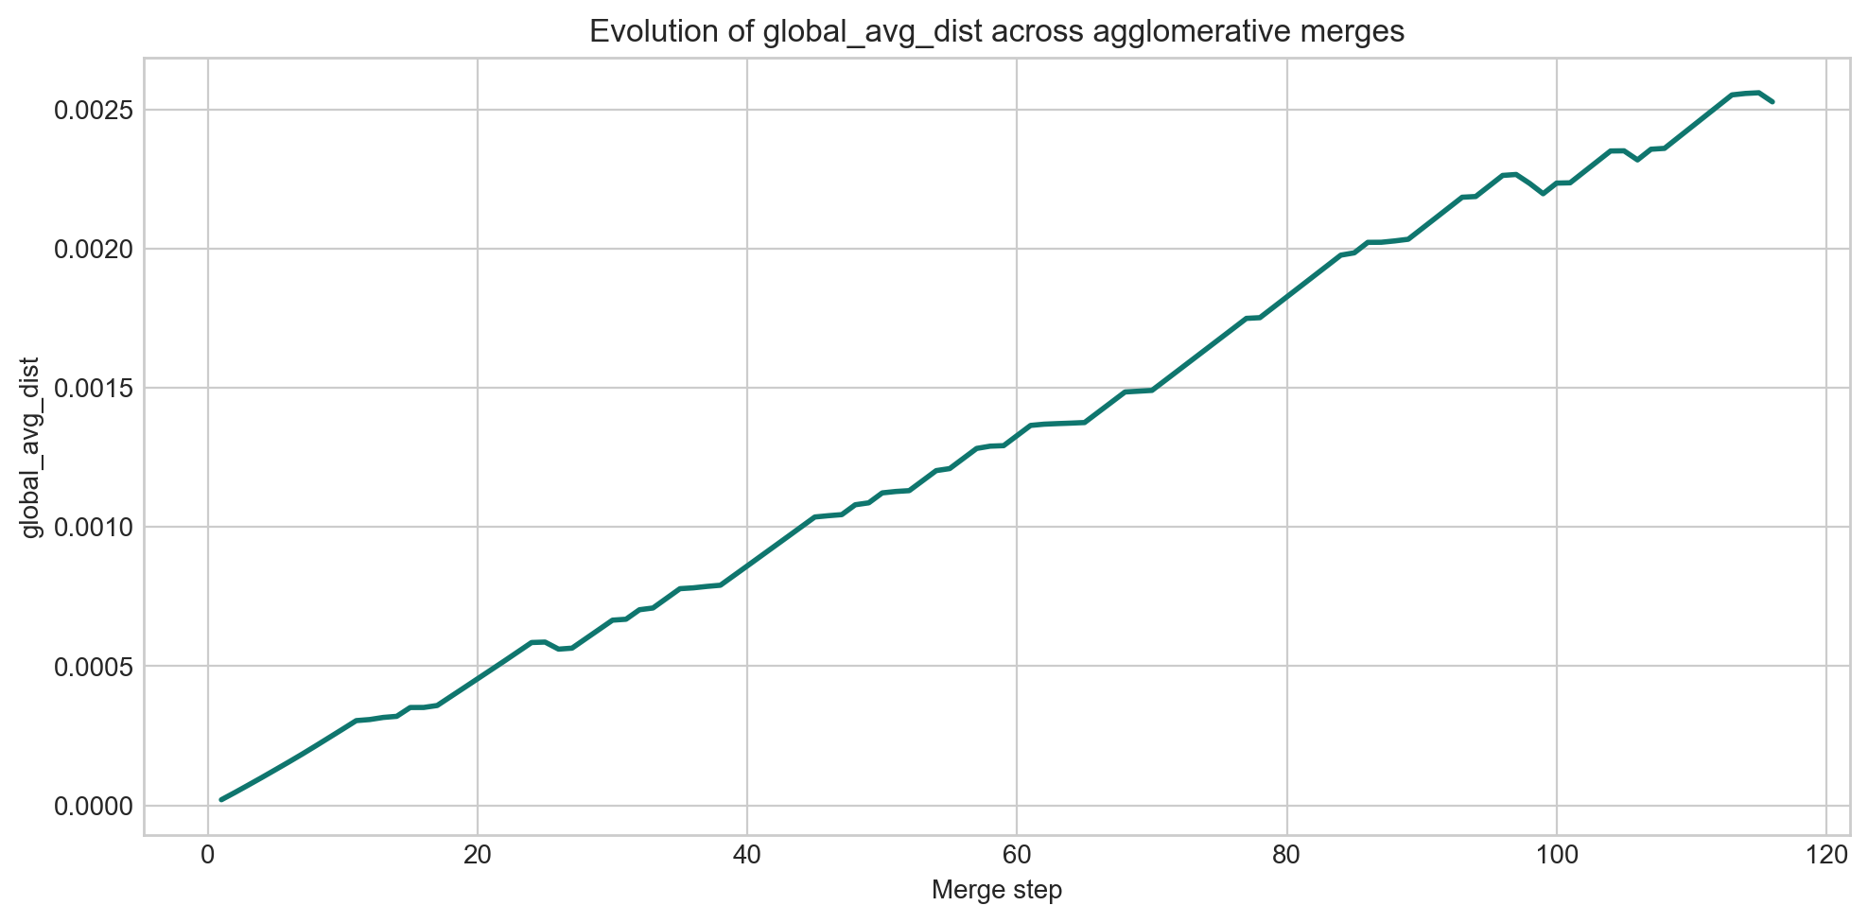
Figure 1. Evolution of global_avg_dist across agglomerative merge steps in Task 1.
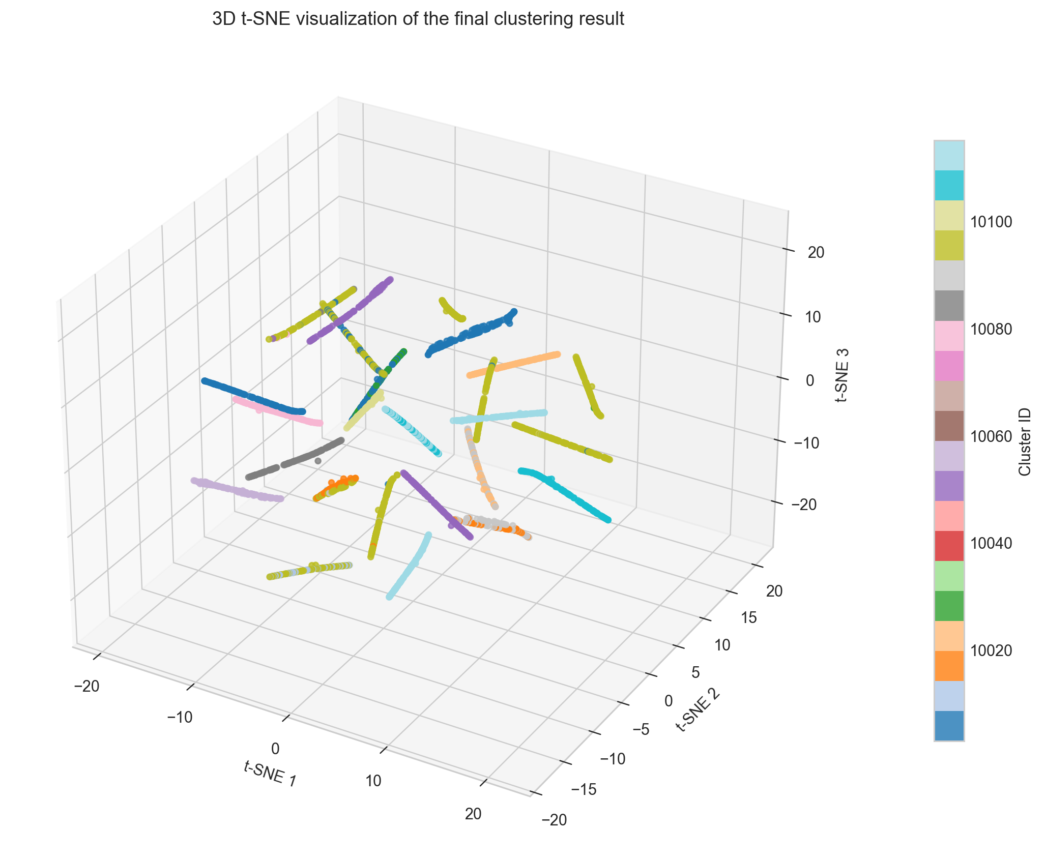
Figure 2. 3D t-SNE visualization used to inspect the final grouping in Task 1.

5. Task 2 - Linear Regression for Gold Price Prediction
In Task 2, we worked with the Vietnamese gold-price dataset and converted it into a supervised learning problem. The assignment required us to read the CSV file with PySpark, create features from the 15 previous dates, split the data randomly into training and test sets with ratio 7:3, and then evaluate linear regression models after dimensionality reduction.
We built a dedicated dataset-preparation class so that the loading and transformation logic remained separate from the experimentation logic. After sorting by date, we generated 15 lag features for each sample and used the sell price at the current date as the label. This made the time-series data compatible with the regression pipeline required by the task.
For the dimensionality-reduction requirement, we created a CUR-style class using PySpark RowMatrix and SVD-based leverage ideas. Our experiment runner then evaluated all reduced dimensions from 15 down to 5. For every dimension, we inferred a new row embedding for the training set and the test set, trained a PySpark linear regression model, collected optimization history, and measured train and test RMSE.
The final executed results showed that the best test-time configuration occurred at reduced dimension k = 6, with test RMSE = 0.3169 and train RMSE = 0.3445. One important outcome for us was that dimensionality reduction did not automatically harm predictive quality. In fact, some reduced settings performed slightly better than the full 15-dimensional input, which supports the idea that the reduced representation preserved the strongest signal while removing redundancy.
- We used PySpark for data loading and model training because the assignment explicitly allowed the PySpark linear regression model and required distributed computation.
- We implemented the experiment loop as a class with configuration parameters instead of copy-pasting code blocks for every dimension.
- We exported the numerical results to CSV so the outcomes could be checked outside the notebook as well.
- We created one combined loss chart and one combined twin-bar chart to match the experimental output format requested in the rubric.
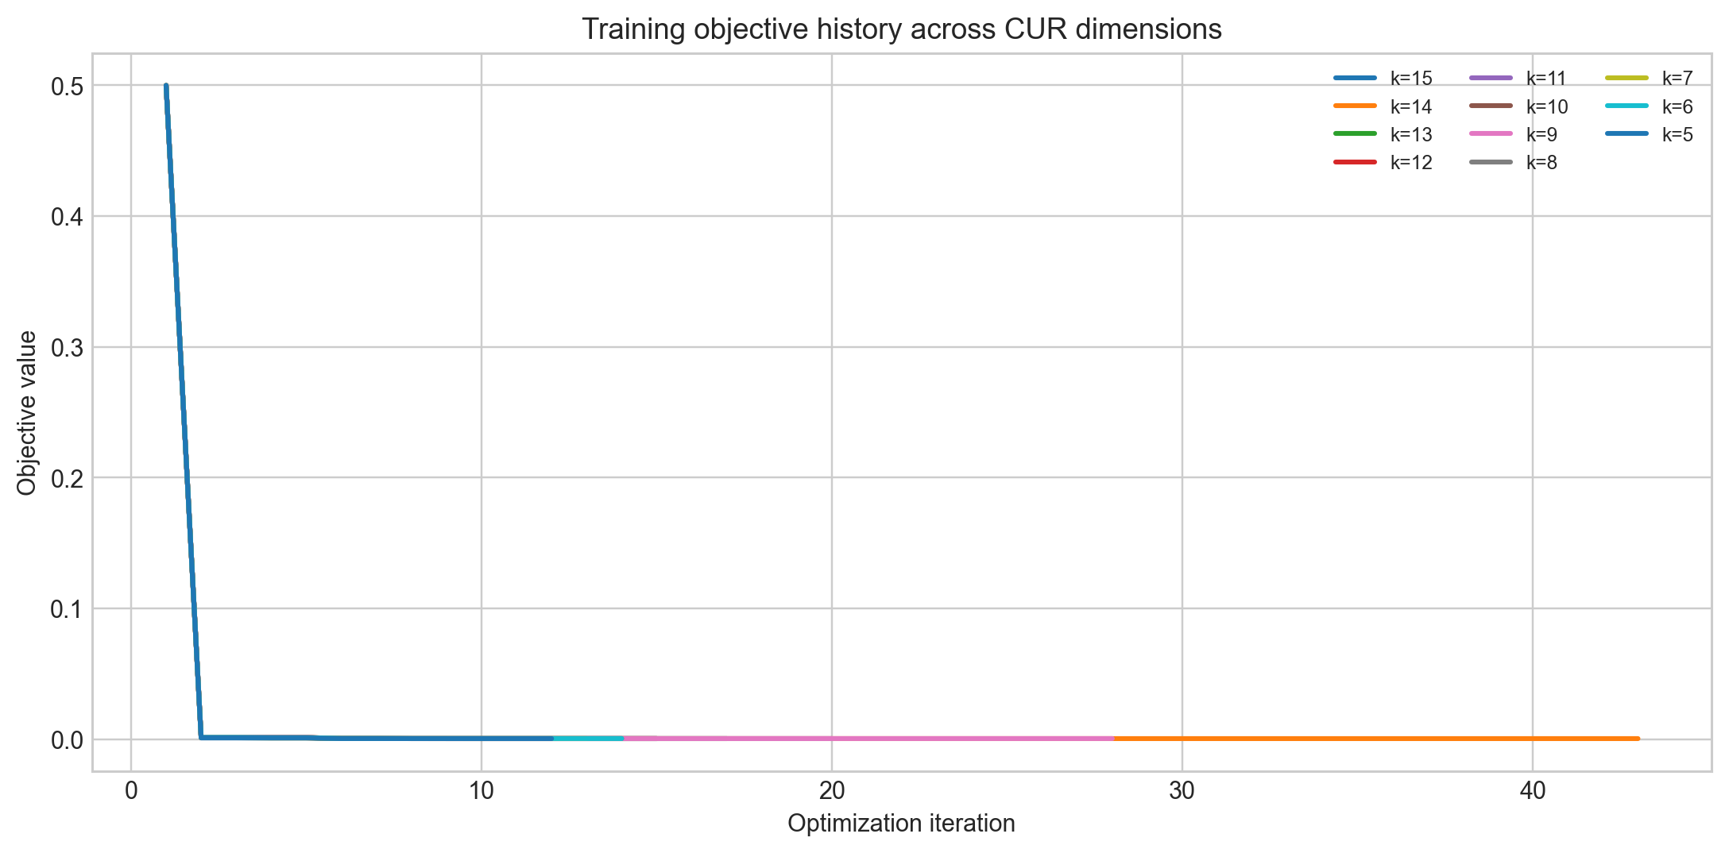
Figure 3. Training loss curves across CUR-reduced dimensions in Task 2.
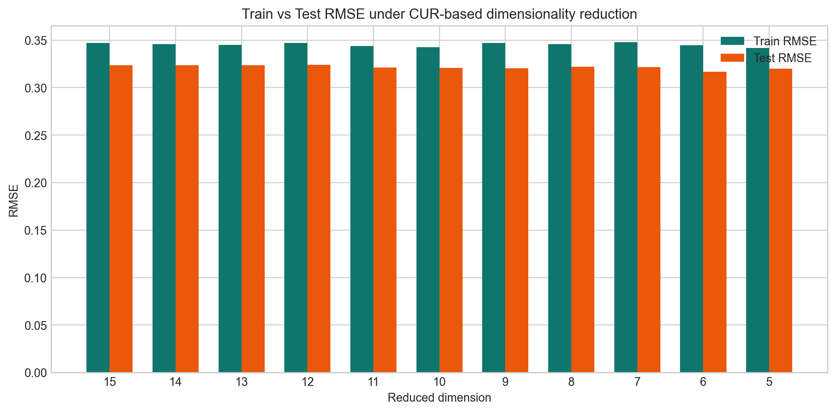
Figure 4. Train-versus-test RMSE comparison across reduced dimensions in Task 2.

6. Task 3 - Collaborative Filtering for Recommendation
In Task 3, we implemented user-based collaborative filtering on the ratings dataset. The assignment emphasized an important interpretation rule: a zero in the user profile does not mean dislike, it only means that the user has not rated that item yet. Because of that, we needed a similarity function that works only on co-rated items and does not treat missing values as negative feedback.
We represented each user as a sparse rating profile and implemented a mean-centered cosine-style similarity over co-rated items only. This made the behavior of the similarity measure consistent with the assignment statement, because unrated items simply did not participate in the comparison.
To make prediction faster, we added an overlap-based hash index. The idea was simple and explainable: if two users share more rated items, they are stronger candidates for similarity computation. Instead of comparing one target user against the entire user set every time, we first retrieved a candidate shortlist from shared-item buckets and only computed exact similarity on that shortlist. This was the core speedup mechanism in our implementation.
We then evaluated several neighbor counts N and measured both RMSE and runtime. The best RMSE in the executed run occurred at N = 10, with RMSE = 0.9532. The indexed version also improved runtime compared with the baseline full scan: baseline = 9.925s, indexed = 7.916s.
- We loaded the ratings data with Spark and split it into training and test sets.
- We built user profiles and item-to-user mappings from the training data.
- We implemented both the baseline prediction path and the indexed prediction path so the runtime comparison would be meaningful and fair.
- We measured RMSE for multiple N values and saved the results to CSV and charts.
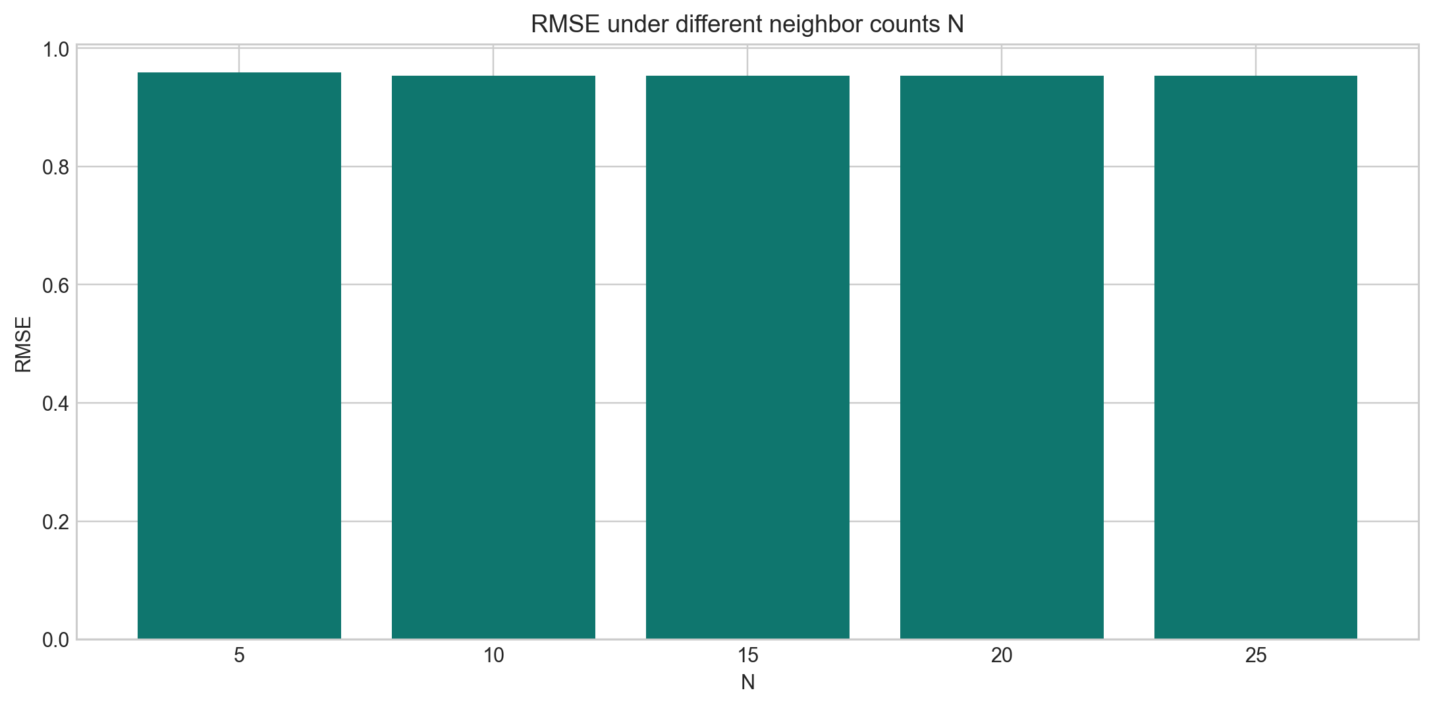
Figure 5. RMSE values for several neighbor counts in Task 3.
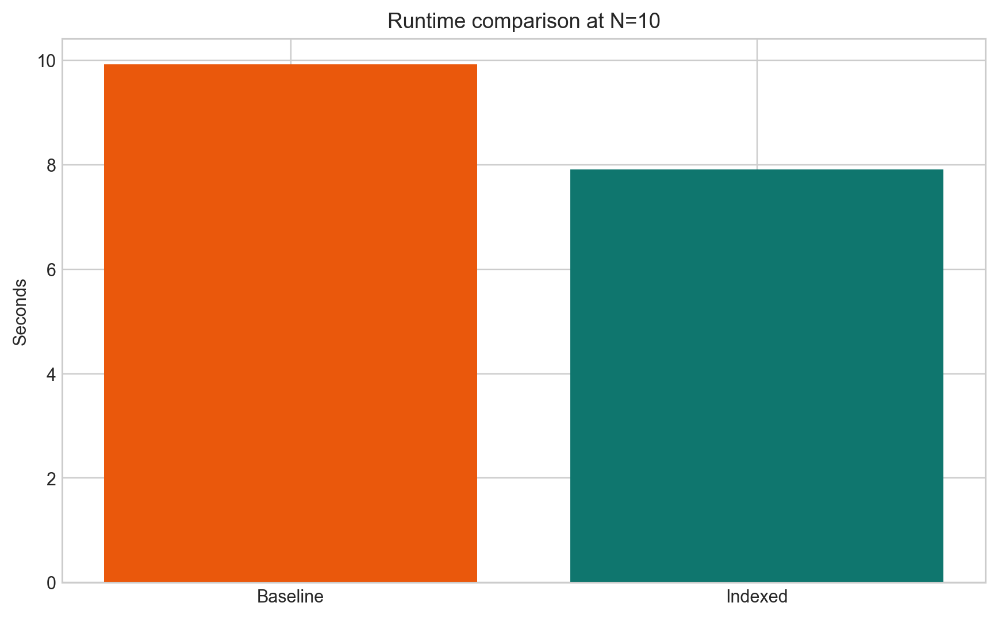
Figure 6. Runtime comparison between baseline lookup and indexed lookup in Task 3.

7. Testing, Execution, and Verification
We did not stop at writing code. We repeatedly executed the notebooks from start to finish and checked whether the outputs matched the intended structure of the assignment. This included verifying that the figures were generated, the CSV outputs were written, the numerical summaries were preserved in the notebooks, and the final folder structure remained consistent with the submission notice.
We also re-ran the notebooks after making important fixes. For example, when we aligned Task 1 more strictly with Approach 2 from the lecture, we re-executed the notebook from the beginning to make sure the outputs and report values were updated consistently.
For the report, we compiled and visually inspected the PDF several times. We corrected layout issues such as table placement and made sure the final PDF version in the submission folder reflected the latest LaTeX source rather than an outdated compiled copy.
- We confirmed that all three notebooks preserve execution outputs.
- We saved every required chart or CSV artifact next to the task that generated it.
- We checked the final report layout by compiling and rendering the PDF instead of relying only on source code inspection.
- We cleaned the submission folder by removing temporary LaTeX build files while keeping all files needed for submission and future compilation.

8. Portability and Google Colab Compatibility
A practical requirement for us was that the notebooks should run not only on our personal machine but also on Google Colab. We therefore made the notebooks self-contained and added package bootstrapping where appropriate. For Tasks 2 and 3, we also added a Colab-friendly upload path so the required CSV file can be uploaded into the runtime if it is not already present.
After those changes, we verified that the notebooks could be executed in Colab and produce outputs there as well. This increased the portability of the submission and reduced the risk that the project would depend too strongly on a single local environment.

9. What We Can Clearly Explain in an Interview
- Why Task 1 used Jaccard distance on 4-shingle sets and how Approach 2 from the lecture shaped the clustering design.
- How the diameter-jump rule works and why we used it as a stopping criterion in Task 1.
- Why Task 2 used lag features, why the dimension range was 15 down to 5, and how the CUR-style reduction was integrated into the regression pipeline.
- Why zero values in Task 3 represent missing data rather than negative preference, and how that affected the design of the similarity metric.
- How the overlap-based hash index accelerates the search for similar users without changing the meaning of the recommendation model.
- How we validated our work through repeated execution, saved outputs, report compilation, and Colab checks.

10. Closing Remarks
Overall, we treated this project as more than a collection of three isolated tasks. We treated it as an end-to-end engineering deliverable: read the assignment carefully, map every rubric item to code, execute the notebooks, save evidence, write the report, verify layout, and package the final folder cleanly.
We believe this project demonstrates not only that we completed the requested algorithms, but also that we took responsibility for clarity, reproducibility, portability, and explainability. That is the main reason we prepared this longer document: we want to show exactly what we built and why each design choice was made.

