Nguyễn Tuấn Kiệt

2274802010459

LAB5

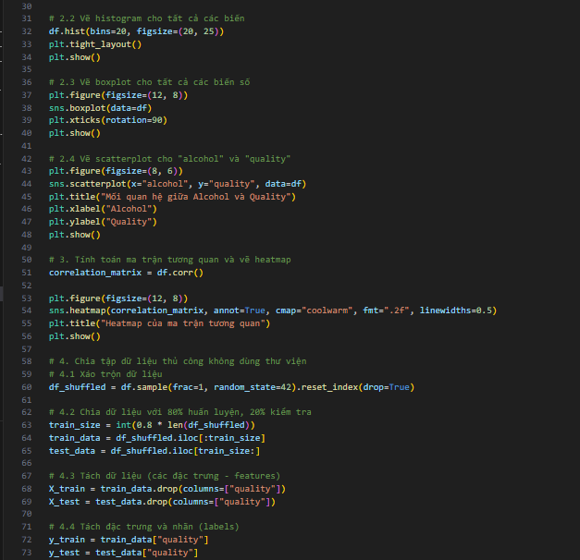

Kết quả:

