**MẪU IMPORT PHÒNG BAN CHỨC DANH CHỨC VỤ**

# Loại phòng ban

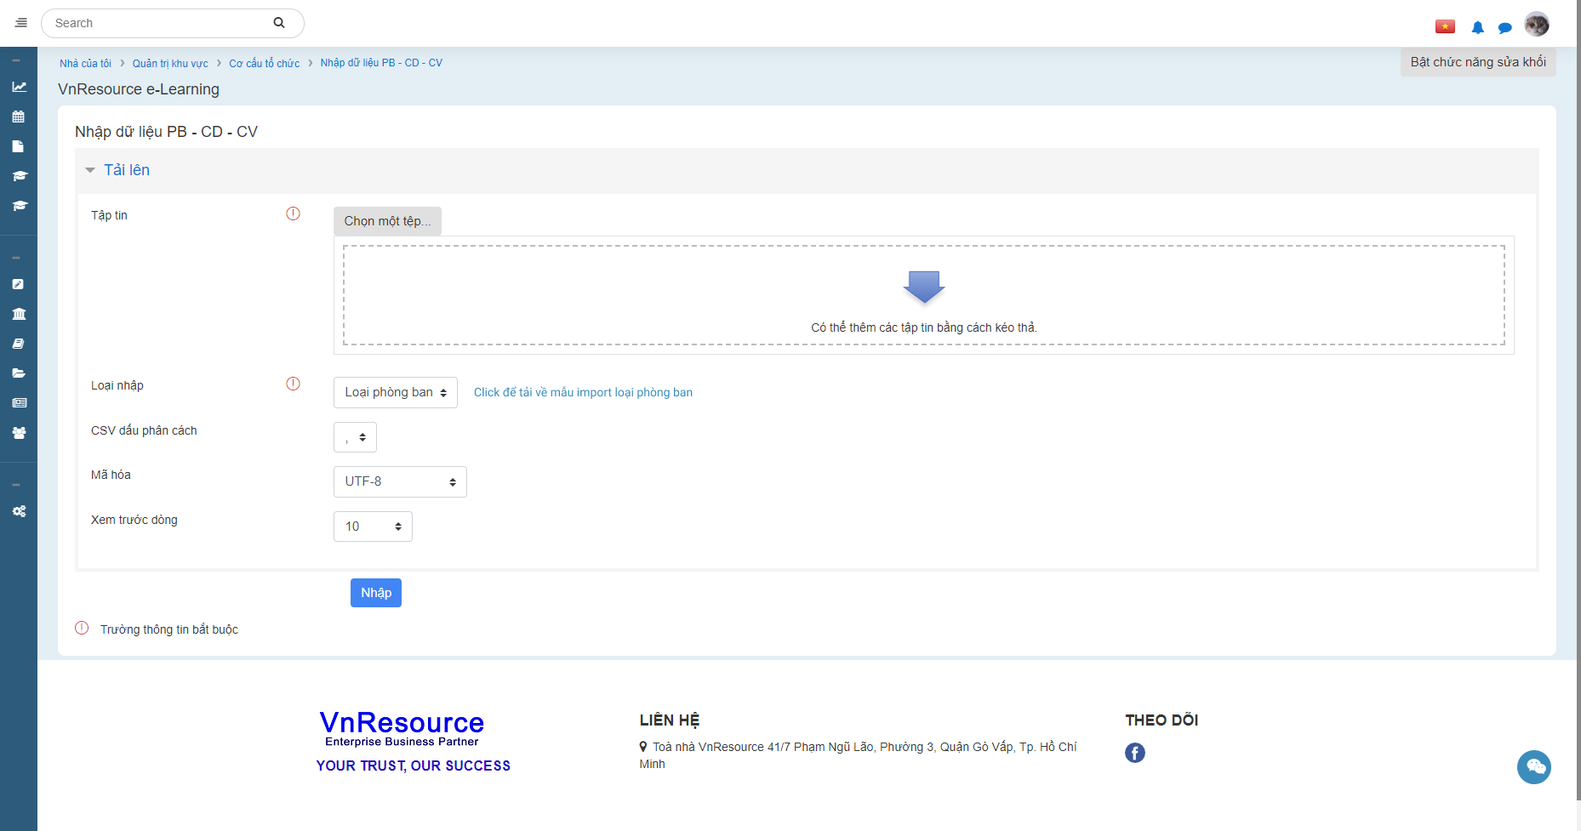

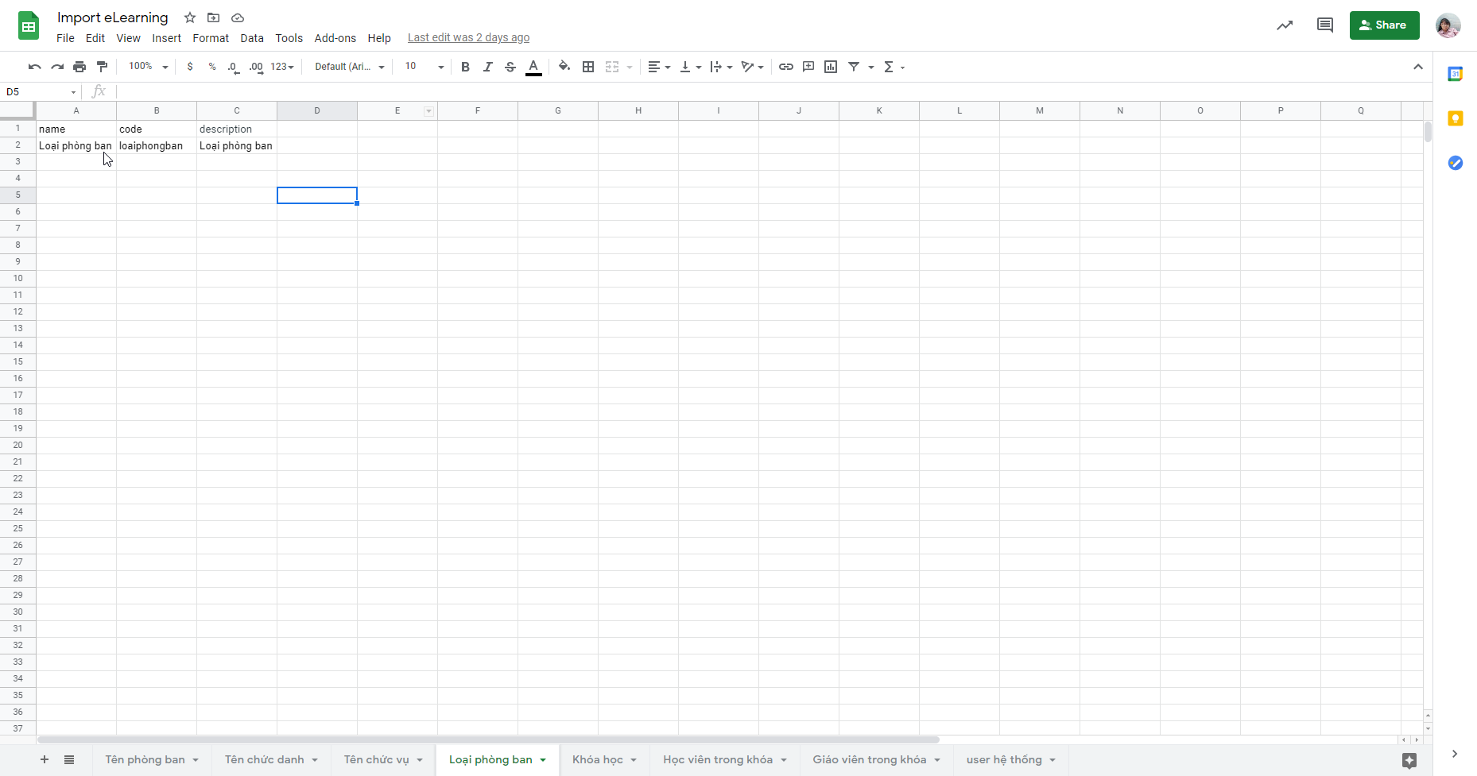

Link xem:

<https://docs.google.com/spreadsheets/d/1aPhoFltX7fOGvnfTPL7GGd3g1LqyLeigbSCV-4_IPgs/edit#gid=1269743816>

# Phòng ban

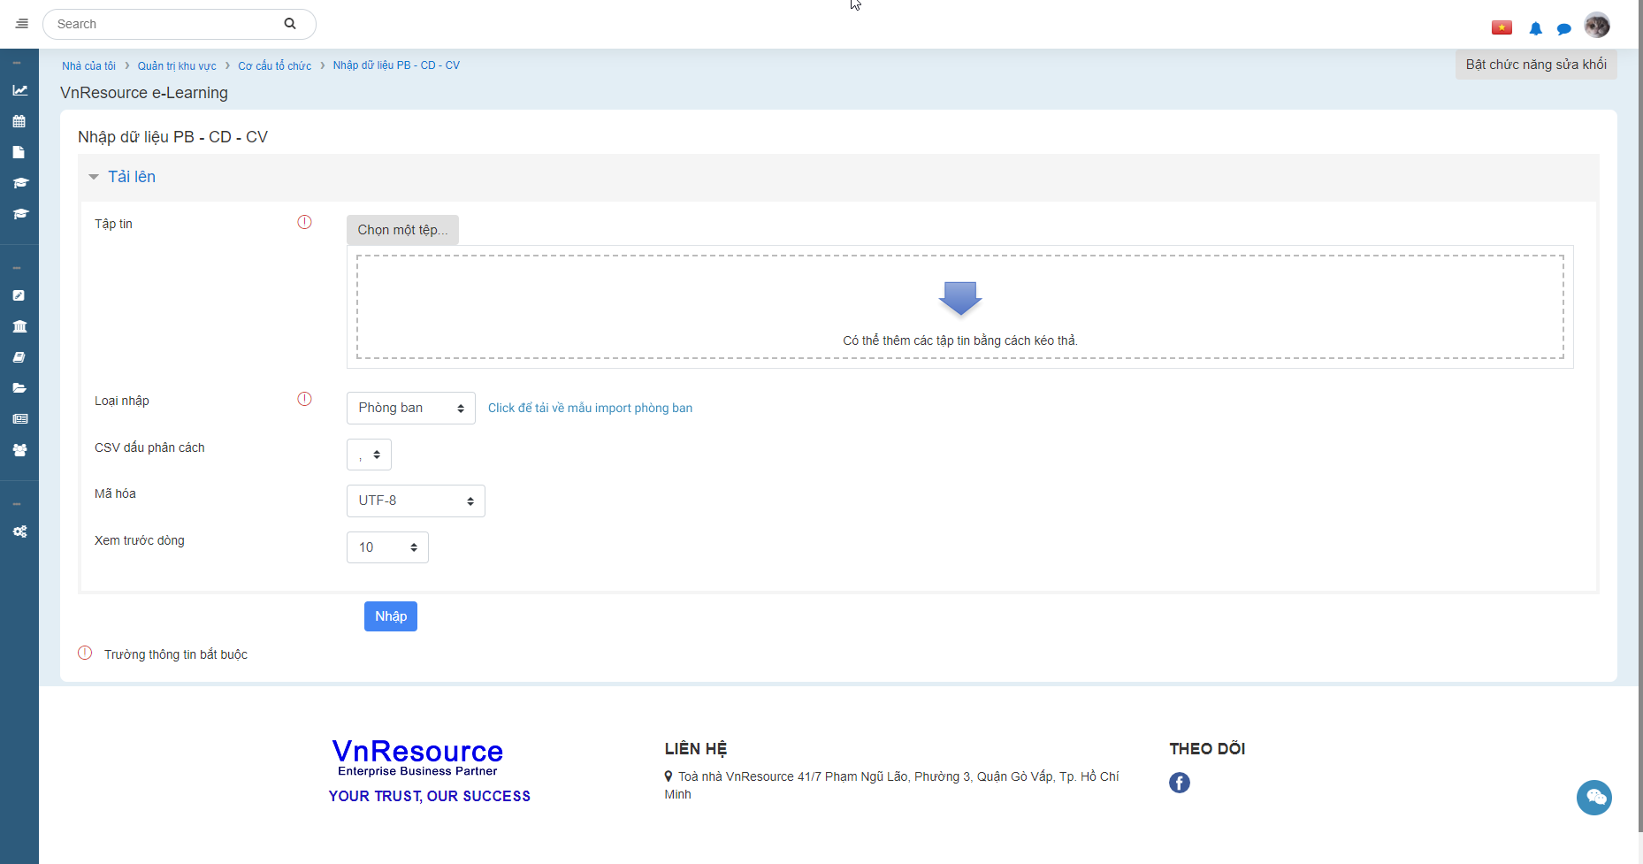



Link xem:

<https://docs.google.com/spreadsheets/d/1aPhoFltX7fOGvnfTPL7GGd3g1LqyLeigbSCV-4_IPgs/edit#gid=1269743816>

# Chức danh

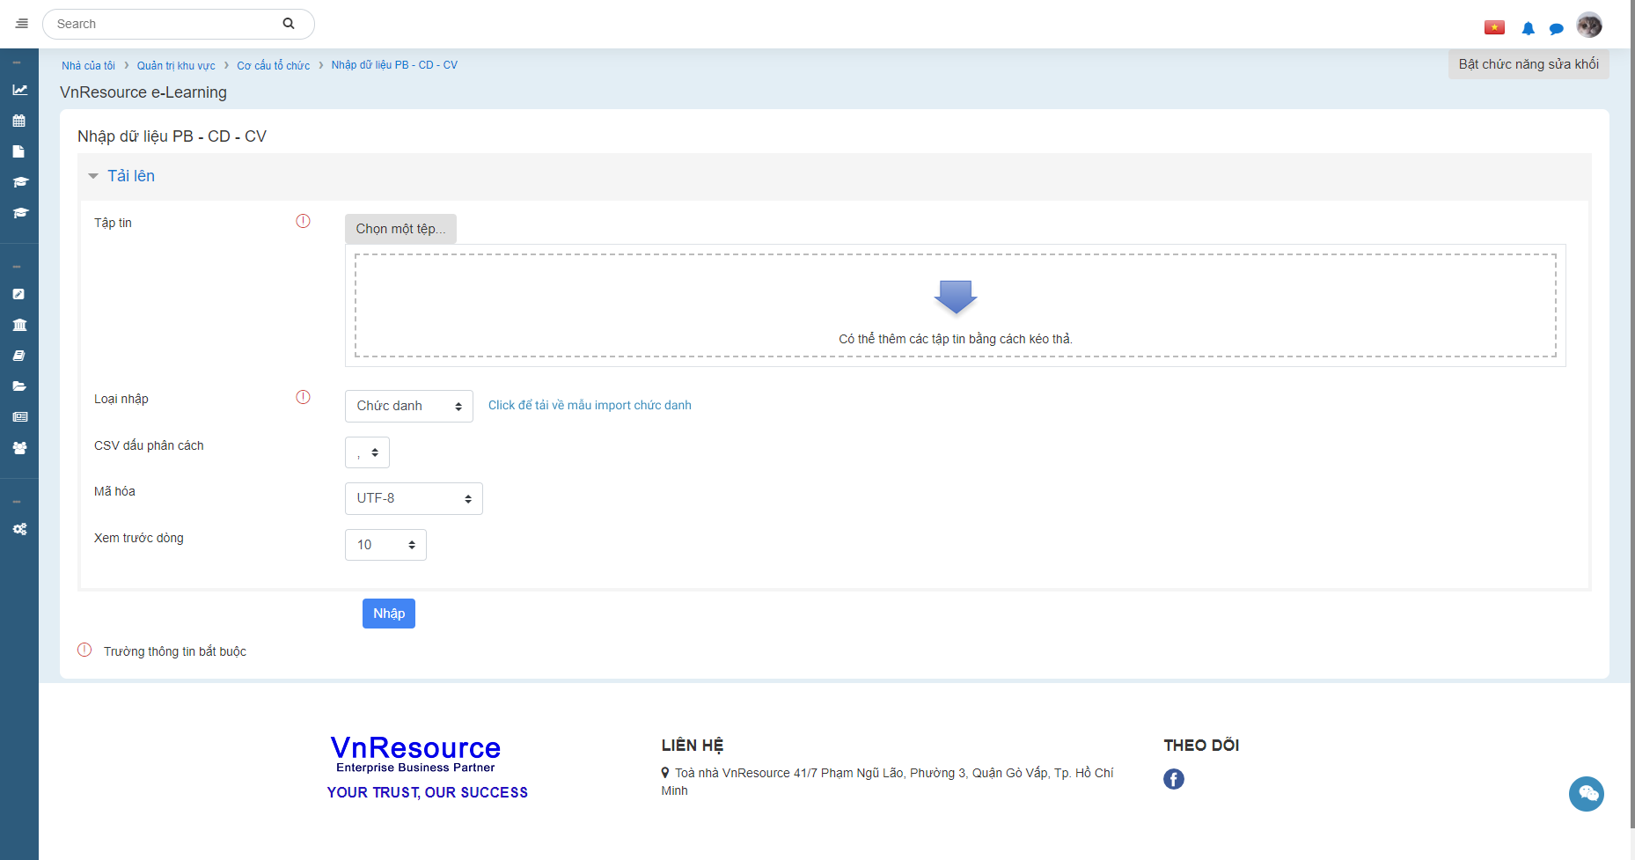

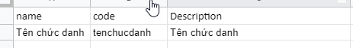

Link xem:

<https://docs.google.com/spreadsheets/d/1aPhoFltX7fOGvnfTPL7GGd3g1LqyLeigbSCV-4_IPgs/edit#gid=1269743816>

# Chức vụ

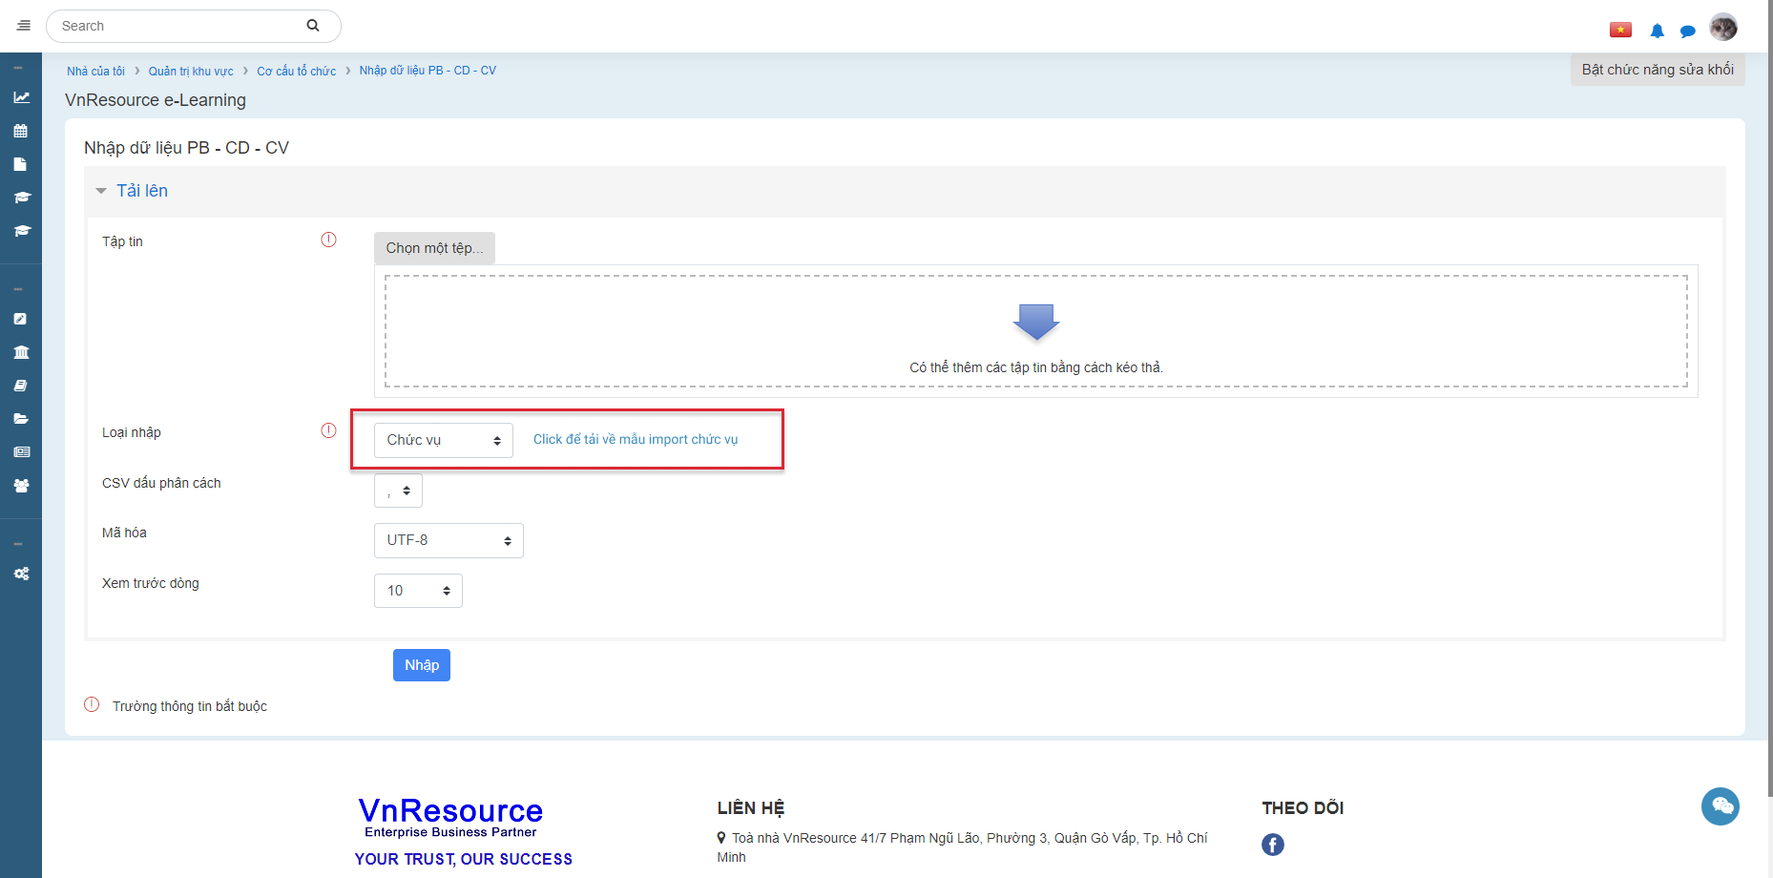



Link xem:

<https://docs.google.com/spreadsheets/d/1aPhoFltX7fOGvnfTPL7GGd3g1LqyLeigbSCV-4_IPgs/edit#gid=1269743816>