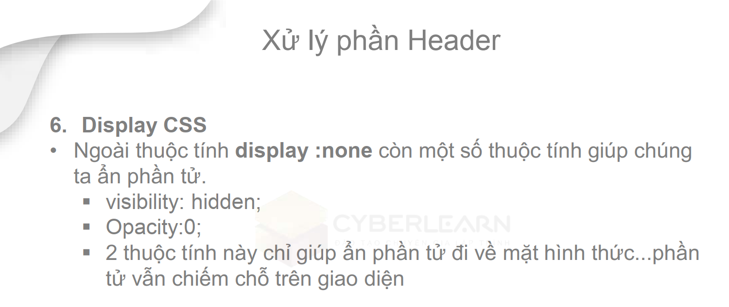
<h3 .carousel__detail--red>Camping & Day Use</h3>
<!-- BEM: block__element--modified
emmet -->
<div class="carousel">
<div class="carousel__content">
<div class="carousel__item">
<div class="carousel__detail">
<img src="./img/bonfire.png" alt="">
<h3 .carousel__detail--red>Camping & Day Use</h3>
<p>Return to your favorite spot or discover a new one that’s right for you.</p>
</div>

