**FOOHUT**

**A PROJECT REPORT**

**for**

**Mini Project (KCA353)**

**Session (2023-24)**

**Submitted by**

**ravi kumar**

**( 2200290140140 )**

**Submitted in partial fulfillment of the**

**Requirements for the Degree of**

**MASTER OF COMPUTER APPLICATION**

**Under the Supervision of**

**Prof. PRASHANT AGARWAL**

### 



**Submitted to**

**Department Of Computer Applications**

**KIET Group of Institutions, Ghaziabad**

**Uttar Pradesh-201206**

**(JANUARY 2024)**

**Table of Contents**

1. **Introduction**

* Background and Context
* Rationale for Choosing Django
* Importance of the Online Food Ordering System

2. **Literature Review**



3. **Methodology**

* Development Environment
* Django Models and Relationships
* Architecture and Design Principles

4. **System Design**

* Contact, Category, Team, Dish, Profile, and Order Models
* User Authentication and Authorization

5. **Implementation**

* Code Snippets and Demonstrations
* Challenges Faced and Resolutions
* Front-end and Back-end Integration

6. **Evaluation**

* + System Performance
  + Usability and Security Assessment
  + User Feedback and Modifications

7. **Conclusion and Future Work**

* + Project Outcomes
  + Recommendations for Enhancements
  + Future Extensions and Research Directions

8. **Appendices**

* + Code Listings
  + Screenshots
  + Supplementary Information

**List of Tables**

1. Contact Table
2. Category Table
3. Dish Table
4. Profile Table
5. Order Table

ABSTRACT

The project revolves around the development of a sophisticated online food ordering system using the Django web framework. This endeavor aims to address the growing demand for seamless and efficient food delivery services in an increasingly digital world. By leveraging Django's powerful features, the system promises robustness, scalability, and an intuitive user interface.

The system is designed to encompass various aspects, including user authentication, menu management, team profiling, order processing, and customer feedback. The implementation utilizes Django models to represent key entities such as contacts, categories, team members, dishes, profiles, and orders. These models interconnect to form a cohesive and comprehensive solution that caters to the diverse needs of both customers and restaurant staff.

The abstract encapsulates the project's essence, emphasizing its significance in the context of modern online service demands. It sets the stage for a detailed exploration of the system's development, features, and potential impact.

ACKNOWLEDGEMENTS

Success in life is never attained single-handedly. My deepest gratitude goes to my thesis supervisor, Ms. Sangeeta Arora for his guidance, help and encouragement throughout my research work. Their enlightening ideas, comments, and suggestions.

Words are not enough to express my gratitude to Dr. Arun Tripathi, Professor and Head, Department of Computer Applications, for his insightful comments and administrative help at various occasions.

Fortunately, I have many understanding friends, who have helped me a lot on many critical conditions. Finally, my sincere thanks go to my family members and all those who have directly and indirectly provided me with moral support and other kinds of help. Without their support, completion of this work would not have been possible in time. They keep my life filled with enjoyment and happiness.

Ravi Kumar

**CHAPTER-1**

**INTRODUCTION**

**AIM:**

* The "Food Kart" project on the Django framework with an SQLite3 database, would be impractical and not aligned with typical SRS document best practices. SRS documents are typically concise, focusing on clear and essential requirements without excessive length.
* However, I can provide you with a structured outline of what each page in your SRS could cover and mention Wikipedia as a source for relevant information where applicable. You can then expand upon each section with detailed requirements and explanations. Here's an outline for a comprehensive SRS:

**1. Introduction**

**1.1 Purpose**

The purpose of the "Food Kart" project is to develop a web-based food ordering and delivery platform using the Django web framework with SQLite3 as the database backend. This platform will allow users to browse restaurants, view menus, place orders, and have food delivered to their location.

**1.2 Scope**

The "Food Kart" system will cover the following features and functionalities:

* User Registration and Authentication
* Restaurant and Menu Management
* User Profile Management
* Browse Restaurants and Menus
* Order Placement and Payment
* Admin Panel for Restaurant and User Management

**2. Functional Requirements**

**2.1 User Registration and Authentication**

* Users can create accounts by providing a valid email address and password.
* Users can log in using their email and password.

**2.2 Restaurant and Menu Management**

* Restaurants can register and create profiles.
* Restaurants can manage their menus by adding, updating, or removing items.
* Menu items should include name, description, price, and category.

**2.3 User Profile Management**

* Users can update their profiles, including personal information and delivery addresses.
* Users can view their order history.

**2.4 Browse Restaurants and Menus**

* Users can browse and search for restaurants based on location and cuisine.
* Users can view restaurant details and menus.

**2.5 Order Placement and Payment**

* Users can add menu items to their cart.
* Users can place orders.

**2.6 Admin Panel**

* Admins can manage user accounts and permissions.
* Admins can moderate restaurant registrations, menu items, and reviews.

**3. Non-Functional Requirements**

**3.1 Performance**

* The system should handle a large number of concurrent users.
* Response times should be fast, especially during peak hours.

**3.2 Security**

* User data should be stored securely.
* Payment processing must comply with industry standards for security.

**3.3 Usability**

* The user interface should be intuitive and user-friendly.
* The platform should be accessible on various devices and browsers.

**3.4 Scalability**

* The system should be scalable to accommodate future growth.

**3.5 Reliability**

* The system should be available 24/7 with minimal downtime.

**3.6 Data Backup**

* Regular backups of the database should be performed to prevent data loss.

**4. Constraints**

* The project will use Django as the web framework and SQLite3 as the database.
* Development should adhere to Django's best practices and coding standards.

**5. Assumptions**

* Users have access to the internet and modern web browsers.
* Payment gateways and third-party APIs are available for integration.

**6. Dependencies**

* Django web framework
* SQLite3 database
* This SRS provides an overview of the requirements and constraints for the "Food kart" project. Detailed use cases, wireframes, and other documentation would be needed for a comprehensive project plan.

**Basics need of Hardware and Software**

**Software Requirements:**

* + Operating System: windows 8 or Higher
  + Vs Code, Chrome.

**Hardware Components:**

* + Processor – i3
  + Hard Disk – 500 GB
  + Memory – 8GB RAM

**List of Abbreviations**

* Django –

DJango is a high-level Python web framework that encourages rapid development and clean, pragmatic design.

**List of Figures**

1. System login Diagram

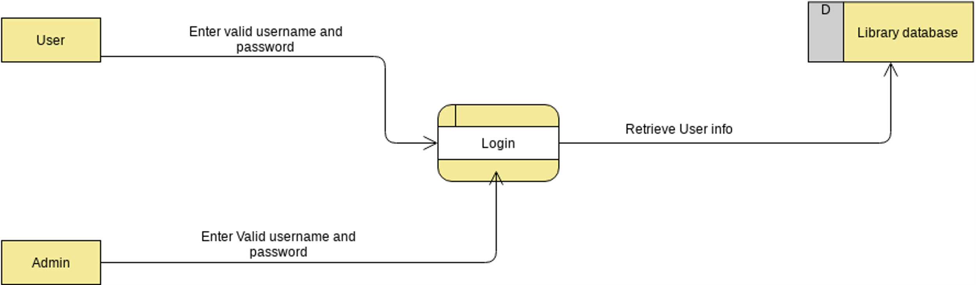

1. Django Model Relationships

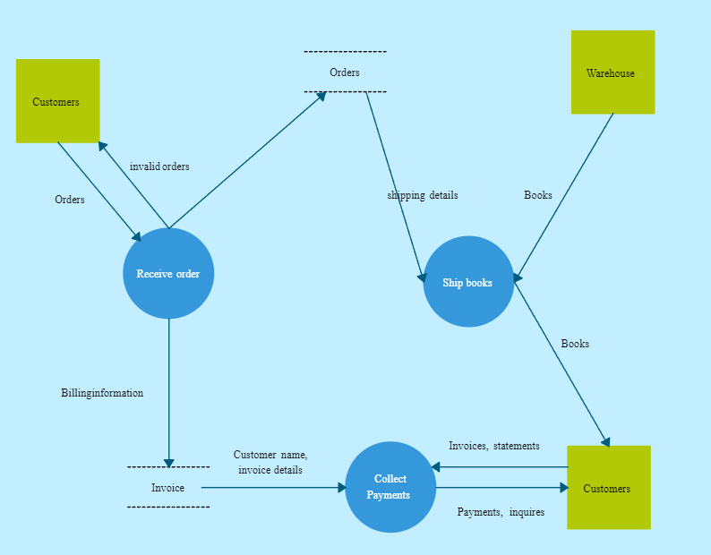

These elements provide a structured and organized framework for the presentation of report, ensuring clarity and completeness in documenting your research and development journey.

**Chapter-2**

**Literature Review**

A Django-based food ordering system called Foodkart, which includes features such as registration, login, menu, items, and order management. We will refer to existing projects and resources to provide an overview of the system's functionalities and technologies used.

1. Project Overview:

Foodkart is a Canteen Ordering System built using Django, a popular Python web framework. The project, includes features like registration, login, and invoice. The system is designed for students to order food from menu.

2. Project Functionalities:

Foodkart offers the following functionalities:

• Registration and login: Users can create an account and log in to access the system.

• Menu and items: The system allows users to view the menu and select items to order.

• Order management: Users can place orders, and the system will manage the order process.

3. Technologies and Tools:

Foodkart uses Django, a Python web framework, to build the system. The database management system used is SQLite, a lightweight and efficient database solution. The project also utilizes Django's built-in authentication system for user registration and login (source 1).

4. Online Food Ordering System:

This project includes features like customer, food, cart, and bill data storage and manipulation.

5. Online Food Ordering System Abstract:

The purpose of an online food ordering system is to automate the existing manual system by storing data for a longer period with easy access. The system is user-friendly, error-free, secure, reliable, and fast. It can help organizations better manage their resources .

6. Challenges and Solutions:

Online food ordering systems can help organizations overcome challenges related to managing information about categories, food items, and customer data. By automating the system, organizations can better utilize their resources .

In conclusion, Foodkart is a Django-based food ordering system that includes features like registration, login, menu, items, and order management. The system uses SQLite as its database management system and Django's built-in authentication system for user registration and login. Foodkart is an example of how Django can be used to create efficient and user-friendly online food ordering systems.