
SYNOPSIS

Report on

Student MANAGEMENT SYSTEM

By

Sheetal gupta- Roll No.2200290140142

Session: 2023-2024 (III Semester)

Under the supervision of

Dr. Shashank Bhardwaj

(Assistant Professor)

KIET GROUP OF INSTITUTIONS, Delhi-NCR, Ghaziabad

DEPARTMENT OF COMPUTER APPLICATIONS

KIET GROUP OF INSTITUTIONS, DELHI-NCR,

GHAZIABAD-201206

(2023-2024)

Page 1 of 10


ABSTRACT

A Student Management System is an environment that manages all the data of the students who are studying in an educational institution. This data is computerized through an automated system. Here, computerization is more advantageous than the usual method.

Thus, a student management system offers many benefits to an educational institution. It allows teachers to easily change and access student data, and parents can easily focus on children with a clear environment to meet state level compliance and other regulatory requirements.

This system we have created also facilitates the entry, maintenance and viewing and of all authorized student details. Here we mainly focus on the examination of students, their subjects, the registration department which conducts the registration process, the examination department which conducts the examinations, the IT division which is important component of the result and the smart ID components.

The special thing is that we have given all the students a unique ID and the degree program they are involved in has also focused on age, gender and contact number. Each department has a unique ID. For convenience, a designated location and e-mail address are also used

Page 2 of 10

CONTENTS

- Introduction Of Project

- Literature Review

- Objective Of the Project

- Research Methodology

- Project Outcome

- Proposed Time Duration

- References

Page 3 of 10
1.INTRODUCTION

Introduction to a Student Management System:

A Student Result Management System is a comprehensive software solution designed to streamline and automate the process of managing academic results and related data within educational institutions. This system plays a pivotal role in modernizing and improving the efficiency of educational administration by digitizing and centralizing critical student-related information.

Key Features and Functions:

1. Student Registration : The system allows administrators to easily enrol new students, capturing their personal details, course information, and other relevant data.

2. Result Entry: Teachers can input and update students' exam scores, assignments, and other performance indicators. The system supports various grading systems and can calculate final grades automatically.

3. Report Generation: It facilitates the creation of report cards, transcripts, and progress reports, which can be customized to suit the institution's requirements.

4. Analytics and Insights: Educational administrators can utilize the system to analyze student performance trends, identify areas of improvement, and make data-driven decisions.

7. Record Keeping: It maintains a historical record of students' academic progress, making it easier to track their development over time.

Benefits:

Efficiency: Automates tedious administrative tasks, reducing the time and effort required to manage student record
results.

Accuracy: Minimizes the risk of errors in result calculations and data entry.

Overall, a Student Result Management System plays a crucial role in modern education by promoting efficiency, accuracy, and transparency in managing student information and academic results. It serves as an indispensable tool for educational institutions striving to provide a high-quality learning experience.

Page 4 of 10
2.LITERATURE REVIEW

A literature review on Student Management Systems (SMS) provides insight into the research, development, and implementation of such systems in educational institutions. Here's an overview of some key themes and findings commonly found in SMS literature:

1. Efficiency and Automation:
- Many studies emphasize how SMS can streamline administrative processes, reducing manual work and improving efficiency.
- Automation of result calculations and report generation is a common focus, leading to time savings for educators and administrators.

2. Accuracy and Data Integrity:
- Scholars highlight the importance of data accuracy and integrity in SRMS to ensure reliable academic records.
- Data validation mechanisms and security measures are explored to maintain the quality of information.

3. User-Friendly Interfaces:
- Research often discusses the significance of user-friendly interfaces for teachers, students, and administrators.
- Intuitive design and accessibility features are essential for broad adoption.

4. Customization and Flexibility:
- Many studies stress the need for SRMS systems that can adapt to the unique requirements of different educational institutions.
- Customization options are valued to accommodate various grading systems and reporting formats.

5. Analytics and Decision Support:
- Research highlights the potential for SRMS to provide insights through data analytics.
- Educators and administrators can use these insights for informed decision-making and improving teaching strategies.

Literature reviews on SRMS provide valuable insights for educational institutions looking to adopt or improve such systems. They offer a comprehensive understanding of the benefits, challenges, and best practices associated with managing student results in a digital environment, contributing to the ongoing enhancement of educational administration processes.

Page 5 of 10
3.OBJECTIVE OF PROJECT

The primary objectives of a Student Result Management System (SRMS) are to:

1. Efficiency: Streamline and automate the management of student academic results and related data to reduce manual administrative work and improve operational efficiency.

2. Accuracy: Ensure the accuracy and integrity of student result data by minimizing the risk of errors in result calculations and data entry.

3. Transparency: Provide real-time access to student performance data for teachers, students, and parents, promoting transparency and accountability in the education system.

4 Record Keeping: Maintain a comprehensive historical record of students' academic progress, simplifying tracking and evaluation of their development over time.

5. Reporting: Generate standardized report cards, transcripts, and progress reports that reflect students' academic achievements accurately.

6. Analytics: Support data analytics and reporting tools to help educators identify trends, strengths, weaknesses, and areas for improvement in the educational process.

Overall, the objective of a Student Result Management System is to modernize and optimize the management of student academic records and results, making educational administration more efficient, transparent, and data-driven while ensuring the highest standards of data security and accuracy.

Page 6 of 10
4.Project Methodology
Developing a Student Management System (SMS) typically follows a structured project methodology to ensure successful implementation. Below is an outline of a common project methodology for an SMS:

1. Project Initiation:
- Define the project scope, objectives, and deliverables.
- Identify key stakeholders, including educators, administrators, and IT personnel.

2. Requirement Analysis:
- Gather and document detailed requirements from all stakeholders.
- Understand the grading systems, reporting formats, and specific needs of the educational institution.
- Conduct interviews, surveys, and workshops to clarify requirements.

3. System Design:
- Create a detailed system design based on the requirements.
- Design the database schema for storing student data and results.

4. Development:
- Write code and develop the SRMS according to the design specifications.
- Implement features such as result entry, report generation, user authentication, and communication tools.

5. Testing and Quality Assurance:
- Perform functional testing to ensure that all features work as expected.
- Conduct usability testing to assess user-friendliness.

6. Deployment:
- Prepare the SMS for deployment to the production environment.
- Set up servers, databases, and necessary infrastructure.

7. User Acceptance Testing (UAT):
- Involve key stakeholders in UAT to validate that the system meets their requirements.
- Address any issues or feedback raised during UAT.

Throughout the project, it's essential to maintain clear communication with stakeholders, manage risks, and ensure that the SRMS aligns with the institution's goals and requirements. Following a well-structured methodology helps ensure a successful SRMS project that meets the needs of educators, administrators, and students.

Page 7 of 10
5.Outcome of Project

The outcome of a Student Result Management System (SRMS) project should align with the project's objectives and deliverables. Here are some expected outcomes:

1. Efficient Result Management: The SRMS should streamline the process of managing student academic results, reducing manual effort and administrative workload.

2. Improved Accuracy: The system should ensure the accuracy and integrity of student result data by minimizing errors in calculations and data entry.

3. Transparency and Accessibility: Stakeholders, including teachers, students, and parents, should have real-time access to student performance data, promoting transparency and accountability in the education system.

4.Data-Driven Decision-Making: Educators and administrators should be able to make informed decisions based on performance analytics and historical data trends, contributing to improved teaching strategies and academic planning.

5. Effective Communication: The SRMS should facilitate effective communication between teachers, students, and parents through features like messaging and notifications, enhancing collaboration and engagement.

6.Accurate Reporting:The SRMS should generate standardized report cards, transcripts, and progress reports that accurately reflect students' academic achievements.

Page 8 of 10
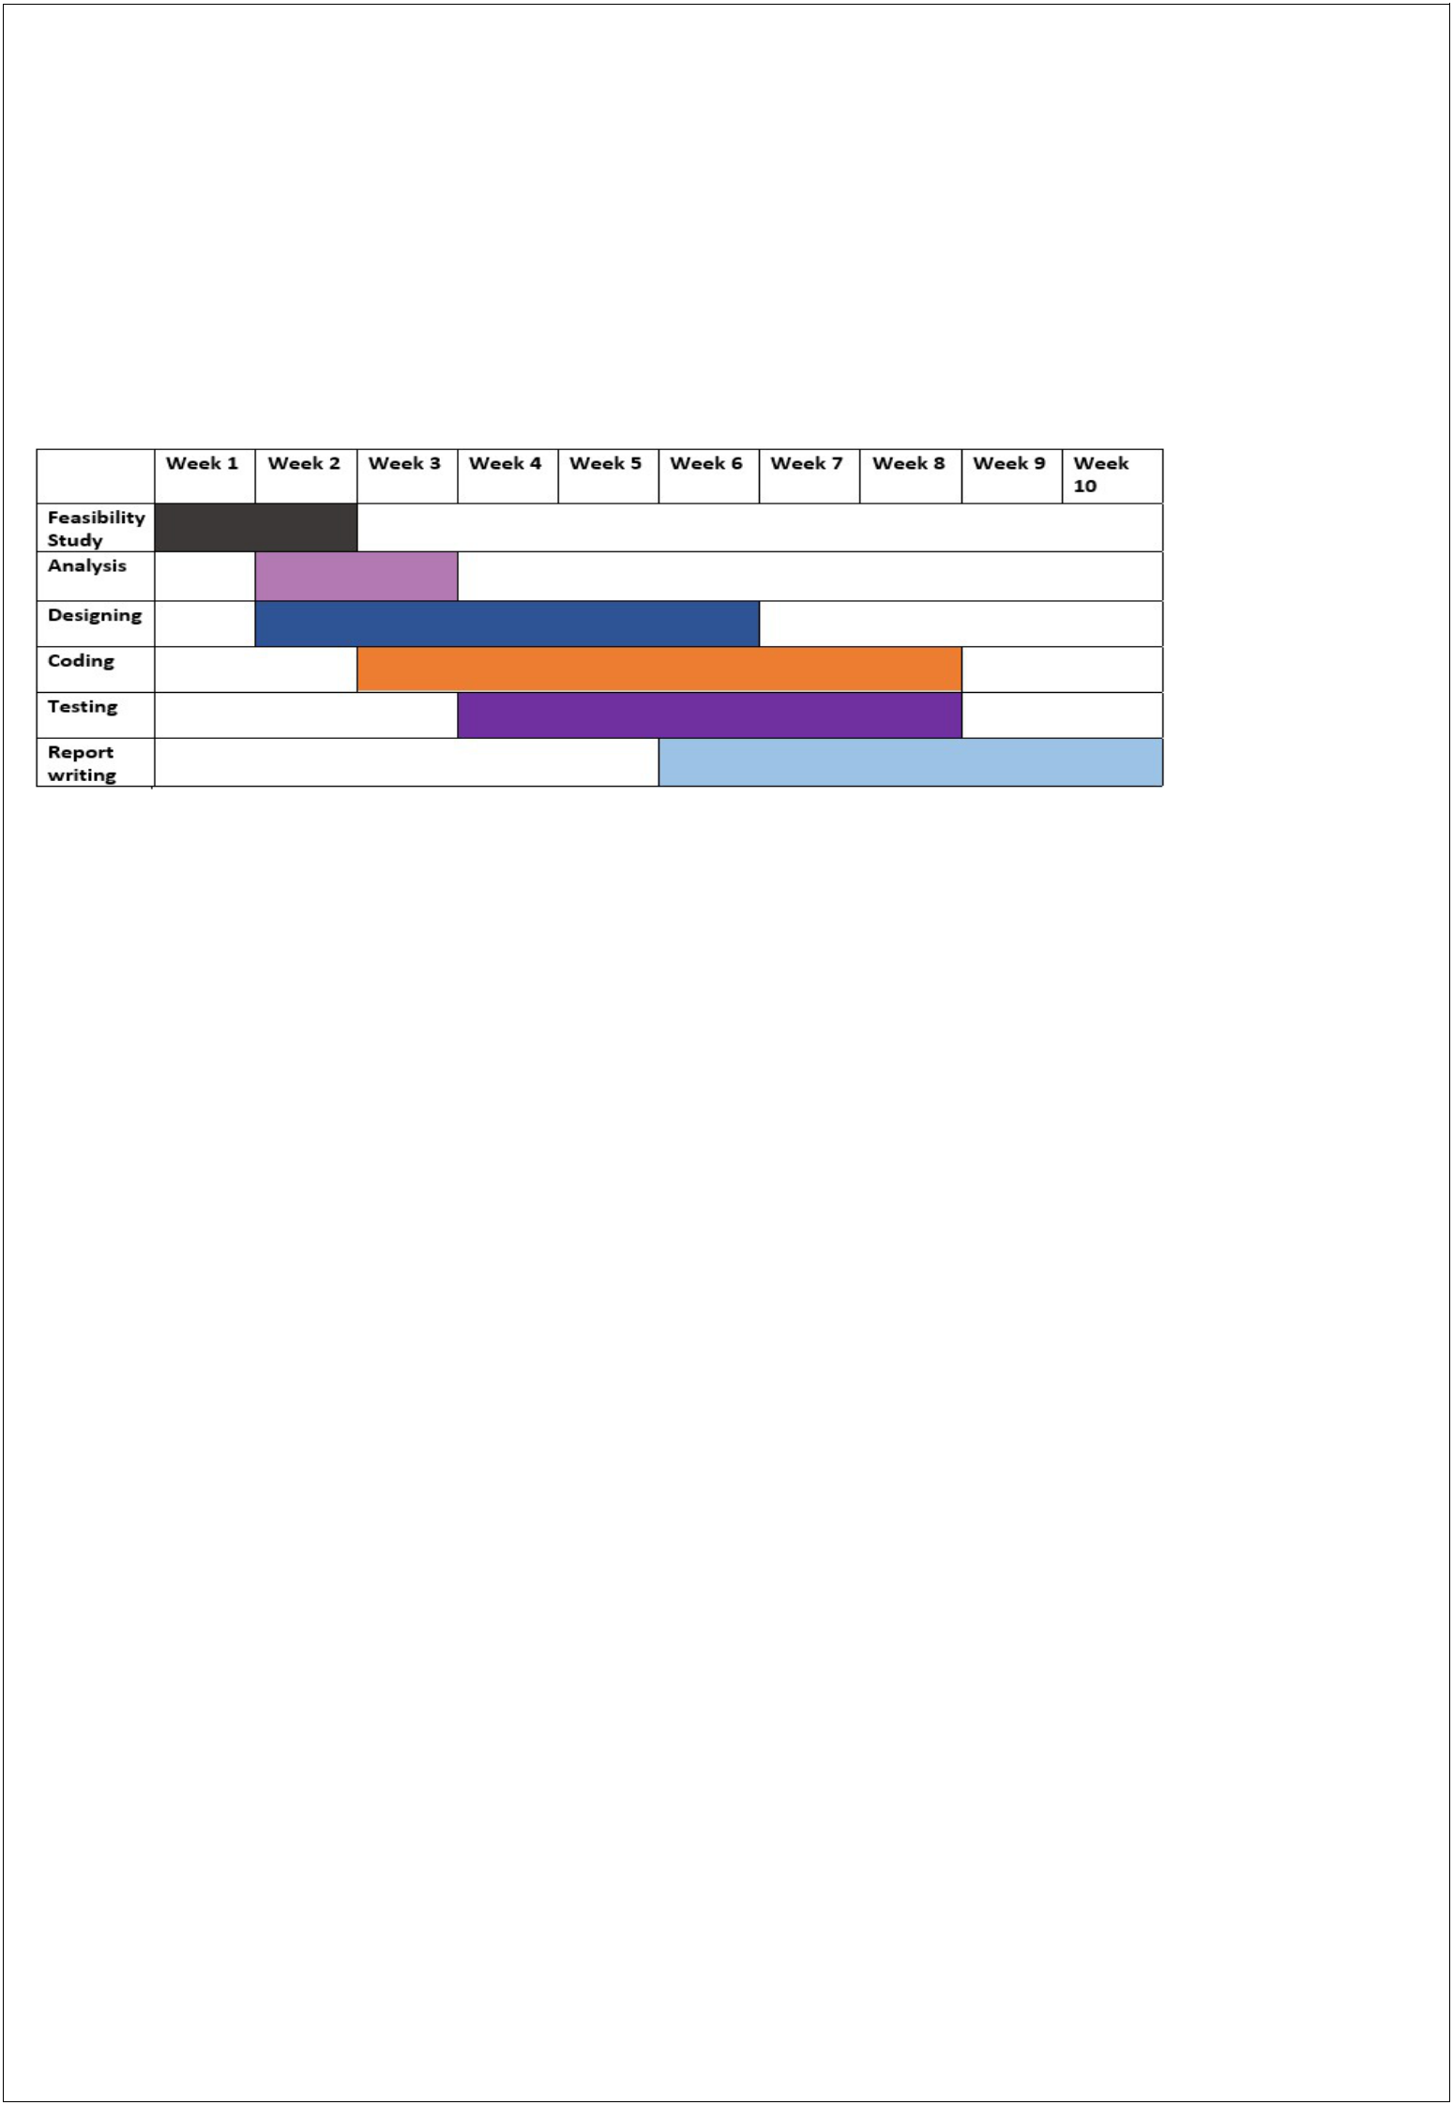
6. Proposed Time Duration

Gantt chart

Feasibility Study: We have decided 2 weeks for feasibility study and requirement gathering for that we can analysis our capabilities and resources.

Analysis: From 2 to 3 week, we proposed our self for esteem analysis of software requirements and risk and resource management.

Designing: In this phase (from 2 week to 6 week) we will focus on designing the blueprint of software and tries to focus on coding part also.

Coding: Form week 3" to week 8, we focus on coding part and tries to follow pre developed prototype of software.

Testing: Testing is not a part of only testing phase hence testing will be applied through each phase of software development life cycle.

Report Writing: During the process of developing project (software) we will constantly writes report on current project.

Hence the total time required to develop this project is around 10 weeks.

Page 9 of 10

7.References

Web Resources

www.java.sun.com

Official Java Website

www.java.sun.com/developer/onlineTraining/J2EE/Intro2/j2ee.html

Training for J2EE

www.java.sun.com/j2se/1.4.2/docs/api/index.html

J2SE Online Documentation from Sun

www.w3schools.com

JavaScript Tutorials

BOOKS

Java2 The Complete Reference(7TH Edition)
By: Herbert Schildt

JSP The Complete Reference By: Philhanna

Oracle 10g

By: Ivan Baross

Software Engineering

By: Roger Pressman

Page 10 of 10

