SYNOPSIS ON

FOOD ORDERING WEBSITE

by

Sushant Chaudhary – 2200290140155

Session:2023-2024 (IV Semester)

Under the supervision of

Dr. Akash Rajak

KIET Group of Institutions, Delhi-NCR, Ghaziabad


DEPARTMENT OF COMPUTER APPLICATIONS

KIET GROUP OF INSTITUTIONS, DELHI-NCR, GHAZIABAD-201206
( 2023- 2024)

1

ABSTRACT

It is an innovative food delivery website that seeks to redefine the
way people experience dining in the digital age. With the rapid
•

growth of the online food delivery industry, The Foodie Express aims to stand out by offering a unique and seamless dining experience for customers while providing a robust platform for restaurants to expand their reach.

Key Features:

- User-Centric Design: This prioritizes user experience with an intuitive and visually appealing interface. Users can effortlessly browse restaurants, explore menus, and place orders within minutes.

- Restaurant Empowerment: Our platform empowers restaurants of all sizes to thrive in the digital marketplace. Restaurants can easily create and manage their profiles, update menus in real-time, and access valuable analytics to make data-driven decisions.

- Effortless Ordering: Customers can discover a diverse range of restaurants, filter by cuisine, and personalize orders to cater to their unique preferences. The shopping cart ensures a smooth and hassle-free checkout process.

- Real-Time Tracking: The Foodie Express provides customers with real-time order tracking, from the moment the order is placed to its delivery at their doorstep. This transparency enhances trust and satisfaction.

- Secure Payments: With state-of-the-art payment processing, we prioritize the security of financial transactions. Multiple payment options are available, making it convenient for users.

- Responsive Support: We provide 24/7 customer support to address inquiries, resolve issues, and ensure a seamless experience for all users.

2

TABLE OF CONTENTS

- Abstract
- Introduction
- Implementations

- Flow Diagram

- Tools/Application

- Functional Requirements

3

INTRODUCTION

Imagine ordering your favorite food from restaurants without leaving your home. That's what is all about. It's a website that makes it super easy to order and enjoy delicious meals from your favorite places.
Key Goals:

Simple Ordering: The Foodie Express makes it easy for you to pick what you want to eat. You can look at menus, choose dishes you like, and order them without any fuss.

Helping Restaurants: We want to help restaurants too. The Foodie Express gives them a way to show their yummy food online and keep their menus up to date.

Easy Check-Out: When you're ready to order, we make it easy to pay and complete your order. It's like shopping online but for food! Delivery You Can Track: You can watch your food as it's prepared and delivered to you. We want you to know exactly when it will arrive. Safe Payments: We make sure your payments are safe and secure, so you don't have to worry.

Share Your Thoughts: You can tell others about your experience by leaving reviews and ratings for restaurants and food you've tried.

The Foodie Express is here to make your life easier and tastier. We're not just about delivering food; we're about making your dining experience great. Join us on this journey where good food is just a click away!
IMPLEMENTATIONS

Diagrams: Below are some important diagrams which explains the working and will be used in implementing the project.
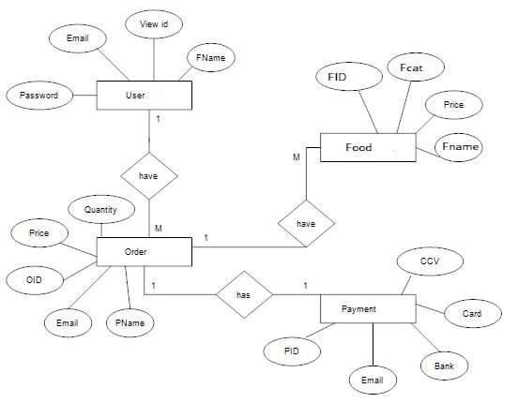
Working

Step 1: User Registration and Login:

To get started, users need to create an account on the food delivery website. They provide some basic information like their name, email, and delivery address. They also create a password to keep their account secure. Once registered, they can log in whenever they want to order food.
Step 2: Browsing and Searching:

Once logged in, users can start browsing restaurants. They can search for specific restaurants or types of cuisine. The website displays a list of nearby restaurants along with their menus, ratings, and estimated delivery times.
Step 3: Menu Selection:

Users can explore restaurant menus, which include dishes, prices, descriptions, and images. They can add items they want to order to their virtual shopping cart. The cart keeps track of everything they've selected.
Step 4: Customization:

Users can customize their orders by specifying preferences or adding special instructions. For example, they can request extra toppings, choose their preferred spice level, or ask for contactless delivery.
Step 5: Checkout and Payment:

When users are ready to complete their order, they proceed to the checkout. Here, they review their order, verify the delivery address, and choose a payment method. Food delivery websites typically accept various payment options, including credit cards, digital wallets, and cash on delivery.
Step 6: Order Confirmation:

Once the order is placed and payment is processed, users receive an order confirmation. This confirmation typically includes an estimated delivery time.
TOOLS

- HTML

- React JS

- Node Js

- MongoDB

- Database
Functional Requirement

1.User Registration and Authentication:

•Users should be able to create accounts, log in, and reset passwords.

•Authentication ensures secure access to personal data and order history.

2.Restaurant Listings:

•Display a list of restaurants with details like name, cuisine type, ratings, and location.

•Allow users to browse and search for restaurants.

3.Menu Display:

•Show restaurant menus with item names, descriptions, prices, and images.

•Update menus in real-time as restaurants make changes.

4.Search and Filters:

•Enable users to search for specific restaurants or cuisine types.

•Provide filters for dietary preferences, price ranges, and delivery times.

5.Shopping Cart:

•Allow users to add items to a cart for ordering.

•Display the cart's contents, total price, and options for order modification.

6.Order Placement:

•Provide a straightforward and intuitive order placement process.

•Allow customization of orders, including special instructions.

7.Checkout and Payment Processing:

•Offer a secure and convenient payment process.

•Integrate with payment gateways for transactions.

•Display order summary and confirmation.

8.Order Tracking:

•Enable real-time tracking of orders from preparation to delivery.

•Notify users of order status changes.

9.Delivery Address Management:

•Allow users to save and manage multiple delivery addresses.

•Support location auto-detection for convenience.

10.Restaurant Management:

•Provide restaurant owners with a dashboard to manage profiles, menus, and orders.

•Offer analytics and reporting features.

THANK

YOU

9

