**A PROJECT REPORT**

**for**

**Mini Project (KCA353)**

**Session (2024-25)**

**Submitted by**

**Rajat Aggarwal(2300290140132)**

**Sarthak semwal (2300290140160)**

**Sanchi Singh(2300290140158)**

**Submitted in partial fulfilment**

**of the**

**Requirements for the Degree of**

MASTER OF COMPUTER APPLICATION

**Under the Supervision of**

**Dr Sangeeta Arora (Associate Professor)**



**Submitted to**

**Department Of Computer Applications**

**KIET Group of Institutions, Ghaziabad Uttar Pradesh-201206**

**(December 2024)**

**CERTIFICATE**

Certified that **Sarthak Semwal (2300290140160), Rajat Aggarwal (2300290140132), Sanchi Singh (2300290140158)** have carried out the project work having “**Tracking**” (**Mini-Project-KCA353**) for **Master of Computer Application** from Dr. A.P.J. Abdul Kalam Technical University (AKTU**)** (formerly UPTU), Lucknow under my supervision. The project report embodies original work, and studies are carried out by the student himself/herself and the contents of the project report do not form the basis for the award of any other degree to the candidate or to anybody else from this or any other University/Institution.

**Dr Sangeeta Arora Dr. Arun Tripathi**

**(Associate Professor) (Head of Department)**

**ABSTRACT**

In today's interconnected world, supply chains involve multiple stakeholders such as manufacturers, suppliers, distributors, and retailers, often operating across vast geographical areas. This complexity leads to several challenges, including lack of transparency, difficulty in tracking products, delays, counterfeit goods, and the inability to verify the authenticity of products. Traditional supply chain systems, often managed by a centralized authority, are prone to fraud, errors, and tampering, further exacerbating these issues. Additionally, the absence of real-time tracking and inadequate communication between stakeholders undermines efficiency and trust.

Our project, Tracking, leverages blockchain technology to address these critical challenges. Blockchain offers a decentralized and immutable ledger system that ensures transparency, security, and traceability in the supply chain. By integrating blockchain into supply chain operations, our solution provides:

1. Real-Time Tracking: Every product's journey is logged on the blockchain, enabling stakeholders to track its movement in real time.
2. Enhanced Transparency: All participants have access to a shared, tamper-proof record of transactions, fostering trust and accountability.
3. Fraud Prevention: The decentralized nature of blockchain eliminates the reliance on a central authority, significantly reducing the risk of fraud and tampering.
4. Product Authentication: Consumers can verify the authenticity and origin of products, improving confidence and satisfaction.

Through our innovative approach, Tracking revolutionizes traditional supply chain management by ensuring efficiency, reliability, and trustworthiness. Our blockchain-powered solution not only streamlines operations but also empowers businesses and consumers to make informed decisions in a secure and transparent ecosystem.

**ACKNOWLEDGEMENTS**

Success in life is never attained single-handedly. My deepest gratitude goes to my project supervisor, **Dr Sangeeta Arora** for her guidance, help, and encouragement throughout my project work. Their enlightening ideas, comments, and suggestions.

Words are not enough to express my gratitude to Dr. Arun Kumar Tripathi, Professor and Head, Department of Computer Applications, for his insightful comments and administrative help on various occasions.

Fortunately, I have many understanding friends, who have helped me a lot on many critical conditions.

Finally, my sincere thanks go to my family members and all those who have directly and indirectly provided me with moral support and other kind of help. Without their support, completion of this work would not have been possible in time. They keep my life filled with enjoyment and happiness.

**Sarthak Semwal**

**Rajat Aggarwal**

**Sanchi Singh**

**TABLE OF CONTENTS**

|  |  |  |  |
| --- | --- | --- | --- |
| Certificate | | | ii |
|  | Abstract | | iii |
|  | Acknowledgements | | iv |
|  | Table of Contents | | v-vi |
|  | List of Figures | | vii |
| **1** | **Introduction** | | **1-3** |
|  | 1.1 | Overview | 1 |
|  | 1.2 | Problem Statement | 1 |
|  | 1.3 | Objective | 1 |
|  | 1.4 | Scope | 2 |
|  | 1.5 | Features | 2 |
|  | 1.6 | Background | 3 |
| **2** | **Feasibility Study** | | **4-7** |
|  | 2.1 | Economic Feasibility | 4 |
|  | 2.2 | Technical Feasibility | 5 |
|  | 2.3 | Operational Feasibility | 5 |
|  | 2.4 | Behavioral feasibility | 6 |
| **3** | **Software requirement specification** | | **8-14** |
|  | 3.1 | Functionalities | 8 |
|  | 3.2 | User and Characteristics | 9 |
|  | 3.3 | Features of project | 10 |
|  | 3.4 | Feature of Admin | 11 |
|  | 3.4 | Features of User | 12 |
| **4** | **System Requirement** | | **15-21** |
|  | 4.1 | Functional and Non-Functional Requirement | 15 |
|  | 4.2 | Design Goal | 16 |
|  | 4.3 | System Sequence Diagram | 17 |
|  | 4.4 | Flowchart of supply chain | 18 |
|  |  |  |  |
| **5** | **System Design** | | **22-24** |
|  | 5.1 | Primary and Secondary Design Phase | 22 |
|  | 5.2 | User Interface | 23 |
|  |  |  |  |
| **6** | **Architecture** | | **25-28** |
|  | 6.1 | Layered Architecture | 25 |
|  | 6.2 | Real Time Update | 26 |
|  |  |  |  |
|  |  |  |  |
|  |  |  |  |
|  |  |  |  |

|  |  |  |  |
| --- | --- | --- | --- |
|  | 6.3 | Security Architecture | 27 |
| **7** | **Project Screenshots** | | **29-32** |
| **8** | **Code Screenshots** | | **33-35** |
| **9** | **Conclusion** | | **36** |

**LIST OF FIGURES**

|  |  |  |
| --- | --- | --- |
| **Figure No.** | **Name of Figure** | **Page No.** |
| 4.3 | System Sequence Diagram | 18 |
| 4.4 | Flowchart of System | 19 |
| 7.1 | Dashboard Page | 28 |
| 7.2 | Add Tracking Page | 29 |
| 7.3 | Get Shipment Page | 30 |
| 7.4 | Start Shipment Page | 31 |
| 7.5 | Complete Shipment Page | 32 |
| 7.6 | Metamask Page | 33 |

**CHAPTER 1**

**INTRODUCTION**

## Overview

Tracking is an innovative solution aimed at transforming supply chain management through the integration of cutting-edge blockchain technology. Utilizing Ethereum's decentralized network, Metamask wallet, and Smart Contracts written in Solidity, the project seeks to streamline and secure the entire process of tracking goods across supply chains. By leveraging the transparency, immutability, and security of blockchain, Tracking offers a highly reliable and tamper-proof method to monitor and record every step of a product’s journey. The application ensures that all transactions related to the movement, storage, and handling of goods are recorded on the Ethereum blockchain, which is visible and accessible to authorized stakeholders in real-time. Smart contracts play a pivotal role by automating key aspects of the supply chain, ensuring that conditions are met before goods are transferred, payments are made, or contracts are executed. The use of Metamask wallet further enhances security and user convenience by enabling secure transactions and interactions within the blockchain ecosystem. Tracking provides an efficient and scalable solution that overcomes the limitations of traditional supply chain management systems, which often suffer from a lack of transparency, inefficiency, and vulnerability to fraud.

## Problem Statement

In the modern supply chain, visibility, transparency, and security are paramount for ensuring efficient operations and fostering trust between multiple stakeholders such as manufacturers, distributors, retailers, and customers. However, existing supply chain management solutions often fall short of these requirements, with issues such as data inaccuracy, delayed information sharing, fraudulent activities, and lack of traceability. The centralized nature of traditional systems leads to dependency on intermediaries, creating opportunities for errors or tampering of critical data.

## Objectives

The main objective of the Tracking project is to manage and optimize the supply chain processes using blockchain technology. This project is designed to track the movement, condition, and status of goods throughout the entire supply chain, from manufacturing to delivery.

## Scope

## The scope of the Tracking project encompasses the development of a decentralized solution designed to track and manage goods throughout the entire supply chain. The application will leverage blockchain technology to create a transparent, secure, and immutable record of transactions and product movement from production to delivery. The project aims to provide a solution for businesses and stakeholders to monitor, verify, and automate supply chain activities, improving efficiency, reducing fraud, and enhancing data integrity.

## 

## Key features within the scope of the project include:

## Blockchain-based Supply Chain Tracking: The core functionality will enable businesses to track products as they move through various stages of the supply chain. All product-related transactions, such as manufacturing, shipping, and delivery, will be recorded on the blockchain to provide real-time, transparent, and immutable records.

## Smart Contracts Integration: The use of Smart Contracts written in Solidity will automate key supply chain processes such as inventory management, order fulfillment, and payment processing. These contracts will automatically execute predefined actions when certain conditions are met, ensuring accuracy and reducing manual intervention.

## Security and Data Integrity: The solution will utilize blockchain’s inherent security features to ensure that all data is tamper-proof and that transactions are protected. The system will also include secure access mechanisms to ensure that only authorized participants in the supply chain can access or modify relevant data.

## Real-Time Monitoring and Updates: The application will provide real-time updates on the status, location, and condition of goods as they move through the supply chain. Stakeholders will be able to monitor the progress of orders, track shipments, and verify the authenticity of products instantly.

## Stakeholder Access and Control: The system will allow different stakeholders (e.g., manufacturers, suppliers, distributors, retailers, and customers) to access the relevant information according to their roles and permissions. This ensures that sensitive data is only accessible to authorized parties while maintaining transparency and collaboration within the supply chain.

## Feature

1. The core functionality will allow businesses to track products and goods through the entire supply chain, recording every transaction and movement on an immutable blockchain.
2. The application will provide real-time updates on the location, status, and condition of products throughout the supply chain.
3. The system will be designed to work across multiple platforms, supporting devices such as desktops, tablets, and smartphones.
4. Secure file transfer with encryption and security protocols to protect privacy and data integrity.
5. A robust authentication mechanism will ensure that only authorized participants (such as manufacturers, distributors, and retailers) can interact with the blockchain system.
6. Blockchain will provide a transparent and immutable audit trail for every product transaction within the supply chain.

## Background

With the increasing complexity and globalization of supply chains, managing the flow of and ensuring transparency has become more challenging than ever before. Traditional supply chain management systems often rely on centralized platforms that can be vulnerable to inefficiencies, delays, and inaccuracies. Moreover, many of these systems are not equipped to handle the rising demands for transparency, security, and real-time tracking that modern businesses and consumers require.

For years, supply chain management has faced issues such as fraud, counterfeit products, and data manipulation. The lack of an efficient, transparent, and verifiable system for tracking products throughout their lifecycle, from production to delivery, often leaves room for errors and disputes between stakeholders. Additionally, the reliance on intermediaries and paper-based systems further exacerbates these problems, leading to increased costs, delays, and a lack of trust between suppliers, manufacturers, distributors, and consumers.

In response to these challenges, blockchain technology has emerged as a groundbreaking solution. Its decentralized, immutable, and transparent nature provides a robust framework for enhancing the traceability and authenticity of products in the supply chain. By using blockchain, businesses can create a digital ledger that records every step of the product’s journey, from manufacturing to transportation, ensuring that the data is secure, tamper-proof, and accessible to all authorized participants.

**CHAPTER 2**

**FEASIBILITY STUDY**

# ECONOMICAL FEASIBILITY

Economic feasibility assesses whether the project can be implemented within a reasonable budget while maintaining the required quality and performance standards. The **"Tracking in Supply Chain Management using Blockchain"** project leverages cutting-edge, cost-effective technologies to deliver a robust solution. By utilizing open-source blockchain platforms, smart contracts, and decentralized applications (dApps), the project is designed to minimize costs and maximize value

## Open-Source Advantages:

* Ethereum is a widely used, open-source blockchain that provides the infrastructure for creating secure, transparent, and immutable records without the need for costly proprietary platforms.

## Minimal Hardware Requirements:

* **Decentralized Architecture**: Since the solution is based on blockchain technology, there is no need for expensive centralized servers or infrastructure. Blockchain nodes can be run on standard computers, reducing the capital expenditure required for infrastructure

## Cost Breakdown:

* Transaction costs (gas fees) for deploying and interacting with smart contracts on Ethereum can vary depending on network congestion. However, these fees are relatively low compared to the operational costs of traditional centralized systems.

# TECHINICAL FEASIBILITY

The technical feasibility of the **"Tracking in Supply Chain Management using Blockchain"** project focuses on determining whether the proposed technologies and system architecture can meet the platform's requirements for scalability, reliability, security, and performance.

## Technical Stack:

* **Ethereum Blockchain:** The foundation of the system is Ethereum, a decentralized blockchain platform known for its robust security features and smart contract capabilities. Ethereum allows for immutable, transparent, and secure record-keeping, which is essential for tracking goods in the supply chain.
* **Node.js and Express.js:** The backend of the system is built using Node.js and Express.js, providing a lightweight, scalable, and fast environment for handling API requests and managing blockchain interactions.
* **IPFS (InterPlanetary File System):** IPFS is a decentralized file storage protocol that can be used to store off-chain data, such as product images, shipment documents, or other metadata.

## Real-Time Capabilities:

* **Blockchain Transaction Confirmation:** Every step of the supply chain (from manufacturing to delivery) will be logged on the blockchain. Real-time transaction confirmations ensure that stakeholders are immediately notified of the status of the products.
* **Smart Contract Automation:** Smart contracts provide automated decision-making based on predefined conditions (e.g., product delivery or payment), ensuring real-time automation without human intervention.

## Cross-Platform Compatibility:

* **Web Application Interface**: The system is designed to work as a web application, accessible via any modern browser on desktops, laptops, tablets, or smartphones. The user interface will allow stakeholders (e.g., manufacturers, suppliers, distributors, and consumers) to interact with the blockchain system seamlessly.
* **Mobile and Web Compatibility**: Since supply chain stakeholders are often on the move, the solution must be compatible across mobile and web platforms.

This technical feasibility study outlines how our blockchain-based supply chain solution can meet the project's performance, scalability, and security requirements.

# OPERATIONAL FEASIBILITY

Operational feasibility evaluates how well the proposed **Tracking in Supply Chain Management using Blockchain** system can be integrated into users' daily workflows and whether it meets operational needs effectively.

## User-Friendly Design:

* **Intuitive Interface**: The platform is designed to be user-friendly, featuring clear and simple navigation that allows users of various technical backgrounds to use it with minimal training.
* The interface will include modules such as a dashboard for tracking product movement, real-time notifications of status updates, and a history log of transactions for transparency.

## Streamlined Workflows:

* **Core Functions Simplified**: Users will be able to perform core tasks such as tracking shipments, verifying product authenticity, and completing transactions through a streamlined workflow.
* **Efficient Process Automation**: Smart contracts will automate various supply chain processes, reducing manual effort and ensuring tasks such as order verification, payment authorization, and inventory updates are completed quickly and accurately.

## Accessibility:

* + - * **Cross-Platform Access**: The platform will be web-based, allowing users to access it from various devices, such as desktops, laptops, tablets, and smartphones. This flexibility is particularly beneficial for users in logistics or transportation who may need to access the system while on the move.

This operational feasibility study illustrates how the platform can effectively support and improve the daily activities of supply chain stakeholders.

# BEHAVIOURAL FEASIBILITY

Behavioral feasibility examines how well the **"Tracking in Supply Chain Management using Blockchain"** system aligns with user preferences and promotes positive interaction and engagement. This aspect focuses on ensuring that the system is not only functional but also appealing and intuitive for its users, encouraging long-term adoption and satisfaction.

## User-Centric Design:

* + - * **Simplicity and Usability**: The platform will prioritize an easy-to-use and intuitive interface that minimizes complexity and maximizes efficiency. Since blockchain technology can sometimes appear overwhelming, the design will be simple and accessible for all users, regardless of their technical expertise.

## Personalization and Engagement:

* + - * **Role-Based Dashboards**: Each user will have a personalized dashboard based on their role, whether they are an administrator, supplier, or retailer. This customization helps users focus on the most relevant information and functionalities..
      * **Admin Dashboard**: Admins will have access to higher-level controls such as managing users, overseeing supply chain processes, and generating reports.

## Enhancing User Behaviour:

* + - * **Interactive Features**: To keep users engaged, the platform will include interactive elements that foster a sense of connection and control over the data.
      * **File Sharing Notifications**: Users will receive real-time alerts when shipments are dispatched, delivered, or updated, encouraging them to track their products continuously.

Behavioural feasibility emphasizes creating a system that not only meets technical requirements but also fosters long-term user satisfaction and engagement.

# CONCLUSION

The feasibility study confirms that the **"Tracking in Supply Chain Management using Blockchain"** project is not only economically viable but also technically sound, operationally efficient, and behaviorally engaging. By leveraging blockchain technology, the project promises to revolutionize supply chain management by offering transparency, security, and decentralization, ensuring that all parties involved have real-time access to critical data without the risk of manipulation

**CHAPTER 3**

**SOFTWARE REQUIREMENT SPECIFICATION**

The app is designed to enhance transparency, security, and efficiency in managing supply chains. By integrating blockchain technology, the platform allows businesses and individuals to securely track, verify, and manage goods as they move through the supply chain. The software will utilize Ethereum blockchain, MetaMask wallet, and smart contracts written in Solidity to enable decentralized tracking, secure transactions, and real-time updates.

This software aims to streamline and automate supply chain processes, offering an immutable and transparent record of transactions, improving operational efficiencies, and ensuring trust across all parties involved in the supply chain.

* 1. **Functionalities:**

The **"Tracking"** project focuses on enhancing transparency, security, and efficiency in supply chain management through blockchain technology. Below are the key functionalities that define the system:

* + - **Secure Tracking:** The system enables real-time tracking of goods as they move through the supply chain, ensuring that each step is recorded on an immutable blockchain ledger..
    - **Automated Agreements:** Smart contracts on the blockchain allow predefined business rules to be executed automatically when specific conditions are met. For instance, payments could be automatically triggered upon delivery confirmation.
    - **Wallet Management:** The platform allows users to manage their MetaMask wallet to facilitate payments, receive rewards, and interact with smart contracts securely.
    - **Transaction Updates:** Stakeholders in the supply chain will receive notifications for key events such as shipment tracking, delivery status, and payment confirmation. This keeps all involved parties informed in real time.
    - **Stakeholder Participation:** The system allows multiple participants in the supply chain, including suppliers, manufacturers, transporters, and consumers, to interact with the platform. Each participant will have access to data relevant to their role in the supply chain.

These functionalities ensure that the **"Tracking in Supply Chain Management using Blockchain"** system will provide a robust, secure, and efficient solution for managing the complexities of modern supply chains. By leveraging blockchain technology, smart contracts, and decentralized systems, the project promises to enhance trust, transparency, and accountability throughout the supply chain..

* + - **Multi-Party Integration**.
    - **Supply Chain Analytics and Reporting**
    - **Secure Payment Mechanisms**.
    - **Decentralized and Scalable Architecture**
  1. **User and Characteristics:**

For this application, two types of users are defined:

These users represent the key participants in the supply chain who interact with the system for tracking and managing products. They can include suppliers, transporters, manufacturers, retailers, and customers.

**Standard User**:

**Characteristics and Responsibilities:**

1. **Product Tracking**: Standard users can track the movement of goods in real-time as they pass through various stages in the supply chain.
2. **View and Confirm Transactions**: They can confirm deliveries and other transactions, such as order receipts or shipment statuses, using blockchain records.
3. **Real-Time Updates**: Users will receive real-time updates on the product status, including shipping milestones and delivery confirmations.
4. **Payment Processing**: Standard users can interact with the system for payment processing via blockchain-based cryptocurrency or tokens, which are triggered by smart contract conditions (e.g., delivery confirmation).
5. Individuals who initiate and receive file transfers using the ShareTo application.
   * Can register and authenticate securely.
   * Initiates secure peer-to-peer file transfer sessions.
   * Manages session controls including pause, resume, and termination.
   * Can access transfer history and logs for personal reference.
6. **Administrator**: Responsible for managing and maintaining the application environment.
   * Oversees user activity and ensures system integrity.
   * Configures system-level settings and logs.
   * Manages security protocols, including encryption and user permissions.
   * Monitors real-time transfer activities for system performance.
   * Has authority to troubleshoot and resolve technical issues.

## Additional Characteristics

* **System Management:** Administrators are responsible for managing the overall system, including monitoring blockchain transactions and ensuring data integrity..
* **User Management:** They manage user accounts, assign roles, and configure user permissions for different participants in the supply chain, ensuring secure access control..
* **Blockchain Configuration:** Administrators configure the blockchain, smart contracts, and consensus mechanisms to ensure proper system operation.

**Features of the project:**

* + - **Secure Account Creation:** Users (such as suppliers, manufacturers, and customers) can create unique accounts to register on the platform.
    - **Immutable Transaction Records:** Every transaction in the supply chain, from order creation to product delivery, is recorded on the blockchain, ensuring transparency and an immutable audit trail.
    - **Real-Time Transaction Status:** Users can track real-time status updates for their goods, such as shipment location, condition, and delivery confirmation.
    - **End-to-End Visibility:** Provides complete transparency into the movement and handling of goods at each stage of the supply chain.
    - **Automation of Agreements:** Smart contracts are used to automatically execute supply chain agreements, such as payments and deliveries, once certain predefined conditions are met (e.g., upon delivery confirmation).
    - **Multi-Device Access:** Users can access the platform from different devices such as desktops, mobile phones, or tablets, ensuring that the supply chain can be monitored and managed at any time, from anywhere.
    - **Operating System Compatibility:** The platform is designed to be compatible with multiple operating systems like Windows, macOS, and Linux, enabling broad accessibility for users across the supply chain.
    - **Alerts for Key Events:** Real-time notifications are sent to users for important supply chain events, including shipment status changes, delays, delivery confirmations, and other critical updates.
    - **Delivery Confirmation:** Users are notified when products are delivered or when certain actions (like payment) have been completed, ensuring clear communication throughout the supply chain.
    - **End-to-End Data Encryption:** All data transactions, including product details and user information, are encrypted and securely recorded on the blockchain, ensuring privacy and protecting sensitive data.
    - **Immutable Product History:** Products’ entire journey in the supply chain is securely logged on the blockchain, preventing tampering with product history and enhancing trust among all stakeholders.
    - **Supply Chain Insights:** The platform provides analytics on supply chain performance, such as delivery time, product condition, and supplier reliability, helping users make data-driven decisions**.**
    - **Inventory Management:** Real-time reporting and alerts help businesses manage inventory effectively by providing up-to-date information about stock levels, product movements, and demand forecasts.
  1. **Features of Admin:**

Administrators play a crucial role in maintaining the functionality, security, and efficiency of the Tracking app. Here are the detailed features available to administrators:

* + - **View and Manage User Accounts:** Administrators can view, query, and manage user accounts across the supply chain platform. This includes adding, updating, or deleting users based on their role (e.g., supplier, manufacturer, distributor, customer).
    - **Role Assignment and Permissions:** Admins can assign roles such as "Supplier", "Manufacturer", "Distributor", or "Customer", and control the permissions granted to each user based on their responsibilities in the supply chain.
    - **Deactivation and Deletion of Inactive Users:** Administrators can deactivate inactive accounts or remove unauthorized users from the platform to maintain security and data integrity.
    - **Real-Time Blockchain Transaction Monitoring:** Admins can monitor the blockchain ledger in real-time, ensuring that all transactions (from orders to delivery) are recorded and validated.
    - **Audit Trail Review:** Administrators can access and review an immutable record of all blockchain transactions to ensure compliance, security, and transparency at every stage of the supply chain.
    - **Transaction Dispute Management:** In case of disputes or discrepancies, administrators can review transaction histories and resolve issues through the blockchain ledger.
    - **Activity Logs:** Admins can view logs of system activities, including login attempts, blockchain transactions, and file transfer activities. This ensures accountability and helps in tracking suspicious activities.
    - **Security Incident Monitoring:** Logs allow administrators to detect potential security breaches, unauthorized access, and other anomalies, ensuring timely intervention and risk mitigation.
    - **Smart Contract Oversight:** Admins can review, approve, or modify smart contracts used for supply chain operations. This ensures that contracts are executed based on defined conditions and remain compliant with regulations.
    - **Smart Contract Auditing:** Administrators are empowered to audit and track smart contract execution, ensuring that terms are met and transactions are verified as per the predefined conditions.
    - **Encryption Protocol Oversight:** Admins can manage and configure the encryption protocols used for securing sensitive data on the blockchain, ensuring compliance with security best practices.

These features empower administrators to maintain the Tracking app as a secure, efficient, and user-friendly platform for peer-to-peer file sharing.

* 1. **Features of User:**

The **"Tracking"** platform offers a comprehensive and secure user experience, enabling individuals in the supply chain (e.g., suppliers, manufacturers, distributors, and customers) to manage and track the flow of goods, transactions, and data across the supply chain ecosystem. Below are the key features available to users:

## User Registration and Login:

* + - * **Account Creation**: Users can create accounts with unique credentials (username, email, password) for secure access to the platform.
      * **Secure Authentication**: JWT-based authentication ensures that only authorized users can log in and access the platform, maintaining the integrity of the system.

## Dashboard and User Interface:

* + - * **Personalized Dashboards:** Users can view a customized dashboard based on their role (e.g., supplier, manufacturer, distributor) that displays relevant data, such as order status, inventory, and supply chain progress.
      * **Real-Time Updates:** The platform provides live updates on order status, inventory levels, shipment tracking, and other supply chain events, ensuring users are always informed.

## Supply Chain Transaction Management:

* + - * **Track Goods:** Users can track the movement of goods through the supply chain in real-time using blockchain-based tracking. Each transaction is securely recorded, providing transparency and preventing fraud.
      * **Initiating and Managing Orders:** Users can create, view, and manage supply chain orders, from procurement to delivery, with full visibility into the transaction history.

## Blockchain-based Smart Contracts:

* + - * **Smart Contract Execution:** Users can view and interact with smart contracts that automatically execute when predefined conditions are met. These contracts help automate processes like order fulfillment, payments, and delivery.

## Data Security and Privacy:

* + - * **End-to-End Encryption:** All data transmitted through the platform is encrypted, ensuring that sensitive business and transaction information remains private and secure.
      * **Immutable Ledger:** Blockchain technology ensures that all transactions are securely recorded and cannot be tampered with, ensuring the integrity of the supply chain data.

## Cross-Platform Support:

* + - * **Platform Accessibility:** The system is compatible with multiple devices and operating systems (Windows, macOS, Android, iOS), allowing users to access the platform from any device.

## Session Expiry and Resource Management:

* + - * **Automatic Session Expiry**: Inactive sessions are automatically detected and terminated to save system resources and ensure security.

## Reporting and Analytics:

* + - * **Supply Chain Insights:** Users can generate reports on supply chain performance, including metrics such as order completion times, inventory levels, and shipping efficiency.

## Collaborative Workflow:

* + - * **Multi-User Collaboration:** Users from different supply chain stages (e.g., suppliers, manufacturers, distributors) can collaborate within the platform, sharing critical data and updates for smoother operations.

## File Preview and Metadata Display:

* + - * **Preview Files**: Users can preview files and view metadata (e.g., file size, type, and date) before initiating transfers, ensuring accuracy.

## Error Handling and Issue Resolution:

* + - * **Issue Reporting:** If any issues arise (e.g., delayed shipments, incorrect order details), users can report them directly through the platform for timely resolution.

## Session Management and Control:

* + - * **Order Management:** Users can initiate, pause, resume, or cancel orders as needed.

**CHAPTER 4**

**SYSTEM REQUIREMENTS**

System requirements define the functional and non-functional aspects essential for the platform’s successful development and deployment. This section provides a detailed explanation of these requirements, focusing on how they support the platform's goals of usability, reliability, and scalability.

# FUNCTIONAL AND NON-FUNCTIONAL REQUIREMENTS

Functional requirements outline the core functionalities that the system must deliver to meet user needs effectively.

* + 1. **Smart Contract Deployment and Execution**
* **Requirement**: Facilitate the deployment of smart contracts to automate specific supply chain processes.
  + Predefined logic for triggering supply chain events.
  + Automatic execution when conditions are met (e.g., payment release on delivery confirmation).
  + Transparent execution logs on the blockchain.

### 

### **Stakeholder Identity Management**

* **Requirement**: Enable all participants in the supply chain (e.g., suppliers, manufacturers, distributors, retailers, and customers) to have unique, verifiable identities on the blockchain.
* **Features**:
  + Digital identity creation.
  + Public/private key authentication.
  + Role-based access control.

**3.Tracking Products from Start to Finish**

* **Requirement:**  Uses blockchain to record each step, with tools like QR codes or sensors for real-time tracking.
* Keeps a permanent record of a product’s journey, from creation to the customer.
  + 1. **Payment and Settlement Automation**

1. **Requirement:** Enable secure and automated payment settlements based on predefined conditions.
   * Integration with cryptocurrency wallets or tokenized payments i.e metamask.
   * Conditional payments triggered by delivery status or quality verification.
   * Support for escrow accounts in smart contracts.
     1. **Handling Disputes**

* **Requirement:**  Keeps a clear and unchangeable record of all transactions and verifies contract terms.
* Makes resolving disagreements easier and faster.
  + 1. **Easy Audits and Reports**
* **Requirement:** Provides dashboards and permanent records for analysis.
* Makes it simple to check and report on supply chain activities.

# DESIGN GOALS

Design goals focus on creating an efficient and scalable system that enhances transparency , efficiency , security and accountability.

## Usability:

The user interface is designed with simplicity in mind, using **Material UI**

and **Tailwind CSS** to create clean and responsive layouts.

* **Transparency**

Nothing can be hidden because all the data is stored on a shared digital ledger that can't be tampered with.

* **Automation**

The system can do things automatically, like releasing payments or updating inventory, without anyone having to press a button.

For example, when goods are delivered, the smart contract can automatically release the payment.

**Efficiency**

Tasks that used to take days, like paperwork or approvals, are do ne instantly through digital means.

This makes the whole supply chain run faster and smoother

* **Security**

Sensitive data is protected so that only the right people can access it.

The system uses strong encryption to keep the data secure.

* **Unchangeable Records (Immutability)**

Once a record is made, it can't be changed or deleted.

This makes it easy to trust the information and audit the records when needed.

* **Traceability**

You can see where a product is at any time, from raw materials to the final delivery.

Things like barcodes or sensors can update the system in real time.

## Ein Bild, das Text, Schrift, Screenshot, Quittung enthält. Automatisch generierte Beschreibung System Sequence Diagram

**Fig.4.1 Sequence Diagram**

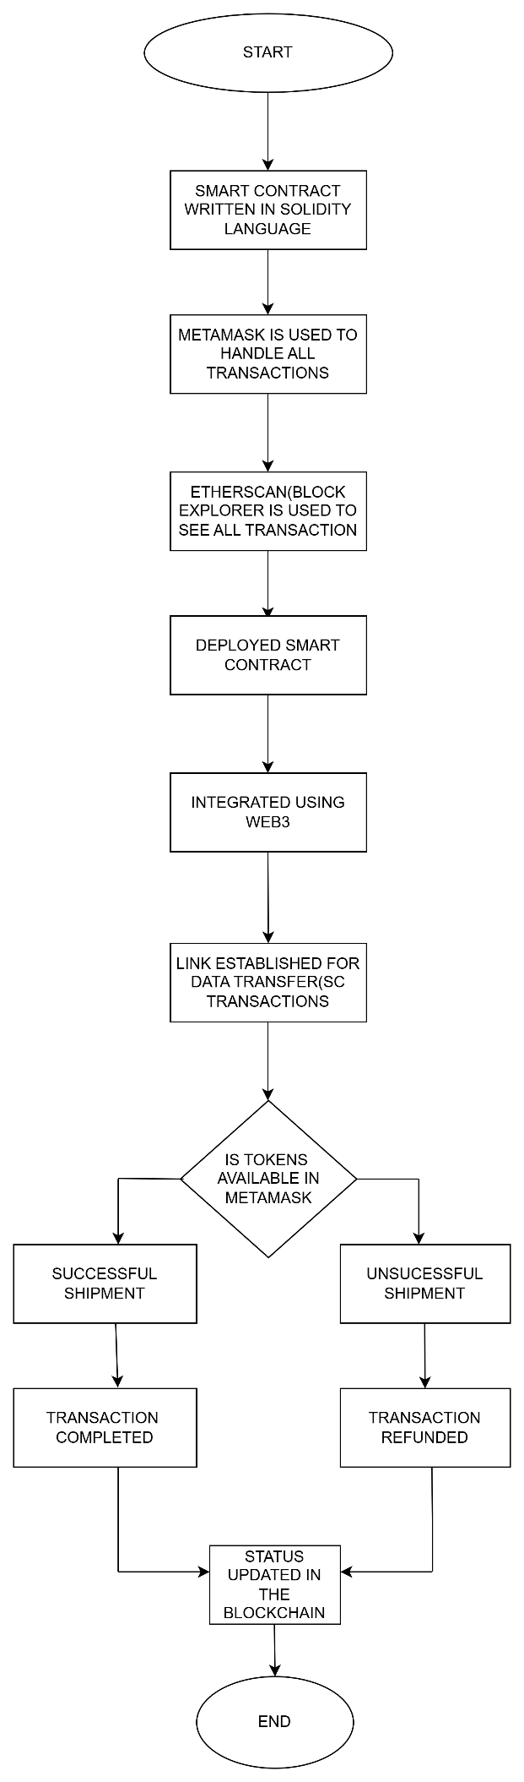

* 1. **Flowchart**

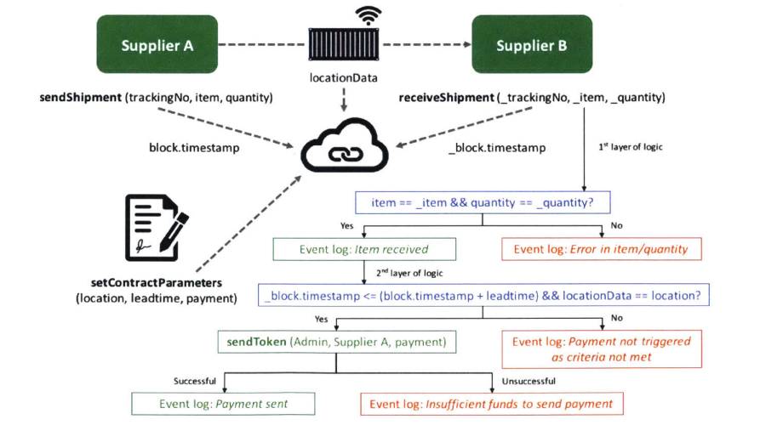

## Logic Flowchart of smart contract supply chain

# CONCLUSION

By aligning functional and non-functional requirements, a smart contract-based supply chain system can enhance transparency, reduce operational inefficiencies, and build trust among stakeholders. Proper implementation of these requirements ensures the system's robustness, scalability, and user satisfaction, ensuring the way for a more efficient and modernized supply chain process.

## CHAPTER 5 SYSTEM DESIGN

System design focuses on creating the structural framework for the platform, ensuring it is efficient, scalable, and user-friendly. This section elaborates on the primary and secondary design phases and the user interface, detailing how they work together to meet project goals.

# DESIGN PHASE

The primary design phase establishes the foundational structure of the system. It involves creating visual and functional representations of core modules to guide development.

**Break the System Into Parts**:

* + **Smart Contracts**: These will handle tasks like tracking products, automating payments, and checking compliance.
  + **Storage**: Some information (like product details or documents) might be too big for the blockchain.
  + **Apps**: Design web or mobile apps so people can interact with the system, check product data, or update shipment statuses.

1. **Decide the Workflow**:

* A supplier registers a product batch on the system.
* The product moves to a manufacturer, who updates the status.
* A distributor delivers the product, and the system automatically releases the payment.

1. **Design the Smart Contracts**
   * They are like digital agreements that do things automatically. For example:
     + If a delivery is confirmed, release payment.
     + If a shipment of the product starts and completed , the status is automatically updated in the blockchain.
2. **Plan How Data Will Flow**
   * A supplier enters product details.
   * IoT devices (like GPS trackers) send updates to the blockchain as the product is shipped.
   * A retailer scans a code to see the product’s history.
3. **Keep Data Safe**:
   * Only the right people (like product owners or regulators) can access sensitive information.
   * Blockchain ensures that no one can change past records.
4. **Prepare for Growth**:
   * Plan for the system to add more people and products and work smoothly.
   * Use technologies like Ethereum layer-2 solutions(e.g sepolia) to make transactions faster and cheaper.
5. **Test with a Small Prototype**
   * Track a few products.
   * Automate payments for a small process.

# USER INTERFACE

The user interface (UI) is the most visible aspect of the platform, designed to provide a seamless and intuitive experience for all users.

## Responsive UI:

* + - * The system adapts to various screen sizes and resolutions, ensuring consistency and usability across devices.

## Key Components:

* + - * **Dashboard**: A centralized hub for user activities, displaying tracking details, shipment updates, and notifications.
      * **Add tracking Modules**: Includes easy-to-use interfaces for creating, updating and managing product shipment.
      * **History Tracking**: A dedicated module displays logs of product status, helping users track their interactions

## Conclusion

The system design process ensures the platform is built on a strong foundation, with clearly defined data flows, and a polished interface. The primary design phase establishes the basic structure, while the secondary phase refines it for performance and usability. A responsive, visually appealing user interface completes the design, ensuring that the system is easy to use and accessible to all.

.

**CHAPTER 6**

**ARCHITECTURE**

The architecture of the platform outlines the structural design and technologies used to ensure scalability, performance, and security. It is built on a layered model with real-time capabilities and robust security mechanisms to meet the project's functional and non-functional requirements.

# LAYERED ARCHITECTURE

The system's architecture is divided into three key layers: frontend, backend, and database, each serving specific purposes.

## Frontend Layer:

* + - * **Technologies Used**: Built using **Next JS** for its flexibility and efficiency in creating dynamic, component-based user interfaces.
      * **Tailwind CSS**: Enhances the visual appeal and responsiveness of the UI, for example: Figma ensuring the platform is accessible on various devices like desktops, tablets, and smartphones.

## Key Functions:

This is the part where the users (suppliers, manufacturers, distributors, and customers) interact with the system. They can:

* **Track Products**: Check where products are at any time.
* **Make Payments**: Pay for products automatically once they’re delivered.
* **View Certificates**: See compliance certificates and other important product data.

## Backend Layer:

* + - * **Technologies Used**: Developed using **Node JS** and **Express** to handle server-side operations effectively.

## Key Responsibilities:

* + - * + Manages application logic, such as authentication, product sharing workflows, and activity tracking.
        + Processes incoming requests from the frontend and communicates with the Ethereum blockchain for data retrieval or storage.
      * **Scalability**: Optimized to handle multiple concurrent users efficiently, ensuring smooth performance even during peak loads.

## Blockchain Layer (Ethereum)

* **Ethereum** is like a digital ledger (a special kind of database) where everything in the supply chain is recorded.
* **Metamask** is a cryptocurrency wallet that allows users to interact with the Ethereum blockchain. MetaMask allows users to store, send, and receive Ethereum tokens.
* **Smart Contracts** are automated programs running on this ledger. They handle tasks automatically, like:
  + **Product Registration**: When a product is added to the system, it gets registered in Ethereum.
  + **Ownership Tracking**: Every time a product changes hands (e.g., from a supplier to a manufacturer), Ethereum tracks it.
  + **Payments**: When a product is delivered, the smart contract automatically makes payments.
  + **Compliance**: Ensures products follow the required rules and certifications.
* **How the Data Flows**
* **Product Registration**: The supplier adds a product to the system. It gets registered on the blockchain.
* **Tracking**: As the product moves from one place to another, the blockchain updates the ownership and tracks its location or condition
* **Payments**: Once the product reaches its destination, the blockchain automatically processes payments.
* **Dispute Resolution**: If something goes wrong (e.g., a product is damaged), the system can help resolve the issue by checking data from the blockchain.

# REAL-TIME UPDATES

* + 1. **Tracking Products in Real-Time**

You can track its location during the journey using sensors. These sensors send updates directly to the blockchain, which automatically updates everyone involved in the supply chain, like:

* **Suppliers**: Know when the product is on its way.
* **Manufacturers**: See where the product is at every moment.
* **Retailers/Customers**: Track the product until it arrives at the store or home.

So, everyone can see the exact location and condition of the product as it moves along.

* + 1. **Real-Time Shipping Updates**

When you send the product, companies like shipping services can give updates on where the product is (e.g., it’s at a warehouse or on a truck). These updates are sent automatically to the blockchain, so:

The **smart contract** (an automatic rule written on the blockchain) knows where the product is and can take actions like notifying people or releasing payment when the product arrives.

* + 1. **Automatic Payments**

When a product arrives at its destination, **smart contracts** can automatically handle the payment, without any human intervention. For example:

Everything happens quickly and without waiting for manual approval.

* + 1. **Notification updates for Everyone**

Everyone in the supply chain gets instant updates .For example:

* A **supplier** might get a notification when their product is delivered.
* A **distributor** might see when the product leaves the warehouse.
* A **retailer** can see when the product arrives at their store.

# SECURITY ARCHITECTURE

Security is a cornerstone of the platform, protecting user data from unauthorized access and ensuring safe transactions.

* + 1. **Blockchain Security (Ethereum)**

The blockchain providing a **secure and immutable ledger** where all transaction are recorded.

* **Immutable Records**: All actions, such as product payments, and shipping updates, are stored on the blockchain. Once recorded, these actions cannot be altered or deleted, ensuring the data’s integrity.
* **Decentralization**: Ethereum operates on a decentralized network of nodes, meaning there is no central authority that can control or alter the data. This reduces the risk of fraud or manipulation.
  + 1. **Smart Contract Security**

Smart contracts are self-executing programs that run on the blockchain. Since they automate processes (like payments or product transfers), they must be secure to avoid errors.

* **Code Audits**: Smart contracts are often reviewed by developers before they are deployed. These audits help ensure that the contract works to ensure that no vulnerabilities exist in the code.
* **Access Control**: Only authorized parties can interact with smart contracts and can execute certain functions in the contract (e.g. initiating payments).
  + 1. **Identity and Authentication**

Each participant in the supply chain (like suppliers, manufacturers, and retailers) needs to be authenticated to ensure they are who they claim to be. Strong identity management prevents unauthorized parties from entering the system.

* **Public and Private Keys**: Ethereum uses public-private key pairs to identify participants. Each participant has a public key (like an ID) and a private key (like a password) to securely sign transactions. Only the holder of the private key can authorize actions related to that address (like making payments).
  + 1. **Access Control & Authorization**

Managing who can access different parts of the system is crucial to maintaining security.

* **Role-Based Access Control (RBAC)**: Only authorized users or systems should have access to sensitive parts of the smart contract. For example, suppliers can update product details, but they can’t initiate payments to themselves.
* **Permissions**: Each participant in the supply chain has specific permissions depending on their role. A manufacturer may only be able to update product status, while a distributor may update shipping information.

# CONCLUSION

The architecture integrates a layered design, real-time capabilities, and advanced security measures to create a powerful, efficient, and user-friendly platform. The frontend ensures seamless interactions, the backend processes logic effectively, and the database manages data reliably. Together, these components make the architecture scalable, secure, and ready for future enhancements.

**CHAPTER 7**

**PROJECT SCREENSHOT**

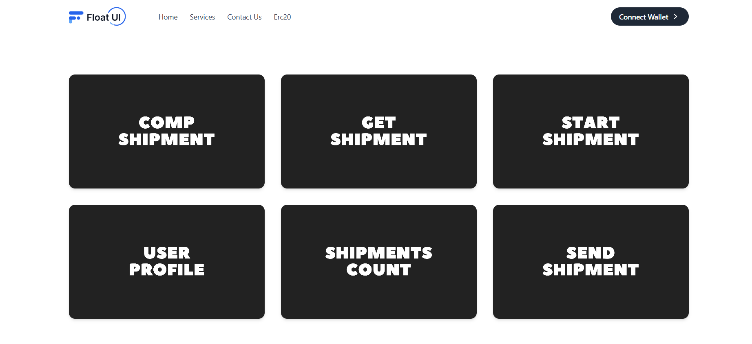 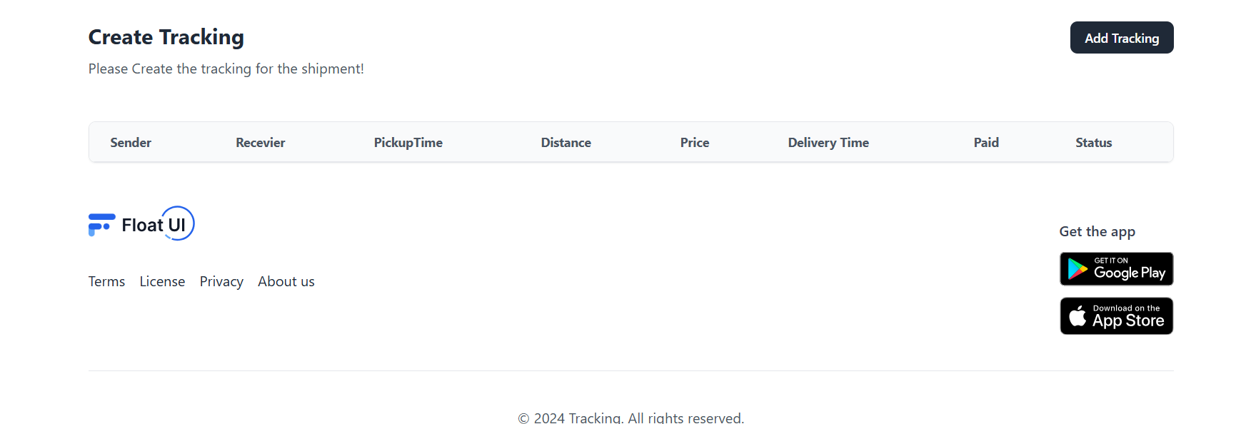

## Fig 7.1 Dashboard Page

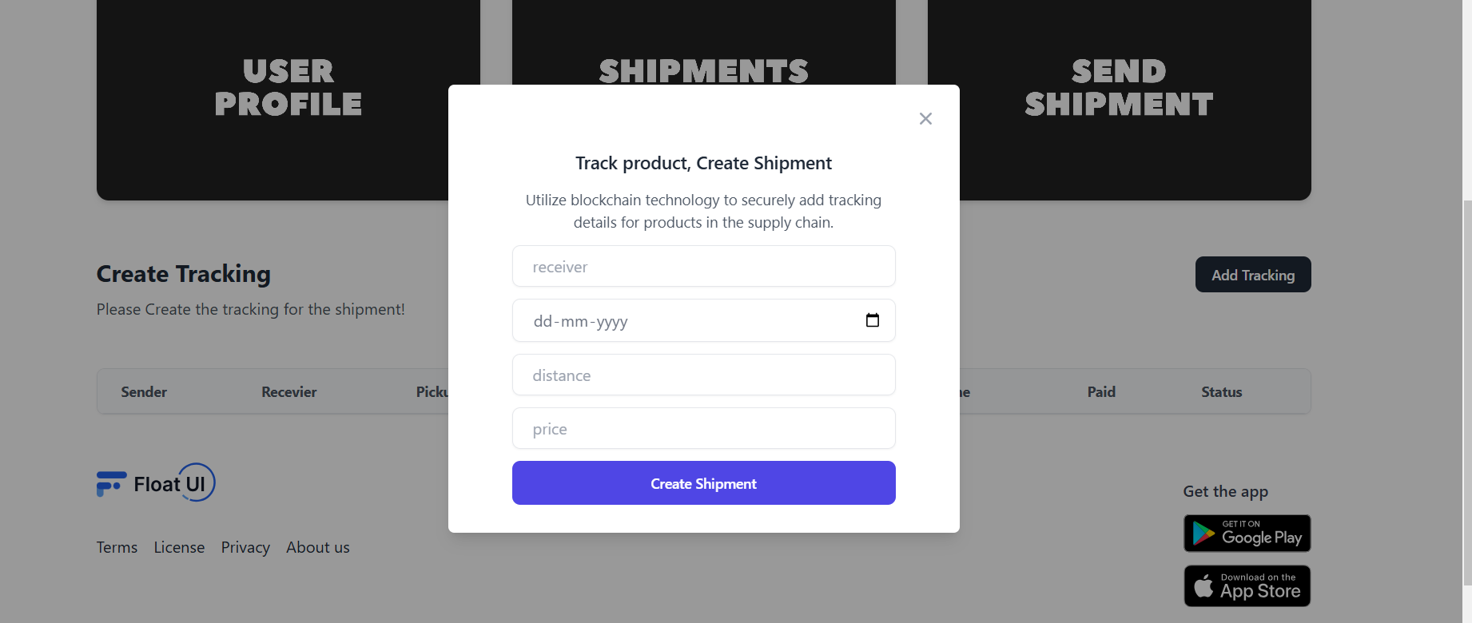

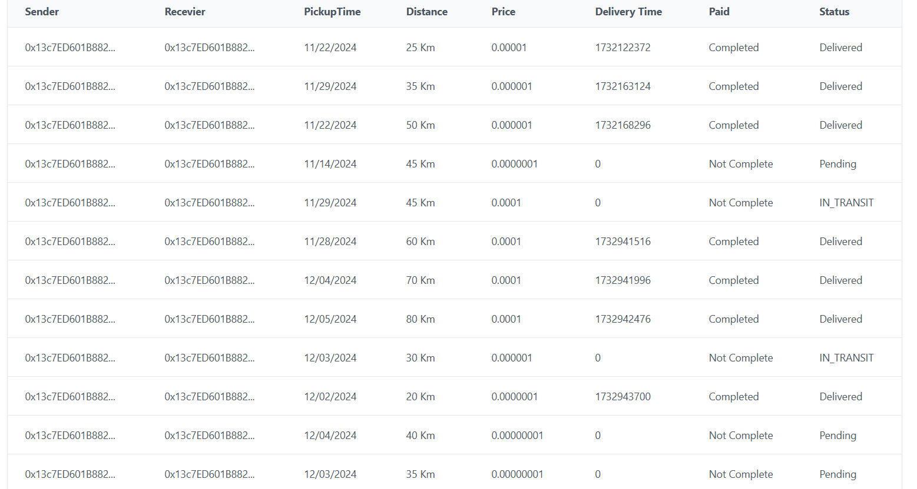

## Fig 7.2 Add Tracking Page

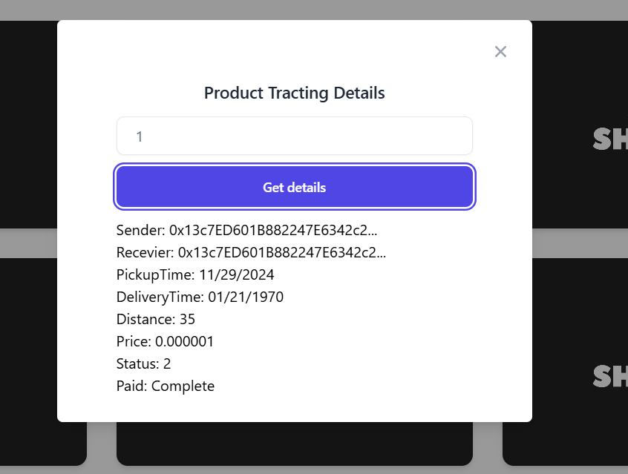

## 

## Fig 7.3 Get Shipment Page

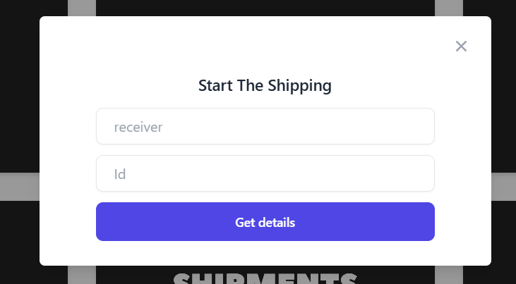

## 

## Fig 7.4 Start Shipment Page

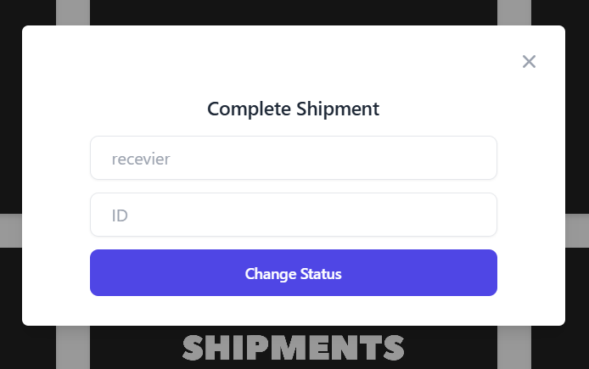

## Fig 7.5 Complete Shipment Page

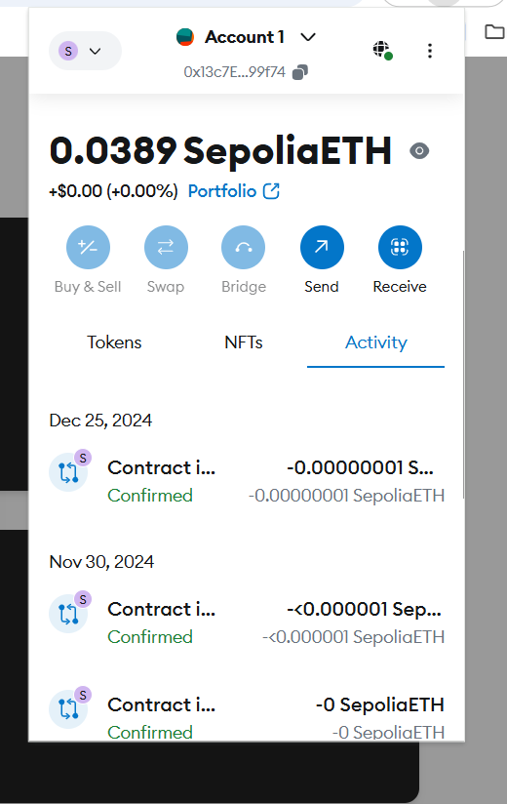

## Fig 7.6 Metamask Page

**CHAPTER 9**

**CONCLUSION**

The **Tracking** project is a transformative solution that leverages blockchain technology to enhance transparency, security, and efficiency across supply chain operations. By addressing key challenges in the traditional supply chain system, this project provides a modern, robust, and scalable approach to managing the flow of goods and information.

1. **Innovative Approach:** The project offers a cutting-edge solution to supply chain management by integrating blockchain technology, ensuring real-time tracking, and fostering accountability at every stage of the supply chain.
2. **Blockchain for Transparency:** By utilizing blockchain’s immutable ledger, the platform guarantees complete transparency in transactions, ensuring that every step of the supply chain is traceable and auditable, reducing fraud and errors.
3. **Enhanced Security:** The system incorporates robust security features, such as end-to-end encryption and smart contracts, ensuring that all data and transactions remain secure and are protected against unauthorized access.
4. **Real-Time Tracking:** The use of blockchain enables real-time tracking of goods, allowing stakeholders to monitor inventory, shipments, and delivery statuses at any given moment, improving efficiency and reducing delays.
5. **Cross-Platform Compatibility:** The platform is designed to be accessible across various devices and operating systems, offering flexibility for users, whether they are suppliers, manufacturers, or distributors, to track supply chain activities from anywhere.
6. **User-Centric Design:** The project includes role-based dashboards and user-friendly interfaces, ensuring that different stakeholders can easily navigate and manage their tasks according to their roles, streamlining operations.
7. **Smart Contracts for Automation:** The use of smart contracts automates key processes such as payments, order fulfillment, and dispute resolution, reducing human intervention and speeding up supply chain operations.
8. **Scalability:** The platform’s architecture is designed to scale with the growing needs of the supply chain, capable of handling increasing transaction volumes and expanding user bases without compromising performance.
9. **Operational Efficiency:** The project improves operational efficiency by optimizing inventory management, reducing paperwork, and eliminating delays in the supply chain, leading to cost savings and faster delivery times.
10. **Wide Application:** Suitable for diverse industries, from manufacturing to retail, the platform promotes better collaboration, decision-making, and transparency across the entire supply chain.

his project highlights the potential of blockchain to revolutionize supply chain management by providing a secure, transparent, and efficient solution.