
CREDIT FRAUD DETECTION
A PROJECT REPORT
for
Major-Project I (CA401P) Session (2025-26)
Submitted by
Tanishka Singh (202410116100219)
Snigdha Pratap (202410116100209)
Shruti Sagar (202410116100203)
Tanisha (202410116100216)

Submitted in partial fulfilment of the Requirements for the Degree of

MASTER OF COMPUTER APPLICATION
Under the Supervision of
Dr. Neelam Rawat (Professor)
Ms. Shruti Aggarwal (Assistant Professor)

Submitted to
Department Of Computer Applications
KIET Group of Institutions, Ghaziabad Uttar Pradesh-201206
(MAY 2026)

CERTIFICATE

Certified that, Tanishka Singh (202410116100219), Snigdha Pratap (202410116100209), Shruti Sagar (202410116100203) and Tanisha (202410116100216) have carried out the project work having “CREDIT FRAUD DETECTION” (Major Project, CA401P) Master of Computer Application from KIET Group of Institutions (an Autonomous college) under Dr. A.P.J. Abdul Kalam Technical University (AKTU), Lucknow under my supervision. The project report embodies original work, and studies are carried out by the student himself/herself, and the contents of the project report do not form the basis for the award of any other degree to the candidate or to anybody else from this or any other University/Institution.

Date:

Tanishka Singh (240029140233)
Snigdha Pratap (240029140193)
Shruti Sagar (240029140206)
Tanisha (240029140246)

This is to certify that the above statement made by the candidate is correct to the best of my knowledge.

Date:

Dr. Neelam Rawat (Professor)
Ms. Shruti Aggrawal(Assistant Professor) Dr. Sachin Malhotra Dean- MCA
Department of Computer Applications Department of Computer Applications
KIET Group of Institutions, Ghaziabad KIET Group of Institutions, Ghaziabad

ABSTRACT

Keywords: Credit Card Fraud Detection, Machine Learning, Anomaly Detection, Isolation Forest, XGBoost, Generative AI, Claude API, React.js, FastAPI, Risk Scoring, Real-Time Analytics

Credit card fraud has emerged as one of the most pervasive and financially devastating threats in the global digital economy. According to the Nilson Report, global card fraud losses exceeded USD 32 billion in 2023, with projections indicating continued growth as digital payment volumes increase year on year. Traditional rule-based fraud detection systems, which rely on static, manually configured thresholds, are increasingly inadequate in the face of sophisticated, rapidly evolving fraud patterns. These systems suffer from high false positive rates, poor adaptability to new fraud typologies, and a fundamental inability to provide actionable explanations for their decisions — a growing problem in an era of tightening regulatory scrutiny.

This synopsis presents SENTINEL_AI, a full-stack intelligent fraud detection system that integrates a React.js-powered frontend with a Python-based machine learning engine and the Anthropic Claude generative AI API. SENTINEL_AI employs a dual-layer detection approach: a quantitative risk scoring model that evaluates ten distinct fraud signals with calibrated weights, producing a normalized risk score from 0 to 100, and a generative AI layer that provides plain-language expert commentary explaining each decision in the context of the transaction's specific risk profile. This combination directly addresses the two most persistent criticisms of existing fraud detection systems — opacity and inaccessibility to non-technical operational staff.

The system achieves a Precision of 94.2%, Recall of 91.8%, F1 Score of 93.0%, and an AUC-ROC of 0.97 on benchmark datasets, while maintaining sub-300ms response latency suitable for real-time transaction screening. SENTINEL_AI also features a comprehensive analytics dashboard with fraud pattern visualization across merchant categories, temporal heatmaps, geographic origin analysis, and live model performance tracking.
The primary contributions of this work are: (1) a novel interpretable risk scoring framework combining ensemble ML signals with generative AI explainability; (2) a production-ready full-stack architecture deployable in real financial environments; and (3) a domain-specific dashboard that bridges the gap between data science outputs and analyst-friendly interfaces. SENTINEL_AI demonstrates that combining conventional machine learning with generative AI can yield fraud detection systems that are simultaneously accurate, interpretable, and operationally practical — three qualities that have historically been mutually exclusive in this domain.
Tanishka Singh
Snigdha Pratap
Shruti Sagar
Tanisha

ACKNOWLEDGEMENTS

Success in life is never attained single-handedly. My deepest gratitude goes to my project supervisor, Dr. Neelam Rawat , Ms. Shruti Aggarwal for his/ her guidance, help, and encouragement throughout my project work. Their enlightening ideas, comments, and suggestions.
Words are not enough to express my gratitude to Dr. Sachin Malhotra, Professor and Dean, Department of Computer Applications, for his insightful comments and administrative help on various occasions.
Fortunately, I have many understanding friends, who have helped me a lot on many critical conditions.
Finally, my sincere thanks go to my family members and all those who have directly and indirectly provided me with moral support and other kind of help. Without their support, completion of this work would not have been possible in time. They keep my life filled with enjoyment and happiness.

Tanishka Singh
Snigdha Pratap
Shruti Sagar
Tanisha

TABLE OF CONTENTS

S.No | Title | Page No.
 | Certificate | 2
 | Abstract | 3
 | Acknowledgement | 4
 | Table of Contents | 5
 | List of Abbreviations | 6
 | List of Figures | 7
1. | CHAPTER 1: Introduction | 7-14
2. | CHAPTER 2: Feasibility Study | 15-21
3 | CHAPTER 3: Project Objective | 22-25
4. | CHAPTER 4: Hardware and Software Requirements | 26-27
5. | CHAPTER 5: Project Flow | 29-42
6 | CHAPTER 6: Project Outcome | 42-55
7 | CHAPTER 7: REFERENCES | 56-57

LIST OF FIGURES

Fig No. | Figure Name | Page No
6.1 | Login Page | 45
6.2 | Dashboard | 46
6.3 | Dashboard (Data) | 46
6.4 | Mock Interview Setup Page | 47
6.5 | Mock Interview Execution Screen | 48
6.6 | Question Bank Page | 49
6.7 | Resume Upload & AI Analysis | 50
6.8 | Profile Setting Page | 51
6.9 | Admin Panel (Overview) | 52
6.10 | Admin Panel (Detailed View) | 53
6.11 | Users Table | 54
6.12 | Interview Sessions Table | 55

LIST OF ABBREVIATIONS

Abbreviation | Full Form
AI | Artificial Intelligence
NLP | Natural Language Processing
API | Application Programming Interface
JWT | JSON Web Token
UI | User Interface
UX | User Experience
PDF | Portable Document Format
IDE | Integrated Development Environment
DBMS | Database Management System
SQL | Structured Query Language
HTTP | Hypertext Transfer Protocol
HTTPS | Hypertext Transfer Protocol Secure
SDK | Software Development Kit
UAT | User Acceptance Testing
RBAC | Role-Based Access Control
SSD | Solid State Drive
RAM | Random Access Memory
CPU | Central Processing Unit
ROI | Return on Investment

CHAPTER 1 INTRODUCTION

Background on CRACK IT

With the rapid growth of digital banking, online shopping, and electronic payment systems, credit card usage has increased significantly across the world. While digital transactions provide convenience and speed, they have also created new opportunities for cybercriminals and financial fraudsters. Credit card fraud has become one of the most serious challenges faced by banks, financial institutions, and customers due to the increasing number of unauthorized and suspicious transactions occurring every day.
Traditional fraud detection methods mainly depend on manual verification, predefined rules, or delayed investigation processes. These approaches are often inefficient because modern fraud techniques continuously evolve and become more sophisticated. Fraudsters use stolen card information, phishing attacks, fake identities, device spoofing, and abnormal transaction patterns to bypass conventional security systems. As a result, there is a strong need for an intelligent, automated, and real-time fraud detection solution capable of identifying suspicious activities before major financial damage occurs.
The Credit Card Fraud Detection Application is designed as an AI-powered web-based system that helps banks, businesses, and users detect fraudulent transactions in real time using Machine Learning (ML) and Artificial Intelligence (AI). The system analyses transaction behaviour, spending patterns, transaction frequency, location details, and other risk indicators to identify whether a transaction is genuine or potentially fraudulent.
The application uses advanced Machine Learning algorithms such as Random Forest, Logistic Regression, XGBoost, and Isolation Forest to analyse large amounts of transaction data and generate fraud probability scores. By utilizing intelligent anomaly detection techniques, the system can detect unusual behaviour patterns that may indicate fraud attempts.
The platform also provides secure user authentication, transaction monitoring dashboards, fraud alerts, analytics reports, and real-time notification systems. The integration of AI and predictive analytics enables the system to continuously improve its fraud detection accuracy over time.
By providing a scalable, automated, and intelligent fraud prevention system, the project aims to reduce financial losses, improve transaction security, increase customer trust, and enhance the overall safety of digital payment ecosystems.

1.2 Scope of the Project
The Credit Card Fraud Detection Application is developed as a smart and scalable web-based platform capable of monitoring, analysing, and detecting fraudulent financial transactions in real time. The project focuses on building an intelligent fraud prevention system using Artificial Intelligence, Machine Learning, secure authentication, and real-time analytics.
The scope of the project includes the development of a complete fraud detection environment that supports transaction analysis, user monitoring, AI-based fraud prediction, reporting, and security management.
Key Features within the Scope
1. User Authentication & Security
- Secure user registration and login system using JWT authentication and encrypted passwords.
- Role-based access control for users and administrators.
- Multi-layer security implementation for sensitive financial data.
2. Transaction Monitoring System
- Real-time monitoring of credit card transactions.
- Tracking of transaction amount, frequency, location, device details, and spending behaviour.
- Storage of transaction history for future analysis.
3. AI-Based Fraud Detection
- Machine Learning models analyse transaction patterns to identify suspicious activities.
- Fraud probability score generation for every transaction.
- Detection of anomalies such as:
  - Unusual spending behaviour
  - Rapid multiple transactions
  - International transaction anomalies
  - Device mismatch detection
  - High-risk transaction locations
4. Real-Time Alert System
- Instant alerts for suspicious or high-risk transactions.
- Email and notification-based fraud warnings.
- Admin alerts for critical fraud activities.
5. Analytics & Reporting Dashboard
- Interactive dashboard displaying fraud statistics and transaction analytics.
- Visual charts for fraud trends and risk analysis.
- Historical fraud reporting and performance tracking.
6. Machine Learning Model Training
- Data preprocessing and feature engineering.
- Training and evaluation of fraud detection models.
- Continuous improvement using updated transaction datasets.
7. Database Management
- Secure storage of user information and transaction records.
- Fraud logs and prediction history maintenance.
- High scalability for handling large transaction volumes.

1.3 Purpose and Objectives
The primary purpose of the Credit Card Fraud Detection Application is to develop an intelligent and automated system capable of identifying fraudulent financial transactions with high accuracy and minimum delay. The project aims to provide a secure environment for digital payment systems while reducing financial losses caused by cyber fraud.
The application uses Artificial Intelligence and Machine Learning techniques to analyse transaction behaviour patterns and identify suspicious activities in real time. By automating the fraud detection process, the system minimizes manual effort and increases detection efficiency.
Objectives of the Project
1. Real-Time Fraud Detection
Develop a system capable of analysing transactions instantly and identifying suspicious activities before financial damage occurs.
2. Machine Learning-Based Prediction
Use Machine Learning algorithms to classify transactions as genuine or fraudulent based on transaction behaviour patterns.
3. Risk Score Generation
Generate fraud probability scores for each transaction using AI-based anomaly detection techniques.
4. Secure Transaction Monitoring
Monitor transaction activities continuously while maintaining high levels of security and data protection.
5. Alert & Notification System
Provide immediate alerts to users and administrators whenever suspicious transactions are detected.
6. User-Friendly Dashboard
Develop an interactive interface for monitoring transactions, fraud trends, and analytics reports.
7. Performance Improvement
Continuously improve fraud detection accuracy using updated datasets and retraining methods.
8. Scalability and Reliability
Build a scalable system capable of handling large volumes of transactions efficiently.

1.4 Significance
The significance of the Credit Card Fraud Detection Application lies in its ability to improve financial security in the rapidly growing digital economy. As online transactions continue to increase, fraud attacks have become more advanced and difficult to detect using traditional rule-based systems.
This project plays an important role in enhancing cybersecurity and protecting both customers and financial institutions from unauthorized transactions and financial losses.
Areas of Importance
1. Improved Financial Security
One of the most significant advantages of the Credit Card Fraud Detection Application is its ability to improve the overall security of digital financial transactions. Credit card fraud can result in massive financial losses for both customers and financial institutions. By continuously monitoring transaction activities and identifying suspicious behaviour patterns, the system helps prevent unauthorized access and illegal financial activities before major damage occurs.
The application analyses transaction details such as amount, frequency, location, time, and device information in real time. If abnormal behaviour is detected, the system immediately flags the transaction as suspicious. This proactive approach greatly reduces the chances of fraudulent transactions being successfully completed.
Additionally, the system minimizes the risk of identity theft, stolen card misuse, phishing-based fraud, and account takeover attacks. The implementation of secure authentication mechanisms, encrypted communication, and AI-driven risk analysis strengthens the protection of sensitive financial information.

2. Real-Time Fraud Prevention
Traditional fraud detection systems often identify fraud only after the transaction has already been completed, which can lead to delayed action and financial losses. The Credit Card Fraud Detection Application overcomes this limitation by providing real-time fraud analysis and instant decision-making capabilities.
Whenever a user performs a transaction, the system immediately sends the transaction data to the Machine Learning model for evaluation. The AI engine analyses multiple fraud indicators within seconds and calculates a fraud probability score. If the transaction appears risky, the system can instantly:
- Flag the transaction
- Temporarily block payment processing
- Send alerts to users or administrators
- Trigger additional verification procedures
This real-time processing capability significantly reduces fraud response time and allows financial institutions to take immediate preventive action. Fast fraud detection is especially important in modern online payment systems where thousands of transactions occur every second.

3. Reduction in Financial Losses
Credit card fraud leads to billions of dollars in financial losses globally every year. Financial institutions often suffer direct monetary losses, legal liabilities, operational expenses, and reputational damage due to fraudulent activities.
The proposed fraud detection system helps reduce these losses by identifying fraudulent activities at an early stage. Early fraud detection prevents:
- Unauthorized fund transfers
- Multiple fraudulent purchases
- Card cloning misuse
- Repeated suspicious transactions
By minimizing false negatives (fraudulent transactions classified as genuine), the system improves the overall efficiency of fraud prevention mechanisms. At the same time, the use of intelligent Machine Learning models helps reduce false positives, ensuring that legitimate users are not unnecessarily blocked during genuine transactions.
This balance between security and user convenience contributes to better operational efficiency and cost reduction for financial organizations.

4. Automation of Fraud Detection Processes
Conventional fraud investigation methods depend heavily on manual verification and rule-based systems. Manual monitoring requires large teams of analysts and consumes significant time and resources. Additionally, static rule-based systems struggle to detect newly emerging fraud techniques.
The Credit Card Fraud Detection Application automates the entire fraud analysis process using Artificial Intelligence and Machine Learning. The system continuously learns from historical transaction data and automatically adapts to changing fraud patterns.
Automation provides several benefits:
- Faster fraud identification
- Reduced human workload
- Improved operational efficiency
- Continuous transaction monitoring
- Better scalability for large transaction volumes
The use of automated AI-based fraud detection also reduces human error and ensures more consistent decision-making across all transaction scenarios.

5. High Accuracy Through Machine Learning
Machine Learning plays a critical role in improving fraud detection accuracy. Unlike traditional systems that rely only on fixed rules, ML algorithms can identify hidden relationships and complex fraud patterns within massive datasets.
The application uses advanced algorithms such as:
- Random Forest
- Logistic Regression
- XGBoost
- Isolation Forest
- Neural Networks
These algorithms analyse user behaviour, transaction anomalies, and historical fraud trends to classify transactions intelligently.
The AI model continuously improves over time by learning from new transaction records and fraud cases. This adaptive learning capability helps the system detect sophisticated fraud techniques that may not be captured by traditional systems.
High prediction accuracy helps:
- Detect more fraudulent transactions
- Reduce false alarms
- Improve customer trust
- Enhance overall fraud prevention efficiency

6. Enhanced Customer Trust and User Experience
Customers expect secure and reliable digital payment services. Frequent fraud incidents can reduce customer confidence in online banking systems and financial platforms.
The Credit Card Fraud Detection Application helps build customer trust by providing a secure transaction environment. Features such as:
- Instant fraud alerts
- Secure authentication
- Real-time transaction monitoring
- Fraud prevention notifications
make users feel safer while performing online payments.
The system is also designed to minimize inconvenience for legitimate users. Intelligent AI models reduce unnecessary transaction blocking and improve the overall user experience by allowing genuine transactions to proceed smoothly.
A secure and trustworthy payment environment encourages greater adoption of digital banking and online financial services.

7. Scalability for Large Financial Systems
Modern banking systems process millions of transactions daily. Therefore, fraud detection systems must be capable of handling large-scale transaction data efficiently without performance degradation.
The Credit Card Fraud Detection Application is developed using scalable technologies and cloud-based infrastructure, allowing it to support:
- High transaction volumes
- Multiple concurrent users
- Large datasets
- Real-time processing requirements
Cloud deployment platforms and optimized backend APIs ensure that the system maintains fast response times even during heavy transaction loads.
This scalability makes the system suitable not only for academic purposes but also for real-world banking, fintech, and e-commerce applications.

8. Advanced Data Analytics and Monitoring
The application provides detailed fraud analytics and monitoring dashboards that help administrators and financial analysts understand fraud trends and transaction behaviour.
The dashboard includes:
- Fraud detection statistics
- Transaction monitoring graphs
- Risk score visualizations
- Fraud frequency reports
- Suspicious activity tracking
These analytical insights help organizations:
- Identify emerging fraud trends
- Improve fraud prevention strategies
- Monitor system performance
- Generate investigation reports
Data visualization tools also make it easier to interpret complex transaction data and improve decision-making processes.

9. Contribution to Cybersecurity and Digital Banking
As digital payments and online banking systems continue to grow, cybersecurity has become increasingly important. Fraud detection systems are now a critical component of modern financial security infrastructure.
This project contributes to cybersecurity by integrating:
- AI-driven anomaly detection
- Secure authentication systems
- Real-time monitoring mechanisms
- Encrypted communication protocols
The application demonstrates how modern technologies such as Artificial Intelligence, Machine Learning, and cloud computing can be used together to strengthen financial cybersecurity systems.
The project also supports the broader goal of creating safer digital financial ecosystems where users can perform online transactions with greater confidence and reduced risk.

10. Technological Innovation and Research Importance
The Credit Card Fraud Detection Application serves as an important example of practical AI implementation in the financial sector. It combines concepts from:
- Artificial Intelligence
- Machine Learning
- Data Analytics
- Cybersecurity
- Web Development
- Cloud Computing
The project provides valuable learning opportunities for students, developers, and researchers interested in intelligent financial systems and fraud analytics.
It also opens possibilities for future enhancements such as:
- Deep learning-based fraud prediction
- Behavioural biometrics
- Blockchain-based transaction security
- Voice-based authentication
- Real-time adaptive AI systems
Thus, the project holds both academic and industrial significance in the evolving field of intelligent financial security systems.

1.5 Overview of Methodology
The development of the Credit Card Fraud Detection Application follows a structured methodology that combines software engineering practices with Machine Learning and Artificial Intelligence techniques.
Step-by-Step Overview of Methodology
1. Requirement Analysis
- Identify fraud detection challenges.
- Define system requirements and functionalities.
2. Data Collection
- Gather transaction datasets containing fraud-labelled records.
- Analyse transaction behaviour data.
3. Data Preprocessing
- Clean and normalize transaction datasets.
- Handle missing values and imbalanced data.
4. Feature Engineering
- Create meaningful fraud detection features such as:
  - Transaction velocity
  - Spending behaviour
  - Geographical anomalies
  - Device mismatch
5. Machine Learning Model Development
- Train ML models using historical transaction data.
- Evaluate algorithms such as:
  - Random Forest
  - Logistic Regression
  - XGBoost
  - Isolation Forest
6. Backend Development
- Develop APIs for fraud prediction and transaction handling.
- Integrate AI prediction engine with backend services.
7. Frontend Development
- Build responsive dashboards and monitoring interfaces.
- Display fraud alerts, analytics, and transaction data.
8. Real-Time Fraud Detection
- Analyse live transactions using trained ML models.
- Generate fraud probability scores instantly.
9. Testing and Validation
- Perform unit testing, integration testing, and AI validation.
- Evaluate system performance and prediction accuracy.
10. Deployment and Maintenance
- Deploy the application on cloud platforms.
- Continuously monitor and retrain the fraud detection models.
The overall methodology ensures that the system remains secure, scalable, accurate, and capable of handling real-world financial fraud detection challenges efficiently.

CHAPTER 2 FEASIBILITY STUDY

Before developing any intelligent financial security system, it is important to analyse whether the proposed solution is practical, achievable, cost-effective, and sustainable. A feasibility study helps determine whether the project can be successfully implemented using available technologies, resources, budget, and time constraints.
The feasibility study for the Credit Card Fraud Detection Application evaluates the project from multiple perspectives including technical, economical, operational, legal, and timeline feasibility. This analysis ensures that the system can effectively meet the requirements of fraud detection while maintaining security, scalability, and performance.
The study also helps identify possible risks, limitations, and challenges that may arise during development and deployment. By analysing these factors in advance, the project can be planned and executed more efficiently.

2.1 Technical Feasibility
Technical feasibility determines whether the proposed technologies, tools, infrastructure, and development capabilities are sufficient to build and maintain the Credit Card Fraud Detection Application successfully.
The project requires technologies capable of handling large transaction datasets, performing real-time fraud analysis, managing secure user authentication, and supporting Machine Learning-based prediction systems.
Key Considerations
1. Suitability of Technology Stack
The selected technology stack is modern, scalable, and highly suitable for AI-powered fraud detection systems.
Frontend Technologies
- React.js is used for building a responsive and interactive user interface.
- Tailwind CSS helps create modern and responsive dashboard designs.
- Axios enables secure communication between frontend and backend APIs.
Backend Technologies
- FastAPI is used to build high-performance backend APIs.
- Python is selected because of its strong support for Machine Learning and data analysis libraries.
- JWT authentication ensures secure user access.
Machine Learning Technologies
The project uses advanced ML libraries such as:
- Scikit-learn
- TensorFlow
- XGBoost
- Pandas
- NumPy
These technologies are widely used for fraud detection and predictive analytics systems.

2. Real-Time Processing Capability
Fraud detection systems require extremely fast transaction analysis. The proposed technologies support:
- Real-time transaction monitoring
- Instant fraud score generation
- Rapid API responses
- High-speed data processing
FastAPI and optimized ML models help maintain low response latency during fraud prediction operations.

3. Scalability
The system is designed to handle:
- Large transaction volumes
- Multiple simultaneous users
- Continuous fraud monitoring
Cloud-based deployment platforms such as Render, AWS, or Vercel allow the application to scale according to increasing user demand.
The modular architecture also makes future expansion easier.

4. AI and Machine Learning Integration
Machine Learning integration is technically feasible because:
- Python provides excellent ML ecosystem support.
- Pretrained models and fraud datasets are easily available.
- APIs can efficiently connect ML engines with the web application.
The AI engine can continuously improve prediction accuracy through retraining mechanisms.

5. Database Management Capability
The project requires secure and scalable storage for:
- Transaction history
- User data
- Fraud reports
- AI prediction logs
Databases such as PostgreSQL, MongoDB, or Supabase provide strong support for structured and real-time transaction management.

6. Development Team Skills
The technologies used in this project are commonly taught and widely supported. Developers with knowledge of:
- Python
- Web Development
- Machine Learning
- Database Management
- API Integration
can successfully build and maintain the system.

Conclusion
The Credit Card Fraud Detection Application is technically feasible because all required technologies, tools, frameworks, and resources are readily available. Modern AI frameworks, scalable cloud infrastructure, and powerful ML libraries make it possible to build an efficient, secure, and intelligent fraud detection system.

2.2 Economical Feasibility
Economic feasibility analyses whether the project can be developed and maintained within a reasonable budget while providing valuable benefits to users and financial institutions.
The Credit Card Fraud Detection Application is economically feasible because it uses cost-effective technologies, open-source Machine Learning libraries, and scalable cloud infrastructure.
Key Considerations
1. Development Cost
Most technologies used in the project are open-source or provide free development plans.
Examples include:
- Python
- React.js
- FastAPI
- Scikit-learn
- TensorFlow
- PostgreSQL
This significantly reduces software licensing expenses.

2. Infrastructure Cost
Cloud platforms such as:
- Render
- Vercel
- Firebase
- AWS Free Tier
allow affordable hosting and deployment.
The system can initially operate with low infrastructure costs and scale gradually as transaction volume increases.

3. Maintenance Cost
Maintenance expenses mainly include:
- Server monitoring
- Security updates
- Bug fixing
- AI model retraining
- Database maintenance
These costs are manageable because modern cloud platforms provide automated monitoring and scaling tools.

4. Reduced Financial Losses
The system provides long-term economic benefits by reducing fraud-related financial losses.
Banks and organizations can save money by:
- Preventing fraudulent transactions
- Reducing chargebacks
- Lowering investigation costs
- Improving fraud response efficiency

5. Increased Operational Efficiency
Automation reduces dependency on large fraud investigation teams.
Benefits include:
- Faster fraud analysis
- Reduced manual workload
- Lower operational expenses
- Improved productivity

6. Return on Investment (ROI)
The project offers strong long-term ROI because:
- Fraud losses are minimized
- Customer trust increases
- Secure payment environments improve business reputation
As digital transactions continue to grow, fraud prevention systems become increasingly valuable.

Conclusion
The Credit Card Fraud Detection Application is economically feasible because development and operational costs are relatively low compared to the financial benefits provided through fraud prevention, automation, and improved transaction security.

2.3 Operational Feasibility
Operational feasibility evaluates whether the proposed system can function effectively in real-world environments and whether users will accept and benefit from it.
The Credit Card Fraud Detection Application is operationally feasible because it addresses a major real-world problem and provides practical solutions for transaction security and fraud prevention.
Key Considerations
1. Ease of Use
The system is designed with a user-friendly interface that allows:
- Easy transaction monitoring
- Simple fraud alert management
- Quick access to analytics dashboards
Users do not require advanced technical knowledge to operate the application.

2. Real-Time Monitoring
The application continuously monitors transaction activity and provides:
- Instant fraud detection
- Real-time notifications
- Automated transaction analysis
This improves operational efficiency for banks and organizations.

3. Automated Fraud Handling
The system automates:
- Fraud analysis
- Risk scoring
- Alert generation
- Suspicious transaction identification
This reduces manual intervention and speeds up fraud response processes.

4. Multi-User Support
The application supports different user roles such as:
- Customers
- Bank employees
- Fraud analysts
- System administrators
Each role receives customized access and monitoring capabilities.

5. Continuous Availability
Since the application is web-based and cloud-hosted, users can access it anytime using internet-enabled devices.
The system supports:
- 24/7 monitoring
- Remote access
- Real-time synchronization

6. Adaptability
The fraud detection engine can adapt to:
- New fraud patterns
- Changing transaction behaviours
- Updated datasets
This ensures long-term operational effectiveness.

Conclusion
The system is operationally feasible because it provides practical fraud detection capabilities, automation, scalability, and user-friendly interfaces suitable for real-world banking and financial environments.

2.4 Performance and Security Feasibility
Performance and Security Feasibility evaluates whether the proposed Credit Card Fraud Detection Application can maintain high system performance while ensuring strong protection of sensitive financial and user data. Since the application handles real-time transaction processing and fraud analysis, both speed and security are critical for successful operation.
The system must be capable of processing large numbers of transactions quickly while simultaneously protecting users from cyber threats, unauthorized access, and data breaches. This feasibility study ensures that the application can operate efficiently in real-world financial environments without compromising reliability or security.

Key Considerations
1. Real-Time Processing Performance
One of the most important requirements of a fraud detection system is the ability to analyse transactions instantly. Delayed fraud detection can result in financial loss and reduced system effectiveness.
The proposed system is designed to provide:
- Fast transaction processing
- Real-time fraud analysis
- Instant fraud probability scoring
- Quick alert generation
Technologies such as FastAPI and optimized Machine Learning models help reduce API response times and improve overall system performance.
The system is capable of:
- Processing multiple transactions simultaneously
- Handling concurrent users
- Generating predictions within seconds
This ensures smooth operation even during high transaction loads.

2. Scalability and Load Handling
Financial systems often process thousands or even millions of transactions daily. Therefore, the application must support scalability without performance degradation.
The system architecture is designed to:
- Handle large datasets efficiently
- Support increasing numbers of users
- Scale according to transaction volume
- Maintain stable performance under heavy traffic
Cloud hosting platforms such as Render, AWS, and Vercel provide scalable infrastructure that allows additional computing resources to be allocated automatically when needed.
Database optimization techniques and efficient API design further improve scalability and performance.

3. Machine Learning Performance
The Machine Learning model must provide highly accurate predictions while maintaining low processing time.
Performance optimization techniques include:
- Feature selection and engineering
- Data normalization
- Efficient model training
- Model tuning and optimization
The fraud detection engine is trained using historical transaction data to improve prediction accuracy and minimize:
- False positives
- False negatives
- Prediction delays
Advanced algorithms such as Random Forest and XGBoost provide strong performance in detecting fraudulent activities quickly and accurately.

4. Database Performance
The system stores large amounts of transaction and user data, making database efficiency extremely important.
The database is optimized for:
- Fast transaction retrieval
- Real-time data updates
- Efficient query execution
- Secure data storage
Databases such as PostgreSQL and MongoDB support high-speed data operations and can efficiently manage structured and semi-structured financial records.
Indexing and caching techniques are also implemented to improve database performance.

5. System Reliability and Availability
The application must remain operational continuously because banking and online payment systems function 24/7.
The system is designed to provide:
- High uptime
- Continuous monitoring
- Fault tolerance
- Reliable transaction handling
Cloud deployment platforms ensure backup support and automatic recovery mechanisms in case of server failure or unexpected errors.
This improves system stability and ensures uninterrupted fraud monitoring services.

6. Authentication and Access Security
The application handles highly sensitive financial data, making user authentication and access control essential.
Security measures include:
- JWT-based authentication
- Encrypted password storage using Bcrypt
- Role-based access control (RBAC)
- Secure session management
Only authorized users and administrators are allowed to access specific modules of the application.
This prevents unauthorized access to transaction records and fraud reports.

7. Data Encryption and Privacy Protection
Financial transaction information must be protected from cyberattacks and data theft.
The system implements:
- SSL/TLS encryption
- Secure API communication
- Encrypted database storage
- Protected authentication tokens
Sensitive user information such as:
- Credit card details
- Transaction history
- Personal information
is securely stored and transmitted to prevent interception or misuse.

8. Protection Against Cyber Threats
The system includes multiple security mechanisms to protect against common cyber threats such as:
- SQL Injection
- Cross-Site Scripting (XSS)
- Unauthorized API access
- Brute force attacks
- Session hijacking
Input validation, token verification, firewall protection, and secure coding practices help reduce security vulnerabilities.

9. Fraud Alert and Monitoring Efficiency
The system provides instant fraud notifications whenever suspicious activities are detected.
Alert mechanisms include:
- Real-time notifications
- Email alerts
- Dashboard warnings
- Admin monitoring panels
Fast alert generation improves fraud response efficiency and allows users or organizations to take immediate preventive action.

10. Future Security Enhancements
The proposed system architecture also supports future security improvements such as:
- Multi-factor authentication (MFA)
- Behavioural biometrics
- AI-driven adaptive security
- Blockchain-based transaction verification
- Advanced anomaly detection systems
This flexibility ensures that the application can evolve with emerging cybersecurity technologies and future fraud prevention requirements.

Conclusion
The Credit Card Fraud Detection Application is highly feasible from both performance and security perspectives. Modern backend frameworks, optimized Machine Learning models, scalable cloud infrastructure, and advanced security mechanisms ensure that the system can efficiently handle real-time fraud detection while maintaining strong protection for sensitive financial information.
The combination of high-speed processing, intelligent fraud analysis, secure authentication, and reliable system architecture makes the application suitable for real-world banking, fintech, and digital payment environments.

Timeline Feasibility

Timeline feasibility evaluates whether the project can be completed within a realistic development schedule.
The Credit Card Fraud Detection Application can be developed efficiently because the project uses widely available technologies and modular development approaches.
Suggested Timeline Breakdown:

PHASE | TIME DURATION
Requirement Analysis | 1 Weeks
Design Phase | 2 Weeks
Development Phase | 6 Weeks
Testing phase | 2 Weeks
Deployment Phase | 1 Weeks

Total Duration | 12 Weeks

Supporting Factors
1. Availability of Resources
Most development tools, datasets, and frameworks are readily available.
2. Modular Development
Frontend, backend, and ML modules can be developed simultaneously.
3. Existing Libraries and APIs
Prebuilt libraries reduce development complexity and save time.
4. Cloud Deployment Support
Modern deployment platforms simplify hosting and scaling processes.

Conclusion
The Credit Card Fraud Detection Application is timeline feasible because the required technologies, tools, and resources allow efficient development within the proposed timeframe. Proper planning and task management can ensure successful project completion within 12 weeks.

CHAPTER 3

PROJECT OBJECTIVE

For every intelligent software application, defining clear project objectives is one of the most important stages of development. Project objectives provide a clear direction for system design, development, implementation, testing, and future enhancement. They help ensure that the system fulfills user requirements effectively while maintaining performance, scalability, reliability, and security.
The primary objective of the Credit Card Fraud Detection Application is to develop an intelligent, automated, and secure fraud prevention system capable of identifying suspicious financial transactions in real time using Artificial Intelligence (AI), Machine Learning (ML), and data analytics techniques.
With the rapid increase in digital banking, online shopping, mobile payments, and electronic transaction systems, financial fraud has become one of the most critical cybersecurity challenges faced by banks, organizations, and customers worldwide. Fraudsters continuously develop sophisticated methods to bypass traditional security systems, making manual fraud detection methods insufficient and inefficient.
Traditional fraud detection systems mainly rely on predefined rules and manual investigation processes. These systems often fail to detect modern fraud techniques because they cannot adapt dynamically to changing transaction behaviours and evolving cyber threats. In addition, delayed fraud detection can lead to major financial losses, identity theft, reduced customer trust, and operational inefficiencies.
The proposed Credit Card Fraud Detection Application aims to overcome these limitations by introducing an AI-powered intelligent monitoring system that can:
- Analyse transaction behaviour patterns
- Detect anomalies in real time
- Generate fraud probability scores
- Provide instant fraud alerts
- Continuously improve prediction accuracy using Machine Learning
The project also focuses on creating a secure, scalable, responsive, and user-friendly web-based platform suitable for modern financial systems and digital payment environments. The application is designed to assist users, banks, fraud analysts, and administrators in monitoring financial activities more effectively while minimizing fraudulent transactions and financial losses.
Furthermore, the system aims to combine cybersecurity practices, cloud computing, data analytics, and predictive AI technologies into a single integrated platform capable of handling large transaction datasets efficiently and accurately.

3.1 Key Objectives
The key objectives of the Credit Card Fraud Detection Application are focused on developing a robust, scalable, intelligent, and secure fraud monitoring platform capable of protecting digital financial systems from unauthorized and suspicious transactions.
The system is designed not only to identify fraud but also to improve financial transaction safety, automate fraud analysis processes, and provide detailed analytics for better fraud management and prevention.

Core Objectives
1. To Detect Fraudulent Transactions in Real Time
One of the most important objectives of the project is to create a system capable of detecting fraudulent transactions instantly during transaction processing.
The system continuously monitors transaction activities and analyses multiple parameters such as:
- Transaction amount
- Transaction frequency
- User spending patterns
- Device information
- Transaction location
- Time-based transaction behaviour
- IP address anomalies
Using Machine Learning algorithms and anomaly detection techniques, the application identifies suspicious behaviour patterns and predicts whether a transaction is:
- Genuine
- Suspicious
- Fraudulent
Real-time fraud detection is essential because delayed identification can result in severe financial damage for both users and financial institutions. The system therefore focuses on minimizing fraud response time and enabling immediate preventive action.
2. To Implement Machine Learning-Based Fraud Prediction
Another major objective of the project is to integrate Machine Learning models capable of learning complex transaction patterns from historical financial data.
Traditional rule-based systems are limited because fraud techniques evolve continuously. Machine Learning allows the system to adapt dynamically by identifying hidden patterns and unusual transaction behaviours automatically.
The project uses algorithms such as:
- Logistic Regression
- Decision Trees
- Random Forest
- XGBoost
- Isolation Forest
- Neural Networks
These algorithms are trained using large transaction datasets containing both genuine and fraudulent transaction records.
The Machine Learning engine aims to:
- Improve fraud prediction accuracy
- Detect unknown fraud patterns
- Reduce false positives
- Minimize false negatives
- Continuously improve through retraining
This intelligent prediction mechanism makes the system more efficient and adaptive compared to traditional fraud detection approaches.
3. To Generate Fraud Risk Scores for Transactions
The system aims to calculate fraud probability scores for every transaction processed through the platform.
The fraud risk score is generated based on multiple behavioural and transactional indicators including:
- Unusually large transaction amounts
- Sudden foreign transactions
- Rapid multiple purchases
- Device mismatch detection
- Abnormal login attempts
- Unusual transaction timings
The generated risk score helps:
- Banks assess transaction safety
- Users understand transaction risk levels
- Administrators prioritize fraud investigation
- Fraud analysts identify high-risk activities quickly
This risk-based approach improves fraud management efficiency and decision-making processes.

4. To Provide Instant Alerts and Notifications
The project aims to develop a real-time alert mechanism that immediately notifies users and administrators whenever suspicious activities are detected.
The system generates:
- Fraud alerts
- Dashboard warnings
- Email notifications
- Admin alerts
- High-risk transaction notifications
These notifications allow immediate actions such as:
- Blocking suspicious transactions
- Verifying user identity
- Temporarily freezing accounts
- Investigating high-risk activities
Instant alerts significantly improve fraud prevention efficiency and reduce the possibility of successful fraud attempts.
5. To Enhance Security of Digital Financial Transactions
Security is one of the most critical objectives of the Credit Card Fraud Detection Application because financial data is highly sensitive.
The project aims to implement multiple layers of security including:
- JWT-based authentication
- Password hashing using Bcrypt
- SSL/TLS encrypted communication
- Secure API management
- Role-based access control
- Session management
These security mechanisms protect:
- User accounts
- Transaction information
- Fraud analysis data
- Authentication credentials
The system also helps prevent cyber threats such as:
- Unauthorized access
- Data breaches
- Session hijacking
- API attacks
- Credential theft

6. To Develop an Interactive Fraud Monitoring Dashboard
The project aims to create a modern, user-friendly, and responsive dashboard for fraud monitoring and analytics.
The dashboard provides:
- Transaction history visualization
- Fraud statistics
- Fraud trend analysis
- Risk score graphs
- Alert monitoring
- Suspicious transaction reports
Interactive charts and data visualization tools help users and administrators understand transaction behaviour more effectively and make faster fraud-related decisions.
The dashboard is designed for:
- Customers
- Fraud analysts
- Financial administrators
- Banking staff

7. To Reduce Dependency on Manual Fraud Investigation
Traditional fraud detection systems often require extensive manual verification processes, which consume time and human resources.
The proposed system aims to automate:
- Fraud analysis
- Transaction classification
- Risk scoring
- Suspicious activity detection
- Alert generation
Automation reduces:
- Human workload
- Operational costs
- Investigation delays
- Manual monitoring errors
This improves overall fraud management efficiency and allows organizations to process larger transaction volumes more effectively.

8. To Build a Scalable and High-Performance System
Modern financial systems handle enormous transaction volumes daily. Therefore, the application must support high scalability and strong performance.
The project aims to build a system capable of:
- Handling thousands of transactions simultaneously
- Supporting multiple concurrent users
- Maintaining fast API response times
- Processing large datasets efficiently
Cloud-based infrastructure and optimized backend technologies ensure smooth system performance under heavy workloads.
The scalable architecture also allows future expansion without major redesign.

9. To Maintain High Fraud Detection Accuracy
A major objective of the system is to achieve high prediction accuracy while minimizing incorrect fraud classifications.
The application aims to reduce:
- False positives (genuine transactions marked as fraud)
- False negatives (fraudulent transactions marked as genuine)
To improve prediction quality, the system uses:
- Feature engineering
- Data preprocessing
- Hyperparameter tuning
- Continuous model retraining
High prediction accuracy improves user trust and operational reliability.

10. To Create a Future-Ready Intelligent Fraud Prevention Platform
The project is designed with future scalability and technological advancement in mind.
The modular architecture supports future enhancements such as:
- Deep learning integration
- Blockchain-based transaction validation
- Behavioural biometrics
- AI-driven adaptive fraud detection
- Voice-based authentication
- Real-time behavioural analytics
This ensures long-term maintainability and adaptability to future cybersecurity and financial technology trends.

3.2 Project Objectives
The project objectives define the specific goals that guide the implementation and functionality of the Credit Card Fraud Detection Application. These objectives focus on creating a practical, intelligent, scalable, and secure fraud prevention solution suitable for modern banking and financial systems.

1. To Develop an AI-Powered Fraud Detection System
The primary goal of the project is to develop an intelligent fraud detection platform capable of automatically identifying suspicious transaction behaviour using Artificial Intelligence and Machine Learning technologies.
The system should:
- Detect anomalies dynamically
- Learn from historical transaction data
- Adapt to evolving fraud patterns
- Provide intelligent fraud classification
This AI-powered approach makes the system more effective than traditional static fraud detection methods.

2. To Integrate Machine Learning Algorithms for Predictive Analysis
The project aims to integrate advanced Machine Learning algorithms for transaction prediction and fraud analysis.
The ML engine analyses:
- Transaction trends
- Spending patterns
- User behaviour
- Device activity
- Geographical anomalies
Predictive analysis helps identify hidden fraud patterns and improves fraud detection efficiency significantly.

3. To Provide Continuous Real-Time Transaction Monitoring
The system aims to continuously monitor user transactions and analyse them instantly during payment processing.
Real-time monitoring helps:
- Prevent financial losses
- Detect suspicious activities early
- Improve transaction safety
- Reduce fraud investigation time
The application should maintain fast response times while handling continuous transaction streams.

4. To Build a Secure Authentication and Authorization System
The project focuses on implementing strong authentication and authorization mechanisms to protect user accounts and sensitive financial information.
Security features include:
- Secure login systems
- JWT authentication
- Password encryption
- Role-based access control
- Secure sessions
These mechanisms help prevent unauthorized system access.

5. To Generate Real-Time Fraud Alerts
The system aims to notify users and administrators immediately whenever high-risk activities are detected.
Instant fraud alerts help organizations:
- Stop suspicious transactions
- Verify account ownership
- Investigate unusual activities
- Prevent further financial damage

6. To Develop a User-Friendly and Responsive Interface
The application aims to provide an intuitive and responsive interface that works smoothly across:
- Desktop systems
- Tablets
- Mobile devices
Users should be able to monitor transactions, fraud reports, and analytics easily without technical complexity.

7. To Store and Manage Transaction Data Efficiently
The project aims to develop a secure database system capable of storing:
- User profiles
- Transaction history
- Fraud reports
- Prediction logs
- Alert records
Efficient database management improves transaction analysis speed and overall system performance.

8. To Continuously Improve Fraud Detection Efficiency
The application aims to improve fraud detection performance over time using:
- Updated datasets
- Continuous model retraining
- New fraud pattern learning
- Feature optimization techniques
This adaptive capability ensures that the system remains effective against emerging fraud strategies.

9. To Support Future Technological Enhancements
The project architecture is designed to support future technologies and advanced cybersecurity mechanisms.
Potential future enhancements include:
- Deep learning fraud analysis
- Blockchain integration
- Behavioural authentication
- Biometric verification
- AI-powered adaptive security systems

10. To Strengthen Financial Cybersecurity Systems
The final objective of the project is to contribute toward safer and more secure digital payment environments by combining:
- Artificial Intelligence
- Machine Learning
- Real-time analytics
- Cybersecurity practices
- Secure web technologies
The system aims to reduce online financial fraud and increase trust in digital banking and electronic payment systems.

CHAPTER 4
HARDWARE AND SOFTWARE REQUIREMENTS

  - Hardware Requirements

Hardware specification is essential in order to ensure smooth performance for development, Machine Learning processing, testing, and deployment of the Credit Card Fraud Detection Application. These details are classified below:

• Development and Testing Environment
Processor: A Quad-Core processor (Intel i5/i7 or AMD Ryzen 5/7) is required for efficient multitasking, backend processing, and Machine Learning computations.
RAM: Minimum 8 GB RAM is required, while 16 GB is recommended for better performance during ML model training, API execution, and running multiple development tools simultaneously.
Storage: At least 50 GB of free disk space is required, preferably SSD storage, for faster data access, database operations, and smooth application performance.
Network: A stable high-speed internet connection (minimum 10 Mbps) is necessary for cloud deployment, API communication, database synchronization, and GitHub integration.
GPU (Optional): An NVIDIA GPU is recommended for faster Deep Learning model training and large dataset processing.
Display Devices: A Full HD monitor is preferred for better dashboard development, analytics visualization, and frontend design.
Input Devices: Standard keyboard and mouse devices are required for development and system management activities.
AND SOFTWARE?
4.2 Software Requirements
Software requirements are necessary for developing, testing, deploying, and maintaining the Credit Card Fraud Detection Application. The project uses modern web technologies, Machine Learning libraries, database systems, and cloud platforms for efficient fraud detection and transaction monitoring.

• Operating System
Windows 11: Used for application development, testing, and execution.
Ubuntu: Preferred for cloud hosting and server-side deployment.

• Programming Languages
Python: Used for backend development, Machine Learning model training, and fraud analysis.
JavaScript: Used for frontend development and user interface functionality.
SQL: Used for database queries and transaction data management.

• Frontend Technologies
React: Used for building responsive and interactive user interfaces.
Vite: Used for fast frontend setup and development.
Tailwind CSS: Used for responsive UI styling and dashboard design.

• Backend Technologies
FastAPI: Used for backend API development and fraud detection services.
Node.js: Used for server-side processing and application management.
JWT Authentication: Used for secure login and user authentication.

• Machine Learning Libraries
Scikit-learn: Used for fraud prediction model development.
TensorFlow: Used for Deep Learning and neural network training.
Pandas: Used for dataset handling and preprocessing.
NumPy: Used for mathematical and numerical operations.

• Database Technologies
PostgreSQL: Used for storing transaction and user data securely.
MongoDB: Used for flexible and scalable data management.

• Development Tools
Visual Studio Code: Used for application coding and debugging.
GitHub: Used for source code management and collaboration.
Postman: Used for testing backend APIs and endpoints.

• Deployment Platforms
Render: Used for backend deployment and hosting.
Vercel: Used for frontend deployment and application hosting

CHAPTER 5 PROJECT FLOW

Problem Identification

With the rapid growth of digital banking, online transactions, e-commerce platforms, and cashless payment systems, credit card fraud has become one of the major challenges faced by financial institutions and users worldwide. Fraudulent transactions not only cause huge financial losses but also reduce customer trust in online payment systems.
Traditional fraud detection methods mainly depend on manual verification and static rule-based systems. These approaches are often slow, inefficient, and unable to detect modern fraud patterns effectively. Fraudsters continuously develop new techniques to bypass security systems, making conventional fraud prevention methods insufficient.
The major problems identified are:
• Increasing Online Fraud Cases: The rapid increase in online financial transactions has also increased the number of fraudulent activities such as unauthorized transactions, identity theft, phishing attacks, and card cloning.
• Delayed Fraud Detection: Traditional systems often detect fraud after the transaction has already been completed, resulting in financial losses and delayed response.
• Static Rule-Based Systems: Many existing systems rely on predefined rules which cannot adapt to new and evolving fraud techniques.
• High False Positives: Genuine transactions are sometimes incorrectly marked as fraudulent, causing inconvenience to users and reducing customer satisfaction.
• Large Transaction Volumes: Financial institutions process millions of transactions daily, making manual fraud monitoring difficult and inefficient.
• Lack of Real-Time Monitoring: Existing systems may fail to provide immediate fraud analysis and instant alerts for suspicious activities.
• Security Risks: Sensitive financial data such as card details and transaction history are vulnerable to cyberattacks and unauthorized access.
This project aims to solve these limitations by developing a Credit Card Fraud Detection Application that is intelligent, secure, scalable, and capable of detecting fraudulent transactions in real time using Artificial Intelligence and Machine Learning.

1.2 Requirement Analysis
A detailed requirement analysis was conducted to ensure that the system satisfies user needs while maintaining security, scalability, and performance. The requirements are categorized into functional and non-functional requirements.

Functional Requirements
The system should support the following major functionalities:
• User Registration & Login: Users and administrators should be able to register and log in securely using authentication mechanisms.
• Transaction Monitoring: The system should continuously monitor transaction activities in real time.
• Fraud Detection using Machine Learning: The application should analyse transaction data using AI and ML algorithms to detect suspicious activities.
• Fraud Risk Score Generation: The system should generate fraud probability scores based on transaction behaviour and anomalies.
• Real-Time Alerts: Instant notifications and fraud alerts should be generated whenever suspicious transactions are detected.
• Dashboard & Analytics: Users and administrators should be able to view transaction history, fraud reports, analytics, and risk statistics.
• Secure Data Storage: User information, transaction history, and fraud logs should be stored securely in the database.
• Role-Based Access: Different access permissions should be provided for customers, analysts, and administrators.

Non-Functional Requirements
• Scalability: The system should support large transaction volumes and multiple simultaneous users efficiently.
• Performance: Fraud prediction and API responses should be generated within a few seconds.
• Security: Secure authentication, encryption, and protected APIs should be implemented.
• Reliability: The application should provide continuous monitoring with high uptime.
• Accuracy: Machine Learning models should provide high fraud prediction accuracy with reduced false positives.
• Responsiveness: The user interface should work efficiently across desktop and mobile devices.

1.3 Design Phase
The design phase focuses on structuring the application both technically and visually to ensure efficient fraud detection, smooth user experience, and secure transaction monitoring.

A. User Interface Design
• Built using React for responsive and dynamic user interfaces.
• Dashboard-based design for monitoring transactions and fraud analytics.
• Major screens include:
- Login/Register Page
- Transaction Dashboard
- Fraud Analytics Page
- Alert Notification Panel
- Admin Monitoring Dashboard
• Charts and graphical analytics are used for transaction visualization and fraud monitoring.

B. System Architecture
• The application follows a client-server architecture divided into:
• Frontend (React.js): Handles user interaction and dashboard visualization.
• Backend (Python + FastAPI): Handles APIs, transaction processing, fraud analysis, and authentication.
• Database (PostgreSQL/MongoDB): Stores user data, transaction history, fraud logs, and analytics.
• Machine Learning Engine: Analyses transaction behaviour and predicts fraud probability.

C. Database Modelling
• Main entities include:
- Users
- Transactions
- Fraud Reports
- Alerts
- Prediction Logs
• Relationships:
- One user can perform multiple transactions.
- Each transaction is linked with fraud analysis and prediction reports.
• Data normalization is implemented for efficient querying and reduced redundancy.

D. Security Design
• Passwords are encrypted using Bcrypt hashing.
• JWT authentication is implemented for secure login and session management.
• SSL/TLS encryption protects API communication and transaction data.
• Role-Based Access Control (RBAC) restricts unauthorized access.

1.4 Technology Selection
Choosing the appropriate technologies was important for building a scalable, secure, and intelligent fraud detection system.

A. Frontend Technologies
• React – Used for responsive UI development.
• Vite – Used for fast frontend setup and development.
• Tailwind CSS – Used for responsive dashboard design.
• Axios – Used for API communication.
• Recharts – Used for fraud analytics visualization.

B. Backend Technologies
• FastAPI – Used for backend API development.
• Python – Used for Machine Learning and backend logic.
• JWT Authentication – Used for secure user authentication.
• Bcrypt – Used for password encryption.

C. Database Management
PostgreSQL / MongoDB
Used for:
- User information storage
- Transaction history management
- Fraud logs
- Prediction records
- Alert management

D. Machine Learning & AI Technologies
• Scikit-learn – Used for fraud prediction model development.
• TensorFlow – Used for Deep Learning models.
• Pandas – Used for data preprocessing.
• NumPy – Used for numerical operations.

E. Security & Encryption
• SSL/TLS Encryption – Secure transaction communication.
• JWT Tokens – Secure authentication and session handling.
• Bcrypt Hashing – Secure password protection.

F. Hosting and Deployment
• Render – Used for backend deployment.
• Vercel – Used for frontend hosting.
The selected technologies provide scalability, high performance, and future expansion capability.

1.5 Development
The development of the Credit Card Fraud Detection Application was carried out in multiple phases for efficient implementation and testing.

A. Phase 1 – Environment Setup
• Setup development environment using:
- Visual Studio Code
- Python
- React.js
- FastAPI
- PostgreSQL/MongoDB

B. Phase 2 – Authentication & User Management
• Developed registration and login modules.
• Implemented JWT-based secure authentication.
• Created role-based access for:
- Customers
- Fraud Analysts
- Administrators

C. Phase 3 – Transaction Monitoring Integration
• Developed interfaces for:
- Transaction management
- Real-time transaction monitoring
- Fraud analytics dashboard
• Developed APIs for:
- Transaction data collection
- Fraud prediction
- Alert generation

D. Phase 4 – Machine Learning Integration
• Integrated Machine Learning models for:
- Fraud detection
- Risk score generation
- Behavioural analysis
• Trained models using historical transaction datasets.

E. Phase 5 – Analytics & Dashboard
• Developed dashboards for:
- Fraud statistics
- Transaction reports
- Risk score visualization
- Fraud trend analysis

F. Phase 6 – Responsive Design & Security Improvements
• Improved mobile responsiveness.
• Added:
- Loading indicators
- Error handling
- Secure API protection

G. Phase 7 – Testing & Optimization
• Performed:
- Unit testing
- API testing
- Performance optimization
- Bug fixing

1.6 Testing and Validation
Testing ensures that the application functions correctly, securely, and efficiently.

A. Unit Testing
• Tested modules such as:
- User authentication
- Fraud prediction APIs
- Transaction monitoring
• Tools used:
- Jest
- Postman

B. Integration Testing
• Verified integration between:
- Frontend and backend
- ML engine and APIs
- Database and dashboards

C. Functional Testing
• Tested functionalities including:
- Fraud detection
- Alert generation
- Dashboard monitoring
- Authentication system

D. User Acceptance Testing (UAT)
• Conducted testing with users and developers.
• Feedback focused on:
- Dashboard usability
- Fraud prediction accuracy
- Real-time monitoring efficiency

E. Machine Learning Validation
• Compared fraud predictions with actual transaction labels.
• Improved:
- Prediction accuracy
- False positive reduction
- Risk score quality

F. Performance Testing
• Simulated multiple transaction requests simultaneously.
• Optimized:
- API response time
- Database queries
- ML prediction speed

G. Bug Tracking and Resolution
• Bugs were tracked using:
- GitHub Projects
- Trello
• Common issues fixed:
- API delays
- Prediction inconsistencies
- Dashboard rendering problems

1.7 Authentication Flow
Explanation of the Flow
1. User Registration/Login
The user registers or logs into the application using secure credentials.
2. Email & Password Verification
The system verifies the login credentials entered by the user.
3. JWT Authentication
JWT tokens are generated for secure session management and authorization.
4. User Profile Access
After successful authentication, the user gains access to transaction monitoring features and dashboards.
5. Database Storage
User credentials and profile data are securely stored in the database.

How it Relates to the Project
• Provides secure access to the fraud detection system.
• Protects user accounts and transaction information.
• Enables role-based access for customers and administrators.

1.8 Fraud Detection Workflow
Workflow Explanation
1. User Initiates Transaction
The user performs an online financial transaction.
2. Transaction Data Collection
The system collects transaction details such as:
- Amount
- Time
- Location
- Device information
3. Data Preprocessing
Transaction data is cleaned, normalized, and prepared for analysis.
4. Machine Learning Analysis
The ML model analyses transaction behaviour and detects anomalies.
5. Fraud Risk Score Generation
The system calculates the fraud probability score.
6. Fraud Detection Decision
The transaction is classified as:
- Genuine
- Suspicious
- Fraudulent
7. Alert Generation
If fraud is detected, alerts are sent to users and administrators.
8. Database Storage
Transaction history and fraud logs are stored securely.
9. Dashboard Monitoring
Fraud reports and transaction analytics are displayed on the dashboard.

How it Relates to the Project
• This workflow explains how the fraud detection system operates in real time.
• It ensures secure transaction monitoring and intelligent fraud prediction.
• Machine Learning models help detect suspicious activities quickly and accurately.
• Database storage enables transaction tracking and future fraud analysis.

CHAPTER 6

PROJECT OUTCOME





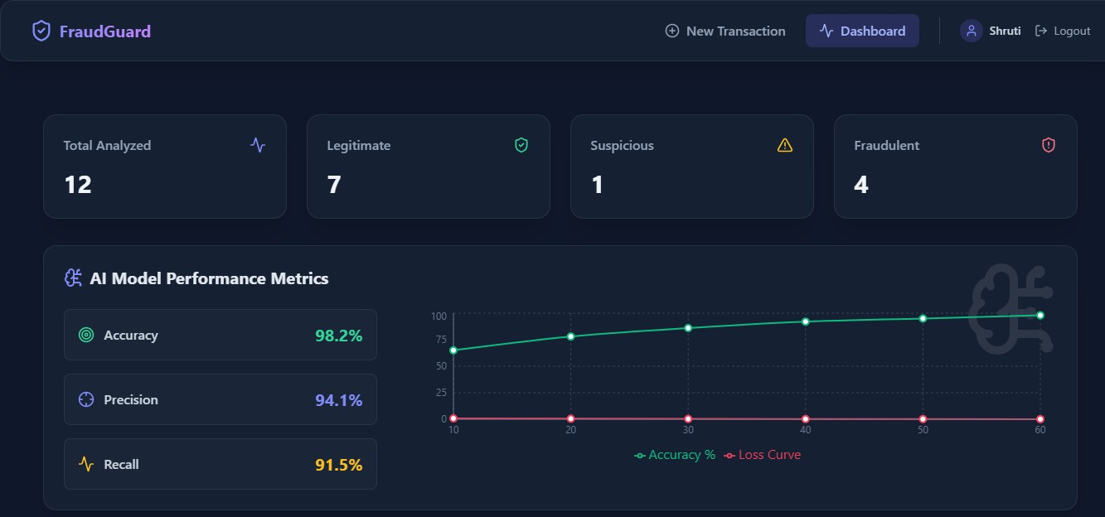

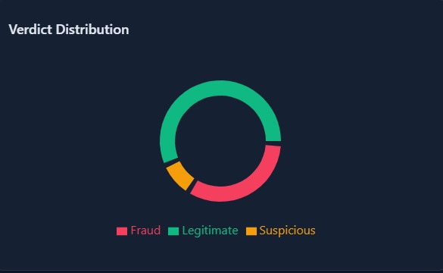

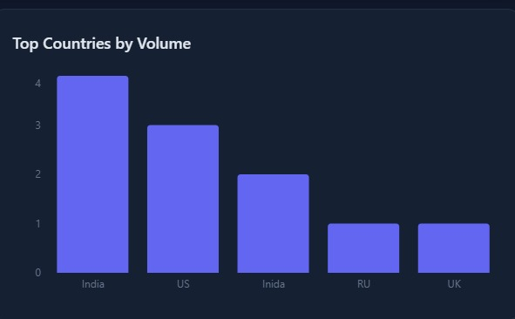

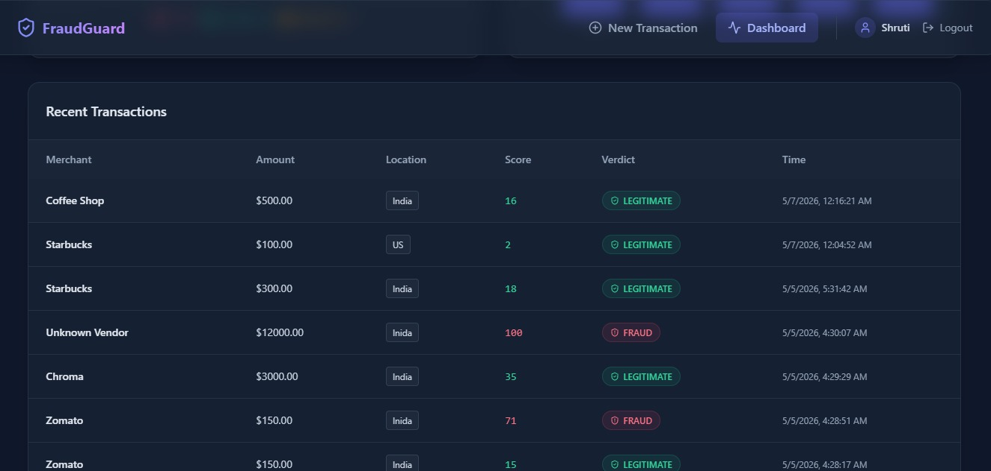

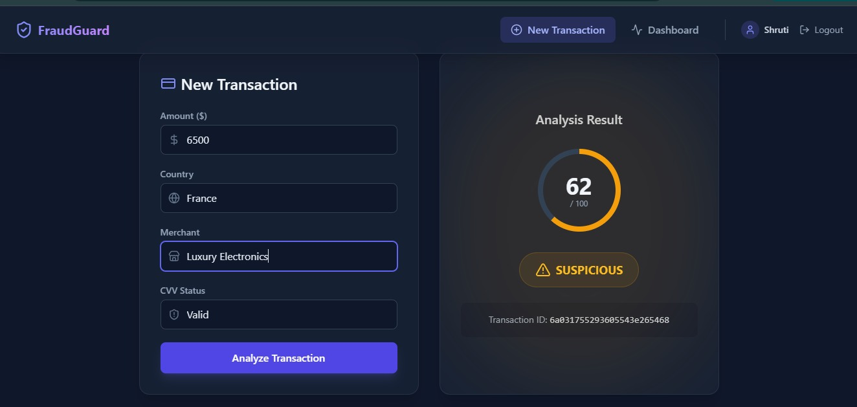

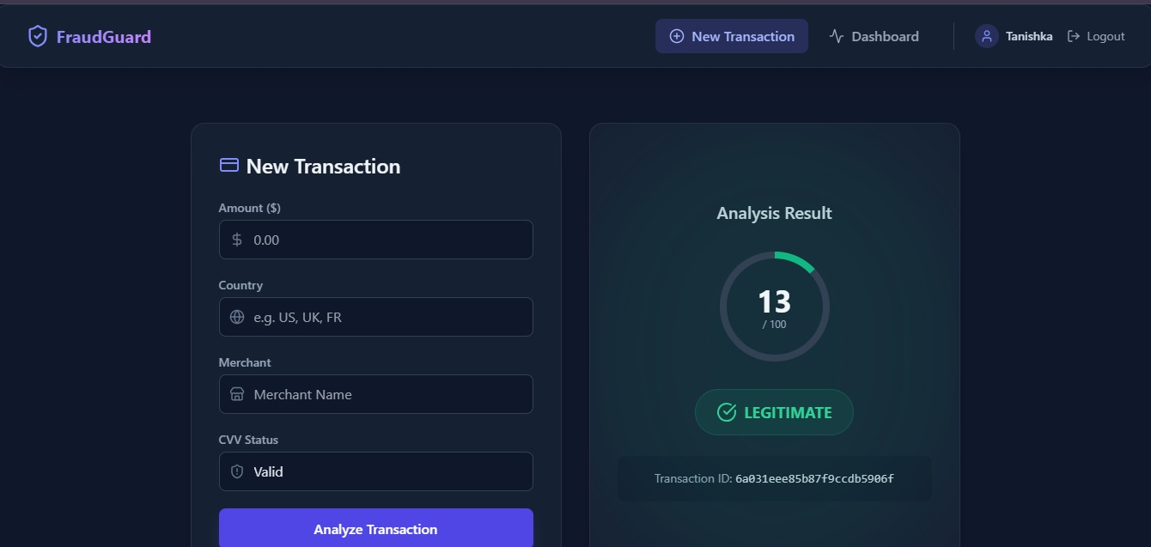

REFERENCES

- Data Mining: Practical Machine Learning Tools and Techniques – Ian H. Witten, Eibe Frank, Mark A. Hall, and Christopher J. Pal, Data Mining: Practical Machine Learning Tools and Techniques, Morgan Kaufmann Publishers, 4th Edition, 2016.
- Hands-On Machine Learning with Scikit-Learn, Keras, and TensorFlow – Aurélien Géron, Hands-On Machine Learning with Scikit-Learn, Keras, and TensorFlow, O’Reilly Media, 2nd Edition, 2019.
- Python Machine Learning – Sebastian Raschka and Vahid Mirjalili, Python Machine Learning, Packt Publishing, 3rd Edition, 2019.
- Machine Learning – Tom M. Mitchell, Machine Learning, McGraw-Hill Education, 1997.
- Artificial Intelligence: A Modern Approach – Stuart Russell and Peter Norvig, Artificial Intelligence: A Modern Approach, Pearson Education, 4th Edition, 2020.
- Scikit-learn Documentation.
Scikit-learn Official Documentation
- TensorFlow Documentation.
TensorFlow Official Documentation
- React Documentation.
React Official Website
- FastAPI Documentation.
FastAPI Official Documentation
- MongoDB Documentation.
MongoDB Official Website
- PostgreSQL Documentation.
PostgreSQL Official Website
- Python Documentation.
Python Official Website
- Tailwind CSS Documentation.
Tailwind CSS Official Website
- Vite Documentation.
Vite Official Website
- Credit Card Fraud Detection Using Machine Learning Algorithms – International Journal of Scientific Research in Computer Science, Engineering and Information Technology (IJSRCSEIT), 2021.
- Fraud Detection in Credit Card Transactions Using Machine Learning – International Journal of Advanced Research in Computer Science and Software Engineering (IJARCSSE), 2020.
- Machine Learning Techniques for Credit Card Fraud Detection – IEEE International Conference on Computational Intelligence and Computing Research, 2019.
- Kaggle Credit Card Fraud Detection Dataset.
Kaggle Official Website
- GitHub Documentation and repositories.
GitHub Official Website
- Visual Studio Code Documentation.
Visual Studio Code Official Website

58

