CodeMentra.AI

A PROJECT REPORT
for
Major Project-2 (CA401P)
Session (2026-27)

Submitted by

Tanya Singh
(202410116100222)
Shubhranshu
(202410116100205)
Shweta Patel
(202410116100206)

Submitted in partial fulfilment of the
Requirements for the Degree of

MASTER OF COMPUTER APPLICATION

Under the Supervision of
Dr. Neelam Rawat, Ms. Shruti Aggarwal
Associate Professor, Assistant Professor



Submitted to

Department Of Computer Applications
KIET Group of Institutions, Ghaziabad
Uttar Pradesh-201206
(FEBRUARY 2026)

ABSTRACT

Learning programming effectively requires not only solving problems but also understanding the underlying concepts and logic behind each solution. Many existing coding platforms focus mainly on competition and problem completion, often neglecting conceptual clarity and personalized guidance. This creates a gap between practice and true understanding, especially for beginners and intermediate learners.
CodeMentra.AI is an AI-powered coding and learning platform designed to bridge this gap by integrating Artificial Intelligence directly into the coding environment. The platform allows users to practice programming problems using an in-browser code editor while receiving intelligent assistance through AI-generated editorials and a context-aware chatbot. By leveraging the Gemini AI API, CodeMentra.AI provides step-by-step explanations, optimized solution approaches, and real-time doubt resolution based on the user’s code and problem context.
The system is developed using the modern MERN stack, with ReactJS for the frontend, Node.js and Express.js for backend services, and MongoDB Atlas for secure and scalable data storage. JWT-based authentication ensures safe and authorized access to the platform. The integrated AI chatbot enhances the learning experience by enabling users to ask natural language questions and receive instant, relevant responses without leaving the coding interface.
CodeMentra.AI transforms coding practice from a trial-and-error process into a guided, concept-driven learning experience. The platform supports self-paced learning, improves problem-solving skills, and prepares students for academic assessments and technical interviews. This project demonstrates the practical application of Artificial Intelligence in education and highlights the potential of AI-assisted learning systems in modern software engineering.

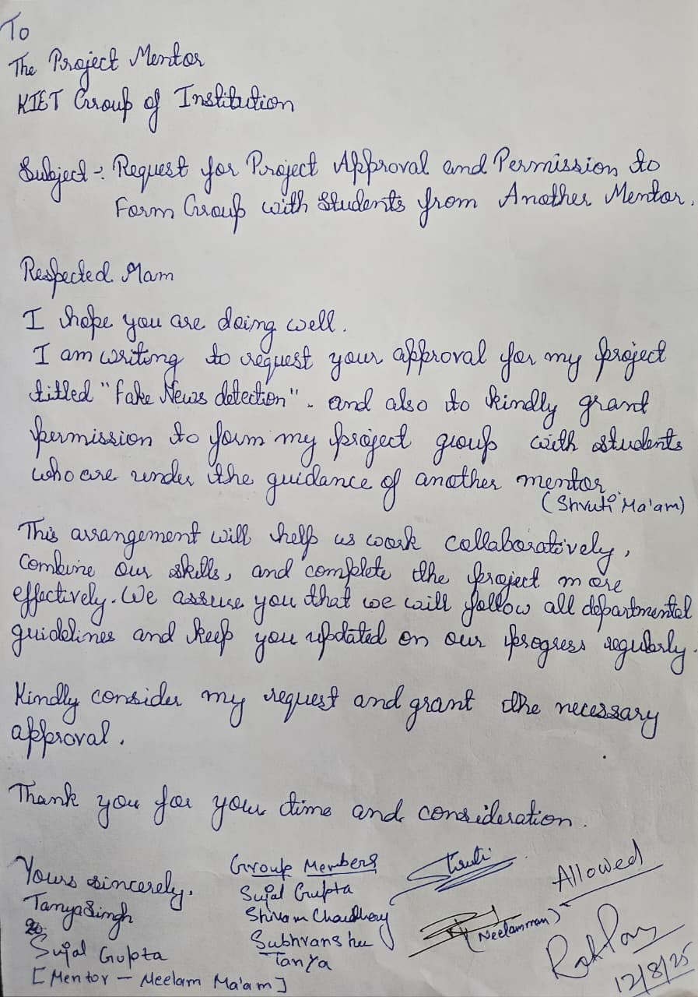

TABLE OF CONTENTS

Page Number
- Introduction 4
- Literature Review 5
- Project Objective 6
- Software Requirements 8
- Project Flow 9
- Project Outcome 10
- Proposed Time Duration 11
- References 12

Introduction

In today’s digital era, programming and problem-solving skills have become essential for students and professionals in computer science and related fields. With the rapid growth of technology and software-based solutions, the demand for skilled programmers is continuously increasing. However, many learners face difficulties in understanding programming concepts and developing strong logical thinking skills due to the lack of personalized guidance and real-time support.
Although several online coding platforms and learning resources are available, most of them focus mainly on problem completion and competition. They provide limited explanations and do not offer interactive, context-aware assistance to help learners understand their mistakes. As a result, students often rely on trial-and-error methods or external tutorials, which leads to shallow learning and confusion.
To overcome these challenges, CodeMentra.AI is proposed as an AI-powered coding and learning platform that integrates intelligent guidance directly into the coding environment. The system uses Artificial Intelligence (Gemini AI) to analyze programming problems and user-written code, and then provides step-by-step explanations, optimized solutions, debugging help, and real-time conceptual support.
CodeMentra.AI aims to transform traditional coding practice into a guided, interactive learning experience. By combining hands-on coding with AI-driven assistance, the platform helps learners improve their problem-solving abilities, algorithmic thinking, and confidence. This project focuses on making programming education more accessible, effective, and learner-centric for students of all backgrounds.

Literature Review

Evolution of Fake News Detection Approaches

1. Early Approaches: Rule-Based and Keyword Matching
The earliest attempts at fake news detection relied heavily on manual keyword matching and rule-based systems. These systems identified deceptive or misleading content based on the presence of certain words, phrases, or heuristic rules predefined by experts. While straightforward, this approach suffered from major limitations. Specifically, it was not scalable given the rapidly growing volume of digital news, and it lacked contextual understanding. For instance, the same keyword could appear in both genuine and false contexts, leading to high false positives or negatives. These limitations highlighted the urgent need for more robust, automated techniques.

2. The Machine Learning Era
With the advancement of machine learning (ML) and its adoption in natural language processing (NLP), researchers began applying supervised algorithms to fake news detection. Classical models such as Naïve Bayes, Logistic Regression, and Support Vector Machines (SVMs) were extensively used. These models relied on textual features like bag-of-words (BoW), term frequency–inverse document frequency (TF-IDF), and n-grams, which quantified patterns of word usage. Compared to keyword-based methods, ML significantly improved detection performance by capturing statistical correlations between words and labels.
However, the major limitation was that these models processed language as independent tokens without understanding deeper semantic meaning or context, thus failing to generalize when fake news involved more nuanced writing styles.

3. Deep Learning Advances
The onset of the deep learning era transformed fake news detection. Researchers began employing algorithms such as Recurrent Neural Networks (RNNs), Long Short-Term Memory networks (LSTMs), and Convolutional Neural Networks (CNNs) to capture sequential patterns and hierarchical textual features. These architectures made it possible to model contextual dependencies in news articles — an essential requirement, since fake news often uses subtle cues spread across sentences.
The most significant leap came with transformer architectures. Models like BERT (Bidirectional Encoder Representations from Transformers) introduced deep bidirectional context learning, where every word is encoded with awareness of its surrounding words. BERT-based architectures achieved state-of-the-art performance in text classification, pushing accuracy and robustness to new heights compared to classical ML and earlier deep learning models.

4. Current Trends and Innovations
The field has now moved to transfer learning and fine-tuning of pre-trained, large-scale language models. Models such as BERT, RoBERTa, DistilBERT, and XLNet are widely applied to fake news detection, as they leverage vast amounts of prior linguistic knowledge and require relatively little task-specific labeled data to deliver strong performance.
Additionally, researchers are increasingly exploring multimodal fake news detection, which combines textual signals with visual and contextual cues (e.g., images, videos, or metadata from social platforms). This trend addresses the fact that much of today’s disinformation spreads through multimedia-rich platforms, making text-only detection insufficient.

Identified Gaps and Challenges
Despite significant progress, several gaps remain:

Real-time, scalable detection:
Current transformer-based solutions, while accurate, are computationally heavy. Real-time detection of fake news across large-scale dynamic streams (e.g., social media feeds) remains a significant challenge.

Detection of nuanced disinformation:
Sophisticated fake news articles exploit stylistic subtleties, satire, and implicit bias that even advanced models struggle with. Capturing intent, tone, and cross-document context continues to be difficult.

Explainability and trust:
Although deep learning and transformer models achieve high accuracy, they often function as black boxes. The growing field of Explainable AI (XAI) in fake news detection is still underdeveloped. Without transparency, it is difficult to convince policymakers, journalists, and the general public to trust automated fake news detectors.

Project Objective
The main objective of the CodeMentra.AI project is to design and develop an AI-powered coding and learning platform that provides intelligent, real-time conceptual guidance to students while they practice programming problems. The system aims to bridge the gap between problem-solving and true understanding by integrating Artificial Intelligence directly into the coding workflow.

Specific Objectives
- To provide AI-driven conceptual guidance
To develop an AI-based system that generates problem editorials, step-by-step solution explanations, and optimized coding approaches to help learners understand the logic and algorithms behind each problem.
- To analyze user-written code and problem context
To enable the system to examine both the programming problem and the user’s submitted code in order to identify logical errors, syntactical mistakes, inefficient approaches, and conceptual gaps.
- To offer real-time, context-aware assistance
To integrate a smart AI chatbot that allows users to ask coding-related questions and receive instant, relevant responses based on the current problem and their code.
- To deliver personalized feedback and learning support
To provide immediate AI-generated feedback on code correctness, efficiency, and structure, along with suggestions for improvement and alternative solutions.
- To track user progress and learning performance
To record coding activities, submissions, and AI interactions so that learners can monitor their progress, identify weak areas, and improve systematically.
- To develop a secure, scalable web-based platform
To design the system using modern web technologies that ensure data security, scalability, and smooth performance for multiple users.
- To make coding education accessible and learner-centric
To ensure that the platform is easy to use, accessible from any device, and suitable for learners from different academic backgrounds and skill levels.

Software Requirements

The software tools and technologies used in CodeMentra.AI ensure efficient development, deployment, and smooth execution of the platform. The system is built using modern and reliable technologies to support AI-based learning features and secure user interaction.
Programming Language
- JavaScript (ES6+) for both frontend and backend development.
Frontend Technologies
- ReactJS for building dynamic user interfaces
- HTML5 and CSS3 for structuring and styling the web pages
- Tailwind CSS for responsive and modern UI design
Code Editor
- Monaco Editor for in-browser coding with syntax highlighting, auto-completion, and error highlighting.
Backend Framework
- Node.js with Express.js for handling server-side logic and RESTful APIs.
Database
- MongoDB Atlas for secure, scalable, cloud-based data storage.
AI Integration
- Gemini AI API for AI-based editorials, explanations, and chatbot assistance.
Authentication & Security
- JWT (JSON Web Tokens) for secure user authentication and session management.
Development Tools / IDE
- Visual Studio Code for coding, debugging, and version control.
Testing Tools
- Postman for API testing
- Browser developer tools for frontend debugging and performance testing.

PROJECT FLOW
- User Registration & Login
The user first registers on the platform and logs in using secure JWT-based authentication.
- Dashboard Access
After login, the user is redirected to the dashboard where available coding problems, progress status, and learning history are displayed.
- Problem Selection
The user selects a coding problem from the problem list based on difficulty level or topic.
- In-Browser Coding
The user writes and edits code in the integrated Monaco Editor with syntax highlighting and auto-completion.
- Code Submission
The user submits the written code for evaluation.
- AI Analysis
The system sends the problem statement and user code to the Gemini AI API for analysis.
- AI Feedback Generation
The AI generates:
  - Step-by-step explanation
  - Error identification
  - Optimized solution suggestions
  - Conceptual guidance
- Result Display
The feedback and explanations are shown to the user inside the platform.
- Chatbot Interaction
The user can ask questions related to the problem or their code using the AI chatbot.
- Progress Tracking
All submissions, AI feedback, and learning progress are saved in the database.
- Continuous Learning
The user repeats the process with new problems to improve coding skills.

PROJECT OUTCOMES
- Improved Conceptual Understanding
Learners gain a clear understanding of programming concepts through AI-generated step-by-step explanations and editorials.
- Enhanced Problem-Solving Skills
The platform helps users develop strong logical and algorithmic thinking by analyzing their code and suggesting optimized approaches.
- Real-Time Intelligent Feedback
Users receive instant feedback on errors, inefficiencies, and logic mistakes, reducing trial-and-error learning.
- Personalized Learning Experience
The system provides context-aware guidance and chatbot support tailored to each user’s code and learning progress.
- Increased Confidence in Coding
Continuous AI assistance builds learner confidence and reduces fear of making mistakes.
- Time-Efficient Learning
Students no longer need to search multiple external resources, saving time and maintaining learning focus.
- Accessible Coding Education
The web-based platform allows learners to practice anytime and anywhere using standard devices.
- Performance Tracking and Self-Improvement
Users can track their progress, identify weak areas, and monitor improvement over time.
- Preparation for Academic and Technical Assessments
The system supports learners in preparing for exams, coding tests, and technical interviews.
- Demonstration of AI in Education
The project showcases how AI can be effectively integrated into educational platforms for guided and interactive learning.

PROPOSED TIME DURATION
● Phase 1 (Weeks 1–2):
Requirement analysis, problem formulation, literature review, and system planning.
● Phase 2 (Weeks 3–4):
System architecture design, database schema creation, and UI wireframe design.
● Phase 3 (Weeks 5–7):
Frontend development (React UI, Monaco Editor, authentication pages).
● Phase 4 (Weeks 8–9):
Backend development (Node.js, Express APIs, MongoDB integration, JWT authentication).
● Phase 5 (Weeks 10–11):
Gemini AI integration, AI editorials, chatbot module, and code analysis features.
● Phase 6 (Week 12):
Testing, bug fixing, deployment preparation, and final documentation.
Total Duration: ~12 Weeks (Approximately 3 Months)

REFERENCES
- • Google DeepMind, Gemini AI Documentation, Google, 2024.
- • ReactJS Official Documentation. Available at: https://react.dev
- • Node.js Official Documentation. Available at: https://nodejs.org
- • Express.js Framework Documentation. Available at: https://expressjs.com
- • MongoDB Atlas Documentation. Available at: https://www.mongodb.com/atlas
- • Monaco Editor Documentation. Available at: https://microsoft.github.io/monaco-editor
- • JSON Web Token (JWT) Introduction and Documentation. Available at: https://jwt.io
- • Tailwind CSS Documentation. Available at: https://tailwindcss.com
- • OpenAI & Google Research on AI in Education, 2023–2024.
- • Jurafsky, D. & Martin, J. H., Speech and Language Processing, Pearson Education, 2022.
- • Pressman, R. S., Software Engineering: A Practitioner’s Approach, McGraw-Hill, 2021.
- • Sommerville, I., Software Engineering, Pearson Education, 2020.

