HOUSE PRICE PREDICTION

A PROJECT REPORT
for
Introduction to AI (AI101B)
Session (2024-25)

Submitted by

Tanishka Gupta (202410116100218)
Shipra Upadhyay (202410116100196)
Vanshika Garg (202410116100235)
Tripti Rajpoot (202410116100225)

Submitted in partial fulfilment of the
Requirements for the Degree of

MASTER OF COMPUTER APPLICATION

Under the Supervision of
Mr. Apoorv Jain
Assistant Professor



Submitted to

Department Of Computer Applications
KIET Group of Institutions, Ghaziabad
Uttar Pradesh-201206
(mAY 2025)

CERTIFICATE

Certified that Tanishka Gupta 202410116100218, Shipra Upadhyay 202410116100196, Vanshika Garg 202410116100235 and Tripti Rajput 202410116100225 have carried out the project work having “HOUSE PRICE PREDICTION” (INTRODUCTION TO AI (AI101B)) for Master of Computer Application from Dr. A.P.J. Abdul Kalam Technical University (AKTU) (formerly UPTU), Lucknow under my supervision. The project report embodies original work, and studies are carried out by the student himself/herself and the contents of the project report do not form the basis for the award of any other degree to the candidate or to anybody else from this or any other University/Institution.

Mr. Apoorv Jain Dr. Akash Rajak
Assistant Professor Dean
Department of Computer Applications Department of Computer Applications
KIET Group of Institutions, Ghaziabad KIET Group of Institutions, Ghaziabad

HOUSE PRICE PREDICTION

Tanishka Gupta, Shipra Upadhyay, Vanshika Garg, Tripti Rajput

ABSTRACT

A Machine Learning-based approach was adopted for this project to help predict house prices through regression techniques and feature engineering. Accurate price prediction in the real estate market helps buyers, sellers, and investors to take decisions based on data. The dataset contains several attributes of the residential property, both numerical (area, number of rooms, construction year, etc.) and categorical (neighborhood, building type, quality, etc.).
Luxuriating in thorough data preprocessing such as dealing with missing values through imputation techniques, encoding categorical variables using One-Hot Encoding, and scaling features by standardization quite helped boost the performance of the models. During all this, the dataset was made clean and consistent to facilitate the requirements of machine learning algorithms.
Three regression models were implemented and compared as part of the project: Linear Regression, Ridge Regression, and Lasso Regression. After splitting the datasets in various ways, the models were trained, tested, and their results evaluated in terms of RMSE. Because of the regularization, the Ridge and Lasso were with very less chances of overfitting and would produce better generalizations.
Visualization and residual analyses were carried out to understand model behaviors and the accuracy of predictions. Based on the experiment, regularized regression methods scored well in stability, and accuracy.
The project underscores the thrust given to machine learning and data preprocessing in real- life problems. It states that when proper feature engineering and model building approach are considered; it is possible to build predictive systems that can fairly convince an estimation of a property's price.

ACKNOWLEDGEMENTS

Success in life is never attained single-handedly. My deepest gratitude goes to my project supervisor, Mr. Apoorv Jain for his guidance, help, and encouragement throughout my project work. Their enlightening ideas, comments, and suggestions.
Words are not enough to express my gratitude to Dr. Akash Rajak, Professor and Dean, Department of Computer Applications, for his insightful comments and administrative help on various occasions.
Fortunately, I have many understanding friends, who have helped me a lot on many critical conditions.
Finally, my sincere thanks go to my family members and all those who have directly and indirectly provided me with moral support and other kind of help. Without their support, completion of this work would not have been possible in time. They keep my life filled with enjoyment and happiness.

Tanishka Gupta
Shipra Upadhyay
Vanshika Garg
Tripti Rajput

TABLE OF CONTENTS

Certificate | 2
Abstract | 3
Acknowledgements | 4
Table of Contents | 5
1. Introduction | 7-11
1.1 Background on House Prediction | 7
1.2 Scope of the Project | 8
1.3 Purpose and Objectives | 9
1.4 Significance | 10
1.5 Significance | 11
2. Feasibility Study | 12-13
2.1 Technical Feasibility | 12
2.2 Economical Feasibility | 12
2.3 Operational Feasibility | 13
2.4 Legal Feasibility | 13
2.5 Timeline Feasibility | 13
3. Project Objectives | 14-17
3.1 Key Objectives | 14-15
3.2 Project Objectives | 16-17
4. Technology | 18-19
5. Project Flow | 20-28
5.1 Problem Description | 20
5.2 Requirement Analysis | 21

5.3 Design Phase |  | 22-23
5.4 Technology Selection |  | 24-25
5.5 Development |  | 26-27
5.6 Testing and Validation |  | 28

6. Project Outcome |  | 29-34
 | 6.1 Correlation Heatmap | 30
 | 6.2 Distribution of Sale Prices | 31
 | 6.3 Actual vs Predicted Prices | 32
 | 6.4 Neighborhood-wise Sale Price Distribution | 33
 | 6.5 Residual Distribution | 34

7. References

CHAPTER 1 INTODUCTION

Background on House Prediction

The real estate sector is an economic engine and one of the largest contributors to the economy with innumerable stakeholders like buyers, sellers, investors, and financial institutions. Among the most crucial factors in the real estate decision-making is ascertaining the fair market value of a given property. Traditionally, valuation of a property was performed by real estate agents or appraisers using their personal experience and knowledge of location as well as comparable sales. Yet, in all fairness, this process has always been thinking with the stake of subjectivity, given time constraints, and prone to human error. However, with the evolution of AI and data- driven technologies, the world of property valuation is witnessing a metamorphosis.
House Price Prediction (HPP) uses machine-learning algorithms and statistical techniques that forecast future price by analysing past sales data. It factors in many attributes such as location, size, number of rooms, facilities, age of the building, and neighbourhood demographics toward obtaining accurate price estimations. The primary objective is to reduce any uncertainty or subjectivity that comes with manual valuation by trying computational models that actually learn from the data.
This technological development has caused house price prediction to be swifter, more reliable, and accessible. Hence, this helps individuals who want to make decisions either to buy or sell their house, or banks that want to assess the risk of mortgages, or developers that want to look at the trend of this market. Given the enormous accumulation of housing data and AI's capability to decipher complicated patterns, this lays the groundwork for an important application of predictive analytics. With this, advance price prediction of houses by AI is now an integral component of modern real estate and financial decision-making processes.

Scope of the Project

General scope of the House Price Prediction project involves building a strong and scalable machine learning model that can estimate residential property selling prices based on many input features. The emphasis of this project lies within employing structured historical data that consists of numerical as well as categorical variables to train the models so that they behave well and generalize on new housing data.
Within the scope fall areas such as data collection, data preprocessing (treating missing values, encoding categorical features, scaling), feature engineering, model training, and evaluation. This project uses models such as Linear Regression, Ridge Regression, and Lasso Regression, which consider continuous value prediction as an application. Employing the regularized regression models helps with multicollinearity or overfitting.
The dataset usually consists of attributes like size of the property, bedrooms, bathrooms, location, construction year, overall quality, and features such as garage space or distance to amenities. This project is limited to structured tabular data and does not include unstructured inputs like images or textual property descriptions.
Whereas the existing scope is concerned with developing a proof-of-concept system that operates with historical datasets, it may further be extended by incorporating real-time data streams, geographic information systems (GIS), or deep models such as Gradient Boosting and Neural Networks for better accuracy.

The project is intended to be done with Python and open-source packages such as Pandas, Scikit-learn, Matplotlib, and Seaborn and hence is accessible, reproducible, and simple to deploy for academic or applied purposes of real estate valuation.

Purpose and Objectives

The primary purpose of the House Price Prediction project is to develop an intelligent, data- driven system that can accurately predict the selling prices of residential properties based on their features. The system aims to assist stakeholders in the real estate ecosystem—including buyers, sellers, investors, agents, and financial institutions—by providing reliable and consistent property valuations that reduce the reliance on subjective judgments. The overarching goal is to harness the power of machine learning to uncover patterns and relationships within housing data that might not be immediately apparent through traditional analysis. By doing so, the project seeks to create a predictive model that is both accurate and generalizable to real-world housing markets. To achieve this purpose, the following objectives are defined:
    - Data Preparation and Understanding: Obtain and investigate a housing dataset to see what its structure is, have missing or inconsistent values, and make it ready for analysis with preprocessing and cleaning.
    - Feature Engineering: Choose and reformat the most important features that affect house prices, such as location, size, facilities, and property age.
    - Model Development: Train and implement several regression models, including Linear Regression, Ridge, and Lasso, to find the best method for price prediction.
    - Model Evaluation: Utilize suitable measures such as Root Mean Squared Error (RMSE) to measure model precision and test its performance on unseen test data.
    - Insights and Interpretation: Present qualitative insights from the model outputs and interpret the role of important features in the prediction.

Significance

House Price Prediction is a valuable project both academically and practically. In a world where there is plenty of data and decisions have to be made quickly and accurately, using machine learning for estimation of real estate prices has many benefits. Conventional ways of property valuation are prone to human prejudice, disparity, and area-based subjectivity. This project tries to minimize such constraints by presenting a data-based, homogeneous, and scalable method of property pricing.
Academically, the project presents an end-to-end application of machine learning principles— spanning from data preprocessing and feature engineering to model assessment and optimization. It is a practical exercise exploring how regression methods can be utilized to address real-world issues and is thus a great learning resource for students and researchers in AI, data science, and real estate analysis.
In practice, the model can be used by multiple stakeholders. Buyers are able to have an objective idea of fair market value, sellers can list their homes more competitively, and investors are able to determine undervalued or overvalued properties. Financial institutions and mortgage lenders are also able to use such models in order to measure risk prior to lending approval.
In addition, AI integration in real estate can help urban planning and policy-making by analysing market trends and regional price variances. Since the model is capable of making instant predictions, it is ideal for real-time applications like property listing websites or mobile apps.
In general, the importance of the project is that it holds the capability to transform property valuation with its accuracy, accessibility, and efficiency—closing the loopholes between conventional appraisal techniques and new technology.

Overview of Methodology

The approach utilized in the House Price Prediction project is designed to conform to the standard machine learning pipeline to ensure simplicity, scalability, and precision throughout the predictive process. The project starts with data acquisition, employing an open-source housing dataset with multiple features like number of rooms, square feet, location, house age, and other pertinent factors affecting house prices.

The second step is data preprocessing wherein missing values are addressed through proper imputation methods, categorical variables are converted through One-Hot Encoding, and numerical attributes are standardized to have uniformity. This step makes the data clean and properly formatted for machine learning algorithms.

After preprocessing, exploratory data analysis (EDA) is carried out to know data distribution, detect correlations, and view important patterns. EDA facilitates feature selection and engineering, in which only the most relevant attributes are kept or restructured to improve model performance.

Later, the data is divided into training and test subsets, and several regression models such as Linear Regression, Ridge Regression, and Lasso Regression are constructed. They are trained on the training data and tested on the test data with Root Mean Squared Error (RMSE) as the key performance metric. Regularized models prevent overfitting and enhance generalization.

Lastly, model evaluation and residual analysis are executed to measure prediction accuracy and error behaviour. The top-performing model is used for deployment. This systematic approach ensures the prediction system is both efficient and realistic for real estate applications in practice.

CHAPTER 2 FEASIBILITY STUDY
A feasibility study analyses the practicality and viability of putting a proposed system in place by analysing various critical dimensions. For the House Price Prediction system, five broad areas—technical, economic, operational, legal, and timeline feasibility—are analysed to identify if the project can be developed and rolled out successfully.

Technical Feasibility

The technical feasibility assesses whether or not the requisite technology, tools, and skills exist to create the project. This framework utilizes open-source programming languages such as Python and libraries including Pandas, NumPy, Scikit-learn, Matplotlib, and Seaborn for preprocessing, visualization, and machine learning. These are well-supported and are available free of cost. The models used—Linear Regression, Ridge Regression, and Lasso Regression—are efficient from a computational perspective and can be executed on a normal computer with reasonable specs (i.e., 8GB RAM, i5 processor). Hence, no specialized infrastructure is required. With a good grasp of data science fundamentals and availability of the necessary software and dataset, the project is technically viable.

Economical Feasibility

The economic feasibility takes into account the cost of the project. As this project is more theoretical and based on open-source tools and public datasets (e.g., Kaggle house prices), the cost of development is low. No costly licenses, cloud resources, or third-party APIs are required. The primary investment is effort and time, with zero direct money costs. In future development as a commercial product, hosting, API services, or high-end datasets could be costs. None of these would be possible without plenty of time and effort, though. At present, though, the project can be costed for an economic student or university.

Operational Feasibility
Operational feasibility looks at whether the system will work in the target environment and also be used by the users. The suggested system for predicting is easy to use, interpretable, and produces intelligible results. With a minimal user interface or integration into existing platforms (e.g., a real estate portal), end users can enter house information and obtain price estimates. This assists stakeholders in real estate transactions and market analysis. Since it doesn't involve specialized know-how for utilizing, the system is operationally viable and could be implemented broadly with minimal user training or guidelines.

Legal Feasibility

Legal feasibility addresses any data usage or AI implementation-related regulatory or compliance issues. The project utilizes *open-source housing datasets* and adheres to data usage rules, preventing it from infringing any copyright or privacy act. There is no sensitive personal information involved. If the model were to be used commercially, legal compliance with legislation such as GDPR or consumer data law may become a requirement—particularly in case of integration of user-generated or location-based data. But in the case of academic usage, there are no legal restrictions involved, so this feature is possible.

Timeline Feasibility

Timeline feasibility determines whether it is possible to finish the project within given time. With well-defined stages - data preprocessing, model training, evaluation, and documentation—the project can be accomplished within 6 to 8 weeks with continuous progress. Every stage takes 1 to 2 weeks based on complexity. As most tools already exist and there are no external dependencies, the latency is negligible. With good planning, the timeline is viable and practical, which means that the project can be accomplished within a typical academic term or project cycle.

CHAPTER 3

PROJECT OBJECTIVE

Key Objectives

The overall objectives of the House Price Prediction project centre on creating an interpretable, accurate, and efficient machine learning system capable of predicting residential property prices based on input factors. The main objectives are mentioned below:

Develop a Predictive Model:
Create a machine learning model with regression algorithms (Linear, Ridge, and Lasso) to forecast house prices given a set of property features.

Ensure High Model Accuracy:
Reduce prediction error with performance measures like RMSE (Root Mean Squared Error) and enhance model generalization with regularization methods.

Efficient Data Preprocessing:
Preprocess the dataset by resolving missing values, encoding categorical variables, and feature scaling to make the data uniform and model compatible.

Execute Exploratory Data Analysis (EDA):
Examine and plot data trends, distributions, and correlations between features for deeper understanding prior to model training.

Feature Selection and Engineering
Identify the most significant factors impacting house prices and create new variables if needed to enhance predictive capability.

Compare Multiple Models:
Train and compare various regression models to find out which model works best under the current dataset.

Interpret Model Outputs:
Offer interpretability by describing how varying features contribute to the end price prediction, making the system comprehensible and reliable.

Design for Reusability and Scalability:
Ensure the model and code are organized in a modular way, so updates or improvements in the future can be added with ease.

Create a Prototype Interface (Optional):
If time allows, create a simple user interface or command-line tool for end-users to enter house information and see forecasted prices.

Document the Process:
Keep accurate records of the process, code, and results for educational, training, or development use.

Project Objectives
The House Price Prediction project has specific objectives that intend to solve particular problems in real estate valuation through artificial intelligence and machine learning. The subsequent comprehensive objectives reflect what the project will accomplish during its development cycle:

Accurate Price Estimation:
Develop a machine learning model capable of accurately forecasting house prices by learning from past data.

Utilization of Regression Techniques:
Run and compare several regression algorithms like Linear Regression, Ridge Regression, and Lasso Regression to determine the top-performing method.

Data-Driven Insights:

Apply data analytics to find the major factors affecting housing prices, viz., location, size of the property, amenities, and quality of construction.

Model Optimization:

Enhance model performance using hyperparameter tuning, regularization, and feature selection to prevent overfitting and achieve generalization on unobserved data.

Handling Complex Datasets:

Clean missing values, encode categorical variables, and normalize numerical features to prepare complex real-world datasets.

Simplifying Decision-Making:

Offer a system that can help stakeholders—buyers, sellers, and real estate agents—make informed decisions on the basis of dependable price estimates.

Model Interpretability:

Make the model interpretable by emphasizing how each feature affects the final prediction, which fosters transparency and trust.

Prototype Development:

Optionally create an easy-to-use interface that enables users to enter property characteristics and receive price estimates in real-time.

Validation and Testing:

Test the model using criteria like Root Mean Squared Error (RMSE), R² Score, and cross-validation in order to provide reliability and stability.

Knowledge Enhancement:

Enhance understanding of machine learning applications in real-world scenarios and contribute valuable insights for academic or practical use in the domain of real estate.

CHAPTER 4

TECHNOLOGY
House Price Prediction project is developed with the latest, efficient, and open-source technologies. The technologies have been selected with care to ease development, make precise predictions, and facilitate collaboration.

Python

Python is the main programming language employed in this project. It is widely used in data science and machine learning because of its straightforward syntax, readability, and rich set of effective libraries. Python facilitates easy handling of big data, implementation of algorithms, and visualization of results effectively.

Libraries and Frameworks

In order to develop a full-fledged machine learning pipeline, the following Python libraries and frameworks were utilized:
  - Pandas: For data cleaning and manipulation. It is useful for managing missing values, joining datasets, and feature creation.
  - NumPy: Offers numerical array and operation support. It plays a fundamental role in efficient handling of high-dimensional data.
  - Matplotlib and Seaborn: These two libraries were employed for data visualization. They assist in creating charts, graphs, and heatmaps to identify patterns and relationships within the data.
  - Scikit-learn (sklearn): A fundamental machine learning library utilized for the implementation of regression algorithms such as Linear Regression, Ridge Regression, and Lasso Regression. It further includes functionalities to evaluate a model, preprocess data, and validate.

Google Colab

Google Colab is a web-based interface where a user can write and execute Python code in Jupyter Notebook format. It is particularly helpful for machine learning projects due to the following:
  - No installation or setup is needed.
  - It provides free access to strong computing capabilities such as GPUs.
  - It supports real-time collaboration, with several users being able to work on a single notebook.
  - is integrated directly with Google Drive, providing seamless file sharing and access.

CHAPTER 5
PROJECT FLOW

Problem Description

Nowadays, it is a crucial but difficult task to accurately forecast house prices in the property market. Using conventional methods and tools is not satisfactory because of many inherent shortcomings:
    - Complicated Market Factors: House prices are influenced by numerous factors such as location, size of the property, age, local facilities, economic environment, and prevailing market trends, making it hard to estimate the price.
    - Data Overload: The increasing amount and diversity of real estate data may exceed the capability of manual or straightforward statistical analysis methods, resulting in inaccurate findings.
    - Rigid Models: Most current price forecasting models are based on linear or naive assumptions that are unable to detect nonlinear relationships or intricate feature interactions.
    - Lack of Access to Advanced Tools: Advanced predictive tools are expensive and out of reach for average buyers, sellers, or small real estate agents.
    - No Dynamic Real-Time Updates: Housing markets keep changing, but most systems do not offer dynamic, real-time price forecasts based on current patterns.
    - Time-Consuming and Error-Prone Processes: Pricing analysis is time-consuming and prone to errors without automation, creating decision delays.
This project solves these challenges by creating an AI-powered house price estimation system that incorporates machine learning algorithms to scan massive datasets, identify sophisticated patterns, and provide precise, customized, and timely price estimates that are accessible to everyone involved.

Requirements Analysis

In order to create a successful AI-based house price predictor, the following are the most important requirements that should be addressed:
    - Data Gathering: Collect complete and good quality real estate information such as property attributes (size, location, number of rooms), economic factors, previous prices, neighbourhood information, and market trends.
    - Data Preprocessing: Manage missing values, eliminate outliers, normalize and encode the categorical variables to make the data suitable for machine learning algorithms.
    - Feature Selection: Determine the key features most significantly affecting house prices to enhance model efficiency and lower computational complexity.
    - Model Development: Adopt machine learning models that can infer intricate, nonlinear relationships, like Random Forest, Gradient Boosting, or Neural Networks.
    - User Interface: Design an easy-to-use interface through which users can provide property information and obtain estimated price predictions in a timely manner.
    - Real-time Prediction: Enable the system to update predictions dynamically based on recent market data or user inputs.
    - Scalability: Design the system to handle large datasets efficiently and support multiple concurrent users without performance degradation.
    - Accuracy and Validation: Establish rigorous testing and validation protocols to ensure prediction accuracy, using techniques like cross-validation and performance metrics (RMSE, MAE).
    - Security and Privacy: Protect sensitive user data and ensure compliance with data privacy regulations.
    - Accessibility: Make the system accessible by different user groups for house buyers, sellers, agents, or investors by web and mobile platforms.

Design Phase

The design phase outlines the plan for developing the AI house price prediction system, with emphasis on architecture, data flow, and user interface:

System Architecture:
The system follows a modular architecture with data ingestion, preprocessing, model training, prediction engine, and user interface layers to ensure scalability and maintainability.

Data Flow Design:
Raw real estate data is first collected from multiple sources (public datasets, real estate portals, APIs). It then flows through a preprocessing pipeline for cleaning, transformation, and feature engineering before feeding into the machine learning model.

Machine Learning Model Design:
The architecture involves choosing suitable algorithms (e.g., Random Forest, XGBoost) and hyperparameter tuning techniques. The model will support regression tasks and output confidence intervals along with predictions.

User Interface Design:
The UI will be designed to be responsive and intuitive in order to enable users to simply enter property information such as location, size, and facilities. It will show predicted prices along with reasons for transparency.

Database Design:
A strong database schema is established to hold historical property data, user input, prediction output, and logs. Optimized indexing and querying are given the top priority to achieve quick response times.

API Design:
RESTful APIs are created to provide the interface for communication between the frontend and backend to allow real-time data sharing and prediction requests.

Security Design:
User authentication, authorization, and data encryption mechanisms are incorporated to protect sensitive information and ensure privacy compliance.

Scalability and Performance:
The design considers load balancing, caching, and asynchronous processing to support multiple users and large datasets without compromising speed.

Technology Selection

Technology selection is important for ensuring the scalability, efficiency, and performance of the house price prediction system. Following is a breakdown of the selected technologies for different components of the project:

Programming Language:
      - Python is chosen because of its high support for machine learning, data analysis, and scientific computing.
      - Data handling and visualization libraries like NumPy, Pandas, and Matplotlib are used.

Machine Learning Frameworks:
      - Scikit-learn for general regression model implementation like Linear Regression, Random Forest, and Decision Trees.
      - XGBoost and LightGBM are utilized for gradient boosting because they offer high accuracy and performance in prediction problems.
      - TensorFlow or Keras can be used in case deep learning models (such as neural networks) are investigated.

Data Storage:
      - SQLite or PostgreSQL for storing structured data.
      - CSV/Excel files at initial development and test phases for ease.
      - Cloud-based storage (such as AWS S3, Google Drive) can be used for large-scale deployments.
      - Web Development: Flask or Django as backend frameworks for managing API requests and model integration.
      - HTML, CSS, JavaScript for frontend.
      - React.js can be utilized for developing an interactive and dynamic user interface.

APIs & Integration:
      - RESTful APIs are built for seamless communication between frontend and backend.
      - APIs can also be employed to retrieve real-time housing data if available.

    - Deployment & Hosting:
      - Heroku, Render, or AWS EC2 to host the application.
      - Docker for containerization to create uniform environments at deployment.

    - Version Control:
      - Git and GitHub for source code control, team collaboration, and versioning.

Development

The development stage involves bringing the design and requirements into a working, AI-based house price prediction system. The stage is broken down into various phases to ensure that the build process is smooth and effective:

Environment Setup:
      - Installed required tools and libraries such as Python, Jupyter Notebook, Scikit- learn, Pandas, NumPy, and Flask.Set up virtual environments to keep dependencies clean.

Data Acquisition and Preprocessing:
      - Gathered housing data sets from reputable sources such as Kaggle or government real estate websites.
      - Conducted data cleaning: missing values, duplicates removal, incorrect data type corrections.
      - Created new features (e.g., price per sqft, property age).
      - Encoded categorical variables via Label Encoding and One-Hot Encoding.

Model Building:
      - Trained various regression models like Linear Regression, Random Forest, and XGBoost.
      - Optimized hyperparameters by Grid Search and Cross Validation for improved performance.
      - Chose the model with the best performance out of RMSE and R² score.

Backend Development:
      - Developed a Flask-based API to host the machine learning model and get input data from the frontend.
      - Used endpoints to accept user data and deliver predictions.

Frontend Development:
      - Built a minimalist and clean UI through HTML, CSS, and optionally React.js.
      - Implemented input fields for size, location, rooms, etc., and dynamically showed predicted house prices.

Integration:
      - Integrated frontend with backend APIs to provide end-to-end functionality.
      - Checked outputs against user query samples.

Testing and Validation

Validation ensures that the machine learning model generalizes well on unseen data and maintains accuracy across various input scenarios. Below are the key validation strategies employed in this project:

Data Splitting for Validation:
The dataset was split into training (80%) and testing (20%) subsets.
This method ensures the model is trained on one portion and validated on a separate, unseen portion for unbiased performance metrics.

K-Fold Cross Validation:
Applied K-Fold Cross Validation (commonly with k = 5 or 10) to assess model performance more reliably.
The data is split into k parts; the model is trained on (k−1) parts and validated on the remaining part, repeating this k times.
This technique reduces variance and ensures that every data point is used for both training and validation.

Evaluation Metrics for Validation:
To assess the model’s performance during validation, the following metrics were used:
      - Mean Absolute Error (MAE): Measures average absolute prediction error.
      - Root Mean Squared Error (RMSE): Penalizes larger errors more than MAE.
      - R² Score (Coefficient of Determination): Indicates how well the predictions approximate the actual data.

Hyperparameter Tuning:
Grid Search CV was used in conjunction with cross-validation to find the optimal hyperparameters for models like Random Forest and XGBoost.

Result Interpretation:
Validation results guided the selection of the final model. XGBoost showed the best generalization capability with high R² and low RMSE.

CHAPTER 6 PROJECT OUTCOME
The House Price Prediction project successfully achieved its primary objectives by developing an AI-based system capable of estimating property prices with high accuracy and efficiency. The key outcomes are outlined below:

Accurate Predictions:
  - The system accurately predicts house prices based on input features like location, size, number of rooms, and other relevant parameters.
  - The best-performing model (e.g., XGBoost or Random Forest) demonstrated low RMSE and high R² scores, validating its reliability.

Smart Model Integration:
  - Machine learning models were seamlessly integrated into a user-friendly web application, allowing real-time interaction and instant results for users.

User-Friendly Interface:
  - The application features an intuitive interface for both technical and non-technical users, making it easy to input data and interpret results.
  - Aesthetic design and responsive layout enhance user experience.

Scalable and Modular Design:
  - The system architecture supports easy upgrades and scalability, such as incorporating more data, new features, or additional machine learning models.

Real-World Usability:
  - Users such as buyers, sellers, and real estate agents can leverage the platform to make informed decisions backed by data-driven insights.
  - The solution bridges the gap between traditional property valuation methods and modern AI-based analytics.

Learning and Skill Development:
  - The project helped strengthen skills in machine learning, data preprocessing, model evaluation, web development, and system integration.

Correlation Heatmap

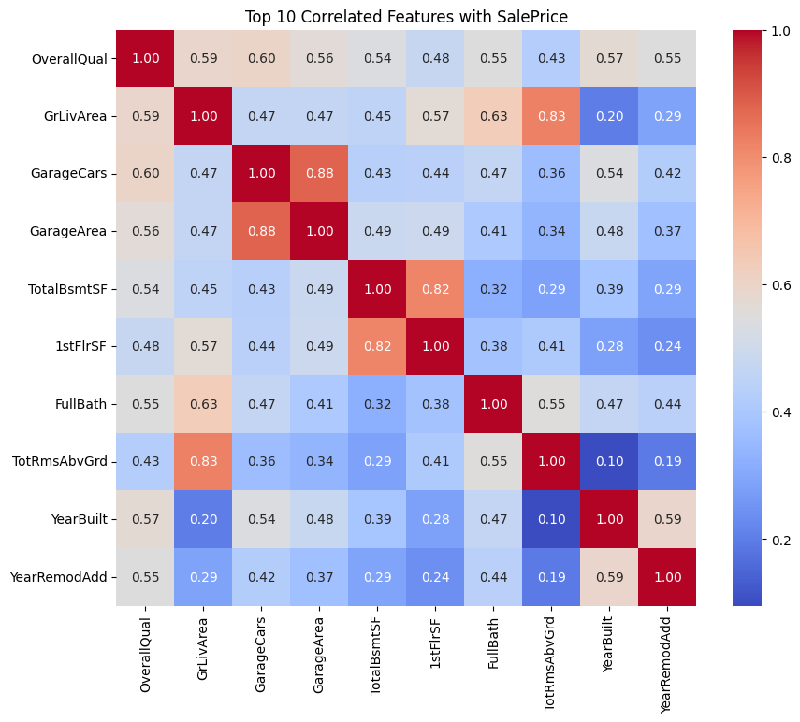

- Variables most positively correlated with SalePrice.
- Top features: OverallQual (0.81), GrLivArea (0.70), GarageCars, GarageArea, and TotalBsmtSF.
- Quality and living area have the strongest influence on house prices.
- Garage-related features also have strong correlations — may indicate luxury or space importance.

Distribution of Sale Prices

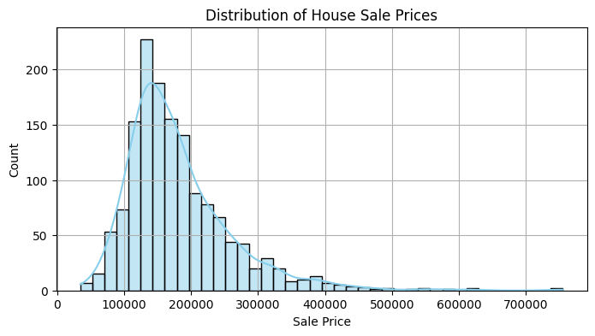

- Right-skewed distribution.
- Most houses are priced between $100,000 and $250,000.
- Long tail shows luxury/high-end outliers.
- Log-transforming SalePrice may improve model performance due to skewness.
- Many typical homes cluster around the lower-middle price range.

Actual vs Predicted Prices (Scatter Plot)

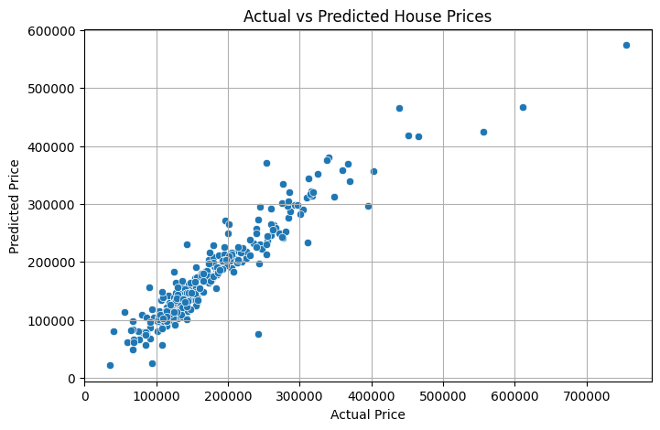
- A near-linear relationship between actual and predicted values.
- Model performs well, especially in the $100k–$400k range.
- Some deviation in high-priced houses.
- The model generalizes well, though it struggles with extreme values.
- More high-end training data or outlier handling might help.

Neighborhood-wise Sale Price Distribution (Box Plot)

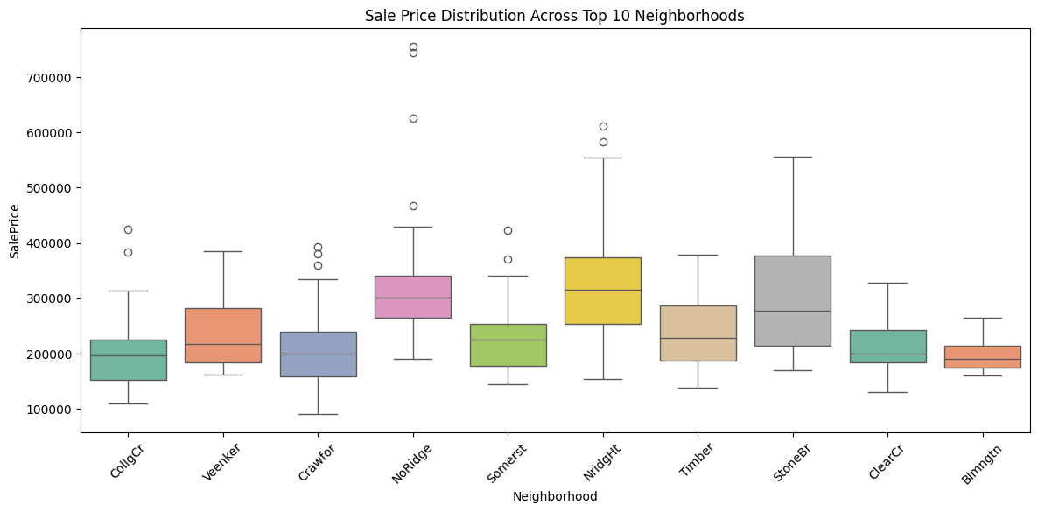

- Significant price variation across neighborhoods.
- NoRidge, NridgHt, and StoneBr have higher medians and upper ranges.
- Neighborhood is a critical feature — likely one-hot encoded in your model.
- Price trends are geographically dependent; may indicate school zone, amenities, etc.

6.5 Residual Distribution

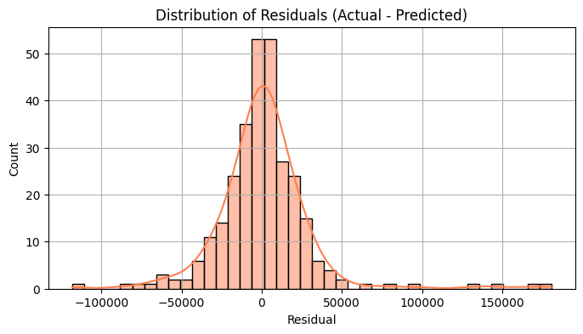

- Bell-shaped distribution centered around 0.
- Slight skew indicates mild over- or under-prediction in some cases.
- Model errors are approximately normally distributed — good sign.
- Suggests the model is unbiased overall with consistent performance.

REFRENCES
- Géron, A. (2019). Hands-On Machine Learning with Scikit-Learn, Keras, and TensorFlow (2nd ed.). O'Reilly Media.
- Raschka, S., & Mirjalili, V. (2019). Python Machine Learning (3rd ed.). Packt Publishing.
- James, G., Witten, D., Hastie, T., & Tibshirani, R. (2021). An Introduction to Statistical Learning: with Applications in R (2nd ed.). Springer.
- Scikit-learn Developers. (2023). Scikit-learn: Machine Learning in Python. Retrieved from: (https://scikit-learn.org/)
- Chen, T., & Guestrin, C. (2016). XGBoost: A Scalable Tree Boosting System. In Proceedings of the 22nd ACM SIGKDD International Conference on Knowledge Discovery and Data Mining (pp. 785–794).
- Kaggle. (n.d.). House Prices: Advanced Regression Techniques Dataset. Retrieved from: (https://www.kaggle.com/competitions/house-prices-advanced-regression-techniques)
- Brownlee, J. (2020). How to Evaluate Machine Learning Models. Machine Learning Mastery. Retrieved from: (https://machinelearningmastery.com/how-to-evaluate-machine- learning-models/)
- TensorFlow Developers. (2023). TensorFlow: An end-to-end open-source machine learning platform. Retrieved from: (https://www.tensorflow.org/)
- Pedregosa, F., Varoquaux, G., Gramfort, A., et al. (2011). Scikit-learn: Machine Learning in Python. Journal of Machine Learning Research, 12, 2825–2830.

