**AN**

**INDUSTRIAL PROJECT REPORT (RCA-662) ON**

**ZIMOZI CORPORATE WEBSITE**

SUBMITTED IN PARTIAL FULLMENT OF THE REQUIREMENTS FOR THE COURSE OF

**MASTER OF COMPUTER APPLICATION**

FROM

**DR. A.P.J. ABDUL KALAM TECHNICAL UNIVERSITY, LUCKNOW**

UNDERTAKEN AT

**ZIMOZI SOLUTIONS PVT LTD**



BY

**SHUBHAM PAL**

**1900290149095**

SUBMITTED TO:

**M.C.A. DEPARTMENT**

**KIET Group of Institution, Ghaziabad**

# CERTIFICATE

# CERTIFICATE

Certified that **Shubham Pal** (**1900290149095**) has carried out the project work presented in this report entitled “**Zimozi Corporate Website**” for the award of **Master of Computer Application** from Dr. A.P.J. Abdul Kalam Technical University, Lucknow under my supervision. The report embodies result of original work, and studies are carried out by the student himself and the contents of the report do not form the basis for the award of any other degree to the candidate or to anybody else from this or any other University.

**Mr. Ankit Verma External Examiner**

Assistant Professor

Dept. of Computer Application

KIET Group of Institutions, Ghaziabad

Date:

**DECLARATION**

I, **SHUBHAM PAL** hereby declare that this project report entitled “ZIMOZI CORPORATE WEBSITE” at “ZIMOZI SOLUTIONS PVT LTD, NOIDA” is

bonafide record of Training Work done by me during Jan.2021-July.2021 for the partial fulfillment of requirement of award of **Master of Computer Application** of **A.K.T.U. University, Lucknow under** the guidance of **Mr. Vinay Sharma and Mr. Kumar Raushan**.

I likewise pronounce that the venture work is either completely or mostly have not beforehand shaped the reason for the honor of any degree, recognition, association or other Title of any general public or University.

Date: 05/08/2021

Place: Noida

# ACKNOWLEDGEMENTS

This project is prepared in the partial fulfillment of the requirement for the degree of Master of Computer Application. The satisfaction and success of completion of this task would be incomplete without heartfelt thanks to people whose constant guidance, support and encouragement made this work successful. On doing this postgraduate project I have been fortunate to have help, support and encouragement from many people I would like to acknowledge them for their cooperation. Our first thanks go to **Abdul Kalam Technical University** for designing such a worthy syllabus and making us do this project. Our next batch of thanks goes to the faculty of Management of **KIET GROUP OF INSTITUITON, GHAIZABAD**.

This list includes Head of MCA department Dr. Ajay Srivastav and all the faculty members. Our very sincere and heartfelt thanks go to Mr. Kumar Raushan my project supervisor who constantly guided me through the project time period. Without his guidance, our project would have been impossible. Last but not the least we want to thank every direct and indirect hands that were involved in completion of this project. Finally, our heartfelt thanks go to Mr. Vinay Sharma, Director, Zimozi Solutions Pvt Ltd and Mr. Arul Jennie, CEO, Zimozi Solutions Pvt Ltd thanks for sharing the valuable time with me to evaluate my work and provide professional suggestion to me. This project has been a wonderful experience where I have learnt and experienced many beneficial things.

# Table Of Content

|  |  |  |
| --- | --- | --- |
| **S.no** | **Particulars** | **Page_no** |
| 1. | Front Page | 1 |
| 2. | Certificate | 2 |
| 3. | Declaration | 3 |
| 4. | Acknowledgement | 4 |
| 5. | Table of Contents | 5,6 |
| 6. | About Organization | 7 |
| 7. | Actual working of the organization for which the website to be carried out | 7 |
| 8. | Description of various departments and their working | 8 |
| 9. | Business Model and Flow of Working Within the Organization | 8,9 |
| 10. | Chapter - 1 INTRODUCTION | 10 |
| 11. | 1.1 Introduction to Zimozi Corporate Website | 10 |
| 12. | 1.2 Literature Review | 10 |
| 13. | 1.3 Problem Statement | 10 |
| 14. | 1.4 Objective of the Project | 11 |
| 15. | 1.4.1 Primary objective | 11 |
| 16. | 1.4.2 Secondary objective | 11 |
| 17. | 1.5 Features of Project | 11,12 |
| 18. | 1.6 Scope of the Website | 12 |
| 19. | CHAPTER-2 BACKGROUND KNOWLEDGE | 13 |

|  |  |  |
| --- | --- | --- |
| 20. | 2.1 Architectural Review | 13,14,15 |
| 21. | 2.2 Database Theory | 16 |
| 22. | 2.2.1 WordPress Database | 16 |
| 23. | 2.2.2 Structured Query Language (SQL) | 17 |
| 24. | 2.3 FRONTEND | 17 |
| 25. | 2.3.1HTML | 17,18 |
| 26. | 2.3.2 CSS | 18 |
| 27. | 2.3.3 JavaScript | 18,19 |
| 28. | 2.3.2 jQuery | 19 |
| 29. | 2.4 Backend | 20 |
| 30. | 2.4.1 WordPress Backend | 20,21,22,23,24 |
| 31. | 2.4.2 SQL | 24 |
| 32. | CHAPTER-3 REQUIREMENT | 25 |
| 33. | 3.1 Background Research | 25 |
| 34. | 3.2 Requirement Analysis | 25 |
| 35. | 3.3 System Requirement | 25 |
| 36. | 3.4 Users Requirement | 26 |
| 37. | 3.5 Feasibility Analysis | 26,27 |
| 38. | 3.6 Hardware Requirement | 27 |
| 39. | 3.7 Software Requirement | 27 |
| 40. | CHAPTER- 4: LOGICAL DESIGN OF THE WEBSITE | 28 |

|  |  |  |
| --- | --- | --- |
| 41. | CHAPTER- 5: DESIGN IMPLEMENTATION | 29-63 |
| 42. | CHAPTER- 6: DEBUGGING AND TESTING | 64 |
| 43. | 6.1 Purpose of Testing | 64 |
| 44. | 6.2 Type of Testing | 64 |
| 45. | 6.2.1 Unit Testing | 64 |
| 46. | CHAPTER- 7: CONCLUSION AND LESSON LEARNT | 65 |
| 47. | 7.1 Conclusion | 65 |
| 48. | 7.2 Lesson Learnt | 65 |
| 49. | 7.2 Future Enhancement | 65 |
| 50. | Bibliography | 67 |

About Organization-

Zimozi brings their vast expertise from working with start-ups to Fortune 100 companies, to provide a seamless and all-encompassing experience tailored to your needs.

Zimozi Solutions means a place complete of energy, enthusiasm, or liveliness. We are ageratum of problem solvers, creative thinkers, programmers, and designers. We are an agency small enough to be cohesive and agile enough to approach every single project with devotion, care, and flexibility. Yet, big enough to accept coding challenges of all shapes and sizes.

It is based out Noida, India and Singapore.

We provide automated & smart solutions to the Enterprises and Brands. Zimozi Solutions isn’t an ad agency, and we don’t build campaign-driven apps. Instead, we work to get her with our clients to build compelling products that provide lasting excitement and value to their customers.

Our understanding of CRM/ERP, iPhone, Android, iPad and web-based technology enables us to bring a level of expertise to your enterprise like no one else. We know how to build products that can scale to your business’ needs, no matter how large.

Actual working of the organization for which the website to be carried out- Organization’s main work is to build

* Mobile apps,
* Web apps,
* Cross platforms,
* Artificial Intelligence solutions,
* Creative services,
* Logo designing,
* Video Production,
* Mobile & Web UI/UX,
* Social Media Marketing,
* SEO & Online Marketing,
* Content Awareness Marketing,

Description of various departments and their working- There are various departments in the organization

* Leadership- Leaderships the management of the organization which irresponsible for all business activities of the organization.
* Front-End Engineering- The department maintains the designing and development part for the organization by building and creating interactive solutions needed.
* Back-End Engineering- The department is responsible for all the backend development maintaining and building the database and working with logics.
* Mobile & Quality Analytics- The department is responsible for building mobile solutions and quality check of the various projects.
* Creatives&Operation-ThedepartmenthasallthebusinessassociatesandHRwho manages all the business needs and HR maintains the organization events and various managements.

Business Model and Flow Of Working Within the Organization-

The organization follows Agile software development that refers to a group of software development technologies based on iterative development, where requirements and solutions evolve through collaboration between self-organizing cross-functional teams. Agile development refers to any development process that is aligned with the concepts of the Agile Manifesto.

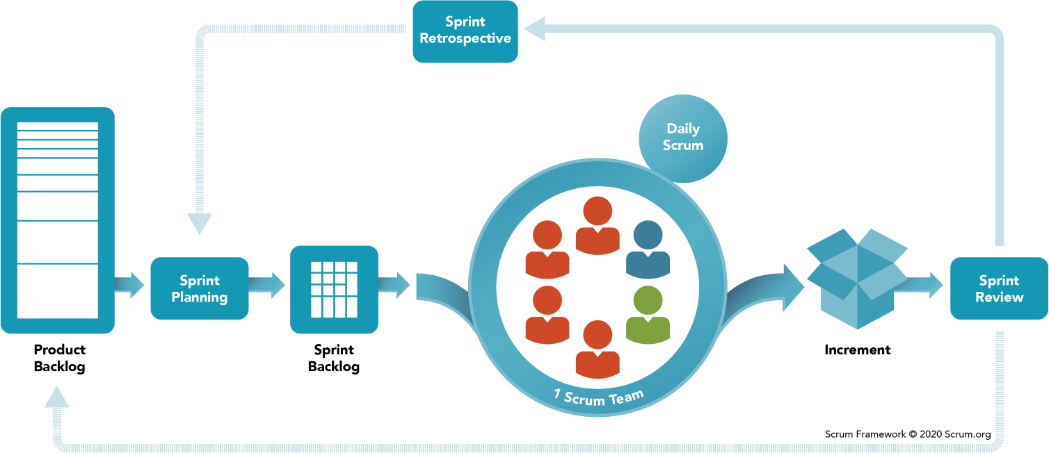

Scrum is a subset of Agile. It is a lightweight process framework for agile development, and the most widely used one

A “process framework” is a particular set of practices that must be followed in order for a process to be consistent with the framework. (For example, the Scrum process framework requires the use of development cycles called prints, the Frame work enquires pair programming, and so forth.)

“Lightweight “means that the overhead of the process is kept as small as possible, to maximize the amount of productive time available for getting useful work done.

# Chapter - 1 INTRODUCTION

* 1. **Introduction to Zimozi Corporate Website**

The project Zimozi Corporate Website is a complete responsive website designed on WordPress (CMS) ContentManagementSystem.Themainaimoftheprojectistodevelopacorporatewebsite in which all the information regarding the company services is presented. It is content management-based website which has admin component to manage the design of pages, blogs and maintenance of the website. This website is based on presenting various services build, maintained by the company. The website contains general organization profile, recent case studies, services, contact details and location of the organization. There is a provision of updating the pages and design of website if needed. The look and feel of website are created in such a way to make the user understand and navigate through the website easily. The website is rich in UI/UX and graphics and provides complemented activity to the users. To make any changes in the existing website one need to login to the server and WordPress dashboard which is only possible with credentials. It is done for the safety and reduce the threats from website.

# Literature Review

Servicesareconsideredasthebusinessresourcesfortheorganization.Thisincludesmanagingthe services with appropriate way to review any time as per the requirement. Therefore, itis important for a company to have a website which has the ability to represent all the services and different aspects of a business organization. Before developing this website, we came up with different mobile web apps development-based website existing in the market, which helps to give the knowledge for the development of our project. These websites are used by the large organization but so we came up with the website which can be used by our company for the representing the different aspects of the organization business. After analyzing the other websites, we decided to include some of common and key features that should be included in every mobile and web app development-based website. So, we decided to include those things that help our organization in a way or other.

# Problem Statement

After analyzing many existing corporate websites, we have now the obvious vision of the project to be developed. Before we started to build the website, I faced many challenges. I define my problem statement as:

* + - To make a responsive web and mobile website.
    - To make the website easy to use and is with rich UI/UX and graphics.
    - Tocoveralltheservicesandrequirementsofthecompanywithothervisualpresentations of website.

# Objective of the Project

* + 1. **Primary objective**

The primary objectives of the project are mentioned below:

* + - To fulfill the requirement for achieving the Master of Computer Applications
    - To know the fundamentals of the WordPress CMS, designing and web development

# Secondary objective

The secondary objectives of this project are mentioned below:

* + - To develop a website that deals with the day-to-day requirement of any corporate organization
    - To develop a responsive website which can be used in all devices
    - To create an interactive website with rich UI/UX, graphics and animations
    - To provide competitive advantage to the organization.
    - To represent the various services and aspects of the organization

# Features of Project

This website is used to show various services provided by the organization. It gives the details about the prices and offers provided by the company. The details components are described below:

* Home:

Firstly, user has to go to the URL: [https://www.zimozi.co](https://www.zimozi.co/)

This URL redirects the user to the home or main page of zimozi which contains a little about company and various sections that display details about the company such as recent case studies, services, client testimonials and contact form.

* Our Creations:

This page displays the various case studies about the projects created by the company. Different case studies will redirect to different pages that contains the detail case study about that project including the contact form at the last.

* Our Expertise:

This page displays the detailed services provided by the company with interactive visual presentation along with the contact form at the last.

* Reach Us:

ReachUsreferstothecontactpagethatrepresentsthevariouslocationswherecompanyis located via map and complete address of the company office on both the locations i.e. India & Singapore. This page also includes the contact form for clients and users to contact us for their future projects.

# Scope of the Website

ZimoziCorporateWebsiteistargetedtorepresentallthebusinessaspectsandservicesacorporate website needs to show.

Some of the scopes are:

* Many users can visit the website at the same time
* It is security driven
* Page, sections, and blogs are added and removed as per requirements.
* Rights can also be provided which will help the organization that which user can see which module
* Direct requirement can be sent to the organization via contact form by client

# CHAPTER-2 BACKGROUND KNOWLEDGE

* 1. **Architectural Review**

CMS stands for Content Management System. WordPress is one of the most popular content management system solutions in use. It is a free and open-source content management system (CMS) written in PHP and paired with a MySQL or MariaDB database. Features include a plugin architecture and a template system, referred to within WordPress as Themes. WordPress was originally created as a blog-publishing system but has evolved to support other web content types including more traditional mailing lists and forums, media galleries, membership sites, learning management systems (LMS) and online stores.

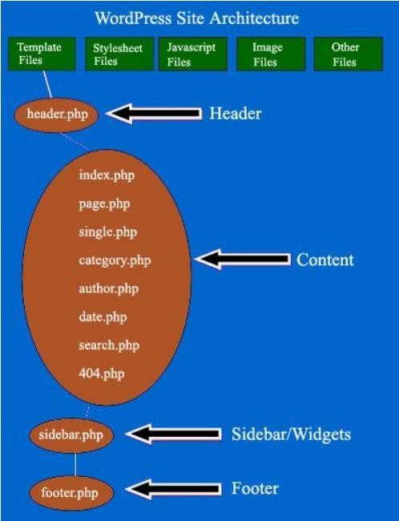

**The following figure shows the WordPress Architecture**

Every WordPress installation comes with a default theme. You can either use this theme or you can use a custom theme. In either case, A WordPress theme is made up of template files, stylesheet files, JavaScript files, Image files and some other files like function php.

WordPress uses the query string to decide which template or set of templates should be used to display the page. The query string is information that is contained in the link to each part of your website. It comes after the initial question mark and may contain a number of parameters separated by ampersands.

the template hierarchy is the choice-structure WordPress uses to determine what file in the theme will be used to generate the full, final HTML for a given page of your WordPress website.

WordPress needs to have a way to know how to interact with the theme. It would be possible that someone could write various different types of complex PHP logic for their theme that explained to WordPress how to interact with it. It could, perhaps, be a PHP class that matched WordPress- defined interface (in the object-oriented programming sense) that each theme would need to respond to.

The template hierarchy exists to make it easier for theme designers and developers to customize the look of a WordPress site. It’s very common for a client to make the “tag archive” pages for their blog different from the single-post page. So, WordPress’s template hierarchy supports that need.

* + - header.php- This file displays headers and navigations
    - index.php- This template file is used to display the blog post index
    - home.php- This template file can also be used to display the blog post index & can be set to display on the front page of your website or on a separate static page.
    - single.php- This template file displays blog post’s title, content, author’s name, date of post, post category tags, comment list, comment form ,navigation to the previous and next post.
    - category.php- This template file controls how category pages should be displayed.
    - author.php- This template file controls how an author page should be displayed.
    - search.php- This template file controls how search pages should be displayed.
    - 404.php- This template file is used when WordPress cannot fine page or post which is queried.
    - footer.php- You can change the footer of each web page by editing this file.
    - style.css- This is the main stylesheet of your WordPress theme and is used to control the design and layout of your webpages.
    - sidebar.php- It is used to control the side bar display.

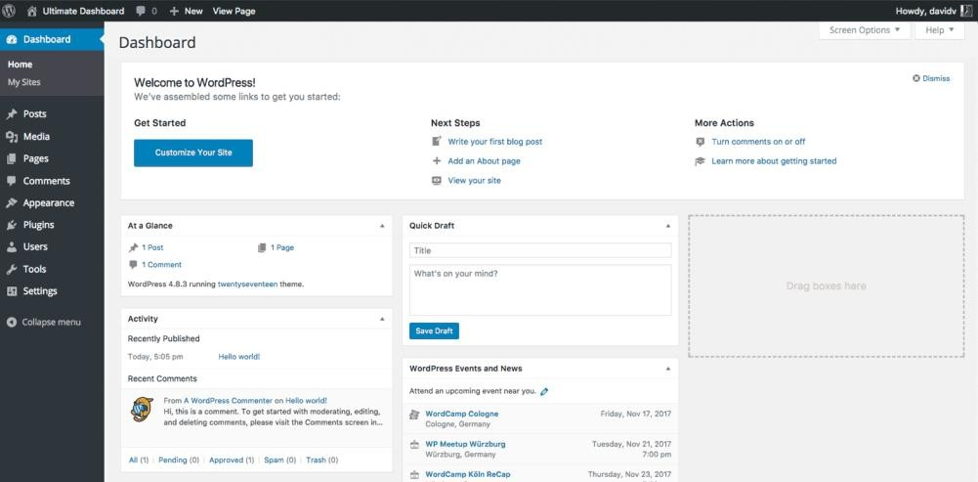

**The following figure shows the basic WordPress Dashboard**

* 1. **Database Theory**

A database is a collection of information that is organizes so that it can easily be accessed, managed and updated. In one view, database can be classified according to types of content: bibliography, full-text, numeric, and image. In computing, database are sometime classified according to their organizational approach. A distributed database is one that can be dispersed or replicated among different points in a net work

* + 1. **WordPress Database**

WordPress uses MySQL as its database management system. MySQL is a software used to create databases, store and get data when requested. MySQL is also an open-source software, just like WordPress and works best with other popular open-source software, such as Apache web server, PHP, and Linux operating system.

To install WordPress, you need a MySQL database. All WordPress hosting providers offer MySQL included in their hosting packages.

WordPress will automatically create tables inside your database. At the time of writing this, a default installation of WordPress would create the following tables:

* + - wp_commentmeta
    - wp_comments
    - wp_links
    - wp_options
    - wp_postmeta
    - wp_posts
    - wp_terms
    - wp_term_relationships
    - wp_term_taxonomy
    - wp_usermeta
    - wp_users

Each of these tables would have different columns where data is stored. For example, wp_users table in WordPress has these columns:

* + - ID
    - user_login
    - user_pass
    - user_nicename
    - user_email
    - user_url
    - user_registered
    - user_activation_key
    - user_status
    - display_name

# Structured Query Language (SQL)

SQL is abbreviation for Structured Query Language, it is a special programming language used to manage databases. An instruction issued by SQL to the database server to retrieve data is called a query WordPress uses MySQL queries to get data and use it to generate webpages. SQL has three major Components:

* + - * Data Manipulation Language (DML)
      * Data Definition Language (DDL)
      * Data Control Language (DCL) A typical MySQL query looks like this:

SELECT * FROM posts WHERE ID = 23.

WordPress databases can be managed using phpMyAdmin, which is an open-source web application with a nice easy graphical user interface to manage MySQL databases. There are also many WordPress plugins available which can help you create WordPress database backups.

# FRONTEND

* + 1. **HTML**

The **Hyper Text Markup Language**, or **HTML** is the standard [markup language](https://en.wikipedia.org/wiki/Markup_language) for documents designed to be displayed in a [web browser](https://en.wikipedia.org/wiki/Web_browser). It can be assisted by technologies such as [Cascading](https://en.wikipedia.org/wiki/Cascading_Style_Sheets) [Style Sheets](https://en.wikipedia.org/wiki/Cascading_Style_Sheets)(CSS) and [scripting languages](https://en.wikipedia.org/wiki/Scripting_language) such as [JavaScript](https://en.wikipedia.org/wiki/JavaScript).

receive HTML documents from a server or from local storage and [render](https://en.wikipedia.org/wiki/Browser_engine) the documents into multimedia web pages. HTML describes the structure of a [webpage](https://en.wikipedia.org/wiki/Web_page)[s semantically](https://en.wikipedia.org/wiki/Semantic_Web) and originally included cues for the appearance of the document.

[HTML elements](https://en.wikipedia.org/wiki/HTML_element) are the building blocks of HTML pages. With HTML constructs, [images](https://en.wikipedia.org/wiki/HTML_element#Images_and_objects) and other objects such as [interactive forms](https://en.wikipedia.org/wiki/Fieldset) may be embedded into the rendered page. HTML provides a means to create [structureddocuments](https://en.wikipedia.org/wiki/Structured_document)bydenotingstructural[semantics](https://en.wikipedia.org/wiki/Semantics)fortextsuchasheadings, paragraphs,lists,[links,](https://en.wikipedia.org/wiki/Hyperlink)quotesandotheritems.HTMLelementsaredelineatedby*tags*,written

<**input** />

<**img**/>

using [angle brackets.](https://en.wikipedia.org/wiki/Bracket#Angle_brackets) Tags such as

and

directly introduce content into the

page. Other tags such as surround and provide information about document text and may

<**p**>

include other tags as sub-elements. Browsers do not display the HTML tags but use them to interpret the content of the page.

HTML can embed programs written in a [scripting language](https://en.wikipedia.org/wiki/Scripting_language) such as [JavaScript](https://en.wikipedia.org/wiki/JavaScript), which affects the behavior and content of web pages. Inclusion of CSS defines the look and layout of content. The [World Wide Web Consortium](https://en.wikipedia.org/wiki/World_Wide_Web_Consortium) (W3C), former maintainer of the HTML and current maintainer of the CSS standards, has encouraged the use of CSS over explicit presentational HTML since 1997.

* + 1. **CSS**

**Cascading Style Sheets** (**CSS**) is a [style sheet language](https://en.wikipedia.org/wiki/Style_sheet_language) used for describing the [presentation](https://en.wikipedia.org/wiki/Presentation_semantics) of a document written in a [markup language](https://en.wikipedia.org/wiki/Markup_language) such as [HTML.](https://en.wikipedia.org/wiki/HTML) CSS is a cornerstone technology of the [World Wide Web,](https://en.wikipedia.org/wiki/World_Wide_Web) alongside HTML and [JavaScript](https://en.wikipedia.org/wiki/JavaScript)

CSS is designed to enable the separation of presentation and content, including [layout](https://en.wikipedia.org/wiki/Page_layout), [colors](https://en.wikipedia.org/wiki/Color), and [fonts.](https://en.wikipedia.org/wiki/Typeface) This separation can improve content [accessibility,](https://en.wikipedia.org/wiki/Accessibility) provide more flexibility and control in the specification of presentation characteristics, enable multiple [web pages](https://en.wikipedia.org/wiki/Web_page) to share formatting by specifying the relevant CSS in a separate .CSS file which reduces complexity and repetition in the structural content as well as enabling the.CSS file to be [cached](https://en.wikipedia.org/wiki/Cache_(computing)) to improve the page load speed between the pages that share the file and its formatting.

Separation of formatting and content also makes it feasible to present the same markup page in different styles for different rendering methods, such as on-screen, in print, by voice (via speech- based browser or [screen reader](https://en.wikipedia.org/wiki/Screen_reader)), and on [Braille-based](https://en.wikipedia.org/wiki/Braille_display) tactile devices. CSS also has rules for alternate formatting if the content is accessed on a [mobile device.](https://en.wikipedia.org/wiki/Mobile_device)

The name *cascading* comes from the specified priority scheme to determine which style rule applies if more than one rule matches a particular element. This cascading priority scheme is predictable.

The CSS specifications are maintained by the [World Wide Web Consortium](https://en.wikipedia.org/wiki/World_Wide_Web_Consortium) (W3C). Internet

media type ([MIME type](https://en.wikipedia.org/wiki/MIME_media_type)) is registered for use with CSS by RFC 2318 (March 1998).

text/css

The W3C operates a free [CSS validation service](https://en.wikipedia.org/wiki/W3C_Markup_Validation_Service#CSS_validation) for CSS documents.

In addition to HTML, other markup languages support the use of CSS including [XHTML,](https://en.wikipedia.org/wiki/XHTML) [plain](https://en.wikipedia.org/wiki/Plain_Old_XML) [XML,](https://en.wikipedia.org/wiki/Plain_Old_XML) [SVG](https://en.wikipedia.org/wiki/Scalable_Vector_Graphics), and [XUL.](https://en.wikipedia.org/wiki/XUL)

* + 1. **JavaScript**

**JavaScript** often abbreviated as **JS**, is a [programming language](https://en.wikipedia.org/wiki/Programming_language) that conforms to the [ECMA](https://en.wikipedia.org/wiki/ECMAScript) [Script](https://en.wikipedia.org/wiki/ECMAScript) specification. JavaScript is [high-level,](https://en.wikipedia.org/wiki/High-level_programming_language) often [just-in-time compiled,](https://en.wikipedia.org/wiki/Just-in-time_compilation) and [multi-paradigm.](https://en.wikipedia.org/wiki/Programming_paradigm) It has [curly-bracket syntax,](https://en.wikipedia.org/wiki/List_of_programming_languages_by_type#Curly-bracket_languages) [dynamic typing,](https://en.wikipedia.org/wiki/Dynamic_typing) [prototype-based](https://en.wikipedia.org/wiki/Prototype-based_programming) [object-orientation,](https://en.wikipedia.org/wiki/Object-oriented_programming) and [first-class](https://en.wikipedia.org/wiki/First-class_function) [functions.](https://en.wikipedia.org/wiki/First-class_function)

Alongside [HTML](https://en.wikipedia.org/wiki/HTML) and [CSS,](https://en.wikipedia.org/wiki/CSS) JavaScript is one of the core technologies of the [World Wide](https://en.wikipedia.org/wiki/World_Wide_Web) [Web.](https://en.wikipedia.org/wiki/World_Wide_Web) Over 97% of [websites](https://en.wikipedia.org/wiki/Website) use it [client-side](https://en.wikipedia.org/wiki/Client-side) for [web page](https://en.wikipedia.org/wiki/Web_page) behavior often incorporating third- party [libraries.](https://en.wikipedia.org/wiki/Library_(computing))[[12]](https://en.wikipedia.org/wiki/JavaScript#cite_note-lib_usage-12)All major [web browsers](https://en.wikipedia.org/wiki/Web_browser) have a dedicated [JavaScript engine](https://en.wikipedia.org/wiki/JavaScript_engine) to execute the code on the [user](https://en.wikipedia.org/wiki/User_(computing))'s device.

As a multi-paradigm language, JavaScript supports [event-driven,](https://en.wikipedia.org/wiki/Event-driven_programming) [functional,](https://en.wikipedia.org/wiki/Functional_programming) and [imperative](https://en.wikipedia.org/wiki/Imperative_programming) [programming styles.](https://en.wikipedia.org/wiki/Programming_paradigm) It has [application programming interfaces](https://en.wikipedia.org/wiki/Application_programming_interface) (APIs) for working with text, dates, [regular expressions,](https://en.wikipedia.org/wiki/Regular_expression) standard [data structures](https://en.wikipedia.org/wiki/Data_structure), and the [Document Object](https://en.wikipedia.org/wiki/Document_Object_Model) [Model](https://en.wikipedia.org/wiki/Document_Object_Model)(DOM).

The ECMA Script standard does not include any [input/output](https://en.wikipedia.org/wiki/Input/output)(I/O), such as [networking,](https://en.wikipedia.org/wiki/Computer_network) [storage](https://en.wikipedia.org/wiki/Data_storage), or [graphics](https://en.wikipedia.org/wiki/Computer_graphics) facilities. In practice, the web browser or other [runtime system](https://en.wikipedia.org/wiki/Runtime_system) provides JavaScript APIs for I/O.

JavaScript engines were originally used only in web browsers, but they are now core components of [other](https://en.wikipedia.org/wiki/JavaScript#Other_usage) software systems, most notably [servers](https://en.wikipedia.org/wiki/Server_(computing)) and a variety of [applications.](https://en.wikipedia.org/wiki/Application_software)

Although here are similarities between JavaScript and [Java,](https://en.wikipedia.org/wiki/Java_(programming_language)) including language name, [syntax ,](https://en.wikipedia.org/wiki/Syntax_(programming_languages))and respective [standard libraries,](https://en.wikipedia.org/wiki/Standard_library) the two languages are distinct and differ greatly in design.

JavaScript is the dominant [client-side](https://en.wikipedia.org/wiki/Client-side) scripting language of the Web, with 97% of [web sites](https://en.wikipedia.org/wiki/Website) using it for this purpose[.[](https://en.wikipedia.org/wiki/JavaScript#cite_note-deployedstats-11)Scripts are embedded in or included from [HTML](https://en.wikipedia.org/wiki/HTML) documents and interact with the [DOM.](https://en.wikipedia.org/wiki/Document_Object_Model) All major [web browsers](https://en.wikipedia.org/wiki/Web_browser) have a built-in [JavaScript engine](https://en.wikipedia.org/wiki/JavaScript_engine) that executes the code on the user's device.

* + 1. **jQuery**

jQuery is a lightweight, "write less, do more", JavaScript library.

The purpose of jQuery is to make it much easier to use JavaScript on your website.

jQuery takes a lot of common tasks that require many lines of JavaScript code to accomplish and wraps them into methods that you can call with a single line of code.

jQuery also simplifies a lot of the complicated things from JavaScript, like AJAX calls and DOM manipulation.

The jQuery library contains the following features:

* + - HTML/DOMmanipulation
    - CSSmanipulation
    - HTML eventmethods
    - Effects andanimations
    - AJAX
    - Utility

# BACKEND

* + 1. **WordPress Backend**

The WordPress backend is part of the website that is available only for authenticated users. By default, all registered users have access to it and the number of available actions is based on user’s capabilities.

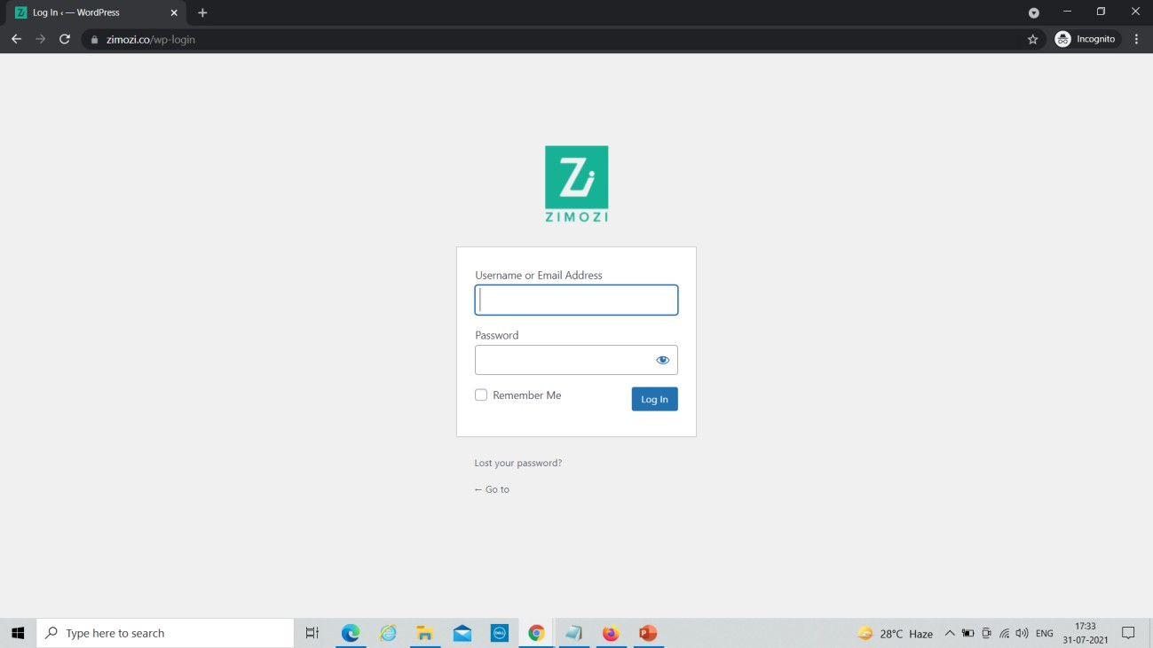

**WordPress Login Dashboard**

The WordPress backend is divided into pages that are either WordPress core pages like Media Library, Plugins, Tools, Themes or custom pages that are registered and rendered by third-party plugins or themes.

Each backend page has unique URL that points to the specific PHP file. For example, Media Library points to /wp-uploads and Users to /wp-admin/usership. However, there are three exceptions:

* + - * Posts, Pages and Custom Post Types (CPTs) point to the same PHP file /wp- admin/edits. The only difference is in the post type parameter.
      * All taxonomies like categories or tags point to the /wp-admin/edit-tags’ file with the unique taxonomy parameter.
      * All custom pages, that are registered and rendered by third party plugins or themes, point to the /wp-admin/admin. php with unique page parameter.
      * The list of all backend pages is organized as the backend menu and is rendered on the left side of the backend interface. Some menus may have submenus. Additionally, some backend pages are listed on the top admin bar.

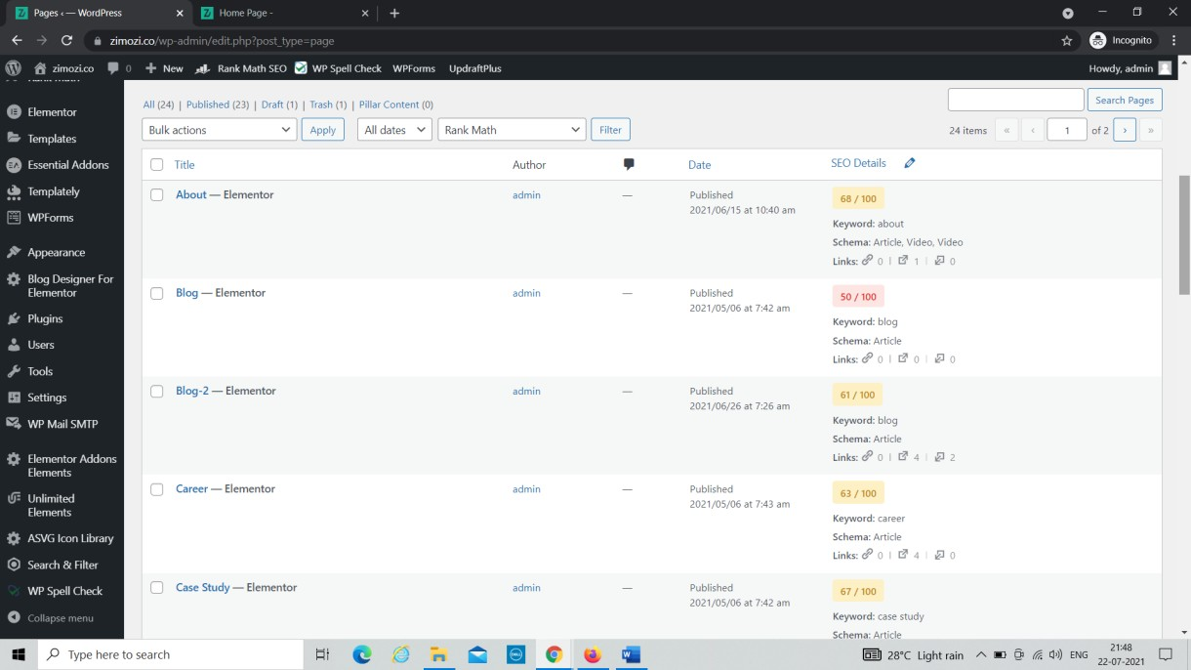

**WordPress Pages Dashboard**

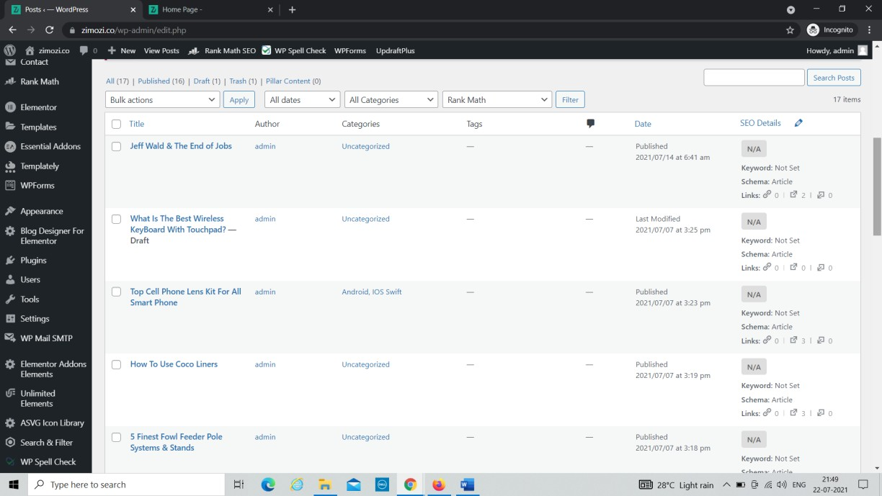

**WordPress Post Dashboard**

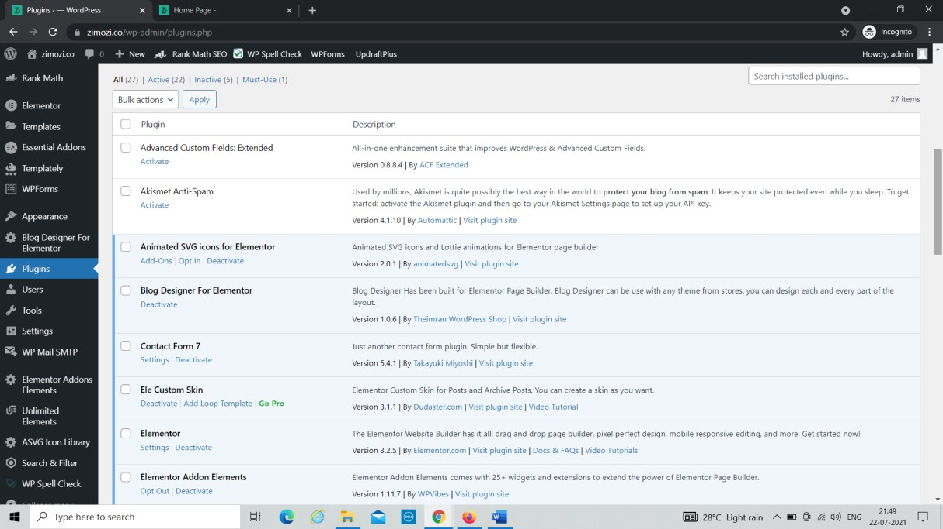

**Plugins Dashboard**

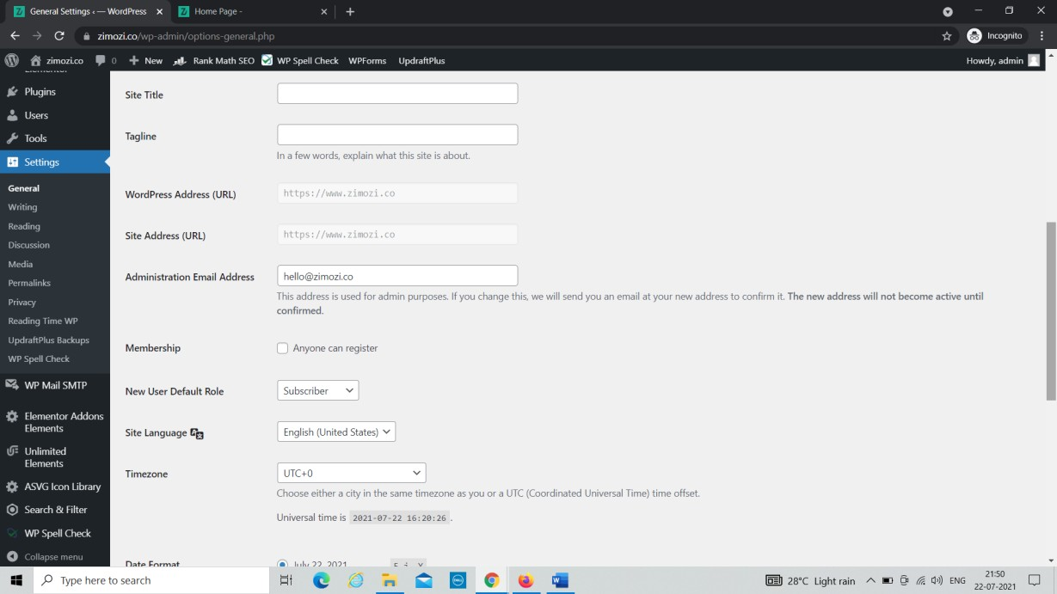

**WordPress Settings Dashboard**

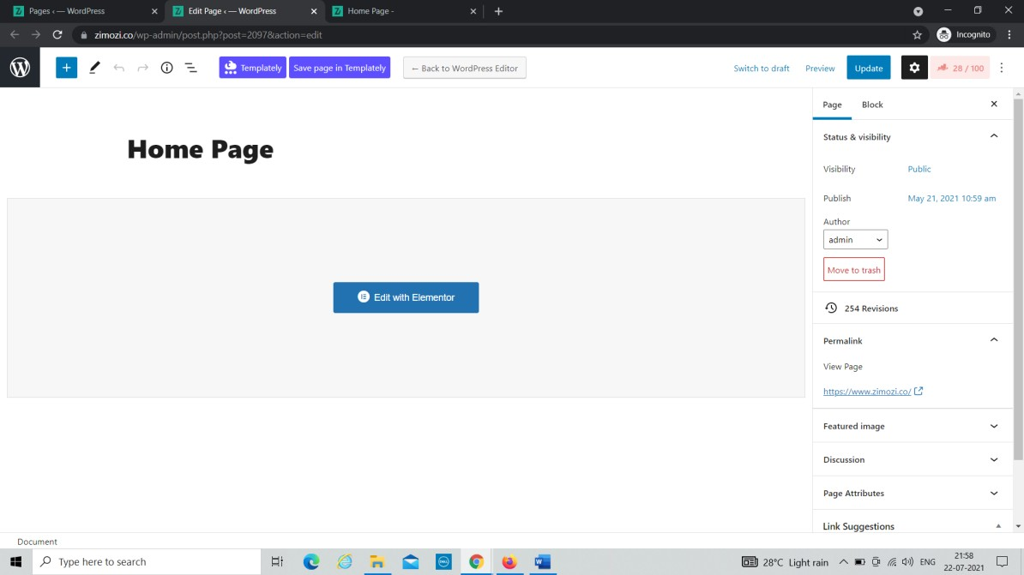

**WordPress Editor**

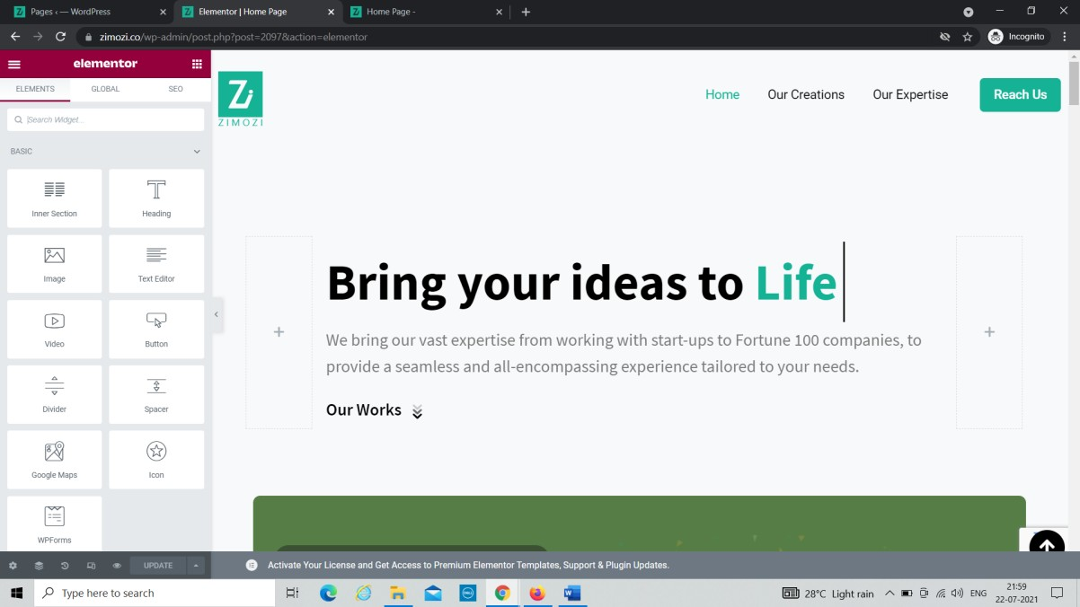

**WordPress Element or Editor**

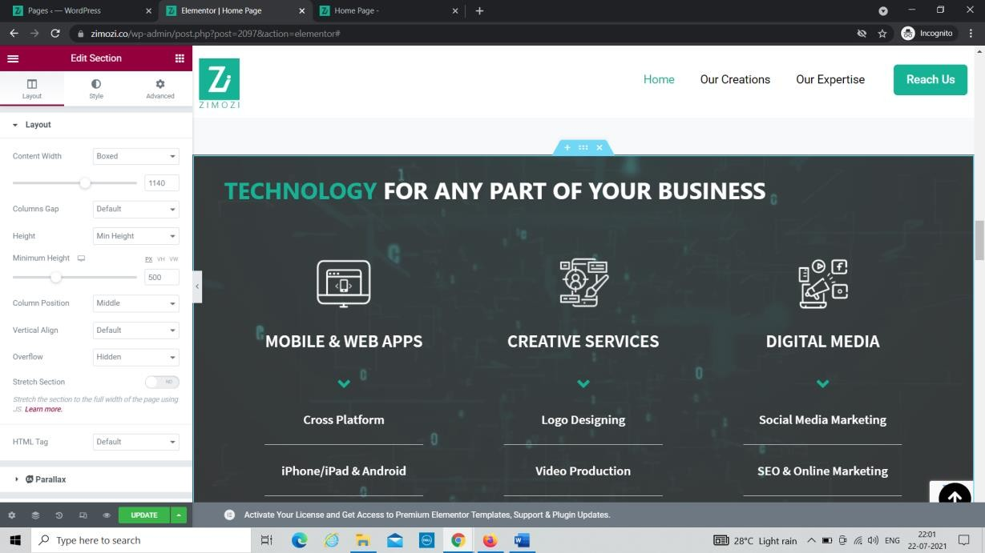

**Formatting Styles**

* + 1. **SQL**

Structured Query Language (SQL) is the standard language for relational database management systems. It is used to interact with the database that is a part of the back end

* SQL stands for Structured Query Language
* SQL lets you access and manipulate databases
* SQL became a standard of the American National Standards Institute (ANSI) in 1986, and of the International Organization for Standardization (ISO) in1987

USES OF SQL

* SQL can execute queries against adatabase
* SQL can retrieve data from adatabase
* SQL can insert records in adatabase
* SQL can update records in adatabase
* SQL can delete records from adatabase
* SQL can create newdatabases
* SQL can create new tables in adatabase
* SQL can create stored procedures in adatabase
* SQL can create views in adatabase
* SQL can set perMs.ions on tables, procedures, andviews

# CHAPTER-3: REQUIREMENTANALYSIS

* 1. **Background Research**

We started research by identifying the need of website in the organization. Initially we bounded our research to find the general reasons that emerged the needs of corporate website. We used different techniques and referred various other corporate websites to collect the data that can clearly give us the overall image of the website. The techniques we used were interview with the designers, visiting online websites that are presented as the templates. Basically, the following factors forced us to develop Zimozi Corporate Website:

* + - Cost and affordability
    - Error
    - Need to present company services
    - Effective showcase of designing and development
    - Difficulty in representing different aspects of services and prices offered by company.

# Requirement Analysis

We collected a number of requirements for project from our primitive research, website visits, and interview to the concerned personnel and their experiences regarding the concepts of its development.

* + - I have personally seen importance of corporate website in Zimozi Solutions Pvt Ltd.
    - I then decided to build same type of website with different logic flow and new framework which will be suitable for the any organization.

# System Requirement

The goal for the website is to represent the various services provided by zimozi and offer the best prices and practices to the client as per their requirements. Once it is placed on system, all the functionscanbeeffectivelymanagedandtheorganizationcanachievethecompetitiveadvantage. Business requirement are discussed in the Scope section, with the following additional details.

* + - Helps to get a clear idea of all services provided by Zimozi.
    - Details information about the projects successfully completed and maintained.
    - Brief Information of the organization today’s status in terms of news, achievements and other information.
    - It is rich inanimations.
    - All the information is secured and doesn’t provide any harm to users.
    - Only authenticated users can login to admin dashboard to make changes.

# Users Requirement

User requirement are categorized by the user type

# Admin

* Able to create new post, pages.
* Able to edit the current information displayed on website.
* Able to add, modify and delete the pages, posts or comments.
* Able to manage the content easily.

# User

* Able to use the website easily and effectively.
* Able to navigate through website without any trouble.
* Able to contact to company for their requirements.

# Feasibility Analysis

This website has been tested for various feasibility criterions from various point of views.

# Economic Feasibility

Thewebsiteisestimatedtobeeconomicallyaffordable.Thewebsiiteismediumscaledesktopand mobile application and has affordable price. The benefits include increase deficiency, effectiveness, and the better performance. Comparing the cost and benefits the website is found to be economically feasible.

# Technical Feasibility

Development of the system requires tools like:

* + - * WordPress CMS Version 5.7.2 or above
      * Web server-Apache
      * PHP Version7.3.18.
      * MySQL version 5.6 or greater OR MariaDB version 10.1 or greater.
      * HTTP Supports.

# Operational Feasibility

The website provides better solution to the libraries by adding the typical requirement and necessities. The solution provided by this website will be acceptable to ultimate solution for the corporate website.

# Schedule Feasibility

The organized schedule for the development of the website is presented in the schedule sub- section. The reasonable timeline reveals that the website development can be finished on desired time framework

# Hardware Requirement

* Window Window 10, Window7
* Processor i3
* Memory 4.00GB
* System type 64-bit operating system

# Software Requirement

* Word Press CMS Version 5.7.2 or above
* Web server-Apache
* PHP Version7.3.18.
* MySQL version 5.6 or greater OR MariaDB version 10.1 or greater.
* HTTPS supports.

# Chapter - 6 DEBUGGING AND TESTING

* 1. **Purpose of Testing**

The purpose of testing is to access or evaluate the capabilities or attributes of a websites ability to adequately meet the applicable standards and application need. Testing does not ensure quality and the purpose of testing is not to find bugs. Testing can be verification and validation or reliability estimation. The primary objective if testing includes:

To identifying defects on the website.

The most important role of testing is simply to provide information.

To check the proper working of the website while inserting updating and deleting anything from website.

# Type of Testing

We have used one type of testing to ensure the error free features of our website:

# Unit Testing

Thistypeoftestingisthetestingofindividualcomponents.Itistypicallydonebytheprogrammer and not by the testers. It requires details information and knowledge about the internal program design and code to perform this. During unit testing, we carried out various testing task such as the reflection of the unit data on database and its interface. Various types of bugs associated with the component were identified and fixed. We use various functional keys to test our website. In our website unit testing is concerned with the proper visualization of all elements in different resolutions.

# CHAPTER- 7: CONCLUSION AND LESSON LEARNT

* 1. **Conclusion**

To conclude, Zimozi Corporate Website is a simple, animations rich responsive website suitable for all resolutions. It has every basic item which are used for the any type of corporate website. Our team is successful in making the website where we can update, insert and delete the item as per the requirement.

# Lesson Learnt

Doing something for long time periods always gives good lesson. Some of the things that our team learnt are listed as below:

Basically, we learnt to work in team. Learnt about the Zimozi Organization.

Learnt about WordPress dashboard, its components and ways to implement them Learnt to work in pressure and to be patient.

Learnt to manage the database and maintain the website.

# Future Enhancements

Since this project was started with very little knowledge about the corporate website, we came to know about the enhancement capability during the process of building it. Some of the scope we can increase for the betterment and effectiveness are listed below:

* + - Interactive user interface design.
    - Content Management.
    - Online payment system can be added.

# Bibliography

**Website Reference**

* <https://utilitynyc.com/>
* <https://fueled.com/>
* <https://cemtrexlabs.com/>
* <https://www.zimozi.co/>[old website of Zimozi]
* <https://www.lateral-inc.com/>
* <https://elements.envato.com/>
* <https://elementor.com/>
* <https://dribbble.com/>