Practical File

On

Software Engineering Lab (KCA-352)

# Session 2021-22



**Department of Computer Applications**

# KIET Group of Institutions

### Submitted To:

Mr.Ankit Verma

Department of Computer Applications KIET Group of Institutions

### Submitted By:

Rekha Rani

(2000290140101)

Jatin Bhardwaj

**INSTRUCTIONS -:**

**Index**

1. All Experiments must be drawn either in start UML or any other online tool
2. You may consider your mini-project area as chosen for various Diagrams

|  |  |  |  |  |
| --- | --- | --- | --- | --- |
| **S. No.** | **Experiments** | **Date of**  **Completion** | **Faculty**  **Signature** | **Remarks** |
| 1 | Prepare an SRS document in line with the IEEE  recommended standards for the specified Case Study. | 15-09-2021  18-09-2021 |  |  |
| (Functional Requirements) |
| 2 | Prepare an SRS document in line with the IEEE  recommended standards for the specified Case Study. (Non- | 22-09-2021  25-09-2021 |  |  |
| Functional Requirements. |
| 3 | Draw the use case diagram and specify the role of each of the | 29-09-2021 |  |  |
| actors for the specified Case Study. | 06-10-2021 |
| 4 | Prepare state the precondition, post condition and function of each use case for the specified Case Study. | 09-10-2021  20-10-2021 |  |  |
| 5 | Draw the activity diagram for the specified Case Study. | 23-10-2021  27-10-2021 |  |  |
| 6 | Identify the classes. Classify them as weak and strong classes and draw the class diagram for the specified Case Study. | 30-10-2021 |  |  |
| 7 | Draw the sequence diagram for any two scenarios. | 10-11-2021  13-11-2021 |  |  |
| 8 | Draw the collaboration diagram for the specified Case Study. | 17-11-2021 |  |  |
| 9 | Draw the state chart diagram for the specified Case Study. | 20-11-2021  24-11-2021 |  |  |
| 10 | Draw the component diagram for the specified Case Study. | 27-11-2021  01-12-2021 |  |  |
| 11 | Draw the deployment diagram for the specified Case Study. | 04-12-2021  08-12-2021 |  |  |
| 12 | Design a test suite for the specified Case Study. | 11-12-2021  15-12-2021 |  |  |

### Practical - 1

**AIM:** Prepare an SRS document in line with the IEEE recommended standards for the specified Case Study. (FunctionalRequirements)

### Functional Requirements:

The Student does the following function(s):

1. Add student

New entries must be entered in database 2. Update Information

Any changes in student information should be updated in case of update

3. Delete

Article Wrong/Expiry/Un-usable entry must be removed from system 4. Inquiry

Members Inquiry all current enrolled student to view their details

#### Admin does the following function(s):

* 1. Authentication

User must be authenticated before accessing system 2. Search drive

User can search any drive 3. Check company details

Check the company criteria and requirements for student shortlist.

4. Check Account

This use case is used to check account details

#### Company HR does the following function(s):

Prepare student database All data base must be prepared Guest does the following function(s):

1. Register user

User must full fill all application form for registration

**AIM:** Prepare an SRS document in line with the IEEE recommended standards for the specified Case Study. (Non-Functional Requirements)

# Non-Functional Requirements:

#### Safety Requirements

The database may get crashed at any certain time due to virus or operating system failure. Therefore, it is required to take the database backup.

#### Security Requirements

We are going to develop a secured system for the college. There are different categories of users namely Company HR, administrator, Department Head, Students etc., Depending upon the category of user the access rights are decided. It means if the user is an administrator, then he can be able to modify the data, delete, append etc., Company HR is able view the marks,resume of the eligible students and send them direct sms/mails for further process.

#### Software Quality Attributes

The Quality of the database is maintained in such a way so that it can be very user friendly to all the users of the database

#### Hardware Constraints

The system requires a database to store persistent data. The database should have backup capabilities.

#### Software Constraints

The development of the system will be constrained by the availability of required software such as database and development tools.

**AIM:** Draw the use case diagram for Training and Placement Management System.

**Use Case Diagram:**

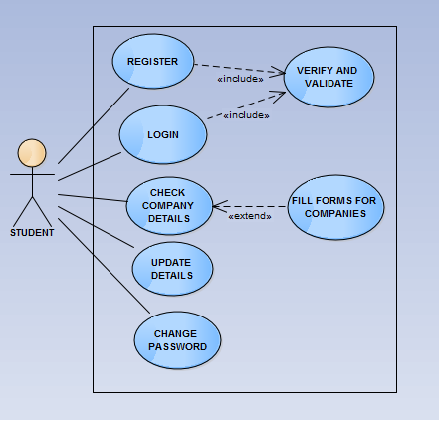

**Practical 4**

**Aim:** Preconditions and Postconditions for Training and placement Management System.

* 1. **Registration page**
     1. Preconditions:
        1. User should have a valid email address
        2. User shouldn’t be already registered
        3. User should have a stable Internet connection
        4. Username should not have any special characters other than ‘_’
     2. Postconditions:
        1. User should get a verification code on their email
        2. User’s account should be created after the verification
  2. **Login Page**
     1. Preconditions:
        1. User should have a registered account
        2. User should enter valid username/email
        3. User should enter correct password
        4. User should have a stable Internet connection
     2. Postconditions:
        1. User should be redirected to home page
        2. User should be able to access the enrolled drives

## Logout Page

* + 1. Preconditions:
    2. User should be logged in
    3. User should have a stable Internet connection
  1. Postconditions:
     1. User should be logged out from all the tabs
     2. Login/register page should appear

## Other preconditions and postconditions

* 1. Preconditions:
     1. User should have basic knowledge of using websites
     2. User should be familiar with the study-online concept
  2. Postconditions:
     1. User should be able to use the website easily

**AIM:** Draw the activity diagram for Training and Placement Management System.

### Activity Diagram:

The activity diagram used to describe flow of activity through a series of actions. Activity diagram is a important diagram to describe the system. The activity described as a action or operation of the system.

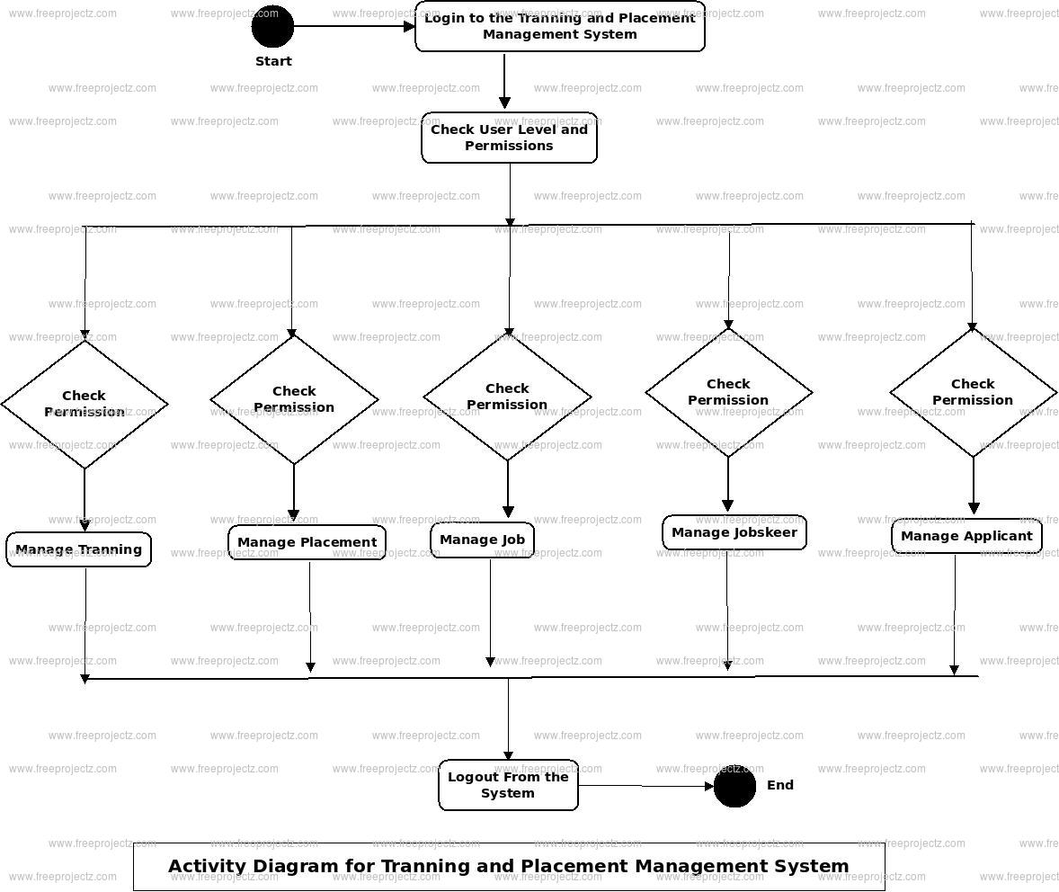

**AIM:** Draw the class diagram for Training and Placement Management System.

### Class Diagram:

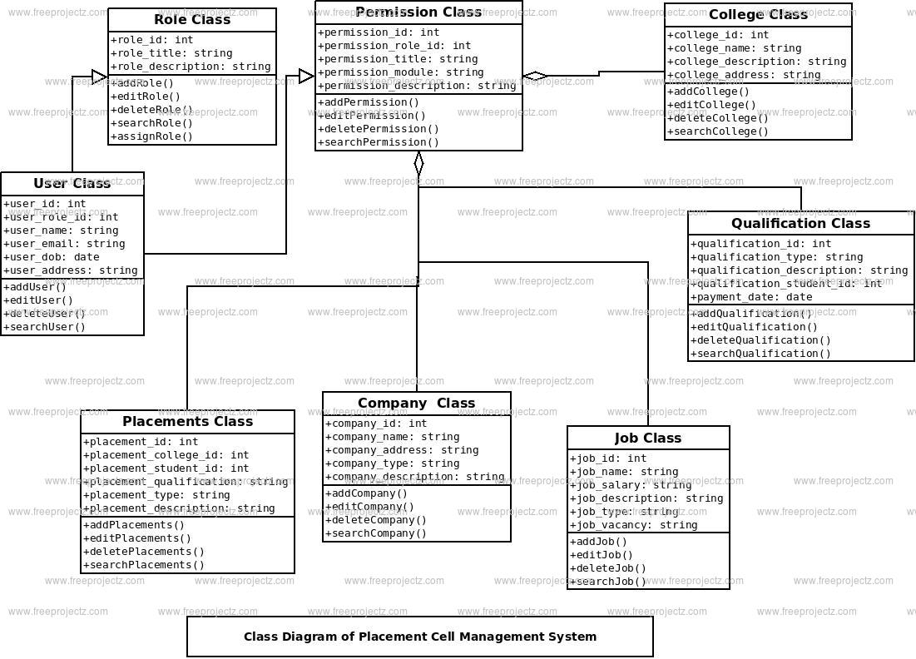

**AIM:** Draw the sequence diagram for Training and Placement Management System.

**Sequence Diagram:**

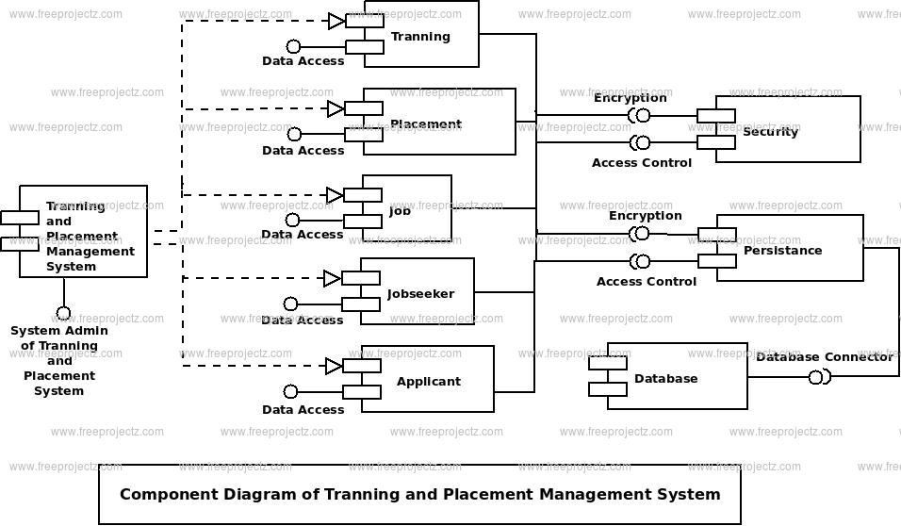

**AIM:** Design a test suite for Library Management System.

### Training and Placement Management System Login test cases

* Check if the username field accepts a valid username, and the password field accepts a valid password.
* Check if the wrong username and valid password allow access to any specific account.
* Check if the valid username and wrong password allow access to any specific account.
* Check if the forgot username link leads to a username recovery page.
* Check if the forgot password link leads to the password recovery page.
* Check if the invalid username and password trigger any warning.
* Check if the invalid credentials open the random account.
* Check if the user is logged in, allows you to log out by using the link at the bottom of the application.
* Check if the logout link function as expected.