
HTML STYLE- CSS

Cascading Style Sheets (CSS) is used to format the layout of a

webpage.

USING CSS-

Inline- by using the style attribute inside HTML elements. Internal- by using a <style> element in the <head>section.

External- by using a <link> element to link to an external CSS file.
HTML JAVASCRIPT

JavaScript makes HTML pages more dynamic and interactive.

<script>

document.getElementById("demo").innerHTML = "HelloJavaScript!";

</script>
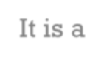

WHAT IS REACT ?

• It is a library for creating user interfaces.

• It is a library of JavaScript.

• React creates a VIRTUAL DOM in memory.

• React only changes what needs to be changed!
BUILDING COMPONENTS NOT NOT TEMPLATES

• Components are the building block of React.

• Very similar to directives in Angular JS.

• Components can be written in pure Javascript.


BENEFITS OF REACT JS

• It boosts productivity and facilitates further maintenance.

• It guarantees stable code.

• It comes with a helpful developer toolset.

• React is a Handy and Powerful JavaScript Library.

THE BEST WEBSITES EXAMPLES BUILT WITH REACT JS

• Facebook

• Netflix

• Flipboard

• Salesforce
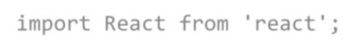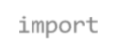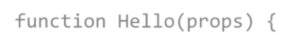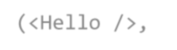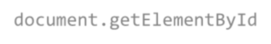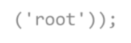

HOW TO IMPORT REACT ?

• import React from ' r e a c t ' ;

• import ReactDOM from 'react-dom';

• import ReactDOM from 'react-dom';

• function Hello(props) {

• return <h1>Hello World!</h1>;

• }

• ReactDOM.render( <Hel l o / >, document . get El ement ByI d( ' r oot ' ) ) ;


WHAT IS NODE JS
?
• Node.js is an open source server environment.

• Node.js is free.

• Node.js runs on various platforms (Windows, Linux, Unix, Mac OS X,

etc.)

• Node.js uses JavaScript on the server
APPLICATIONAREAS

• Web pages development. HTML is heavily used for creating pages

that are displayed on the world wide web

• Responsive images on web pages

• JavaScript enhances our Web page

• Creation of Dynamic web applications is easier in React JS

• Node.js uses asynchronous programming


CONCLUSION

• We come a long way in your journey to learn web development.

• We learned how to create structured and functional documents

Using HTML , CSS, JS, React JS, Node JS.

THANK YOU

