**Estate Agent and eproperty management System**

**(eproperty)**

**A Project Report Submitted**

**In partial fulfillment of the Requirements**

**for the Degree of**

**MASTER OF COMPUTER APPLICATION**

**by**

**Abhishek Kumar Yadav**

**University Roll No 1900290140002**

**Under the Supervision of**

**Prof. Neelam Rawat**

**Assistant Professor**

**KIET Group of Institutions, Delhi -NCR ,Ghaziabad**



**to the**

**Faculty of Master Of Computer Application**

**DR. APJ ABDUL KALAM TECHNICAL UNIVERSITY**

**LUCKNOW**

**(Formerly Uttar Pradesh Technical University, Lucknow)**

**June, 2022**

**Certificate**

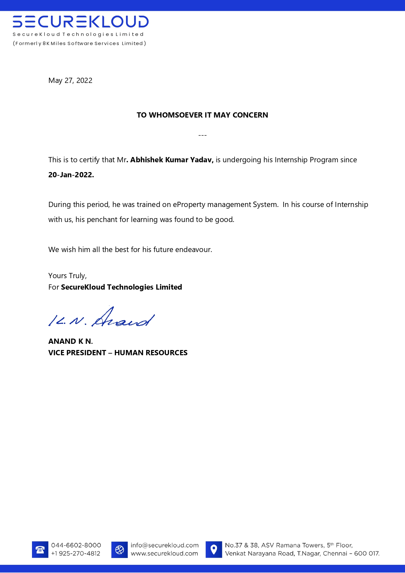

**Declaration**

I hereby declare that The Project entitled Bihar Tourist Guide Application is an outcome of my own efforts under the guidance of **Prof. Neelam Rawat**. The project is submitted to the department of MCA. For the partial fulfilment of Master of Computer Application 2019-22.

I also declare that project report is not submitted in any of the university previously.

Date: 24-May-2022

**Place: Ghaziabad**

# ABSTRACT

eProperty – is an Estate Agent and Property Management System is a user-friendly contact and property manager for real estate professionals. Save time and sell more by empowering to easily keep track of leads, manage listings, and market to new prospects. Estate Agent / Property Management System – eProperty is complete end to end solution to cover all aspects of Estate Agent Day to day activity and Property buying selling procedure for small and large organization. Maintain client details line contact details, required property details, client type like residential and commercial client. Price limit. Preference. Maintain property details, registration of property for sale includes property address, property description, price, facilities available. Store property floor plan, property documents. Creation of thumbnail of property images for brochure.

**ACKNOWLEDGEMENTS**

Success in life is never attained single handed. My deepest gratitude goes to my team leader at The **Securekloud** **Technologies Pvt Ltd** for his guidance, help and encouragement throughout my work. Their enlightening ideas, comments, and suggestions. Words are not enough to express my gratitude to Dr. Ajay Kumar Shrivastava, Professor and Head, and all faculties of Department of Computer Applications, for his insightful comments and administrative help at various occasions.

Fortunately, I have many understanding friends, who have helped me a lot on many critical conditions.

Finally, my sincere thanks go to my family members and all those who have directly and indirectly provided me moral support and other kind of help. Without their support, completion of this work would not have been possible in time. They keep my life filled with enjoyment and happiness.

Contents

ABSTRACT 4

Introduction 9

1.1 Project Description 9

PROPERTY MANAGEMENT SYSTEM PROJECT 11

2.1 Problem definition 13

Chapter 3 15

PROJECT CATEGORY 15

Key PMS System Features To Look For 17

Data Dictionary 19

Table: appointment 19

Functional Requirement of e Property Management System: 21

Waterfall Model 30

The waterfall is a universally accepted SDLC model. In this method, the whole process of software development is divided into various phases. 30

The waterfall model is a continuous software development model in which development is seen as flowing steadily downwards (like a waterfall) through the steps of requirements analysis, design, implementation, testing (validation), integration, and maintenance. 30

RAD Model 31

RAD or Rapid Application Development process is an adoption of the waterfall model; it targets developing software in a short period. 31

The RAD model is based on the concept that a better system can be developed in lesser time by using focus groups to gather system requirements. 31

Spiral Model 31

The spiral model is a risk-driven process model. This SDLC model helps the group to adopt elements of one or more process models like a waterfall, incremental, waterfall, etc. The spiral technique is a combination of rapid prototyping and concurrency in design and development activities. 31

Incremental Model 32

o The incremental model is not a separate model. It is necessarily a series of waterfall cycles. The requirements are divided into groups at the start of the project. For each group, the SDLC model is followed to develop software. The SDLC process is repeated, with each release adding more functionality until all requirements are met. In this method, each cycle act as the maintenance phase for the previous software release. 32

o Modification to the incremental model allows development cycles to overlap. After that subsequent cycle may begin before the previous cycle is complete. 32

Agile Model 32

o Agile methodology is a practice which promotes continues interaction of development and testing during the SDLC process of any project. In the Agile method, the entire project is divided into small incremental builds. All of these builds are provided in iterations, and each iteration lasts from one to three weeks. 32

Iterative Model 32

o It is a particular implementation of a software development life cycle that focuses on an initial, simplified implementation, which then progressively gains more complexity and a broader feature set until the final system is complete. In short, iterative development is a way of breaking down the software development of a large application into smaller pieces. 32

Big bang model 33

o Prototype Model 33

• 5.4Tools for Conducting a Feasibility Study 37

Suggested Best Practices 37

5.5 Suggested Components 38

Property Management System 40

A property management system (PMS) is a android application for the operations of hospitality accommodations and commercial residential rental properties. PMS is also used in manufacturing industries, local government and manufacturing. A property management system is sometimes referred to as a hotel operating system or hotel OS. 40

6.2Benefits Property Management 40

7.1 Master Modules 41

7.3 Search / Query Module 43

Analysis (DFDs, ER diagrams/Class diagrams) 53

8.3 System Architecture 54

High Level Solution Architecture 54

Use Case Diagram Guidelines 58

Relationships in Use Case Diagrams 58

o Performance 61

o Availability 61

o Reliability 61

o Scalability 61

o Location 61

o Setup/Installation 61

DESIGN METHODOLOGY - 62

PROPERTY MANAGEMENT SYSTEM 62

Data structures as per the project requirement for all modules 64

Process logic of each module - PROPERTY MANAGEMENT SYSTEM PROJECT 66

Chapter :9 67

ScreenShot 67

9.1 ResidentialProperty 67

67

9.2 Search Builder 69

Testing 71

Introduction 71

Preconditions 71

Test Organization 72

Roles and Responsibilities 72

1. Deliverables 72

2. Test Environment 72

3. Hardware and Software 72

Testing Schedules 72

Threats to Testing 72

TESTING METHODOLOGY: 74

Implementation Methodology 75

Overall network architecture 76

Further Enhancement - PROPERTY MANAGEMENT SYSTEM PROJECT 78

Bibliography 81

Websites 81

**Chapter 1**

# Introduction

# 1.1 Project Description

This project has been developed to override the problems prevailing in the practicing manual system. This application is supported to eliminate and, in some cases, reduce the hardships faced by the existing system. Moreover, this application is designed for the particular need of the company to carry out operations in a smooth and effective manner.

This application is developed to avoid errors while entering the data. It also provides error messages while entering invalid data. No formal knowledge is needed for the user to use this system. Thus, by this all it proves it is user friendly. So, this “property system” can lead to error-free, secure, reliable and fast system. It helps to buy and sell the property digitally. It also provides secure environment for the customer and seller. We are moving toward making the existing System in android application.

**1.2 Background**

As someone who travels often, it is a challenge for me to connect with the local people and culture where I travel. Problems can happen when someone travels to a whole new country where local people have different type of thinking, culture, beliefs, etc. This application come out to help tourist to get quick and better view about where they are about to visit, as well as better connects with local people and reduce the chance that troubles happen along the journey. Developing a mobile app plays an important role in the technology nowadays, as the number of mobile devices are multiple times more than the number of our population. From that huge market, Android devices get 85.9% of all mobile devices, which show us how big potential that an Android application has to affect our society. Android Studio is one of the most useful types of API, which offers a cross platform mobile development. Developing an application for android using Android Studio will give us an opportunity for later, if we want to expand the application to IOS operating system. C# is one of the most popular programming languages at the moment, with approximately 31% of all developers using it regularly. The language creates 17000 jobs each month globally. It is very effective and powerful.

**1.3 Motivations**

The motivation for this project comes from personal issues of myself, as I love traveling usually, and most of the time when I travel through Bihar, I have to spend quite a lot of time doing research while being busy with College and daily routine. The problem does not only occur to me, but also to many young travelers. This could lead to many other serious problems, as the difference in cultures is huge, and the number of people who travel is enormous and still growing rapidly. Similar to AirBnb, which shows the 8 problem of housing, this application could show the problem about guiding. The motivation also comes from the personal practice as a Android developer in my training.

**CHAPTER TWO**

##### LITERATURE REVIEW

According to Scarrett (1995) “property management system seeks to advice the establishment of an appropriate framework within which to oversee property holdings to achieve the agreed short and long-term objectives of the estate owner and particularly to have regard to the purpose for which the estate is held.

The basic needs will be to carry out such tasks as negotiating lettings on suitable terms; initiating and negotiating rent reviews and lease renewals, overseeing physical maintenance and the enforcement of lease covenants (Michael, 2003).

Successful property management system is a demanding activity which requires relevant understanding, ability and appropriate technical and organizational skills as well as resources to successfully maintain and improve property value through to its obsolescence (Huang, 2000).

 Property assets, which include land and buildings, are a key resource for all types of organizations, including local authorities and central governments. In the same way as other resources - human, financial and information - contribute to the success of these organizations, and so does the property resource. (Rhodes, 2008).

These activities will take place within an agreed strategic framework where there is a need to be mindful of the necessity of upgrading and merging interests where possible, recognizing other opportunities for the development of potential and fulfilling the owner’s legal and social duties to the community” (James and Donald 2000)**.** Not only is a large amount of capital devoted to these assets, they can also add value to an organization through effective and often creative management.

Two of the major criticisms of inadequate management practices are the lack of a strategic approach to property management and the limited recognition of the value of these assets by property users and operational decision makers, resulting in potential asset becoming a major liability (Huang, 2000). But many organizations, internally and externally, have responded to the challenges and introduced a number of measures in order to improve their management practices related to operational property.

### 2.1 Problem definition

Property management system for this organization uses traditional method of keeping records of the client’s files. This manual record keeping in the organization has been characterized by a lot of problems, such as:

a.Lack of skill in interpretation of reports from the activities of the organization.

b.Data losses: loss of data perhaps would happen if all information only kept inside paper on.

c.Data redundancies: abundant and repetition data also perhaps will happen.

d.No database to store information: by using manual system, loss of data perhaps will happen.

e.No backup and security: still information to contemporary system perhaps have been trespassed easily or stolen, this is because of the insecurity in the manual system used in the organization.

**2.2 Project planning**

Project planningis part of [project management](http://en.wikipedia.org/wiki/Project_management), which relates to the use of [schedules](http://en.wikipedia.org/wiki/Schedule_(project_management)) such as [Gantt charts](http://en.wikipedia.org/wiki/Gantt_chart) to plan and subsequently report progress within the project environment. Below is a table illustrating a project planning of this project.

**2.3 Project Scheduling (PERT chart)**

The [project schedule](http://www.projectinsight.net/features/intelligent-scheduling) is the tool that communicates what work needs to be performed, which resources of the organization will perform the work and the timeframes in which that work needs to be performed. The project schedule should reflect all of the work associated with delivering the project on time. Without a full and complete schedule, the project manager will be unable to communicate the complete effort, in terms of cost and resources, necessary to deliver the project.

A PERT chart is a project management tool used to schedule, organize, and coordinate tasks within a project. PERT stands for Program Evaluation Review Technique. The fig1 below shows the pert chart expression used in this project

## Chapter 3

## PROJECT CATEGORY

**3.1 Technology Used**

**Android Studio**

Android Studio is the official Integrated Development Environment (IDE) for Android app development, based on [IntelliJ IDEA](https://www.jetbrains.com/idea/). On top of IntelliJ's powerful code editor and developer tools, Android Studio offers even more features that enhance your productivity when building Android apps.

**SoftWare and Applications Used**

APPLICATION : Android Studio

OPERATING SYSTEM : WINDOWS 10

FRONT END : JAVA, Xml

BACK END : Firebase

**Back-end : Firebase**

* **Firebase:-** It is Realtime database developed by firebase and then acquired by Google in 2014 used for developing the high quality applications act as a storage of information of various data.

**3.2** **Language Used**

This project has been developed XML and Java.

* **XML:** XML stands for extensible markup language. A markup language is a set of codes, or tags, that describes the text in a digital document. The most famous markup language is hypertext markup language (HTML), which is used to format Web pages.
* **JAVA:** Java is an object-oriented programming language developed by Sun Microsystems, and it was released in 1995.

James Gosling initially developed Java in Sun Microsystems (which was later merged with Oracle Corporation).

Java is a set of features of C and C++. It has obtained its format from C, and OOP features from C++.

Java programs are platform independent which means they can be run on any operating system with any processor as long as the Java interpreter is available on that system.

Java code that runs on one platform does not need to be recompiled to run on another platform; it's called write once, run anywhere(WORA)

**3.3 APPLICATION DESCRIPTION**

Not all [property management software](https://www.hirum.com.au/property-management-software/) is created equally. Modern systems, however, combine multiple functions into a single piece of software to make the guest and hotel management process as seamless and easy as possible.

### Key PMS System Features To Look For

The key features of a good PMS should include:

* Reservation management
* Front desk operations management
* Channel management integration
* Mobile apps
* Marketing support
* CRM & guest communication
* Housekeeping management
* Maintenance management
* Accounting and revenue management
* Reports and analytics

**3.3.1 Function Description**

The purpose of the application is to create an environment for people who buy or sells often to meet locals, who provide the service through an android application. The application includes two separate view, which provide different function to different group of users.

• Buyer User Group: First allows the user to register, then uses that register information to log in. In the main tab, the user will be able to view past request, as well as create a new request which will be sent to buyer User Group for their acceptance. This will require the user to enable the location service on their mobile application, for the authorization.

• Seller User Group: This view also allows the user to register and log in. From the main tab, users of this group will see all the pending requests, which they will be able to click in, in order to view the information of that pending request, as well as contact the one who sent the request in order to negotiate about the upcoming trip. After that, the guide person will either accept that request, so that other sells users will not see that request or choose to leave it for the other sells users.

**Chapter 4**

**SOFTWARE REQUIREMENT SPECIFICATION**

**3 Requirement Specifications:**

The software requirement specification is produced at the analysis task. The function and performance allocated to application as part of system engineering are refined by establishing a complete information description, a detailed functional and behavioural description, an indication of performance requirements and design constraints.

# Data Dictionary

Data dictionary of Property Management System

## Table: appointment

**Owner:** dbo

**Destination DB name:** eProperty

**Number of columns:** 14

**Number of indexes:** 1

**Number of foreign keys:** 1

**Extended attributes:**

**OnFileGroup** PRIMARY

**Clustered PK** Yes

|  |  |  |  |
| --- | --- | --- | --- |
| **Columns** | **Data type** | **Allow NULLs** | **Value/range** |
| **Appointment** | Int | Not allowed |  |
| **AppointmentType** | Varchar(50) | Not allowed |  |
| **AppointmentwithName** | Varchar(100) | Not allowed |  |
| **Address** | Varchar(100) | Not allowed |  |
| **ClientRefNo** | Int | Not allowed |  |
| **PropRefNo** | Int | Not allowed |  |
| **VenderRefNo** | Int | Not allowed |  |
| **AppointmentStatus** | Varchar(5) | Not allowed |  |
| **Date** | Int | Not allowed |  |
| **Time** | Int | Not allowed |  |
| **View** | Int | Not allowed |  |
| **Seen** | Int | Not allowed |  |
| **Like** | Varchar(50) | Not allowed |  |
| **Note** | Datetime | Allowed |  |

|  |  |  |
| --- | --- | --- |
|  |  |  |

**4.1 Functional Requirements:**

**Internet Connectivity:**

As discussed, that Application will work on Online mode so it needs regular Internet Connectivity to sign up and login.

**Facebook Account**

User can directly login to the Facebook account to access this application they don’t need to signing in apps environment for which Facebook account is mandatory.

**Email id and Mobile Number**

To access the application and to signing or login user must have email id and mobile number to fill the mandatory field in the form.

### Functional Requirement of e Property Management System:

#### **Registration:**

Users can register themself in the system. Admin will verify their profile to work properly. Once a user is registered with the system. He/she can register his/her property-to-Property Management System. Admin will view the property and verify that property only if that would be real with a reasonable price.

#### **Validation:**

Validation is very important in the system. Invalid data can corrupt the valid data. So, we need to apply validation in each module. Validation would ensure the safety and security of data.

#### **Client Record:**

Client data should be secure. We should take care of clients’ data privacy in our minds. The client is the basic unit of our business. Client data and records would help us to provide them better information.

#### **Add Property:**

This function allows the admin and client to add the property details. But only the admin can verify the property details. Without verification property, details would not reflect in the system.

#### **List of Property with details**:

All properties should be listed and reflected client. The client can view these listed properties and book the desired property.

#### **Payment options:**

Clients can pay the money or property via any mode they wish to do. They can pay via cash, credit cards, debit cards, online net banking, online wallets, etc. The system should not restrict them to some payment option.

#### **Feedback and Suggestion**:

Feedback and suggestions are key to improve in business. Therefore, we need to take the feedback from our customers to improve our services.

**4.2 Non-functional Requirements:**

**Performance Requirements**

1. User friendly**:** The system should be user friendly so that it can easily be understand by the user without any difficulty.
2. Ease of maintenance: - System should be easy to maintain and use.
3. Less time consuming: The system should be less time consuming which could be achieved by good programming.
4. Error free: The system should easily handle the user error in any case.
5. Static: Application runs on standalone machine i.e. Android mobile phone of API level 16 and onward. Support only single user.

#### **Improve Search option:**

The search option should be rich enough to provide the property details to clients as per their requirements and wish. The search option should search in the whole database. Efficient search option attracts the client to buy and rent the property.

#### **Support Multi-User**:

Nowadays, every system work in an environment of multi-users. As per the requirement of the system, our system is developed in a multi-user environment.

#### **Fast:**

The search option should be fast enough to produce a result of the search in seconds. Every module should to compatible with other modules. There should not be any lag or delay in processing the data.

#### **Available(24X7):**

Property Management System should be available to clients 24X7. The user can access the system whenever they need to access it, wherever they want to access provided having an internet connection and device to access.

**SOFTWARE AND HARDWARE REQUIREMENTS**

This section describes the software and hardware requirements of the system.

**4.4 SOFTWARE REQUIREMENTS**

• **Operating system**- Android operating system is required for the android apps with the API Level 16 and onwards.

• **Database**: - Firebase is used as database as it is easy to maintain and retrieve records by simple queries which are in English language which are easy to understand and easy to write.

• **Development tools and Programming language**- XML is used to write the whole designing code and coding is done in java programming language.

**4.5 HARDWARE REQUIREMENTS**

* Android Mobile phone of API Level 19 and onward.
* Memory Used Total 6.31 MB with 5.98 MB of application space and 340 KB of data

**4.6 Software System Attributes**

* **Security**: The system should be secure from the unauthorized access and should be password protected so that no other user can access it.

If the user is new then he needs to Sign up with required details and a can also login with the Facebook.

* **Portability**: - The system should be machine independent.
* **Maintainability**: The system will be designed in a maintainable order. The system can be easily modified and renewed according to the need of the organization.

**4.7 Methodology**

The methodologies of this research include:

·Using available data/information

·Oral interview.

·Observation.

·Database design and web programming

The observation here refers to the method which involves careful looking at the staff and institution of the students when carrying out activities in their works, since the project focused on Android Application development with database, it is important therefore to use good database design and android programming tools.

The database management system of choice is Firebase while the android programming was done with XML and Java.

**Benfit Of Property Management System**

* Type of property and features searching for.
* Match with properties for sale by number of bedrooms / price criteria.
* Filter all views for easy record location
* Allow easy entry of Property and Vendor details
* Easy to use and impressive GUI.
* Auto spells checker facility to check spelling and suggest for changes while entering data by connecting MS Word spell checker.
* Easy maintenance monitoring
* Easy payments from tenants and contractors
* Property management
* Data tracking

**Features of Property management system:**

* **Communicating**– You can contact tenants directly through text messages and by email using a designed-in communication feature and functionality. You could even send messages separately or even in mass, build groups and save the chat history inside the application.
* **Online payments**– Integration of payments will help you to mitigate the hours spent on billing and bring down the cost incurred on paper records and collect funds safely. You give your audience a fast solution by providing an online payment feature, as well as allowing them the opportunity to check their bank statements or collect receipts. With automatic alerts and email updates, the online payment feature functions perfectly.
* **Maintenance Management**– Property management software enables support and maintenance requests to be handled, service providers and suppliers to be scheduled and tenants and property owners to communicate about scheduled maintenance tasks.
* **Space Management**– The space management feature and functionality role simplifies the allocation of resources, tracks, reports on the usage of space and materials and allows physical properties to be properly controlled.
* **Document Management**– All the data about your property, land, tenants, and finances can be saved by your property management software. You can upload, import, and handle documents such as flow statements or lease rolls using a personalized solution.
* Security of data.
* Ensures data accuracy.
* Minimize manpower.
* Minimum time consumption.
* Greater efficiency.
* Fast
* Better services.
* User friendliness and interactive.
* Minimum time required.

• Easy to update

• User friendly

• Free for the user

• knowing about Bihar, India

**Preliminary investigation:**

Fact Finding:

After obtaining the background knowledge, we began to collect data on the existing system.

The tools that are used in information gathering are as follows:

* On-site observation.
* Questionnaire.
* Review of the peoples.

The model we have used is Waterfall Model. In this model, first of all the existing system is observed, then customer requirements are taken in consideration then planning, modelling, construction and finally deployment.

**Application System Attributes**

1. **Security**: The system should be secure from the unauthorized access and should be password protected so that no other user can access it.

If the user is new then he needs to Signup with required details and a can also login with the facebook.

1. **Portability**:- The system should be machine independent.
2. **Maintainability**: The system will be designed in a maintainable order. The system can be easily modified and renewed according to the need of the organization.

**4.10** **Approach used**

Software Development life cycle (SDLC) is a spiritual model used in project management that defines the stages include in an information system development project, from an initial feasibility study to the maintenance of the completed application.

There are different software development life cycle models specify and design, which are followed during the software development phase. These models are also called "**Software Development Process Models**." Each process model follows a series of phase unique to its type to ensure success in the step of software development.

**Here, are some important phases of SDLC life cycle:**

### [Waterfall Model](https://www.javatpoint.com/software-engineering-waterfall-model)

### The waterfall is a universally accepted SDLC model. In this method, the whole process of software development is divided into various phases.

### The waterfall model is a continuous software development model in which development is seen as flowing steadily downwards (like a waterfall) through the steps of requirements analysis, design, implementation, testing (validation), integration, and maintenance.

Linear ordering of activities has some significant consequences. First, to identify the end of a phase and the beginning of the next, some certification techniques have to be employed at the end of each step. Some verification and validation usually do this mean that will ensure that the output of the stage is consistent with its input (which is the output of the previous step), and that the output of the stage is consistent with the overall requirements of the system.

### [RAD Model](https://www.javatpoint.com/software-engineering-rapid-application-development-model)

### RAD or Rapid Application Development process is an adoption of the waterfall model; it targets developing software in a short period.

### The RAD model is based on the concept that a better system can be developed in lesser time by using focus groups to gather system requirements.

* Business Modeling
* Data Modeling
* Process Modeling
* Application Generation
* Testing and Turnover

### [Spiral Model](https://www.javatpoint.com/software-engineering-spiral-model)

### The spiral model is a ****risk-driven process model****. This SDLC model helps the group to adopt elements of one or more process models like a waterfall, incremental, waterfall, etc. The spiral technique is a combination of rapid prototyping and concurrency in design and development activities.

* Each cycle in the spiral begins with the identification of objectives for that cycle, the different alternatives that are possible for achieving the goals, and the constraints that exist. This is the first quadrant of the cycle (upper-left quadrant).
* The next step in the cycle is to evaluate these different alternatives based on the objectives and constraints. The focus of evaluation in this step is based on the risk perception for the project.
* The next step is to develop strategies that solve uncertainties and risks. This step may involve activities such as benchmarking, simulation, and prototyping.

### [Incremental Model](https://www.javatpoint.com/software-engineering-incremental-model)

### The incremental model is not a separate model. It is necessarily a series of waterfall cycles. The requirements are divided into groups at the start of the project. For each group, the SDLC model is followed to develop software. The SDLC process is repeated, with each release adding more functionality until all requirements are met. In this method, each cycle act as the maintenance phase for the previous software release.

### Modification to the incremental model allows development cycles to overlap. After that subsequent cycle may begin before the previous cycle is complete.

### [Agile Model](https://www.javatpoint.com/software-engineering-agile-model)

### Agile methodology is a practice which promotes continues interaction of development and testing during the SDLC process of any project. In the Agile method, the entire project is divided into small incremental builds. All of these builds are provided in iterations, and each iteration lasts from one to three weeks.

* Any agile software phase is characterized in a manner that addresses several key assumptions about the bulk of software projects:
* It is difficult to think in advance which software requirements will persist and which will change. It is equally difficult to predict how user priorities will change as the project proceeds.
* For many types of software, design and development are interleaved. That is, both activities should be performed in tandem so that design models are proven as they are created. It is difficult to think about how much design is necessary before construction is used to test the configuration.
* Analysis, design, development, and testing are not as predictable (from a planning point of view) as we might like.

### [Iterative Model](https://www.javatpoint.com/software-engineering-iterative-model)

### It is a particular implementation of a software development life cycle that focuses on an initial, simplified implementation, which then progressively gains more complexity and a broader feature set until the final system is complete. In short, iterative development is a way of breaking down the software development of a large application into smaller pieces.

### [Big bang model](https://www.javatpoint.com/software-engineering-big-bang-model)

* Big bang model is focusing on all types of resources in software development and coding, with no or very little planning. The requirements are understood and implemented when they come.
* This model works best for small projects with smaller size development team which are working together. It is also useful for academic software development projects. It is an ideal model where requirements are either unknown or final release date is not given.

### [Prototype Model](https://www.javatpoint.com/software-engineering-prototype-model)

The prototyping model starts with the requirements gathering. The developer and the user meet and define the purpose of the software, identify the needs, etc.

* A '**quick design**' is then created. This design focuses on those aspects of the software that will be visible to the user. It then leads to the development of a prototype. The customer then checks the prototype, and any modifications or changes that are needed are made to the prototype.

**4.9Approach used: Agile Approach**

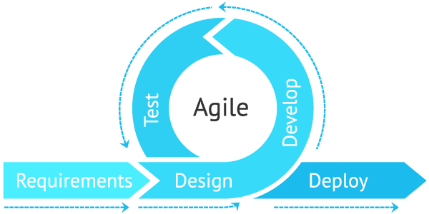

Agile is **an iterative approach to project management and software development that helps teams deliver value to their customers faster and with fewer headaches**. Instead of betting everything on a "big bang" launch, an agile team delivers work in small, but consumable, increments.

**4.10 Preliminary Description:**

The first step in the system development life cycle is the preliminary investigation to determine the feasibility of the system. The purpose of preliminary investigation is to evaluate project requests. It is not a design study nor does it include the collection of details to describe the system in all respect. Rather, it is the collecting of information that helps committee members to evaluate the merits of project request and make an informed judgement about the feasibility of the proposed project.

**Analyst working on the preliminary investigation should accomplish the following objectives:**

* Clarify and understand the project request.
* Determine the size of the project.
* Access costs and benefits of alternative approaches.
* Determine the technical and operational feasibility of alternative approaches.
* Report the findings to management with recommendations outlining the acceptance and rejection of the proposal.

**Chapter 5**

**Feasibility study**

* After studying and analysing all the existing and requires functionalities of the system, the next task is to do the feasibility study for the project. Feasibility study includes consideration of all the possible ways to provide a solution to a given problem. The proposed solution should satisfy all the user requirements and should be flexible enough so that future changes can be easily done based on the future upcoming requirements.

**5.1 Economical Feasibility:**

It will be freely available on the Google play store without having any cost. **Economic feasibility** is a kind of [cost](https://ceopedia.org/index.php/Cost)-benefit analysis of the examined [project](https://ceopedia.org/index.php/Project), which assesses whether it is possible to implement it. This term means the assessment and analysis of a project's potential to support the decision-making [process](https://ceopedia.org/index.php/Process) by objectively and rationally identifying its strengths, weaknesses, opportunities and risks associated with it, the resources that will be needed to implement the project, and an assessment of its chances of success. It consists of [**market**](https://ceopedia.org/index.php/Market)**analysis**, **economic analysis**, **technical and**[**strategic analysis**](https://ceopedia.org/index.php/Strategic_analysis).

**5.2 Technical feasibility:**

This included the study of function, performance and constraints that may affect the ability to achieve an acceptable system. For this feasibility study, we studied complete functionalities to be provided in the system, as described in the System Requirement Specification (SRS), and checked if everything was possible using different type of front end and back-end platform.

**5.3 Operational Feasibility:**

No doubt the technically growing property management needs more enhancement in technology, this apps is very user friendly and all inputs to be taken easily, Operational feasibility is **the measure of how well a proposed system solves the problems**, and takes advantage of the opportunities identified during scope definition and how it satisfies the requirements identified in the requirements analysis phase of system development

* explanatory even to a layman. As far our study is concerned, the clients are comfortable and happy as the system has cut down their loads and doings.

## 5.4Tools for Conducting a Feasibility Study

### Suggested Best Practices

Although each project can have unique goals and needs, below are some

best practices for conducting a feasibility study:

* Conduct a preliminary analysis, which involves getting feedback about the new concept from the appropriate stakeholders; consider other business scenarios and ideas
* Analyze and ask questions about the data obtained in the early phase of the study to make sure that it's solid
* Conduct a market survey or market research to identify the market demand and opportunity for pursuing the project or business
* Write an organizational, operational, or business plan, including identifying the amount of labor needed, at what cost, and for how long
* Prepare a projected [income statement,](https://www.investopedia.com/terms/i/incomestatement.asp) which includes revenue, operating costs, and[profit](https://www.investopedia.com/terms/n/netincome.asp)
* Prepare an opening day [balance sheet](https://www.investopedia.com/terms/b/balancesheet.asp)
* Identify obstacles and any potential vulnerabilities, as well as how to deal with them
* Make an initial "go" or "no-go" decision about moving ahead with the plan

### 5.5 Suggested Components

Once the initial due diligence has been completed, listed below are several of the components that are typically found in a feasibility study:

* **Executive summary**: Formulate a narrative describing details of the project, product, service, plan, or business.
* **Technological considerations**: Ask what will it take. Do you have it? If not, can you get it? What will it cost?
* **Existing marketplace**: Examine the local and broader markets for the product, service, plan, or business.
* **Marketing strategy**: Describe it in detail.
* **Required staffing**(including an organizational chart): What are the [human capital](https://www.investopedia.com/terms/h/humancapital.asp) needs for this project?
* **Schedule and timeline**: Include significant interim markers for the project's completion date.
* **Project financials Findings and recommendations**: Break down into subsets of technology,marketing, organization, and financials.

**Chapter 6**

**Planning and Scheduling and Flow**

6.1 Gantt chart

A Gantt chart can be developed for the entire project or a separate chart can be developed for each function. A tabular form is maintained where rows indicate the task with milestones and columns indicate duration(weeks/months).

|  |  |  |  |  |  |  |  |  |  |  |  |  |  |  |
| --- | --- | --- | --- | --- | --- | --- | --- | --- | --- | --- | --- | --- | --- | --- |
| days  Process | 1-5 | | 6-25 | 26-30 | | | 30-80 | | 80-85 | | | 85-90 | | |
| Requirement  Gathering |  |  |  |  | | |  | |  | | |  | | |
| Design |  |  |  |  | | |  | |  | | |  | | |
| Test Cases |  | |  |  |  |  | |  | | |  | | |  |
| Coding |  | |  |  |  | |  | |  | | |  | | |
| Testing |  | |  |  | | |  | |  |  | |  |  | |

# Property Management System

# A property management system (PMS) is a android [application](https://www.techtarget.com/searchsoftwarequality/definition/application) for the operations of hospitality accommodations and commercial residential rental properties. PMS is also used in manufacturing industries, local government and manufacturing. A property management system is sometimes referred to as a hotel operating system or hotel OS.

PMS provides a centralized computer system to organize, schedule and perform the day-to-day functions and transactions involved in accommodations businesses.

# 6.2Benefits Property Management

* Match with properties for sale by number of bedrooms / price criteria.
* Filter all views for easy record location
* Allow easy entry of Property and Vendor details
* Easy to use and impressive GUI.
* Auto spells checker facility to check spelling and suggest for changes while entering data by connecting MS Word spell checker.

**Chapter 7**

**Modules Description**

### 7.1 Master Modules

Master module is developed to maintain property registration, floor plan and property images, maintain property document, client registration, vendor registration solicitor details, and user management.

* **Property Registration:** This module is used to register new property details, there are two different types of forms for Residential property and commercial property, all property are registered with . I.
* **Property Document**:
* **Floor Plan and Property Images**:
* **Client Registration**:
* **Vendor Registration**:
* **Solicitor Master**:
* **Login:** User must provide their user’s name and.
* **Main Menu:** After successfully login system display main screen with.
* **User Master:** The System Administrator can able to add, modify system users, and also set the login rights and.
* **Change Password:** User can change his/her own password.

**7.2 Transaction Modules**

Transaction module is developed to perform various activities like match property with clients, maintain history for. Send email.

* **Match client with properties:** This module is used to match client requirement with register property, system has flexible options to select client’s requirement and it search the database and show all matched same window.
* **Match Property with clients:**
* **Property History:**
* **Client History:**
* **Vendor History:**
* **Offer Letter:**
* **Offer Acceptance Letter:**
* **Confirmation:**
* **Agent Outgoing Phone**:
* **Incoming Phone/ Enquiry**:
* **Appointment**: t.
* **Diary / Set appointment**:
* **Property Thumbnail**: System generate HTML page for properties with property images and all details like cost, location. This file can be saved and send client via email.

### 7.3 Search / Query Module

* Search and Query module is used for the user, supervisor and management of Property Management System.
* The search and query module will include the following features:

**Search Module**:

* **Extensive Search:** System has unique keyword-based search engine, which allow user to search anything from entire database, It helps user when he not sure where to search, for example if user want to search for ‘AJAY’, this search will search for all table and all field for ‘AJAY’ and produce search results.
* Update Keyword: This is used to generate keyword
* Both of these areas of functionality will be delivered as the first version of the Property Management System is released. Functionality is described in more detail later in this document.

**7.4 SYSTEM IMPLEMENTATION**

* **Implementation of security mechanisms at various levels.**

This document describes the user acceptance test plan for the Property

ManagementSystem. The complete test strategy for the Property

Management System is to perform the following kinds of tests, in

sequence:

**7.5 TESTING**

Testing plays a vital role in the success of the system. System testing makes a

logical assumption that if all parts of the system are correct, the goal will be

successfully achieved. Once program code has been developed, testing begins.

The testing process focuses on the logical internals of the software, ensuring that

all statements have been tested, and on the functional externals, that is conducted

tests to uncover errors and ensure that defined input will produce actual results

that agree with required results.

**OBJECTIVES OF TESTING:**

1) Testing is a process of executing a program with the intent of finding the error.

2) A good test case is one that has a high probability of finding on unpredictable error.

3) A successful test is one that provides solution for unpredictable error.

The Minimum aim of testing process is to identify all defects existing in software product. Software product testing accomplishes a variety of things, but most importantly it measures the quality of the software that is developed. This view presupposes that there as defects in the software waiting to be discovered and this view is rarely disproves or even dispute.

**III] TESTING PLAN:**

Specifications of the product would be related to:

i) Functions of the system.

ii) Response criteria

iii) Volume constraints (no. of users)

iv) Stability criteria (24 hour)

v) Database responses (flushing, cleaning)

vi) Network criteria (network traffic)

vii) Compatibility (Environment & Browsers)

viii) User Interface / Friendliness criteria

ix) Modularity (ability to easily interface)

x) Security

**TESTING STRATEGY:**

i) As each module is developed it is tested and if found faultless is integrated in main module.

ii) If the module is not perfect it is built again.

Each test plan item should have the following specific characteristics:

i) It should be uniquely identifiable.

ii) It should be unambiguous.

iii) It should have well-defined test-data (test parameters)

iv) It should have well-defined pass/fail criteria for each sub-item and overall-criteria for the pass/fail of the entire test itself.

v) It should be easy to record.

vi) It should be easy to demonstrate repeatedly

vii) To prepare test plans.

viii) To specify conditions for user acceptance testing.

ix) To prepare test data for transaction path testing.

x) To plan user training.

**TESTING PROCEDURE:**

The testing part forms an important aspect of any System and is vital for success of the system. System testing makes a logical assumption that if all the parts of the system are correct, the goal will be successfully achieved. Philosophy behind testing the system is to find errors & rectify it.

The system test change is transitional one, as it represents the period during which control of the newly developed system passes from the hands of the development team to final users. It is therefore a critical point as it is the last opportunity to check the system before it is being used. The testing stage seeks to ensure following aspects of system from user point of view:

·Completeness

Correctness

·Reliability

Thus a testing plan is necessary, as it will aid to maximize the effectiveness of discovering error by early & controlled production of test plans & test specifi

**Chapter 8**

**ER Diagram**

**8.1 ER Diagram** stands for Entity Relationship Diagram, also known as ERD is a diagram that displays the relationship of entity sets stored in a database. In other words, ER diagrams help to explain the logical structure of databases. ER diagrams are created based on three basic concepts: entities, attributes and relationships.

ER Diagrams contain different symbols that use rectangles to represent entities, ovals to define attributes and diamond shapes to represent relationships.

**Following are the main components and its symbols in ER Diagrams:**

* **Rectangles:** This Entity Relationship Diagram symbol represents entity types
* **Ellipses:** Symbol represent attributes
* **Diamonds:** This symbol represents relationship types
* **Lines:** It links attributes to entity types and entity types with other relationship types
* **Primary key:** attributes are underlined
* **Double Ellipses:** Represent multi-valued attributes

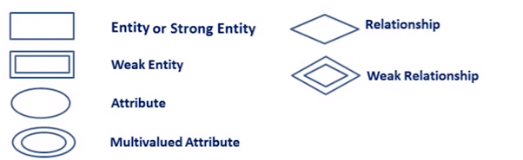

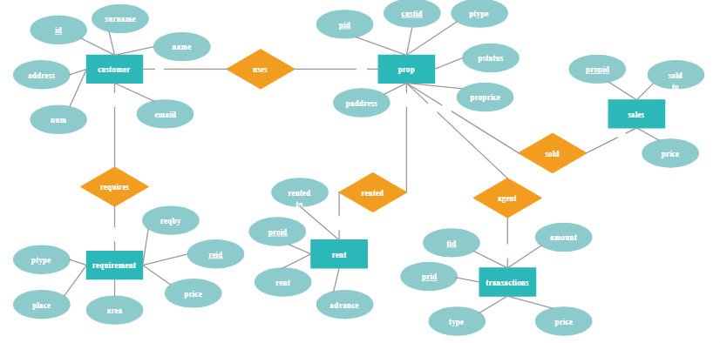

Fig 1.1 ER Diagram of Property management system

**Data Objects:**

A data object is a representation of almost any composite information that must be understood by the software. By composite information, we mean something that has a number of different properties or attributes. A data object encapsulates data only there is no reference within a data object to operations that act on the data.

**Attributes:**

Attributes define the properties of a data object and take on one of three different characteristics. They can be used to:

·Name an instance of data object.

·Describe the instance.

·Make reference to another instance in other table.

Below is a graphical representation of ER diagram

**8.2 Data Flow Diagram**

**DFD** is the abbreviation for **Data Flow Diagram**. The flow of data of a system or a process is represented by DFD. It also gives insight into the inputs and outputs of each entity and the process itself. DFD does not have control flow and no loops or decision rules are present. Specific operations depending on the type of data can be explained by a flowchart. Data Flow Diagram can be represented in several ways. The DFD belongs to structured-analysis modelling tools. Data Flow diagrams are very popular because they help us to visualize the major steps and data involved in software-system processes.

#### Components of DFD

The Data Flow Diagram has 4 components:

* **Process**  
  Input to output transformation in a system takes place because of process function. The symbols of a process are rectangular with rounded corners, oval, rectangle or a circle. The process is named a short sentence, in one word or a phrase to express its essence
* **Data Flow**  
  Data flow describes the information transferring between different parts of the systems. The arrow symbol is the symbol of data flow. A relatable name should be given to the flow to determine the information which is being moved. Data flow also represents material along with information that is being moved. Material shifts are modelled in systems that are not merely informative. A given flow should only transfer a single type of information. The direction of flow is represented by the arrow which can also be bi-directional.
* **Warehouse**  
  The data is stored in the warehouse for later use. Two horizontal lines represent the symbol of the store. The warehouse is simply not restricted to being a data file rather it can be anything like a folder with documents, an optical disc, a filing cabinet. The data warehouse can be viewed independent of its implementation. When the data flow from the warehouse it is considered as data reading and when data flows to the warehouse it is called data entry or data updation.
* **Terminator**  
  The Terminator is an external entity that stands outside of the system and communicates with the system. It can be, for example, organizations like banks, groups of people like customers or different departments of the same organization, which is not a part of the model system and is an external entity. Mode led systems also communicate with terminator.

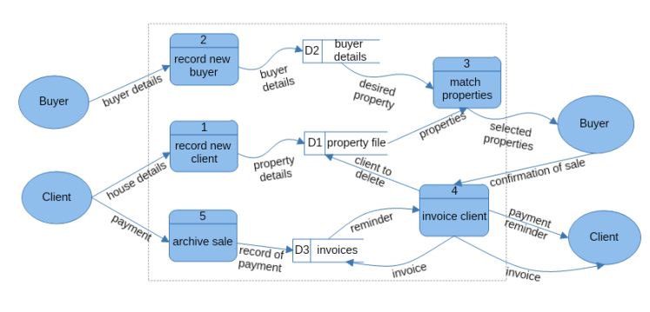

Fig 1.2 DFD of Property management system

### Analysis (DFDs, ER diagrams/Class diagrams)

The development of an improved property management system for any organization starts with the analysis of a particular problem that can be solved and ends up with the newly-developed system being fasted and put into place. First you need to investigate and analyze the problem, then, software needs to be written, and computer programmers write instruction for the computer in a language it can understand. There is need to think in a logical, detailed and careful way in order to develop a successful system.

The proposed system is an automated property management system for organizations which store and record information about property available for sale by the organization. It accepts data as inputs, processes and produces to stored record information of the department. The inputs specifications are variable that are attribute of the staffs, administrator and their section they belongs to.

**Solution Concept**The Property Management System consists of:

* **Master Module:**  
  A master module is developed to maintain property registration, floor plan and property images, maintain property document, client registration, vendor registration solicitor details, and user management.
* **Transaction Module:**  
  A transaction module is developed to perform various activities like match property with clients, maintain history for client, property and history. Generating offer letter, print offer letter. Managing incoming and outgoing calls, Maintain appointment and diary. Generating property thumbnail. Send email
* **Search and Query Module:**  
  Search and Query module is used for the user, supervisor and management of Property Management System. This module includes query builder and keyword based search facilities.

# 8.3 System Architecture

## High Level Solution Architecture

Data

Data Warehouse

OLAP Access

**Data Access**

SQL OLEDB Driver

Properties

Client

Vendor

Match property with client

Search and Retrieval

of Information

**Transactional Facade**

**Retrieval Facade**

**System**

Windows Application

Microsoft VB Run Time

.Net Framework 2.0

CLR

Database Engine

Search and Query data

High Level Solution Architecture of online Property Management System

A system architecture is the conceptual model that defines the structure, behavior, and more views of a system. An architecture description is a formal description and representation of a system, organized in a way that supports reasoning about the structures and behaviors of the system.

An architecture is "the fundamental organization of a system, embodied in its components, their relationships to each other and the environment, and the principles governing its design and evolution

**Use Case Diagram**

A use case diagram is used to represent the dynamic behavior of a system. It encapsulates the system's functionality by incorporating use cases, actors, and their relationships. It models the tasks, services, and functions required by a system/subsystem of an application. It depicts the high-level functionality of a system and also tells how the user handles a system.

**Use Case Diagram objects**

Use case diagrams consist of 4 objects.

* Actor
* Use case
* System
* Package

The objects are further explained below.

##### Actor

Actor in ause case diagram is **any entity that performs a role** in one given system. This could be a person, organization or an external system and usually drawn like skeleton shown below.



##### Use Case

A use case **represents a function or an action within the system**. It’s drawn as an oval and named with the function.

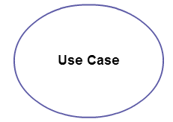

##### System

The system is used to **define the scope of the use case** and drawn as a rectangle. This an optional element but useful when you’re visualizing large systems. For example, you can create all the use cases and then use the system object to define the scope covered by your project. Or you can even use it to show the different areas covered in different releases.

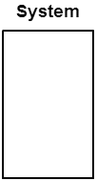

##### Package

The package is another optional element that is extremely useful in complex diagrams. Similar to [class diagrams](https://creately.com/diagram-type/class-diagram), packages are **used to group together use cases**. They are drawn like the image shown below.

[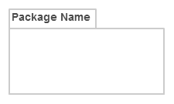](https://d3n817fwly711g.cloudfront.net/blog/wp-content/uploads/2014/03/Package1.png)

### Use Case Diagram Guidelines

Although use case diagrams can be used for various purposes there are some common guidelines you need to follow when [drawing use cases.](https://creately.com/diagram/example/hfuu87vt2/login page)

These include naming standards, directions of arrows, the placing of use cases, usage of system boxes and also proper usage of relationships.

We’ve covered these guidelines in detail in a separate blog post. So go ahead and check out [use case diagram guidelines](https://creately.com/blog/diagrams/use-case-diagram-guidelines/).

### Relationships in Use Case Diagrams

There are five types of relationships in a use case diagram. They are

* Association between an actor and a use case
* Generalization of an actor
* Extend relationship between two use cases
* Include relationship between two use cases
* Generalization of a use case

We have covered all these relationships in a separate blog post that has examples with images. We will not go into detail in this post but you can check out [relationships in use case diagrams](https://creately.com/blog/diagrams/use-case-diagram-relationships/).

8.4 Usage Summary

User

Supervisor

Administrator

**Property Management System**

Property Management System Version 1.0 will address the following use cases. Selected use cases will be expanded into usage scenarios and features that are derived from both use cases and the usage scenarios, as represented in the following diagram:

**7.5** **General Rquirement for Server/Client:**

|  |  |  |
| --- | --- | --- |
| **Type** | **Software** | **Hardware** |
| Work Station/ Node | 1. Windows XP  2. .NET Framework 2.0 | 1. P-4  2. RAM -256 MB  3.Hard Disk-40GB |
| Database Server | 1.Win2000 Advance Server  2. SQL Server 2005 | 1.P-4  2.RAM- 1GB  3.Hard Disk-40GB |
| Application Server | 1.Win 2000 Advance Server | 1.P-4  2.RAM- 1GB  3.Hard Disk-40GB |

**Features Of Application**

## Performance

## Availability

## Reliability

## Scalability

* + Security
  + . Interoperability

## Location

## Setup/Installation

Setup and installation must not interrupt the system user’s daily tasks and work flow.

No more than a 5-percent degradation in average query response is allowed while all concurrent user are using the system.

Processor utilization should not exceed 80 percent during all concurrent users are using the system.

Because the system is accessed by more than one concurrent user so there should not be any single point of failure.

Every resource in the system is defined by the role and privileged. System administrator assigned user role and privileged for their access rights.

### DESIGN METHODOLOGY -

### PROPERTY MANAGEMENT SYSTEM

The systems development life-cycle concept applies to a range of hardware and software configurations, as a system can be composed of hardware only, software only, or a combination of both. If the SDLC concept is adhere to, the programmer will derive good software that is error free that will satisfied all the needs in a good condition. The phases are as follows:

**Requirements Phase**:automation needs of the business functions are collected and quantified.The requirements include business rules that govern the work of the user, definition of specific business functions or processes, and levels of security needed to protect the business’ information.

**Analysis phase**:In the analysis phase the requirements gathered in the requirements phase, are used to create report definitions and layouts, screen definitions and layouts, data element definitions, workflow diagrams, and security matrices.

**Design** phase:in the design phase the logical model developed in the analysis phase, is used to develop a “physical” model of the application.The physical model contains business object logic, database schemas identifying relationships, web object design and layout, report calculations and processing, and the security object definition.

**Coding/development phase**:In the coding/development phase the individual objects or components of the application are coded from the physical model. Once the system objects have been developed, they are gathered and connected together (integrated) to create a working application.The integrated application is placed on a staging server for testing.

**Testing phase**: This encompasses three testing stages; component testing, requirements testing, and acceptance testing.In all testing stages, defects are identified and returned to the development/coding phase for correction.

**Maintenance phase**: In the maintenance phase the deployed application is maintained through scheduled backups. Any changes to the application are presented to the programmer.

The maintenance phase **happens after the project team deploys the software and it's fully operational in the customer environment**. During the maintenance phase, the customer monitors the software to ensure it continues to operate according to the coding specifications.

**Number of Modules**

·Main Menu - Display available options

·Property Master

·Search module

·Agent

· Administration Module

### Data structures as per the project requirement for all modules

Table 2: Main Menu

|  |  |  |
| --- | --- | --- |
| Field | Description | Type |
| 1 | Banner | Image |
| 2 | Links | Text |
| 3 | Body | Image and Text |
| 4 | Footer | Text |

Table 3: Property master:

|  |  |  |
| --- | --- | --- |
| Field | Description | Type |
| 1 | Banner | Image |
| 2 | Links | Text |
| 3 | Body | Image and Text |
| 4 | Footer | Text |

Table 4: Search module:

|  |  |  |
| --- | --- | --- |
| Field | Description | Type |
| 1 | Banner | Image |
| 2 | Links | Text |
| 3 | Body | Image |
| 4 | Footer | Text |

Table 5: Agent Module

|  |  |  |
| --- | --- | --- |
| Field | Description | Type |
| 1 | Banner | Image |
| 2 | Links | Text |
| 3 | Body | Text |
| 4 | Footer | Text |

Table 6: Administration module

|  |  |  |
| --- | --- | --- |
| Field | Description | Type |
| 1 | Banner | Image |
| 2 | Links | Text |
| 3 | Body | Image |
| 4 | Footer | Text |

### Process logic of each module -PROPERTY MANAGEMENT SYSTEM PROJECT

**Main menu**: The main menu will contain banner of the company, will be visually engaging and also provide clear navigation to the rest of the web page. And the customers can see more about our new product. Below is the graphical representation of the main menu.

**Property master**: To post property on website the property owner has to register first. After successful registration property owner can login to proceed ahead. Below is the snapshot of property master.

**Search module**: In search module user can search for different types of property uploaded by registered user. User will get to know all information about property its location, area, its approximate price, owner details. The search module snapshot is below:

**Agent module**: Agent is having the same functionality as property owner. The main advantage of agent is that if the user is having property to sell or rent but he does not have knowledge of computer and internet then he can sell or rent property through agent.

**Administrator module**:In administrator module administrator allow the property to be uploaded and active that property to show other user who search for property. Administrator can add new category and type of property to the system so that users can add their property according to the category and type. Below is the administration module snapshot

# Chapter :9

# ScreenShot

### 9.1 ResidentialProperty

### 

Residential property is **property zoned specifically for living or dwelling for individuals or households**; it may include standalone single-family dwellings to large, multi-unit apartment buildings. Our aim is to align this form in mobo friendly environment and to develop the Android Application. Now a days we are converting all these technology into Android.

### 9.2 Search Builder

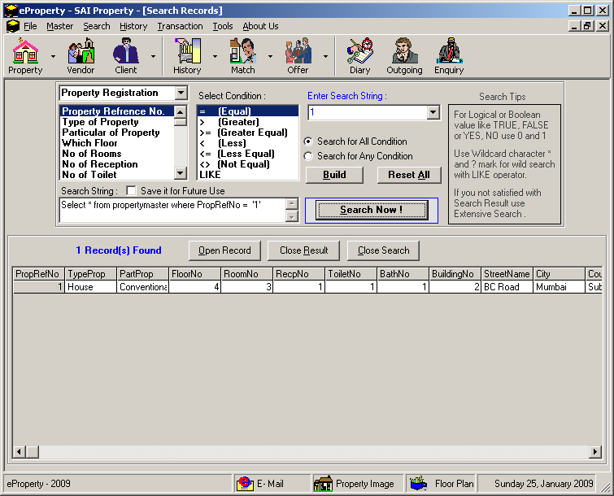

Search builder is use to provide the facility to find best builder registered in the application/ software to serve the customers.

**9.3** **Match Property**

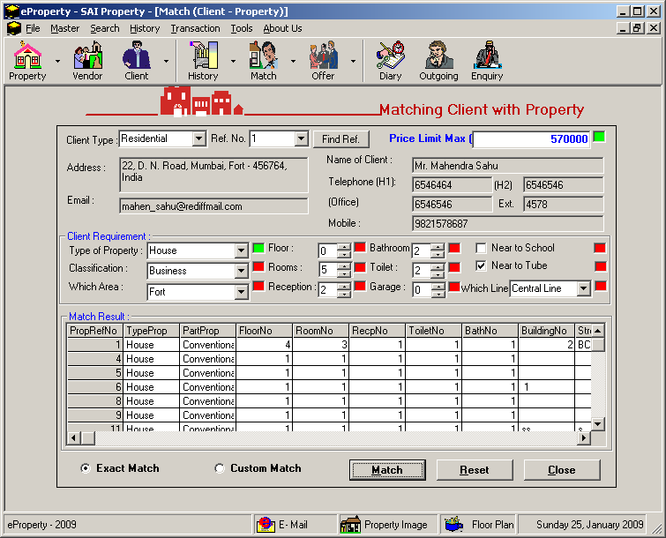

According to the parameter given by customer it will help in filtering the property for the user that is best match for them.

## Testing

## Introduction

This document describes the user acceptance test plan for the Property ManagementSystem. The complete test strategy for the Property Management System is to perform the following kinds of tests, in sequence:

1. **Component testing** of each component that makes up the Property ManagementSystem
2. **Integration testing** of the Property ManagementSystem, to ensure the correct interworking of its components
3. **Validation testing** of the Property ManagementSystem, to ensure that it works correctly in a pseudo-live environment
4. **User acceptance testing** of the Property ManagementSystem, to ensure that its function is acceptable to its users

Acceptance testing is the last set of tests to be performed before the application goes officially live.

## Preconditions

The following items are required before testing can take place:

* A complete and coherent functional specification of the Property Management System expressed as use cases and usage scenarios
* Sufficient, suitable resources to carry out the testing

## Test Organization

## Roles and Responsibilities

* The following roles are defined:
* QA lead/test manager—responsible for planning and ensuring the smooth running of the test process
* Tester—carries out the tests according to the test plan, and then reports the results
* Product manager—ensures that the tests are carried out successfully from a user perspective

## Deliverables

## Test Environment

## Hardware and Software

## Testing Schedules

* The user acceptance testing schedules are shown in the project structure document and resulting Gantt charts.

## Threats to Testing

* Potential threats to the testing process are as follows:
* **Insufficient resources available for testing.** Testing resources have been seconded from the development departments, whose time is at a premium. Mitigation: ensure department heads apply a high priority to the testing of the Property ManagementSystem.
* **Availability of sales personnel for testing.** The test team should be overseen by at least one sales representative. Mitigation: gain prior agreement from the vice president of Sales for two sales representatives to be assigned to test the application.

**TESTING STRATEGY:**

i) As each module is developed it is tested and if found faultless is integrated in main module.

ii) If the module is not perfect it is built again.

Each test plan item should have the following specific characteristics:

i) It should be uniquely identifiable.

ii) It should be unambiguous.

iii) It should have well-defined test-data (test parameters)

iv) It should have well-defined pass/fail criteria for each sub-item and overall-criteria for the pass/fail of the entire test itself.

v) It should be easy to record.

vi) It should be easy to demonstrate repeatedly

vii) To prepare test plans.

viii) To specify conditions for user acceptance testing.

ix) To prepare test data for transaction path testing.

x) To plan user training.

### TESTING METHODOLOGY:

To be truly robust, distributed applications require more than simple functional testing before release into production. At least one and preferably all of the following types of testing before releasing application to customers should be performed.

·Performance Testing

·Load Testing

·Stress Testing

·Endurance Testing

**TESTING PROCEDURE:**

The testing part forms an important aspect of any System and is vital for success of the system. System testing makes a logical assumption that if all the parts of the system are correct, the goal will be successfully achieved. Philosophy behind testing the system is to find errors & rectify it.

The system test change is transitional one, as it represents the period during which control of the newly developed system passes from the hands of the development team to final users. It is therefore a critical point as it is the last opportunity to check the system before it is being used. The testing stage seeks to ensure following aspects of system from user point of view:

·Completeness

·Correctness

·Reliability

Thus a testing plan is necessary, as it will aid to maximize the effectiveness of discovering error by early & controlled production of test plans & test specification.

### Implementation Methodology

Behind every successful project implementation is a combination of critical factors such as the right technology, the implementation, integration services and training. The failure of one of these factors hinders the implementation and success of the project.

Based on my research, expertise and industry best practices, an implementation methodology is to offer unparalleled service. The implementation processes are as follows:

* Deliverables are well-defined, documented and signed off
* Technical pre-requisites are documented and communicated
* Delivery process is understood and agreed to by all key participants
* Solution is designed and tested to meet client specifications
* Progress is documented and communicated to key participants
* Changes are managed and controlled
* Issues are logged, tracked, and acted upon
* The deployment of the solution is controlled and risk-free

**List of report**

Following are the reports names that are generated by the Project for property management system;

·Details of Administrative staff

·Class wise detail of Clients

·Date wise detail of agents based on date of admission

·Detail of clients according to name wise

·Administration report based on the Date of joining

##### 

### Overall network architecture

**Network Architecture**

**UML** standard has no separate kind of diagrams to describe **network architecture** and provides no specific elements related to the networking.[Deployment diagrams](http://www.uml-diagrams.org/deployment-diagrams-overview.html) could be used for this purpose usually with some extra networking [stereotypes](http://www.uml-diagrams.org/profile-diagrams.html" \l "stereotype). Network architecture diagram will usually show networking [nodes](http://www.uml-diagrams.org/deployment-diagrams.html" \l "node) and between them. The example of the network diagram below shows network architecture with configuration called "two firewall demilitarized zone". Demilitarized zone **(DMZ)** is a host or network segment located in a "neutral zone" between the Internet and an organization’s intranet (private network). It prevents outside users from gaining direct access to an organization’s internal network while not exposing a web, email or DNS server directly to the Internet.

The following diagram is the Network architecture diagram overview - network devices and communications. Note: this diagram uses networking icons that are **not** part of the UML standard. UML's standard for the node [device](http://www.uml-diagrams.org/deployment-diagrams.html" \l "device)is a 3-dimensional view of a cube.

## 

**Future Scope**

As per the user Requirement our whole project is designed. We can add an additional constraint to our project. We will also try to make the modification, update, delete, any other facility in our project. This can be used in educational institutions as well as for other commercial purpose.

Some of them are:-

·This can be used in educational institutions as well as in corporate world.

·Business relationship with comprehensive online services like transport, banking etc.

·Affiliate Marketing Systems, Web site Design, and Development and Search Engine optimization.

·Integration with other standard Application Software Products &Booking Engines / Platforms, Fare & Content Management Systems

### Further Enhancement - PROPERTY MANAGEMENT SYSTEM PROJECT

Nothing is perfect in this world. So, we are also no exception. Although, we have tried our best to present the information effectively, yet, there can be further enhancement in the Application.

We have taken care of all the critical aspects, which need to take care of during the development of the Project.

Like the things this project also has some limitations and can further be enhances by someone, because there are certain drawbacks that do not permit the system to be 100% accurate.

The application is yet to be released and a lot of enhancements are already thought of which are proposed to be implemented in the final version of the web-application. The web-application has also provided feedback page on its home page so that the users can provide their inputs of any functionalities/facilities they would like to have in the web application.

The system is highly flexible one and is well efficient to make easy interactions with the client. The key focus is given on data security, as the project is online and will be transferred in network. The speed and accuracy will be maintained in a proper way.

This will be a user-friendly one and can successfully overcome strict and severe validation checks. The system will be a flexible one and changes whenever can be made easy. Using the facility and flexibility in .NET and SQL, the software can be developed in a neat and simple manner there by reducing the operator’s work.

Since the project is developed in .NET as a front-end and SQL Server as a back-end it can be modified easily and used for a long period. Following are some of the enhancement proposed to be implemented in final version.

·Maps are provided to facilitate the users.

·Lease option should be provided regarding properties.

·Give access of website on mobile and PDAs

·Send SMS to property owner who have registered and uploaded his property.

·Giving property site for all metro cities.

·Upload videos / 3d views of the property.

**PURPOSE**

The old system was suffering from a series of drawbacks. Since whole of the system was to be maintained with hands, the process of keeping, maintaining and retrieving the information was very tedious and lengthy. There would always be unnecessary consumption of time by listening the different different history of the same place which was not the real one A property management system (PMS) is software that **facilitates a hotel's reservation management and administrative tasks**. The most important functions include front-desk operations, reservations, channel management, housekeeping, rate and occupancy management, and payment processing.

**CONCLUSION**

Property Management System (PMS) software is very crucial for all the Hotels. Especially Opera PMS constitutes the most appropriate PMS software for Hilton Athens. It is user friendly, connects with Central Reservation System (CRS), Point of Sale (POS) etc. and provides all the tools the hotel needs in order to operate effectively. In this project property assistance in hand will help to get help from property in this new version of Digitalization.

# Bibliography

## Websites

* <https://www.javatpoint.com/java-tutorial>
* <https://econsortium.aktu.ac.in/?p=53567>
* <https://econsortium.aktu.ac.in/?p=44663>
* <https://econsortium.aktu.ac.in/?p=45859>
* <https://econsortium.aktu.ac.in/?p=50743>
* <https://econsortium.aktu.ac.in/?p=48665>
* <https://econsortium.aktu.ac.in/?p=44431>
* <https://econsortium.aktu.ac.in/?p=47417>
* <https://econsortium.aktu.ac.in/?p=48102>

<https://econsortium.aktu.ac.in/?p=47417>