**PARK TICKET MANAGEMENT**

**(Using Python django)**

# A PROJECT REPORT

**Submitted in partial fulfillment of the Requirements**

**for the Degree of**

MASTER OF COMPUTER APPLICATION

# by

**AKSHAY KUMAR GOYAL**

**(Univ. Roll No.: 1900290140005)**

**Under the Supervision**

**Of**

**MS. NEELAM RAWAT**

**Associate Professor**



**Submitted to**

**DEPARTMENT OF COMPUTER APPLICATIONS**

**KIET Group of Institutions, Ghaziabad**

**Uttar Pradesh (20120**

**DR. A.P.J. ABDUL KALAM TECHNICAL UNIVERSITY, LUCKNOW (MAY ,2022)**

# DECLARATION

I hereby declare that the work presented in this report entitled “Park Ticket management (using Python and Django)", was carried out by me. I have not submitted the matter embodied in this report for the award of any other degree or diploma of any other University or Institute.

I have given due credit to the original authors/sources for all the words, ideas, diagrams, graphics, computer programs, experiments, results, that are not my original contribution. I have used quotation marks to identify verbatim sentences and given credit to the original authors/sources.

I affirm that no portion of my work is plagiarized, and the experiments and results reported in the report are not manipulated. In the event of a complaint of plagiarism and the manipulation of the experiments and results, I shall be fully responsible and answerable.

Name: Akshay Kumar Goyal

Roll.No.:1900290140005

Branch: MCA

**(Candidate Signature)**

**TRAINING CERTIFICATE**



**To Whomsoever it may concern**

This is to certify that Akshay Kumay Goyal has successfully completed training on python with the add Python and Django framework from 1/2/2022 to 30/04/2022. Akshay Kumar Goyal is trained under the guidance of Sanjay Gupta.

In course of the training, he showed a very positive attitude toward training.

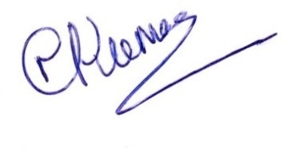Authorized Signatory

Nittin Mogha

Chief Manager – Human Resource

**CERTIFICATE**

Certified that **Akshay Kumar Goyal (**enrollment no 1900290140040) has carried out the project work presented in this thesis entitled **“Park ticket management (using Python and Django)”** for the award of **Master of Computer Application** from Dr. APJ Abdul Kalam Technical University, Lucknow under my supervision. The thesis embodies results of original work, and studies are carried out by the student herself and the contents of the thesis do not form the basis for the award of any other degree to the candidate or to anybody else from this or any other University.

## Ms. NEELAM RAWAT External Examiner

(Internal Examiner)

Associate Professor

Dept. of Computer Applications

KIET Group of Institutions, Ghaziabad

Date:

**ABSTRACT**

Park Ticket Management System on python and Django framework is an application based on various services.

This project manages people and provides ticket to the person who comes to visits in park with his/her family. With this project admin is able to see how many people is visiting in park and also see how many tickets is generating in particular period.

The objective of this project is to develop a web application for Online Ticket system

➢ The objective of this project is to provide the daily data.

➢ The objective of this project is to provide the data of people who are visiting.

➢ It makes use of various technologies to get required crime-oriented information more quickly, easily, colorfully and attractively.

# ACKNOWLEDGEMENT

Success in life is never attained single handedly. My deepest gratitude goes to my thesis supervisor, **Ms. Neelam** for her guidance, help and encouragement throughout my project work. Their enlightening ideas, comments, and suggestions.

Words are not enough to express my gratitude to **Dr. Ajay Kumar Shrivastava**, Professor and Head, Department of Computer Applications, for his insightful comments and administrative help at various occasions.

Fortunately, I have many understanding friends, who have helped me a lot in many critical conditions.

Finally, my sincere thanks go to my family members and all those who have directly and indirectly provided me moral support and other kinds of help. Without their support, completion of this work would not have been possible in time. They keep my life filled with enjoyment and happiness.

Akshay Kumar Goyal

Enrollment no-1900290140005

**TABLE OF CONTENT**

### PageNo.

### Chapter 1. Introduction

1. Introduction to the System 4
2. Problem Definition 4
3. Aim 4
4. Objective 4
5. Goal 5
6. Need of System 5

**Chapter 2. Literature Review** 13-18

### Chapter 3. Hardware and Software requirement

1. Introduction 20
2. System environment 20
3. Software requirement 21
4. Hardware requirements 21

### Chapter 4. System Analysis

1. Purpose 23
2. Project Scope 23
3. Existing System 23
4. Proposed System 23
5. System Description 24

### [Chapter 5. Implementation issues](#chap 8)

1. Python 25
2. HTML 25
3. Cascading style sheet (CSS) 26
4. Sqlite 27

**Chapter 6. System Design**

1. Introduction 30
2. Conceptual Design 31
3. ER-Diagram 32
4. Logical Design 33
5. Physical Design 34
6. Data Flow Diagram 35

### [Chapter 7. User Screens](#chap 8) 38-46

### [Chapter 8. Coding](#chap 8) 47-82

**Chapter 9. Advantages and limitations**

1. Features of “Park Ticketing Management System” 83
2. Benefits Accrued from “PTMS” 83
3. Limitations of “PTMS” 84

Chapter 10. Conclusion 85

Chapter 11. Bibliography 86

**Chapter 12. References** 87

**LIST OF FIGURES**

1. Admin

2. Dfd (Data Flow Diagram)

3. Er Diagram

4. Sequence Diagram for Administrator

5. Class Diagram:

6. Home Page

7. Admin Dashboard Page

8. Manage Ticket Type Page

9. Add Ticket Page Manage Ticket Page

10. Search Between Dates Reports Page

11. View Between Date Reports

12. Search Ticket Page

13. Change Password Page

**CHAPTER 1**

**Introduction**

*Contents:*

* Introduction
* Problem Definition
* Aim
* Objective
* Goal
* Need of System

**Introduction to the System:**

Park Ticketing Management System is a web-based technology which manages people and provides ticket to the person who comes to visits in park with his/her family. This web application provides a way to effectively control record & track the people who visit to park.

A park Ticketing Management system effectively manages and handles all the functioning of a park. The software system can store the data of people tickets that came to visit in the park. The system also maintains and calculates the price of ticket. The system needs an administrator to input the detail of ticket like how many are adult and how many are child and print the ticket and give it to person.

**Problem Definition:**

In present all park ticketing work done on the paper. The whole year record is stored in the registers. We can’t generate reports as per our requirements because its take more time to calculate the park ticketing report.

**Disadvantage of present system:**

* **Not user friendly:** The present system not user friendly because data is not stored in structure and proper format.
* **Manual Control:** All report calculation is done manually so there is a chance of error.
* **Lots of paper work:** Ticketing records maintain in the register so lots of paper require storing details.
* **Time consuming**

**Need of the System:**

There is always a need of a system that will provide a way to effectively control records & track peoples traffic in the park.

Thus, there is a big need of developing park ticketing management system is to computerized the traditional way of ticketing management. Another need for developing this application is to generate the report automatically.

**CHAPTER 2**

**LITERATURE REVIEW**

# 2.1 Configurable hardware components generator in Python

Traditional hardware description languages are limited when describing highly configurable and reusable hardware components. The paper introduces methodology based on a Python language for design of hardware component generators on higher abstraction level. The scripting language is used to produce customizable cycle accurate hardware behavior and open-source tools provide automatic conversion to register transfer level. A case study presents configurable graphics processing component design. The automatic interface insertion, state machine synthesis and pipeline configuration provided by the proposed methodology enables efficient hardware description and design space exploration.

**2.2 A Survey: How Python Pitches in IT-World**

This paper lights on Python amongst other different programming paradigms used in the IT World, which enhances development speed. Although, Python was conceptualized in the late 1980s and after its implementation in 1989, it has emerged as a new multi-paradigm language platform with advent of Big Data. Python includes various data structures, standard libraries with the implementation of sentiment analysis and data science code. The real aim is to provide awareness to all the programmers about various facts of python language. It tells how Python works with various commercial and social communities and provides complete and desirable results. There are many areas and applications where Python makes its own stand as compared to other programming languages.

**2.3 JS Optimizer: An Extensible Framework for JavaScript Program Optimization**

JavaScript has become a popular programming language. It is widely used in both client-side and server-side programming in web applications. The robustness and performance of JavaScript programs become vital. Unfortunately, real-world JavaScript programs often suffer from various issues. In this work, we present nine issue patterns derived from open-source projects and propose a general static analysis framework, JSOptimizer, to help detect such patterns of issues and optimize the code accordingly. Comparing to existing work, JSOptimizer is not only highly extensible but also performs code optimizations automatically. We applied JS Optimizer to seven real open-source JavaScript projects and five bugs detected by it have been confirmed by developers. Besides, we conducted a case study based on a popular project and found that addressing the issues detected by our framework can speed up the original project by over 300%. This shows the usefulness of JS Optimizer.

**2.4 Javascript ahead-of-time compilation for embedded web platform**

Web applications (apps) programmed using HTML, CSS, and JavaScript have advantages in portability and productivity, compared to Android or IOS apps. However, web apps are involved with some performance issue, due to JavaScript with its dynamic typing and prototypes which are difficult to execute efficiently. One popular way of accelerating JavaScript is using the just-in-time compilation (JITC), which translates the JavaScript source code to the machine code at runtime. Unfortunately, JavaScript JITC for web apps suffers from the parsing and compilation overhead seriously, which offsets the performance gain of executing the compiled code. In this paper, we propose ahead-of-time compilation (AOTC) of JavaScript at the client device. We save the code generated by the JITC at the first run of the web app, so that we can reuse the code in the next runs to remove the parsing and the compilation overhead.

**2.5 Modern JavaScript frameworks: A Survey Study**

With the increasing popularity of the web, some new web technologies emerged and introduced dynamics to web applications, in comparison to HTML, as a static programming language. JavaScript is the language that provided a dynamic web site which actively communicates with users. JavaScript is used in today's web applications as a client script language and on the server side. The JavaScript language supports the Model View Controller (MVC) architecture that maintains a readable code and clearly separates parts of the program code. The topic of this research is to compare the popular JavaScript frameworks: AngularJS, Ember, Knockout, Backbone. All four frameworks are based on MVC or similar architecture. In this paper, the advantages and disadvantages of each framework, the impact on application speed, the ways of testing such JS applications and ways to improve code security are presented.

**2.6 Integration of HTML pages in Web Pages**

The growing number of Web pages on the Internet introduces a need to combine and integrate information from HTML tables of different Web pages that contain similar information into a single Web page, especially information from the same domain of interest. This paper presents an approach of HTML table integration by combining several existing methods that are proved to solve different issues in the integration processes. The integration of HTML table consists of three phases: (1) extraction of the structure of the tables; (2) integration of the tables' schema; (3) integration of the data values. To solve the conflicts in semantics and naming in the tables schema, domain-ontology is used.

**2.7 Extracting Elements of HTML Documents**

Information on the Web, which are conglomeration of heterogeneous data, such as texts, images and audio clips, are often accessed through documents written according to the HTML specification. According to the HTML specification, HTML documents are semistructured in nature. We propose a high-level stack machine (HSM) which accesses an HTML document through its URL and constructs a semistructured data graph (SDG) of the document. The SDG of an HTML document H precisely captures the structure of the semistructured data embedded in H based on the dependency relationship among the data objects in H. HSM is configurable to accommodate a user's interest with respect to the HTML elements in H to be considered during the construction process of the SDG of H.

**2.8 A Webpage Data Hiding Method by Using Tag and CSS Attribute Setting**

Computer networks connection becomes the most important way for people to contact each other, share information, and transmit privacy data. Because the Internet is not secure enough, data hiding techniques provide a good manner to deliver secret data with security. HTML webpage not only can be used to advertise a company's product but also used to share someone experience or knowledge. The HTML file is different from a digital image because it is composed of tags but pixels. CSS provides more options and assistance to help HTML file coding to create colorful web pages. The proposed method utilizes both HTML and CSS's properties to achieve the goal of secret data delivery. The experimental results indicate that the proposed method has a larger embedding capacity than others.

**2.9 High performance PL/SQL programming**

Performance engineering is a vital aspect in PL/SQL programming, as most of the Database associated applications are built with PL/SQL Code. There subsists many ways of writing PL/SQL statement to retrieve same result set, but the approach which levies minimum impact on DBMS engine is always esteemed. Most commercial transaction scripts are written using PL/SQL code. The proposed idea(s) are envisioned to oblige as tuning utility and benchmark for tuning PL/SQL queries. This paper enunciates different techniques that can reduce time and space complexity of a native SQL query and PL/SQL script. Our analysis reduced the rate of Context switching (an overhead) among SQL engine and PL/SQL engine.

**2.10 On the IO Characteristics of the SQLite Transactions**

This work is dedicated to study the IO characteristics of SQLite transaction in Android platform. We collect the block level IO trace from for six months. We develop an elaborate pattern matching algorithm. It allows us to identify the individual SQLite transactions from the raw IO trace, which is essentially an interleaved mixture of IO requests from concurrently running smartphone applications. Among the various observations obtained from the study, we can summarize the key findings as follows. We carefully believe that these deserve special attention. First, SQLite transaction is under extreme inefficiency. In an SQLite transaction, the IO's for SQLite journaling and EXT4 filesystem journaling account for over 75% of the entire IO volume in a transaction. Second, the suspend and the wakeup feature of the smartphone can leave the SQLite transaction to an extreme delay, a few minutes.

**2.11 A Method of Optimizing Django Based on Greedy Strategy**

Django on Python does well in agile web development. Python is dynamic programming language, as is known, its runtime efficiency is low. the question is how it will affect Django's efficiency. This Paper answered the question from the angle of memory optimization, by improving the efficiency of Python in memory use, we will see how it will affect django. Python manages non-container objects with the technology of memory pool, after a consequence of allocate and free operations, it will produce memory fragment, and the garbage collection module can hardly handle it. This paper proposed a new non-container object management greedy algorithm, it can minimize the probability of generating fragments, thus the garbage collection module can collect garbage non-container objects in time. We conduct our experiment on the benchmark of an open-source project named Unladen-Swallow. When Django renders a template, it will save about 10% memory, with almost the same time consuming.

**2.12 Development of a Continuous System Simulation Engine in Python Programming Language**

This paper portrays the development of an simulation engine in Python programming language with focus on the continuous system simulation. Features of the engine are based on CSMP block-oriented language and software for continuous system simulation. The aim of the paper is threefold. Firstly, the paper describes the need and usage of such engine. Second goal is to analyze Python concepts used for the implementation of the simulation engine - API development, communication with smart systems, real-time data processing, integration of differential equations, threading and parallel programming. And last, this paper will depict the engine architecture, use cases and usage of the analyzed concepts in the development process.

**2.13 Extraction of information from log files Using Python Programming and Tableau**

Application servers generate daily log files with a significant part of their activity. This information is recorded sequentially over time but mixes various types of information. The absence of a standard for formatting the data record and the respective volume, make it difficult to extract the corresponding information. The lack of work, specifically in the treatment of SOA server log files, did not allow the comparisson with pre-existing Key Performance Indicators (KPI) or a set of best practices that could be followed. This work results in a description of the process that can serve as a guide for: definition of a logging structure; construction of a data extraction process; definition of a data structure to support the extracted information; definition of control metrics; definition of analysis and control processes for the extracted data.

**CHAPTER 3**

**Hardware and Software Requirements**

*Contents:*

##### Introduction

* System environment
* Software requirement
* Hardware requirements

**Introduction:**

In this chapter we mentioned the software and hardware requirements, which are necessary for successfully running this system. The major element in building systems is selecting compatible hardware and software. The system analyst has to determine what software package is best for the **“Online Park Ticketing Management System”** and, where software is not an issue, the kind of hardware and peripherals needed for the final conversion.

**System Environment:**

After analysis, some resources are required to convert the abstract system into the real one.

The hardware and software selection begins with requirement analysis, followed by a request for proposal and vendor evaluation.

Software and real system are identified. According to the provided functional specification all the technologies and its capacities are identified. Basic functions and procedures and methodologies are prepared to implement. Some of the Basic requirements such as hardware and software are described as follows: -

**Hardware and Software Specification**

**Software Requirements:**

* Technology: Python Django
* IDE : Pycharm/Atom
* Client Side Technologies: HTML, CSS, JavaScript , Bootstrap
* Server Side Technologies: Python
* Data Base Server: Sqlite
* Operating System: Microsoft Windows/Linux

**Hardware Requirements:**

* Processor: Pentium-III (or) Higher
* Ram: 64MB (or) Higher
* Hard disk: 80GB (or) Higher

**CHAPTER 4**

**System Analysis**

*Contents:*

##### Purpose

* Project Scope
* Existing System
* Proposed System
* System Overview

### Purpose:

# The purpose of developing park ticketing management system is to computerized the traditional way of ticketing. The system maintains and calculates the price of ticket. Another purpose for developing this application is to generate the report automatically.

**Project Scope:**

The project has a wide scope, as it is not intended to a particular organization. This project is going to develop generic software, which can be applied by any business’s organization. More over it provides facility to its users. Also, the software is going to provide a huge amount of summary data.

**Proposed System:**

The proposed system will affect or interface with the person who visits in the park and administrator.

The system works and fulfills all the functionalities as per the proposed system.

It will provide reduced response time against the queries made by different users.

This project is based on PYTHON language with SQLITE database which manages people and provides ticket to the person who comes to visits in park with his/her family.

All possible features such as verification, validation, security, user friendliness etc have been considered.

**System Overview:**

The key features required in the system are as follows:

1. **Dashboard**: In this section, admin can see how many foreigners and Indian ticket is generating today and yesterday.
2. **Manage Ticket**: In this section, admin can update price and ticket type of ticket.
3. **Indian Ticket**: In this section, admin can add the detail of number of adult and number of child and print the ticket with their total cost.
4. **Foreigner Ticket:** In this section, admin can add the detail of number of adult and number of child and print the ticket with their total cost.
5. **Search:** In this section admin, can search ticket by ticket id.
6. **Reports:** In this section admin can view how many ticket has been generate in particular period
7. Admin can also change the password.

**CHAPTER 5**

**Implementation issues**

**Python**

Python is a widely used general-purpose, high level programming language. It was initially designed by Guido van Rossum in 1991 and developed by Python Software Foundation. It was mainly developed for emphasis on code readability, and its syntax allows programmers to express concepts in fewer lines of code.

Python is a programming language that lets you work quickly and integrate systems more efficiently.

Python is dynamically typed and garbage-collected. It supports multiple programming paradigms, including procedural, object-oriented, and functional programming. Python is often described as a "batteries included" language due to its comprehensive standard library.

**HTML**

HTML (Hypertext Markup Language) is the set of markup symbols or codes inserted in a file intended for display on a World Wide Web browser page. The markup tells the Web browser how to display a Web page's words and images for the user. Each individual markup code is referred to as an element (but many people also refer to it as a tag). Some elements come in pairs that indicate when some display effect is to begin and when it is to end.

**CASCADING STYLE SHEET (CSS)**

Cascading Style Sheets (CSS) are a collection of rules we use to define and modify web pages. CSS are similar to styles in Word. CSS allow Web designers to have much more control over their pages look and layout. For instance, you could create a style that defines the body text to be Verdana, 10 point. Later on, you may easily change the body text to Times New Roman, 12 point by just changing the rule in the CSS. Instead of having to change the font on each page of your website, all you need to do is redefine the style on the style sheet, and it will instantly change on all of the pages that the style sheet has been applied to. With HTML styles, the font change would be applied to each instance of that font and have to be changed in each spot.

CSS can control the placement of text and objects on your pages as well as the look of those objects.

HTML information creates the objects (or gives objects meaning), but styles describe how the objects should appear. The HTML gives your page structure, while the CSS creates the “presentation”. An external CSS is really just a text file with a .css extension. These files can be created with Dreamweaver, a CSS editor, or even Notepad.

The best practice is to design your web page on paper first so you know where you will want to use styles on your page. Then you can create the styles and apply them to your page.

**JAVASCRIPT**

JavaScript is a programming language commonly used in web development. It was originally developed by Netscape as a means to add dynamic and interactive elements to websites. While JavaScript is influenced byJava, the syntax is more similar to C and is based on ECMAScript, a scripting language developed by Sun Microsystems.

JavaScript is a client-side scripting language, which means the source code is processed by the client's web browser rather than on the web server. This means JavaScript functions can run after a webpage has loaded without COMMUNICATING with the server. For example, a JavaScript function may check a web form before it is submitted to make sure all the required fields have been filled out. The JavaScript code can produce an error message before any information is actually transmitted to the server.

Like server-side scripting languages, such as PHP and ASP, JavaScript code can be inserted anywhere within the HTML of a webpage. However, only the output of server-side code is displayed in the HTML, while JavaScript code remains fully visible in the source of the webpage. It can also be referenced in a separate .JS file, which may also be viewed in a browser.

**DJANGO**

Django is a web application framework written in Python programming language. It is based on MVT (Model View Template) design pattern. The Django is very demanding due to its rapid development feature. It takes less time to build application after collecting client requirement.

This framework uses a famous tag line: **The web framework for perfectionists with deadlines.**

**CHAPTER 6**

**System Design**

*Contents:*

* Use case diagram
* Class Diagram
* Sequence Diagram
* Data flow diagram

**Use Case Diagram:**

* Use case diagram consists of use cases and actors and shows the interaction between them. The key points are:
* The main purpose is to show the interaction between the use cases and the actor.
* To represent the system requirement from user’s perspective.
* The use cases are the functions that are to be performed in the module.

**ADMIN**

**DFD (Data Flow Diagram)**

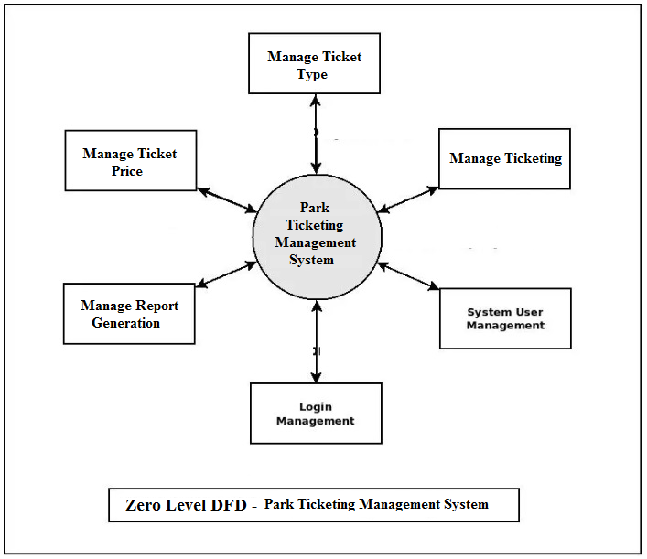

**ER DIAGRAM**

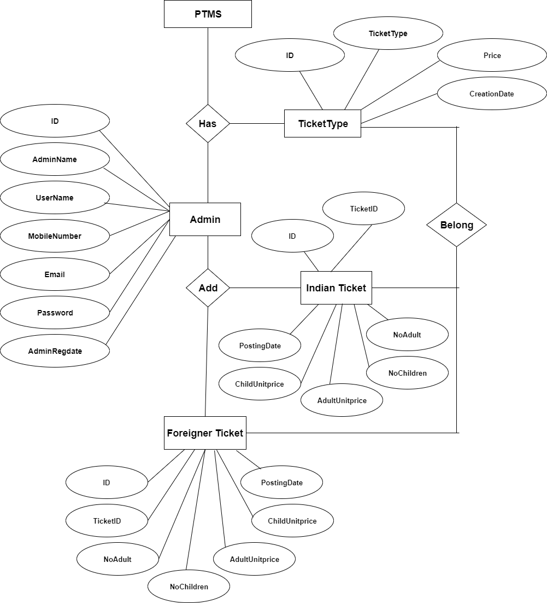

**Sequence Diagram For Administrator: -**

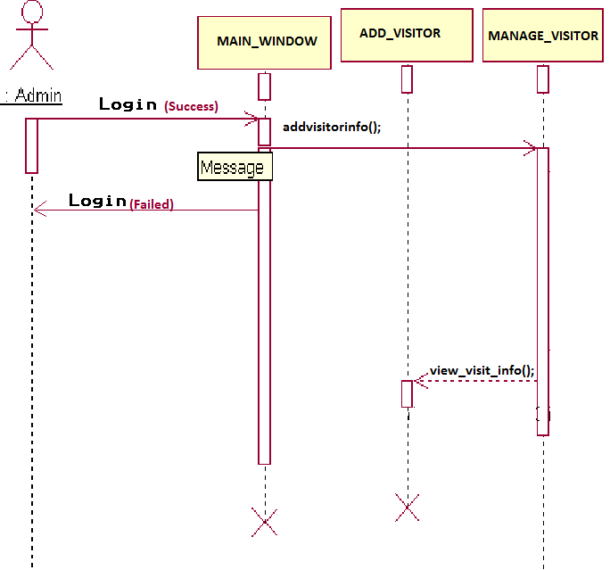

**Administrator**

**Success:hide()**

Fig.5.4

**Class Diagram:**

A description of set of objects that share the same attributes operations, relationships, and semantics

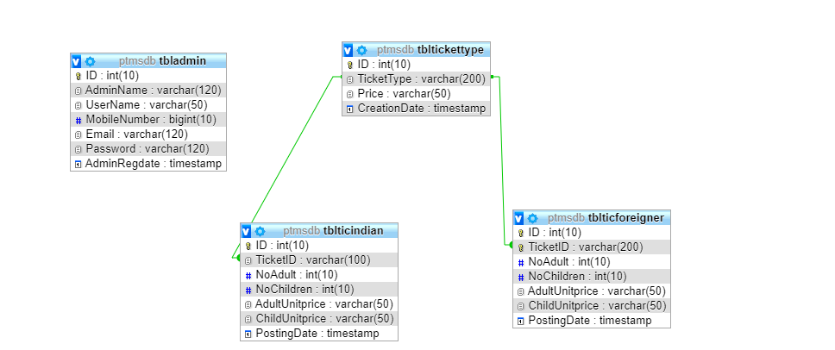

**Implementation and System Testing**

After all phase have been perfectly done, the system will be implemented to the server and the system can be used.

**System Testing**

The goal of the system testing process was to determine all faults in our project. The program was subjected to a set of test inputs and many explanations were made and based on these explanations it will be decided whether the program behaves as expected or not. Our Project went through two levels of testing

1. Unit testing

2. Integration testing

**UNIT TESTING**

Unit testing is commenced when a unit has been created and effectively reviewed. In order to test a single module, we need to provide a complete environment i.e. besides the section we would require

* The procedures belonging to other units that the unit under test calls
* Non local data structures that module accesses
* A procedure to call the functions of the unit under test with appropriate parameters

**1. Test for the admin module**

* **Testing admin login form-**This form is used for log in of administrator of the system. In this form we enter the username and password if both are correct administration page will open otherwise if any of data is wrong it will get redirected back to the login page and again ask the details.
* **Report Generation:** admin can generate report from the main database.

**INTEGRATION TESTING**

In the Integration testing we test various combination of the project module by providing the input.

The primary objective is to test the module interfaces in order to confirm that no errors are occurring when one module invokes the other module.

**CHAPTER 7**

**Output screens**

**HOME PAGE**

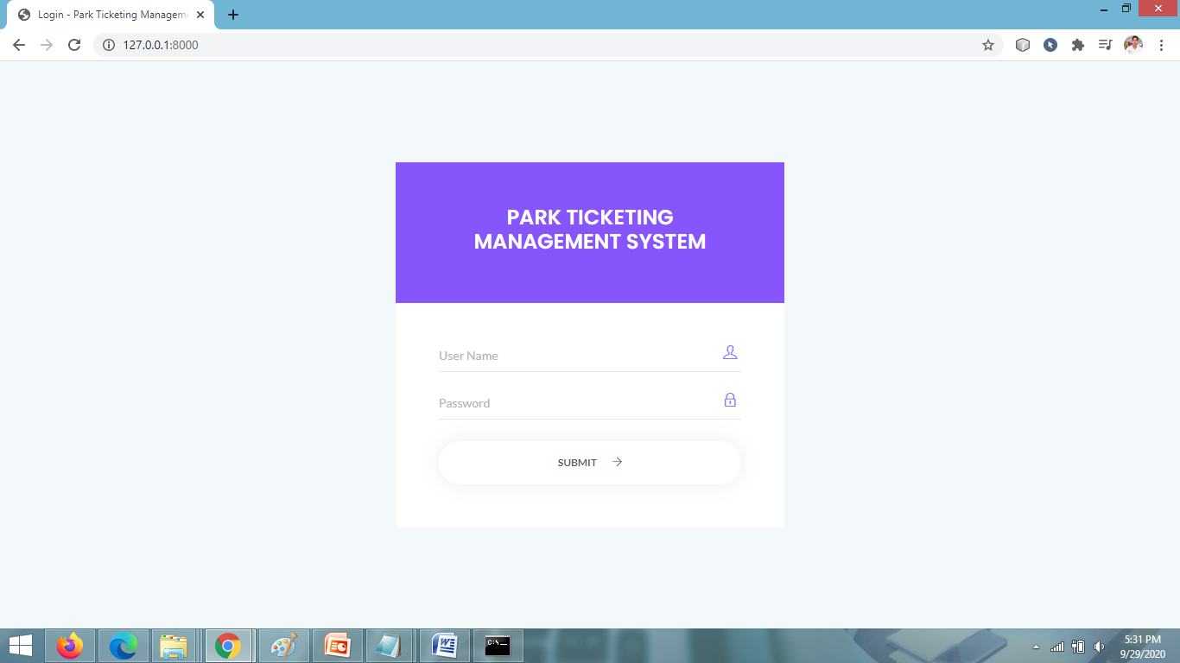

**ADMIN DASHBOARD PAGE**

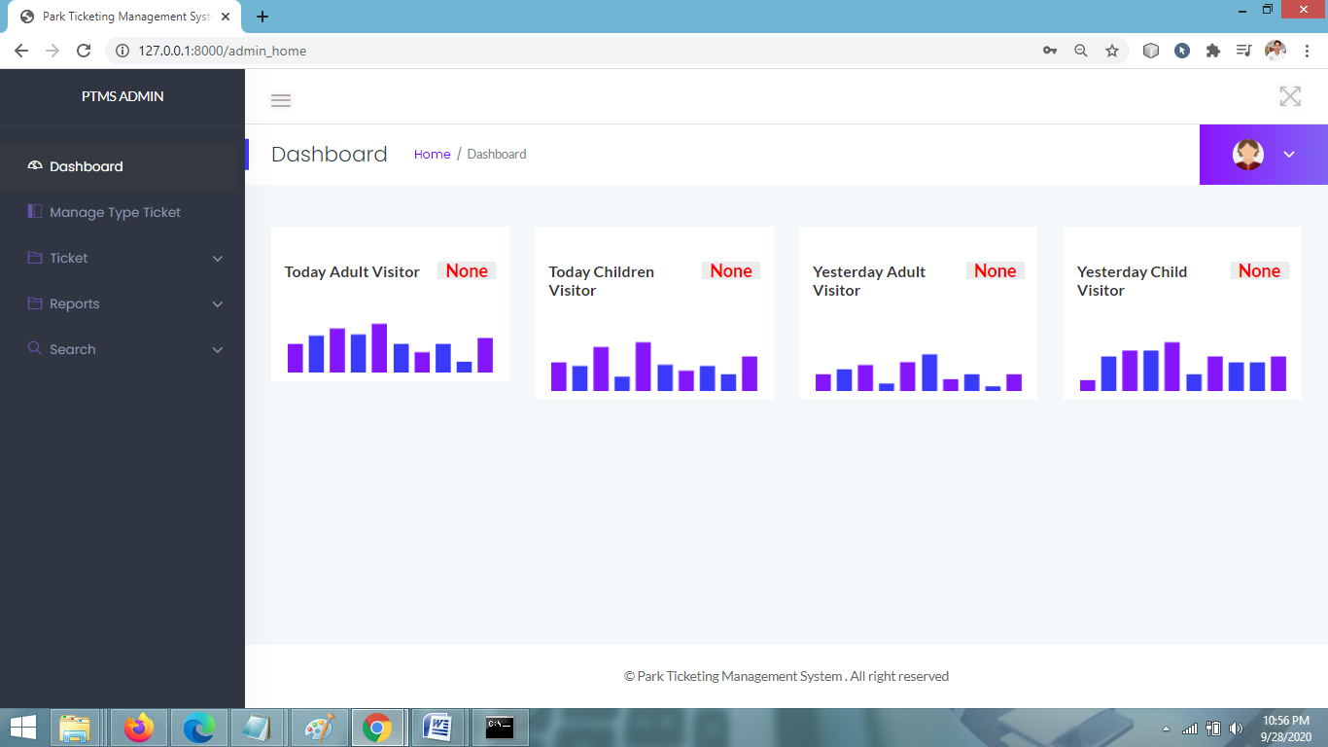

**MANAGE TICKET TYPE PAGE**

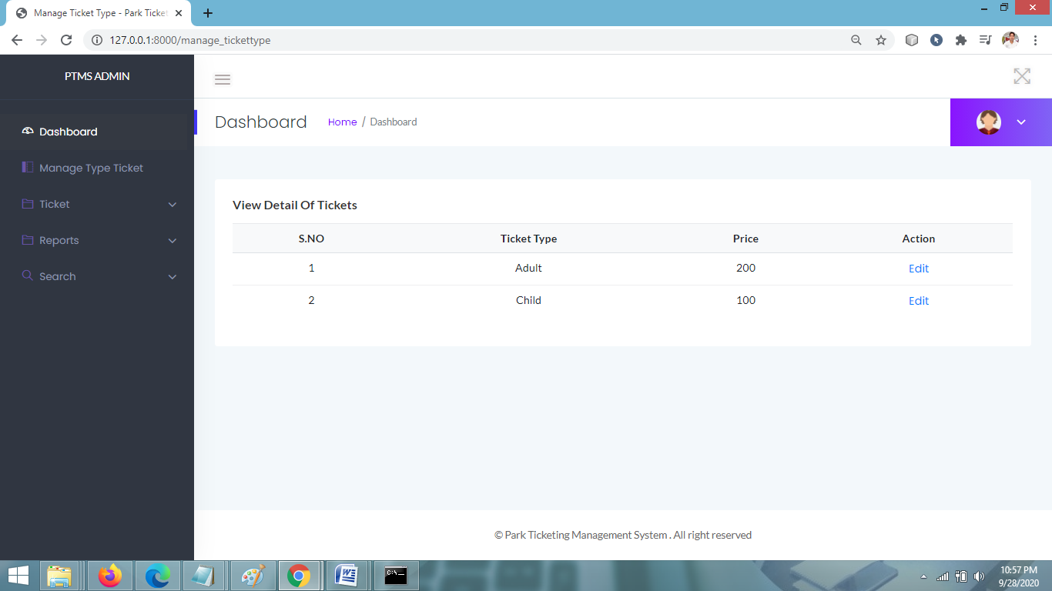

**ADD TICKET PAGE**

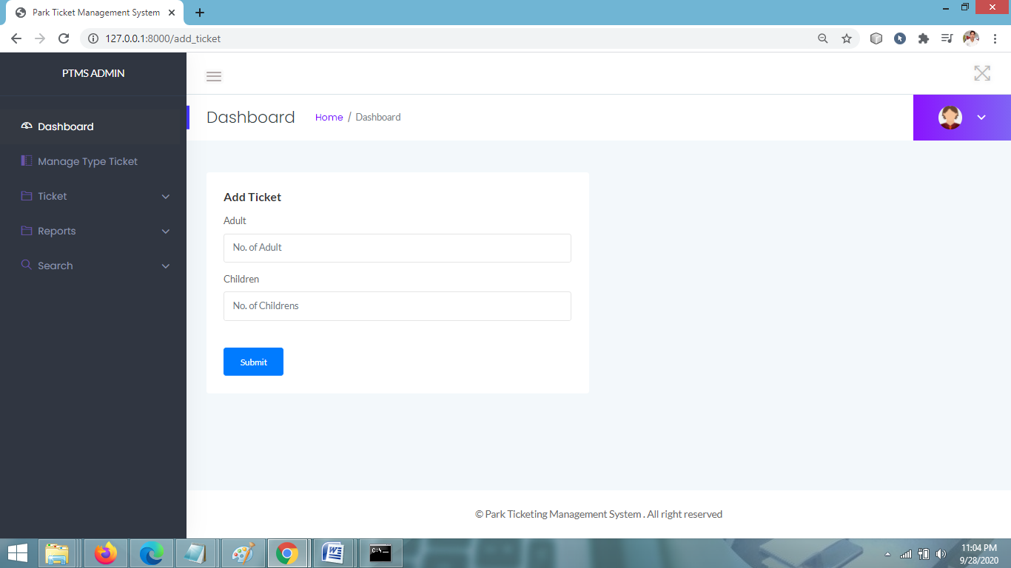

**MANAGE TICKET PAGE**

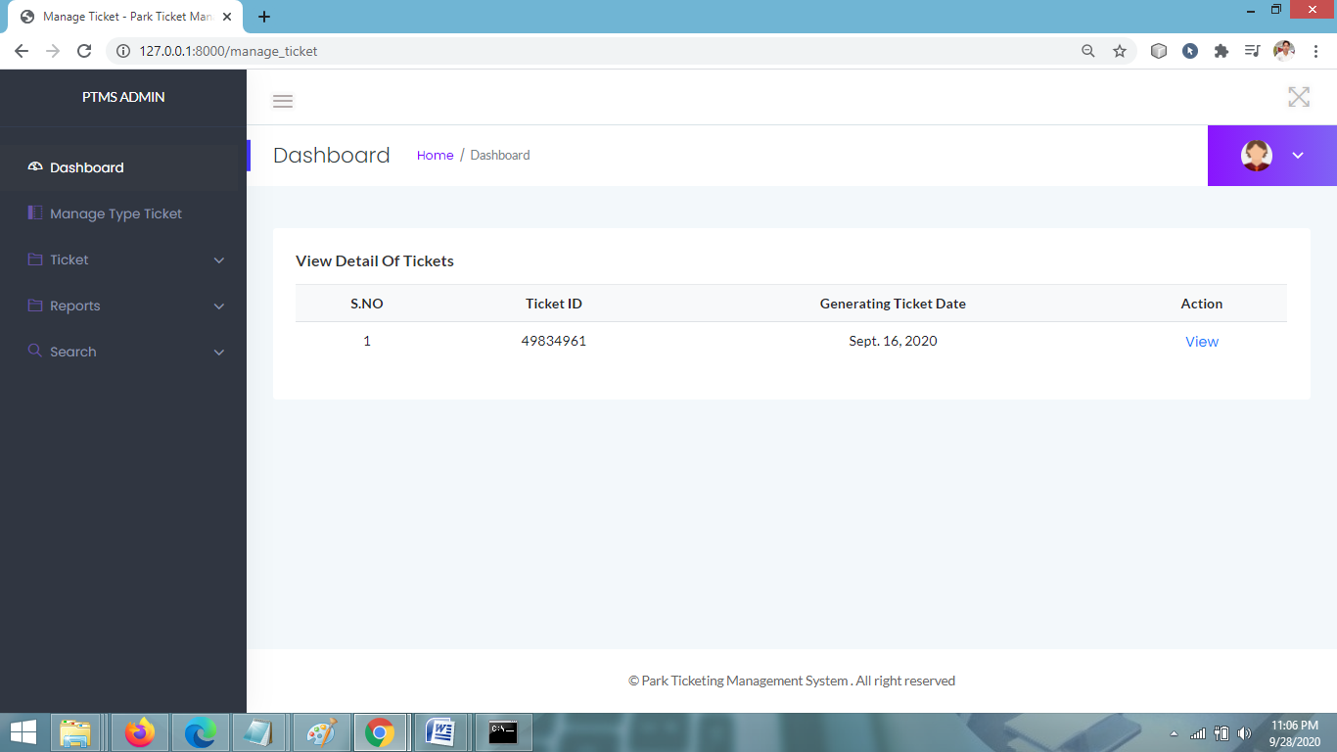

**SEARCH BETWEEN DATES REPORTS PAGE**

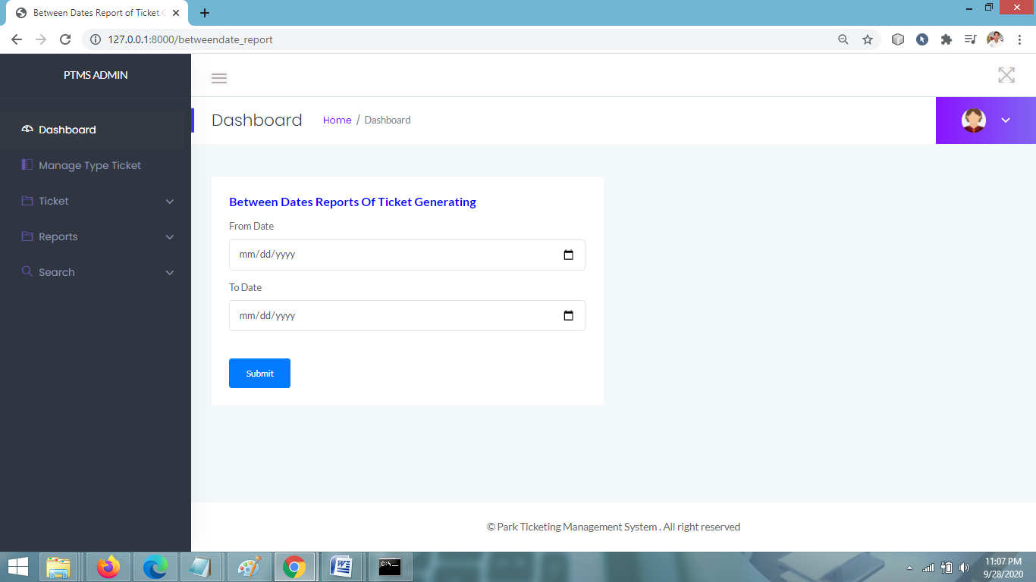

**VIEW BETWEEN DATE REPORTS**

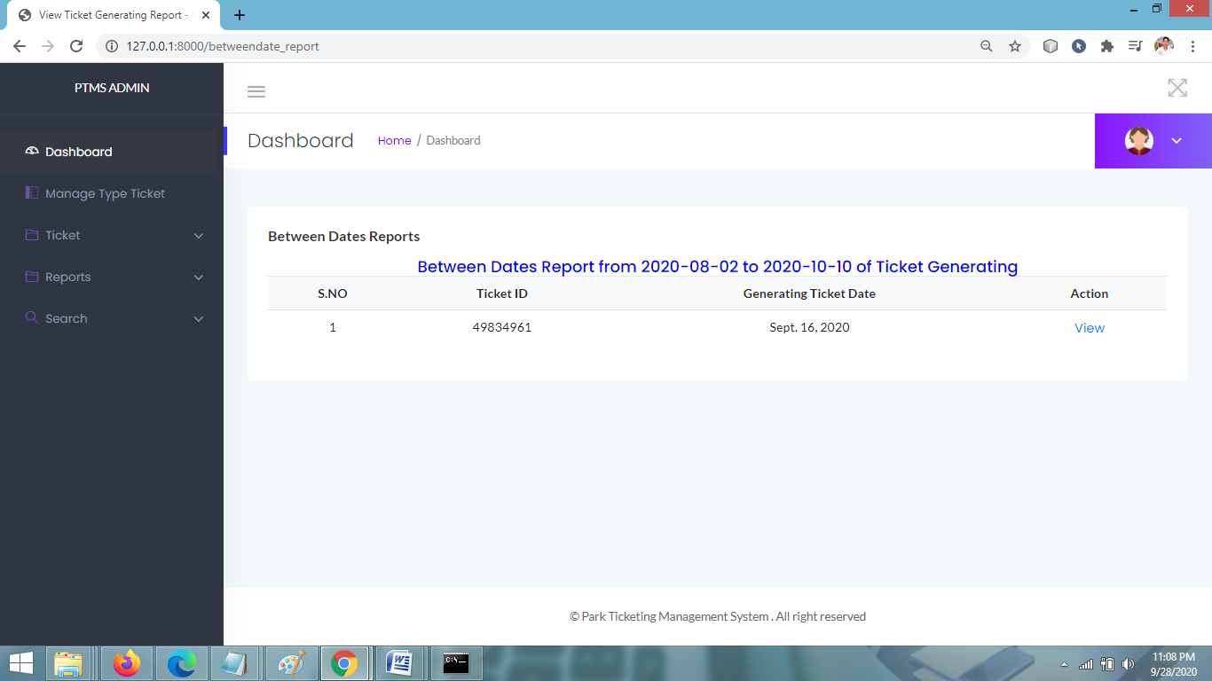

**SEARCH TICKET PAGE**

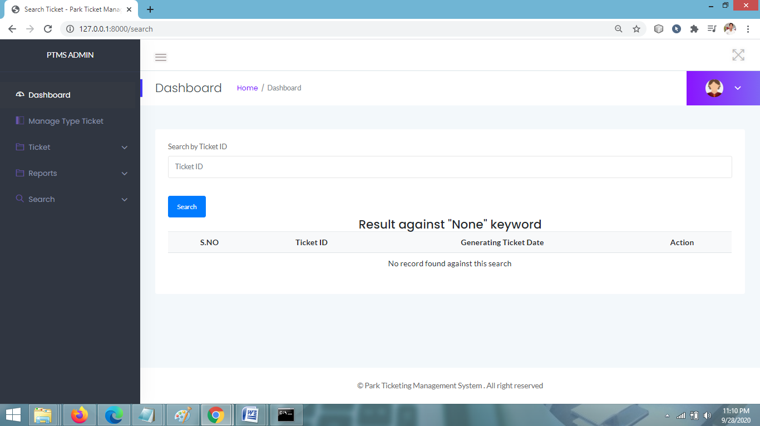

**CHANGE PASSWORD PAGE**

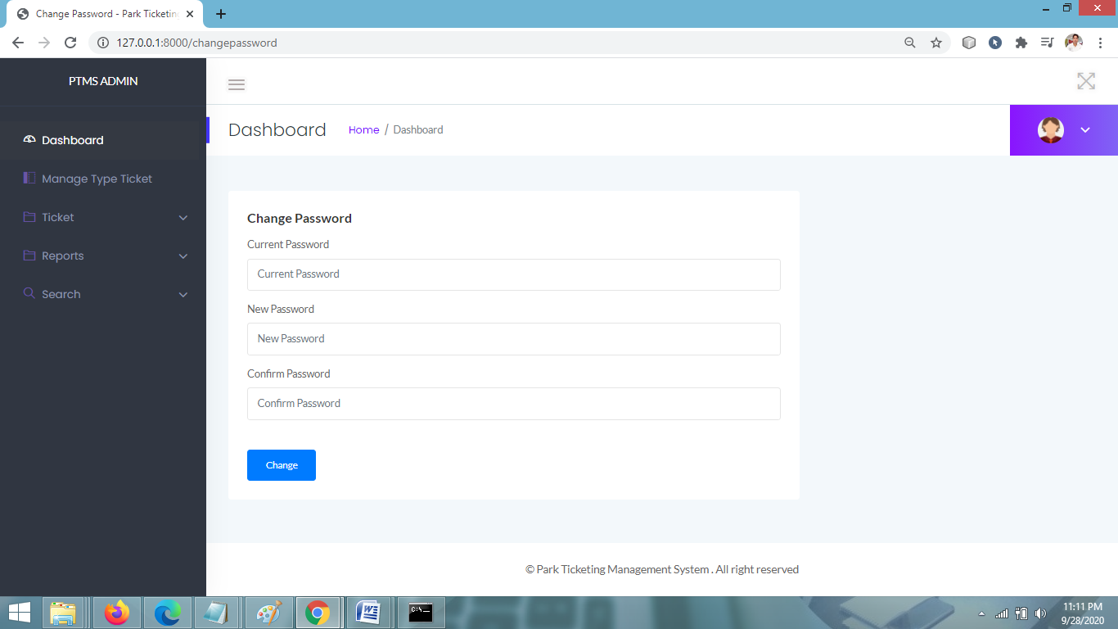

**CHAPTER 8**

**Coding**

**ADMIN LOGIN PAGE CODING**

**{% load static %}**

**{% block body %}**

**<html class="no-js" lang="en">**

**<head>**

**<meta charset="utf-8">**

**<meta http-equiv="x-ua-compatible" content="ie=edge">**

**<title>Login - Park Ticketing Management System</title>**

**<meta name="viewport" content="width=device-width, initial-scale=1">**

**<link rel="shortcut icon" type="image/png" href="{% static 'assets/images/icon/favicon.ico' %}">**

**<link rel="stylesheet" href="{% static 'assets/css/bootstrap.min.css' %}">**

**<link rel="stylesheet" href="{% static 'assets/css/font-awesome.min.css' %}">**

**<link rel="stylesheet" href="{% static 'assets/css/themify-icons.css' %}">**

**<link rel="stylesheet" href="{% static 'assets/css/metisMenu.css' %}">**

**<link rel="stylesheet" href="{% static 'assets/css/owl.carousel.min.css' %}">**

**<link rel="stylesheet" href="{% static 'assets/css/slicknav.min.css' %}">**

**<!-- amchart css -->**

**<link rel="stylesheet" href="https://www.amcharts.com/lib/3/plugins/export/export.css" type="text/css" media="all" />**

**<!-- others css -->**

**<link rel="stylesheet" href="{% static 'assets/css/typography.css' %}">**

**<link rel="stylesheet" href="{% static 'assets/css/default-css.css' %}">**

**<link rel="stylesheet" href="{% static 'assets/css/styles.css' %}">**

**<link rel="stylesheet" href="{% static 'assets/css/responsive.css' %}">**

**<!-- modernizr css -->**

**<script src="{% static 'assets/js/vendor/modernizr-2.8.3.min.js' %}"></script>**

**</head>**

**<body>**

**<!--[if lt IE 8]>**

**<![endif]-->**

**<!-- preloader area start -->**

**<div id="preloader">**

**<div class="loader"></div>**

**</div>**

**<!-- preloader area end -->**

**<!-- login area start -->**

**<div class="login-area">**

**<div class="container">**

**<div class="login-box ptb--100">**

**<form action="#" method="post" name="login">**

**{% csrf_token %}**

**<p style="font-size:16px; color:red" align="center"> </p>**

**<div class="login-form-head">**

**<h4>Park Ticketing Management System</h4>**

**</div>**

**<div class="login-form-body">**

**<div class="form-gp">**

**<label for="exampleInputEmail1">User Name</label>**

**<input type="text" id="username" name="username" required="true">**

**<i class="ti-user"></i>**

**</div>**

**<div class="form-gp">**

**<label for="exampleInputPassword1">Password</label>**

**<input type="password" id="password" name="password" required="true">**

**<i class="ti-lock"></i>**

**</div>**

**<div class="submit-btn-area">**

**<button id="form_submit" type="submit" name="login">Submit <i class="ti-arrow-right"></i></button>**

**</div>**

**</div>**

**</form>**

**</div>**

**</div>**

**</div>**

**<!-- login area end -->**

**<!-- jquery latest version -->**

**<script src="{% static 'assets/js/vendor/jquery-2.2.4.min.js' %}"></script>**

**<!-- bootstrap 4 js -->**

**<script src="{% static 'assets/js/popper.min.js' %}"></script>**

**<script src="{% static 'assets/js/bootstrap.min.js' %}"></script>**

**<script src="{% static 'assets/js/owl.carousel.min.js' %}"></script>**

**<script src="{% static 'assets/js/metisMenu.min.js' %}"></script>**

**<script src="{% static 'assets/js/jquery.slimscroll.min.js' %}"></script>**

**<script src="{% static 'assets/js/jquery.slicknav.min.js' %}"></script>**

**<!-- others plugins -->**

**<script src="{% static 'assets/js/plugins.js' %}"></script>**

**<script src="{% static 'assets/js/scripts.js' %}"></script>**

**</body>**

**</html>**

**{% ifequal error "no" %}**

**<script>**

**alert('logged in successfully');**

**window.location=('{% url 'admin_home' %}');**

**</script>**

**{% endifequal %}**

**{% ifequal error "yes" %}**

**<script>**

**alert('Invalid Login Credentials,Try Again...');**

**</script>**

**{% endifequal %}**

**{% endblock %}**

**ADMIN HOME PAGE CODING**

**{% load static %}**

**{% block body %}**

**<html class="no-js" lang="en">**

**<head>**

**<meta charset="utf-8">**

**<meta http-equiv="x-ua-compatible" content="ie=edge">**

**<title>Park Ticketing Management System || Dashboard</title>**

**<meta name="viewport" content="width=device-width, initial-scale=1">**

**<link rel="shortcut icon" type="image/png" href="{% static 'assets/images/icon/favicon.ico' %}">**

**<link rel="stylesheet" href="{% static 'assets/css/bootstrap.min.css' %}">**

**<link rel="stylesheet" href="{% static 'assets/css/font-awesome.min.css' %}">**

**<link rel="stylesheet" href="{% static 'assets/css/themify-icons.css' %}">**

**<link rel="stylesheet" href="{% static 'assets/css/metisMenu.css' %}">**

**<link rel="stylesheet" href="{% static 'assets/css/owl.carousel.min.css' %}">**

**<link rel="stylesheet" href="{% static 'assets/css/slicknav.min.css' %}">**

**<!-- amchart css -->**

**<link rel="stylesheet" href="https://www.amcharts.com/lib/3/plugins/export/export.css" type="text/css" media="all" />**

**<!-- others css -->**

**<link rel="stylesheet" href="{% static 'assets/css/typography.css' %}">**

**<link rel="stylesheet" href="{% static 'assets/css/default-css.css' %}">**

**<link rel="stylesheet" href="{% static 'assets/css/styles.css' %}">**

**<link rel="stylesheet" href="{% static 'assets/css/responsive.css' %}">**

**<!-- modernizr css -->**

**<script src="{% static 'assets/js/vendor/modernizr-2.8.3.min.js' %}"></script>**

**</head>**

**<body>**

**{% include 'sidebar.html' %}**

**<!-- page container area start -->**

**<div class="page-container">**

**<!-- sidebar menu area start -->**

**<!-- sidebar menu area end -->**

**<!-- main content area start -->**

**<div class="main-content">**

**<!-- header area start -->**

**{% include 'header.html' %}**

**<!-- header area end -->**

**<!-- page title area start -->**

**{% include 'pagetitle.html' %}**

**<!-- page title area end -->**

**<div class="main-content-inner">**

**<!-- sales report area start -->**

**<div class="sales-report-area sales-style-two">**

**<div class="row">**

**<div class="col-xl-3 col-ml-3 col-md-6 mt-5">**

**<div class="single-report">**

**<div class="s-sale-inner pt--30 mb-3">**

**<div class="s-report-title d-flex justify-content-between">**

**<h3 class="header-title mb-0">Today Adult Visitor</h3>**

**<p style="font-size: 20px;color: red">{{ta.noofadult__sum}}</p>**

**</div>**

**</div>**

**<canvas id="coin_sales4" height="100"></canvas>**

**</div>**

**</div>**

**<div class="col-xl-3 col-ml-3 col-md-6 mt-5">**

**<div class="single-report">**

**<div class="s-sale-inner pt--30 mb-3">**

**<div class="s-report-title d-flex justify-content-between">**

**<h4 class="header-title mb-0">Today Children Visitor</h4>**

**<p style="font-size: 20px;color: red">{{tc.noofchild__sum}}</p>**

**</div>**

**</div>**

**<canvas id="coin_sales5" height="100"></canvas>**

**</div>**

**</div>**

**<div class="col-xl-3 col-ml-3 col-md-6 mt-5">**

**<div class="single-report">**

**<div class="s-sale-inner pt--30 mb-3">**

**<div class="s-report-title d-flex justify-content-between">**

**<h4 class="header-title mb-0">Yesterday Adult Visitor</h4>**

**<p style="font-size: 20px;color: red">{{ya.noofadult__sum}}</p>**

**</div>**

**</div>**

**<canvas id="coin_sales6" height="100"></canvas>**

**</div>**

**</div>**

**<div class="col-xl-3 col-ml-3 col-md-6 mt-5">**

**<div class="single-report">**

**<div class="s-sale-inner pt--30 mb-3">**

**<div class="s-report-title d-flex justify-content-between">**

**<h4 class="header-title mb-0">Yesterday Child Visitor</h4>**

**<p style="font-size: 20px;color: red">{{yc.noofchild__sum}}</p>**

**</div>**

**</div>**

**<canvas id="coin_sales7" height="100"></canvas>**

**</div>**

**</div>**

**</div>**

**</div>**

**<!-- sales report area end -->**

**</div>**

**</div>**

**<!-- main content area end -->**

**<!-- footer area start-->**

**{% include 'footer.html' %}**

**<!-- footer area end-->**

**</div>**

**<!-- page container area end -->**

**<!-- offset area start -->**

**<!-- offset area end -->**

**<!-- jquery latest version -->**

**<!-- jquery latest version -->**

**<script src="{% static 'assets/js/vendor/jquery-2.2.4.min.js' %}"></script>**

**<!-- bootstrap 4 js -->**

**<script src="{% static 'assets/js/popper.min.js' %}"></script>**

**<script src="{% static 'assets/js/bootstrap.min.js' %}"></script>**

**<script src="{% static 'assets/js/owl.carousel.min.js' %}"></script>**

**<script src="{% static 'assets/js/metisMenu.min.js' %}"></script>**

**<script src="{% static 'assets/js/jquery.slimscroll.min.js' %}"></script>**

**<script src="{% static 'assets/js/jquery.slicknav.min.js' %}"></script>**

**<!-- start chart js -->**

**<script src="https://cdnjs.cloudflare.com/ajax/libs/Chart.js/2.7.2/Chart.min.js"></script>**

**<!-- start highcharts js -->**

**<script src="https://code.highcharts.com/highcharts.js"></script>**

**<!-- start zingchart js -->**

**<script src="https://cdn.zingchart.com/zingchart.min.js"></script>**

**<script>**

**zingchart.MODULESDIR = "https://cdn.zingchart.com/modules/";**

**ZC.LICENSE = ["569d52cefae586f634c54f86dc99e6a9", "ee6b7db5b51705a13dc2339db3edaf6d"];**

**</script>**

**<!-- all line chart activation -->**

**<script src="{% static 'assets/js/line-chart.js' %}"></script>**

**<!-- all bar chart activation -->**

**<script src="{% static 'assets/js/bar-chart.js' %}"></script>**

**<!-- all pie chart -->**

**<script src="{% static 'assets/js/pie-chart.js' %}"></script>**

**<!-- others plugins -->**

**<script src="{% static 'assets/js/plugins.js' %}"></script>**

**<script src="{% static 'assets/js/scripts.js' %}"></script>**

**</body>**

**</html>**

**{% endblock %}**

**MANAGE TICKET TYPE PAGE CODING**

**{% load static %}**

**{% block body %}**

**<html class="no-js" lang="en">**

**<head>**

**<meta charset="utf-8">**

**<meta http-equiv="x-ua-compatible" content="ie=edge">**

**<title>Manage Ticket Type - Park Ticket Management System</title>**

**<meta name="viewport" content="width=device-width, initial-scale=1">**

**<link rel="shortcut icon" type="image/png" href="{% static 'assets/images/icon/favicon.ico' %}">**

**<link rel="stylesheet" href="{% static 'assets/css/bootstrap.min.css' %}">**

**<link rel="stylesheet" href="{% static 'assets/css/font-awesome.min.css' %}">**

**<link rel="stylesheet" href="{% static 'assets/css/themify-icons.css' %}">**

**<link rel="stylesheet" href="{% static 'assets/css/metisMenu.css' %}">**

**<link rel="stylesheet" href="{% static 'assets/css/owl.carousel.min.css' %}">**

**<link rel="stylesheet" href="{% static 'assets/css/slicknav.min.css' %}">**

**<!-- amcharts css -->**

**<link rel="stylesheet" href="https://www.amcharts.com/lib/3/plugins/export/export.css" type="text/css" media="all" />**

**<!-- Start datatable css -->**

**<link rel="stylesheet" type="text/css" href="https://cdn.datatables.net/1.10.19/css/jquery.dataTables.css">**

**<link rel="stylesheet" type="text/css" href="https://cdn.datatables.net/1.10.18/css/dataTables.bootstrap4.min.css">**

**<link rel="stylesheet" type="text/css" href="https://cdn.datatables.net/responsive/2.2.3/css/responsive.bootstrap.min.css">**

**<link rel="stylesheet" type="text/css" href="https://cdn.datatables.net/responsive/2.2.3/css/responsive.jqueryui.min.css">**

**<!-- style css -->**

**<link rel="stylesheet" href="{% static 'assets/css/typography.css' %}">**

**<link rel="stylesheet" href="{% static 'assets/css/default-css.css' %}">**

**<link rel="stylesheet" href="{% static 'assets/css/styles.css' %}">**

**<link rel="stylesheet" href="{% static 'assets/css/responsive.css' %}">**

**<!-- modernizr css -->**

**<script src="{% static 'assets/js/vendor/modernizr-2.8.3.min.js' %}"></script>**

**</head>**

**<body>**

**<!-- page container area start -->**

**<div class="page-container">**

**<!-- sidebar menu area start -->**

**{% include 'sidebar.html' %}**

**<!-- sidebar menu area end -->**

**<!-- main content area start -->**

**<div class="main-content">**

**<!-- header area start -->**

**{% include 'header.html' %}**

**<!-- header area end -->**

**<!-- page title area start -->**

**{% include 'pagetitle.html' %}**

**<!-- page title area end -->**

**<div class="main-content-inner">**

**<div class="row">**

**<!-- data table start -->**

**<div class="col-12 mt-5">**

**<div class="card">**

**<div class="card-body">**

**<h4 class="header-title">View Detail of Tickets</h4>**

**<div class="data-tables">**

**<table class="table text-center">**

**<thead class="bg-light text-capitalize">**

**<tr>**

**<th>S.NO</th>**

**<th>Ticket Type</th>**

**<th>Price</th>**

**<th>Action</th>**

**</tr>**

**</thead>**

**{% for i in ttype %}**

**<tbody>**

**<tr data-expanded="true">**

**<td>{{forloop.counter}}</td>**

**<td>{{i.tickettype}}</td>**

**<td>{{i.price}}</td>**

**<td><a href="{% url 'edit_tickettype' i.id %}">Edit</a>**

**</tr>**

**{% endfor %}**

**</tbody>**

**</table>**

**</div>**

**</div>**

**</div>**

**</div>**

**<!-- data table end -->**

**</div>**

**</div>**

**</div>**

**<!-- main content area end -->**

**<!-- footer area start-->**

**{% include 'footer.html' %}**

**<!-- footer area end-->**

**</div>**

**<!-- page container area end -->**

**<!-- jquery latest version -->**

**<script src="{% static 'assets/js/vendor/jquery-2.2.4.min.js' %}"></script>**

**<!-- bootstrap 4 js -->**

**<script src="{% static 'assets/js/popper.min.js' %}"></script>**

**<script src="{% static 'assets/js/bootstrap.min.js' %}"></script>**

**<script src="{% static 'assets/js/owl.carousel.min.js' %}"></script>**

**<script src="{% static 'assets/js/metisMenu.min.js' %}"></script>**

**<script src="{% static 'assets/js/jquery.slimscroll.min.js' %}"></script>**

**<script src="{% static 'assets/js/jquery.slicknav.min.js' %}"></script>**

**<!-- Start datatable js -->**

**<script src="https://cdn.datatables.net/1.10.19/js/jquery.dataTables.js"></script>**

**<script src="https://cdn.datatables.net/1.10.18/js/jquery.dataTables.min.js"></script>**

**<script src="https://cdn.datatables.net/1.10.18/js/dataTables.bootstrap4.min.js"></script>**

**<script src="https://cdn.datatables.net/responsive/2.2.3/js/dataTables.responsive.min.js"></script>**

**<script src="https://cdn.datatables.net/responsive/2.2.3/js/responsive.bootstrap.min.js"></script>**

**<!-- others plugins -->**

**<script src="{% static 'assets/js/plugins.js' %}"></script>**

**<script src="{% static 'assets/js/scripts.js' %}"></script>**

**</body>**

**</html>**

**{% endblock %}**

**ADD TICKET PAGE**

**{% load static %}**

**{% block body %}**

**<html class="no-js" lang="en">**

**<head>**

**<meta charset="utf-8">**

**<meta http-equiv="x-ua-compatible" content="ie=edge">**

**<title>Park Ticket Management System</title>**

**<meta name="viewport" content="width=device-width, initial-scale=1">**

**<link rel="shortcut icon" type="image/png" href="{% static 'assets/images/icon/favicon.ico' %}">**

**<link rel="stylesheet" href="{% static 'assets/css/bootstrap.min.css' %}">**

**<link rel="stylesheet" href="{% static 'assets/css/font-awesome.min.css' %}">**

**<link rel="stylesheet" href="{% static 'assets/css/themify-icons.css' %}">**

**<link rel="stylesheet" href="{% static 'assets/css/metisMenu.css' %}">**

**<link rel="stylesheet" href="{% static 'assets/css/owl.carousel.min.css' %}">**

**<link rel="stylesheet" href="{% static 'assets/css/slicknav.min.css' %}">**

**<!-- amchart css -->**

**<link rel="stylesheet" href="https://www.amcharts.com/lib/3/plugins/export/export.css" type="text/css" media="all" />**

**<!-- others css -->**

**<link rel="stylesheet" href="{% static 'assets/css/typography.css' %}">**

**<link rel="stylesheet" href="{% static 'assets/css/default-css.css' %}">**

**<link rel="stylesheet" href="{% static 'assets/css/styles.css' %}">**

**<link rel="stylesheet" href="{% static 'assets/css/responsive.css' %}">**

**<!-- modernizr css -->**

**<script src="{% static 'assets/js/vendor/modernizr-2.8.3.min.js' %}"></script>**

**</head>**

**<body>**

**<!-- page container area start -->**

**<div class="page-container">**

**<!-- sidebar menu area start -->**

**{% include 'sidebar.html' %}**

**<!-- sidebar menu area end -->**

**<!-- main content area start -->**

**<div class="main-content">**

**<!-- header area start -->**

**{% include 'header.html' %}**

**<!-- header area end -->**

**<!-- page title area start -->**

**{% include 'pagetitle.html' %}**

**<!-- page title area end -->**

**<div class="main-content-inner">**

**<div class="row">**

**<div class="col-lg-6 col-ml-12">**

**<div class="row">**

**<!-- basic form start -->**

**<div class="col-12 mt-5">**

**<div class="card">**

**<div class="card-body">**

**<h4 class="header-title">Add Ticket</h4>**

**<form method="post" action="" name="">**

**{% csrf_token %}**

**<div class="form-group">**

**<label for="exampleInputEmail1">Adult</label>**

**<input type="text" class="form-control" id="noadult" name="noadult" aria-describedby="emailHelp" placeholder="No. of Adult" value="" required="true">**

**</div>**

**<div class="form-group">**

**<label for="exampleInputEmail1">Children</label>**

**<input type="text" class="form-control" id="nochildren" name="nochildren" aria-describedby="emailHelp" placeholder="No. of Childrens" value="" required="true">**

**</div>**

**<input type="hidden" name="aprice" value="{{aprice.price}}">**

**<input type="hidden" name="cprice" value="{{cprice.price}}">**

**<button type="submit" class="btn btn-primary mt-4 pr-4 pl-4" name="submit">Submit</button>**

**</form>**

**</div>**

**</div>**

**</div>**

**<!-- basic form end -->**

**</div>**

**</div>**

**</div>**

**</div>**

**</div>**

**<!-- main content area end -->**

**<!-- footer area start-->**

**{% include 'footer.html' %}**

**<!-- footer area end-->**

**</div>**

**<!-- page container area end -->**

**<!-- offset area start -->**

**<!-- jquery latest version -->**

**<script src="{% static 'assets/js/vendor/jquery-2.2.4.min.js' %}"></script>**

**<!-- bootstrap 4 js -->**

**<script src="{% static 'assets/js/popper.min.js' %}"></script>**

**<script src="{% static 'assets/js/bootstrap.min.js' %}"></script>**

**<script src="{% static 'assets/js/owl.carousel.min.js' %}"></script>**

**<script src="{% static 'assets/js/metisMenu.min.js' %}"></script>**

**<script src="{% static 'assets/js/jquery.slimscroll.min.js' %}"></script>**

**<script src="{% static 'assets/js/jquery.slicknav.min.js' %}"></script>**

**<!-- others plugins -->**

**<script src="{% static 'assets/js/plugins.js' %}"></script>**

**<script src="{% static 'assets/js/scripts.js' %}"></script>**

**</body>**

**</html>**

**{% ifequal error "no" %}**

**<script>**

**alert('Ticket information has been added.');**

**window.location=('{% url 'manage_ticket' %}');**

**</script>**

**{% endifequal %}**

**{% ifequal error "yes" %}**

**<script>**

**alert('Something Went Wrong. Please try again');**

**</script>**

**{% endifequal %}**

**{% endblock %}**

**MANAGE TICKET PAGE CODING**

**{% load static %}**

**{% block body %}**

**<html class="no-js" lang="en">**

**<head>**

**<meta charset="utf-8">**

**<meta http-equiv="x-ua-compatible" content="ie=edge">**

**<title>Manage Ticket - Park Ticket Management System</title>**

**<meta name="viewport" content="width=device-width, initial-scale=1">**

**<link rel="shortcut icon" type="image/png" href="{% static 'assets/images/icon/favicon.ico' %}">**

**<link rel="stylesheet" href="{% static 'assets/css/bootstrap.min.css' %}">**

**<link rel="stylesheet" href="{% static 'assets/css/font-awesome.min.css' %}">**

**<link rel="stylesheet" href="{% static 'assets/css/themify-icons.css' %}">**

**<link rel="stylesheet" href="{% static 'assets/css/metisMenu.css' %}">**

**<link rel="stylesheet" href="{% static 'assets/css/owl.carousel.min.css' %}">**

**<link rel="stylesheet" href="{% static 'assets/css/slicknav.min.css' %}">**

**<!-- amcharts css -->**

**<link rel="stylesheet" href="https://www.amcharts.com/lib/3/plugins/export/export.css" type="text/css" media="all" />**

**<!-- Start datatable css -->**

**<link rel="stylesheet" type="text/css" href="https://cdn.datatables.net/1.10.19/css/jquery.dataTables.css">**

**<link rel="stylesheet" type="text/css" href="https://cdn.datatables.net/1.10.18/css/dataTables.bootstrap4.min.css">**

**<link rel="stylesheet" type="text/css" href="https://cdn.datatables.net/responsive/2.2.3/css/responsive.bootstrap.min.css">**

**<link rel="stylesheet" type="text/css" href="https://cdn.datatables.net/responsive/2.2.3/css/responsive.jqueryui.min.css">**

**<!-- style css -->**

**<link rel="stylesheet" href="{% static 'assets/css/typography.css' %}">**

**<link rel="stylesheet" href="{% static 'assets/css/default-css.css' %}">**

**<link rel="stylesheet" href="{% static 'assets/css/styles.css' %}">**

**<link rel="stylesheet" href="{% static 'assets/css/responsive.css' %}">**

**<!-- modernizr css -->**

**<script src="{% static 'assets/js/vendor/modernizr-2.8.3.min.js' %}"></script>**

**</head>**

**<body>**

**<!-- page container area start -->**

**<div class="page-container">**

**<!-- sidebar menu area start -->**

**{% include 'sidebar.html' %}**

**<!-- sidebar menu area end -->**

**<!-- main content area start -->**

**<div class="main-content">**

**<!-- header area start -->**

**{% include 'header.html' %}**

**<!-- header area end -->**

**<!-- page title area start -->**

**{% include 'pagetitle.html' %}**

**<!-- page title area end -->**

**<div class="main-content-inner">**

**<div class="row">**

**<!-- data table start -->**

**<div class="col-12 mt-5">**

**<div class="card">**

**<div class="card-body">**

**<h4 class="header-title">View Detail of Tickets</h4>**

**<div class="data-tables">**

**<table class="table text-center">**

**<thead class="bg-light text-capitalize">**

**<tr>**

**<th>S.NO</th>**

**<th>Ticket ID</th>**

**<th>Generating Ticket Date</th>**

**<th>Action</th>**

**</tr>**

**</thead>**

**{% for i in ticket %}**

**<tbody>**

**<tr data-expanded="true">**

**<td>{{forloop.counter}}</td>**

**<td>{{i.ticketid}}</td>**

**<td>{{i.postingdate}}</td>**

**<td><a href="{% url 'view_ticketdetail' i.id %}">View</a>**

**</tr>**

**{% endfor %}**

**</tbody>**

**</table>**

**</div>**

**</div>**

**</div>**

**</div>**

**<!-- data table end -->**

**</div>**

**</div>**

**</div>**

**<!-- main content area end -->**

**<!-- footer area start-->**

**{% include 'footer.html' %}**

**<!-- footer area end-->**

**</div>**

**<!-- page container area end -->**

**<!-- jquery latest version -->**

**<script src="{% static 'assets/js/vendor/jquery-2.2.4.min.js' %}"></script>**

**<!-- bootstrap 4 js -->**

**<script src="{% static 'assets/js/popper.min.js' %}"></script>**

**<script src="{% static 'assets/js/bootstrap.min.js' %}"></script>**

**<script src="{% static 'assets/js/owl.carousel.min.js' %}"></script>**

**<script src="{% static 'assets/js/metisMenu.min.js' %}"></script>**

**<script src="{% static 'assets/js/jquery.slimscroll.min.js' %}"></script>**

**<script src="{% static 'assets/js/jquery.slicknav.min.js' %}"></script>**

**<!-- Start datatable js -->**

**<script src="https://cdn.datatables.net/1.10.19/js/jquery.dataTables.js"></script>**

**<script src="https://cdn.datatables.net/1.10.18/js/jquery.dataTables.min.js"></script>**

**<script src="https://cdn.datatables.net/1.10.18/js/dataTables.bootstrap4.min.js"></script>**

**<script src="https://cdn.datatables.net/responsive/2.2.3/js/dataTables.responsive.min.js"></script>**

**<script src="https://cdn.datatables.net/responsive/2.2.3/js/responsive.bootstrap.min.js"></script>**

**<!-- others plugins -->**

**<script src="{% static 'assets/js/plugins.js' %}"></script>**

**<script src="{% static 'assets/js/scripts.js' %}"></script>**

**</body>**

**</html>**

**{% endblock %}**

**VIEW TICKET DETAIL PAGE CODING**

**{% load static %}**

**{% block body %}**

**<html class="no-js" lang="en">**

**<head>**

**<meta charset="utf-8">**

**<meta http-equiv="x-ua-compatible" content="ie=edge">**

**<title>View Indian Ticket - Park Ticket Management System</title>**

**<meta name="viewport" content="width=device-width, initial-scale=1">**

**<link rel="shortcut icon" type="image/png" href="{% static 'assets/images/icon/favicon.ico' %}">**

**<link rel="stylesheet" href="{% static 'assets/css/bootstrap.min.css' %}">**

**<link rel="stylesheet" href="{% static 'assets/css/font-awesome.min.css' %}">**

**<link rel="stylesheet" href="{% static 'assets/css/themify-icons.css' %}">**

**<link rel="stylesheet" href="{% static 'assets/css/metisMenu.css' %}">**

**<link rel="stylesheet" href="{% static 'assets/css/owl.carousel.min.css' %}">**

**<link rel="stylesheet" href="{% static 'assets/css/slicknav.min.css' %}">**

**<!-- amchart css -->**

**<link rel="stylesheet" href="https://www.amcharts.com/lib/3/plugins/export/export.css" type="text/css" media="all" />**

**<!-- others css -->**

**<link rel="stylesheet" href="{% static 'assets/css/typography.css' %}">**

**<link rel="stylesheet" href="{% static 'assets/css/default-css.css' %}">**

**<link rel="stylesheet" href="{% static 'assets/css/styles.css' %}">**

**<link rel="stylesheet" href="{% static 'assets/css/responsive.css' %}">**

**<!-- modernizr css -->**

**<script src="{% static 'assets/js/vendor/modernizr-2.8.3.min.js' %}"></script>**

**</head>**

**<body>**

**<!-- page container area start -->**

**<div class="page-container">**

**<!-- sidebar menu area start -->**

**{% include 'sidebar.html' %}**

**<!-- sidebar menu area end -->**

**<!-- main content area start -->**

**<div class="main-content">**

**<!-- header area start -->**

**{% include 'header.html' %}**

**<!-- header area end -->**

**<!-- page title area start -->**

**{% include 'pagetitle.html' %}**

**<!-- page title area end -->**

**<div class="main-content-inner">**

**<div class="row">**

**<div class="col-lg-8 col-ml-12">**

**<div class="row">**

**<!-- basic form start -->**

**<div class="col-12 mt-5">**

**<div class="card">**

**<div class="card-body" id="exampl">**

**<h4 class="header-title" style="color: blue">View Detail of Ticket ID: {{ticket.ticketid}}</h4>**

**<h5 class="header-title" style="color: blue">Visiting Date: {{ticket.postingdate}}</h5>**

**<table border="1" class="table table-striped table-bordered first" >**

**<tr>**

**<th>#</th>**

**<th>No of Tickets</th>**

**<th>Price per unit</th>**

**<th>Total</th>**

**</tr>**

**<tr>**

**<th >Number of Adult </th>**

**<td style="padding-left: 10px">{{ticket.noofadult}}</td>**

**<td style="padding-left: 10px">{{ticket.adultunitprice}} Rs.</td>**

**<td style="padding-left: 10px">{{totalcostadult }} Rs.</td>**

**</tr>**

**<tr>**

**<th>Number of Chlidren </th>**

**<td style="padding-left: 10px">{{ticket.noofchild}}</td>**

**<td style="padding-left: 10px">{{ticket.childunitprice}} Rs.</td>**

**<td style="padding-left: 10px">{{totalcostchild }} Rs.</td>**

**</tr>**

**<tr>**

**<th style="text-align: center;color: red;font-size: 20px" colspan="3">Total Ticket Price</th>**

**<td style="padding-left: 10px;">{{total}} Rs.</td>**

**</tr>**

**</table>**

**</div>**

**<p style="margin-top:1%" align="center">**

**<i class="fa fa-print fa-2x" style="cursor: pointer;" OnClick="CallPrint(this.value)" ></i>**

**</p>**

**</div>**

**</div>**

**<!-- basic form end -->**

**</div>**

**</div>**

**</div>**

**</div>**

**</div>**

**<!-- main content area end -->**

**<!-- footer area start-->**

**{% include 'footer.html' %}**

**<!-- footer area end-->**

**</div>**

**<!-- page container area end -->**

**<!-- offset area start -->**

**<!-- jquery latest version -->**

**<script src="{% static 'assets/js/vendor/jquery-2.2.4.min.js' %}"></script>**

**<!-- bootstrap 4 js -->**

**<script src="{% static 'assets/js/popper.min.js' %}"></script>**

**<script src="{% static 'assets/js/bootstrap.min.js' %}"></script>**

**<script src="{% static 'assets/js/owl.carousel.min.js' %}"></script>**

**<script src="{% static 'assets/js/metisMenu.min.js' %}"></script>**

**<script src="{% static 'assets/js/jquery.slimscroll.min.js' %}"></script>**

**<script src="{% static 'assets/js/jquery.slicknav.min.js' %}"></script>**

**<!-- others plugins -->**

**<script src="{% static 'assets/js/plugins.js' %}"></script>**

**<script src="{% static 'assets/js/scripts.js' %}"></script>**

**<script>**

**function CallPrint(strid) {**

**var prtContent = document.getElementById("exampl");**

**var WinPrint = window.open('', '', 'left=0,top=0,width=800,height=900,toolbar=0,scrollbars=0,status=0');**

**WinPrint.document.write(prtContent.innerHTML);**

**WinPrint.document.close();**

**WinPrint.focus();**

**WinPrint.print();**

**WinPrint.close();**

**}**

**</script>**

**</body>**

**</html>**

**{% endblock %}**

**SEARCH B/W DATE REPORTS PAGE CODING**

**{% load static %}**

**{% block body %}**

**<html class="no-js" lang="en">**

**<head>**

**<meta charset="utf-8">**

**<meta http-equiv="x-ua-compatible" content="ie=edge">**

**<title>Between Dates Report of Ticket Generating - Park Ticket Management System</title>**

**<meta name="viewport" content="width=device-width, initial-scale=1">**

**<link rel="shortcut icon" type="image/png" href="{% static 'assets/images/icon/favicon.ico' %}">**

**<link rel="stylesheet" href="{% static 'assets/css/bootstrap.min.css' %}">**

**<link rel="stylesheet" href="{% static 'assets/css/font-awesome.min.css' %}">**

**<link rel="stylesheet" href="{% static 'assets/css/themify-icons.css' %}">**

**<link rel="stylesheet" href="{% static 'assets/css/metisMenu.css' %}">**

**<link rel="stylesheet" href="{% static 'assets/css/owl.carousel.min.css' %}">**

**<link rel="stylesheet" href="{% static 'assets/css/slicknav.min.css' %}">**

**<!-- amchart css -->**

**<link rel="stylesheet" href="https://www.amcharts.com/lib/3/plugins/export/export.css" type="text/css" media="all" />**

**<!-- others css -->**

**<link rel="stylesheet" href="{% static 'assets/css/typography.css' %}">**

**<link rel="stylesheet" href="{% static 'assets/css/default-css.css' %}">**

**<link rel="stylesheet" href="{% static 'assets/css/styles.css' %}">**

**<link rel="stylesheet" href="{% static 'assets/css/responsive.css' %}">**

**<!-- modernizr css -->**

**<script src="{% static 'assets/js/vendor/modernizr-2.8.3.min.js' %}"></script>**

**</head>**

**<body>**

**<!-- page container area start -->**

**<div class="page-container">**

**<!-- sidebar menu area start -->**

**{% include 'sidebar.html' %}**

**<!-- sidebar menu area end -->**

**<!-- main content area start -->**

**<div class="main-content">**

**<!-- header area start -->**

**{% include 'header.html' %}**

**<!-- header area end -->**

**<!-- page title area start -->**

**{% include 'pagetitle.html' %}**

**<!-- page title area end -->**

**<div class="main-content-inner">**

**<div class="row">**

**<div class="col-lg-6 col-ml-12">**

**<div class="row">**

**<!-- basic form start -->**

**<div class="col-12 mt-5">**

**<div class="card">**

**<div class="card-body">**

**<h4 class="header-title" style="color: blue">Between Dates Reports of Ticket Generating</h4>**

**<form method="post" name="bwdatesreport" >**

**{% csrf_token %}**

**<div class="form-group">**

**<label>From Date</label>**

**<input type="date" id="fromdate" name="fromdate" value="" class="form-control" required="true"></div>**

**<div class="form-group">**

**<label>To Date</label>**

**<input type="date" id="todate" name="todate" value="" class="form-control" required="true">**

**</div>**

**<button type="submit" class="btn btn-primary mt-4 pr-4 pl-4" name="submit">Submit</button>**

**</form>**

**</div>**

**</div>**

**</div>**

**<!-- basic form end -->**

**</div>**

**</div>**

**</div>**

**</div>**

**</div>**

**<!-- main content area end -->**

**<!-- footer area start-->**

**{% include 'footer.html' %}**

**<!-- footer area end-->**

**</div>**

**<!-- page container area end -->**

**<!-- offset area start -->**

**<!-- jquery latest version -->**

**<script src="{% static 'assets/js/vendor/jquery-2.2.4.min.js' %}"></script>**

**<!-- bootstrap 4 js -->**

**<script src="{% static 'assets/js/popper.min.js' %}"></script>**

**<script src="{% static 'assets/js/bootstrap.min.js' %}"></script>**

**<script src="{% static 'assets/js/owl.carousel.min.js' %}"></script>**

**<script src="{% static 'assets/js/metisMenu.min.js' %}"></script>**

**<script src="{% static 'assets/js/jquery.slimscroll.min.js' %}"></script>**

**<script src="{% static 'assets/js/jquery.slicknav.min.js' %}"></script>**

**<!-- others plugins -->**

**<script src="{% static 'assets/js/plugins.js' %}"></script>**

**<script src="{% static 'assets/js/scripts.js' %}"></script>**

**</body>**

**</html>**

**{% endblock %}**

**CHANGE PASSWORD PAGE CODING**

**{% load static %}**

**{% block body %}**

**<html lang="en">**

**<head>**

**<!-- Required meta tags-->**

**<meta charset="UTF-8">**

**<meta name="viewport" content="width=device-width, initial-scale=1, shrink-to-fit=no">**

**<meta name="description" content="au theme template">**

**<meta name="author" content="Hau Nguyen">**

**<meta name="keywords" content="au theme template">**

**<!-- Title Page-->**

**<title>CVSM Change Password</title>**

**<!-- Fontfaces CSS-->**

**<link href="{% static 'css/font-face.css' %}" rel="stylesheet" media="all">**

**<link href="{% static 'vendor/font-awesome-5/css/fontawesome-all.min.css' %}" rel="stylesheet" media="all">**

**<link href="{% static 'vendor/font-awesome-4.7/css/font-awesome.min.css' %}" rel="stylesheet" media="all">**

**<link href="{% static 'vendor/mdi-font/css/material-design-iconic-font.min.css' %}" rel="stylesheet" media="all">**

**<!-- Bootstrap CSS-->**

**<link href="{% static 'vendor/bootstrap-4.1/bootstrap.min.css' %}" rel="stylesheet" media="all">**

**<!-- Vendor CSS-->**

**<link href="{% static 'vendor/animsition/animsition.min.css' %}" rel="stylesheet" media="all">**

**<link href="{% static 'vendor/bootstrap-progressbar/bootstrap-progressbar-3.3.4.min.css' %}" rel="stylesheet" media="all">**

**<link href="{% static 'vendor/wow/animate.css' %}" rel="stylesheet" media="all">**

**<link href="{% static 'vendor/css-hamburgers/hamburgers.min.css' %}" rel="stylesheet" media="all">**

**<link href="{% static 'vendor/slick/slick.css' %}" rel="stylesheet" media="all">**

**<link href="{% static 'vendor/select2/select2.min.css' %}" rel="stylesheet" media="all">**

**<link href="{% static 'vendor/perfect-scrollbar/perfect-scrollbar.css' %}" rel="stylesheet" media="all">**

**<!-- Main CSS-->**

**<link href="{% static 'css/theme.css' %}" rel="stylesheet" media="all">**

**</head>**

**<body class="animsition">**

**<div class="page-wrapper">**

**<!-- HEADER MOBILE-->**

**{% include 'sidebar.html' %}**

**<!-- END HEADER MOBILE-->**

**<!-- MENU SIDEBAR-->**

**<!-- END MENU SIDEBAR-->**

**<!-- PAGE CONTAINER-->**

**<div class="page-container">**

**<!-- HEADER DESKTOP-->**

**{% include 'header.html' %}**

**<!-- HEADER DESKTOP-->**

**<!-- MAIN CONTENT-->**

**<div class="main-content">**

**<div class="section__content section__content--p30">**

**<div class="container-fluid">**

**<div class="row">**

**<div class="col-lg-12">**

**<div class="card">**

**<div class="card-header">**

**<strong>Change</strong> Admin Password**

**</div>**

**<div class="card-body card-block">**

**<form action="" method="post" enctype="multipart/form-data" class="form-horizontal" name="changepassword" onsubmit="return checkpass();">**

**{% csrf_token %}**

**<div class="row form-group">**

**<div class="col col-md-3">**

**<label class=" form-control-label">Current Password</label>**

**</div>**

**<div class="col-12 col-md-9">**

**<input type="password" id="currentpassword" name="currentpassword" value="" class="form-control" required="">**

**</div>**

**</div>**

**<div class="row form-group">**

**<div class="col col-md-3">**

**<label class=" form-control-label">New Password</label>**

**</div>**

**<div class="col-12 col-md-9">**

**<input type="password" id="newpassword" name="newpassword" value="" class="form-control" required="">**

**</div>**

**</div>**

**<div class="row form-group">**

**<div class="col col-md-3">**

**<label class=" form-control-label">Confirm Password</label>**

**</div>**

**<div class="col-12 col-md-9">**

**<input type="password" id="confirmpassword" name="confirmpassword" class="form-control" maxlength="10" value="" required="">**

**</div>**

**</div>**

**<div class="card-footer">**

**<p style="text-align: center;"><button type="submit" name="submit" id="submit" class="btn btn-primary btn-sm">Change**

**</button></p>**

**</div>**

**</form>**

**</div>**

**</div>**

**</div>**

**</div>**

**</div>**

**</div>**

**</div>**

**</div>**

**<!-- Jquery JS-->**

**<script src="{% static 'vendor/jquery-3.2.1.min.js' %}"></script>**

**<!-- Bootstrap JS-->**

**<script src="{% static 'vendor/bootstrap-4.1/popper.min.js' %}"></script>**

**<script src="{% static 'vendor/bootstrap-4.1/bootstrap.min.js' %}"></script>**

**<!-- Vendor JS -->**

**<script src="{% static 'vendor/slick/slick.min.js' %}">**

**</script>**

**<script src="{% static 'vendor/wow/wow.min.js' %}"></script>**

**<script src="{% static 'vendor/animsition/animsition.min.js' %}"></script>**

**<script src="{% static 'vendor/bootstrap-progressbar/bootstrap-progressbar.min.js' %}">**

**</script>**

**<script src="{% static 'vendor/counter-up/jquery.waypoints.min.js' %}"></script>**

**<script src="{% static 'vendor/counter-up/jquery.counterup.min.js' %}">**

**</script>**

**<script src="{% static 'vendor/circle-progress/circle-progress.min.js' %}"></script>**

**<script src="{% static 'vendor/perfect-scrollbar/perfect-scrollbar.js' %}"></script>**

**<script src="{% static 'vendor/chartjs/Chart.bundle.min.js' %}"></script>**

**<script src="{% static 'vendor/select2/select2.min.js' %}">**

**</script>**

**<!-- Main JS-->**

**<script src="{% static 'js/main.js' %}"></script>**

**</body>**

**</html>**

**<!-- end document-->**

**{% ifequal error "yes" %}**

**<script>**

**alert('Password Changed.....');**

**window.location=('{% url 'logout' %}')**

**</script>**

**{% endifequal %}**

**{% ifequal error "not" %}**

**<script>**

**alert('New Password and Confirm Password are not match');**

**</script>**

**{% endifequal %}**

**{% endblock %}**

**CHAPTER 9**

**Advantages & Limitations**

**Advantages of “Park Ticketing Management System”:**

“Park Ticketing Management System” provides various features, which complement the information system and increase the productivity of the system. These features make the system easily usable and convenient. Some of the important features included are listed as follows:

* Intelligent User Forms Design
  + - Data access and manipulation through same forms
    - Access to most required information
* Data Security
* Restrictive data access, as per login assigned only.
* Organized and structured storage of facts.

.

* Strategic Planning made easy.
* No decay of old Records.
* Exact financial position of the business.

**Limitations of “Park Ticketing Management System”:**

Besides the above achievements and the successful completion of the project, we still feel the project has some limitations, listed as below:

* + It is not a large-scale system.
  + Only limited information provided by this system.
  + Since it is an online project, customers need internet connection to buy products.
  + People who are not familiar with computers can’t use this software.

**CHAPTER 10**

**Future Scope**

**FUTURE SCOPE**

Thisweb application involves almost all the basic features of the online park ticketing management system. The future implementation will be online help for the users and chatting with website administrator.

**CONCLUSION**

The project entitled “Online Park Ticketing Management System” is developed using HTML, CSS and Bootstrap as front end and Python Django and Sqlite database in back end to computerize the process of ticketing management. This project covers only the basic features required.

The project titled as **Park Ticketing Management System** was deeply studied and analyzed to design the code and implement. It was done under the guidance of the experienced project guide. All the current requirements and possibilities have been taken care during the project time.

**Park Ticketing Management System** is a web-based application which manages and handles the people ticket who visited in the park.

.

**CHAPTER 11**

**Bibliography**

**BIBLIOGRAPHY**

* Wikipedia
* <https://www.geeksforgeeks.org/python-django/>
* <https://www.javatpoint.com>
* <https://www.python.org/>
* <https://www.tutorialspoint/>

**CHAPTER 12**

**Reference books**

**REFERENCE BOOKS**

* Fajfar, I. (2015). Start Programming Using HTML, CSS, and JavaScript (1st ed.). Chapman and Hall/CRC. <https://doi.org/10.1201/b19402>
* Lightweight Django by Elman and Mark Lavin.
* Two scoops of Django for 1.11by Daniel Greenfeld’s and Audery Greenfield.
* Lightweight Django by Elman and Mark lavin.
* Wang, P.S. (2013). Dynamic Web Programming and HTML5 (1st ed.). Chapman and Hall/CRC.
* Head-first python, 2nd edition by parulbarry(o’Reilly,2016)
* J. Chou, L. Chen, H. Ding, J. Tu and B. Xu, "A Method of Optimizing Django Based on Greedy Strategy," 2013 10th Web Information System and Application Conference, 2013, pp. 176-179, doi: 10.1109/WISA.2013.41.
* Trost and A. Žemva, "Configurable hardware components generator in Python," 2015 4th Mediterranean Conference on Embedded Computing (MECO), 2015, pp. 96-99, doi: 10.1109/MECO.2015.7181876.