**Bihar Tourist Guide Application**

**A Project Report Submitted**

**In partial fulfillment of the Requirements**

**for the Degree of**

**MASTER OF COMPUTER APPLICATION**

**by**

**NIRANJAN DARSHAN**

**University Roll No 1900290140021**

**Under the Supervision of**

**Prof. Vidushi Mishra**

**Assistant Professor**

**KIET Group of Institutions, Delhi -NCR ,Ghaziabad**



**to the**

**Faculty of Master Of Computer Application**

**DR. APJ ABDUL KALAM TECHNICAL UNIVERSITY**

**LUCKNOW**

**(Formerly Uttar Pradesh Technical University, Lucknow)**

**June, 2022**

**Certificate**

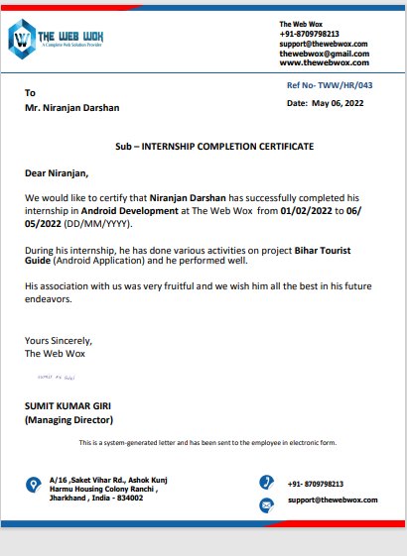

**Declaration**

I hereby declare that The Project entitled Bihar Tourist Guide Application is an outcome of my own efforts under the guidance of **Prof. Vidushi Mishra**. The project is submitted to the department of MCA. For the partial fulfilment of Master of Computer Application 2019-22.

I also declare that project report is not submitted in any of the university previously.

Date: 24-May-2022

Place: Ghaziabad

**Abstract**

The purpose of “**Bihar Tourist Guide**” is to automate the existing system by the help of android application, fulfilling their requirements, so that their valuable information can be stored for a longer period with easy accessing and manipulation of the same. The required software and hardware are easily available and easy to work with.This application helps tourist to get all the required information about the places without the needs of guide man. That means one need not be distracted by information that is not relevant, while being able to reach the information. Basically the project describes how to manage for good performance and better services for the clients.

**ACKNOWLEDGEMENTS**

Success in life is never attained single handedly. My deepest gratitude goes to my team leader at The WebWox for his guidance, help and encouragement throughout my work. Their enlightening ideas, comments, and suggestions. Words are not enough to express my gratitude to Dr. Ajay Kumar Shrivastava, Professor and Head, Department of Computer Applications and all the faculties, for his insightful comments and administrative help at various occasions.

Fortunately, I have many understanding friends, who have helped me a lot on many critical conditions.

Finally, my sincere thanks go to my family members and all those who have directly and indirectly provided me moral support and other kind of help. Without their support, completion of this work would not have been possible in time. They keep my life filled with enjoyment and happiness.

**Table of contents**

|  |  |  |
| --- | --- | --- |
| **S.No.** | **Description of Project** | **Page No**. |

**i Declaration 2**

**ii Abstract 3**

**iii Acknowledgements 4**

**1. CHAPTER 1 :INTRODUCTION 12-13**

**1.1. Project Description 12**

**1.2 Background 12**

**1.3 Motivations 13**

**2. CHAPTER 2 :Literature Review 14-15**

**3. CHAPTER 3: Project Category 16-20**

**3.1 Technology Used 16**

**3.2. Language Used 17**

**3.3 Application Description 18**

**3.4 Quality Function Deployment 19**

**3.4.1 Must have requirements 19**

**3.4.2 Should have requirements 19**

**3.4.3 Nice to have requirements 19**

**3.5 Database and UI Design 20**

**3.5.1 Database Design 20**

**3.5.2 User Interface Design 20**

**3. CHAPTER:4 Software Requirement Specification 21-33**

**4.1 General Description 21**

**4.1.1 Product Description 21**

**4.1.2 Problem Statement 21**

**4.2 System objectives 22**

**4.2.1 Requirement Specifications 22**

**4.3 Functional Requirements 23**

**4.4 Non-functional Requirement 24**

**4.5 Software and Hardware Requirement 24**

**4.5.1 Software Requirements 24**

**4.5.2 Hardware Requirement 24**

**4.6 Existing Vs Proposed System 25**

**4.7 Software System attributes 25**

**4.8 Features of Bihar tourist guide 26**

**4.9 Preliminary investigation 27**

**4.10 Approach used:Agile apporach 28-32**

**4.11 Preliminary description 33**

**4. CHAPTER :5 Feasibility study 34-36**

**5.1 Economical feasibility 34**

**5.2. Technical feasibility 34**

**5.3 Operational feasibility 35**

**5.4Tools for Conducting a Feasibility Study 35**

**5.4.1 Suggested Best Practices 35**

**5.4.2 Suggested Components 36**

**5. CHAPTER:6 Planning and Scheduling &flow 37-57**

**6.1 Gantt chart 37**

**6.1.1 Software requirement & specification 38**

**6.1.2 Hardware requirement with specification 38**

**6.2 Data flow diagram 39-41**

**6.3 Entity relationship diagram 42-43**

**6.4 Use Case Diagram 44-45**

**6.5 Relationship in Use Case Diagram 46**

**6.6 Use Case Diagram of Tourist Guide Apps 47**

**6.7 Sequence Diagram 48-50**

**6.8 Application Architecture 51**

**6.9 Proposed System 52**

**6.10 Methodology 53**

**6.(a) Data Structure(Tables) 54-55**

**6.11 (b) Modules 56-57 6.11.1 login module 56**

**6.11.2 Signup module 56**

**6.11.3 District module 57**

**6. CHAPTER:7 Activities intent in the project 58-71**

**7.1 welcome page 58**

**7.2 login page 59-60**

**7.3 Signup page 61-62**

**7.4 Place Bihar 63-64**

**7.5 Patna place 65-66**

**7.6 Expandiable item of the list 67-71**

**7.6.1 Information activity 67-68**

**7.6.2 Maps: 69**

**7.6.3 Direction 70-71**

**7. CHAPTER:8 Module Description 72-73**

**8.1 Modules of Bihar Tourist Guide Apps 72**

**8. CHAPTER 9: TEST STRATEGY 74-76**

## 9.1 The Objective of Test Strategy 74

**9.2 Test Trategies Used in Project 75**

**9.3 How to do Testing 76**

**9. Objective 77**

**10. Purpose 78**

**11. Scope 79**

**12. Conclusion 80**

**13. Bibliography 81**

**List of Figures**

|  |  |  |
| --- | --- | --- |
| **Fig Num** | **Name Of Figure** | **Page Num** |
| 01 | Approach Used in development | 30 |
| 02 | Gantt Chart | 36 |
| 03 | DFD Of Bihar Toursit Guide Application | 40 |
| 04 | ER Diagram Of Bihar Tourist Guide Apps | 42 |
| 05 | Use Case Diagram Of Tourist Guide Apps | 46 |
| 06 | User Log in Sequence Diagram | 47 |
| 07 | User insert Sequence Diagram | 48 |
| 08 | Guide User Method Sequence Diagram | 49 |
| 09 | Architectural Design | 50 |
| 10 | Methodology Used | 52 |
| 11 | Login Module | 55 |
| 12 | SignUp Module | 55 |
| 13 | Districts Module | 56 |
| 14 | Welcome Page | 57 |
| 15 | Login Page | 59 |
| 16 | SignUP Page | 61 |
| 17 | Districts Of Bihar | 63 |
| 18 | Tourist Places of a particular District | 65 |
| 19 | Introduction of particular place | 67 |
| 20 | Location of tourist place on Map | 68 |
| 21 | Route to reach tourist place | 70 |

**List Of Tables**

|  |  |  |
| --- | --- | --- |
| **Table Number** | **Table Name** | **Page Number** |
| 1 | Software Requirement with Specification | 38 |
| 2 | Hardware Requirement with Specification | 38 |
| 3 | Datastructure of Signup Page | 55 |
| 4 | Datastructure of Login Page | 55 |
| 5 | Datastructure of Login with Facebook Page | 56 |

**Chapter 1**

**Introduction**

**1.1 Project Description**

This project has been developed to override the problems prevailing in the practicing manual system. This application is supported to eliminate and in some cases reduce the hardships faced by the existing system. Moreover, this application is designed for the particular need of the company to carry out operations in a smooth and effective manner.

This application is developed to avoid errors while entering the data. It also provides error messages while entering invalid data. No formal knowledge is needed for the user to use this system. Thus by this all it proves it is user friendly. So, This “Bihar Tourist Guide” can lead to error-free, secure, reliable and fast system.

Every districts has different tourist places, therefore we design exclusive application that are adapted by the tourist to know about the place . This is designed to assist in strategic planning and will help you ensure that every person has android mobile phone as its general needs with the right level of information and details for future goal. This application will ultimately allow us for better Guide resources.

**1.2 Background**

As someone who travels often, it is a challenge for me to connect with the local people and culture where I travel. Problems can happen when someone travels to a whole new country where local people have different type of thinking, culture, beliefs, etc. This application come out to help tourist to get quick and better view about where they are about to visit, as well as better connects with local people and reduce the chance that troubles happen along the journey. Developing a mobile app plays an important role in the technology nowadays, as the number of mobile devices are multiple times more than the number of our population. From that huge market, Android devices get 85.9% of all mobile devices, which show us how big potential that an Android application has to affect our society. Android Studio is one of the most useful types of API, which offers a cross platform mobile development. Developing an application for android using Android Studio will give us an opportunity for later, if we want to expand the application to IOS operating system. C# is one of the most popular programming languages at the moment, with approximately 31% of all developers using it regularly. The language creates 17000 jobs each month globally. It is very effective and powerful.

**1.3 Motivations**

The motivation for this project comes from personal issues of myself, as I love traveling usually, and most of the time when I travel through Bihar, I have to spend quite a lot of time doing research while being busy with College and daily routine. The problem does not only occur to me, but also to many young travelers. This could lead to many other serious problems, as the difference in cultures is huge, and the number of people who travel is enormous and still growing rapidly. Similar to AirBnb, which shows the 8 problem of housing, this application could show the problem about guiding. The motivation also comes from the personal practice as a Android developer in my training.

**Chapter 2**

**LITERATURE REVIEW**

In the earlier tourism industry, tour and travel information is obtained mainly through communication media like newspaper, magazines etc. But the tourists on travel do not get the necessary travel information on time. While today's mobile devices are becoming more intelligent, which provides information in mobile itself. Mobile Technology is now set to improve tourism in various fields. Due to busy schedule people want quick and easy ways to obtain information of all kinds and tourism is no different. The tour management system which is based on internet provides self guidance for tourists in mobile phones . This proposed paper presents travel guidance that draws out a number of methods for designing tourist management system.

The smart phone or a tablet is portable and always in the pocket for anytime use. The combination of tourism and technology makes the business towards the development of mobile applications, to provide services to the customers efficiently. The travel management system makes it possible for the users to plan their trips, make reservations and make other required arrangements for their trips. This would provide them with more time to enjoy their vacation.

The increasing growth of tourism industry has a good scope in today’s world. This industry is posing greater competition in the business oriented world. Since this is a technology oriented world, our priorities for tours and travel are keeps on changing. In earlier days people used to go to travel consultancies for tour travel destinations and other travel related information. Now there is tremendous changes in earlier and current tourism. The travellers make excess use of internet to collect the information about the various destinations and offers. For the effective management of tourism quality, the complex information technologies are used by travel industry. The products, information and services should be of higher quality for the consumers satisfaction. The user actually look for is the value for their money. The tourism business makes use of internet for effective operation.

**Chapter 3**

**PROJECT CATEGORY**

**3.1 Technology Used**

**Android Studio**

Android Studio is the official Integrated Development Environment (IDE) for Android app development, based on [IntelliJ IDEA](https://www.jetbrains.com/idea/). On top of IntelliJ's powerful code editor and developer tools, Android Studio offers even more features that enhance your productivity when building Android apps.

**SoftWare and Applications Used**

APPLICATION : Android Studio

OPERATING SYSTEM : WINDOWS 10

FRONT END : JAVA , Xml

BACK END : Firebase

**Back-end : Firebase**

* **Firebase:-** It is realtime database developed by firebase and then acquired by Google in 2014 used for developing the high quality applications act as a storage of information of various data.

**3.2** **Language Used**

This project has been developed XML and Java.

* **XML:** XML stands for extensible markup language. A markup language is a set of codes, or tags, that describes the text in a digital document. The most famous markup language is hypertext markup language (HTML), which is used to format Web pages..
* **JAVA:** Java is an object-oriented programming language developed by Sun Microsystems, and it was released in 1995.

James Gosling initially developed Java in Sun Microsystems (which was later merged with Oracle Corporation).

Java is a set of features of C and C++. It has obtained its format from C, and OOP features from C++.

Java programs are platform independent which means they can be run on any operating system with any processor as long as the Java interpreter is available on that system.

Java code that runs on one platform does not need to be recompiled to run on another platform; it's called write once, run anywhere(WORA).

**3.3 APPLICATION DESCRIPTION**

**3.3.1 Function Description**

The purpose of the application is to create an environment for people who travels often to meet locals, who provide the guide service through an android application. The application includes two separate view, which provide different function to different group of users.

• Travel User Group: First allows the user to register, then uses that register information to log in. In the main tab, the user will be able to view past request, as well as create a new request which will be sent to Guide User Group for their acceptance. This will require the user to enable the location service on their mobile application, for the authorization.

• Guide User Group: This view also allows the user to register and log in. From the main tab, users of this group will see all the pending requests, which they will be able to click in, in order to view the information of that pending request, as well as contact the one who sent the request in order to negotiate about the upcoming trip. After that, the guide person will either accept that request, so that other guide users will not see that request or choose to leave it for the other guide users.

**3.4 Quality Function Deployment**

**3.4.1 Must have requirements**

For Travel User Group The user of this group must be able to register into the application with an account which holds an email and password. After that, the account information can be used to log in to the application. From the application, a new request from user’s upcoming trip can be created, stored in the database and sent to Guide User Group. For Guide User Group: The user of this group must be able to register into the application with an account which hold email and password. The account will be used later to 13 log in to the user into the main tab. After logging in, that user will see a list of requests, which are pending. He can choose to view the details of that request, then click accept it if he agrees with the travel user about the upcoming trip.

**3.4.2 Should have requirements**

Users from both of the groups should be able to use their social media account to register and log in to the application. The travel user should be requested to enable the location service to identify their location for authorization purpose. A travel user should also be able to review their past requests.

**3.4.3 Nice to have requirements**

Both views of the application should have a responsive user interface without bug. It would be better if the travel user could get a notification if their request has been accepted. Guide user group should be able to see their past requests that they approved before.

**3.5 DATABASE AND UI DESIGN**

**3.5.1 Database Design**

Firebase service is used to save all the data of the application. There are three tables for the application, they are

• **TravelUser**: store user ID, name and password for the travel user group

• **GuidePerson**: store user ID, name and password for the guide user group

• Request: store request data that User group send and retrieve those data back to GuidePerson group users.

Since Firebase do not support diagrams in the same way as a normal database does, a third-party tool is used to draw the ER diagram, which is Visual Paradigm.

The user table has a one-to-many relationship with PendingRequest table, since one user could create many requests, but one request cannot belong to many users. The GuidePerson table has a one-to-many relationship with the PendingRequest table as well, it means that one guide person can get many requests, but one request cannot be selected by many Guide users.

**3.5.2 User Interface design**

The application includes two separate views, one for the travel user and one for the guide person. However, only one page will be designed for both views, in order to focus on the function

**Chapter 4**

**SOFTWARE REQUIREMENT SPECIFICATION**

**4.1 GENERAL DESCRIPTION**

**4.1.1 PRODUCT DESCRIPTION:**

Bihar tourist Guide is a computerized system which helps user(tourist) to visit the tourist places in electronic format. It reduces the risk of manpower such as Guide man and time saving.

**4.1.2 PROBLEM STATEMENT:**

The problem occurred before having computerized system includes:

* Seeking for the Guide man at the tourist place.
* Improper information or sometimes it is seen that false information given by the tourist.
* Animal type behavior by the guide man with the outsider.
* Excessive expenses on the tourist guide.
* Unavalibility of knowledge to reach the destination.

**4.2 SYSTEM OBJECTIVES**

• **Improvement in control and performance**

The system is developed to cope up with the current issues and problems of tourist .The system can add user, validate user and is also bug free.

**• Save cost**

After computerized system is implemented less man power will be required to maintain the tourist place thus reducing the overall cost.

**• Save time**

Tourists are able to get particular name of the district record by clicking on it thus saving his valuable time.

**• Option of getting direction**

Tourists will be able to provide a brief description of tourist places of particular district of Bihar.

**4.2.1 Requirement Specifications:**

The software requirement specification is produced at the analysis task. The function and performance allocated to application as part of system engineering are refined by establishing a complete information description, a detailed functional and behavoural description, an indication of performance requirements and design constraints.

**4.3 Functional Requirements:**

**Internet Connectivity:**

As discussed that Application will work on Online mode so it need regular Internet Connectivity to signup and login.

**Facebook Account**

User can directly login to the facebook account to access this application they don’t need to signin in apps environment for which facebook account is mandatory.

**Email id and Mobile Number**

To access the application and to signin or login user must have email id and mobile number to fill the mandatory field in the form.

**4.4 Non-functional Requirements:**

Performance Requirements

1. User friendly**:** The system should be user friendly so that it can easily be understand by the user without any difficulty.
2. Ease of maintenance :- System should be easy to maintain and use.
3. Less time consuming: The system should be less time consuming which could be achieved by good programming.
4. Error free: The system should easily handle the user error in any case.
5. Static: Application runs on stand alone machine i.e. Android mobile phone of API level 16 and onward. Support only single user.

**4.5 SOFTWARE AND HARDWARE REQUIREMENTS**

This section describes the software and hardware requirements of the system .

**4.5.1 SOFTWARE REQUIREMENTS**

• **Operating system**- Android operating system is required for the android apps with the API Level 16 and onwards.

• **Database**:- Firebase is used as database as it is easy to maintain and retrieve records by simple queries which are in English language which are easy to understand and easy to write.

• **Development tools and Programming language**- XML is used to write the whole designing code and coding is done in java programming language.

**4.5.2 HARDWARE REQUIREMENTS**

* Android Mobile phone of API Level 19 and onward.
* Memory Used Total 6.31 MB with 5.98 MB of application space and 340 KB of data

**4.6 EXISTING VS PROPOSED SYSTEM**

Existing system does not have a facility of online information of tourist place whereas proposed system has a facility of online information of tourist places of respective districts of Bihar

Existing system does not have any facility of online Location of the tourist place where location of particular tourist place can be known by this apps.

Existing System does not highlight many of the tourist places but this app will provide you all the places related to devotees, Histroy etc. and will also update after finding the data.

Existing system does not have any facility of direction or the traffic route to reach the destination whereas proposed system provides tourists with a tool to reach destination.

**4.7 Software System Attributes**

1. **Security**: The system should be secure from the unauthorized access and should be password protected so that no other user can access it.

If the user is new then he needs to Signup with required details and a can also login with the facebook.

1. **Portability**:- The system should be machine independent.
2. **Maintainability**: The system will be designed in a maintainable order. The system can be easily modified and renewed according to the need of the organization.

**4.8 Features of Bihar tourist Guide:**

* Security of data.
* Ensures data accuracy.
* Minimize manpower.
* Minimum time consumption.
* Greater efficiency.
* Fast
* Better services.
* User friendliness and interactive.
* Minimum time required.

• Easy to update

• User friendly

• Free for the user

• knowing about Bihar, India

The basic idea of the application is that the user only needs a Android mobile phone with the ability to connect to the Internet. By using the Internet the user can open play store and download it by searching the name. When the user has started the application the user can find the district name where he want to go for tour and with the map there will be icons that represent different locations of interest. These icons will be different depending on what the user wants to have information about, and this should be customized on the mobile phone. The information displayed should be easy to customize. **Our suggestion is that the user could choose different ‘skins’ and that these skins would represent different types of stores and events**. Our vision is to encourage the tourist to visit the places without any hurdle in there journey. The user will always have the brief information about the tourist places along with map and direction they don’t need to pay extra amount to the Guide man of that place tom make there safe and memorable journey.

**4.9 Preliminary investigation:**

Fact Finding:

After obtaining the background knowledge, we began to collect data on the existing system.

The tools that are used in information gathering are as follows:

* On-site observation.
* Questionnaire.
* Review of the peoples.

The model we have used is Waterfall Model. In this model, first of all the existing system is observed, then customer requirements are taken in consideration then planning, modelling, construction and finally deployment.

**4.10** **Approach used**

Software Development life cycle (SDLC) is a spiritual model used in project management that defines the stages include in an information system development project, from an initial feasibility study to the maintenance of the completed application.

There are different software development life cycle models specify and design, which are followed during the software development phase. These models are also called "**Software Development Process Models**." Each process model follows a series of phase unique to its type to ensure success in the step of software development.

**Here, are some important phases of SDLC life cycle:**

### [Waterfall Model](https://www.javatpoint.com/software-engineering-waterfall-model)

### The waterfall is a universally accepted SDLC model. In this method, the whole process of software development is divided into various phases.

### The waterfall model is a continuous software development model in which development is seen as flowing steadily downwards (like a waterfall) through the steps of requirements analysis, design, implementation, testing (validation), integration, and maintenance.

Linear ordering of activities has some significant consequences. First, to identify the end of a phase and the beginning of the next, some certification techniques have to be employed at the end of each step. Some verification and validation usually do this mean that will ensure that the output of the stage is consistent with its input (which is the output of the previous step), and that the output of the stage is consistent with the overall requirements of the system.

### [RAD Model](https://www.javatpoint.com/software-engineering-rapid-application-development-model)

### RAD or Rapid Application Development process is an adoption of the waterfall model; it targets developing software in a short period.

### The RAD model is based on the concept that a better system can be developed in lesser time by using focus groups to gather system requirements.

* Business Modeling
* Data Modeling
* Process Modeling
* Application Generation
* Testing and Turnover

### [Spiral Model](https://www.javatpoint.com/software-engineering-spiral-model)

### The spiral model is a ****risk-driven process model****. This SDLC model helps the group to adopt elements of one or more process models like a waterfall, incremental, waterfall, etc. The spiral technique is a combination of rapid prototyping and concurrency in design and development activities.

Each cycle in the spiral begins with the identification of objectives for that cycle, the different alternatives that are possible for achieving the goals, and the constraints that exist. This is the first quadrant of the cycle (upper-left quadrant).

The next step in the cycle is to evaluate these different alternatives based on the objectives and constraints. The focus of evaluation in this step is based on the risk perception for the project.

The next step is to develop strategies that solve uncertainties and risks. This step may involve activities such as benchmarking, simulation, and prototyping.

### [V-Model](https://www.javatpoint.com/software-engineering-v-model)

### In this type of SDLC model testing and the development, the step is planned in parallel. So, there are verification phases on the side and the validation phase on the other side. V-Model joins by Coding phase.

### [Incremental Model](https://www.javatpoint.com/software-engineering-incremental-model)

### The incremental model is not a separate model. It is necessarily a series of waterfall cycles. The requirements are divided into groups at the start of the project. For each group, the SDLC model is followed to develop software. The SDLC process is repeated, with each release adding more functionality until all requirements are met. In this method, each cycle act as the maintenance phase for the previous software release.

### Modification to the incremental model allows development cycles to overlap. After that subsequent cycle may begin before the previous cycle is complete.

### [Agile Model](https://www.javatpoint.com/software-engineering-agile-model)

### Agile methodology is a practice which promotes continues interaction of development and testing during the SDLC process of any project. In the Agile method, the entire project is divided into small incremental builds. All of these builds are provided in iterations, and each iteration lasts from one to three weeks.

Any agile software phase is characterized in a manner that addresses several key assumptions about the bulk of software projects:

1. It is difficult to think in advance which software requirements will persist and which will change. It is equally difficult to predict how user priorities will change as the project proceeds.
2. For many types of software, design and development are interleaved. That is, both activities should be performed in tandem so that design models are proven as they are created. It is difficult to think about how much design is necessary before construction is used to test the configuration.
3. Analysis, design, development, and testing are not as predictable (from a planning point of view) as we might like.

### [Iterative Model](https://www.javatpoint.com/software-engineering-iterative-model)

### It is a particular implementation of a software development life cycle that focuses on an initial, simplified implementation, which then progressively gains more complexity and a broader feature set until the final system is complete. In short, iterative development is a way of breaking down the software development of a large application into smaller pieces.

### [Big bang model](https://www.javatpoint.com/software-engineering-big-bang-model)

Big bang model is focusing on all types of resources in software development and coding, with no or very little planning. The requirements are understood and implemented when they come.

This model works best for small projects with smaller size development team which are working together. It is also useful for academic software development projects. It is an ideal model where requirements are either unknown or final release date is not given.

### [Prototype Model](https://www.javatpoint.com/software-engineering-prototype-model)

The prototyping model starts with the requirements gathering. The developer and the user meet and define the purpose of the software, identify the needs, etc.

A '**quick design**' is then created. This design focuses on those aspects of the software that will be visible to the user. It then leads to the development of a prototype. The customer then checks the prototype, and any modifications or changes that are needed are made to the prototype.

**Agile Approach**

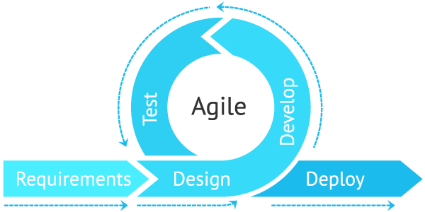

**Fig 1** Approach Used in development

Agile is **an iterative approach to project management and software development that helps teams deliver value to their customers faster and with fewer headaches**. Instead of betting everything on a "big bang" launch, an agile team delivers work in small, but consumable, increments.

This Project goes from various development models i.e. incremental model, evalution model and most important Agile Approach. Every model give a brief description about the project development. Each has its own importance.

**4.11 Preliminary Description:**

The first step in the system development life cycle is the preliminary investigation to determine the feasibility of the system. The purpose of preliminary investigation is to evaluate project requests. It is not a design study nor does it include the collection of details to describe the system in all respect. Rather, it is the collecting of information that helps committee members to evaluate the merits of project request and make an informed judgement about the feasibility of the proposed project.

**Analyst working on the preliminary investigation should accomplish the following objectives:**

* Clarify and understand the project request.
* Determine the size of the project.
* Access costs and benefits of alternative approaches.
* Determine the technical and operational feasibility of alternative approaches.
* Report the findings to management with recommendations outlining the acceptance and rejection of the proposal.

**Chapter 5**

**Feasibility study**

After studying and analyzing all the existing and requires functionalities of the system, the next task is to do the feasibility study for the project. Feasibility study includes consideration of all the possible ways to provide a solution to a given problem. The proposed solution should satisfy all the user requirements and should be flexible enough so that future changes can be easily done based on the future upcoming requirements.

**5.1 Economical Feasibility:**

It will be freely available on the Google play store without having any cost. This term means the assessment and analysis of a project's potential to support the decision-making [process](https://ceopedia.org/index.php/Process) by objectively and rationally identifying its strengths, weaknesses, opportunities and risks associated with it, the resources that will be needed to implement the project, and an assessment of its chances of success. It consists of [**market**](https://ceopedia.org/index.php/Market)**analysis**, **economic analysis**, **technical and**[**strategic analysis**](https://ceopedia.org/index.php/Strategic_analysis).

* 1. **Technical feasibility:**

This included the study of function, performance and constraints that may affect the ability to achieve an acceptable system. For this feasibility study, we studied complete functionalities to be provided in the system, as described in the System Requirement Specification (SRS), and checked if everything was possible using different type of front end and back end platform. Technical feasibility is **the process of figuring out how you're going to produce your product or service to determine whether it's possible for your company**. Before launching your offerings, you must plan every part of your operations, from first sourcing your production materials all the way to tracking your sales.

* 1. **Operational Feasibility:**

No doubt the technically growing Bihar needs more enhancement in technology, this apps is very user friendly and all inputs to be taken all self-explanatory even to a layman. Operational feasibility is **the measure of how well a proposed system solves the problems**, and takes advantage of the opportunities identified during scope definition and how it satisfies the requirements identified in the requirements analysis phase of system development.

## 5.4Tools for Conducting a Feasibility Study

### 5.4.1 Suggested Best Practices

Although each project can have unique goals and needs, below are some best practices for conducting a feasibility study:

* Conduct a preliminary analysis, which involves getting feedback about the new concept from the appropriate stakeholders; consider other business scenarios and ideas
* Analyze and ask questions about the data obtained in the early phase of the study to make sure that it's solid
* Conduct a market survey or market research to identify the market demand and opportunity for pursuing the project or business
* Write an organizational, operational, or business plan, including identifying the amount of labor needed, at what cost, and for how long
* Prepare a projected [income statement,](https://www.investopedia.com/terms/i/incomestatement.asp) which includes revenue, operating costs, and [profit](https://www.investopedia.com/terms/n/netincome.asp)
* Prepare an opening day [balance sheet](https://www.investopedia.com/terms/b/balancesheet.asp)
* Identify obstacles and any potential vulnerabilities, as well as how to deal with them
* Make an initial "go" or "no-go" decision about moving ahead with the plan

### 5.4.2 Suggested Components

Once the initial due diligence has been completed, listed below are several of the components that are typically found in a feasibility study:

* **Executive summary**: Formulate a narrative describing details of the project, product, service, plan, or business.
* **Technological considerations**: Ask what will it take. Do you have it? If not, can you get it? What will it cost?
* **Existing marketplace**: Examine the local and broader markets for the product, service, plan, or business.
* **Marketing strategy**: Describe it in detail.
* **Required staffing**(including an organizational chart): What are the [human capital](https://www.investopedia.com/terms/h/humancapital.asp) needs for this project?
* **Schedule and timeline**: Include significant interim markers for the project's completion date.
* **Project financials**.
* **Findings and recommendations**: Break down into subsets of technology, marketing, organization, and financials.

**Chapter 6**

**Planning and Scheduling and Flow**

**6.1** **Gantt chart**

A Gantt chart can be developed for the entire project or a separate chart can be developed for each function. A tabular form is maintained where rows indicate the task with milestones and columns indicate duration(weeks/months).

A Gantt chart shows all of the tasks that need to be done, the amount of time each task is expected to take, the time frames in which individual tasks are to be completed, and the relationship between various tasks

|  |  |  |  |  |  |  |  |  |  |  |  |  |  |  |
| --- | --- | --- | --- | --- | --- | --- | --- | --- | --- | --- | --- | --- | --- | --- |
| Days  Process | 1-5 | | 6-25 | 26-30 | | | 30-80 | | 80-85 | | | 85-90 | | |
| Requirement  Gathering |  |  |  |  | | |  | |  | | |  | | |
| Design |  |  |  |  | | |  | |  | | |  | | |
| Test Cases |  | |  |  |  |  | |  | | |  | | |  |
| Coding |  | |  |  |  | |  | |  | | |  | | |
| Testing |  | |  |  | | |  | |  |  | |  |  | |
| Build |  | |  |  | | |  | |  | | |  |  | |

Fig 2 Gantt Chart

**6.1.1 Software Requirements with specifications**

|  |  |
| --- | --- |
| Name of Components | Specifications |
| Operating system | Android Operating system |
| Language | Java eclipse 2 Runtime Environment |
| Database | Firebase |
| Software Development kit | Android Studio |
| Markup Language Enable | Xml |

**Table Num 1: Software requirement with specifications**

**6.1.2 Hardware Requirements with specifications**

|  |  |
| --- | --- |
| Name of Components | Specifications |
| Cell Phone | Android Mobile phone API 17 and onward |
| Application | 13.52MB |
| Data | 304KB |

**Table Num 2: Hardware requirement with specifications**

**6.2 DATA FLOW DIAGRAM**

**DFD** is the abbreviation for **Data Flow Diagram**. The flow of data of a system or a process is represented by DFD. It also gives insight into the inputs and outputs of each entity and the process itself. DFD does not have control flow and no loops or decision rules are present. Specific operations depending on the type of data can be explained by a flowchart. Data Flow Diagram can be represented in several ways. The DFD belongs to structured-analysis modeling tools. Data Flow diagrams are very popular because they help us to visualize the major steps and data involved in software-system processes.

#### Components of DFD

The Data Flow Diagram has 4 components:

* **Process**  
  Input to output transformation in a system takes place because of process function. The symbols of a process are rectangular with rounded corners, oval, rectangle or a circle. The process is named a short sentence, in one word or a phrase to express its essence
* **Data Flow**  
  Data flow describes the information transferring between different parts of the systems. The arrow symbol is the symbol of data flow. A relatable name should be given to the flow to determine the information which is being moved. Data flow also represents material along with information that is being moved. Material shifts are modeled in systems that are not merely informative. A given flow should only transfer a single type of information. The direction of flow is represented by the arrow which can also be bi-directional.
* **Warehouse**  
  The data is stored in the warehouse for later use. Two horizontal lines represent the symbol of the store. The warehouse is simply not restricted to being a data file rather it can be anything like a folder with documents, an optical disc, a filing cabinet. The data warehouse can be viewed independent of its implementation. When the data flow from the warehouse it is considered as data reading and when data flows to the warehouse it is called data entry or data updation.
* **Terminator**  
  The Terminator is an external entity that stands outside of the system and communicates with the system. It can be, for example, organizations like banks, groups of people like customers or different departments of the same organization, which is not a part of the model system and is an external entity. Modeled systems also communicate with terminator.

**Data flow diagram levels**

Data flow diagrams are also categorized by level. Starting with the most basic, level 0, DFDs get increasingly complex as the level increases. As you build your own data flow diagram, you will need to decide which level your diagram will be.

**Level 0 DFDs**, also known as context diagrams, are the most basic data flow diagrams. They provide a broad view that is easily digestible but offers little detail. Level 0 data flow diagrams show a single process node and its connections to external entities.

**Level 1 DFDs** are still a general overview, but they go into more detail than a context diagram. In a level 1 data flow diagram, the single process node from the context diagram is broken down into subprocesses. As these processes are added, the diagram will need additional data flows and data stores to link them together.

**Level 2+ DFDs** simply break processes down into more detailed subprocesses. In theory, DFDs could go beyond level 3, but they rarely do. Level 3 data flow diagrams are detailed enough that it doesn’t usually make sense to break them down further.

**Data Flow Diagram Of Bihar Tourist Guide Applications**

Welcome Page

Login Page

Already a user?

**yes**

LOGIN or login with facebook

SIGNUP or login with facebook

**No**

DISTRICT NAME

TOURIST PLACE

**Fig 3** DFD Of Bihar Toursit Guide Application

**6.3 ENTITY RELATIONSHIP DIAGRAM:**

**ER Diagram** stands for Entity Relationship Diagram, also known as ERD is a diagram that displays the relationship of entity sets stored in a database. In other words, ER diagrams help to explain the logical structure of databases. ER diagrams are created based on three basic concepts: entities, attributes and relationships.

ER Diagrams contain different symbols that use rectangles to represent entities, ovals to define attributes and diamond shapes to represent relationships.

**Following are the main components and its symbols in ER Diagrams:**

* **Rectangles:**This Entity Relationship Diagram symbol represents entity types
* **Ellipses :**Symbol represent attributes
* **Diamonds:**This symbol represents relationship types
* **Lines:**It links attributes to entity types and entity types with other relationship types
* **Primary key:**attributes are underlined
* **Double Ellipses:**Represent multi-valued attributes

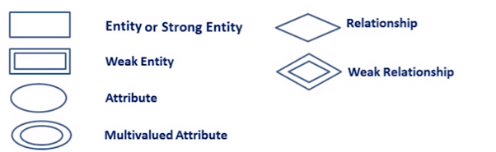

**ER Diagram of Bihar Tourist Guide Application**

Welcome Page

Sign Up

Login

Login Page

District Name

Tourist Place

**Fig 4** ER Diagram Of Bihar Tourist Guide Apps

* 1. **Use Case Diagram**

A use case diagram is used to represent the dynamic behavior of a system. It encapsulates the system's functionality by incorporating use cases, actors, and their relationships. It models the tasks, services, and functions required by a system/subsystem of an application. It depicts the high-level functionality of a system and also tells how the user handles a system.

**Use Case Diagram objects**

Use case diagrams consist of 4 objects.

* Actor
* Use case
* System
* Package

The objects are further explained below.

##### **Actor**

Actor in ause case diagram is **any entity that performs a role** in one given system. This could be a person, organization or an external system and usually drawn like skeleton shown below.



##### **Use Case**

A use case **represents a function or an action within the system**. It’s drawn as an oval and named with the function.

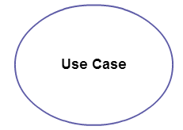

##### **System**

The system is used to **define the scope of the use case** and drawn as a rectangle. This an optional element but useful when you’re visualizing large systems. For example, you can create all the use cases and then use the system object to define the scope covered by your project. Or you can even use it to show the different areas covered in different releases.

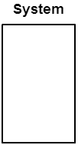

##### **Package**

The package is another optional element that is extremely useful in complex diagrams. Similar to [class diagrams](https://creately.com/diagram-type/class-diagram), packages are **used to group together use cases**. They are drawn like the image shown below.

[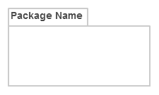](https://d3n817fwly711g.cloudfront.net/blog/wp-content/uploads/2014/03/Package1.png)

### Use Case Diagram Guidelines

Although use case diagrams can be used for various purposes there are some common guidelines you need to follow when [drawing use cases.](https://creately.com/diagram/example/hfuu87vt2/login%20page)

These include naming standards, directions of arrows, the placing of use cases, usage of system boxes and also proper usage of relationships.

We’ve covered these guidelines in detail in a separate blog post. So go ahead and check out [use case diagram guidelines](https://creately.com/blog/diagrams/use-case-diagram-guidelines/).

### 6.5 Relationships in Use Case Diagrams

There are five types of relationships in a use case diagram. They are

* Association between an actor and a use case
* Generalization of an actor
* Extend relationship between two use cases
* Include relationship between two use cases
* Generalization of a use case

We have covered all these relationships in a separate blog post that has examples with images. We will not go into detail in this post but you can check out [relationships in use case diagrams](https://creately.com/blog/diagrams/use-case-diagram-relationships/).

**6.6 Use Case Diagram Of Tourist Guide Application**

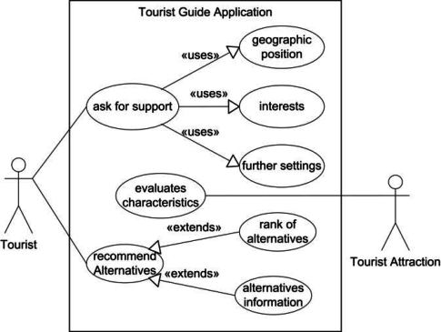

**Fig 5** Use Case Diagram Of Tourist Guide Apps

As shown in the Guide User use case diagram, the user can register for an account, then log in with that account information. After logging in, the user will be able to access to a number of features. First, the user will be able to see a list of requests from different tabs, which are Waiting, Processing and Processed. After that, this user can check all the details of the request’s user and put the request’s status into Processing. After negotiating with the travel user about the upcoming trip, this user will be able to put the request status to Processed or not, if the user decides to do so, the request will be moved to Processed tab and removed from Processing tab.

The travel Application for the first user group includes the signing up and logging in method, which is using the email and password attributes. If the value is valid, it will be accepted, the data is inserted in the database. Then the user enters that information to log in. If the information is correct with data in the database, the user will be navigated to Main Tab, otherwise the user will see a toast, which asks him to check again the data that he enters.

**6.7 Sequence Diagram**

User from both groups will enter the register data, which includes email and password, then hit the register button. If the value is valid, it will be accepted, the data is inserted in the database. Then the user enters that information to log in. If the information is correct with data in the database, the user will be navigated to Main Tab, otherwise the user will see a toast, which asks him to check again the data that he enters.

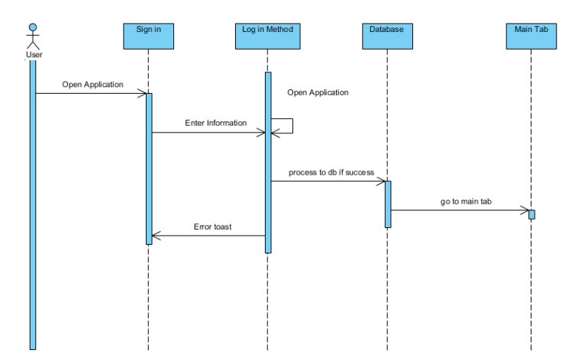

**Fig 6** User Log in Sequence Diagram

When the Travel user decides to add a new request, the user will be navigated to a view, where he can use the Insert Method. First the user will fill in all the details of the fields as well as allowing the location service. If the data that user input is valid, it will be inserted to the database, otherwise the user will get an error alert to let that user know that the value is invalid.

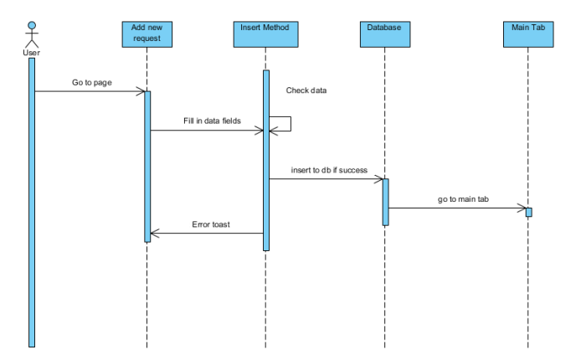

**Fig 7** User Insert Sequence Diagram

The Guide person will be able to check all the details of requests, which include Waiting request and Processing request. For the Waiting request, the user can mark as Processing by clicking on the Process button and calling the Process method. After that, the status value of the request will be changed and updated to the database. Similarly, the user can mark the Processing request to Processed, which will call the Accept method, change the status value of the request to 2 and updated to the database.

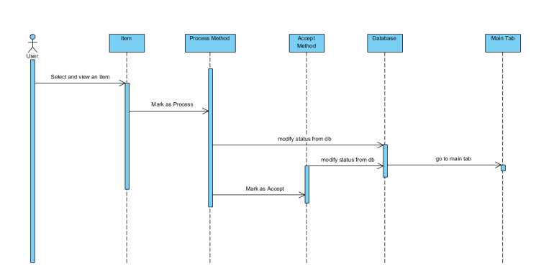

**Fig 8** Guide User Method Sequence Diagram

**6.8 APPLICATION ARCHITECTURE**

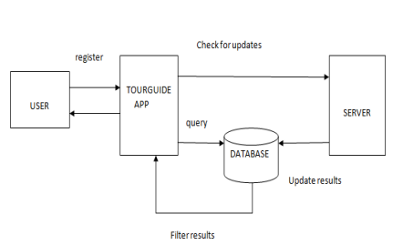

**Fig 9** Architectural Design

The three layers of architectural design are presentation layer business layer and access layer.

1. **Presentation layer:**

The front end of the system is in the presentation layer. Interaction of the presentation layer with the user transforms all the activities that the user performs into requests which is then passed to next layer called business layer. When response is received from access layer the results are displayed in a way that is appropriate to the user.

1. **Business layer:**

All the calculations and operations in the system are performed by the logic, which is present in this layer. The operations are performed on the data, which is received from the previous layer i.e. Presentation layer. Then the results are stored in the database which is present in the access layer. This layer doesn’t perform data storage and display mechanism.

1. **Access layer**:

The data is stored to and retrieved from the database which is present in this layer.

**6.9. PROPOSED SYSTEM**

Bihar Tourist Guide Application first requires the new user or the tourist to register and if the user has already registered they may login into their account. Once the user logs in successfully, they can search for the desired places by entering the name of the place. After the search operation completes, the user gets the image and description of the selected places. The caching of all the information about the places is made for the quick access by tourists without using the external sources . The user can also view the map of the selected place for better guidance .The application provides weather forecasting facilities to the user. There is an option for creating tour and the user can select any of the three facilities available such as travelling, food and lodging. The minimum distance between the current location of user and the target destination is measured using GPS module . Based on the users selection cost is estimated for the individual facilities. Total cost is then calculated by summation of individual costs. The users can also select the individual facilities. It also provides customised packages, based on the cost and number of days. Before selecting the package user can view the predefined list of dates, places and hotels. The users can then view the orders placed and pay online. The user will get the notification about the ongoing activity and the current time when he reaches the entered destination . They can also provide the feedback regarding their experience. The feedback provided by each user is visible to everyone, so that the other users can plan for a better trip. The users after visiting the desired locations, can upload the pictures which can be viewed by other users. The uploaded pictures can be liked, disliked or commented by other users.

**6.10 METHODOLOGY**

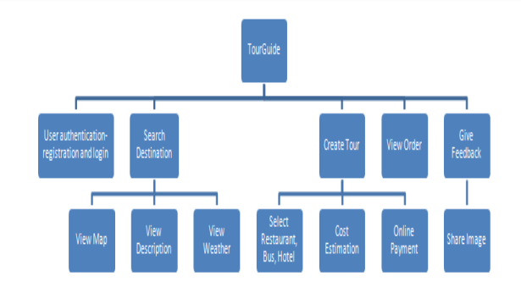

**Fig 10** Methodology Used

Tourist Guide Application has five modules namely:

• **User Authentication** – The user who has no account must first register to create an account. The user who already has an account logs in.

• **Search Destination**- The user after logging in searches the location he wants to visit. This has three sub modules namely:

View map-The user views the map of desired location.

View description-The user views the description of the desired location.

View weather- The user can view the weather condition of the selected place.

• **Create Tour**-The user can plan a tour by selecting any of the options like travel, hotels and restaurants. The cost is then estimated based on the selection and payment is done online.

• **View Order**-The orders placed by the users can be viewed by them.

• **Give Feedback**-The user can give feedback about the application.

Share image- The user can upload the image of the visited place and share tour experience.

**Table 3 Data Structure of SignUp Page:-**

|  |  |  |
| --- | --- | --- |
| **FIELD** | **DATATYPE** | **DEFAULT** |
| User name | VARCHAR(50) | NOT NULL |
| Email id | VARCHAR(255) | NOT NULL |
| Password | VARCHAR(255) | NOT NULL |
| Mobile Number | Integer | NOT NULL |

**Table 4 Data Structure of Login Page:-**

|  |  |  |
| --- | --- | --- |
| **FIELD** | **DATATYPE** | **DEFAULT** |
| Email id | VARCHAR(255) | NOT NULL |
| Password | VARCHAR(255) | NOT NULL |

**Table 5 Data Structure of Login with Facebook :-**

|  |  |  |
| --- | --- | --- |
| **FIELD** | **DATATYPE** | **DEFAULT** |
| Email id | VARCHAR(255) | NOT NULL |
| Password | VARCHAR(255) | NOT NULL |

(Note:- If Facebook is Logout then only you need to give above details otherwise it will take your logged in Facebook id)

**6.11 Modules**

**6.11.1. Login Module**

Users

Password

Email id

**Fig 11** Login Module

6.11.2 **SignUp Module**

SignUp

email

Password

Name

Mobile

**Fig 12** SignUp Module

**6.11.3 District Module:**

Districts Name

Tourist Place

Information

Map

Direction

**Fig 13** Districts Module

**Chapter 7**

**Activities Intent in the Project**

* 1. **Welcome Page** :

This page consist of the written Statement **“Welcome To Bihar”** with the animated Image having its design page in the xml markup language with the coding part the coding part is declared in java language.

**This activity page looks like:**

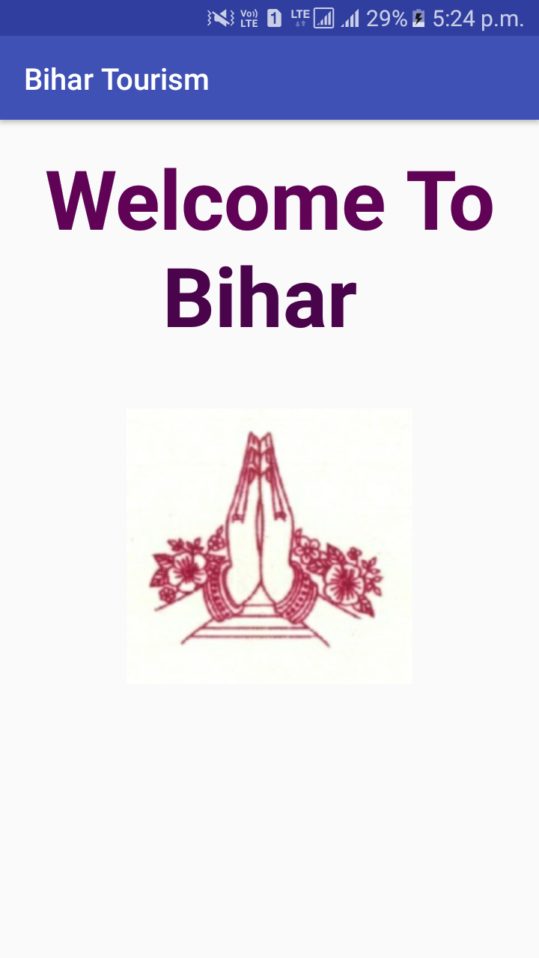

Fig 14 Welcome Page

* 1. **Login Page:**

This page allows the registered users to login this page to access the apps to go to the frequired activity the user wants. The information get stored in the database. In this page we had usen the “Skip>>” button in which we can also access the apps by not login it with email id and password by entering the registered email id and password the page contain the Login Button also by which the user can access the apps by logging it in.

By clicking on the signup Button the new Users can give there details to become the authenticated users and there details will be more secure and can be placed in the Firebase the cloud Database.

By clicking the button “Login with facebook ” the button will automatically access the logged in id in the system and if any of the id is not logged in the System will ask you to enter the required field details to logged in with the facebook.

We can also access the apps by Facebook login .

The visitors may also go to the Sign up page through this page .

The Activity Page Look Like:-

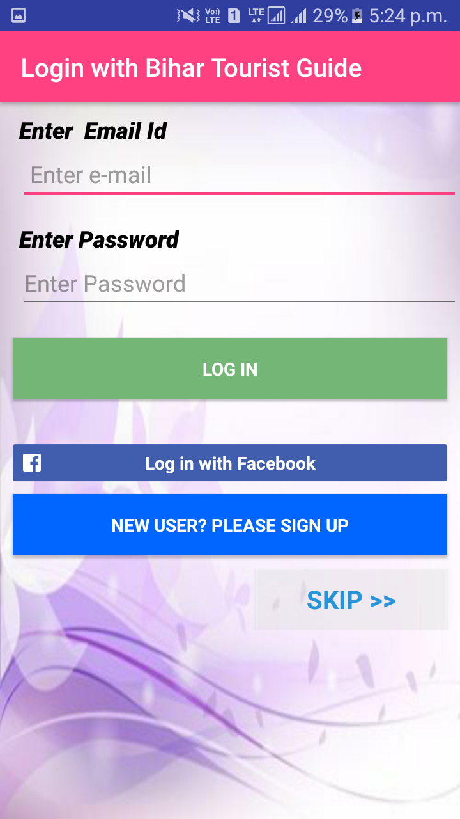

Fig 15: Login Page

* 1. **SignUp Page:**

This page consist of the all details required to authenticate the new users to access the Application.

It consist of many Columns:-

1. Users Name:- This column have to get the name of the User to be registered in the authenticated area of the Database.
2. Phone Number:- This edit text column provide you the facility to enter the phone number of a particular person which must be valid hoping to add the new feature with this apps may help you to get updated with it.
3. E-mail id:- The user have to give the e mail id which must contain atleast “@” and “.com” the email id must be valid which may be used for the further use in the future.
4. Password :- The users have to create a password must be above 6 varchars which will be used for login the apps.
5. SignUp Now:- This is a button used to Signup the application by storing these details in firebase database.

This page Look Like:-

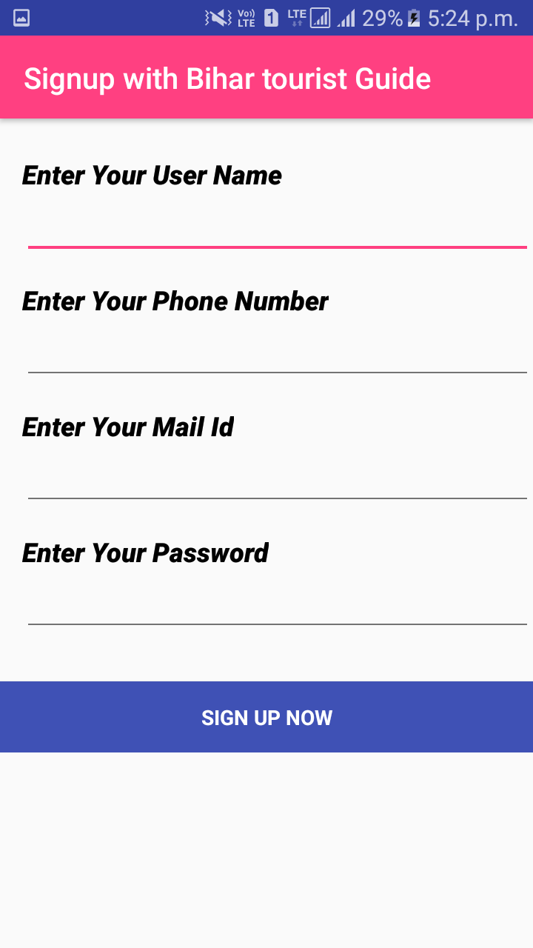

Fig 16 SignUP

* 1. **Place Bihar:**

This activity consist of the districts name in Bihar. These district is more known for the tourist place in Bihar in the historical point of view as well as the nature beauty and also known for the devotional purpose.

Few of the District names are:-

1.Patna

2. Bodhgaya

3. Sonepur

4. Darbhanga

5. Nalanda

6. Bhagalpur

7. Rajgir

**The outlook of the activity are:-**

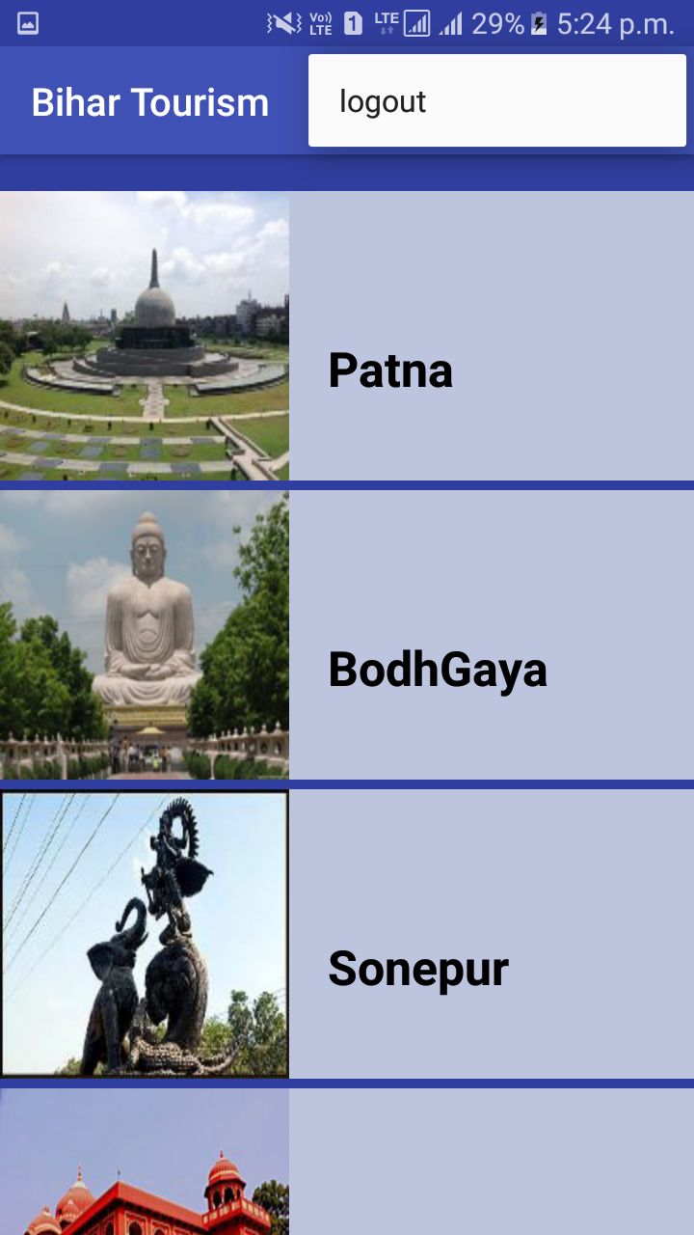

**Fig 17 Districts Of Bihar**

* 1. **Patna Place:**

This activity contain the lists of all the tourist places in Patna District.

Some of the mentioned Tourist Place of Patna are:-

1. GolGhar
2. Agamkuan
3. GandhiMaidan
4. Patna Planitorium
5. Shri Krishna Memorial Hall
6. Mahavir Mandir
7. Maa Patneshwari Mandir
8. Budha Smriti Park
9. Sanjay Gandhi Jaivik Udhyaan
10. Bihar Museum
11. Takhat Shri Harimandir Saheb ji
12. Jalla Hanuman Mandir

All of the places mentioned above are some of the tourist places of Patna District and many of the places will be included later on time to time. These places are the expandible list which contain Information, Map, Direction as the child.

Similar to this all the District have Similar type of design with there respective tourist places. The designing part will have one activity and one new layout.

Layout for the list of Tourist place in that district and other for the Expandible list.

The Activity will Look like:

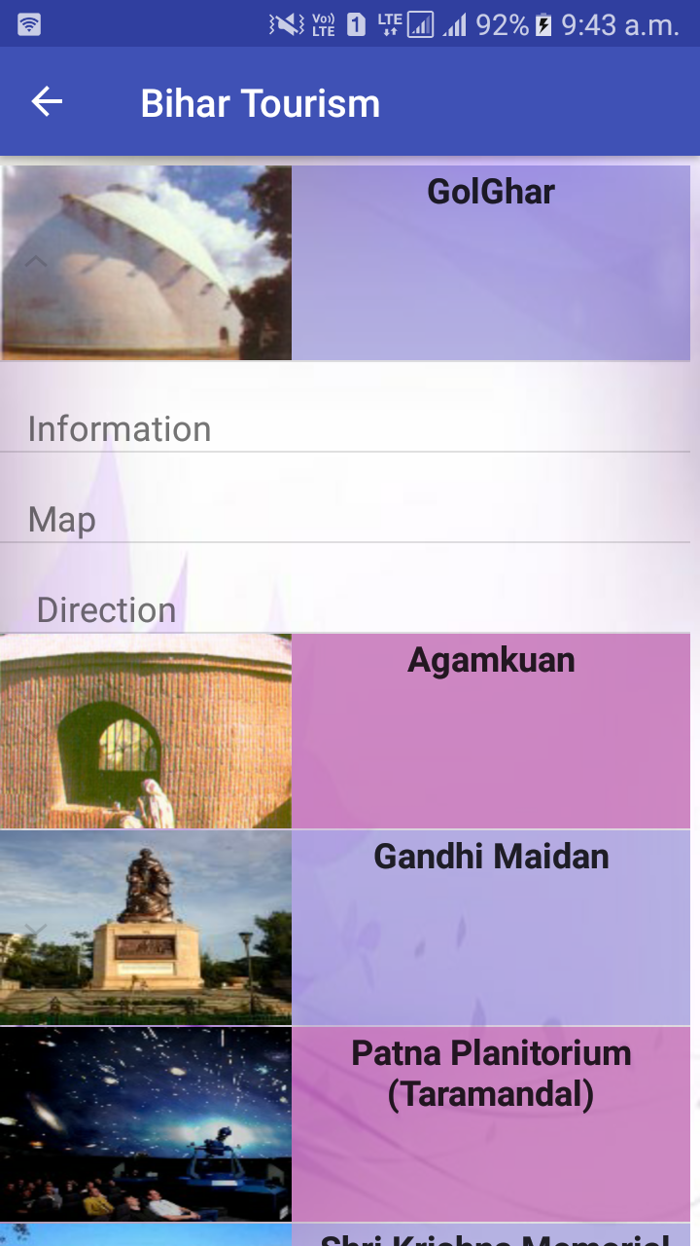

Fig 18 Tourist Places of a particular District

**7.6 Expandible Items of the List:**

1. Information
2. Maps
3. Direction

Every tourist places of a particular District contain these child list with the separate functionality. This apps contain the list of the District in Bihar and the District contain the Tourist place of the particular District to visit and all these Tourist places have these list intended to perform the task. We call these list as the child list and the Tourist place list is called as the Parent List.

**7.6.1 Information Activity:**

This Activity consist of brief information of the particular place which may be Historical, Devotional and Nature Beauty. This activity also contain the image view as well as the paragraph in string form in the value folder under res and value contain the String.xml layout and the paragraph is written nicely over here.

**Res->values->String.xml**

This activity also consist of Designing as well as Coding part. Designing is in xml and coding in java programming language.

Image view consist of the image of a particular Image of that place.

This Activity look like:-

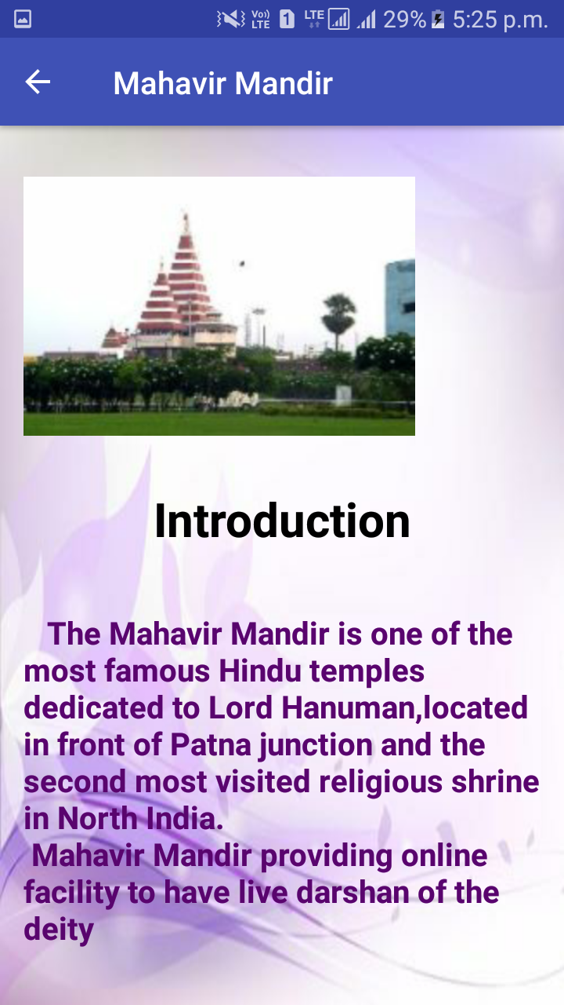

Fig 19 Introduction of particular place

**7.6.2 Maps:**

This Activity consist of location of the particular place which may be Historical, Devotional and Nature Beauty. This activity also contain the fragment tag .

This activity is new activity named as Google Activity which make both xml as well as java part with them.

This activity also consist of Designing as well as Coding part. Designing is in xml and coding in java programming language.

It also have alert dialogue box while existing out from the activity.

**This Activity look like:**

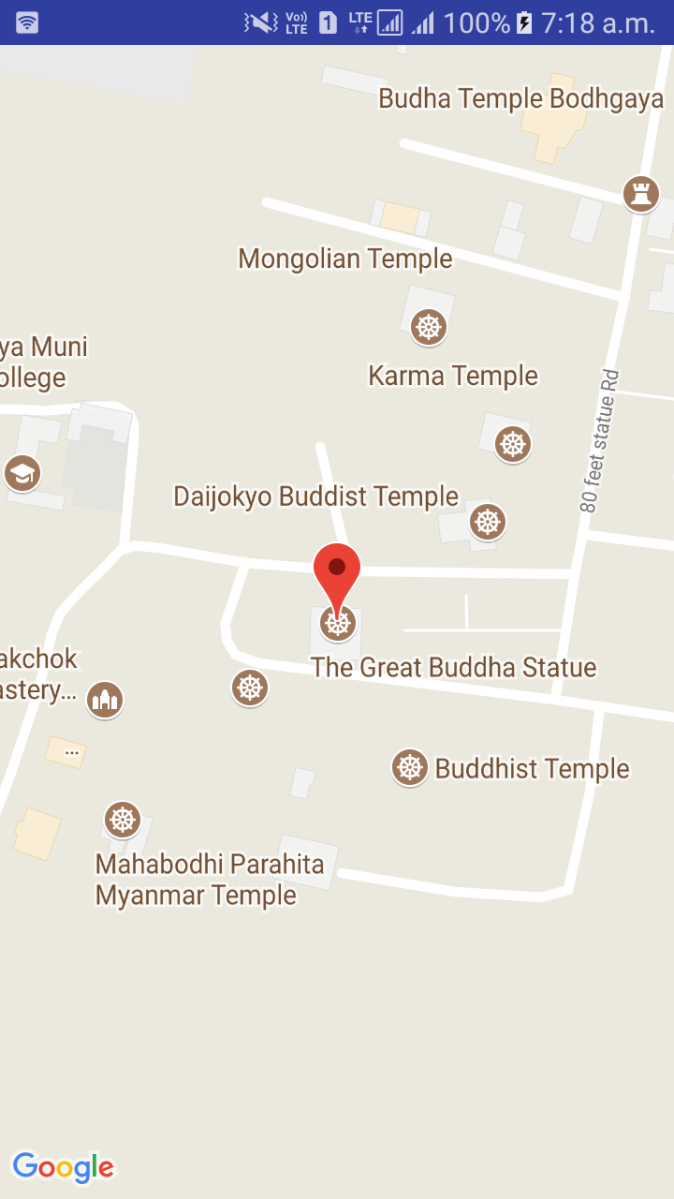

**Fig 20 Location of tourist place on Map**

**7.6.3 Direction**:

It will allocate the tourist place with the direction to approach the destination from particular location to the particular Tourist Place.

This Activity consist of location of the particular place which may be Historical, Devotional and Nature Beauty. This activity also contain the fragment tag .

This activity is new activity named as Google Activity which make both xml as well as java part with them.

This activity also consist of Designing as well as Coding part. Designing is in xml and coding in java programming language.

It shows all the navigational route to move from one place to the destination.

It also shows the traffic and the routes by vehicle or by foot or by metro and train.

It help people to know approximately how much time does it take to reach one place to other.

It also have alert dialogue box while existing out from the activity.

It means it ask the user to confirm whether they wants to close the application or the current windows or not?

This Activity look like:-

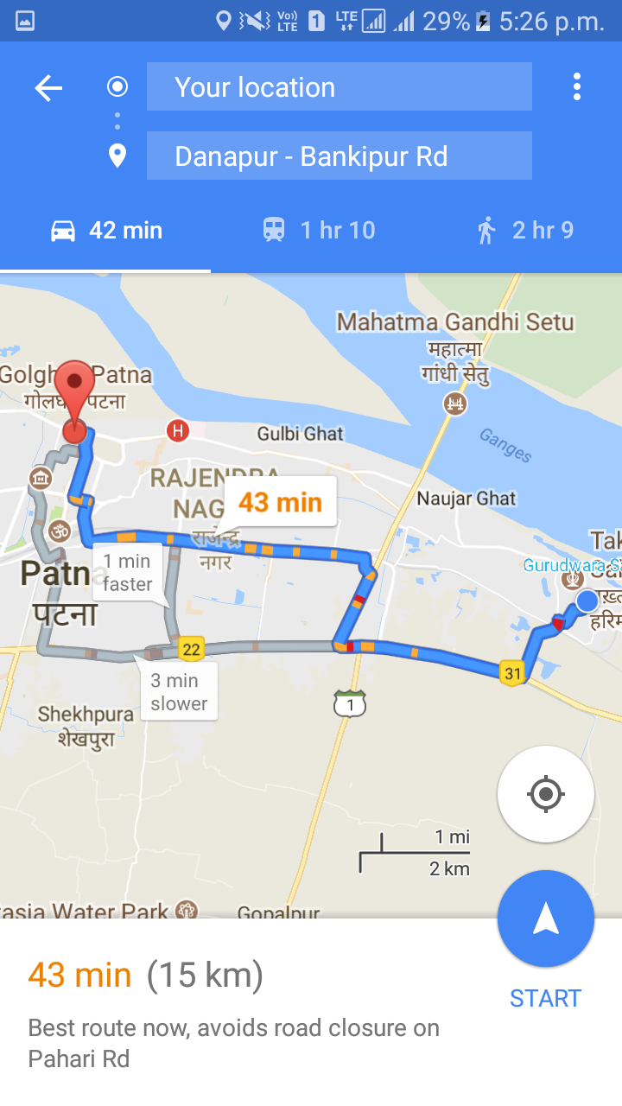

**Fig 21 Route to reach tourist place**

**Chapter 8**

**Module Description**

It is a high-level description of a functional area, consisting of a group of processes describing the functionality of the module and a group of packages implementing the functionality.

**8.1 Modules of Bihar Tourist Guide Apps**

* **Login:** It’s a login page where you can login as a tourist.
* **Sign Up:** This activity is used to register the user for future login and secure placement of data flow.
* **Facebook Login:** This module work mainly for login user with facebook id it validate all the data needs of the user by this mode of login where user don’t need to register first then use .
* **District Module:** In this module we can get the name of the districts of Bihar technically we can say the list of items here place is listed in the list which acts as a object here.
* **Tourist Place** : This will provide all the tourist place name of the particular district.
  + - Information :- This will provide the brief description of the Tourist place.

A tourist attraction is a place of interest that tourists visit, typically for its inherent or an exhibited natural or cultural value, historical significance, natural or built beauty, offering leisure and amusement of Bihar.

* + - Map:- This will allocate the current location of the tourist place.

Tourist maps are often **topographic maps with added information**  eg walking, skiing or cycling routes, mountain huts or watersports facilities. They may have added pictorial symbols to show tourist attractions eg stately homes, good beaches, theme parks

* + - Direction:- This will provide the tourist to reach the destination from his/her current location and the short distance to reach the destination. It shows how people can reach from one to other by trhe different modes of transportation. This will also shows the shortest path and the route having traffic jam and so on.

**Chapter 9**

**Test Strategy**

A high-level document is used to validate the test types or levels to be executed for the product and specify the **Software Development Life Cycle's** testing approach is known as Test strategy document.

Once the test strategy has been written, we cannot modify it, and it is approved by the **Project Manager, development team.**

The development design document includes the following documents:

* **System design documents:** Primarily, we will use these documents to write the test strategy.
* **Design documents:** These documents are used to specify the software's functionality to be enabled in the upcoming release.
* **Conceptual design documents:** These are the document which we used Infrequently.

## 9.1 The Objective of Test Strategy

The primary objective of writing the test strategy is to make sure that all purposes are covered entirely and understood by all stakeholders, we should systematically create a test strategy.

Furthermore, a test strategy objective is to support various quality assurance stockholders in respect of **planning of resources, language, test and integration levels, traceability, roles and responsibilities,** etc.

**Software Testing is Important** because if there are any bugs or errors in the software, it can be identified early and can be solved before delivery of the software product. Properly tested software product ensures reliability, security and high performance which further results in time saving, cost effectiveness and customer satisfaction.

## 9.2 Testing Strategies

Here are important strategies in software engineering:

**Unit Testing:**This software testing basic approach is followed by the programmer to test the unit of the program. It helps developers to know whether the individual unit of the code is working properly or not.

**Integration testing:**It focuses on the construction and design of the software. You need to see that the integrated units are working without errors or not.

**System testing:**In this method, your software is compiled as a whole and then tested as a whole. This testing strategy checks the functionality, security, portability, amongst others.

## Program Testing

**Program Testing** in software testing is a method of executing an actual software program with the aim of testing program behavior and finding errors. The software program is executed with test case data to analyse the program behavior or response to the test data. A good program testing is one which has high chances of finding bugs.

### Manual testing

The process of checking the functionality of an application as per the customer needs without taking any help of automation tools is known as manual testing. While performing the manual testing on any application, we do not need any specific knowledge of any testing tool, rather than have a proper understanding of the product so we can easily prepare the test document.

Manual testing can be further divided into three types of testing, which are as follows:

* **White box testing**
* **Black box testing**
* **Gray box testing**

### Automation testing

Automation testing is a process of converting any manual test cases into the test scripts with the help of automation tools, or any programming language is known as automation testing. With the help of automation testing, we can enhance the speed of our test execution because here, we do not require any human efforts. We need to write a test script and execute those scripts.

**Functional Testing**

Functional testing is a type of testing that seeks to establish whether each application feature works as per the software requirements. Each function is compared to the corresponding requirement to ascertain whether its output is consistent with the end user’s expectations. The testing is done by providing sample inputs, capturing resulting outputs, and verifying that actual outputs are the same as expected outputs.

The prime objective of Functional testing is checking the functionalities of the software system. It mainly concentrates on –

* **Mainline functions**:  Testing the main functions of an application
* **Basic Usability**: It involves basic usability testing of the system. It checks whether a user can freely navigate through the screens without any difficulties.
* **Accessibility**:  Checks the accessibility of the system for the user
* **Error Conditions**: Usage of testing techniques to check for error conditions.  It checks whether suitable error messages are displayed.

**9.3 How to do Functional Testing** :

* Understand the Functional Requirements
* Identify test input or test data based on requirements
* Compute the expected outcomes with selected test input values
* Execute test cases
* Compare actual and computed expected results

**Objective**

The main objective of the project on Bihar Tourist Guide is to manage the details of districts, tourist places of respective district. It manages all the information regarding history of the place, map shows the locative, and direction to reach the destination. The project is built user friendly, only the valid user is authorized to access.

The main objective of this project are as follows:

* It manages all the tourist place of Bihar’s districts.
* It provide brief information about the tourist place.
* It stores all the necessary details of the users which is fully protected and secured.
* It show the location of the area in the Google Map.
* It also show the direction and the shortest path to travel the destination.

**PURPOSE**

The old system was suffering from a series of drawbacks. Since whole of the system was to be maintained with hands, the process of keeping, maintaining and retrieving the information was very tedious and lengthy. There would always be unnecessary consumption of time by listening the different different history of the same place which was not the real one. One more problem was that it was very difficult to find guide of best human nature and dedicated on the “Atithi Devo Bhabha” while journey. The reason behind it is to make the safe and memorable journey of the tourists who eagerly want to see the beauty and history of Bihar. For this reason, we have provided present system with fully featured and automated actually existing system is quite unsafe and helpless.

**SCOPE**

It may help collecting perfect details. In a very short time, collection will be obvious, simple and sensible. It may help a person to know the places and culture of the place nearby them. It will also reduce the cost of **Guide** **man.**

The main aim of this project are:

* To automate the tourist place.
* It satisfies the user requirements.
* Easy to understand the user and operator.
* Have a good user interface.
* Be expandable.
* Portable
* Delivered on schedule within the budget.

**CONCLUSION**

In this project, we present a mobile tourist application (Bihar Tourist Guide) that is designed for Bihar state (District wise) and will become operable on android phone of respective API Level. The goal of this application is to provide tourism the geographical services through mobile phone application that encourage tourist to travel around the city and reduce efforts and shorten the time to organize the city trip and the outsider does not need any tourist guide for there journey this project will also provide the history of the respective tourist place this is best suited for safe and memorable journey.

**BIBLIOGRAPHY :**

* **<https://www.javatpoint.com/java-tutorial>**
* [**https://econsortium.aktu.ac.in/?p=53567**](https://econsortium.aktu.ac.in/?p=53567)
* [**https://econsortium.aktu.ac.in/?p=44663**](https://econsortium.aktu.ac.in/?p=44663)
* [**https://econsortium.aktu.ac.in/?p=45859**](https://econsortium.aktu.ac.in/?p=45859)
* [**https://econsortium.aktu.ac.in/?p=50743**](https://econsortium.aktu.ac.in/?p=50743)
* [**https://econsortium.aktu.ac.in/?p=48665**](https://econsortium.aktu.ac.in/?p=48665)
* [**https://econsortium.aktu.ac.in/?p=44431**](https://econsortium.aktu.ac.in/?p=44431)
* [**https://econsortium.aktu.ac.in/?p=47417**](https://econsortium.aktu.ac.in/?p=47417)
* [**https://econsortium.aktu.ac.in/?p=48102**](https://econsortium.aktu.ac.in/?p=48102)
* [**https://econsortium.aktu.ac.in/?p=47417**](https://econsortium.aktu.ac.in/?p=47417)
* **AbhiAndroid**