Online Medical Store

A project report

## Submitted in partial fulfilment of the Requirements for the Degree of

Master of Computer Application

**by**

# PRACHI SINGH

**(University Roll No 1900290140023)**

**Batch:2019-2022**

**Under the Supervision of**

**Ms. Vidushi**

**(Assistant Professor)**

## KIET Group of Institutions



**DEPARTMENT OF COMPUTER APPLICATIONS**

# DR.APJ ABDUL KALAM TECHNICAL UNIVERSITY LUCKNOW

**(**Formerly Uttar Pradesh Technical University, Lucknow)

June,2022

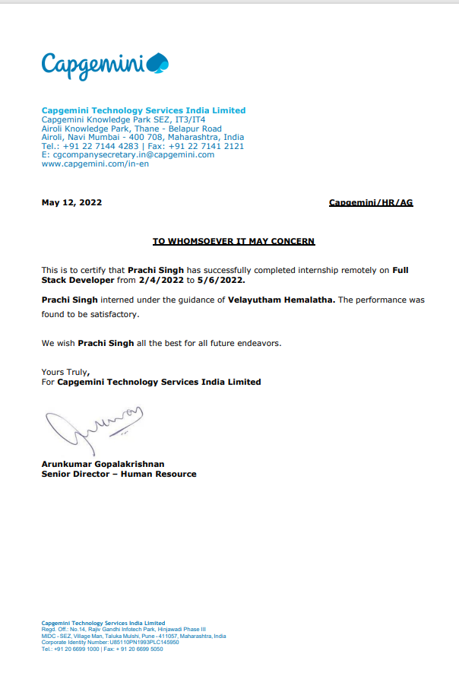

# DECLARATION

I hereby declare that the work presented in this report entitled “Online Medical Store", was carried out by me. I have not submitted the matter embodied in this report for the award of any other degree or diploma of any other University or Institute. I have given due credit to the original authors/sources for all the words, ideas, diagrams, graphics, computer programs, experiments, results, that are not my original contribution. I have used quotation marks to identify verbatim sentences and given credit to the original authors/sources. I affirm that no portion of my work is plagiarized, and the experiments and results reported in the report are not manipulated. In the event of a complaint of plagiarism and the manipulation of the experiments and results, I shall be fully responsible and answerable.

Name :

Roll. No. : Branch :

(Candidate Signature)

# //correct highlighted part

# CERTIFICATE

Certified that **Prachi Singh (University Roll No 1900290140023)** have carried out the project work having “Online Medical Store” for Master of Computer Applications from Dr. A.P.J. Abdul Kalam Technical University (AKTU) (formerly UPTU),Technical University, Lucknow under my supervision. The project report embodies original work, and studies are carried out by the student himself/herself and the contents of the project report do not form the basis for the award of any other degree to the candidate or to anybody else from this or any other University/Institution.

Signature Signature

(Name of Supervisor) (Name of Supervisor)

(Designation) (Designation)

(Address) (Address)

Date:

**Dr. Ajay Shrivastava**

**Head, Department of Computer Applications KIET Group of Institutions, Ghaziabad**

**// Title**

**// Your name**

# ABSTRACT

Average Indians spend a significant amount of income on medicine. A reliable and fast online medicine delivery system is not ubiquitous. Most people buy medicine from the local Pharmacies. They need to go to medicine stores to buy the specific medicine prescribed by the specialized doctors. Sometimes all prescribed medicines are not available in local Pharmacies therefore people need to go to other areas to buy the medicines. It is very time consuming and people need to spend money as well for this. In our country, traffic jams are a very big problem. People waste longer time on the road due to traffic jams.

Here most of the pharmacies are closed at night time but sometimes in an emergency situation medicine is very essential. In this case an online web based e-commerce medicine delivery system is needed very much. Online pharmacy is web based application. User can post requirement for medicine. User can purchase medicine online. Medicine delivery provided by the nearest associate store. Prescription is mandatory for ordering medicine. As per prescription user can search medicine and useful information.

This application can provide information for daily consumption of medicine. This application provides pre- information of side effects and allergy of medicine. This application provides logins to the users. They can maintain their account.

# ACKNOWLEDGEMENT

Success in life is never attained single handed. My deepest gratitude goes to my thesis supervisorfor his guidance, help and encouragement throughout my research work. Their enlightening ideas, comments, and suggestions.

Words are not enough to express my gratitude to **Dr. Ajay Kumar Shrivastava, Professor and Head, Department of Computer Applications**, for his insightful comments and administrative help at various occasions.

Fortunately, I have many understanding friends, who have helped me a lot on many critical conditions.

Finally, my sincere thanks go to my family members and all those who have directly and indirectly provided me moral support and other kind of help. Without their support, completion of this work would not have been possible in time. They keep my life filled with enjoyment and happiness.

### Prachi Singh

# Table of Contents

|  |  |
| --- | --- |
| Declaration | 2 |
| Certificate | 3 |
| Abstract | 4 |
| Acknowledge | 5 |
| Table of content  List of Figures | 6-7  8 |
| Chatpter -1 introduction |  |
| 1.1 Project Description | 9 |
| 1.2 Project Scope | 9 |
| 1.3 Technology used | 10-11 |
| 1.4 Requirements | 12 |
| Chapter 2 Literature Review | 13 |
| Chapter 3 Feasibility study |  |
| 3.1 Technical feasibility | 14 |
| 3.2 operational feasibility | 14 |
| 3.3 behavioral feasibility | 15 |
|  |  |

3.5 Economic feasibility 16

3.6 Financial Feasibility 18

3.7 Schedule Feasibility 19

Chapter 4 System Specification 20-28

Chapter 5 Language and technology used 29-32

Chapter 6 System Design and development 33

Chapter 7 SDLC 34-35

Chapter 8 ER diagram 36-39

Chapter 9 Conclusion and future enhancement 40

Chapter 10 coding 41-72

Chapter 11 testing 73-78

Chapter 12 References 79-80

**List of Figures**

Figure :1 Feasibility Study 15

Figure:2 System Architecture 30

Figure:3 ER Diagram 38

Figure 4: Home page 64

Figure:5 Index Page 65

Figure:6 About us page 66

Figure:7 Contact us page 67

**CHAPTER 1 INTRODUCTION**

## PROJECT DESCRIPTION

An online medicine delivery system is an online based web application that operates over the Internet and sends orders to customers through credit cards, shipping companies, or pay on delivery system. People can buy and sell their products sitting at home. It is getting popular day by day all over the world even in domestic market space. The aim is to make the ordering process and delivery systems of medicines much easier and customer-friendly. It’s very important to make a user friendly environment.

The illustration goes as follows: firstly the user will visit the homepage and log in with his designated username and password. If anyone provides an invalid or incorrect username and password, the system will display an error message. For new customer the provider needs to give proper name and email address to register.

After registration is complete the user can purchase any item form the website. There is a search machine form which one can search for specific medicine. After selecting the desired item user can add them to cart and order the item. Then, deliver system will take place. The delivery boy will take the order to nearby store and deliver the item within a short time. The above figure of the flowchart illustrates the methodology in which our system conducts the processes.

The most important objective of online remedy ordering gadget is to automate the existing manual system with the assist of increase automated software so, that treasured statistics can be stored for longer period with clean having access to and manipulation of the identical. The registered user can get admission to the account with valid credentials. User can surf the drugs gadgets consistent with classes, Cart and online charge options are available to user.

User can tune their orders with the medicine info. In Online medicine Ordering System Admin can deal with the functionalities like add new medicinal drug objects.

It can edit/delete medication items, Enable/Disable the medicine objects in line with availability and their expiry dates. Admin have authority to view order details and update the transport popularity of medicines.

The client is a small scale pharmaceutical company that is distributing generic medicines to emergency medicines and having a good network of medical (retail) stores. Main need of the client is to prepare an online application to help the needy people in finding the availability of the medicine and a list of medical stores where the medicine is available. The visitor can quickly find the nearest medical store by selecting the area in the search tools.

This application also provides a login account to a registered medical store. Using this account a person from the medical store can update the list of medicines and their stock on daily-wise. This avoids providing outdated data to the visitor.

## PROJECT SCOPE

## It may help collecting perfect management in details. In a very short time , the collection will be obvious,simple and sensible. It will help a person to know the management of passed year perfectly and vividly. It also helps in current all works relative to online medical store. It will be also reduced the cost of collecting the management and collection procedure will go on smoothly.

## Our project aims at Business process automation i.e we have tried to computerized various processes of online Medical Store.

## In computer system the person has to fill the various forms and number of copies of the forms can be easiy generated at a time .

## In computer system,it is not necessary to create the manifest but we can directly print it, which saves our time.

## To assist the staff in capturing the effort spent on their respective working areas.

## To utilize resources in an efficient manner by increasing their productivity through automation.

## The system generates types of information that can be used for various purposes.

## It satisfy the user requirement .

## Be easy to understand by the user and operator.

## Be easy to operate .

## Have a good user interface.

* 1. **REQUIREMENTS**

**FUNCTIONAL REQUIREMENT**

It is the primary requirements that are fulfilled by our web site .It’s allowing the users, customers to use our website at the level of ease .The purpose of our website is to provide the full information that is required to the user. Here is the following requirement that is fulfilled by our system.

**User**

**User Login**

This feature used by the user/admin to login into system. A user must login with his user name and password to the system after registration but the admin is forced to login because admin’s username and password is initialized as default. If they are invalid, the user and admin will not be allowed to enter the system.

* Username and password will be provided after user registration is confirmed.
* Password should be hidden from others while typing it in the field

**Register New User**

A new user will have to register in the system by providing essential details in order to shop the products in the system.

* System must be able to verify and validate information.
* The system must encrypt the password of the customer to provide security.

### Non Functional Requirements

**Efficiency Requirement**

When an Online Medical Store Management implemented customer can purchase product in an efficient manner.

**Reliability Requirement**

The system should provide a reliable environment to both customers and Admin. All orders should be reaching at the admin without any errors.

**Usability Requirement**

The web site is designed for user friendly environment and ease of use.

**Implementation Requirement**

Implementation of the system using Html, css, Javascript and BOOTSTRAP in front end with PHP as back end and it will be used for database connectivity. And the database part is developed by My sql. Responsive web designing is used for making the website compatible for any type of screen.

**Delivery Requirement**

The whole system is expected to be delivered in four months of time with weekly evaluation by Medical store Management System Project guide.

**Database Security**

Unauthorized person cannot access the panel and database, do not read and write the information.

# CHAPTER 2 LITERATURE REVIEW

The main goal of online medical system is to manage all record and transaction within the inventory and managing of sells. Online medical system is a very effective tool for an organization to be efficient in business management. The traditional of managing sells in inventory is perform by using the pen and paper to write down the type and quantity of the stock but error in inventory record still exist even when the management uses Ip system and product data capturing technology to improve the inventory system.

Inventory managers have to face inaccuracy of inventory record either at the store or at the warehouse level in order to improve accuracy of inventory rechecking , people started using auto id technologies . In EPC global report auto id technologies defined as the post of technologies that are used to help machines to identify objects.It is about identifying items,capturing all information about the items,sending and storing those data into a computer with minimal human intervation.

**Technical Review**

Online medical system is the web based system that work as a website to manage and functioning all Medical activities through a web server(Apache). A web page is what you see on the screen when you type in a web address click on a link or put a query in a search engine .A web page can contain any type of information and can include text,color,graphics ,animation and sound.When someone gives you their web address it generally takes you to their website home page which should introduce you to what that site offers in terms of an information or other services .

From the home page you can click on link to reach other sections of this site .A website can consist of one page or of 10,000 pages depending on what the size owner is trying to accomplish.

# CHAPTER 3 FEASIBILITY STUDY

Feasibility Study can be considered as preliminary investigation that helps the management to take decision about whether study of system should be feasible for development or not.

* + It identifies the possibility of improving an existing system, developing a new system, and produce refined estimates for further development of system.
  + It is used to obtain the outline of the problem and decide whether feasible or appropriate solution exists or not.
  + The main objective of a feasibility study is to acquire problem scope instead of solving the problem.
  + The output of a feasibility study is a formal system proposal act as decision document which includes the complete nature and scope of the proposed system.

Steps Involved in Feasibility Analysis

The following steps are to be followed while performing feasibility analysis −

* + Form a project team and appoint a project leader.
  + Develop system flowcharts.
  + Identify the deficiencies of current system and set goals.
  + Enumerate the alternative solution or potential candidate system to meet goals.
  + Determine the feasibility of each alternative such as technical feasibility, operational feasibility, etc.
  + Weight the performance and cost effectiveness of each candidate system.
  + Rank the other alternatives and select the best candidate system.
  + Prepare a system proposal of final project directive to management for approval.

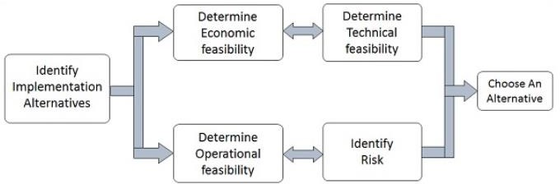

Figure:1

Feasibility study

**3.1 TECHNICAL FEASIBILITY**

This assessment is based on the online design of system requirements to determine whether the company have the technical expertise to handle completion of the project when writing a feasibility report, the following should be taken to consideration.

* A brief description of the business to assess more possible factors which could affect the study
* The part of the business being examined
* The human and economic factor
* The possible solutions to the problem

At this level, the concern is whether the proposal is both technically and legally feasible (assuming moderate cost).

The technical feasibility assessment is focused on gaining an understanding of the present technical resources of the organization and their applicability to the expected needs of the proposed system. It is an evaluation of the hardware and software and how it meets the need of the proposed system.

## OPERATIONAL FEASIBILITY

Operational feasibility is the measure of how well a proposed system solves the problems, and takes advantage of the opportunities identified during scope definition and how it satisfies the requirements identified in the requirements analysis phase of system development.

The operational feasibility assessment focuses on the degree to which the proposed development project fits in with the existing business environment and objectives with regard to development schedule, delivery date, corporate culture and existing business processes.

To ensure success, desired operational outcomes must be imparted during design and development. These include such design-dependent parameters as reliability, maintainability, supportability, usability, predictability, disposability, sustainability.

These parameters are required to be considered at the early stages of design if desired

A system design and development requires appropriate and timely application of engineering and management efforts to meet the previously mentioned parameters. A system may serve its intended purpose most effectively when its technical and operating characteristics are engineered into the design.

Therefore, operational feasibility is a critical aspect of systems engineering that needs to be an integral part of the early design phases.

## BEHAVIORAL FEASIBILITY

It evaluates and estimates the user attitude or behavior towards the development of new system.

It helps in determining if the system requires special effort to educate, retrain, transfer, and changes in employee's job status on new ways of conducting business.

People are inherently resistant to change, and computers have been known to facilitate change. An estimate should be made of how strong a reaction the user staff is likely to have toward the development of a computerized system. [t is common knowledge that computer installations have something to do with turnover, transfers, retraining, and changes in employee job status. Therefore, it is understandable that the introduction of a candidate system requires special effort to educate, sell, and train the staff on new ways of conducting business.

# 3.3Economic Feasibility

* + It is evaluating the effectiveness of candidate system by using cost/benefit analysis method.
  + It demonstrates the net benefit from the candidate system in terms of benefits and costs to the organization.
  + The main aim of Economic Feasibility Analysis (EFS) is to estimate the economic requirements of candidate system before investments funds are committed to proposal.
  + It prefers the alternative which will maximize the net worth of organization by earliest and highest return of funds along with lowest level of risk involved in developing the candidate system.

## TIME FEASIBILITY

A time feasibility study will take into account the period in which the project is going to take up to its completion. A project will fail if it takes too long to be completed before it is useful. Typically this means estimating how long the system will take to develop, and if it can be completed in a given time period using some methods like payback period. Time feasibility is a measure of how reasonable the project timetable is. Given our technical expertise, are the project deadlines reasonable? Some projects are initiated with specific deadlines. It is necessary to determine whether the deadlines are mandatory or desirable.

## 3.5FINANCIAL FESIBILITY

In case of a new project, financial viability can be judged on the following parameters:

* Total estimated cost of the project
* Financing of the project in terms of its capital structure, debt to equity ratio and promoter's share of total cost
* Existing investment by the promoter in any other business
* Projected cash flow and profitability The financial viability of a project should provide the following information:[12]
* Full details of the assets to be financed and how liquid those assets are.
* Rate of conversion to cash-liquidity (i.e., how easily the various assets can be converted to cash).
* Project's funding potential and repayment terms.
* Sensitivity in the repayments capability to the following factors:
* Mild slowing of sales.
* Acute reduction/slowing of sales.
* Small increase in cost.
* Large increase in cost.
* Adverse economic condition.

## Schedule Feasibility

It is defined as the probability of a project to be completed within its scheduled time limits, by a planned due date. If a project has a high probability to be completed on-time, then its schedule feasibility is appraised as high. In many cases a project will be unsuccessful if it takes longer than it was estimated: some external environmental conditions may change, hence a project can lose its benefits, expediency and profitability. If a work to be accomplished at a project does not fit the timeframes demanded by its customers, then a schedule is unfeasible (amount of work should be reduced or other schedule compression methods applied).

If the project managers want to see their projects completed before they can lose their utility, they (project managers) need to give proper attention to controlling their schedule feasibility: to calculate and continually reexamine whether it is possible to complete all amount and scope of work lying ahead, utilizing the given amount of resources, within required period of time. Schedule feasibility study includes use of the following matters:

* + - Project Estimation;
    - Gantt and PERT charts;
    - CPM (Critical Path Method);
    - Change Management;

# 

# CHAPTER 4

# SYSTEM SPECIFICATION.

A **System Requirements Specification** (abbreviated SysRS when need to be distinct from a software requirements specification (SRS) ) is a structured collection of information that embodies the requirements of a system. A business analyst, sometimes titled system analyst, is responsible for analyzing the business needs of their clients and stakeholders to help identify business problems and propose solutions. Within the systems development life cycle domain, the BA typically performs a liaison function between the business side of an enterprise and the information technology department or external service providers.

To be used efficiently, all computer software needs certain hardware components or other software resources to be present on a computer. These prerequisites are known as (computer) **system requirements** and are often used as a guideline as opposed to an absolute rule. Most software defines two sets of system requirements: minimum and recommended. With increasing demand for higher processing power and resources in newer versions of software, system requirements tend to increase over time. Industry analysts suggest that this trend plays a bigger part in driving upgrades to existing computer systems than technological advancements. A second meaning of the term of System requirements, is a generalization of this first definition, giving the requirements to be met in the design of a system or sub- system. Typically an organization starts with a set of Business requirements and then derives the System requirements from there.

### 4 (i) Hardware requirements:

(a)RAM (1GB or above) (b)Pentium IV or above processor (c)Hard disk (20GB with free space) (d)VRAM_PCI, VGA(32MB)

### 4(a).RAM

**Random-access memory** (**RAM** ) is a form of computer data storage that stores data and machine code currently being used. A random-access memory device allows data items to be read or written in almost the same amount of time irrespective of the physical location of data inside the memory. In contrast, with other direct-access data storage media such as hard disks, CD-RWs, DVD-RWsand the older magnetic tapes and drum memory, the time required to read and write data items varies significantly depending on their physical locations on the recording medium, due to mechanical limitations such as media rotation speeds and arm movement.

RAM contains multiplexing and demultiplexing circuitry, to connect the data lines to the addressed storage for reading or writing the entry. Usually more than one bit of storage is accessed by the same address, and RAM devices often have multiple data lines and are said to be "8-bit" or "16-bit", etc. devices.

In today's technology, random-access memory takes the form of integrated circuits. RAM is normally associated with volatile types of memory (such as DRAM modules), where stored information is lost if power is removed, although non-volatile RAM has also been developed. Other types of non-volatile memories exist that allow random access for read operations, but either do not allow write operations or have other kinds of limitations on them. These include most types of ROM and a type of flash memory called *NOR-Flash*.

Integrated-circuit RAM chips came into the market in the early 1970s, with the first commercially available DRAM chip, the Intel 1103, introduced in October 1970.

### 4(b).PENTIUM-IV PROCESSOR:

**Pentium-iv** is a brand by Intel for an entire series of single-core CPUs for desktops, laptops and entry-level servers. The processors were shipped from November 20, 2000, until August 8, 2008.

All Pentium 4 CPUs are based on the Net Burst architecture. The Pentium 4 *Willamette* (180 nm) introduced SSE2, while the *Prescott* (90 nm) introduced SSE3. Later versions introduced Hyper-Threading Technology (HTT).

The first Pentium 4-branded processor to implement 64-bit was the *Prescott* (90 nm) (February 2004), but this feature was not enabled. Intel subsequently began selling 64-bit Pentium 4s using the *"E0" revision* of the Prescott’s, being sold on the OEM market as the Pentium 4, model F. The E0 revision also adds execute Disable (XD) (Intel's name for the NX bit) to Intel 64. Intel's official launch of Intel 64 (under the name EM64T at that time) in mainstream desktop processors was the N0 stepping Prescott-2M.

### 4(c).Hard disk:

A **hard disk drive** (**HDD**), **hard disk**, **hard drive**, or **fixed disk**,is an electromechanical data storage device that uses magnetic storage to store and retrieve digital information using one or more rigid rapidly rotating disks (platters) coated with magnetic material. The platters are paired with magnetic heads, usually arranged on a moving actuator arm, which read and write data to the platter surfaces. Data is accessed in a random-access manner, meaning that individual blocks of data can be stored or retrieved in any order and not only sequentially. HDDs are a type of non-volatile storage, retaining stored data even when powered off.

Introduced by IBM in 1956, HDDs became the dominant secondary storage device for general-purpose computers by the early 1960s. Continuously improved, HDDs have maintained this position into the modern era of servers and personal computers. More than

200 companies have produced HDDs historically, though after extensive industry consolidation most units are manufactured by segues, Toshiba, and Western Digital. HDDs dominate the volume of storage produced (extra bytes per year) for servers. Though production is growing slowly, sales revenues and unit shipments are declining because solid- state drives (SSDs) have higher data-transfer rates, higher areal storage density, better reliability, and much lower latency and access times.

The revenues for SSDs, most of which use NAND, slightly exceed those for HDDs. Though SSDs have nearly 10 times higher cost per bit, they are replacing HDDs in applications where speed, power consumption, small size, and durability are important.

The primary characteristics of an HDD are its capacity and performance. Capacity is specified in unit prefixes corresponding to powers of 1000: a 1-terabyte (TB) drive has a

capacity of 1,000 gigabytes (GB; where 1 gigabyte = 1 billion bytes). Typically, some of an HDD's capacity is unavailable to the user because it is used by the file system and the computer operating system, and possibly inbuilt redundancy for error correction and recovery. Also there is confusion regarding storage capacity, since capacities are stated in decimal Gigabytes (powers of 10) by HDD manufacturers, whereas some opera ring systems report capacities in binary Gibbets, which results in a smaller number than advertised. Performance is specified by the time required to move the heads to a track or cylinder (average access time) adding the time it takes for the desired sector to move under the head (average latency, which is a function of the physical rotational speed in revolutions per minute), and finally the speed at which the data is transmitted (data rate).

### 4(d).VRAM:

**Video RAM**, or **VRAM**, is a [dual-ported](https://en.wikipedia.org/wiki/Dual-ported_RAM) variant of [dynamic RAM](https://en.wikipedia.org/wiki/Dynamic_RAM) (DRAM), which was once commonly used to store the [frame buffer](https://en.wikipedia.org/wiki/Framebuffer) in [graphics adapters](https://en.wikipedia.org/wiki/Graphics_card).

It was invented by F. Dill, D. Ling and R. Matick at [IBM Research](https://en.wikipedia.org/wiki/IBM_Research) in 1980, with a patent issued in 1985 (US Patent 4,541,075). The first commercial use of VRAM was in a high- resolution graphics adapter introduced in 1986 by IBM for its [RT PC](https://en.wikipedia.org/wiki/IBM_RT_PC) system, which set a new standard for graphics displays. Prior to the development of VRAM, dual-ported memory was quite expensive, limiting higher resolution bitmapped graphics to high-end workstations. VRAM improved the overall frame buffer throughput, allowing low cost, high-resolution, high-speed, color graphics. Modern GUI-based operating systems benefitted from this and thus it provided a key ingredient for proliferation of [graphical user interfaces](https://en.wikipedia.org/wiki/Graphical_user_interface) (GUIs) throughout the world at that time.

VRAM has two sets of data output pins, and thus two ports that can be used simultaneously. The first port, the DRAM port, is accessed by the host computer in a manner very similar to traditional DRAM. The second port, the video port, is typically read-only and is dedicated to providing a high throughput, serialized data channel for the graphics chipset.

Typical DRAM arrays normally access a full row of bits (i.e. a word line) at up to 1,024 bits at one time, but only use one or a few of these for actual data, the remainder being discarded. Since DRAM cells are destructively read, each row accessed must be sensed, and re-written. Thus, 1,024 sense amplifiers are typically used. VRAM operates by not discarding the excess

bits which must be accessed, but making full use of them in a simple way. If each horizontal scan line of a display is mapped to a full word, then upon reading one word and latching all 1,024 bits into a separate row buffer, these bits can subsequently be serially streamed to the display circuitry. This will leave access to the DRAM array free to be accessed (read or write) for many cycles, until the row buffer is almost depleted. A complete DRAM read cycle is only required to fill the row buffer, leaving most DRAM cycles available for normal accesses.

### 4(ii) Software requirement:

1. **: window Operating system xp,7,10**

### :Application server: apache tomcat 4(ii)(a) Operating system:

**Windows 7** is a personal computer operating system that was produced by Microsoft as part of the Windows NT family of operating systems. It was released to manufacturing on July 22, 2009 and became generally available on October 22, 2009 less than three years after the release of its predecessor, Windows Vista. Windows 7's server counterpart, Windows Server 2008 R2, was released at the same time.

Windows 7 was primarily intended to be an incremental upgrade to Microsoft Windows, intended to address Windows Vista's poor critical reception while maintaining hardware and software compatibility. Windows 7 continued improvements on Windows Aero (the user interface introduced in Windows Vista) with the addition of a redesigned taskbar that allows applications to be "pinned" to it, and new window management features. Other new features were added to the operating system, including libraries, the new file sharing system Home Group, and support for multi touch input. A new "Action Center" interface was also added to provide an overview of system security and maintenance information, and tweaks were made to the User Account Control system to make it less intrusive. Windows 7 also shipped with updated versions of several stock applications, including Internet Explorer 8, Windows Media Player, and Windows Media Center.

In contrast to Windows Vista, Windows 7 was generally praised by critics, who considered the operating system to be a major improvement over its predecessor due to its increased performance, its more intuitive interface (with particular praise devoted to the new taskbar), fewer User Account Control popup, and other improvements made across the platform. Windows 7 was a major success for Microsoft; even prior to its official release, pre-order sales for 7 on the online retailer Amazon.com had surpassed previous records. In just six months, over 100 million copies had been sold worldwide, increasing to over 630 million licenses by July 2012. As of December 2018, 35.55% of computers running Windows are running Windows 7.

### 4(ii)(b)Application server:

An **application server** is a software framework that provides both facilities to create web applications and a server environment to run them.

Application Server Frameworks contain a comprehensive service layer model. An application server acts as a set of components accessible to the software developer through a standard API defined for the platform itself. For Web applications, these components are usually performed in the same running environment as their web server(s), and their main job is to support the construction of dynamic pages. However, many application servers target much more than just Web page generation: they implement services like clustering, fail-over, and load-balancing, so developers can focus on implementing the business logic.

**Apache Tomcat**, often referred to as **Tomcat Server**, is an open-source Java Servlet Container developed by the Apache Software Foundation (ASF). Tomcat implements several Java EE specifications including Java Servlet, JavaServer Pages (JSP), Java EL, and Web Socket, and provides a "pure Java" HTTP web server environment in which Java code can run.

**4(iii) System architecture**

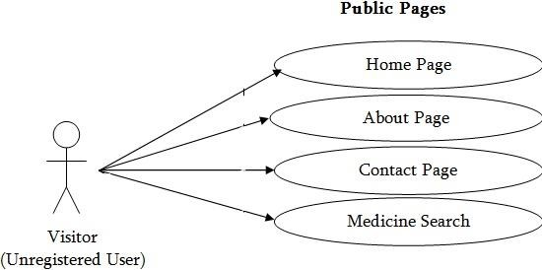

Figure:2

System Architecture

# CHAPTER 5

**Language and technology used**

The language and technology which we are going to use in project hospital management system are given below .Here in this section we mention front end technology, back end technology as well as database and required language.

### Front end technology:

(a)HTML (b)JAVA SCRIPT

(c) JSP (JAVA SERVER PAGES)

1. **HTML: Hypertext Markup Language** (**HTML**) is the standard markup language for creating web pages and web applications. With Cascading Style Sheets (CSS) and JavaScript, it forms a triad of cornerstone technologies for the World Wide Web.

Web browsers receive HTML documents from a web server or from local storage and render the documents into multimedia web pages. HTML describes the structure of a web page semantically and originally included cues for the appearance of the document.

HTML Elements are the building blocks of HTML pages. With HTML constructs, images and other objects such as interactive forms may be embedded into the rendered page. HTML provides a means to create structured documents by denoting structural semantics for text such as headings, paragraphs, lists, links, quotes and other items. HTML elements are delineated by *tags*, written using angle brackets. Tags such

as and directly introduce content into the page. Other tags such

<img/>

<input/>

as surround and provide information about document text and may include other tags as

<**p**>

sub-elements. Browsers do not display the HTML tags, but use them to interpret the content of the page.

### JAVA SCRIPT:

**JAVA**

**SCRIPT**:

**JavaScript** often

abbreviated

as **JS**,

is

a high-

level, interpreted programming language that conforms to the java script specification. It is a programming language that is characterized as dynamic, weakly typed, prototype-

based and multi-paradigm.

Alongside HTML and CSS, JavaScript is one of the core technologies of the World Wide

Web. JavaScript enables interactive web pages and is an essential part of web applications. The vast majority of websites use it, and major web browsers have a dedicated JavaScript engine to execute it.

As a multi-paradigm language, JavaScript supports event-driven, functional, and imperative (including object-oriented and prototype-based) programming styles . It has APIs for working with text, arrays, dates, regular expressions, and the DOM, but the

language itself does not include any I/O, such as networking, storage, or graphics facilities. It relies upon the host environment in which it is embedded to provide these features.

Initially only implemented client-side in web browsers, JavaScript engines are now embedded in many other types of host software, including server-side in web servers and databases, and in non-web programs such as word processors and PDF software, and in runtime environments that make JavaScript available for writing mobile and desktop applications, including desktop widgets.

The terms *Vanilla JavaScript* and *Vanilla JS* refer to JavaScript not extended by any frameworks or additional libraries. Scripts written in Vanilla JS are plain JavaScript code.

Although there are similarities between JavaScript and Java, including language name, syntax, and respective standard libraries, the two languages are distinct and differ greatly in design. JavaScript was influenced by programming languages such as self and Scheme.

1. **JSP (JAVA SERVER PAGES): Java Server Pages** (**JSP**) is a technology that helps software developers create dynamically generated web pages based on HTML, XML, or other document types. Released in 1999 by Sun Microsystems, JSP is similar to PHP and ASP, but it uses the java programming language. A **Java Server Pages compiler** is a program that parses JSPs, and transforms them into executable [Java Servlets](https://en.wikipedia.org/wiki/Java_Servlets). A program of this type is usually embedded into the [application server](https://en.wikipedia.org/wiki/Application_server) and run automatically the first time a JSP is accessed, but pages may also be precompiled for better performance, or compiled as a part of the build process to test for errors.

Some JSP containers support configuring how often the container checks JSP [file](https://en.wikipedia.org/wiki/Computer_file) [timestamps](https://en.wikipedia.org/wiki/Timestamp) to see whether the page has changed. Typically, this timestamp would be set to a short interval (perhaps seconds) during [software development,](https://en.wikipedia.org/wiki/Software_development) and a longer interval (perhaps minutes, or even never) for a deployed [Web application](https://en.wikipedia.org/wiki/Web_application). JSP can be used independently or as the view component of a server-side model–view–controller design, normally with JavaBeans as the model and Java servlets (or a framework such as Apache Struts) as the controller. This is a type of Model 2 architecture.

JSP allows Java code and certain predefined actions to be interleaved with static web markup content, such as HTML, with the resulting page being compiled and executed on the server to deliver a document. The compiled pages, as well as any dependent Java libraries, contain Java byte code rather than machine code. Like any other Java program, they must be executed within a Java virtual machine (JVM) that interacts with the server's host operating system to provide an abstract, platform-neutral environment.

JSPs are usually used to deliver HTML and XML documents, but through the use of Output Stream, they can deliver other types of data as well.

The Web container creates JSP implicit objects like request, response, session, application, configuration, page, page Context, out and exception. JSP Engine creates these objects during translation phase.

# CHAPTER 6

**SYSTEM DESIGN AND DEVELOPMENT**

# SYSTEM DESIGN

The design and development of the online medicine order service was based on the methodology for pharmaceutical care and Service Experiment Blueprint concepts, enabling the design of service characteristics and functionalities required by chronic patients . Service Experience Blueprint ensures a customer driven design able to co-create value with end customers . This method enhances the design of customer experiences, especially for technology-enabled services and contributes for a stronger focus on customer-firm relationship. Modeling methodologies can also provide an additional understanding of the dynamics of an organization to better align medical services’ design with operations .

A medicine delivery system is a solution designed specifically for users who want to order medicine products online and get them delivered to their home. A bit more details an online medicine delivery system is an online based web development that operates over the Internet and sends orders to customers through credit cards, shipping companies, or pay on delivery systems. People can buy and sell their products sitting at home . In this current pandemic situation of e-commerce businesses are becoming more popular. People have started to believe in online business to a great extent . In this pandemic the using and ordering from e- commerce site has become very famous. According to Statista, the size of the local e-commerce market was $ 1648 million.

# CHAPTER 7

**SDLC(waterfall model)**

### SDLC (Waterfall model):

Waterfall approach was first SDLC Model to be used widely in Software Engineering to ensure success of the project. In "The Waterfall" approach, the whole process of software development is divided into separate phases. In this Waterfall model, typically, the outcome of one phase acts as the input for the next phase sequentially.

The sequential phases in Waterfall model are −

* 1. **Requirement Gathering and analysis** − All possible requirements of the system to be developed are captured in this phase and documented in a requirement specification document.
  2. **System Design** − The requirement specifications from first phase are studied in this phase and the system design is prepared. This system design helps in specifying hardware and system requirements and helps in defining the overall system architecture.
  3. **Implementation** − With inputs from the system design, the system is first developed in small programs called units, which are integrated in the next phase. Each unit is developed and tested for its functionality, which is referred to as Unit Testing.
  4. **Integration and Testing** − All the units developed in the implementation phase are integrated into a system after testing of each unit. Post integration the entire system is tested for any faults and failures.
  5. **Deployment of system** − Once the functional and non-functional testing is done; the product is deployed in the customer environment or released into the market.
  6. **Maintenance** − There are some issues which come up in the client environment. To fix those issues, patches are released. Also to enhance the product some better versions are released. Maintenance is done to deliver these changes in the customer environment.

### Advantages of waterfall model:

1. This model is simple and easy to understand and use.
2. It is easy to manage due to the rigidity of the model – each phase has specific deliverables and a review process.
3. In this model phases are processed and completed one at a time. Phases do not overlap.

20

1. Waterfall model works well for smaller projects where requirements are clearly defined and very well understood.

### Disadvantages of waterfall model:

* 1. Once an application is in the testing stage, it is very difficult to go back and change something that was not well-thought out in the concept stage.
  2. No working software is produced until late during the life cycle.
  3. High amounts of risk and uncertainty.
  4. Not a good model for complex and object-oriented projects.
  5. Poor model for long and ongoing projects.
  6. Not suitable for the projects where requirements are at a moderate to high risk of changing

# 

# CHAPTER 8 ER-DIAGRAM

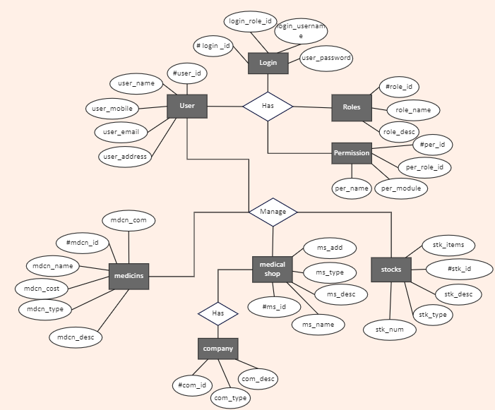

Figure:3

ER diagram

**CHAPTER 9**

**CONCLUSION AND FUTURE ENHANCEMENTS**

# 9.1CONCLUSION

We will hire some delivery people to deliver the medicines. We also need marketing people to make it available to the wider users of the system. As a startup company it is predicted that it will have huge success by cindering the current demand of this system. After launching when we will have huge customer data and reviews we will apply big data analysis and machine learning technique to get more customers and for suitability of the system.

# 9.2FUTURE ENHANCEMENTS

This chapter discusses the future scope or the implementation of this system. Our online medicine delivery system will be explored with some future plans door to door. In future more extra features will be added. It will include the android mobile application with many advanced features. We have planned to launch this web- application as a business site which will work as an e-commerce site.

# CHAPTER 10

**Coding**

# SOURCE CODE CSS File

/*CSS Reset*/

*{

margin:0px; padding:0px;

}

/*Header Styling*/

#top{

color:rgb(245, 10, 10); text-align:center;

font-size:46px;

font-family: 'Ubuntu Mono', monospace;

}

#top1{

text-align:center; color:black;

font-size:21px;

/* Navigation bar styling*/

/*Navbar image styling*/ #navbar img{

display:block; width: 30px; height:30px; margin:auto;

margin-bottom: 3px;

}

/*Navbar Functionality*/ #navbar{

display:flex;

flex-direction: column; background-color: gray; height: 14vh;

width: 100vw;

font-family: 'Ubuntu Mono', monospace; margin-top:10px;

border: 2px solid black; border-radius:15px;

}

/*Navbar content functionality*/ #navcontent{

display: flex;

justify-content: center;

}

/*Navbar content styling*/ ul li{

list-style: none; margin: 15px; border-radius: 20px;

}

ul li a{

padding: 1px; color:white;

text-decoration: none; border-radius:10px;

}

ul li a:hover{ background-color: red; border-radius: 10px;

}

/* website background image designing */ #container1{

position: relative; display: flex;

flex-direction: column; align-items: center; width: 100vw; height:63vh;

}

/*Setting the background image using before pseudo selector*/ #container1::before{

content:'';

background: url("med - 4.jpg") no-repeat center center/cover; width: 100vw;

height:59vh; position: absolute; top:0px;

left: 0px;

font-family: 'Ubuntu Mono', monospace; margin-right:45px;

font-weight: bold; z-index: -1;

opacity: 0.89;

border: 2px solid black;

border-bottom-left-radius: 100px;

}

#row1{

color: black;

font-weight:bold; font-size: 2rem; text-align: center; margin-top: 35px;

}

/*Button Styling*/

.btn{

margin-top:15px; border: 3px solid white; border-radius:15px;

background-color:yellow; font-size:20px;

font-weight: bold;

font-family: 'Ubuntu Mono', monospace;

}

.btn:hover{ cursor: pointer;

background-color: white;

}

#container3{ display: flex;

justify-content: space-evenly;

}

#row2{

width:24vw; height:21vh;

box-shadow: 2px 7px 16px 19px; margin-top:51px;

margin-bottom: 51px; display: flex;

justify-content: center; align-items: flex-end; position: relative; margin-right: 38px; border-radius: 40px;

}

#row2::before{ content: '';

background: url('med - 2.jpg') no-repeat center center/cover;

position: absolute; top: 0px;

left:0px; width: 24vw; height:21vh; z-index: -1;

border-radius: 40px;

}

#row3{

position: relative; width: 24vw; height:21vh; display: flex;

justify-content: center; align-items: flex-end;

box-shadow: 2px 7px 16px 19px; margin-top:51px;

margin-bottom: 51px;

margin-left: 38px; border-radius: 40px;

}

#row3::before{ content: '';

background: url('med - 3.jpg') no-repeat center center/cover; position: absolute;

top:0px; left:0px; width: 24vw; height:21vh; z-index: -1;

border-radius: 40px;

}

/* website background image designing */ #container1{

position: relative; display: flex;

flex-direction: column; align-items: center; width: 100vw; height:63vh;

}

/*Setting the background image using before pseudo selector*/ #container1::before{

content:'';

background: url("med - 4.jpg") no-repeat center center/cover; width: 100vw;

height:59vh; position: absolute; top:0px;

left: 0px;

font-family: 'Ubuntu Mono', monospace; margin-right:45px;

font-weight: bold; z-index: -1;

opacity: 0.89;

border: 2px solid black;

border-bottom-left-radius: 100px;

}

#row1{

color: black;

font-weight:bold; font-size: 2rem; text-align: center; margin-top: 35px;

}

/*Button Styling*/

.btn{

margin-top:15px; border: 3px solid white; border-radius:15px;

background-color:yellow; font-size:20px;

font-weight: bold;

font-family: 'Ubuntu Mono', monospace;

}

#top3{

text-align: center; color:red;

font-family: 'Ubuntu Mono', monospace;

}

#container4{ display: grid;

grid-template-columns: repeat(auto-fit, minmax(350px, 1fr)); margin: 41px;

}

#row4{

width: 29vw; height: 360px;

border: 2px solid black;

background:url('med - 5.jpg') no-repeat center center/cover; display: flex;

justify-content:center; align-items:flex-end; border-radius: 15px;

}

#row5{

width: 29vw; height: 360px;

border: 2px solid black;

background:url('med - 8.jpg') no-repeat center center/cover; display: flex;

justify-content:center; align-items:flex-end; border-radius: 15px;

}

#row6{

width: 30vw; height: 360px;

border: 2px solid black;

background:url('med - 7.jpg') no-repeat center center/cover; display: flex;

justify-content:center; align-items:flex-end;

border-radius: 15px;

}

/*Designing the footer*/ footer{

text-align: center;

}

/*Designing of Contact Us*/ #ContactUs{

width:100vw; height:100vh; display:flex;

flex-direction: column; align-items: center; background-color: gray;

}

.form-shape input, .form-shape select, .form-shape textarea{ width: 92%;

padding: 0.5rem;

}

/*Changing the color of placeholder*/

::placeholder{ color:gray;

}

/*Making the webpage responsive using media quries*/

@media only screen and (max-width:1131px){ #row4{

width: 42vw;

}

#row5{

width:45vw;

}

#row6{

margin-top: 20px; width:90vw;

}

}

@media only screen and (min-width:600px) and (max-width:781px)

{

#row4{

width:84vw; margin: auto; margin-left: 22px;

}

#row5{

width:84vw; margin: auto; margin-top: 20px;

margin-left: 22px;

}

#row6{

width:84vw; margin: auto; margin-top: 20px; margin-left: 22px;

}

}

@media only screen and (max-width:600px){ #row4{

width:78vw; margin: auto; margin-left: 3px;

}

#row5{

width:78vw; margin: auto; margin-top: 20px; margin-left: 3px;

}

#row6{

width:78vw;

margin: auto; margin-top: 20px; margin-left: 3px;

}

}

@media only screen and (min-height:1000px){ #navbar{

height:10vh;

}

#container1::before{ height:39vh;

}

#container1{ height:44vh

}

}

# MEDICINE – HTML FILE

<!DOCTYPE html>

<html>

<head>

<meta charset="UTF-8" />

<title>HTML FORM</title>

<link rel="stylesheet" type="text/css" href="css/reset.css" />

<link rel="stylesheet" type="text/css" href="css/mycss.css" />

<style type="text/css"> body {

color: white;

background-color: blue } img {

border: 5px solid #555;

}

</style>

</head>

<body>

<script type="text/javascript"> function alertUser(msg) { alert(msg);

}

</script>

</head>

<body onload="alertUser('Hello welcome!')">

<div style="text-align:center;padding:10px;">

<h1 style="color:white;">Welcome to our site</h1>

</div>

<h3>MEDICINE ORDER</h3>

<p><i>This Online Medicine ordering system lead to the efficiency of medicine businesses can be increased and the amount of time and effort spent can be reduced in dealing with medicine deliveries at home. This system is designed on elderly, person with disability, lactating mother and chronically ill patients that are not able to go in the pharmacy.They will just have an access through online delivery of medicine.An online pharmacy, internet pharmacy, or mail-order pharmacy is a pharmacy that operates over the Internet and sends orders to customers through mail, shipping companies, or online pharmacy web portal.</i></p>

<BR/>

<BR/>

<img src="” <BR/>

<BR/>

<BR/>

<BR/>

<fieldset>

<form>

<legend><h3>Personal Information</h3></legend>

<b>First name:</b>

<input type = "text" name = "first_name" />

<br>

<b>Last name:</b>

<input type = "text" name = "last_name" />

<br>

<BR/>

<b> Gender:</b>

<BR/>

<input type="radio" name="gender" value="male"> Male

<br>

<input type="radio" name="gender" value="female"> Female

<br>

<BR/>

<b>Account No:</b>

<input type="numeric" name="account" /><br />

<br>

<b> Date of Birth:

<input type="date" name="birthday" />

</fieldset>

**<hr** />

<table>

<tr>

<h3>Extra deliver charges for ordered medicines</h3>

<td><ul><li>Upto 750 </li></ul></td>

<td>-- Free delivery</td>

</tr>

<tr>

<td><ul><li>From 751 - 2500</li></ul></td>

<td>-- 10 per Km</td>

</tr>

<tr>

<td><ul><li>Above 2500</li></ul></td>

<td>-- 20 per Km</td>

</tr>

</table>

</div>

<div class="forms2">

<fieldset>

<legend><h3>Select the Ailment</h3> </legend>

<label for="Illness name">Choose your illness:</label>

<select name="Disease" id="Select the Ailment">

<option value="1">Fever </option>

<option value="2">Headache </option>

<option value="3">Diarrohea </option>

<option value="4">Vomitting</option>

</select>

</fieldset>

<fieldset>

<legend><h3>Available Fever Tablets</h3></legend>

<input type="radio" name="cheese" value="1" />Paracetamol - 250 mg

<input type="radio" name="cheese" value="2" />Paracetamol - 500 mg

<input type="radio" name="cheese" value="3" />Dolo - 650 mg

</fieldset>

<fieldset>

<legend><h3>Available Anti - Vomitting Tablets</h3></legend>

<input type="radio" name="sauce" value="1" />Zofran

<input type="radio" name="sauce" value="2" />Attivan

<input type="radio" name="sauce" value="3" />Holdol

</fieldset>

<fieldset>

<legend><h3>If medicine needed is not in the list , please describe them here</h3></legend>

<textarea name="instructions" rows="3" cols="42"></textarea>

</fieldset>

<table>

<tr>

<fieldset>

<legend><h3>Available Fever Tablets</h3></legend>

<input type="radio" name="cheese" value="1" />Paracetamol - 250 mg

<input type="radio" name="cheese" value="2" />Paracetamol - 500 mg

<input type="radio" name="cheese" value="3" />Dolo - 650 mg

</fieldset>

<fieldset>

<legend><h3>Available Anti - Vomitting Tablets</h3></legend>

<input type="radio" name="sauce" value="1" />Zofran

<input type="radio" name="sauce" value="2" />Attivan

<input type="radio" name="sauce" value="3" />Holdol

</fieldset>

<fieldset>

<legend><h3>If medicine needed is not in the list , please describe them here</h3></legend>

<h4><b>Ulcer Medicines Price List</b></h4>

<td><ul><li>Digene</li></ul></td>

<td>-- 240</td>

</tr>

<tr>

<td><ul><li>Carafate</li></ul></td>

<td>-- 90</td>

</tr>

<tr>

<td><ul><li>Pepcid</li></ul></td>

<td>-- 120</td>

</tr>

<tr>

</table>

</div>

<div class="forms2">

<BR/>

<fieldset>

<legend>Ulcer Medicine </legend>

<label for="Ulcer">Choose medicine:</label>

<select name="Ulcer" id="Ulcer">

<option value="1">Digene</option>

<option value="2">Carafate</option>

<option value="3">Pepcid</option>

</fieldset>

</select>

</div>

<fieldset>

<legend>Select the count of tonic bottles </legend>

<input type="radio" name="sauce" value="1" />1

<input type="radio" name="sauce" value="2" />2

<input type="radio" name="sauce" value="3" />3

</fieldset>

</div>

</div>

<fieldset>

<legend>If medicine needed is not in the list , please describe them here</legend>

<textarea name="instructions" rows="3" cols="42"></textarea>

</fieldset>

<table>

<tr>

<h4>Measuring instruments</h4>

<td><ul><li>Digital thermometer</li></ul></td>

<td>-- 500</td>

</tr>

<tr>

<td><ul><li>Pulse Oximeter</li></ul></td>

<td>-- 1200</td>

</tr>

<tr>

<td><ul><li>Diabetic Analyser</li></ul></td>

<td>-- 1400</td>

</tr>

<tr>

</table>

</div>

<BR/>

<fieldset>

<legend>Instrument quantity </legend>

<label for="Instrument" >Choose Quantity:</label>

<select name="Quantity" id="Instrument">

<option value="1">1</option>

<option value="2">2</option>

<option value="3">3</option>

</fieldset>

</select>

</div>

</div>

<div>

<br>

<legend>If instrument needed is not in the list , please describe them here</legend>

<textarea name="instructions" rows="3" cols="42"></textarea>

</div>

</fieldset>

<fieldset>

<legend>Ulcer Medicine </legend>

<label for="Ulcer">Choose medicine:</label>

<select name="Ulcer" id="Ulcer">

<option value="1">Digene</option>

<option value="2">Carafate</option>

<option value="3">Pepcid</option>

</fieldset>

</select>

</div>

<fieldset>

<legend>Select the count of tonic bottles </legend>

<input type="radio" name="sauce" value="1" />1

<input type="radio" name="sauce" value="2" />2

<input type="radio" name="sauce" value="3" />3

</fieldset>

</div>

</div>

<div><br>

<button id="order" onclick="ordered()" value="PLACE YOUR ORDER"><b>PLACE YOUR ORDER</b></button>

<button type="reset" id="reset" value="START OVER"

/><b>Reset</b></button>

<script>

function ordered(){

alert("your order has been placed");

}

</script>

</div>

</form>

<H4 style="color:black;">Today</H4>

<p id="date" </p>

<!-- Sign and date the page, ! -->

<script>

var d=new Date(); document.getElementById("date").innerHTML=d;

</script>

<div style="color:blue;text-align:center;"><br><br> <b><i>Thank You ..Visit again<b><i></div>

</body>

</html>

# SCREEN SHOT HOME PAGE

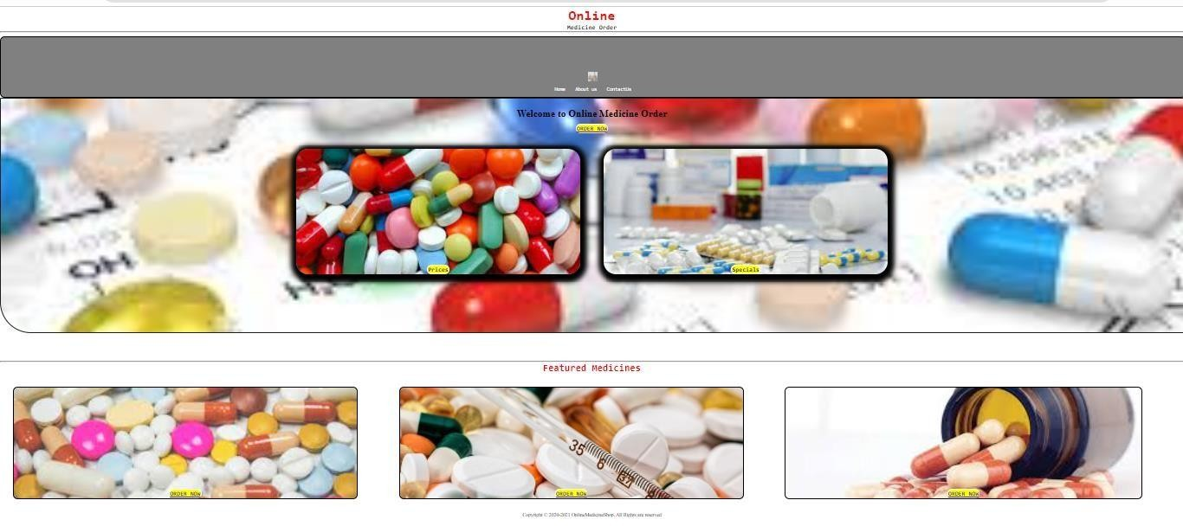

**Figure:4**

**Home Page**

**INDEX PAGE**

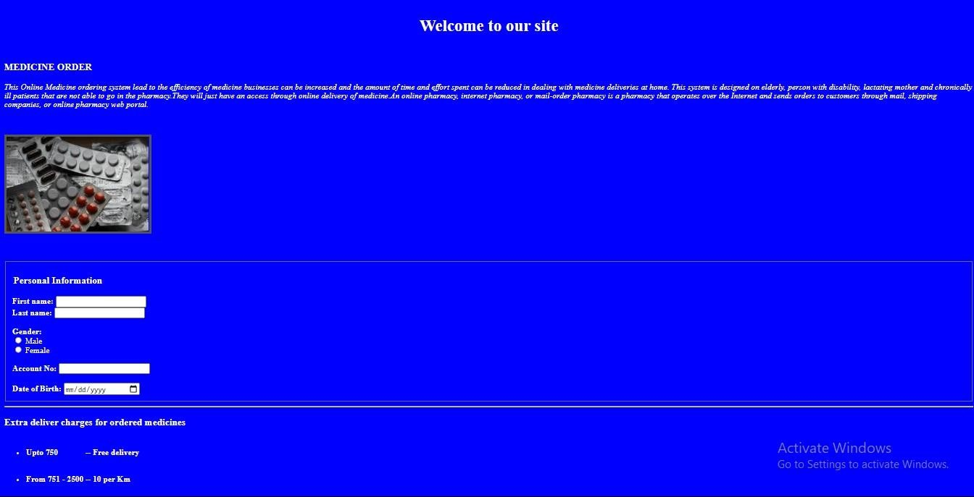

Figure:5

Index Page

# ABOUT US PAGE

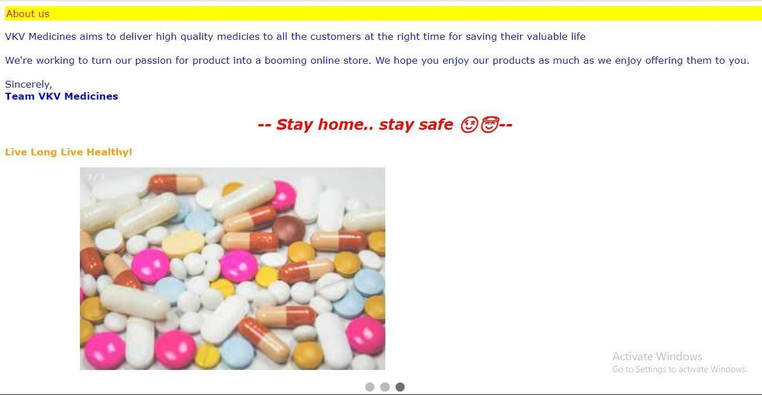

**Figure:6**

**About us page**

**CONTACT US PAGE**

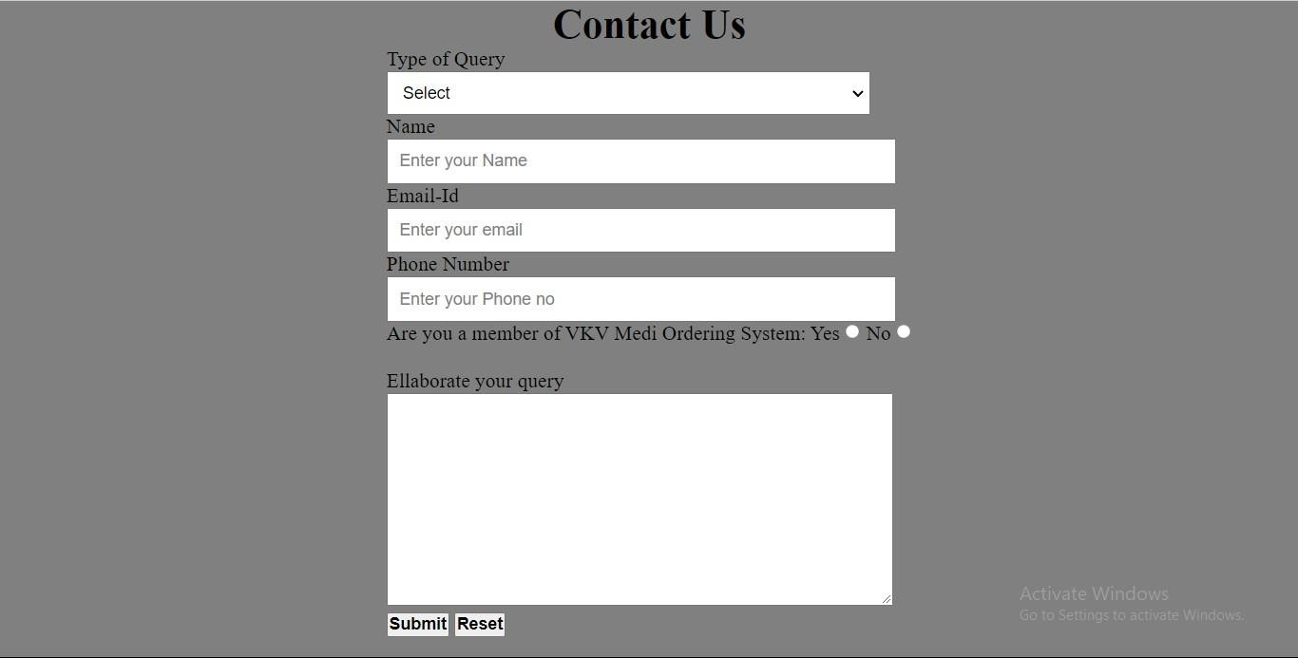

**Figure :7**

**Contact us page**

# CHAPTER 11

**Testing**

**Testing** is an investigation conducted to provide stakeholders with information about the quality of the software product or service under test. Software testing can also provide an objective, independent view of the software to allow the business to appreciate and understand the risks of software implementation. Test techniques include the process of executing a program or application with the intent of finding software bugs (errors or other defects), and verifying that the software product is fit for use.

Software testing involves the execution of a software component or system component to evaluate one or more properties of interest. In general, these properties indicate the extent to which the component or system under test:

* meets the requirements that guided its design and development,
* responds correctly to all kinds of inputs,
* performs its functions within an acceptable time,
* it is sufficiently usable,
* can be installed and run in its intended environments, and
* Achieves the general result its stakeholder’s desire.

### 11(i) Static vs. dynamic testing:

There are many approaches available in software testing. Reviews, walkthroughs, or inspections are referred to as static testing, whereas executing programmed code with a given set of test cases is referred to as dynamic testing.

Static testing is often implicit, like proofreading, plus when programming tools/text editors check source code structure or compilers (pre-compilers) check syntax and data flow as static program analysis. Dynamic testing takes place when the program itself is run. Dynamic testing may begin before the program is 100% complete in order to test particular sections of code and are applied to discrete functions or modules. Typical techniques for these are either using stubs/drivers or execution from a debugger environment.

### 11(ii) White-box testing:

White-box testing (also known as clear box testing, glass box testing, transparent box testing and structural testing) verifies the internal structures or workings of a program, as opposed to the functionality exposed to the end-user. In white-box testing, an internal perspective of the system (the source code), as well as programming skills, are used to design test cases. The tester chooses inputs to exercise paths through the code and determine the appropriate outputs. This is analogous to testing nodes in a circuit, e.g., in-circuit testing (ICT).

While white-box testing can be applied at the unit, integration, and system levels of the software testing process, it is usually done at the unit level. It can test paths within a unit, paths between units during integration, and between subsystems during a system–level test. Though this method of test design can uncover many errors or problems, it might not detect unimplemented parts of the specification or missing requirements.

Techniques used in white-box testing include:

* API testing – testing of the application using public and private APIs (application programming interfaces)
* Code coverage – creating tests to satisfy some criteria of code coverage (e.g., the test designer can create tests to cause all statements in the program to be executed at least once)
* Fault injection methods – intentionally introducing faults to gauge the efficacy of testing strategies
* Mutation testing methods
* Static testing methods

Code coverage tools can evaluate the completeness of a test suite that was created with any method, including black-box testing. This allows the software team to examine parts of a system that are rarely tested and ensures that the most important function points have been tested. Code coverage as a software metric can be reported as a percentage for:

* + Function coverage, which reports on functions executed
  + Statement coverage, which reports on the number of lines executed to complete the test
  + Decision coverage, which reports on whether both the True and the False branch of a given tens.
  + it has been executed

100% statement coverage ensures that all code paths or branches (in terms of control flow) are executed at least once. This is helpful in ensuring correct functionality, but not sufficient since the same code may process different inputs correctly or incorrectly. Pseudo-tested functions and methods are those that are covered but not specified (it is possible to remove their body without breaking any test case).

### 11(iii) Black-box testing



Black-box testing (also known as functional testing) treats the software as a "black box,"

examining functionality without any knowledge of internal implementation, without seeing the source code. The testers are only aware of what the software is supposed to do, not how it does it. Black-box testing methods include: equivalence partitioning, boundary value analysis, all-pairs testing, state transition tables, decision table testing, fuzz testing, model-based testing, use case testing, exploratory testing, and specification-based testing.

There are many types of Black Box Testing but the following are the prominent ones –

* **Functional testing** – This black box testing type is related to the functional requirements of a system; it is done by software testers.
* **Non-functional testing**– This type of black box testing is not related to testing of specific functionality, but non-functional requirements such as performance, scalability, usability.
* **Regression testing**– [Regression Testing](https://www.guru99.com/regression-testing.html) is done after code fixes, upgrades or any other system maintenance to check the new code has not affected the existing code.

Specification-based testing aims to test the functionality of software according to the applicable requirements This level of testing usually requires thorough test cases to be provided to the tester, who then can simply verify that for a given input, the output value (or behavior), either "is" or "is not" the same as the expected value specified in the test case. Test cases are built around specifications and requirements, i.e., what the application is supposed to do. It uses external descriptions of the software, including

specifications, requirements, and designs to derive test cases. These tests can be functional or non-functional, though usually functional.

Specification-based testing may be necessary to assure correct functionality, but it is insufficient to guard against complex or high-risk situations.

One advantage of the black box technique is that no programming knowledge is required. Whatever biases the programmers may have had, the tester likely has a different set and may emphasize different areas of functionality. On the other hand, black-box testing has been said to be "like a walk in a dark labyrinth without a flashlight.” Because they do not examine the source code, there are situations when a tester writes many test cases to check something that could have been tested by only one test case or leaves some parts of the program untested.

This method of test can be applied to all levels of software testing: unit, integration, system and acceptance. It typically comprises most if not all testing at higher levels, but can also dominate unit testing as well.

Specification-based testing aims to test the functionality of software according to the applicable requirements This level of testing usually requires thorough test cases to be provided to the tester, who then can simply verify that for a given input, the output value (or behavior), either "is" or "is not" the same as the expected value specified in the test case. Test cases are built around specifications and requirements, i.e., what the application is supposed to do. It uses external descriptions of the software, including

specifications, requirements, and designs to derive test cases. These tests can be functional or non-functional, though usually functional.

Specification-based testing may be necessary to assure correct functionality, but it is insufficient to guard against complex or high-risk situations.

# REFERENCES

1. A. de Solages and J. Traor´e, “An efficient fair off-line electronic cash system with extensions to checks and wallets with observers,” in International Conference on Telemedicne. Springer, 1998, pp. 275–295.
2. National preparedness Resource Plan for Telemedicine 209_291.
3. Hyperlocal : The Future of Online Pharmacy Business Model.
4. I. Teranishi, J. Furukawa, and K. Sako, “Why we Buy medicine online? (extended abstract),” in Advances 2018. Springer, 2004, pp. 308–322.
5. I. Teranishi and K. Sako, “k-times anonymous authentication with a constant proving cost,” in Medicare - PKC 2006, M. Yung, Y. Dodis, A. Kiayias, and T. Malkin, Eds. Springer, 2006, pp. 525–542.
6. L. Nguyen and R. Safavi-Naini, “Dynamic k-times anonymous authentication,” in Applied In tele medicine. Springer, 2005, pp. 318–333.
7. L. Nguyen, “Efficient dynamic k-times anonymous authentication,” in Progress in medicine - VIETCRYPT 2006. Springer, 2006, pp. 81–98
8. M. Bellare, D. Micciancio, and B. Warinschi, “Foundations of group signatures: Formal definitions, simplified requirements, and a construction based on general assumptions,” in International Conference on the Theory and Applications of micro biology Techniques.

Springer, 2003, pp. 614–629.

1. O. Bic¸er and A. K¨upc¸ ¨ u, “Versatile abs: Usage limited, revocable, threshold traceable, authority hiding, decentralized attribute based signatures.” E-commerce Archive, vol. 2019, p. 203, 2019.

[10] Y. Dodis and A. Yampolskiy, “A verifiable random function with short proofs and keys,” in International Workshop on Hospitality. Springer, 2005, pp

[1I]. Teranishi, J. Furukawa, and K. Sako, “Why we Buy medicine online? (extended abstract),” in Advances 2018. Springer, 2004, pp. 308–322.

[12]I. Teranishi and K. Sako, “k-times anonymous authentication with a constant proving cost,” in Medicare - PKC 2006, M. Yung, Y. Dodis, A. Kiayias, and T. Malkin, Eds. Springer, 2006, pp. 525–542.

[13]L. Nguyen and R. Safavi-Naini, “Dynamic k-times anonymous authentication,” in Applied In tele medicine. Springer, 2005, pp. 318–333.