EPRS DOMAIN

## A PROJECT REPORT SUBMITTED BY

**SHUBHAM KUMAR VISHNOI**

**(**University Roll No:1900290140036)

**A Thesis Submitted**

**in Partial Fulfillment of the Requirements for the Degree of**

MASTER OF COMPUTER APPLICATION

## Under the Supervision of Ms. Vidushi ASSISTANT PROFESSOR

## KIET Group of Institution, Ghaziabad



## DR. APJ ABDUL KALAM TECHNICAL UNIVERSITY

## (Formerly Uttar Pradesh Technical University) LUCKNOW

## June 20

# 

# DECLARATION

I hereby declare that the work presented in this report entitled “EPRS Payment Gateway", was carried out by me. I have not submitted the matter embodied in this report for the award of any other degree or diploma of any other University or Institute.

I have given due credit to the original authors/sources for all the words, ideas, diagrams, graphics, computer programs, experiments, results, that are not my original contribution. I have used quotation marks to identify verbatim sentences and given credit to the original authors/sources.

I affirm that no portion of my work is plagiarized, and the experiments and results reported in the report are not manipulated. In the event of a complaint of plagiarism and the manipulation of the experiments and results, I shall be fully responsible and answerable.

Name : SHUBHAM KUMAR VISHNOI

Roll. No. : University Roll No.1900290140036

Field : M.C.A. 6th Semester

(Candidate Sign)

Shubham Kumar Vishnoi

**CERTIFICATE**

Certified that **Shubham Kumar Vishnoi (**Roll no 1900290140036) has carried out the research work presented in this report entitled **“**EPRS Payment Gateway**”** for the award of **Masters of Computer Application** from Dr. APJ Abdul Kalam Technical University, Lucknow under my supervision. This report embodies results of original work, and studies are carried out by the student herself and the contents of the report do not form the basis for the award of any other degree to the candidate or to anybody else from this or any other University/Institution

## Date: Shubham Kumar Vishnoi

## University Roll No.1900290140036

## Ms. Vidushi Associate Professor

## Department of Computer Applications KIET Group of Institutions, Ghaziabad

## Signature of Internal Examiner Signature of External Examiner

**ABSTRACT**

The EPRS Payment Gateway Management Systemis an application for maintaining a person's account in a bank. In this project I tried to show the working of a banking account system and cover the basic functionality of a Bank Account Management System. To develop a project for solving financial applications of a customer in banking environment in order to nurture the needs of an end banking user by providing various ways to perform banking tasks. Also, to enable the user’s work space to have additional functionalities which are not provided under a conventional banking project.

The EPRS Payment Gateway Management Systemundertaken as a project is based on relevant technologies. The main aim of this project is to develop software for EPRS Payment Gateway Management System. This project has been developed to carry out the processes easily and quickly, which is not possible with the manuals systems, which are overcome by this software. This project is developed using Java language. Creating and managing requirements is a challenge of IT, systems and product development projects or indeed for any activity where you have to manage a contractual relationship. Organization need to effectively define and manage requirements to ensure they are meeting needs of the customer, while proving compliance and staying on the schedule and within budget.

The impact of a poorly expressed requirement can bring a business out of compliance or even cause injury or death. Requirements definition and management is an activity that can deliver a high, fast return on investment. The project analyzes the system requirements and then comes up with the requirements specifications. It studies other related systems and then come up with system specifications. The system is then designed in accordance with specifications to satisfy the requirements. The system design is then implemented with Java. The system is designed as an interactive and content management system. The content management system deals with data entry, validation confirm and updating whiles the interactive system deals with system interaction with the administration and users. Thus, above features of this project will save transaction time and therefore increase the efficiency of the system

**ACKNOWLEDGEMENTS**

Success in life is never attained single handedly. My deepest gratitude goes to **MS. VIDUSHI** for guidance, help and encouragement throughout my research work. Their enlightening ideas, comments, and suggestions.

Words are not enough to express my gratitude to **Dr. Ajay Kumar Shrivastava, Professor and Head, Department of Computer Applications**, for his insightful comments and administrative help at various occasions.

Fortunately, I have many understanding friends, who have helped me a lot on many critical conditions.

Finally, my sincere thanks go to my family members and all those who have directly and indirectly provided me moral support and other kind of help. Without their support, completion of this work would not have been possible in time. They keep my life filled with enjoyment and happiness.

## SHUBHAM KUMAR VISHNOI

## Roll No : 1900290140036

**TABLE OF CONTENTS**PAGE NO

Declaration 2

Certificate 3

Abstract 4

Acknowledge 5

Table of content

**Chapter 1:**9-14

▪Introduction

▪Objective

**Chapter 2:** Literature Review 15-17

**Chapter 3:** Feasibility study 18-27

▪Technical Feasibility & Operational Feasibility

▪System requirement specification

▪SDLC

▪Introduction to front end application

▪Introduction to backend application

**Chapter 4:**28-38

▪DFD

▪E-R DIAGRAM

▪Data structures and database specification

**Chapter 5:**39-42

▪Design

**Chapter 6:**43-50

▪Coding

**Chapter 7:**51-54

▪Testing

**Chapter 8:** Conclusion &Future Scope55

▪Conclusion

▪Future Scope

References 56-57

## LIS OF TABLES

✓**TABLE 1** SQL DATABASE TABLE. 26

✓**TABLE 2** "ACCOUNT_INFO" TABLE 33-35

✓**TABLE 3** "BRANCH_INFO" TABLE 35

✓**TABLE 4** "DEPOSIT_INFO" TABLE 35

✓**TABLE 5** "FIXED_INFO" TABLE 35-36

✓**TABLE 6** "LOGIN_INFO" TABLE. 36

✓**TABLE 7** "WITHDRAWL_INFO" TABLE. 37

✓**TABLE 8** "LOAN_INFO" TABLE. 37

## LIST OF FIGURES

✓**FIGURE 1** SOFTWARE DEVELOPMENT LIFE CYCLE. 21

✓**FIGURE 2** SYTEM DATA FLOW DIAGRAM. 29

✓FIGURE 3 E-R DIAGRAM. 30

**CHAPTER 1 INTRODUCTION**

The “**EPRS Payment Gateway Management System**” project is a model Internet Banking Site. This site enables the customers to perform the basic banking transactions by sitting at their office or at homes through PC or laptop. The system provides the access to the customer to create an account, deposit/withdraw the cash from his account, also to view reports of all accounts present. The customers can access the banks website for viewing their Account details and perform the transactions on account as per their requirements. With Internet Banking, the brick and mortar structure of the traditional banking gets converted into a click and portal model, thereby giving a concept of virtual banking a real shape. Thus, today's banking is no longer confined to branches. E- banking facilitates banking transactions by customers round the clock globally.

The primary aim of this “EPRS Payment Gateway Management System” is to provide an improved design methodology, which envisages the future expansion, and modification, which is necessary for a core sector like banking. This necessitates the design to be expandable and modifiable and so a modular approach is used in developing the application software.

Anybody who is an Account holder in this bank can become a member of EPRS Payment Gateway Management System. He has to fill a form with his personal details and Account Number.

Bank is the place where customers feel the sense of safety for their property. In the bank, customers deposit and withdraw their money. Transaction of money also is a part where customer takes shelter of the bank. Now to keep the belief and trust of customers, there is the positive need for management of the bank, which can handle all this with comfort and ease.

Smooth and efficient management affects the satisfaction of the customers and staff members, indirectly. And of course, it encourages management committee in taking some needed decision for future enhancement of the bank.

Now a day’s, managing a bank is tedious job up to certain limit. So software that reduces the work is essential. Also, today’s world is a genuine computer world and is getting faster and faster day-by-day. Thus, considering above necessities, the software for bank management has become necessary which would be useful in managing the bank more efficiently.

All transactions are carried out online by transferring from accounts in the same Bank or international bank. The software is meant to overcome the drawbacks of the manual system.

**OBJECTIVE OF THE PROJECT**

The Traditional way of maintaining details of a user in a bank was to enter the details and record them. Every time the user needs to perform some transactions he has to go to bank and perform the necessary actions, which may not be so feasible all the time. It may be a hard-hitting task for the users and the bankers too. The project gives real life understanding of Online Banking System and activities performed by various roles in the supply chain. Here, we provide automation for banking system through Internet. Online Banking System project captures activities performed by different roles in real life banking which provides enhanced techniques for maintaining the required information up-to-date, which results in efficiency. The project gives real life understanding of Online Banking System and activities performed by various roles in the supply chain.

The main aim of designing and developing this Internet banking System Java primarily based

Engineering project is to provide secure and efficient net banking facilities to the banking customers over the internet. Apache Server Pages, MYSQL database used to develop this bank application where all banking customers can login through the secured web page by their account login id and password. Users will have all options and features in that application like get money from western union, money transfer to others, and send cash or money to inter banking as well as other banking customers by simply adding them as payees.

## Main Goal

1. **Motto-** Our motto is to develop a software program for managing the entire bank process related to Administration accounts customer accounts and to keep each every track about their property and their various transaction processes efficiently.

Hereby, our main objective is the customer’s satisfaction considering today’s faster in the world.

1. **Customer Satisfaction**: Client can do his operations comfortably without any risk or losing of his privacy. Our software will perform and fulfill all the tasks that any customer would desire.
2. **Saving Customer Time**: Client doesn't need to go to the bank to do small operation.
3. **Protecting the Customer:** It helps the customer to be satisfied and comfortable in his choices, this protection contains customer’s account, money and his privacy.
4. **Transferring Money:** Help client transferring money to/or another bank or country.

**Methods**

•We need to be able to generate an account number

•Account types: Savings or Current Account

•Maintain/update Balance

•Open/Close Account

•Withdraw/Deposit

**Administrative Modules**

Here in my project there are two types of modules. This module is the main module which performs all the main operations in the system. The major operations in the system are:

## Admin Module

Admin can access this project there is an authorization process. If you login as an Admin then you will be redirected to the Admin Home Page and if you are a simple user you will be redirected to your Account Home Page. This performs the following functions: Create Individual Accounts, manage existing accounts, View all transactions, Balance enquiry, Delete/close account etc.

1. Admin login
2. Add/delete/update account
3. Withdrawal/deposit/statements transaction
4. Account Information 5- User details list
5. Active/Inactive account
6. View transaction histories

## User Module

A simple user can access their account and can deposit/withdraw money from their account.

User can also transfer money from their account to any other bank account. User can see their transaction report and balance enquiry too.

1. User login, use PIN system
2. Creating/open new account registration
3. Funds transfer (local/international/domestic) 4- View statements transaction
4. User account details
5. Change Password and Pin

## Banks terms:

1. All requests received from customers are logged for backend fulfillment and are effective from the time they are recorded at the branch.
2. Rules and regulations applicable to normal banking transactions in India will be applicable mutatis mutandis for the transactions executed through this site.
3. The EPRS Payment Bank service cannot be claimed as a right. The bank may also convert this into a discretionary service anytime.
4. Dispute between the customer and the Bank in this service is subject to the jurisdiction of the courts in the Republic of India and governed by the laws prevailing in India.
5. The Bank reserves the right to modify the services offered or the Terms of service of EPRS Bank. The changes will be notified to the customers through a notification on the Site.

## Customer’s obligations

1. The customer has an obligation to maintain secrecy in regard to Username & Password registered with the Bank. The bank presupposes that login using valid Username and Password is a valid session initiated by none other than the customer.
2. Transaction executed through a valid session will be construed by RR to have emanated from the registered customer and will be binding on him/her.
3. The customer will not attempt or permit others to attempt accessing the BAMS Bank through any unlawful means.

**Benefits of online banking**

Many of us lead busy lives. Some of us are up before the crack of dawn, getting ourselves prepared so we can in turn get our families ready for the day. We rush to work, rush to get the kids to school, and at the end of the day we rush home only to brace ourselves for the next day. After a hectic day, the last thing you want to do is spend time waiting in line at the bank, or even the post office. That's where Online Banking comes in. Many of the benefits of doing our banking online are obvious:

1. You don't have to wait in line.
2. You don't have to plan your day around the bank's hours.
3. You can look at your balance whenever you want, not just when you get a statement.

There are some hidden benefits too. As a young bank customer, you're just learning how to manage your money and observe your spending patterns.

Online banking allows you to watch your money on a daily basis if you want to. By keeping close tabs on your funds, you'll always be aware of what's happening in your bank account.

For those experienced spenders, this option is far more appealing than the sudden discovery that you're broke!

It's also helpful to watch how much interest you're gathering on investments and savings or what service charges you have incurred.

## Most available benefits

1. Online banking with key bank is fast, secure, convenient and free.
2. Quick, simple, authenticated access to accounts via the web application.
3. Simply scalable to grow with changing system requirement.
4. Global enterprise wide access to information.
5. Improved data security, restricting unauthorized access.
6. Minimize Storage Space.

// do complete report in single column

**CHAPTER 2 LITERATURE REVIEW**

Dr. Geeta Sharma discussed about role and benefits about internet banking in Indian banking sector. Also discussed the services obtained through internet banking are statements, online fund transfer, online payment services, online requests and intimations and maintaining demat account.

Anju Dagar discussed about importance, advantages, various online services and issues pertaining in online banking.

Ebubeogu Amarachukwu Felix developed software for banking management system using ASP.NET. This project performs the following operations, opening an account, deposits, withdraws, fund transfers and updating the details.

Mahmood Shah discussed about what is meant by E-banking, importance, overview, technologies, human involvement in banking sector, issues, strategic development and future trends in E-banking.Muhammad Abdus Sattar Titu and Md.

Azizur Rahman explained adoption, major components, major online banking services, customer satisfaction and major problems encountered in online banking services in Bangladesh banks.

Bahman Saeidipour et.al, analyzed the factors to adopt internet banking.

D.Amutha conducted a study from 90 respondents in Tuticorin district to understand the awareness and satisfaction related parameters in E- banking.

Internet banking offer convenience to bank customers, allowing them to use services from banks in distance and

avoid hassles to go to the bank branches as wellas it generates substantial cost savings to banks (Sullivan & Wang, 2014).Financial institutions in Kenya cannot ignore technological information systems since they play an important role in their operations[15]

Alternatively, existing banking companies create virtual banks as separately capitalized subsidiary banks of a bank holding company (Furst et al., 2000). A third route is investors purchase the existing charter of a traditional bank, and then to recast the bank as a virtual bank under the existing charter (Furst et al., 2000).[14]

Many experienced bank employees were offered early retirement and the remaining employees faced increased workloads with shorter service hours (Ongkasuwan and Tantichattanon, 2002). This change caused the majority of the Thai banks to use Internet banking to reduce waiting time, errors and costs, and ultimately improve customerssatisfaction.

Internet revolution is global phenomenon and going by the current growth statistics, India expects a spurt in the Internet penetration in coming years particularly in the electronic commerce. It is an obvious notion that electronic (Internet) banking and payments are likely to advance more or less in tandem with ecommerce. Researches indicate that Internet banking has a significant impact on the business models of banks, securities trading firms, brokerage houses, insurance companies etc. Internet banking has also attracted the

attention of, regulators and lawmakers in the developing nations since the late 1990s.

Internet banking is a cause of concern to majority of the offline banks who should be ready for an unprecedented competition from the non-traditional banking institutions that offer banking and financial services over the Internet (Rajgopalan, 2001). Although some of the traditional banks have started offering their services on line, it is only an extension of their offline services (Devi, 2001). Internet banking has now started motivating customers to park their funds with the online banks, which has a substantially impact on the deposit base of the brick and mortar banks.

The use of technology in banking has direct relationship with the profitability. Cetris paribus, investment in electronic banking increase the profit margin of banks by reducing costs and increase in non-interest income, which will increases the ROA and ROE (Sinkney, 1998). Cost-effectiveness in delivery of services directly implies comparatively high consumer satisfaction and a consequent change in the revenue model for the banks. Adoption of the Internet mode of banking would result in increased consumer awareness, attracts the entry of global majors in the market and would lead to the emergence of open standards in the banking industry (Treasury Management, 2001). The integration of the banking services with e-commerce and emergence of e-cash would positively affect the efficiency scores of theanks (Scott, 1999)

However, Internet banking is a mixed blessing in the form of increased risk, the level of confidence reposed by the consumers and

the problem of blending it with the physical system (Hawke, 2001).

Internet banking has brought about a new orientation to risks like settlement risk, international technology transfer risk, crime or fraud risk, regulatory avoidance risk, taxation avoidance risk, and competition risk (Saunders, 1997). Basel II recommendation on operational risk also supports this hypothesis. In India, some banks like HDFC and ICICI have introduced payment gateways running on secure systems having firewalls against hacking (Rao, 2001). Convenience, safety and cost effectiveness are the jargons in the spectrum of online banking (Rose, 1998).

Researchers on various occasions have raised many issues, which must be addressed in context of Internet banking in India. First, the availability of technology and infrastructure to support the new model of banking. Second, the need for Internet banking itself – Internet Banking or an efficient system of instantaneous banking or convenient banking. Third, an adequate mechanism to tackle the security riskand operational risk aspects (Sharma, 2001). Fourth, a proper legal framework to take care of the rights and obligation of the consumers. While most of these issues have been somewhat addressed, an important issue still remains - what existing and potential consumers feel about Internet banking and on the basis ofthis how

an appropriate banking model can be developed in Indian context. There is a need to measure and analyze the consumer perception towards Internet banking, to find out what is wrong

with traditionalbanks and provide a framework for the banks to strategically adopt the Internet so as to maximize value for the consumers.

**CHAPTER 3: FEASIBILITY STUDY**

Depending on the results of the initial investigation, the survey is expanded to a more detailed feasibility study. A feasibility study is a test of a system proposal. According to its workability, impact on the organization, ability to meet user’s needs and effective use of the resources its main task done during the feasibility study are:-

1. Evaluation of existing system and procedures. Our group went to various Banking Professionals to gather information about the software system. They are using and evaluating those system and the procedures invoked in it during the period of feasibility study.
2. Analysis of alternative candidate systems after studying the various systems we derived various alternatives through which we develop our project and evaluated the alternative. The most appropriate is selected.

## FEASIBILITY STUDY

The only tangible benefit provided by the proposed system is that the paper work is reduced to the minimum and hence the reduction in cost incurred on Stationary and its storage. The system provides many benefits that can’t be measured in terms of Money for

e.g. user’s friendliness, more user response being more efficient.

✓TECHNICAL FEASIBILITY:-

The proposed system is technically feasible as it can be developed easily with the help of available technology. The proposed system requires MS – VISUAL Studio 2005 using VB.Net as a Interface for Programming & back-end as MS- SQL Server 2000 for storing/maintaining database. The database can be easily interconnected using MS-SQL Server 2000.

✓OPERATIONAL FEASIBILITY:-

Automation makes our life easy. The proposed system is highly user friendly and is much easily able to interact with the system. Therefore the users will readily accept the system as data entry and making queries can be easily done.

**SYSYTEM REQUIREMENTS**

Hardware specifications

Hardware is a set of physical components, which performs the functions of applying appropriate, predefined instructions. In other words, one can say that electronic and mechanical parts of computer constitute hardware.

This package is designed on a powerful programming language Visual Basic. It is a powerful Graphical User Interface. The backend is ACCESS, which is used to maintain database. It can run on almost all the popular microcomputers. The following are the minimum hardware specifications to run this package: -

Personal Computer: -

It minimum contains P-III Processor with 128 MB RAM

Software Requirements**:**

The software is a set of procedures of coded information or a program which when fed into the computer hardware, enables the computer to perform the various tasks. Software is like a current inside the wire, which cannot be seen but its effect can be felt.

1. Operating System:- Windows NT / 2000 / XP
2. Application Software:- Application software uses front end visual basic and database access etc.

Editor:- Visual basic.

**SOFTWARE DEVELOPMENT LIFE CYCLE**

A system development life cycle is a logical process by which system analysts, software engineers, programmers, and end users build information systems and computer applications to solve business problems and needs.

The major phases involved in the MIS development process are referred to as system development life cycle. Each phase of the development process must have well defined objectives ,and at the end of each phase ,progress towards meeting the objectives must be evaluated.

The development process should not continue until the objectives of all prior phases have been met.

System development life cycle is a phased approach to analysis and design to ensure that systems are best developed.

The system development life cycle can be divided into seven phases as shown in fig

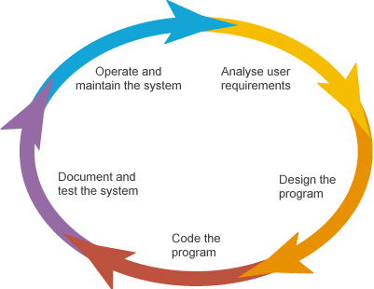

**//use caption with each table and figure**

**INTRODUCTION TO FRONT END TOOL**

➢Visual programming aims at providing the user with an interface that is intuitive and easy to use. In developing such an interface, the programmer employs user-friendly features such as windows, menus, buttons and list boxes.

➢Its Environment provides all features that are required to develop a graphical user interface as ready -to- use components. The programmer does not have to write code to create and display commonly required user-friendly features each time around.

➢When the programmer needs a specific user interface feature such as button, he selects the appropriate ready-to-use component provided by the visual programming environment. These components can be moved, resized and renamed as required.

## ➢For Example:-

If the programmer needs to have a button then the visual programming environment provides him with one. All that, the programmer does this selec t the button and place it on screen at the required position.

➢Typically the mouse is used to select and place the necessary components. Thus, the visual programming environment is also called a point and click environment.

➢A visual programming environment automates the process of creating a user interface. The interface provided by the visual programming environment to the programmer designs the user interface visually instead of writing code.

➢In addition it also provides a means of associating code with each component. In each case of calculator, for each button, we can specific that the code is to execute when we click on it.

## NEED FOR VISUAL PROGRAMMING:-

➢There are several programming tools that allow us to build such visually appealing and intuitive interface. These tools allow us to design interface that employ user friendly features such as menus, buttons, windows etc.

➢However, the disadvantage of such tools is that the interface is designed using code. The programmer has to code the user interface features specifying the size, position etc. this makes designing the user interface a major task in itself.

## ADVANTAGES OF VISUAL PROGRAMMING:-

➢Visual development of graphical user interface which are easy to use and easy to learn.

➢A programmer need not write code to display the required component.

## ➢For Example:-

The visual programming environment displays a list of available components. The programmer picks up the required component from this list to display it.

➢The component can be moved, resized and even deleted, if so required.

➢There is no restriction on the number of controls that can be placed on a form.

➢The interface components provided by the visual programming environment have some code built into them.

## For example:-

A button’ knows’ when it has been clicked upon. In the case of conventional programming tools, the programmer has to write code to determine the component that has been clicked and then execute the appropriate code.

➢Visual Basic is one of the most popular programming tools available today. And it’s also secret that there have been massive changes in it as it became Visual Basic.Net.

➢The reason of that change is Visual Basic itself, which has now become Visual Basic.Net. The difference between Visual Basic.Net and the previous version. Visual Basic 6.0 is revolutionary and far reaching. Visual Basic.Net has been more than four years in the marking and it represents entirely new directions for Visual Basic. Besides the biggest change integrated support for web development the very syntax, of techniques that you’ve probably learned carefully are now completely different such as data handling and many controls; project types and other aspects of Visual Basic 6.0 are no longer available at all.

➢Visual Basic has a long and so far glorious history. When it first appeared, it created a revolution in windows programming. Visual Basic introduced unheard of ease to windows programming just builds the program you want right before your eyes, and then run it. In so doing it changed programming form a chore to something very like fun.

**INTRODUCTION TO BACK END TOOL**

## Introduction to SQL: -

SQL is a standard computer language for accessing and manipulating databases.

•SQL stands for **S**tructured **Q**uery **L**anguage.

•SQL allows you to access a database.

•SQL is an ANSI standard computer language.

•SQL can execute queries against a database.

•SQL can retrieve data from a database.

•SQL can insert new records in a database.

•SQL can delete records from a database.

•SQL can update records in a database.

•SQL is easy to learn.

➢SQL is an ANSI (American National Standards Institute) standard computer language for accessing and manipulating database systems. SQL statements are used to retrieve and update data in a database. SQL works with database programs like MS Access, DB2, Informix, MS SQL Server, Oracle, Sybase, etc.

➢Unfortunately, there are many different versions of the SQL language, but to be in compliance with the ANSI standard; they must support the same major keywords in a similar manner (such as SELECT, UPDATE, DELETE, INSERT, WHERE, and others).

SELECT Last Name FROM Persons

## ➢SQL Database Tables: -

A database most often contains one or more tables. Each table is identified by a name (e.g. "Customers" or "Orders"). Tables contain records (rows) with data.

## Below is an example of a table called "Persons": -

|  |  |  |  |
| --- | --- | --- | --- |
| **Last Name** | **First Name** | **Address** | **City** |
| Hansen | Ola | Timoteivn 10 | Sandnes |
| Svendson | Tove | Borgvn 23 | Sandnes |
| Pettersen | Kari | Storgt 20 | Stavanger |

➢The table above contains three records (one for each person) and four columns (Last Name, First Name, Address, and City).

## ➢SQL Queries: -

With SQL, we can query a database and have a result set returned.

##  A query like this: -

##  Gives a result set like this: -

|  |
| --- |
| **Last Name** |
| Hansen |
| Svendson |
| Petersen |

## SQL Data Manipulation Language (DML)

➢SQL (Structured Query Language) is syntax for executing queries. But the SQL language also includes syntax to update, insert, and delete records.

➢These query and update commands together form the Data Manipulation Language (DML) part of SQL: -

❖ **SELECT** - extracts data from a database table

❖ **UPDATE** - updates data in a database table

❖ **DELETE** - deletes data from a database table

❖ **INSERT INTO** - inserts new data into a database table

## SQL Data Definition Language (DDL)

➢The Data Definition Language (DDL) part of SQL permits database tables to be created or deleted. We can also define indexes (keys), specify links between tables, and impose constraints between database tables.

## ➢The most important DDL statements in SQL are: -

▪ **CREATE TABLE** - creates a new database table

▪ **ALTER TABLE** - alters (changes) a database table

▪ **DROP TABLE** - deletes a database table

▪ **CREATE INDEX** - creates an index (search key)

▪ **DROP INDEX** - deletes an index MS SQL SERVER 2000

**CHAPTER 4: DATA FLOW DIAGRAM**

▪ **DATA FLOW DIAGRAM: -**The data flow diagram is also known as “bubble chart” has the purpose of clarifying system requirements and identifying major transformations that will become programs in system design so it is the starting point of specification down to the lowest level of detail. A DFDs consists of a series if bubbles joined by lines. The bubbles represent data transformation and the lines represent the data flow in the system.

## ▪ DFD SYMBOLS:

✓A system defined a source or destination of data.

✓An arrow identifies data flow, data in motion.

✓A circle represents the process that transforms incoming data flow to outgoing data flow.

✓An open rectangular is data store-data at rest or a temporary repository of data.

**TRANSACTIONS**

**BANKING**

**ACCOUNT HOLDERS**

**DATABASE**

## SYSTEM DATA FLOW DIAGRAM

**E-R DIAGRAM**

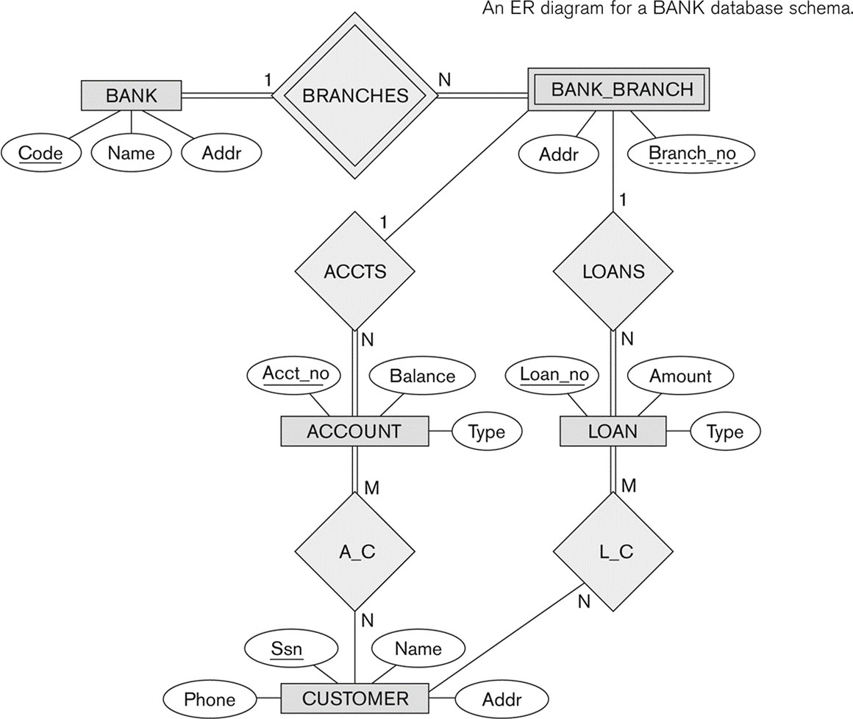

ER-modeling is a data modeling technique used in software engineering to produce a conceptual data model of a information system. Diagrams created using this ER- modeling technique are called Entity-Relationship Diagrams, or ER diagrams or ERDs.

So you can say that Entity Relationship Diagrams illustrate the logical structure of databases.

Dr. Peter Chen is the originator of the Entity-Relationship Model. His original paper about ER-modeling is one of the most cited papers in the computer software field.

Currently the ER model serves as the foundation of many system analysis and design methodologies, computer-aided software engineering (CASE) tools, and repository systems.

The original notation for ER-Diagrams uses rectangles to represent entities, and diamonds to represent relationships.

There are three basic elements in ER-Diagrams:

• Entities are the "things" for which we want to store information. An entity is a person, place, thing or event.

• Attributes are the data we want to collect for an entity.

• Relationships describe the relations between the entities.

ERDs show entities in a database and relationships between tables within that database. It is essential to have ER-Diagrams if you want to create a good database design. The diagrams help focus on how the database actually works.

Entity (Instance)

An instance of a physical object in the real world. Entity Class

: Group of objects of the same type.

–

E.g. Entity Class “Student”, Entities “John”, “Trish” etc Attributes

Properties of Entities that describe their characteristics. Types:

Simple

: Attribute that is not divisible, e.g. age. Composite

: Attribute composed of several simple attributes,

e.g. address (house number, street, district)

Multiple

: Attribute with a set of possible values for the same entity, e.g. Phone (home, mobile etc.) or email

Key

: Uniquely Ids the Entity e.g. PPSN, Chassis No.

Each simple attribute associated with a VS that may be assigned to that attribute for each individual entity,

e.g. age = integer

**DATA STRUCTURES AND DATABASE SPECIFICATIONS**

## “ACCOUNT_INFO” Table: -

|  |  |  |
| --- | --- | --- |
| **Field Name** | **Type** | **Constraints** |
| Account_No | Int | Primary Key |
| Branch_No | Varchar(7) | References Branch_Info(Branch_No) |
| Branch_Name | VARCHAR(50) | Not Null |
| Account_H_Type | Varchar(15) | Not Null |
| No_Account_H | Varchar(5) | Not Null |
| Saluation_F | Varchar(5) | Not Null |
| Name_P_O_F | Varchar(50) | Not Null |
| Fa_Name_F | Varchar(50) | Not Null |
| Gender_F | Varchar(6) | Not Null |
| DOB_F | DateTime | Not Null |
| Age_F | Varchar(3) | Check(Age_F>=0 and Age_F<100) |
| Occupation_F | Varchar(15) | Not Null |
| Photo_F | Image | Not Null |
| Sign_F | Image | Not Null |
| Address_F | Varchar(100) | Not Null |
| Ph_No_F | Varchar(11) | Not Null |
| Mob_No_F | Varchar(14) | Not Null |
| Saluation_S | Varchar(5) |  |
| Name_P_O_S | Varchar(50) |  |
| Fa_Name_S | Varchar(50) |  |
| Gender_S | Varchar(6) |  |

|  |  |  |
| --- | --- | --- |
| DOB_S | DateTime |  |
| Age_S | Varchar(3) | Check(Age_S>=0 and Age_S<100) |
| Occupation_S | Varchar(15) |  |
| Photo_S | Image |  |
| Sign_S | Image |  |
| Address_S | Varchar(100) |  |
| Ph_No_S | Varchar(11) |  |
| Mob_No_S | Varchar(14) |  |
| Saluation_T | Varchar(5) |  |
| Name_P_O_T | Varchar(50) |  |
| Fa_Name_T | Varchar(50) |  |
| Gender_T | Varchar(6) |  |
| DOB_T | DateTime |  |
| Age_T | Varchar(3) | Check(Age_T>=0 and Age_T<100) |
| Occupation_T | Varchar(15) |  |
| Photo_T | Image |  |
| Sign_T | Image |  |
| Address_T | Varchar(100) |  |
| Ph_No_T | Varchar(11) |  |
| Mob_No_T | Varchar(14) |  |
| Account_Type | Varchar(25) | Not Null |
| Witness_Name | Varchar(50) | Not Null |
| Witness_Sign | Image | Not Null |
| Nominee_Rel | Varchar(10) | Not Null |

|  |  |  |
| --- | --- | --- |
| Nominee_Name | Varchar(50) | Not Null |
| Nominee_Sign | Image | Not Null |
| Opening_Bal | Varchar(10) |  |
| T_Date | DateTime | Not Null |

## “Branch_Info” Table: -

|  |  |  |
| --- | --- | --- |
| **Field Name** | **Type** | **Constraints** |
| Branch_No | Varchar(7) | Primary Key |
| Branch_Name | Varchar(50) |  |

## “Deposit_Info” Table: -

|  |  |  |
| --- | --- | --- |
| **Field Name** | **Type** | **Constraints** |
| Account_No | Int | References Account_Info(Account_No) |
| Branch_No | Varchar(7) |  |
| Depositor_Name | Varchar(150) |  |
| Account_H_Type | Varchar(15) |  |
| Deposit_Amt | Varchar(10) |  |
| Deposit_Date | DateTime |  |

## “Fixed_Info” Table: -

|  |  |  |
| --- | --- | --- |
| **Field Name** | **Data type** | **Constraints** |

|  |  |  |
| --- | --- | --- |
| Account_No | Int | References Account_Info(Account_No) |
| Branch_No | Varchar(7) |  |
| Depositor_Name | Varchar(50) |  |
| Account_H_Type | Varchar(15) |  |
| Time_Span | Varchar(5) | References Rate_Of_Interest_Info(Time_Span) |
| ROI | Varchar(5) |  |
| Start_Date | DateTime |  |
| Mature_Date | Varchar(15) |  |
| Deposit_Amt | Varchar(10) |  |
| Mature_Amt | Varchar(10) |  |

## “Login_Info” Table: -

|  |  |  |
| --- | --- | --- |
| Field Name | Data type | Description |
| UserName | Varchar(20) | Primary Key |
| UserPassWord | Varchar(15) |  |

|  |  |  |
| --- | --- | --- |
| Field Name | Data type | Description |
| Time_Span | Varchar(5) | Primary Key |
| ROI | Varchar(5) |  |

## “Withdrawl_Info” Table: -

|  |  |  |
| --- | --- | --- |
| **Field Name** | **Type** | **Constraints** |
| Account_No | Int | References Account_Info(Account_No) |
| Branch_No | Varchar(7) |  |
| Withdrawee_Name | Varchar(150) |  |
| Account_H_Type | Varchar(15) |  |
| Withdrawl_Amt | Varchar(10) |  |
| Withdrawl_Date | DateTime |  |

## “Loan_Info” Table: -

|  |  |  |
| --- | --- | --- |
| **Field Name** | **Type** | **Constraints** |
| Account_No | Int | References Account_Info(Account_No) |
| Branch_No | Varchar(7) |  |
| Acc_Holder_Name | Varchar(50) |  |
| Account_Type | Varchar(15) |  |
| Account_Sub_Type | Varchar(15) |  |
| Time_Span | Varchar(5) | References  Rate_Of_Interest_Info(Time_Span) |
| ROI | Varchar(5) |  |
| Issue_Date | DateTime |  |
| Due_Date | Varchar(15) |  |
| Loan_Sanctioned | Varchar(10) |  |
| No_Installments | Varchar(5) |  |
| EMI | Varchar(10) |  |

|  |  |  |
| --- | --- | --- |
| Total_Loan_Ret | Varchar(10) |  |

**CHAPTER 5:**

**DESIGN**

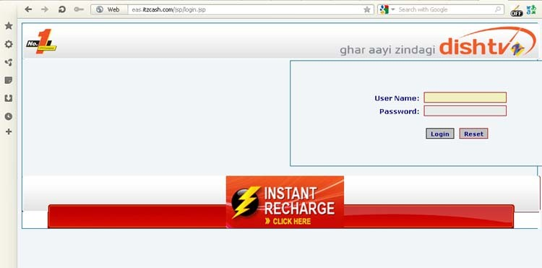▪Login Form

▪LOADING IMAGE

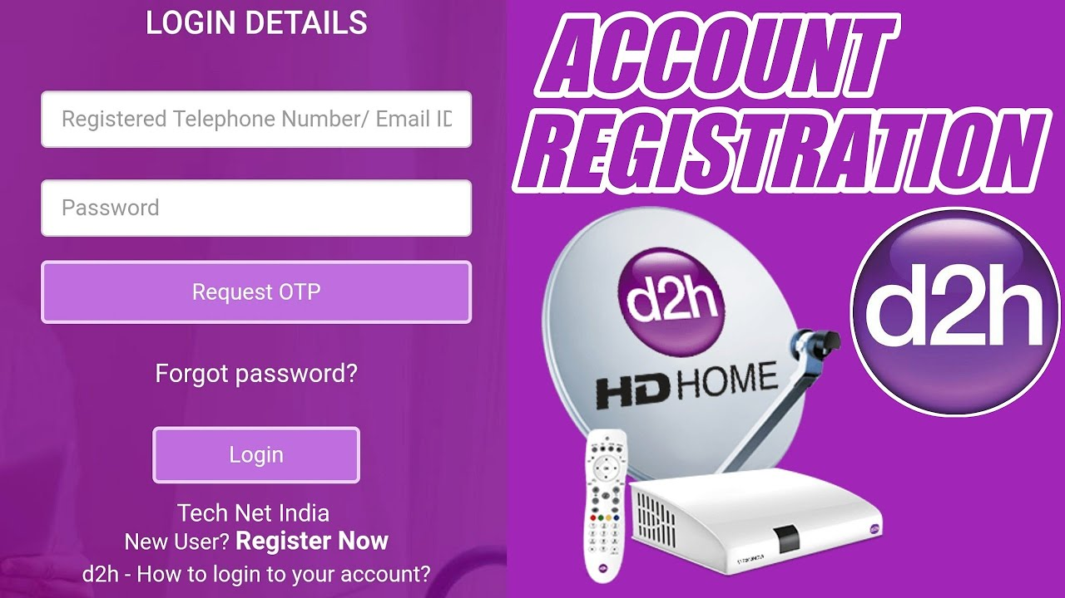

•ACCOUNT OPENING FORM

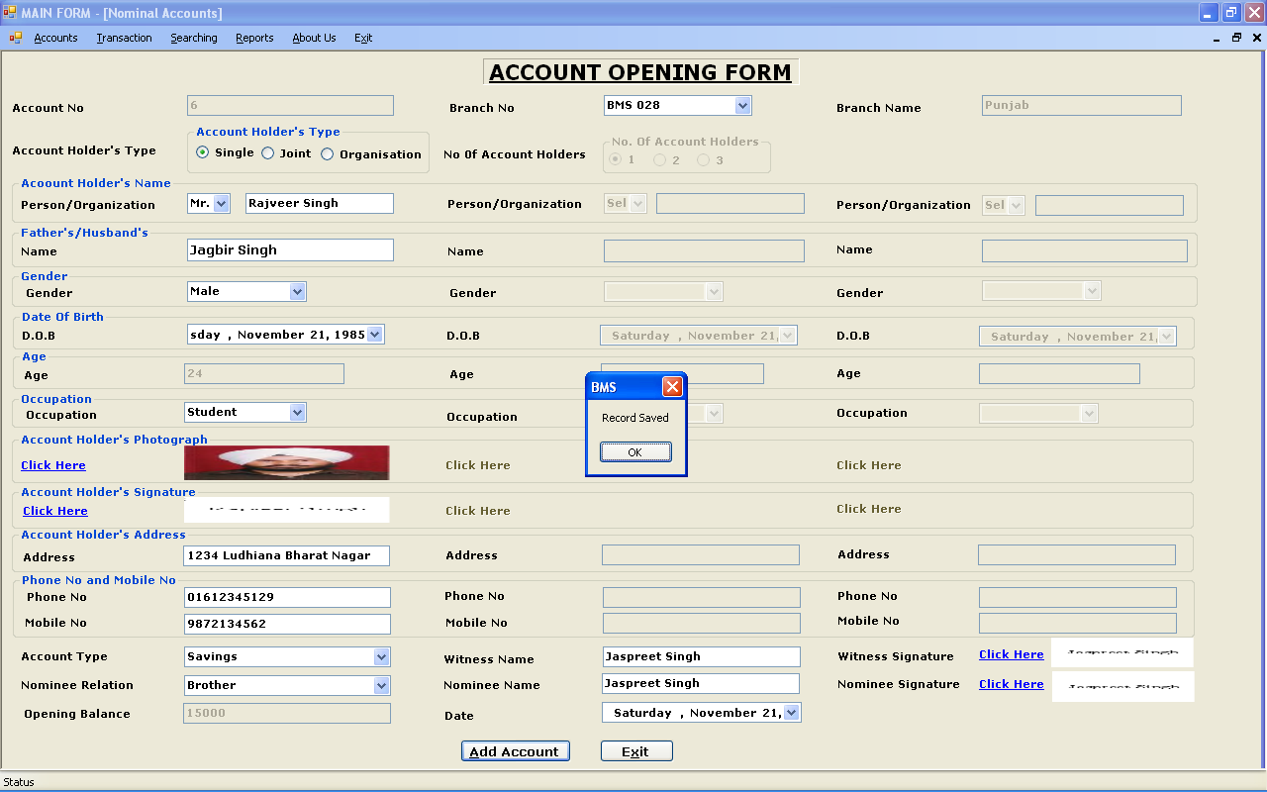

CHAPTER 6:**CODING**

**Deposit.java**

package ASimulatorSystem; import java.awt.*;

import java.awt.event.*; import javax.swing.*; import java.util.*;

public class Deposit extends JFrame implements ActionListener{ JTextField t1,t2;

JButton b1,b2,b3;

JLabel l1,l2,l3;

String pin;

Deposit(String pin){

this.pin = pin;

ImageIcon i1 = new

ImageIcon(ClassLoader.getSystemResource("ASimulatorSystem/icons/atm.jpg")); Image i2 = i1.getImage().getScaledInstance(1000, 1180,

Image.SCALE_DEFAULT);

ImageIcon i3 = new ImageIcon(i2); JLabel l3 = new JLabel(i3); l3.setBounds(0, 0, 960, 1080); add(l3);

l1 = new JLabel("ENTER AMOUNT YOU WANT TO DEPOSIT");

l1.setForeground(Color.WHITE);

l1.setFont(new Font("System", Font.BOLD, 16));

t1 = new JTextField();

t1.setFont(new Font("Raleway", Font.BOLD, 22));

b1 = new JButton("DEPOSIT"); b2 = new JButton("BACK");

setLayout(null);

l1.setBounds(190,350,400,35); l3.add(l1);

t1.setBounds(190,420,320,25);

l3.add(t1);

b1.setBounds(390,588,150,35); l3.add(b1);

b2.setBounds(390,633,150,35); l3.add(b2);

b1.addActionListener(this); b2.addActionListener(this);

setSize(960,1080); setUndecorated(true); setLocation(500,0); setVisible(true);

}

public void actionPerformed(ActionEvent ae){ try{

String amount = t1.getText(); Date date = new Date(); if(ae.getSource()==b1){

if(t1.getText().equals("")){

JOptionPane.showMessageDialog(null, "Please enter the Amount to you want to Deposit");

}else{

Conn c1 = new Conn();

c1.s.executeUpdate("insert into bank values('"+pin+"', '"+date+"', 'Deposit', '"+amount+"')");

JOptionPane.showMessageDialog(null, "Rs. "+amount+" Deposited Successfully");

setVisible(false);

new Transactions(pin).setVisible(true);

}

}else if(ae.getSource()==b2){ setVisible(false);

new Transactions(pin).setVisible(true);

}

}catch(Exception e){ e.printStackTrace();

}

}

public static void main(String[] args){ new Deposit("").setVisible(true);

}

}

## Signup.java

package ASimulatorSystem; import java.awt.*;

import java.awt.event.*;

import javax.swing.*; import java.sql.*;

import com.toedter.calendar.JDateChooser; import java.util.*;

public class Signup extends JFrame implements ActionListener{

JLabel l1,l2,l3,l4,l5,l6,l7,l8,l9,l10,l11,l12,l13,l14,l15; JTextField t1,t2,t3,t4,t5,t6,t7;

JRadioButton r1,r2,r3,r4,r5; JButton b;

JDateChooser dateChooser;

Random ran = new Random();

long first4 = (ran.nextLong() % 9000L) + 1000L; String first = "" + Math.abs(first4);

Signup(){

setTitle("NEW ACCOUNT APPLICATION FORM");

ImageIcon i1 = new ImageIcon(ClassLoader.getSystemResource("ASimulatorSystem/icons/logo.jpg"));

Image i2 = i1.getImage().getScaledInstance(100, 100, Image.SCALE_DEFAULT); ImageIcon i3 = new ImageIcon(i2);

JLabel l11 = new JLabel(i3); l11.setBounds(20, 0, 100, 100); add(l11);

l1 = new JLabel("APPLICATION FORM NO. "+first); l1.setFont(new Font("Raleway", Font.BOLD, 38));

l2 = new JLabel("Page 1: Personal Details"); l2.setFont(new Font("Raleway", Font.BOLD, 22));

l3 = new JLabel("Name:");

l3.setFont(new Font("Raleway", Font.BOLD, 20));

l4 = new JLabel("Father's Name:");

l4.setFont(new Font("Raleway", Font.BOLD, 20));

l5 = new JLabel("Date of Birth:");

l5.setFont(new Font("Raleway", Font.BOLD, 20));

l6 = new JLabel("Gender:");

l6.setFont(new Font("Raleway", Font.BOLD, 20));

l7 = new JLabel("Email Address:"); l7.setFont(new Font("Raleway", Font.BOLD, 20));

l8 = new JLabel("Marital Status:");

l8.setFont(new Font("Raleway", Font.BOLD, 20));

l9 = new JLabel("Address:");

l9.setFont(new Font("Raleway", Font.BOLD, 20));

l10 = new JLabel("City:");

l10.setFont(new Font("Raleway", Font.BOLD, 20));

l11 = new JLabel("Pin Code:");

l11.setFont(new Font("Raleway", Font.BOLD, 20));

l12 = new JLabel("State:");

l12.setFont(new Font("Raleway", Font.BOLD, 20));

l13 = new JLabel("Date");

l13.setFont(new Font("Raleway", Font.BOLD, 14));

l14 = new JLabel("Month");

l14.setFont(new Font("Raleway", Font.BOLD, 14));

l15 = new JLabel("Year");

l15.setFont(new Font("Raleway", Font.BOLD, 14));

t1 = new JTextField();

t1.setFont(new Font("Raleway", Font.BOLD, 14));

t2 = new JTextField();

t2.setFont(new Font("Raleway", Font.BOLD, 14));

t3 = new JTextField();

t3.setFont(new Font("Raleway", Font.BOLD, 14));

t4 = new JTextField();

t4.setFont(new Font("Raleway", Font.BOLD, 14));

t5 = new JTextField();

t5.setFont(new Font("Raleway", Font.BOLD, 14));

t6 = new JTextField();

t6.setFont(new Font("Raleway", Font.BOLD, 14));

t7 = new JTextField();

t7.setFont(new Font("Raleway", Font.BOLD, 14));

b = new JButton("Next");

b.setFont(new Font("Raleway", Font.BOLD, 14)); b.setBackground(Color.BLACK); b.setForeground(Color.WHITE);

r1 = new JRadioButton("Male");

r1.setFont(new Font("Raleway", Font.BOLD, 14)); r1.setBackground(Color.WHITE);

r2 = new JRadioButton("Female");

r2.setFont(new Font("Raleway", Font.BOLD, 14)); r2.setBackground(Color.WHITE);

ButtonGroup groupgender = new ButtonGroup(); groupgender.add(r1);

groupgender.add(r2);

r3 = new JRadioButton("Married"); r3.setFont(new Font("Raleway", Font.BOLD, 14)); r3.setBackground(Color.WHITE);

r4 = new JRadioButton("Unmarried"); r4.setFont(new Font("Raleway", Font.BOLD, 14)); r4.setBackground(Color.WHITE);

r5 = new JRadioButton("Other");

r5.setFont(new Font("Raleway", Font.BOLD, 14)); r5.setBackground(Color.WHITE);

ButtonGroup groupstatus = new ButtonGroup(); groupstatus.add(r3);

groupstatus.add(r4); groupstatus.add(r5);

dateChooser = new JDateChooser();

//dateChooser.setBorder(new LineBorder(new Color(0, 0, 0), 1, true));

dateChooser.setForeground(new Color(105, 105, 105));

dateChooser.setBounds(137, 337, 200, 29); add(dateChooser);

setLayout(null); l1.setBounds(140,20,600,40); add(l1);

l2.setBounds(290,80,600,30); add(l2);

l3.setBounds(100,140,100,30); add(l3);

t1.setBounds(300,140,400,30); add(t1);

l4.setBounds(100,190,200,30); add(l4);

t2.setBounds(300,190,400,30); add(t2);

l5.setBounds(100,240,200,30); add(l5);

dateChooser.setBounds(300, 240, 400, 30); l6.setBounds(100,290,200,30);

add(l6);

r1.setBounds(300,290,60,30); add(r1);

r2.setBounds(450,290,90,30); add(r2);

l7.setBounds(100,340,200,30);

add(l7);

t3.setBounds(300,340,400,30); add(t3);

l8.setBounds(100,390,200,30); add(l8);

r3.setBounds(300,390,100,30); add(r3);

r4.setBounds(450,390,100,30); add(r4);

r5.setBounds(635,390,100,30); add(r5);

l9.setBounds(100,440,200,30); add(l9);

t4.setBounds(300,440,400,30); add(t4);

l10.setBounds(100,490,200,30); add(l10);

t5.setBounds(300,490,400,30); add(t5);

l11.setBounds(100,540,200,30); add(l11);

t6.setBounds(300,540,400,30); add(t6);

l12.setBounds(100,590,200,30); add(l12);

t7.setBounds(300,590,400,30); add(t7);

b.setBounds(620,660,80,30); add(b);

b.addActionListener(this); getContentPane().setBackground(Color.WHITE);

setSize(850,800); setLocation(500,120); setVisible(true);

}

public void actionPerformed(ActionEvent ae){

String formno = first; String name = t1.getText(); String fname = t2.getText(); String dob = ((JTextField)

dateChooser.getDateEditor().getUiComponent()).getText(); String gender = null;

if(r1.isSelected()){ gender = "Male";

}else if(r2.isSelected()){ gender = "Female";

}

String email = t3.getText(); String marital = null; if(r3.isSelected()){

marital = "Married";

}else if(r4.isSelected()){ marital = "Unmarried";

}else if(r5.isSelected()){ marital = "Other";

}

String address = t4.getText(); String city = t5.getText(); String pincode = t6.getText(); String state = t7.getText();

try{

if(t6.getText().equals("")){

JOptionPane.showMessageDialog(null, "Fill all the required fields");

}else{

Conn c1 = new Conn();

String q1 = "insert into signup values('"+formno+"','"+name+"','"+fname+"','"+dob+"','"+gender+"','"+email+"','"+marita

l+"','"+address+"','"+city+"','"+pincode+"','"+state+"')"; c1.s.executeUpdate(q1);

new Signup2(first).setVisible(true); setVisible(false);

}

}catch(Exception e){ e.printStackTrace();

}

}

public static void main(String[] args){ new Signup().setVisible(true);

}

}

**CHAPTER 7 TESTING AND DEBUGGING**

The implementation phase of software development is concerned with translating design specification into source code. The preliminary goal of implementation is to write source code and internal documentation so that conformance of the code to its specifications can be easily verified, and so that debugging, testing and modifications are eased. This goal can be achieved by making the source code as clear and straightforword as possible. Simplicity, clarity and elegance are the hallmark of good programs, obscurity, cleverness, and complexity are indications of inadequate design and misdirected thinking.

Source code clarity is enhanced by structured coding techniques, by good coding style, by, appropriate supporting documents, by good internal comments, and by feature provided in modern programming languages.

The implementation team should be provided with a well-defined set of software requirement, an architectural design specification, and a detailed design description. Each team member must understand the objectives of implementation.

TERMS IN TESTING FUNDAMENTAL

## Error

The term error is used in two ways. It refers to the difference between the actual output of software and the correct output, in this interpretation, error is essential a measure of the difference between actual and ideal. Error is also to used to refer to human action that result in software containing a defect or fault.

## Fault

Fault is a condition that causes to fail in performing its required function. A fault is a basic reason for software malfunction and is synonymous with the commonly used term Bug.

## Failure

Failure is the inability of a system or component to perform a required function according to its specifications. A software failure occurs if the behavior of the software is the different from the specified behavior. Failure may be caused due to functional or performance reasons.

## Unit Testing

The term unit testing comprises the sets of tests performed by an individual programmer prior to integration of the unit into a larger system.

A program unit is usually small enough that the programmer who developed it can test it in great detail, and certainly in greater detail than will be possible when the unit is integrated into an evolving software product. In the unit testing the programs are tested separately, independent of each other. Since the check is done at the program level, it is also called program teasing.

## Module Testing

A module and encapsulates related component. So can be tested without other system module.

## Subsystem Testing

Subsystem testing may be independently design and implemented common problems are sub-system interface mistake in this checking we concentrate on it.

There are four categories of tests that a programmer will typically perform on a program unit.

1. Functional test
2. Performance test
3. Stress test
4. Structure test

## Functional Test

Functional test cases involve exercising the code with Nominal input values for which expected results are known; as well as boundary values (minimum values, maximum values and values on and just outside the functional boundaries) and special values.

## Performance Test

Performance testing determines the amount of execution time spent in various parts of the unit, program throughput, response time, and device utilization by the program unit. A certain amount of avoid expending too much effort on fine-tuning of a program unit that contributes little to the over all performance of the entire system. Performance testing is most productive at the subsystem and system levels.

## Stress Test

Stress test are those designed to intentionally break the unit. A great deal can be learned about the strengths and limitations of a program by examining the manner in which a program unit breaks.

## Structure Test

Structure tests are concerned with exercising the internal logic of a program and traversing particular execution paths. Some authors refer collectively to functional performance and stress testing as “black box” testing. While structure testing is referred to as “white box” or “glass box” testing. The major activities in structural testing are deciding which path to exercise, deriving test date to exercise those paths, determining the test coverage criterion to be used, executing the test, and measuring the test coverage achieved when the test cases are exercised.

**DEBUGGING**

Defect testing is intended to find areas where the program does not confirm to its specifications. Tests are designed to reveal the presence of defect in the system.When defect have been found in the program. There must be discovered and removed. This is called “Debugging”.

**Unit Testing and All Test Cases Design Pattern**

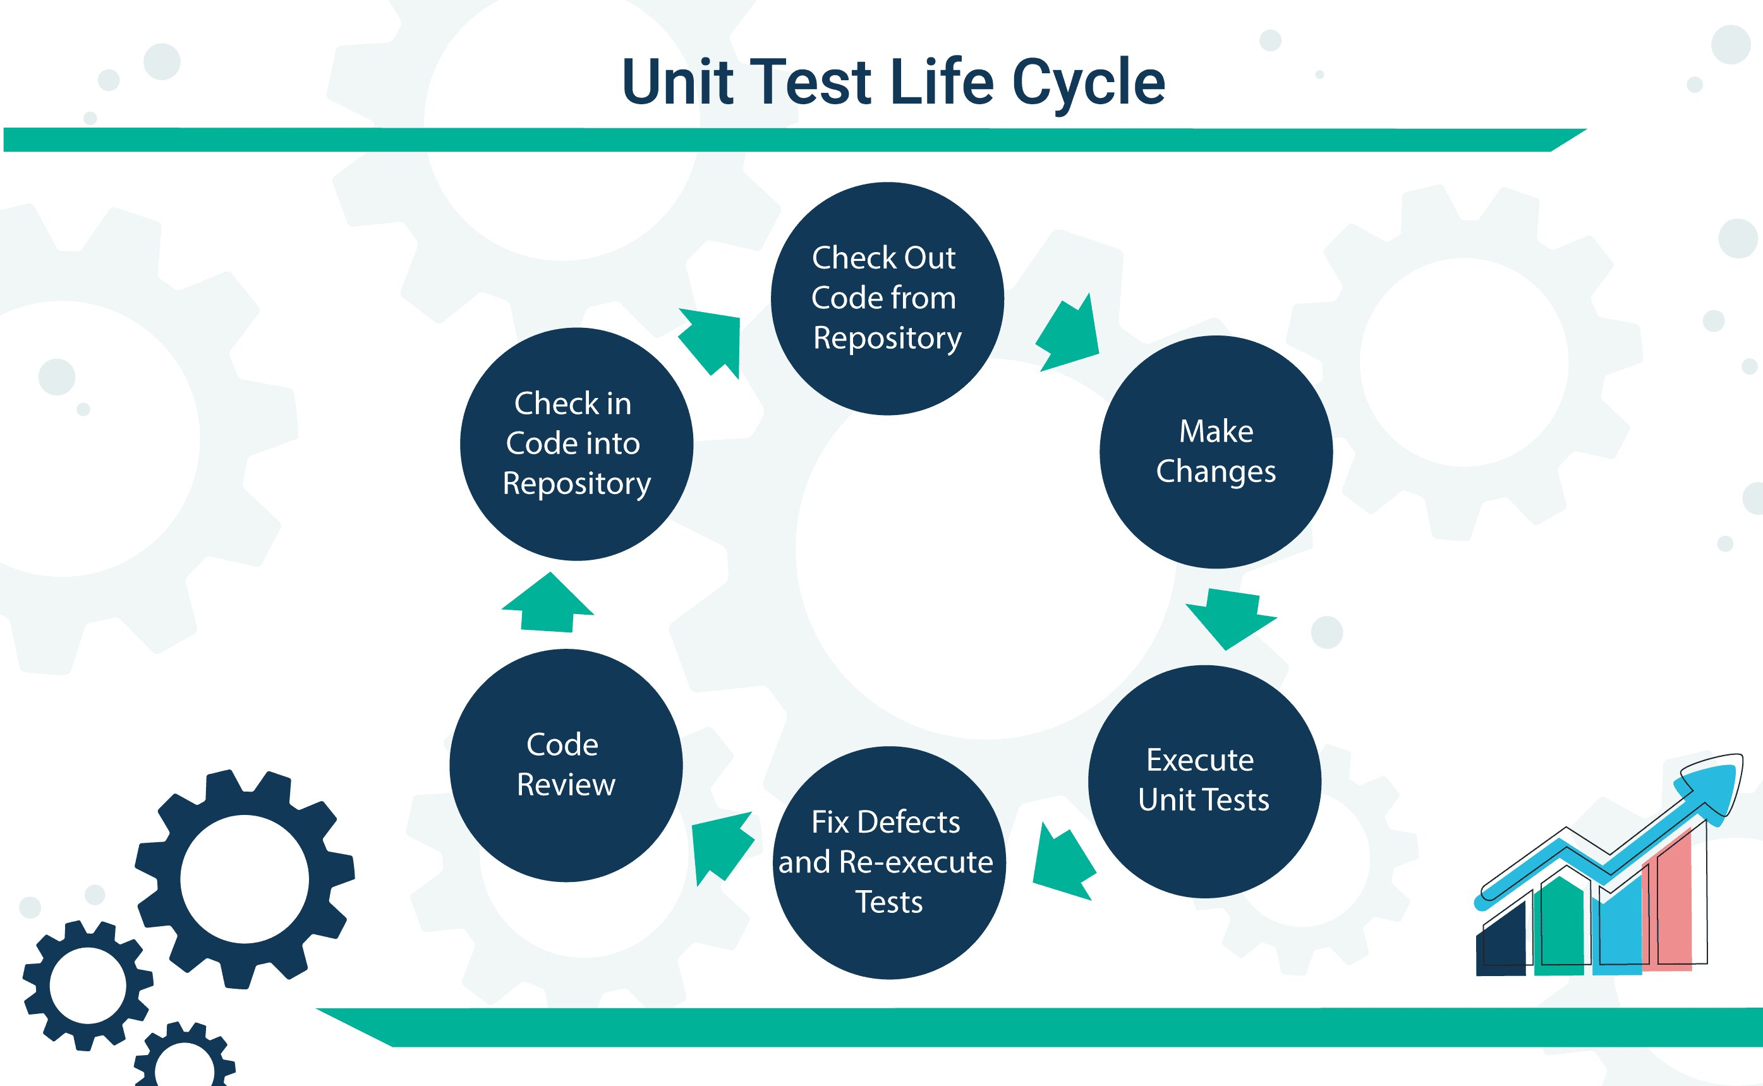

The data used needs to be enough to execute the test. For unit testing, we want to make it as simple as

possible to test the most basic unit of our application. The data could be as simple as making a string

or object variable for which you can control the data. Or a mock framework can be used for the test if a

dependency is not available or you need that dependency to be in a specific state.

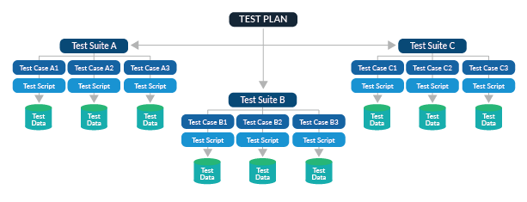

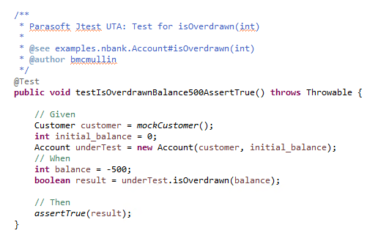

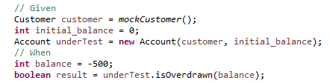

## Module Testing with Execution Plan :

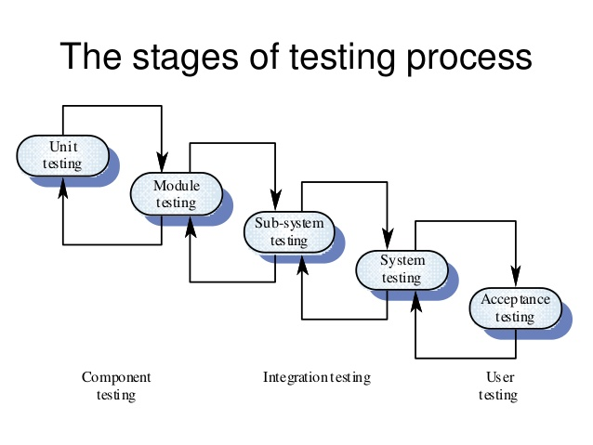

**Test Plan Document**

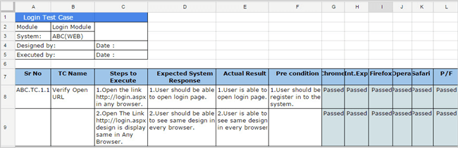

**Functional Testing**

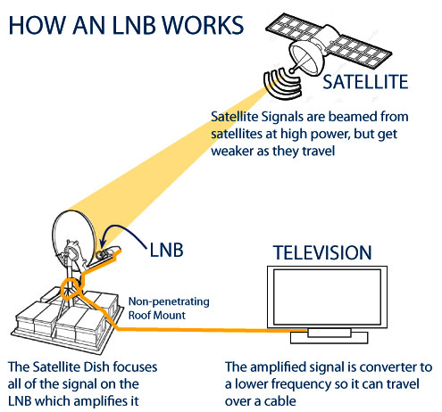

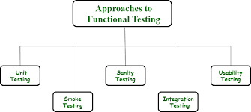

Functional testing is a type of testing that seeks to establish whether each application feature

works as per the software requirements. Each function is compared to the corresponding

requirement to ascertain whether its output is consistent with the end user's expectations .

Functional testing is the process through which QAs determine if a piece of software is

acting in accordance with pre-determined requirements. It uses black-box testing

techniques, in which the tester has no knowledge of the internal system logic.

System testing may be independently design and implemented common problems are sub-system interface mistake in this checking we concentrate on it.

There are saveral categories of tests that a programmer will typically perform on a program unit.

Functional test

Performance test

Stress test

**DEBUGGING**



Debugging is the process of detecting and removing of existing and potential

errors (also called as 'bugs') in a software code that can cause it to behave

unexpectedly or crash. To prevent incorrect operation of a software or system,

debugging is used to find and resolve bugs or defects.

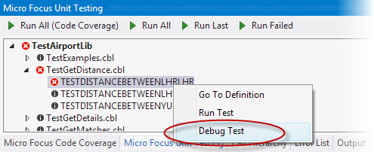

**CHAPTER 8 CONCLUSION & FUTURE SCOPE**

This project is developed to nurture the needs of a user in a banking sector by embedding all the tasks of transactions taking place in a bank. Future version of this project will still be much enhanced than the current version. Writing and depositing checks are perhaps the most fundamental ways to move money in and out of a checking account, but advancements in technology have added ATM and debit card transactions. All banks have rules about how long it takes to access your deposits, how many debit card transactions you're allowed in a day, and how much cash you can withdraw from an ATM. Access to the balance in your checking account can also be limited by businesses that place holds on your funds.

Banks are providing internet banking services also so that the customers can be attracted. By asking the bank employs we came to know that maximum numbers of internet bank account holders are youth and business man. Online banking is an innovative tool that is fast becoming a necessity. It is a successful strategic weapon for banks to remain profitable in a volatile and competitive marketplace of today. If proper training should be given to customer by the bank employs to open an account will be beneficial secondly the website should be made friendlier from where the customers can directly make and access their accounts.

Thus, the EPRS Payment Gateway Management System it is developed and executed successfully

**FUTURE SCOPE**

The “EPRS Payment Gateway Management System is a big and ambitious project. I am thankful for being provided this great opportunity to work on it. **As already mentioned, this project has gone through extensive research work**. On the basis of the research work, we have successfully designed and implemented banking online System. To know what the future of online banking looks like, it’s probably worth looking at the present – online banking isn’t new. When you think of online banking, you probably think about a computer (either a desktop or laptop), a three or four step security process and then an interface that lets you view the balance of your various bank accounts and credit cards, whilst permitting you to

transfer money and pay bills. And you’re not wrong either. The most valuable future looks are following below:

1. More branches of the bank, maybe it will be international, that means more ATM machines outside.
2. Customer issues development based on their needs, so the help desk will be aware of their needs and easy to use.
3. Developing a mobile App for banking system that help users to do the obtained his operations without go to the bank only he needs to sign in using his A/C NO. And password and then use your own PIN. Finally the system will update automatically.

**REFERENCES**

1. [Iztok Fajfar “Start Programming Using HTML,CSS and JavaScript” issue 21 October 2015 Pub. Location New York.](https://www.taylorfrancis.com/chapters/mono/10.1201/b19402-4/content-structure-iztok-fajfar)
2. [Preston Zhang “Practical Guide to Oracle SQL,T-SQL and MySQL” issue 21 November 2017 Pub. Location Boca Raton](https://www.taylorfrancis.com/books/mono/10.1201/9781315101873/practical-guide-oracle-sql-sql-mysql-preston-zhang)
3. [Mitsunori Ogihara “Fundamentals of Java Programming” issue 25 January 2016 Pub.](https://www.springer.com/gp/book/9783319894904)

[Springe,Cham](https://www.springer.com/gp/book/9783319894904)

1. [Richard Wiener “Fundamentals of OOP and Data Structures in Java” issue on June 2012 Pub. Cambridge University Press.](https://www.cambridge.org/core/books/fundamentals-of-oop-and-data-structures-in-java/125A0873C1983BB396D1C328A815986D)
2. [Dr. Geeta Sharma, “Study of Internet Banking Scenario in India”,](https://www.researchgate.net/publication/317037789_Infrastructure_and_its_Impact_on_Digitalization_Process-A_review)  [International Journal of Emerging Research in Management &Technology, ISSN: 2278- 9359, Volume 5, Issue 5, 2016, pp.43-48.](https://www.researchgate.net/publication/317037789_Infrastructure_and_its_Impact_on_Digitalization_Process-A_review)
3. [Anju Dagar, “Online Banking : Benefits and Related Issues”, International Journal of Commerce, Business and Management (IJCBM), ISSN: 2319–2828,Vol. 3, No. 5, 2014, pp.715-719.](https://silo.tips/download/online-banking-benefits-and-related-issues-by-anju-dagar-assistant-professor-ad)
4. [Ebubeogu Amarachukwu Felix, “ Bank Customers Management System”, International Journal of Scientific & Technology Research Volume 4, Issue 08, 2015, pp.326- 343.](https://www.ijemr.net/DOC/BankManagementSystem.PDF)
5. [Mahmood Shah, “E-Banking Management: Issues, Solutions, and Strategies”, 2009. [9]Muhammad Abdus Sattar Titu and Md. Azizur Rahman, “ Online Banking System-Its Application in Some Selected Private Commercial Banks in Bangladesh”, IOSR Journal of Business and Management (IOSR-JBM) e-ISSN: 2278- 487X, Volume 9, Issue 4,2013, pp.37-44.](https://www.semanticscholar.org/paper/E-Banking-Management%3A-Issues%2C-Solutions%2C-and-Shah-Clarke/5a1ea99e0d9b07605a4ddd3b71346b914be09736#related-papers)
6. [Bahman Saeidipour , Hojat Ranjbar and Saeed Ranjbar, “Adoption of Internet banking”, IOSR Journal of Business and Management (IOSR-JBM) e-ISSN: 2278-487X, Volume 11, Issue 2 2013,](https://www.iosrjournals.org/iosr-jbm/papers/Vol11-issue2/G01124651.pdf)
7. [D.Amutha, “A Study of Consumer Awareness towards e- Banking”, Int J Econ Manag Sci, ISSN: 2162-6359, Volume 5, issue 4, 2016,](https://www.researchgate.net/publication/306342149_A_Study_of_Consumer_Awareness_towards_e-Banking)
8. [Sakkthivel, A. M. (2006). Impact of Demographics On The Consumption Of Different Services Online India. Journal of Internet Banking and Commerce, December 2006, Vol. 11, No.3](http://www.theibfr2.com/RePEc/ibf/gjbres/gjbr-v2n1-2008/GJBR-V2N1-2008-4.pdf).
9. [Pikkarainen, T., Pikkarainen, K., Karjaluoto, H., and Pahnila, S. (2004). Consumer acceptance of online banking: An extension of the technology acceptance model. Internet Research, 14(3), 224-235.](https://www.researchgate.net/publication/220146845_Consumer_acceptance_of_online_banking_An_extension_of_the_Technology_Acceptance_Model)
10. [Baldock, R. (1997). The Virtual Bank: Four Marketing Scenarios for the Future. Journal of Financial Service Marketing, 1(3), 260-268.](https://www.ijrdo.org/index.php/bm/article/view/1924)
11. [Chan, L.M. (2001). Is Online Banking Safe, the Star (February), 42](https://www.ijsr.net/archive/v6i11/ART20177850.pdf) [[9359, Volume 5, Issue 5, 2016, pp.43-48.](https://www.ijsr.net/archive/v6i11/ART20177850.pdf)](https://www.researchgate.net/publication/317037789_Infrastructure_and_its_Impact_on_Digitalization_Process-A_review)
12. [[Anju Dagar, “Online Banking : Benefits and Related Issues”, International Journal of Commerce, Business and Management (IJCBM), ISSN: 2319–2828,Vol. 3, No. 5, 2014, pp.715-719.](https://www.ijsr.net/archive/v6i11/ART20177850.pdf)](https://silo.tips/download/online-banking-benefits-and-related-issues-by-anju-dagar-assistant-professor-ad)
13. [[Ebubeogu Amarachukwu Felix, “ Bank Customers Management System”, International Journal of Scientific & Technology Research Volume 4, Issue 08, 2015, pp.326- 343.](https://www.ijsr.net/archive/v6i11/ART20177850.pdf)](https://www.ijemr.net/DOC/BankManagementSystem.PDF)
14. [[Mahmood Shah, “E-Banking Management: Issues, Solutions, and Strategies”, 2009. [9]Muhammad Abdus Sattar Titu and Md. Azizur Rahman, “ Online Banking System-Its Application in Some Selected Private Commercial Banks in Bangladesh”, IOSR Journal of Business and Management (IOSR-JBM) e-ISSN: 2278- 487X, Volume 9, Issue 4,2013, pp.37-44.](https://www.ijsr.net/archive/v6i11/ART20177850.pdf)](https://www.semanticscholar.org/paper/E-Banking-Management%3A-Issues%2C-Solutions%2C-and-Shah-Clarke/5a1ea99e0d9b07605a4ddd3b71346b914be09736#related-papers)
15. [[Bahman Saeidipour , Hojat Ranjbar and Saeed Ranjbar, “Adoption of Internet banking”, IOSR Journal of Business and Management (IOSR-JBM) e-ISSN: 2278-487X, Volume 11, Issue 2 2013,](https://www.ijsr.net/archive/v6i11/ART20177850.pdf)](https://www.iosrjournals.org/iosr-jbm/papers/Vol11-issue2/G01124651.pdf)
16. [[D.Amutha, “A Study of Consumer Awareness towards e- Banking”, Int J Econ Manag Sci, ISSN: 2162-6359, Volume 5, issue 4, 2016,](https://www.ijsr.net/archive/v6i11/ART20177850.pdf)](https://www.researchgate.net/publication/306342149_A_Study_of_Consumer_Awareness_towards_e-Banking)
17. [[Sakkthivel, A. M. (2006). Impact of Demographics On The Consumption Of Different Services Online India. Journal of Internet Banking and Commerce, December 2006, Vol. 11, No.3](https://www.ijsr.net/archive/v6i11/ART20177850.pdf)](http://www.theibfr2.com/RePEc/ibf/gjbres/gjbr-v2n1-2008/GJBR-V2N1-2008-4.pdf)[.](https://www.ijsr.net/archive/v6i11/ART20177850.pdf)
18. [[Pikkarainen, T., Pikkarainen, K., Karjaluoto, H., and Pahnila, S. (2004). Consumer acceptance of online banking: An extension of the technology acceptance model. Internet Research, 14(3), 224-235.](https://www.ijsr.net/archive/v6i11/ART20177850.pdf)](https://www.researchgate.net/publication/220146845_Consumer_acceptance_of_online_banking_An_extension_of_the_Technology_Acceptance_Model)
19. [[Baldock, R. (1997). The Virtual Bank: Four Marketing Scenarios for the Future. Journal of Financial Service Marketing, 1(3), 260-268.](https://www.ijsr.net/archive/v6i11/ART20177850.pdf)](https://www.ijrdo.org/index.php/bm/article/view/1924)
20. [Chan, L.M. (2001). Is Online Banking Safe, the Star (February), 42](https://www.ijsr.net/archive/v6i11/ART20177850.pdf) [[9359, Volume 5, Issue 5, 2016, pp.43-48.](https://www.ijsr.net/archive/v6i11/ART20177850.pdf)](https://www.researchgate.net/publication/317037789_Infrastructure_and_its_Impact_on_Digitalization_Process-A_review)
21. [[Anju Dagar, “Online Banking : Benefits and Related Issues”, International Journal of Commerce, Business and Management (IJCBM), ISSN: 2319–2828,Vol. 3, No. 5, 2014, pp.715-719.](https://www.ijsr.net/archive/v6i11/ART20177850.pdf)](https://silo.tips/download/online-banking-benefits-and-related-issues-by-anju-dagar-assistant-professor-ad)
22. [[Ebubeogu Amarachukwu Felix, “ Bank Customers Management System”, International Journal of Scientific & Technology Research Volume 4, Issue 08, 2015, pp.326- 343.](https://www.ijsr.net/archive/v6i11/ART20177850.pdf)](https://www.ijemr.net/DOC/BankManagementSystem.PDF)
23. [[Mahmood Shah, “E-Banking Management: Issues, Solutions, and Strategies”, 2009. [9]Muhammad Abdus Sattar Titu and Md. Azizur Rahman, “ Online Banking System-Its Application in Some Selected Private Commercial Banks in Bangladesh”, IOSR Journal of Business and Management (IOSR-JBM) e-ISSN: 2278- 487X, Volume 9, Issue 4,2013, pp.37-44.](https://www.ijsr.net/archive/v6i11/ART20177850.pdf)](https://www.semanticscholar.org/paper/E-Banking-Management%3A-Issues%2C-Solutions%2C-and-Shah-Clarke/5a1ea99e0d9b07605a4ddd3b71346b914be09736#related-papers)
24. [[Bahman Saeidipour , Hojat Ranjbar and Saeed Ranjbar, “Adoption of Internet banking”, IOSR Journal of Business and Management (IOSR-JBM) e-ISSN: 2278-487X, Volume 11, Issue 2 2013,](https://www.ijsr.net/archive/v6i11/ART20177850.pdf)](https://www.iosrjournals.org/iosr-jbm/papers/Vol11-issue2/G01124651.pdf)
25. [[D.Amutha, “A Study of Consumer Awareness towards e- Banking”, Int J Econ Manag Sci, ISSN: 2162-6359, Volume 5, issue 4, 2016,](https://www.ijsr.net/archive/v6i11/ART20177850.pdf)](https://www.researchgate.net/publication/306342149_A_Study_of_Consumer_Awareness_towards_e-Banking)
26. [[Sakkthivel, A. M. (2006). Impact of Demographics On The Consumption Of Different Services Online India. Journal of Internet Banking and Commerce, December 2006, Vol. 11, No.3](https://www.ijsr.net/archive/v6i11/ART20177850.pdf)](http://www.theibfr2.com/RePEc/ibf/gjbres/gjbr-v2n1-2008/GJBR-V2N1-2008-4.pdf)[.](https://www.ijsr.net/archive/v6i11/ART20177850.pdf)
27. [[Pikkarainen, T., Pikkarainen, K., Karjaluoto, H., and Pahnila, S. (2004). Consumer acceptance of online banking: An extension of the technology acceptance model. Internet Research, 14(3), 224-235.](https://www.ijsr.net/archive/v6i11/ART20177850.pdf)](https://www.researchgate.net/publication/220146845_Consumer_acceptance_of_online_banking_An_extension_of_the_Technology_Acceptance_Model)
28. [[Baldock, R. (1997). The Virtual Bank: Four Marketing Scenarios for the Future. Journal of Financial Service Marketing, 1(3), 260-268.](https://www.ijsr.net/archive/v6i11/ART20177850.pdf)](https://www.ijrdo.org/index.php/bm/article/view/1924)
29. [Chan, L.M. (2001). Is Online Banking Safe, the Star (February), 42](https://www.ijsr.net/archive/v6i11/ART20177850.pdf) [[9359, Volume 5, Issue 5, 2016, pp.43-48.](https://www.ijsr.net/archive/v6i11/ART20177850.pdf)](https://www.researchgate.net/publication/317037789_Infrastructure_and_its_Impact_on_Digitalization_Process-A_review)
30. [[Anju Dagar, “Online Banking : Benefits and Related Issues”, International Journal of Commerce, Business and Management (IJCBM), ISSN: 2319–2828,Vol. 3, No. 5, 2014, pp.715-719.](https://www.ijsr.net/archive/v6i11/ART20177850.pdf)](https://silo.tips/download/online-banking-benefits-and-related-issues-by-anju-dagar-assistant-professor-ad)
31. [[Ebubeogu Amarachukwu Felix, “ Bank Customers Management System”, International Journal of Scientific & Technology Research Volume 4, Issue 08, 2015, pp.326- 343.](https://www.ijsr.net/archive/v6i11/ART20177850.pdf)](https://www.ijemr.net/DOC/BankManagementSystem.PDF)
32. [[Mahmood Shah, “E-Banking Management: Issues, Solutions, and Strategies”, 2009. [9]Muhammad Abdus Sattar Titu and Md. Azizur Rahman, “ Online Banking System-Its Application in Some Selected Private Commercial Banks in Bangladesh”, IOSR Journal of Business and Management (IOSR-JBM) e-ISSN: 2278- 487X, Volume 9, Issue 4,2013, pp.37-44.](https://www.ijsr.net/archive/v6i11/ART20177850.pdf)](https://www.semanticscholar.org/paper/E-Banking-Management%3A-Issues%2C-Solutions%2C-and-Shah-Clarke/5a1ea99e0d9b07605a4ddd3b71346b914be09736#related-papers)
33. [[Bahman Saeidipour , Hojat Ranjbar and Saeed Ranjbar, “Adoption of Internet banking”, IOSR Journal of Business and Management (IOSR-JBM) e-ISSN: 2278-487X, Volume 11, Issue 2 2013,](https://www.ijsr.net/archive/v6i11/ART20177850.pdf)](https://www.iosrjournals.org/iosr-jbm/papers/Vol11-issue2/G01124651.pdf)
34. [[D.Amutha, “A Study of Consumer Awareness towards e- Banking”, Int J Econ Manag Sci, ISSN: 2162-6359, Volume 5, issue 4, 2016,](https://www.ijsr.net/archive/v6i11/ART20177850.pdf)](https://www.researchgate.net/publication/306342149_A_Study_of_Consumer_Awareness_towards_e-Banking)
35. [[Sakkthivel, A. M. (2006). Impact of Demographics On The Consumption Of Different Services Online India. Journal of Internet Banking and Commerce, December 2006, Vol. 11, No.3](https://www.ijsr.net/archive/v6i11/ART20177850.pdf)](http://www.theibfr2.com/RePEc/ibf/gjbres/gjbr-v2n1-2008/GJBR-V2N1-2008-4.pdf)[.](https://www.ijsr.net/archive/v6i11/ART20177850.pdf)
36. [[Pikkarainen, T., Pikkarainen, K., Karjaluoto, H., and Pahnila, S. (2004). Consumer acceptance of online banking: An extension of the technology acceptance model. Internet Research, 14(3), 224-235.](https://www.ijsr.net/archive/v6i11/ART20177850.pdf)](https://www.researchgate.net/publication/220146845_Consumer_acceptance_of_online_banking_An_extension_of_the_Technology_Acceptance_Model)
37. [[Baldock, R. (1997). The Virtual Bank: Four Marketing Scenarios for the Future. Journal of Financial Service Marketing, 1(3), 260-268.](https://www.ijsr.net/archive/v6i11/ART20177850.pdf)](https://www.ijrdo.org/index.php/bm/article/view/1924)
38. [[Chan, L.M. (2001). Is Online Banking Safe, the Star (February), 42](https://www.ijsr.net/archive/v6i11/ART20177850.pdf)](https://www.ijsr.net/archive/v6i11/ART20177850.pdf)
39. [Sakkthivel, A. M. (2006). Impact of Demographics On The Consumption Of Different Services Online India. Journal of Internet Banking and Commerce, December 2006, Vol. 11, No.3](http://www.theibfr2.com/RePEc/ibf/gjbres/gjbr-v2n1-2008/GJBR-V2N1-2008-4.pdf).
40. [Pikkarainen, T., Pikkarainen, K., Karjaluoto, H., and Pahnila, S. (2004). Consumer acceptance of online banking: An extension of the technology acceptance model. Internet Research, 14(3), 224-235.](https://www.researchgate.net/publication/220146845_Consumer_acceptance_of_online_banking_An_extension_of_the_Technology_Acceptance_Model)
41. [Baldock, R. (1997). The Virtual Bank: Four Marketing Scenarios for the Future. Journal of Financial Service Marketing, 1(3), 260-26](https://www.ijrdo.org/index.php/bm/article/view/1924)[Chan, L.M. (2001). Is Online Banking Safe, the Star (February), 42](https://www.ijsr.net/archive/v6i11/ART20177850.pdf) [[9359, Volume 5, Issue 5, 2016, pp.43-48.](https://www.ijsr.net/archive/v6i11/ART20177850.pdf)](https://www.researchgate.net/publication/317037789_Infrastructure_and_its_Impact_on_Digitalization_Process-A_review)
42. [[Anju Dagar, “Online Banking : Benefits and Related Issues”, International Journal of Commerce, Business and Management (IJCBM), ISSN: 2319–2828,Vol. 3, No. 5, 2014, pp.715-719.](https://www.ijsr.net/archive/v6i11/ART20177850.pdf)](https://silo.tips/download/online-banking-benefits-and-related-issues-by-anju-dagar-assistant-professor-ad)
43. [[Ebubeogu Amarachukwu Felix, “ Bank Customers Management System”, International Journal of Scientific & Technology Research Volume 4, Issue 08, 2015, pp.326- 343.](https://www.ijsr.net/archive/v6i11/ART20177850.pdf)](https://www.ijemr.net/DOC/BankManagementSystem.PDF)
44. [[Mahmood Shah, “E-Banking Management: Issues, Solutions, and Strategies”, 2009. [9]Muhammad Abdus Sattar Titu and Md. Azizur Rahman, “ Online Banking System-Its Application in Some Selected Private Commercial Banks in Bangladesh”, IOSR Journal of Business and Management (IOSR-JBM) e-ISSN: 2278- 487X, Volume 9, Issue 4,2013, pp.37-44.](https://www.ijsr.net/archive/v6i11/ART20177850.pdf)](https://www.semanticscholar.org/paper/E-Banking-Management%3A-Issues%2C-Solutions%2C-and-Shah-Clarke/5a1ea99e0d9b07605a4ddd3b71346b914be09736#related-papers)
45. [[Bahman Saeidipour , Hojat Ranjbar and Saeed Ranjbar, “Adoption of Internet banking”, IOSR Journal of Business and Management (IOSR-JBM) e-ISSN: 2278-487X, Volume 11, Issue 2 2013,](https://www.ijsr.net/archive/v6i11/ART20177850.pdf)](https://www.iosrjournals.org/iosr-jbm/papers/Vol11-issue2/G01124651.pdf)
46. [[D.Amutha, “A Study of Consumer Awareness towards e- Banking”, Int J Econ Manag Sci, ISSN: 2162-6359, Volume 5, issue 4, 2016,](https://www.ijsr.net/archive/v6i11/ART20177850.pdf)](https://www.researchgate.net/publication/306342149_A_Study_of_Consumer_Awareness_towards_e-Banking)
47. [[Sakkthivel, A. M. (2006). Impact of Demographics On The Consumption Of Different Services Online India. Journal of Internet Banking and Commerce, December 2006, Vol. 11, No.3](https://www.ijsr.net/archive/v6i11/ART20177850.pdf)](http://www.theibfr2.com/RePEc/ibf/gjbres/gjbr-v2n1-2008/GJBR-V2N1-2008-4.pdf)[.](https://www.ijsr.net/archive/v6i11/ART20177850.pdf)
48. [[Pikkarainen, T., Pikkarainen, K., Karjaluoto, H., and Pahnila, S. (2004). Consumer acceptance of online banking: An extension of the technology acceptance model. Internet Research, 14(3), 224-235.](https://www.ijsr.net/archive/v6i11/ART20177850.pdf)](https://www.researchgate.net/publication/220146845_Consumer_acceptance_of_online_banking_An_extension_of_the_Technology_Acceptance_Model)
49. [[Baldock, R. (1997). The Virtual Bank: Four Marketing Scenarios for the Future. Journal of Financial Service Marketing, 1(3), 260-268.](https://www.ijsr.net/archive/v6i11/ART20177850.pdf)](https://www.ijrdo.org/index.php/bm/article/view/1924)
50. [Chan, L.M. (2001). Is Online Banking Safe, the Star (February), 42](https://www.ijsr.net/archive/v6i11/ART20177850.pdf) [[9359, Volume 5, Issue 5, 2016, pp.43-48.](https://www.ijsr.net/archive/v6i11/ART20177850.pdf)](https://www.researchgate.net/publication/317037789_Infrastructure_and_its_Impact_on_Digitalization_Process-A_review)
51. [[Anju Dagar, “Online Banking : Benefits and Related Issues”, International Journal of Commerce, Business and Management (IJCBM), ISSN: 2319–2828,Vol. 3, No. 5, 2014, pp.715-719.](https://www.ijsr.net/archive/v6i11/ART20177850.pdf)](https://silo.tips/download/online-banking-benefits-and-related-issues-by-anju-dagar-assistant-professor-ad)
52. [[Ebubeogu Amarachukwu Felix, “ Bank Customers Management System”, International Journal of Scientific & Technology Research Volume 4, Issue 08, 2015, pp.326- 343.](https://www.ijsr.net/archive/v6i11/ART20177850.pdf)](https://www.ijemr.net/DOC/BankManagementSystem.PDF)
53. [[Mahmood Shah, “E-Banking Management: Issues, Solutions, and Strategies”, 2009. [9]Muhammad Abdus Sattar Titu and Md. Azizur Rahman, “ Online Banking System-Its Application in Some Selected Private Commercial Banks in Bangladesh”, IOSR Journal of Business and Management (IOSR-JBM) e-ISSN: 2278- 487X, Volume 9, Issue 4,2013, pp.37-44.](https://www.ijsr.net/archive/v6i11/ART20177850.pdf)](https://www.semanticscholar.org/paper/E-Banking-Management%3A-Issues%2C-Solutions%2C-and-Shah-Clarke/5a1ea99e0d9b07605a4ddd3b71346b914be09736#related-papers)
54. [[Bahman Saeidipour , Hojat Ranjbar and Saeed Ranjbar, “Adoption of Internet banking”, IOSR Journal of Business and Management (IOSR-JBM) e-ISSN: 2278-487X, Volume 11, Issue 2 2013,](https://www.ijsr.net/archive/v6i11/ART20177850.pdf)](https://www.iosrjournals.org/iosr-jbm/papers/Vol11-issue2/G01124651.pdf)
55. [[D.Amutha, “A Study of Consumer Awareness towards e- Banking”, Int J Econ Manag Sci, ISSN: 2162-6359, Volume 5, issue 4, 2016,](https://www.ijsr.net/archive/v6i11/ART20177850.pdf)](https://www.researchgate.net/publication/306342149_A_Study_of_Consumer_Awareness_towards_e-Banking)
56. [[Sakkthivel, A. M. (2006). Impact of Demographics On The Consumption Of Different Services Online India. Journal of Internet Banking and Commerce, December 2006, Vol. 11, No.3](https://www.ijsr.net/archive/v6i11/ART20177850.pdf)](http://www.theibfr2.com/RePEc/ibf/gjbres/gjbr-v2n1-2008/GJBR-V2N1-2008-4.pdf)[.](https://www.ijsr.net/archive/v6i11/ART20177850.pdf)
57. [[Pikkarainen, T., Pikkarainen, K., Karjaluoto, H., and Pahnila, S. (2004). Consumer acceptance of online banking: An extension of the technology acceptance model. Internet Research, 14(3), 224-235.](https://www.ijsr.net/archive/v6i11/ART20177850.pdf)](https://www.researchgate.net/publication/220146845_Consumer_acceptance_of_online_banking_An_extension_of_the_Technology_Acceptance_Model)
58. [[Baldock, R. (1997). The Virtual Bank: Four Marketing Scenarios for the Future. Journal of Financial Service Marketing, 1(3), 260-268.](https://www.ijsr.net/archive/v6i11/ART20177850.pdf)](https://www.ijrdo.org/index.php/bm/article/view/1924)
59. [Chan, L.M. (2001). Is Online Banking Safe, the Star (February), 42](https://www.ijsr.net/archive/v6i11/ART20177850.pdf) [[9359, Volume 5, Issue 5, 2016, pp.43-48.](https://www.ijsr.net/archive/v6i11/ART20177850.pdf)](https://www.researchgate.net/publication/317037789_Infrastructure_and_its_Impact_on_Digitalization_Process-A_review)
60. [[Anju Dagar, “Online Banking : Benefits and Related Issues”, International Journal of Commerce, Business and Management (IJCBM), ISSN: 2319–2828,Vol. 3, No. 5, 2014, pp.715-719.](https://www.ijsr.net/archive/v6i11/ART20177850.pdf)](https://silo.tips/download/online-banking-benefits-and-related-issues-by-anju-dagar-assistant-professor-ad)
61. [[Ebubeogu Amarachukwu Felix, “ Bank Customers Management System”, International Journal of Scientific & Technology Research Volume 4, Issue 08, 2015, pp.326- 343.](https://www.ijsr.net/archive/v6i11/ART20177850.pdf)](https://www.ijemr.net/DOC/BankManagementSystem.PDF)
62. [[Mahmood Shah, “E-Banking Management: Issues, Solutions, and Strategies”, 2009. [9]Muhammad Abdus Sattar Titu and Md. Azizur Rahman, “ Online Banking System-Its Application in Some Selected Private Commercial Banks in Bangladesh”, IOSR Journal of Business and Management (IOSR-JBM) e-ISSN: 2278- 487X, Volume 9, Issue 4,2013, pp.37-44.](https://www.ijsr.net/archive/v6i11/ART20177850.pdf)](https://www.semanticscholar.org/paper/E-Banking-Management%3A-Issues%2C-Solutions%2C-and-Shah-Clarke/5a1ea99e0d9b07605a4ddd3b71346b914be09736#related-papers)
63. [[Bahman Saeidipour , Hojat Ranjbar and Saeed Ranjbar, “Adoption of Internet banking”, IOSR Journal of Business and Management (IOSR-JBM) e-ISSN: 2278-487X, Volume 11, Issue 2 2013,](https://www.ijsr.net/archive/v6i11/ART20177850.pdf)](https://www.iosrjournals.org/iosr-jbm/papers/Vol11-issue2/G01124651.pdf)
64. [[D.Amutha, “A Study of Consumer Awareness towards e- Banking”, Int J Econ Manag Sci, ISSN: 2162-6359, Volume 5, issue 4, 2016,](https://www.ijsr.net/archive/v6i11/ART20177850.pdf)](https://www.researchgate.net/publication/306342149_A_Study_of_Consumer_Awareness_towards_e-Banking)
65. [[Sakkthivel, A. M. (2006). Impact of Demographics On The Consumption Of Different Services Online India. Journal of Internet Banking and Commerce, December 2006, Vol. 11, No.3](https://www.ijsr.net/archive/v6i11/ART20177850.pdf)](http://www.theibfr2.com/RePEc/ibf/gjbres/gjbr-v2n1-2008/GJBR-V2N1-2008-4.pdf)[.](https://www.ijsr.net/archive/v6i11/ART20177850.pdf)
66. [[Pikkarainen, T., Pikkarainen, K., Karjaluoto, H., and Pahnila, S. (2004). Consumer acceptance of online banking: An extension of the technology acceptance model. Internet Research, 14(3), 224-235.](https://www.ijsr.net/archive/v6i11/ART20177850.pdf)](https://www.researchgate.net/publication/220146845_Consumer_acceptance_of_online_banking_An_extension_of_the_Technology_Acceptance_Model)
67. [[Baldock, R. (1997). The Virtual Bank: Four Marketing Scenarios for the Future. Journal of Financial Service Marketing, 1(3), 260-268.](https://www.ijsr.net/archive/v6i11/ART20177850.pdf)](https://www.ijrdo.org/index.php/bm/article/view/1924)
68. [[Chan, L.M. (2001). Is Online Banking Safe, the Star (February), 42](https://www.ijsr.net/archive/v6i11/ART20177850.pdf)](https://www.ijsr.net/archive/v6i11/ART20177850.pdf)

[[Sakkthivel, A. M. (2006). Impact of Demographics On The Consumption Of Different Services Online India. Journal of Internet Banking and Commerce, December 2006, Vol. 11, No.3](https://www.ijrdo.org/index.php/bm/article/view/1924)](http://www.theibfr2.com/RePEc/ibf/gjbres/gjbr-v2n1-2008/GJBR-V2N1-2008-4.pdf).

Github Repositary Link :

<https://github.com/shubhamvishnoi3288/Industrial_Project>

