eBilling and Invoice System
A Project Report Submitted
In partial fulfillment of the Requirements
for the Degree of

MASTER OF COMPUTER APPLICATION
by

DIVYANSH PANDEY
University Roll No 1900290140014

Under the Supervision of
Prof. Neelam Rawat
Assistant Professor
KIET Group of Institutions, Delhi -NCR, Ghaziabad



to the
Faculty of Master Of Computer Application
DR. APJ ABDUL KALAM TECHNICAL UNIVERSITY
LUCKNOW
(Formerly Uttar Pradesh Technical University, Lucknow)
June, 2022

Certificate

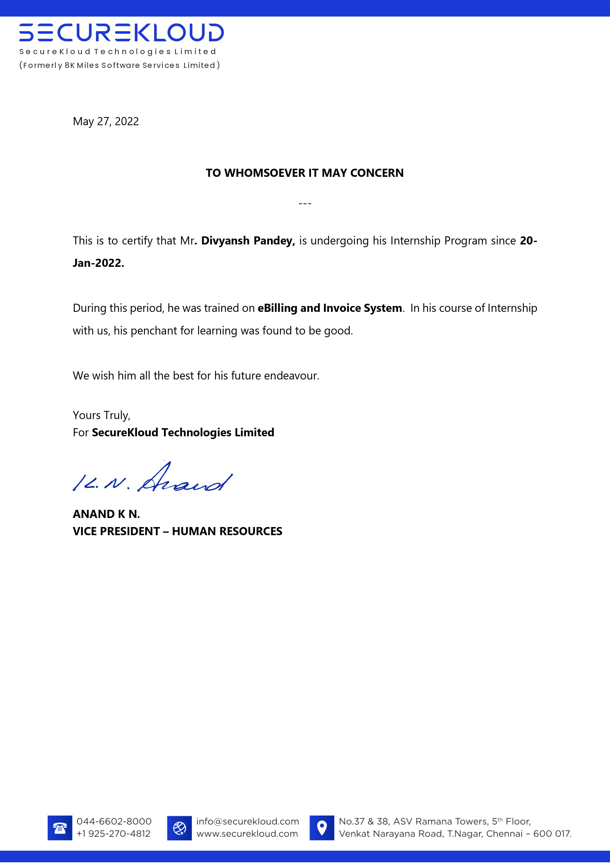

Declaration

I hereby declare that The Project entitled eBilling and Invoice System is an outcome of my own efforts under the guidance of Prof. Neelam Rawat. The project is submitted to the department of MCA. For the partial fulfilment of Master of Computer Application 2019-22.
I also declare that project report is not submitted in any of the university previously.
Date: 26-May-2022
Place: Ghaziabad

Abstract

This project deals with the design of Internet billing system, in which it is possible pay invoices electronically. This approach is implemented via virtual banks, in which the process of money transfer can be implemented. In other hand many applications can be realize such as; deposit e-money, withdrawal e-money and determine account balance. A Gate way translator is used to apply authentication rules, security and privacy. The client uses MS Excel, and maintains their product list, customer list, and prints the invoice, however it is not possible them to share the data from multiple system in multi user environment, there is lot of duplicate work, and chance of mistake. When the product price is changed, they need to update each and every excel file. There is no option to find and print previous saved invoice. There is no security; anybody can access any report and sensitive data, also no reports to find out the sales volume, stock list, and summary report. This E-Billing and invoicing system is used to overcome the entire problem which they are facing currently, and making complete atomization of manual billing and invoicing system.

ACKNOWLEDGEMENTS

Success in life is never attained single handedly. My deepest gratitude goes to my team leader at The SecureKloud for his guidance, help and encouragement throughout my work. Their enlightening ideas, comments, and suggestions. Words are not enough to express my gratitude to Dr. Ajay Kumar Shrivastava, Professor and Head, Department of Computer Applications and all the faculties for his insightful comments and administrative help at various occasions.
Fortunately, I have many understanding friends, who have helped me a lot on many critical conditions.
Finally, my sincere thanks go to my family members and all those who have directly and indirectly provided me moral support and other kind of help. Without their support, completion of this work would not have been possible in time. They keep my life filled with enjoyment and happiness.

Table of Contents
Certificate 2
Declaration 3
Abstract 4
ACKNOWLEDGEMENTS 5
1.1Project Description 11
LITERATURE REVIEW 12
2.1 Technology Used 13
Back-end: Firebase 13
2.2 Language Used 14
SOFTWARE REQUIREMENT SPECIFICATION 15
SYSTEM OBJECTIVE 16
User Profiles 17
Usage Summary 18
Requirements Summary 19
Business Requirements 19
User Requirements 20
Operational Requirements 22
System Requirements 22
Success Criteria 23
Sales Automation 23
Design Goals and Constraints 24
Performance 24
Availability 24
Reliability 24
Scalability 24
Security 24
Interoperability 25
Location 25
Setup/Installation 25
Use Case Summary 25
Manage Orders 25
Description 25
Business Need 26
Priority 26
Manage Products 26
Description 26
Business Need 26
Priority 26
Manage Contacts 26
Description 27
Business Need 27
Priority 27
Analyze Customers 27
Description 27
Business Need 27
Priority 27
Forecast Sales 27
Description 28
Business Need 28
Priority 28
Establish Sales Goals 28
Description 28
Business Need 28
Priority 28
Use Case ID: UC 4.7.1 Retrieve Customer Data 29
Intent 29
Scenario Narrative 29
Assumptions/Preconditions 29
Actors 29
Basic Course 29
Alternate Course 30
Uses/Extends 30
User Implementation Requests 30
Frequency 30
Authority 30
Associated Specifications 30
Issues 30
Decision Points 30
Future Requirements 31
Modification 31
Use Case Model: Retrieve Customer Data 32
Use Case Manage order 33
Use Case ID: UC 04.7.3 Manage Contacts 34
Intent 34
Scenario Narrative 34
Assumptions/Preconditions 34
Actors 34
Uses/Extends 35
User Implementation Requests 35
Frequency 35
Authority 35
Associated Specifications 35
Issues 35
Decision Points 35
Future Requirements 36
Modification 36
Solution Architecture 37
Infrastructure 37
Visual Design 37
Conceptual Design 37
Physical Design 40
eBilling and Invoice System Physical Object Model 40
Add new product to product master sequence diagram 41
eBilling and Invoice System Data Dictionary 42
Table: product master 42
Table: bill 43
Table: bill details 45
Table: Company master 46
Table: user master 47
eBilling and Invoice System – Data Schema ER Diagram 49
eBilling and Invoice System DFD (Data Flow Diagram) 50
Form Design and Coding 51
FrmSplash 51
FrmLogin 53
FrmProducts 54
FrmReports 56
FrmPrintBill 56
Product Summary Report 58
FrmBillSummary 59
FrmUtlity 62
FrmCompactAndRepairDatabase 62
ModBrowse 67
ModRsToWord 67
eBilling and Invoice System Test Plan 68
Introduction 68
Test Scope 68
Test Strategy 69
Preconditions 70
Test Priorities 71
Test Techniques 71
Test Organization 72
Roles and Responsibilities 72
Uses and benefits of e-billing 73
Tips for choosing e-billing software 74
Waterfall Model 76
RAD Model 77
Spiral Model 77
V-Model 78
Incremental Model 78
Agile Model 78
Iterative Model 79
Big bang model 79
Prototype Model 79
Conclusion and future enhancement 80
Bibliography 81

Chapter 1
Introduction

Project Description

This project deals with the design of Internet billing system, in which it is possible pay invoices electronically. This approach is implemented via virtual banks, in which the process of money transfer can be implemented. In other hand many applications can be realize such as; deposit e-money, withdrawal e-money and determine account balance. A Gate way translator is used to apply authentication rules, security and privacy.

The client uses MS Excel, and maintains their product list, customer list, and prints the invoice, however it is not possible them to share the data from multiple system in multi user environment, there is lot of duplicate work, and chance of mistake. When the product price is changed, they need to update each and every excel file.

Chapter 2

LITERATURE REVIEW

E-payment system is increasingly becoming a daring means of payments in today’s business world. This is due to its efficiency, convenience and timeliness. It is a payment system that is continuously being embraced and adopted in the financial system of both developed and developing countries with a view to simplify and ease payments in business transactions. As a result, many studies were conducted around the globe by scholars on e-payment adoption. It is based on this that this research paper looks at the available past literature on e-payment adoption across the world, with a view to highlight the scope, methodology and Information System (IS) models used by previous researchers so as to identify research gaps and recommend such for future studies. The study employed an extensive literature search on e-payment adoption with the aid of Google Scholar for those recent studies between the years 2010-2015. To facilitate the understanding of the issue under study, previous studies were analysed based on scope-geographical location of the study, theories/models adopted and methodology used. Finally, the paper has identified the patterns of previous researches with regards to these three items and further highlights and recommends key areas in which future research should delve on.

Chapter 3

PROJECT CATEGORY

2.1 Technology Used

Android Studio

Android Studio is the official Integrated Development Environment (IDE) for Android app development, based on IntelliJ IDEA . On top of IntelliJ's powerful code editor and developer tools, Android Studio offers even more features that enhance your productivity when building Android apps.
SoftWare and Applications Used
APPLICATION : Android Studio
OPERATING SYSTEM : WINDOWS 10
FRONT END : JAVA, Xml
BACK END : Firebase

Back-end: Firebase
- Firebase: - It is real-time database developed by firebase and then acquired by Google in 2014 used for developing the high-quality applications act as a storage of information of various data.

2.2 Language Used
This project has been developed XML and Java.
- XML: XML stands for extensible markup language. A markup language is a set of codes, or tags, that describes the text in a digital document. The most famous markup language is hypertext markup language (HTML), which is used to format Web pages.
- JAVA: Java is an object-oriented programming language developed by Sun Microsystems, and it was released in 1995.
James Gosling initially developed Java in Sun Microsystems (which was later merged with Oracle Corporation).
Java is a set of features of C and C++. It has obtained its format from C, and OOP features from C++.
Java programs are platform independent which means they can be run on any operating system with any processor as long as the Java interpreter is available on that system.
Java code that runs on one platform does not need to be recompiled to run on another platform; it's called write once, run anywhere (WORA)

Chapter 3

SOFTWARE REQUIREMENT SPECIFICATION

3.1 GENERAL DESCRIPTION

3.1.1 PRODUCT DESCRIPTION:

This project deals with the design of Internet billing system, in which it is possible pay invoices electronically. This approach is implemented via virtual banks, in which the process of money transfer can be implemented. In other hand many applications can be realize such as; deposit e-money, withdrawal e-money and determine account balance.

3.1.2 PROBLEM STATEMENT:

The problem occurred before having computerized system includes:
There is no option to find and print previous saved invoice. There is no security; anybody can access any report and sensitive data, also no reports to find out the sales volume, stock list, and summary report. This E-Billing and invoicing system is used to overcome the entire problem which they are facing currently, and making complete atomization of manual billing and invoicing system.

SYSTEM OBJECTIVE

This project is made for one of the big decorator services in Mumbai, they supply decorating item to film industry for movie shooting. Presently they issue their client handwritten invoice and they enter details in manual register. And maintain MS Excel file for product rate. They want computerization of their manual invoice and bill generation process.
The client uses MS Excel, and maintains their product list, customer list, and prints the invoice, however it is not possible them to share the data from multiple system in multi user environment, there is lot of duplicate work, and chance of mistake. When the product price is changed, they need to update each and every excel file. There is no option to find and print previous saved invoice.
There is no security; anybody can access any report and sensitive data, also no reports to find out the sales volume, stock list, and summary report. This eBilling and invoicing system is used to overcome the entire problem which they are facing currently, and making complete atomization of manual billing and invoicing system.

User Profiles

The following user types are expected for the eBilling and Invoicing System:

User | Brief Description of Use Actions
Sales Representative | Downloads and uploads customer and order information, which affects accounting, inventory and product data. View customer and product data as described in metrics, track orders and deliveries.
Manager | All sales representative use actions, and management reports, quota establishment, reporting and adjustment.
Accountant | View and print stocks, track orders. Update product details like price.
MIS Executive | Generate reports, view and print inventory reports, view and print stock reports.

Usage Summary
eBilling and Invoicing System Version 1.0 will address the following use cases. The complete usage scenarios will be completed during the information-gathering process. Use cases will be created and prioritized. Selected use cases will be expanded into usage scenarios and features that are derived from both use cases and the usage scenarios, as represented in the following diagram:

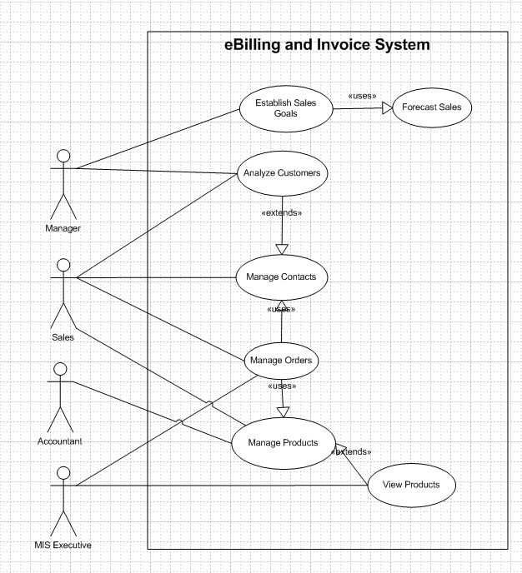

Usage summary use case

Requirements Summary
The following preliminary lists are based on initial interviews

Business Requirements
The business goal for the application is to support an increase the productivity and complete automation of existing manual bill and invoice generation process. Business requirements are discussed in the Scope section, with the following additional detail:

- Sales representatives need a method to store and access sales opportunity data, and when a sale is generated, convert some or all of the information into a sales order without re-entering information.
- Each sales representative should receive customer and sales data pertinent only to them.
- The accountant should be able to enter or update product information in one interface only, with all necessary product information being received by sales staff.
- Manager must receive his or her customer and appointment data plus detailed and rollup information for each sales representative on his or her team.
- The application should support the capability to use multi user environment.
- The MIS Executive should able to generate all type of reports as and when required by the management.

The sales staff wants to improve their current ability to analyze their customers. In particular, they want to focus on identifying their best customers and building long-term relationships within that base. To enable them to accomplish this goal, they want to extract meaningful data that easily answers the following questions:

- What are the early warning signs of problems?
- Who are my best customers across product lines?
- With whom do I focus my efforts for building a long-term relationship?
- What are my customers' issues as groups?
- Geographically, where are my best customers?
- What products are my customers buying and at what rate?

User Requirements
User requirements are categorized by user type.

Sales Staff (Representatives and Managers)

- View the data in various ways, for example:
  - Customers who are the top buyers of specific items
  - Best customers based on criteria to be determined
  - Best customers based on geographical analysis
  - Drops in a customer's sales
- Store multilingual and multiregional information in the database rather than relying on the sales staff to translate the information
- Identify which product prices have been modified, especially on current orders in progress
- Use opportunity rules, which are statements that help the sales representative convert an opportunity into a sale
- Add third-party data sources and financial evaluation tools
- Identify where promotions and programs would be the most beneficial
- Apply discounts to customer orders:
  - Sales representatives can offer discounts up to 15 percent, or up to 20 percent with authorization.
  - Sales managers can offer discounts up to 20 percent
- Enable capture, analysis, and sharing of data about a customer across the company
- Use forecasts to establish sales goals
- Allow all staff to view all contacts, but allow each contact to be assigned to a sales representative

Accountant

- Update product details, including price, photo, and description
- Add, delete, and update product specifications
- Generate stock reports and check the availability, order the item as and when needed.

MIS Executive

- Generate Reports as per requirement.
- Share the data, and convert reports to different format like Text, CSV.

Operational Requirements
The following requirements provide a high-level view of how the system will run:

- Processor usage should not exceed 80 percent during concurrent uses.
- Backups will occur incrementally throughout the day.
- A full weekly backup is required to WORM drives.
- Ensure that information is easy to access either, and meaningful for the sales representative and the company.
- Minimize the technical knowledge that sales and marketing staff need to access the data, generate ad hoc queries, track promotions, and view customer segmentation information.
- Any change to information must be reflected immediately, and the changes must be propagated to the search engine so that employees that perform searches see this new information.
- The application should work with the existing communications and networking infrastructure.
- The application should deploy with a minimum of additional operational processes, manual or otherwise.

System Requirements
These are additional constraints from a system perspective:

- Previous data of customer, product details must be imported in the new system.
- The administrator must be able to monitor everything from the IT department.
- The information must be accessible by everyone in the company as per the rights specify.

Success Criteria
To determine the success of this project, the following metrics can be quantified and used to analyse success factors.

Sales Automation
- Problem customer identification. Ability to identify top 10 developing problem customers by sales representative.
- Identification of best customers across product lines and regions. All customers can be sorted by the factors (to be determined) that rank them qualitatively. Variable sorts and rankings can be chosen by the sales representative.
- Identification of issues across groups. All customers can be sorted by the issues (to be determined) within group categories that can be updated. Variable sorts and rankings can be chosen by the sales representative or other user.
- Analysis of quantities and rates of products. Products can be sorted by the quantity and dates sold. Variable sorts and rankings can be chosen by the user.

Design Goals and Constraints

Performance
No more than a 5-percent degradation in average query response is allowed while all concurrent user are using the system.
Processor utilization should not exceed 80 percent during all concurrent users are using the system.

Availability
Because the system is accessed by sales representative to book the order and print the invoice, and there should not be any single point of failure.

Reliability
Because of the need no single point failure, automatic failover will be required. In addition, existing disaster recovery and backup plans and procedures must be revised to incorporate the eBilling and Invoicing System.

Scalability
eBilling and Invoice System an average load of 50 concurrent users after the system is fully operational, and expects that to grow by 5 percent each year for the next five years.

Security
For the sensitive customer and order data, all users will need to log on the system with their user id and password.

Every resource in the system is defined by the role and privileged. System administrator assigned user role and privileged for their access rights.

Interoperability
In Version 1.0 of the eBilling and Invoice System, there are no requirements for interoperability with other systems.

Location
The eBilling and Invoice System are used in the company office only.

Setup/Installation
Setup and installation must not interrupt the sales staff’s daily tasks and work flow.

Use Case Summary

Manage Orders

Description
This function will enable sales representative to place orders for eBilling and Invoice System products, track submitted orders, and view completed orders and print the invoice.

Business Need
This function will enable sales representative to interact with eBilling and Invoice System catalog directly without the intervention of any other employees.

Priority
High

Manage Products

Description
This function allows user of eBilling and Invoice System to create, maintain, and delete information about products in the product database that can then be viewed and ordered by customers, and accessed and updated by the sales staff.

Business Need
This function will support the sales staff with accurate and relevant information, and will also support the Manage Orders function by ensuring up-to-date product information.

Priority
High

Manage Contacts

Description
This function enables the sales staff to create and manage contacts as well as share contact information with the rest of the company.

Business Need
This function enables user of eBilling and Invoice System to have accurate and up-to-date contact information when working with customers.

Priority
Medium

Analyze Customers

Description
This function allows management to analyze the customer database and find out information, such as the identities of the best customers, the top buyers, and the most popular products.

Business Need
This function will allow management to determine the most (and least) profitable customers and product lines, enabling better decision making in the running of the business.

Priority
Medium

Forecast Sales

Description
This function allows management to plan and track production costs, track sales results, and plan sales staffing needs.

Business Need
This function will allow management to manage the revenue streams of the organizations and control costs.

Priority
Medium

Establish Sales Goals

Description
This function allows management to view current sales trends and employee performance and to determine sales goals for the sales staff within the organization.

Business Need
This function will allow management to set goals for staff, review the performance of staff members, and track employee performance.

Priority
Medium
Usage Scenarios
Usage scenarios that describe how users will use the solution within the context of the business, See following usage scenarios.

Use Case ID: UC 4.7.1 Retrieve Customer Data
Title: UC 04.7.1 Retrieve Customer Data
Abbreviated Title: Retrieve Customer Data
Requirement ID: 21

Intent
Return the selected information about one or more customers.

Scenario Narrative
A sales representative may want to search for and retrieve information about one or more customers for use in analysis and forecasting activities.

Assumptions/Preconditions
- Sales representative has access rights to view customer data.

Actors
- Sales Representative

Basic Course
- Use case begins when the sales representative decides to retrieve customer information.
- System prompts for the type of customer information that is required.
- Sales representative selects the type of customer information to be retrieved.
- System presents the appropriate customer information to the sales representative.
- Use case ends when the selected information is passed to a method of delivery.

Alternate Course
- If no appropriate customer information can be found, system reports this fact.
- Use case restarts to enable sales representative to update the type of customer information.

Uses/Extends
- None

User Implementation Requests
- None

Frequency
Quite frequent

Authority
- Not applicable

Associated Specifications
Number | Name | Category | Type

Issues
- None identified

Decision Points
- None

Future Requirements
- The sales representative may want to apply filters to the retrieved data.
- The sales representative may want to sort the data. For example, the sales representative may want to list the names of customers in chronological order based on the sale date.

Modification
Date | Author | Description

Use Case Model: Retrieve Customer Data

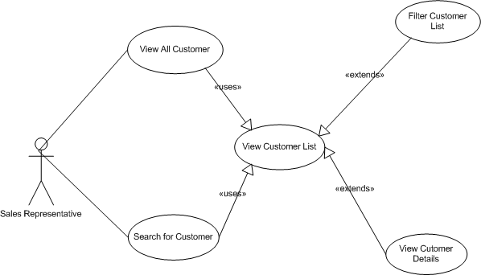

Use Case: Manage Orders

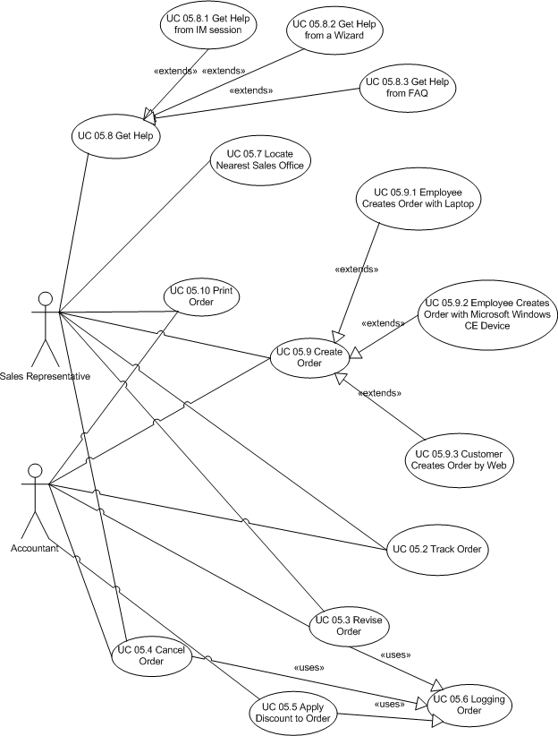

Use Case ID: UC 04.7.3 Manage Contacts
Title: UC 04.7.2 Manage Contacts
Abbreviated Title: Manage Contacts
Requirement ID: 19

Intent
Enable actor to create, view, modify of the information about customer contacts.

Scenario Narrative
An actor wants to create view, modify, and delete the customer contacts.

Assumptions/Preconditions
- The actor has rights to access to the eBilling and Invoice System, and having rights to view, ads, edit and delete the customer contacts.

Actors
- Sales Representative
- Manager
- Accountant

Basic Course:
- Use case begins when actor decides to search customer.
- Actor searches the customer.
- System displays the customer details.
- Actor view the customer contact details:
- Actor add, modify the contact details.

Uses/Extends
- None

User Implementation Requests
1. None

Frequency
Frequent

Authority
- Not applicable

Associated Specifications
Number | Name | Category | Type

Issues
- None

Decision Points
- None

Future Requirements
- None

Modification
Date | Author | Description

Solution Architecture

Infrastructure
New servers must be dual processor 1.26 GHz computers, with 1 GB of RAM. The operating system software will be Microsoft® Windows® 2000 with the latest service pack, although use of Windows Server 2003 will be considered when it is available.

These servers will be installed on existing network.
To help provide security of the application, both an internal and external firewall will be installed.

Visual Design
See later on the visual interface design.

Conceptual Design
For information about the conceptual design see the use case of previous chapters of the eBilling and Invoice System,

Business Rule Catalog of eBilling and Invoice System

BR ID | Business Rule Title | Description | Authority | Current Process
1 | Timely Product Information Adjustments | The product information, price in the system must be current 100% of the time. Adjustments to this information must be made at any time. | Mr. Ajay Kumar, Accountant. Interview dated May 6, 2008 | 1. Product is identified by Manager  2. Current information is reviewed and modifications are identified.  3. Accountant notes changes to information and obtains approval from Manager.  4. Accountant makes the changes to the product information.  5. After approval is given by all owners, Accountant saves the changes.
2 | Reactivating Deleted Products | A product can be "deleted," meaning that it is no longer sold by eBilling and Invoice System. However, the product information should be available in case the product is reactivated at a future time. | Mr. Ajay Kumar, Accountant. Interview dated May 6, 2008 | 1. Product is identified by Manager.  2. Accountant is notified that the product should be removed from the catalog. Notification comes from Manager.  3. Accountant archives product information and saves the information in text and graphics files on an internal business server.  4. If a product is reactivated, the Accountant receives notification from Manager.  5. Accountant creates a new product record in the database and copies the information from the files on the internal business server to the database record.  6. Accountant notifies product information "owners" in Manager to review the new product record.  7. After approval is given by all owners, Accountant makes the product record available to the catalog.
3 | Authorization for Catalog Changes | No change to product information can be made publicly available without the approval from the information "owners," usually Manager. | Mr. Ajay Kumar, Accountant. Interview dated May 6, 2008 | Derived from BR1
4 | Delivery of Daily Pricing Updates to Sales | The Sales force needs to use the most up-to-date information about product pricing and related information, such as availability. Otherwise, sales representatives miss receiving changes that do affect them. This results in the sales representatives having to redo orders and recalculate pricing. | Mr. Ajay Kumar, Accountant. Interview dated May 6, 2008 | Every morning of every day:  1. Accountant Update the pricing from the vendor.
5 | Authorization for Information Access | Certain roles have access to certain information types and functions. Current roles include Sales Representative, Sales Manager, Accountant, MIS Executive | Mr. Joydeep Das, IT Manager. Interview dated May 12, 2008 | 1. A suitable authority is requested for creation of a role.  2. The role is created and authorized by the authorization authority.

Physical Design

eBilling and Invoice System Physical Object Model

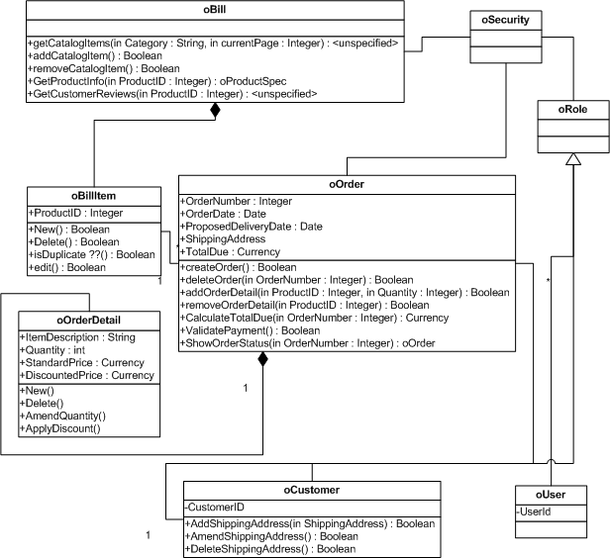
Add new product to product master sequence diagram

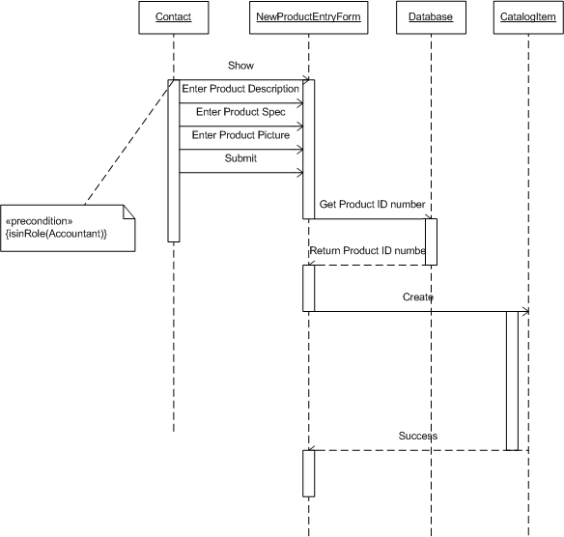

eBilling and Invoice System Data Dictionary

Table: product master
Owner: dbo
Destination DB name: ebill
Number of columns: 5
Number of indexes: 2
Number of foreign keys: 0
Extended attributes:
On Filegroup PRIMARY
Clustered PK Yes

Columns | Data type | Allow NULLs | Value/range
Sno | int | Not allowed
ProdType | nvarchar(60) | Not allowed
ProdSubType | nvarchar(60) | Not allowed
Rate | int | Not allowed
isactive | nvarchar(30) | Not allowed

Indexes | Type | Columns
PK_ProductMaster_sno | clustered, unique, primary key located on PRIMARY | sno

Table: bill
Owner: dbo
Destination DB name: ebill
Number of columns: 15
Number of indexes: 3
Number of foreign keys: 0
Extended attributes:
OnFileGroup PRIMARY
Clustered PK Yes

Columns | Data type | Allow NULLs | Value/range
sno | int | Not allowed
invoiceno | nvarchar(60) | Not allowed
canme | nvarchar(60) | Not allowed
Invoice_date | datetime | Not allowed
location | nvarchar(60) | Not allowed
chalan_no | int | Not allowed
customer_name | nvarchar(100) | Not allowed
Customer_address1 | nvarchar(100) | Not allowed
Customer_address2 | nvarchar(100) | Allowed
Total_amt | int | Not allowed
discount | int | Not allowed
Amt_words | nvarchar(100) | Not allowed
Paid_type | nvarchar(60) | Not allowed
Cheque_no | nvarchar(60) | Allowed
Entry_date | datetime | Not allowed

Indexes | Type | Columns
PK_Bill_SNO | clustered, unique, primary key located on PRIMARY | sno
IX_bill_cname | nonclustered located on PRIMARY | cname
IX_bill_invoiceno | nonclustered, unique located on PRIMARY | invoiceno

Table: bill details
Owner: dbo
Destination DB name: ebill
Number of columns: 6
Number of indexes: 3
Number of foreign keys: 2
Extended attributes:
OnFileGroup PRIMARY
Clustered PK Yes

Columns | Data type | Allow NULLs | Value/range
sno | int | Not allowed
Bill_sno | int | Not allowed
Prod_sno | nvarchar(60) | Not allowed
qty | datetime | Not allowed
rate | nvarchar(60) | Not allowed
amt | int | Not allowed

Indexes | Type | Columns
PK_Bill_details_SNO | clustered, unique, primary key located on PRIMARY | sno
IX_bill_details_bill_sno | nonclustered located on PRIMARY | Bill_sno
IX_bill_deatils_prod_sno | nonclustered, unique located on PRIMARY | Prod_sno

Table: Company master
Owner: dbo
Destination DB name: ebill
Number of columns: 7
Number of indexes: 2
Number of foreign keys: 0
Extended attributes:
OnFileGroup PRIMARY
Clustered PK Yes

Columns | Data type | Allow NULLs | Value/range
Company_name | nvarchar(60) | Not allowed
Address1 | nvarchar(100) | Not allowed
Address2 | nvarchar(100) | Allowed
city | nvarchar(60) | Not allowed
pin | int | Not allowed
telephone | nvarchar(60) | Not allowed
vatno | nvarchar(60) | Not allowed

Indexes | Type | Columns
PK_comapny_master_company_name | clustered, unique, primary key located on PRIMARY | Comapnay_name
IX_ comapny_master_pin | nonclustered located on PRIMARY | pin

Table: user master
Owner: dbo
Destination DB name: ebill
Number of columns: 3
Number of indexes: 2
Number of foreign keys: 0
Extended attributes:
OnFileGroup PRIMARY
Clustered PK Yes

Columns | Data type | Allow NULLs | Value/range
user_name | nvarchar(60) | Not allowed
User_password | nvarchar(60) | Not allowed
User_type | nvarchar(60) | Allowed

Indexes | Type | Columns
PK_user_master_user_name | clustered, unique, primary key located on PRIMARY | user_name
IX_ user_master_user_type | nonclustered located on PRIMARY | User_type

eBilling and Invoice System – Data Schema ER Diagram

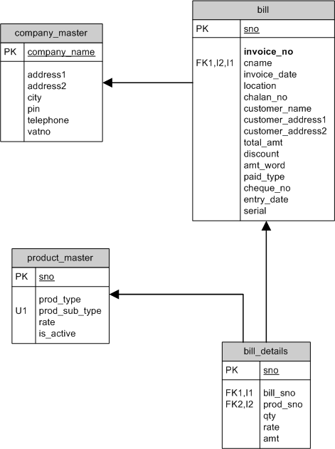

eBilling and Invoice System DFD (Data Flow Diagram)

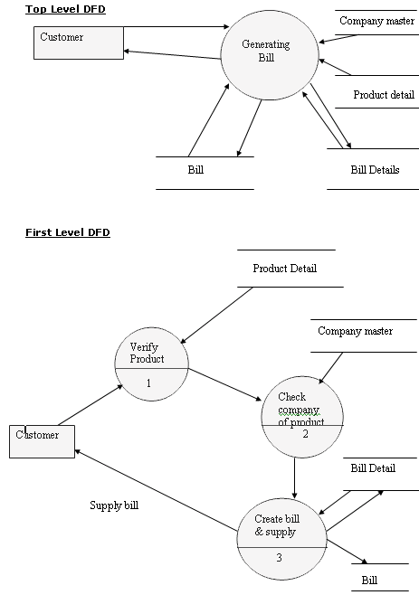

Form Design and Coding

FrmSplash
(Module to show startup screen)

Electronic billing or e-billing is the process by which bills are sent and paid electronically. This process enables customers to receive bills via email, web portal or even in machine-readable data formats, facilitating more efficient delivery and payment.

This Splash is basically a startup screen which shows only name and version of this copyright software. Which is delivered to various firm,store,organigation and updation of this software is in android applications which will be mob friendly.

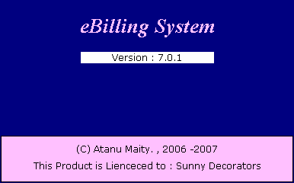

FrmLogin
(Module to Authenticate User)

A login page is a web page or an entry page to a website that requires user identification and authentication, regularly performed by entering a username and password combination.

This Android application is more focused on security privacy integrity of the system.

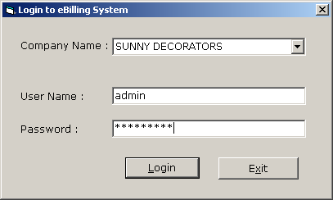

FrmProducts
(Maintain Product master)

A product master is a data management solution that compiles, validates, enriches, and curates all your organization's product-related data into a complete, accurate, and easily reportable golden copy.

FrmBill
(Create and modify bill and print the saved bill)

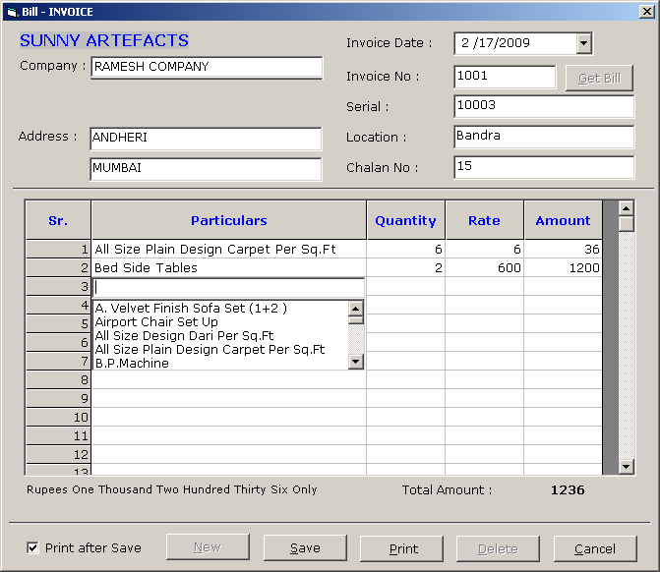

(Print out of the bill) 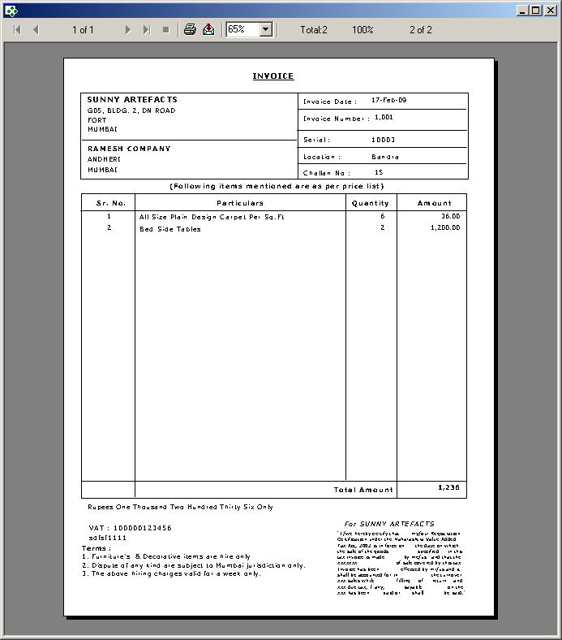

FrmReports
(Show Different Report Options)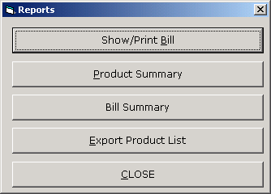

FrmPrintBill
(Print already saved bill)

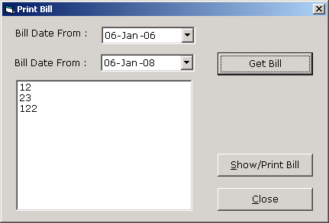

Product Summary Report
(Show Product Summary report in crystal report)

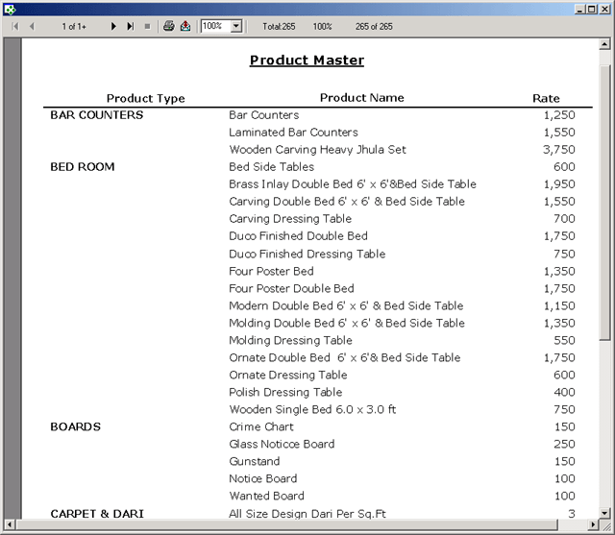

FrmBillSummary
(Show bill summary for particular date range)

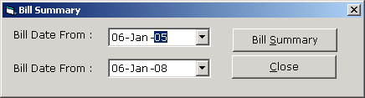

Bill Summary Report

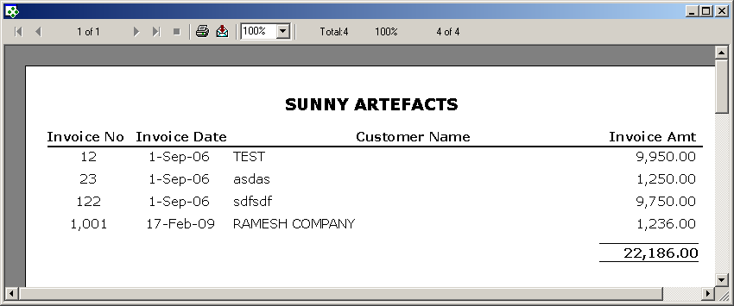

FrmExportData
(Export product Data in FlexGrid and MS-Excel with formatting)

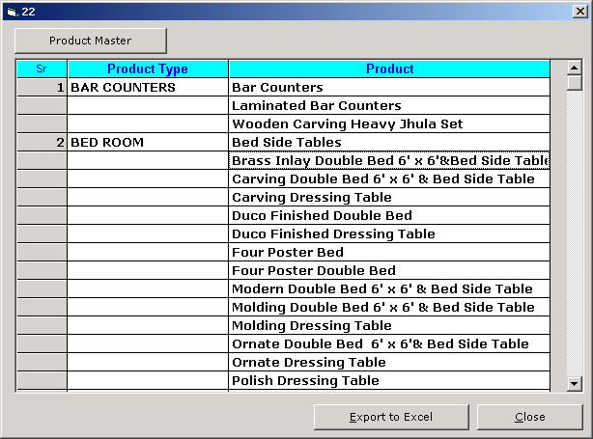

Export product Data MS-Excel with formatting

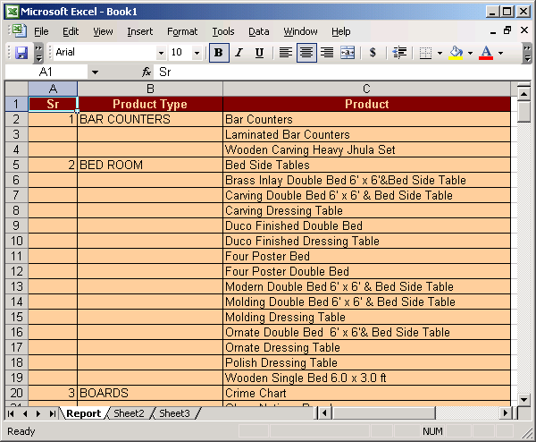

FrmUtlity
(To Access different utility program like compact, backup, change password etc.)

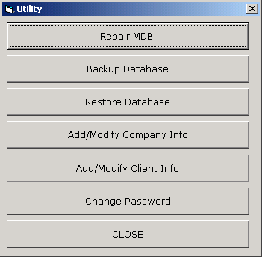

FrmCompactAndRepairDatabase
(To shrink and compact main database data.mdb.)

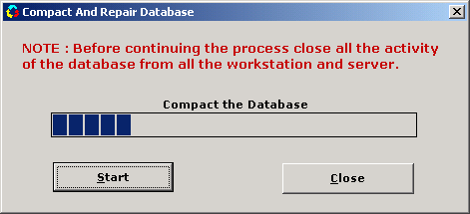

FrmBackupDatabase
(To take backup of main database data.mdb.)

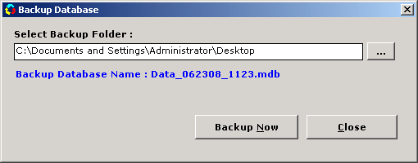

FrmCompanyInfo
(Add/Modify Company Info)

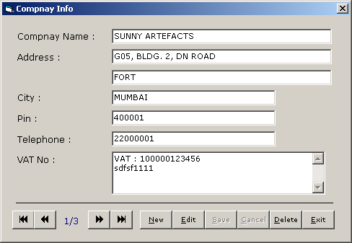

FrmClientInfo
(Add/Modify Client Info)

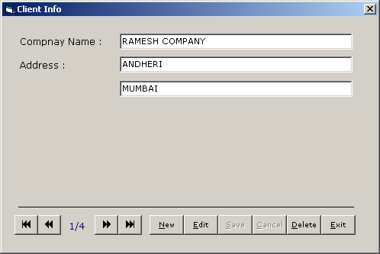

FrmChangePassword
(Change password for currently logged user)

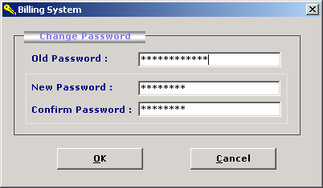

ModBrowse

ModRsToWord
(Convert Rs to Word)

eBilling and Invoice System Test Plan

Introduction
This document describes the user acceptance test plan for the eBilling and Invoice System. The complete test strategy for the eBilling and Invoice System is to perform the following kinds of tests, in sequence:

- Component testing of each component that makes up the eBilling and Invoice System
- Integration testing of the eBilling and Invoice System, to ensure the correct interworking of its components
- Validation testing of the eBilling and Invoice System, to ensure that it works correctly in a pseudo-live environment
- User acceptance testing of the eBilling and Invoice System, to ensure that its function is acceptable to its users

Acceptance testing is the last set of tests to be performed before the application goes officially live.

Test Scope
The scope of the user acceptance testing covers:

- Version 1 of the eBilling and Invoice System
- User-facing functionality defined by a set of use cases
- Administrator-facing functionality defined by a set of use cases

The aim of the testing is to determine how well the application meets its functional requirements from the perspective of the user, and to identify any issues so they can be resolved. Also, the testing serves to compile a set of test data and results that can be used during subsequent test cycles, to test for non-regression of the software in later releases or after the application is in maintenance.

Working practices might vary from user to user and are considered outside the scope of the testing.

Test Strategy
The basis of user acceptance testing is that other tests were completed successfully, so the application and its required infrastructure are considered to be stable and reliable. Acceptance testing concentrates on the application from the user’s perspective, that is, how the application is used and whether it meets the necessary quality criteria.

Change requests will be sent to the development team as the actionable documentation. Change criteria will be determined by the Test team and the Development team prior to the beginning of testing. For instance, criteria may include impact to desired functionality, amount of code impacted by proposed change, and design required by proposed change. The tester will evaluate the criteria. The test lead will determine Change Required or not. Once a bug has been determined as Change Required, the bug report will be translated into a Change Request and passed on to development.

The customer of the acceptance testing is the System Users, Supervisor and Administrator for eBilling and Invoice System. The progress of the acceptance testing will be reported to the customer, together with any issues that are discovered and their planned resolutions. Sign-off of the tests, and therefore the acceptance of the application, will be performed by the customer or a selected representative.

Preconditions
The following items are required before testing can take place:

- A complete and coherent functional specification of the eBilling and Invoice System expressed as use cases and usage scenarios
- A complete and validation-tested release of eBilling and Invoice System, delivered according to the delivery plan
- An agreed-upon procedure for dealing with any anomalies that are discovered during the testing process
- A set of test specifications describing how each functional area of the eBilling and Invoice System is to be acceptance tested
- An implemented test environment for the testing
- Sufficient, suitable resources to carry out the testing
- Available standards for the acceptance testing

Test Priorities
During testing of the eBilling and Invoice System, the following qualities will be tested in order of priority:
- Functionality—whether the required functions are available and working as expected
- Usability—how user-friendly and intuitive the eBilling and Invoice System is
- Security—how well-protected and guaranteed corporate and user data is
- Performance—whether the response times are within acceptable limits
- Customization—how straightforward it is to use the application in new, unpredicted ways

Test Techniques
The following techniques will be applied:
- Scripted tests—sequences of user interactions (based on the use case and usage scenarios) using predefined data sets against predicted results
- Unscripted tests—based on scripted tests, the tester tries to modify the scenarios to explore what-if possibilities
- Penetration tests—scripted tests to attempt unauthorized entry into the system
- Usability checklists—tests to determine the complexity of interactions
- Performance statistics—generation of performance information to check against desired performance criteria

Test Organization

Roles and Responsibilities
The following roles are defined:

- QA lead/test manager—responsible for planning and ensuring the smooth running of the test process
- Tester—carries out the tests according to the test plan, and then reports the results
- Product manager—ensures that the tests are carried out successfully from a user perspective
- Project sponsor/client—acts as main stakeholder, and ensures that the needs of the customer community as a whole are considered
- Test support—provides technical assistance, such as test environment configuration, and non-technical assistance, such as methodological support

Weekly team meetings will be held involving the test manager, testers, and product managers. At these meetings, the progress of the testing process will be reported, any issues will be discussed, and actions will be agreed upon.

Uses and benefits of e-billing
e-Billing is a process by which a business bills its customers. It also automates collecting payments, invoice tracking, sending out recurring invoices, etc. It is used to get paid quickly and securely. It offers a win-win situation for both business and customers by offering faster, convenient and secure modes of payment. Below are some of the benefits of using e-billing software:
- Improved accuracy and efficiency: There are direct communication between the electronic billing system and the accounting software, resulting in reduced errors. Also, the generation of e-bill requires less time than paper ones. This leads to improved efficiency.
- Brings Automation: Nowadays, businesses are trying to automate repetitive manual processes to improve efficiency. e-Billing is a big opportunity for billing process automation.
- Better customer experience: e-Bills can be generated more professionally with smooth access and payment processing. This results in an enhanced customer experience.
- Better scalability: e-Billing system provides easy scalability as compared to paper billing. If billing volumes are increased, e-billing can easily scale up, whereas paper billing requires increased printing, management, and delivery investment.
- Energy efficient: e-Bills are energy efficient compared to paper bills, which require more energy and resources for production and delivery.
- Reduced overhead costs: By switching to e-bills, one can save printing, delivery, and postage costs. This results in reduced overhead costs.

Tips for choosing e-billing software
There is a variety of e-billing software available in the market. Here are some of the tips for choosing the right e-billing software:
- Understand your needs: The first thing to do is understand your requirements from the software. Do you want it to be integrated with other software in the organization, or do you just want it for invoice generation and tracking? Based on your needs, you can choose a favorable option.
- Industry-specific software: There are different needs for different industries. Based on your industry-specific needs, you can choose a preferable option.
- Integration: Your business might be using multiple systems for different functions such as human resources, accounting, payroll, billing, etc. Choose a billing software that can easily communicate with other software in the organization for smooth data flow.

billing software provides the enhanced features of e-billing systems such as:
- It helps to create invoices, bill estimates, proforma invoices, quotations, e-way bills, credit and debit notes, etc.
- It sends invoices with QR codes and payment links to make the payment process easy.
- You can check the payment status of your bills on the Clear One app within seconds.
- It facilitates cloud-based storage for easy access.
- It stores customer data on a secured network.

4.10 Approach used
Software Development life cycle (SDLC) is a spiritual model used in project management that defines the stages include in an information system development project, from an initial feasibility study to the maintenance of the completed application.
There are different software development life cycle models specify and design, which are followed during the software development phase. These models are also called "Software Development Process Models." Each process model follows a series of phase unique to its type to ensure success in the step of software development.
Here, are some important phases of SDLC life cycle:

Waterfall Model
The waterfall is a universally accepted SDLC model. In this method, the whole process of software development is divided into various phases.
The waterfall model is a continuous software development model in which development is seen as flowing steadily downwards (like a waterfall) through the steps of requirements analysis, design, implementation, testing (validation), integration, and maintenance.
Linear ordering of activities has some significant consequences. First, to identify the end of a phase and the beginning of the next, some certification techniques have to be employed at the end of each step. Some verification and validation usually do this mean that will ensure that the output of the stage is consistent with its input (which is the output of the previous step), and that the output of the stage is consistent with the overall requirements of the system.

RAD Model
RAD or Rapid Application Development process is an adoption of the waterfall model; it targets developing software in a short period.
The RAD model is based on the concept that a better system can be developed in lesser time by using focus groups to gather system requirements.

- Business Modeling
- Data Modeling
- Process Modeling
- Application Generation
- Testing and Turnover

Spiral Model
The spiral model is a risk-driven process model. This SDLC model helps the group to adopt elements of one or more process models like a waterfall, incremental, waterfall, etc. The spiral technique is a combination of rapid prototyping and concurrency in design and development activities.
Each cycle in the spiral begins with the identification of objectives for that cycle, the different alternatives that are possible for achieving the goals, and the constraints that exist. This is the first quadrant of the cycle (upper-left quadrant).
The next step in the cycle is to evaluate these different alternatives based on the objectives and constraints. The focus of evaluation in this step is based on the risk perception for the project.
The next step is to develop strategies that solve uncertainties and risks. This step may involve activities such as benchmarking, simulation, and prototyping.

V-Model
In this type of SDLC model testing and the development, the step is planned in parallel. So, there are verification phases on the side and the validation phase on the other side. V-Model joins by Coding phase.

Incremental Model
The incremental model is not a separate model. It is necessarily a series of waterfall cycles. The requirements are divided into groups at the start of the project. For each group, the SDLC model is followed to develop software. The SDLC process is repeated, with each release adding more functionality until all requirements are met. In this method, each cycle act as the maintenance phase for the previous software release.

Modification to the incremental model allows development cycles to overlap. After that subsequent cycle may begin before the previous cycle is complete.

Agile Model
Agile methodology is a practice which promotes continues interaction of development and testing during the SDLC process of any project. In the Agile method, the entire project is divided into small incremental builds. All of these builds are provided in iterations, and each iteration lasts from one to three weeks.
Any agile software phase is characterized in a manner that addresses several key assumptions about the bulk of software projects:
- It is difficult to think in advance which software requirements will persist and which will change. It is equally difficult to predict how user priorities will change as the project proceeds.
- For many types of software, design and development are interleaved. That is, both activities should be performed in tandem so that design models are proven as they are created. It is difficult to think about how much design is necessary before construction is used to test the configuration.
- Analysis, design, development, and testing are not as predictable (from a planning point of view) as we might like.

Iterative Model
It is a particular implementation of a software development life cycle that focuses on an initial, simplified implementation, which then progressively gains more complexity and a broader feature set until the final system is complete. In short, iterative development is a way of breaking down the software development of a large application into smaller pieces.

Big bang model
Big bang model is focusing on all types of resources in software development and coding, with no or very little planning. The requirements are understood and implemented when they come.
model works best for small projects with smaller size development team which are working together. It is also useful for academic software development projects. It is an ideal model where requirements are either unknown or final release date is not given.

Prototype Model
The prototyping model starts with the requirements gathering. The developer and the user meet and define the purpose of the software, identify the needs, etc.
A 'quick design' is then created. This design focuses on those aspects of the software that will be visible to the user. It then leads to the development of a prototype. The customer then checks the prototype, and any modifications or changes that are needed are made to the prototype.

Conclusion and future enhancement

This project was developed to fulfill user and business requirement; however, there are lots of scope to improve the performance of the eBilling and Invoice System in the area of user interface, database performance, and query processing time. Etc.

So, there are many things for future enhancement of this project. The future enhancements that are possible in the project are as follows.

- Linking and integration of any legacy system for accounting.
- Integration with travel agent through Web Services
- Connection to third-party OLAP applications
- Electronic Data Interchange (EDI) system between banks, other credit verification agency and their vendors
- In the area of data security and system security.
- Provide more online tips and help.
- To optimize the query which is embedded in the system.

Bibliography
- http://www.google.com
- http://www.microsoft.com
- http://www.programmer2programmer.net
- http://www.codeproject.com
- http://www.msdn.com.
- http://www.vb123.com
- http://www.vbcode.com
- http://www.sqltuner.com
- https://econsortium.aktu.ac.in/?p=48665
- https://econsortium.aktu.ac.in/?p=44431
- https://econsortium.aktu.ac.in/?p=47417
- https://econsortium.aktu.ac.in/?p=48102

