Blood Bank Management
A Project Report Submitted In Partial Fulfillment of the Requirements for The Degree of

MASTER OF COMPUTER APPLICATIONS
by
Rohit
(Roll no.: 1900290140027)

Under the supervision of

Prof. Vidushi Mishra
Associate Professor

KIET GROUP OF INSTITUTIONS, GHAZIABAD


to the

DEPARTMENT OF COMPUTER APPLICATIONS

DR. A.P.J. ABDUL KALAM TECHNICAL UNIVERSITY LUCKNOW
(Formerly Uttar Pradesh Technical University, Lucknow)
May 2022

DECLARATION

I hereby declare that the work presented in this report entitled “Blood Bank” Application was carried out by US. I have not submitted the matter embodied in this report for the award of any other degree or diploma of any other University or Institute. I have given due credit to the original authors/sources for all the words, ideas, diagrams, graphics, computer programs,experiments,results, that are not my original contribution.
I have used quotation marks to identify verbatim sentences and given credit to the original authors/sources.
I affirm that no portion of my work is plagiarized, and the experiments and results reported in the report are not manipulated. In the event of a complaint of plagiarism and the manipulation of the experiments and results, We shall be fully responsible and answerable.

Rohit

University Roll No. :1900290140028

TRAINING CERTIFICATE



CERTIFICATE

Certified that Rohit (Univ. Roll No.-1900290140028) have carried out the project work having “Blood Bank” for Master of Computer Application from Dr.A.P.J.Abdul Kalam Technical University (AKTU), Technical University, Lucknow under my supervision. The project report embodies original work, and studies are carried out by the student himself/herself and the contents of the project report do not form the basis for the award of any other degree to the candidate or to anybody else from this or any other University/Institution.
Date:

Rohit (Univ. Roll No -1900290140028)

This is to certify that the above statement made by the candidate is correct to the best of our knowledge.
Miss Vidushi
Assistant Professor
Department of Computer Applications KIET Group of Institutions, Ghaziabad
Date:

Signature of External Examiner Signature of Internal Examiner

Dr. Ajay Kumar Shrivastava
Head, Department of Computer Applications
KIET Group of Institutions, Ghaziabad

ABSTRACT

This system mainly reduces the work task and it is easy to maintain the records for a long time than normal hand written records as well give ease. The user can check his record details by just entering his demand no need to search all the record.
So, the maintenance and Presidency of institute became very easy.
- Easy accessibility.
- It makes searching records easier and faster.
- User is no longer required to check his register in search of records, as now it can be searched over the software by choosing some options.
- The user need not to type in most of the information.
- On the whole it liberates the user from keeping lengthy manual records.
- Everyone wants his/her work to be done by computer automatically and displaying the result for further manipulations.
- So, this project is about providing convenience.

ACKNOWLEDGEMENTS

Success in life is never attained single handedly. My deepest gratitude goes to my thesis supervisor Dr. Sangeeta Arora, for his guidance, help and encouragement throughout our project work. Their enlightening ideas, comments, and suggestions.

Words are not enough to express my gratitude to Dr. Ajay Kumar Shrivastava, Professor and Head, Department of Computer Application, for his insightful comments and administrative help at various occasions.
Fortunately, I have many understanding friends, who have helped me a lot on many critical conditions.

Finally, my sincere thanks go to my family members and all those who have directly and indirectly provided me moral support and other kind of help. Without their support, completion of this work would not have been possible in time. They keep my life filled with enjoyment and happiness.

Rohit
Univ. Roll No. 1900290140028

TABLE OF CONTENT

Chapter 1: Introduction
1.1 Project Title ,1.2 Project Details | 10-11
1.3 Problem Definition | 12
1.4 Proposed System | 12
1.5 Hardware / Software used in project | 13
1.4 Project Schedule

Chapter 2: Feasibility Study
2.1 Technical feasibility

2.2 Economical Feasibility
2.3 Operational Feasibility

2.4 Benefits 31

2.5 SRS

Chapter 3 & 4: Design 34-44
4.1 Introduction | 34
4.2 Analysis | 35
4.3 SDLC | 37
4.4 Soft. Engg. Paradigm | 39
4.4.1 Prototype model
4.5 DFD 42
4.7 ER Diagram 44
Chapter 5: Report 45-51
- Gist 45
- Some Screenshots 46
Chapter 6: Coding 52-59
Chapter 7: Testing 60-62
- Introduction 60
- Level of testing 61
- Some Important observations 62
- test case result summary 62
Chapter 8: Conclusion & Future scope 64
- Conclusion 64
- Future Scope 64
Bibliography 65

LIST OF FIGURES

Figure 1.1 Pert chart 18
Figure 1.2: Gannt chart for project 19
Figure 2.1: Design 23
Figure 2.2: Flow of website 23
Figure 2.3: Some screens 24
Figure 4.1: Above image depicting the planning step 377
Figure 4.2: Prototype model 40
Figure 4.3: Apex Work 42
Figure 4.4 Context level 42
Figure 4.5 Dfd 1 level 43
Figure 4.6: Uml use case diagram 43
Figure 4.7:ER diagram of system 444
Figure 5.1 System 455
Figure 7.1: Testing pyramid 61

INTRODUCTION
1.1. Project Overview

The Blood Donation Agent is to create an e-Information about the donor and organization that are related to donating the blood. Through this application any person who is interested in donating the blood can register himself in the same way if any organization wants to register itself with this site that can also register. Moreover if any general consumer wants to make request blood online he can also take the help of this site. Admin is the main authority who can do addition, deletion, and modification if required.

1.2. Project Description

This project is aimed to developing an online Blood Donation Information. The entire project has been developed keeping in view of the distributed client server computing technology, in mind.
The Blood Donation Agent is to create an e-Information about the donor and organization that are related to donating the blood. Through this application any person who is interested in donating the blood can register himself in the same way if any organization wants to register itself with this site that can also register. Moreover if any general consumer wants to make request blood online he can also take the help of this site.
Admin is the main authority who can do addition, deletion, and modification if required.
The project has been planned to be having the view of distributed architecture, with centralized storage of the database. The application for the storage of the data has been planned. Using the constructs of MS-SQL Server and all the user interfaces have been designed using the ASP.Net technologies.
The database connectivity is planned using the “SQL Connection” methodology. The standards of security and data protective mechanism have been given a big choice for proper usage.
The application takes care of different modules and their associated reports, which are produced as per the applicable strategies and standards that are put forwarded by the administrative staff.
The entire project has been developed keeping in view of the distributed client server computing technology, in mind. The specification has been normalized up to 3NF to eliminate all the anomalies that may arise due to the database transaction that are executed by the general users and the organizational administration. The user interfaces are browser specific to give distributed accessibility for the overall system. The internal database has been selected as MS-SQL server 2000.
The basic constructs of table spaces, clusters and indexes have been exploited to provide higher consistency and reliability for the data storage. The MS-SQL server 2000 was a choice as it provides the constructs of high-level reliability and security. The total front end was dominated using the ASP.Net technologies. At all proper levels high care was taken to check that the system manages the data consistency with proper business rules or validations.
The database connectivity was planned using the latest “SQL Connection” technology provided by Microsoft Corporation. The authentication and authorization was crosschecked at all the relevant stages. The user level accessibility has been restricted into two zones namely.

Problem Definition
1.3 Existing System
- Cannot Upload and Download the latest updates.
- No use of Web Services and Remoting.
- Risk of mismanagement and of data when the project is under development.
- Less Security.
- No proper coordination between different Applications and Users.
- Fewer Users – Friendly
Disadvantages
- User friendliness is provided in the application with various controls.
- The system makes the overall project management much easier and flexible.
- Readily upload the latest updates, allows user to download the alerts by clicking the URL.
- There is no risk of data mismanagement at any level while the project development is under process.
- It provides high level of security with different level of authentication.
1.4. Proposed System
To debug the existing system, remove procedures those cause data redundancy, make navigational sequence proper. To provide information about audits on different level and also to reflect the current work status depending on organization/auditor or date. To build strong password mechanism.

Advantages:
- User friendliness I provided in the application with various controls.
- The system makes the overall project management much easier and flexible.
- Readily upload the latest updates ,allows user to download the alerts by clicking the url.
- It provides high level of security with different level of authentication.

1.3 HARDWARE / SOFTWARE USED IN PROJECT

- HARDWARE REQUIREMENT

Hardware | Configuration
Processor | Above 4.4
Ram | 4GB
Rom | 100 GB

- SOFTWARE REQUIREMENT

Software | Configuration
Database | Firebase
Language | Typescript and JavaScript
Frameworks | Angular and NestJs

2.0 Feasibility Study

Preliminary investigation examine project feasibility, the likelihood the system will be useful to the organization. The main objective of the feasibility study is to test the Technical, Operational and Economical feasibility for adding new modules and debugging old running system. All system is feasible if they are unlimited resources and infinite time. There are aspects in the feasibility study portion of the preliminary investigation:
- Technical Feasibility
- Operation Feasibility
- Economical Feasibility

2.1. Technical Feasibility
The technical issue usually raised during the feasibility stage of the investigation includes the following:
- Does the necessary technology exist to do what is suggested?
- Do the proposed equipments have the technical capacity to hold the data required to use the new system?
- Will the proposed system provide adequate response to inquiries, regardless of the number or location of users?
- Can the system be upgraded if developed?
- Are there technical guarantees of accuracy, reliability, ease of access and data security?

Earlier no system existed to cater to the needs of ‘Secure Infrastructure Implementation System’. The current system developed is technically feasible. It is a web based user interface for audit workflow at NIC-CSD. Thus it provides an easy access to the users.
The database’s purpose is to create, establish and maintain a workflow among various entities in order to facilitate all concerned users in their various capacities or roles. Permission to the users would be granted based on the roles specified. Therefore, it provides the technical guarantee of accuracy, reliability and security.
The software and hard requirements for the development of this project are not many and are already available in-house at NIC or are available as free as open source. The work for the project is done with the current equipment and existing software technology. Necessary bandwidth exists for providing a fast feedback to the users irrespective of the number of users using the system.

2.2. Operational Feasibility
Proposed projects are beneficial only if they can be turned out into information system. That will meet the organization’s operating requirements. Operational feasibility aspects of the project are to be taken as an important part of the project implementation. Some of the important issues raised are to test the operational feasibility of a project includes the following: -
- Is there sufficient support for the management from the users?
- Will the system be used and work properly if it is being developed and implemented?
- Will there be any resistance from the user that will undermine the possible application benefits?

This system is targeted to be in accordance with the above-mentioned issues. Beforehand, the management issues and user requirements have been taken into consideration. So there is no question of resistance from the users that can undermine the possible application benefits.
The well-planned design would ensure the optimal utilization of the computer resources and would help in the improvement of performance status.
2.3. Economic Feasibility
A system can be developed technically and that will be used if installed must still be a good investment for the organization. In the economical feasibility, the development cost in creating the system is evaluated against the ultimate benefit derived from the new systems. Financial benefits must equal or exceed the costs.
The system is economically feasible. It does not require any addition hardware or software. Since the interface for this system is developed using the existing resources and technologies available at NIC, There is nominal expenditure and economical feasibility for certain.

System Analysis

3.1. Software Requirement Specification (SRS)
The software, Site Explorer is designed for management of web sites from a remote location.
INTRODUCTION
Purpose: The main purpose for preparing this document is to give a general insight into the analysis and requirements of the existing system or situation and for determining the operating characteristics of the system.
Scope: This Document plays a vital role in the development life cycle (SDLC) and it describes the complete requirement of the system. It is meant for use by the developers and will be the basic during testing phase. Any changes made to the requirements in the future will have to go through formal change approval process.

DEVELOPERS RESPONSIBILITIES OVERVIEW:
The developer is responsible for:

- Developing the system, which meets the SRS and solving all the requirements of the system?
- Demonstrating the system and installing the system at client's location after the acceptance testing is successful.
- Submitting the required user manual describing the system interfaces to work on it and also the documents of the system.
- Conducting any user training that might be needed for using the system.
- Maintaining the system for a period of one year after installation.

The modules involved are:
- Administration:
In this module the Administrator has the privileges to add all the Blood Groups, Blood Type, Organization, Type, Country, State, City, and Location. He can search all the info about the Organization, Donor.
User Account:
- AccountID
- Username
- Password
- UserDesc
- HintQuestion
- Answer
- RoleID
- Active
Functionality

    - Association User Account with UserRole.
    - Association User Account with Organisation.
    - Association User Account with personal Details.
    - Association User Account with Employee deatails.
    - Association User Account with BloodDonation Details.
Alerts:
- All fields are mandatory
- Select user role
- Select role id
- Select role name

UserRole:
    - RoleID
    - RoleName
    - RoleDesc
    - Active

Functionality:
- Association user role with user Account
Alerts:
- Select Role Id
- Select role name
BDA State:
- StateID
- StateName
- StateCode
- StateDesc
- CountryID
- Active
Functionality:
- Association state with city
- Assocition state with Address

Alerts:
- Select State id
- Select state name
Country:
- CountryID
- CountryName
- CountryDesc
- CountryCode
- Active
Functionality:
- Association state with country
- Assocition state with Address

Alerts:
- Select countryId
- Select countryname
- Select country code
BDA City:
- CityID
- CityName
- CityDesc
- CityCode
- StateID
- Active
Functionality:
- Association Location with city
- Assocition Address with city.
Alerts:
- Select cityId
- Select cityNane
- Select state code
BDALocation:
- LocationID
- LocationName
- LocationDesc
- LocationCode
- CityID
- Pin code
- Active
Functionality:
- Association Location with Address.
Alerts:
- Select LocationId
- Select Location Name
- Select Pincode.
BloodGroup:
  - BloodGroupID
  - BloodGroup
  - Description
  - Active
Functionality:
- Association Blood group with Personal details.
Alerts:
- Select BloodGroupID
- Select BloodGroupID
Blood Type:
- BloodTypeID
- TypeName
- TypeDesc
- Active
Functionality:
- Association Blood type with Personal details.
Alerts:
        - Select BloodGroupID
        - Select TypeName
Personal Details:

- UserAccountID
- FirstName
- MiddleName
- LastName
- Email
- DOB
- Weight
- Gender
- ImageURL
- BloodGroupID
- BloodType
- BloodType
- AddressID
- ContactNo_Office
- ContactNo_Residence
- MobileNo
- Active
Functionality:
- Association personal detaials with preferd location Day Time Details.

Alerts:
- Select user account id
- Select Email id
- Select date of birth
Call Center:
In this module all the employee who has been appointed by Admin will come. Admin will add all the information of employee and assign user name and password to them. By using that user name and password they will enter to their login and can search for all the donor, and about all the blood request which have been made by either consumer, donor or any organization. Call center people will assign donor to related request.

Employee Detail:
- EmpId
- Name
- Address
- Phone
- Email
- Active

Functionality:
- Association Employee Details type with user Accounts.
Alerts:
- Select Emp Id
- Select email id
Donor:
Donor is that person who is interested in donating their blood so they can register themselves through this website. If any requirement comes then they will be contacted and they can donate their blood. Along with it they can search for the various organization locations wise and can also make request for blood if needed
Donation Frequencies:
- Frequency ID
- Frequency
- Description
Functionality:
- Association Donor Frequencies with Blood donation preferences.

Alerts:
- Select Frequency Id
Donor Preferred Organization:

- User Account D
- Organization ID
- Active
Functionality:
- Association Donor preferred organization with personal details.
Alerts:
- Select user account id
- Select organization id.
Organization:
In this module if any organization wants to register itself then it can do it. It can also search for donor location wise and if needed then it can also make request for blood

Organization:
- OrgID
- OrgName
- OrgType
- Email
- OrgAddrID
- OrgImageURL
- OrgDescription
- ContactNo
- MobileNo
- Active
- Comment

Functionality:
- Association organization type with Organization type.
Alerts:
- Select OrgId
- Select Email
Organization Type:
- TypeID
- TypeName
- Type Description

Functionality:
- Association organization type with Organization.
Alerts:
- Select Type Id
- Select Type Name

HARDWARE REQUIREMENTS:

- PIV 2.8 GHz Processor and Above
- RAM 512MB and Above
- HDD 20 GB Hard Disk Space and Above

SOFTWARE REQUIREMENTS:

- WINDOWS OS (XP / 2000 / 200 Server / 2003 Server)
- Visual Studio .Net 2005 Enterprise Edition
- Internet Information Server 5.0 (IIS)
- Visual Studio .Net Framework (Minimal for Deployment)
- SQL Server 2000 Enterprise Edition

System Design

5.1. Data Flow Diagrams (DFD)
A data flow diagram is graphical tool used to describe and analyze movement of data through a system. These are the central tool and the basis from which the other components are developed. The transformation of data from input to output, through processed, may be described logically and independently of physical components associated with the system. These are known as the logical data flow diagrams.
The physical data flow diagrams show the actual implements and movement of data between people, departments and workstations. A full description of a system actually consists of a set of data flow diagrams. Using two familiar notations Yourdon, Gane and Sarson notation develops the data flow diagrams. Each component in a DFD is labeled with a descriptive name. Process is further identified with a number that will be used for identification purpose.
The development of DFD’S is done in several levels. Each process in lower level diagrams can be broken down into a more detailed DFD in the next level. The lop-level diagram is often called context diagram. It consists a single process bit, which plays vital role in studying the current system. The process in the context level diagram is exploded into other process at the first level DFD.
The idea behind the explosion of a process into more process is that understanding at one level of detail is exploded into greater detail at the next level. This is done until further explosion is necessary and an adequate amount of detail is described for analyst to understand the process.
Larry Constantine first developed the DFD as a way of expressing system requirements in a graphical from, this lead to the modular design.
A DFD is also known as a “bubble Chart” has the purpose of clarifying system requirements and identifying major transformations that will become programs in system design. So it is the starting point of the design to the lowest level of detail. A DFD consists of a series of bubbles joined by data flows in the system.
DFD SYMBOLS:
In the DFD, there are four symbols
- A square defines a source(originator) or destination of system data
- An arrow identifies data flow. It is the pipeline through which the information flows
- A circle or a bubble represents a process that transforms incoming data flow into outgoing data flows.
- An open rectangle is a data store, data at rest or a temporary repository of data

Process that transforms data flow.

Source or Destination of data
Data flow

Data Store

CONSTRUCTING A DFD:
Several rules of thumb are used in drawing DFD’S:

- Process should be named and numbered for an easy reference. Each name should be representative of the process.
- The direction of flow is from top to bottom and from left to right. Data traditionally flow from source to the destination although they may flow back to the source. One way to indicate this is to draw long flow line back to a source. An alternative way is to repeat the source symbol as a destination. Since it is used more than once in the DFD it is marked with a short diagonal.
- When a process is exploded into lower level details, they are numbered.
- The names of data stores and destinations are written in capital letters. Process and dataflow names have the first letter of each work capitalized

A DFD typically shows the minimum contents of data store. Each data store should contain all the data elements that flow in and out.
Questionnaires should contain all the data elements that flow in and out. Missing interfaces redundancies and like is then accounted for often through interviews.

SAILENT FEATURES OF DFD’S
- The DFD shows flow of data, not of control loops and decision are controlled considerations do not appear on a DFD.
- The DFD does not indicate the time factor involved in any process whether the dataflow take place daily, weekly, monthly or yearly.
- The sequence of events is not brought out on the DFD.

TYPES OF DATA FLOW DIAGRAMS
- Current Physical
- Current Logical
- New Logical
- New Physical

CURRENT PHYSICAL:
In Current Physical DFD proecess label include the name of people or their positions or the names of computer systems that might provide some of the overall system-processing label includes an identification of the technology used to process the data. Similarly data flows and data stores are often labels with the names of the actual physical media on which data are stored such as file folders, computer files, business forms or computer tapes.
CURRENT LOGICAL:
The physical aspects at the system are removed as mush as possible so that the current system is reduced to its essence to the data and the processors that transform them regardless of actual physical form.

NEW LOGICAL:
This is exactly like a current logical model if the user were completely happy with he user were completely happy with the functionality of the current system but had problems with how it was implemented typically through the new logical model will differ from current logical model while having additional functions, absolute function removal and inefficient flows recognized.

NEW PHYSICAL:
The new physical represents only the physical implementation of the new system.

RULES GOVERNING THE DFD’S

PROCESS
- No process can have only outputs.
- No process can have only inputs. If an object has only inputs than it must be a sink.
- A process has a verb phrase label.

DATA STORE
- Data cannot move directly from one data store to another data store, a process must move data.
- Data cannot move directly from an outside source to a data store, a process, which receives, must move data from the source and place the data into data store
- A data store has a noun phrase label.

SOURCE OR SINK
The origin and /or destination of data.

- Data cannot move direly from a source to sink it must be moved by a process
- A source and /or sink has a noun phrase land

DATA FLOW
- A Data Flow has only one direction of flow between symbols. It may flow in both directions between a process and a data store to show a read before an update. The later is usually indicated however by two separate arrows since these happen at different type.
- A join in DFD means that exactly the same data comes from any of two or more different processes data store or sink to a common location.
- A data flow cannot go directly back to the same process it leads. There must be atleast one other process that handles the data flow produce some other data flow returns the original data into the beginning process.
- A Data flow to a data store means update (delete or change).
- A data Flow from a data store means retrieve or use.
Context Diagram
Blood Donation Agent
Future Use
Admin

Donor

Organization

Call Center

DataBase

1st Level DFD’s

Level 1 DFD: For Admin Module

Admin
login

Login data

View of value Abilities details

Value Abilities Table

Level 1 DFD: For Users Module

Call Center
Login

updating and
editing

Value Abilities Table

DFD For Donor Creation

Donor Id
Donor
Details

Donor Details

DFD For Operator Creation

Operator Id
Operator Details

Operator Details

DFD For Call Center Creation

Call Center Id
Call Center Details

Call Center Details

Donor
Details

DFD for Donor Creation
Donor Id
Donor Details
Organization Details

Insert Donor Details

Check in Organization
Insert Donor Id

Check for Dates
Check for Appointment Details
Check for Blood Type

Blood Details
Dates Details
Appointment Details

Donor Details

3rd Level DFD’S

DFD For Donor Creation

Dates Details

Donor Details

Organization Details

Request for new Donor

Database Updated
Donar Details

Blood Details

Appointment Details

Work Flow of All Modules

Login data

Appointment Details

Blood Details
Donor Report
Operator Report
Call Center Report

5.2. UML Diagrams

Use Case Diagram:
  - The unified modeling language allows the software engineer to express an analysis model using the modeling notation that is governed by a set of syntactic semantic and pragmatic rules.
  - A UML system is represented using five different views that describe the system from distinctly different perspective. Each view is defined by a set of diagram, which is as follows.
  - User Model View
    - This view represents the system from the users perspective.
    - The analysis representation describes a usage scenario from the end-users perspective.
Structural model view
- In this model the data and functionality are arrived from inside the system.
- This model view models the static structures.
Behavioral model view
It represents the dynamic of behavioral as parts of the system, depicting the interactions of collection between various structural elements described in the user model and structural model view.
Implementation Model View
In this the structural and behavioral as parts of the system are represented as they are to be built.
Environmental Model View
In this the structural and behavioral aspects of the environment in which the system is to be implemented are represented.
UML is specifically constructed through two different domains they are
- UML Analysis modeling, which focuses on the user model and structural model views of the system.
- UML design modeling, which focuses on the behavioral modeling, implementation modeling and environmental model views.

Use case Diagrams represent the functionality of the system from a user’s point of view. Use cases are used during requirements elicitation and analysis to represent the functionality of the system. Use cases focus on the behavior of the system from external point of view.
Actors are external entities that interact with the system. Examples of actors include users like administrator, bank customer …etc., or another system like central database.
Use case Model
SYSTEM NAME

Use case 1

Use case 2

Use case n

Actor
Actor

Use Cases of Blood Donation Agent Interface
Use case For Admin Module

Blood Donation Agent Interface

Home Page

Login Page

Donar Home Page

DonorAccountDetail

MakeRequestForBlood

Organization Search Page

Search

Contact S

About US

Admin

Use case For Donor Module

Blood Donation Agent Interface

Home Page

Login Page

Donar Home Page

Donor Account Detail

Make Request For Blood

Organization Search Page

Search

Contact S

About us

Donor

Use case For Call Center Module

Blood Donation Agent Interface

Home Page

Login Page

Call Center Home Page

Blood Donation Detail

Search Donor According To Request

Search Blood Donor

Search

Contact S

About US

Call Center

Use case For Organization Module

Blood Donation Agent Interface

Home Page

Login Page

Organization Home Page

DonorSearchPage

MakeRequestForBlood

OrganizationAccountDetail

Search

Contact S

About US

Organization

Use case name | Login
Participating actors | Admin, Donor, Call Center, Organization
Flow of events | The Actor will give the user name and password to the system. The system will verify the authentication.
Entry Condition | The actor will enter the system by using username and password
Exit condition | If un authenticated should be exited
Quality Requirements | Password must satisfy the complexity requirements.

Use case name | Admin Registration
Participating actors | Admin
Flow of events | The Admin will submit all the details and place in the application.
Entry Condition | Must satisfy all the norms given by the Blood Donation Agent interface site.
Exit condition | Successful or Un successful completion of creation of account.
Quality Requirements | All fields are mandatory.

Use case name | Donor Registration
Participating actors | Donor
Flow of events | The Donor must enter all his personal details.
Entry Condition | View Home page
Exit condition | Registered Donor should be successfully logged out. Error Message should be displayed on Un successful creation.
Quality Requirements | Best Error Handling techniques. Check on Mandatory fields.

Use case name | Call Center Registration
Participating actors | Call Center
Flow of events | The Call Center must enter all his personal details.
Entry Condition | View Home page
Exit condition | Registered Call Center should be successfully logged out. Error Message should be displayed on Un successful creation.
Quality Requirements | Best Error Handling techniques. Check on Mandatory fields.

Use case name | Organization Registration
Participating actors | Organization
Flow of events | The Organization must enter all his personal details.
Entry Condition | View Home page
Exit condition | Registered Organization should be successfully logged out. Error Message should be displayed on Un successful creation.
Quality Requirements | Best Error Handling techniques. Check on Mandatory fields.

SEQUENCE DIAGRAMS
Sequence Diagrams Represent the objects participating the interaction horizontally and time vertically.

Sequence Diagram for Admin
Time
Admin
: Login
: Create Bank Account
: Log Out
Use url
Press login button
Press Create Account
Sequence Diagram for Donor
Donor
: Login
: Accounts
DB
Press login button ()

Get login page ()

Validate forms ()
Press create accounts button ()

Sequence Diagram for callcenter
Call Center
: Login
: Accounts
DB
Press login button ()

Get login page ()

Validate forms ()
Press create accounts button ()

Sequence Diagram for organization
Organization
: Login
: Accounts
DB
Press login button ()

Get login page ()

Validate forms ()
Press create accounts button ()

Sequence Diagram 5
Admin
: Login
: TX Validate
: DB

Press login button()
Press Accept/Reject Button
: Account
Validate
Admin Home Page
Select Validate or Reject
Transaction ()
Select Validate or Reject Account()
Reports()

5.4. Database Design
Entities with Attributes:
1.Administration:
Use rAccount:
- AccountID
- Username
- Password
- UserDesc
- HintQuestion
- Answer
- RoleID
- Active

UserRole:
- RoleID
- RoleName
- RoleDesc
- Active

BDAState:
- StateID
- StateName
- StateCode
- StateDesc
- CountryID
- Active
Country:
- CountryID
- CountryName
- CountryDesc
- CountryCode

BDACity
- CityID
- CityName
- CityDesc
- CityCode
- StateID
- Active
:
BDALocation:

- LocationID
- LocationName
- LocationDesc
- LocationCode
- CityID
- Pin code
- Active
BloodGroup:
  - BloodGroupID
  - BloodGroup
  - Description
  - Active
BloodType:
- BloodTypeID
- TypeName
- TypeDesc
- Active
PersonalDetails:
- UserAccountID
- FirstName
- MiddleName
- LastName
- Email
- DOB
- Weight
- Gender
- ImageURL
- BloodGroupID
- BloodType
- BloodType
- AddressID
- ContactNo_Office
- ContactNo_Residence
- MobileNo
- Active
EmployeeDetail:
- EmpId
- Name
- Address
- Phone
- Email
- Active
DonationFrequencies:
- FrequencyID
- Frequency
- Description
- Active

Donor Preferred Organization:
- UserAcountID
- OrganisationID
- Active

Organisation:
- OrgID
- OrgName
- OrgType
- Email
- OrgAddrID
- OrgImageURL
- OrgDescription
- ContactNo
- MobileNo
- Active
- Comment
OrganisationType:
- TypeID
- TypeName
- TypeDescription
- OrgImage
- Active

ER Diagrams

ER diagram for User Account and Users

User Account:

e
UserRole:

UserRole:
RoleID
RoleName
RoleDesc
Active
UserAccount:
AccountID
Username
Password
UserDesc
HintQuestion
Answer
RoleID

ER diagram for User Account and Organisation

Organisation:
User Account

UserAccount:
AccountID
Username
Password
UserDesc
Hint Question
Answer
RoleID
Organisation:
OrgID
OrgName
OrgType
Email
OrgAddrID
OrgImageURL
OrgDescription
ContactNo
MobileNo
Active
Comment

ER diagram for Users Account and Personal Details

User Account:
Personal details

Personal Details:
First Name
Email
DOB
Weight
Gender
ImageURL
BloodGroupID
BloodType
BloodType
AddressID
ContactNo_Office
ContactNo_Residence
MobileNo
Active
MiddleName
UserAccount:
AccountID
Username
Password
UserDesc
HintQuestion
Answer
RoleID

ER diagram for User Account and Employee Details

Employee Details

User Account

Employee Details:
Emp Id
Name
Address
Phone
Email
Active
User Account:
AccountID
Username
Password
User Desc
Hint Question
Answer
Role ID

ER diagram for User Role and Blood User account

User Account
UserRole
User Account:
AccountID
Username
Password
User Desc
Hint Question
Answer
Role ID
UserRole:
RoleID
RoleName
RoleDesc
Active

diagram for State and BDA City

State
BDAcity
BDACity:
CityID
CityName
CityDesc
CityCode
StateID
Active
BDAState:
StateID
StateName
StateCode
StateDesc
CountryID
Active

ER diagram for State and Address

State
Address:
BDAState:
StateID
StateName
StateCode
StateDesc
CountryID
Active
dBDA_Address
AddressID
AddressLine1
LocationID
CityID
StateID
CountryID
CountryID
Zipcode
Active

ER diagram for State and Country:

State
Country
BDAState:
StateID
StateName
StateCode
StateDesc
CountryID
Active
Country:
CountryID
CountryName
CountryDesc
CountryCode
Active

ER diagram for Location and City

Location:
State
BDALocation:
LocationID
LocationName
LocationDesc
LocationCode
CityID
Pin code
Active
BDAState:
StateID
StateName
StateCode
StateDesc
CountryID
Active

ER diagram for Location and City

DBDAddress:
City:

BDACity:
CityID
CityName
CityDesc
CityCode
StateID
Active
dBDA_Address
AddressID
AddressLine1
LocationID
CityID
StateID
CountryID
CountryID
Zipcode
Active

ER diagram for Location and Address

BDALocation:
DBDAddress:
DBDAAddress
AddressID
AddressLine1
LocationID
CityID
StateID
CountryID
CountryID
Zipcode
Active
BDALocation:
LocationID
LocationName
LocationDesc
LocationCode
CityID
Pin code
Active

ER diagram for Blood group Personal details
Blood group:
Personal details

BloodGroup:
BloodGroupID
BloodGroup
Description
Active
Personal details:
UserAccountID
FirstName
MiddleName
LastName
Email
DOB
Weight
Gender
ImageURL
BloodGroupID
BloodType
AddressID
ContactNo_Office
ContactNo_Residence
MobileNo
Active

ER diagram for Personal details and Blood Donation preferences
Personal details
Preferd location Day Time Details.
Personal details:
UserAccountID
FirstName
MiddleName
LastName
Email
DOB
Weight
Gender
ImageURL
BloodGroupID
BloodType
AddressID
ContactNo_Office
ContactNo_Residence
MobileNo
Active
PreferredDonationDayTime
DonorPreferenceID
WeekDay
TimeFrom
TimeFrom
TimeUpto
UserAccountID
Comment
Active

ER diagram for Donor Frequencies and Blood Donation Preferences

DonationFrequencies:

BloodDonationPreference
DonationFrequencies:
FrequencyID
Frequency
Description
Active
BloodDonationPreference:
PreferenceID
UserAccountID
DonationFrequencyID
WantToDonateWhitecells
Active

ER diagram for Donor preferred organization and personal details
Donar preferred organization
Persanal Details

DonorPreferredOrganisation:
UserAcountID
OrganisationID
Active
Personal details:
UserAccountID
FirstName
MiddleName
LastName
Email
DOB
Weight
Gender
ImageURL
BloodGroupID
BloodType
AddressID
ContactNo_Office
ContactNo_Residence
MobileNo
Active

ER diagram for Organization type and Organization .
Organization
Organization type
OrganisationType:
TypeID
TypeName
TypeDescription
OrgImage
Active
Organisation:
OrgID
OrgName
OrgType
Email
OrgAddrID
OrgImageURL
OrgDescription
ContactNo
MobileNo
Active
Comment

5.5. Database Tables
1.Entities

- BDA_BloodDonationDetails
- BDA_BloodDonationPreference
- BDA_BloodGroup
- BDA_BloodRequest
- BDA_BloodType
- BDA_City
- BDA_Country
- BDA_DonationFrequencies
- BDA_DonorPreferredOrganisation
- BDA_EmployeeDetail
- BDA_FAQ
- BDA_Location
- BDA_Organisation
- BDA_OrganisationType
- BDA_PersonalDetails
- BDA_PreferredDonationDayTime
- BDA_State
- BDA_UserAccount
- BDA_UserRole
2.Entities with Attributes
- BDA_Address
- AddressID
- AddressLine1
- LocationID
- CityID
- StateID
- CountryID
- Zipcode
- Active
- BDA_BloodDonationDetails
  - ID
- DonorID
- DonationDate
- TakerID
- OrgID
- Quantity
- Comment
- Active
- BDA_BloodDonationPreference
- PreferenceID
- UserAccountID
- DonationFrequencyID
- WantToDonateWhitecells
- Active
- BDA_BloodRequest
- RequestID
- DonorId
- OrgId
- Name
- Email
- Phone
- Country
- State
- City
- Location
- BloodRequireAddress
- BloodType
- BloodGroup
- AppDate
- ReqDate
- Status
- RequestType
- BDA_BloodGroup
- BloodGroupID
- BloodGroup
- Description
- Active
- BDA_BloodType
- BloodTypeID
- TypeName
- TypeDesc
- Active
- BDA_City
- CityID
- CityName
- CityDesc
- CityCode
- StateID
- Active
- BDA_Country
- CountryID
- CountryName
- CountryDesc
- CountryCode
- Active

- BDA_DonationFrequencies
- FrequencyID
- Frequency
- Description
- Active
- BDA_DonorPreferredOrganisation
- UserAcountID
- OrganisationID
- Active
- BDA_EmployeeDetail
- EmpId
- Name
- Address
- Phone
- Email
- Active
- BDA_FAQ
- FaqID
- Question
- Answer
- Active
- BDA_Location
- LocationID
- LocationName
- LocationDesc
- LocationCode
- CityID
- Pincode
- Active

- BDA_Organisation
- OrgID
- OrgName
- OrgType
- Email
- OrgAddrID
- OrgImageURL
- OrgDescription
- ContactNo
- MobileNo
- Active
- Comment
- BDA_OrganisationType
- TypeID
- TypeName
- TypeDescription
- OrgImage
- Active
- BDA_PersonalDetails
- UserAccountID
- FirstName
- MiddleName
- LastName
- Email
- DOB
- Weight
- Gender
- ImageURL
- BloodGroupID
- BloodType
- AddressID
- ContactNo_Office
- ContactNo_Residence
- MobileNo
- Active
- BDA_PreferredDonationDayTime
- DonorPreferenceID
- WeekDay
- TimeFrom
- TimeUpto
- UserAccountID
- Comment
- Active
- BDA_State
- StateID
- StateName
- StateCode
- StateDesc
- CountryID
- Active
- BDA_UserAccount
- AccountID
- Username
- Password
- UserDesc
- HintQuestion
- Answer
- RoleID
- Active

2.Data Dictionary
BDA_ Address

Sno | Column name | Data type | Constraint | reference
1 | AddressID | Bigint | Primary Key
2 | AddressLine1 | varchar(512) | Not null
3 | LocationID | Bigint | Foreign key | BDA_Location
4 | CityID | Bigint | Foreign key | BDA_City
5 | StateID | Bigint | Foreign key | BDA_state
6 | CountryID | Bigint | Allow Null | BDA_Country
7 | Zipcode | varchar(10) | Allow Null
8 | Active | Bit | Not Null

BDA_BloodDonationDetails

Sno | Column name | Datatype | Constraint | reference
1 | ID | Bigint | Primary Key
2 | DonorID | Bigint | Foreign key | BDA_BloodRequest
3 | DonationDate | Datetime | Notnull
4 | TakerID | Bigint | Foreign key | BDA_UserAccount
5 | OrgID | Bigint | Foreign key | Bda_Organisation
6 | Quantity | varchar(10) | Allow Null
7 | Comment | varchar(1024) | Allow Null
8 | Active | Bit | Notnull

BDA_BloodDonationPreference

Sno | Columnname | Datatype | Constraint | Reference
1 | PreferenceID | bigint | Primary key
2 | UserAccountID | bigint | Foreign key | BDA_UserAccount
3 | DonationFrequencyID | tinyint | Foreign key | BDA_Donation Frequencies
4 | WantToDonateWhitecells | bit | AllowNull
5 | Active | bit | AllowNull

BDA_BloodGroup

Sno | Columnname | Datatype | Constraint | reference
1 | BloodGroupID | tinyint | Primary Key
2 | BloodGroup | varchar(10) | Not Null
3 | Description | varchar(1024) | Allow Null
4 | Active | bit | Not Null

BDA_BloodRequest

Sno | Columnname | Datatype | Constraint | Reference
1 | RequestID | int | Primary Key
2 | DonorId | bigint | Foreign key | BDA_UserAccount
3 | OrgId | bigint | Foreign key | BDA_Organisation
4 | Name | varchar(50) | Allow Null
5 | Email | varchar(50) | Allow Null
6 | Phone | varchar(20) | Allow Null
7 | Country | varchar(50) | Allow Null
8 | State | varchar(50) | Allow Null
9 | City | varchar(50) | Allow Null
10 | Location | varchar(50) | Allow Null
11 | BloodRequireAddress | varchar(100) | Allow Null
12 | BloodType | varchar(50) | Allow Null
13 | BloodGroup | varchar(50) | Allow Null
14 | AppDate | datetime | Allow Null
15 | ReqDate | datetime | Allow Null
16 | Status | varchar(10) | Allow Null
17 | RequestType | varchar(50) | Allow Null

BDA_City

Sno | Columnname | Datatype | Constraint | Reference
1 | CityID | bigint | Primary key
2 | CityName | varchar(100) | Not null
3 | CityDesc | varchar(1024) | allownull
4 | CityCode | varchar(5) | Allownull
5 | StateID | bigint | Foreign key | BDA_State
6 | Active | bit | notnull

BDA_BloodType

Sno | Columnnames | Datatypes | Constraint | reference
1 | BloodTypeID | tinyint | Primary Key
2 | TypeName | varchar(50) | Not null
3 | TypeDesc | varchar(1024) | AllowNull
4 | Active | bit | Notnull

BDA_Country

Sno | Columnname | Datatype | Constraint | Reference
1 | CountryID | bigint | Primary key
2 | CountryName | varchar(100) | Not null
3 | CountryDesc | varchar(1024) | Allow Null
4 | CountryCode | varchar(5) | Allow Null
5 | Active | bit | Not null

BDA_DonationFrequencies

Sno | Columnname | Datatype | Constraint | Reference
1 | FrequencyID | tinyint | Primary key
2 | Frequency | varchar(50) | Not null
3 | Description | varchar(255) | Allow null
4 | Active | bit | Allow null

BDA_DonorPreferredOrganisation

Sno | Columnname | Datatype | Constraint | Reference
1 | UserAcountID | bigint | Primary key
2 | OrganisationID | bigint | Not null
3 | Active | bit | Allow null

BDA_EmployeeDetail

Sno | Columnname | Datatype | Constraint | reference
1 | EmpId | bigint | Primary Key
2 | Name | varchar(60) | Allow Null
3 | Address | varchar(150) | Allow Null
4 | Phone | varchar(20) | Allow Null
5 | Email | varchar(25) | Allow Null
6 | Active | tinyint | Allow Null

BDA_FAQ

Sno | Columnname | Datatype | Constraint | reference
1 | FaqID | bigint | Primary key
2 | Question | varchar(300) | Allow null
3 | Answer | varchar(1000) | Allow null
4 | Active | bit | Allow null

BDA_Location

Sno | Columnname | Datatype | Constraints | reference
1 | LocationID | bigint | Primary Key
2 | LocationName | varchar(100) | Not Null
3 | LocationDesc | varchar(1024) | Allow null
4 | LocationCode | varchar(5) | Allow null
5 | CityID | bigint | Allow null
6 | Pincode | varchar(10) | Allow null
7 | Active | bit | Allow null

BDA_Organisation
Sno | Columnname | Datatype | Constraint | reference
1 | OrgID | bigint | Primary key
2 | OrgName | varchar(100) | Not null
3 | OrgType | tinyint | Foreign key | BDA_Organisation Type
4 | Email | varchar(50) | Allownull
5 | OrgAddrID | bigint | Foreign key | BDA_Address
6 | OrgImageURL | varchar(155) | Allownull
7 | OrgDescription | varchar(1024) | Allownull
8 | ContactNo | varchar(20) | Allownull
9 | MobileNo | varchar(20) | Allownull
10 | Active | bit | Allownull
11 | Comment | varchar(512) | Allownull
BDA_OrganisationType
Sno | Columnname | Datatype | Constraint | Reference
1 | TypeID | tinyint | Primary key
2 | TypeName | varchar(50) | Not null
3 | TypeDescription | varchar(50) | Allow null
4 | OrgImage | varchar(300) | Allow null
5 | Active | bit | Allow null
BDA_PreferredDonationDayTime
Sno | Columnnames | Datattype | Constarint | Reference
1 | DonorPreferenceID | bigint | Primary Key
2 | WeekDay | varchar(10) | Not null
3 | TimeFrom | varchar(10) | Allow null
4 | TimeUpto | varchar(10) | Allow null
5 | UserAccountID | bigint | Allow null
6 | Comment | varchar(1024) | Allow null
7 | Active | bit | Not null
8
BDA_PersonalDetails
Sno | Columnname | Datatype | Constraint | Reference
1 | UserAccountID | bigint | Primary Key
2 | FirstName | varchar(50) | Not Null
3 | MiddleName | varchar(50) | Allow Null
4 | LastName | varchar(50) | Allow Null
5 | Email | varchar(100) | Allow Null
6 | DOB | datetime | Notnull
7 | Weight | float | Allow Null
8 | Gender | varchar(6) | Not Null
9 | ImageURL | varchar(155) | Allow Null
10 | BloodGroupID | tinyint | Foreign key | BDA_Bloodgroup
11 | BloodType | tinyint | Foreign key | BDA_BloodType
12 | AddressID | bigint | Foreign key | BDA_Address
13 | ContactNo_Office | varchar(20) | Allow Null
14 | ContactNo_Residence | varchar(20) | Allow Null
15 | MobileNo | varchar(20) | Not Null
16 | Active | bit | Allow Null

BDA_UserRole

Sno | Columnname | DAtatype | Constraint | Reference
1 | RoleID | tinyint | Primary key
2 | RoleName | varchar(50) | Not null
3 | RoleDesc | varchar(1024) | Allow null
4 | Active | bit | Not null

BDA_State

Sno | Columnname | Datatype | Constraint | Reference
1 | StateID | bigint | Primary key
2 | StateName | varchar(100) | Not null
3 | StateCode | varchar(5) | Allow null
4 | StateDesc | varchar(1024) | Allow null
5 | CountryID | bigint | Foreign Key | BDA_Country
6 | Active | bit | Not null

BDA_UserAccount

Sno | Columnname | Datatype | Constraint | Reference
1 | AccountID | bigint | Primary key
2 | Username | varchar(100) | Not null
3 | Password | varchar(100) | Not null
4 | UserDesc | varchar(1024) | Allow null
5 | HintQuestion | varchar(155) | Allow null
6 | Answer | varchar(155) | Allow null
7 | RoleID | tinyint | Foreign key | BDA_UserRole
8 | Active | bit | Not null

Software Development Environment

6.1. Introduction To .Net Framework

The .NET Framework is a new computing platform that simplifies application development in the highly distributed environment of the Internet. The .NET Framework is designed to fulfill the following objectives:

- To provide a consistent object-oriented programming environment whether object code is stored and executed locally, executed locally but Internet-distributed, or executed remotely.
- To provide a code-execution environment that minimizes software deployment and versioning conflicts.
- To provide a code-execution environment that guarantees safe execution of code, including code created by an unknown or semi-trusted third party.
- To provide a code-execution environment that eliminates the performance problems of scripted or interpreted environments.
- To make the developer experience consistent across widely varying types of applications, such as Windows-based applications and Web-based applications.
- To build all communication on industry standards to ensure that code based on the .NET Framework can integrate with any other code.
The .NET Framework has two main components: the common language runtime and the .NET Framework class library. The common language runtime is the foundation of the .NET Framework. You can think of the runtime as an agent that manages code at execution time, providing core services such as memory management, thread management, and Remoting, while also enforcing strict type safety and other forms of code accuracy that ensure security and robustness. In fact, the concept of code management is a fundamental principle of the runtime. Code that targets the runtime is known as managed code, while code that does not target the runtime is known as unmanaged code.

FEATURES OF THE COMMON LANGUAGE RUNTIME:
The common language runtime manages memory, thread execution, code execution, code safety verification, compilation, and other system services. These features are intrinsic to the managed code that runs on the common language runtime.
With regards to security, managed components are awarded varying degrees of trust, depending on a number of factors that include their origin (such as the Internet, enterprise network, or local computer). This means that a managed component might or might not be able to perform file-access operations, registry-access operations, or other sensitive functions, even if it is being used in the same active application.
The runtime enforces code access security. For example, users can trust that an executable embedded in a Web page can play an animation on screen or sing a song, but cannot access their personal data, file system, or network. The security features of the runtime thus enable legitimate Internet-deployed software to be exceptionally featuring rich.
The runtime also enforces code robustness by implementing a strict type- and code-verification infrastructure called the common type system (CTS). The CTS ensures that all managed code is self-describing. The various Microsoft and third-party language compilers
Generate managed code that conforms to the CTS. This means that managed code can consume other managed types and instances, while strictly enforcing type fidelity and type safety.
In addition, the managed environment of the runtime eliminates many common software issues. For example, the runtime automatically handles object layout and manages references to objects, releasing them when they are no longer being used. This automatic memory management resolves the two most common application errors, memory leaks and invalid memory references.
The runtime also accelerates developer productivity. For example, programmers can write applications in their development language of choice, yet take full advantage of the runtime, the class library, and components written in other languages by other developers. Any compiler vendor who chooses to target the runtime can do so. Language compilers that target the .NET Framework make the features of the .NET Framework available to existing code written in that language, greatly easing the migration process for existing applications.

.NET FRAMEWORK CLASS LIBRARY

The .NET Framework class library is a collection of reusable types that tightly integrate with the common language runtime. The class library is object oriented, providing types from which your own managed code can derive functionality. This not only makes the .NET Framework types easy to use, but also reduces the time associated with learning new features of the .NET Framework. In addition, third-party components can integrate seamlessly with classes in the .NET Framework.
For example, the .NET Framework collection classes implement a set of interfaces that you can use to develop your own collection classes. Your collection classes will blend seamlessly with the classes in the .NET Framework.
As you would expect from an object-oriented class library, the .NET Framework types enable you to accomplish a range of common programming tasks, including tasks such as string management, data collection, database connectivity, and file access. In addition to these common tasks, the class library includes types that support a variety of specialized development scenarios. For example, you can use the .NET Framework to develop the following types of applications and services:
- Console applications.
- Scripted or hosted applications.
- Windows GUI applications (Windows Forms).
- ASP.NET applications.
- XML Web services.
- Windows services.
For example, the Windows Forms classes are a comprehensive set of reusable types that vastly simplify Windows GUI development. If you write an ASP.NET Web Form application, you can use the Web Forms classes.

CLIENT APPLICATION DEVELOPMENT

Client applications are the closest to a traditional style of application in Windows-based programming. These are the types of applications that display windows or forms on the desktop, enabling a user to perform a task. Client applications include applications such as word processors and spreadsheets, as well as custom business applications such as data-entry tools, reporting tools, and so on. Client applications usually employ windows, menus, buttons, and other GUI elements, and they likely access local resources such as the file system and peripherals such as printers.
Another kind of client application is the traditional ActiveX control (now replaced by the managed Windows Forms control) deployed over the Internet as a Web page. This application is much like other client applications: it is executed natively, has access to local resources, and includes graphical elements.
In the past, developers created such applications using C/C++ in conjunction with the Microsoft Foundation Classes (MFC) or with a rapid application development (RAD) environment such as Microsoft® Visual Basic®. The .NET Framework incorporates aspects of these existing products into a single, consistent development environment that drastically simplifies the development of client applications.
The Windows Forms classes contained in the .NET Framework are designed to be used for GUI development. You can easily create command windows, buttons, menus, toolbars, and other screen elements with the flexibility necessary to accommodate shifting business needs.
For example, the .NET Framework provides simple properties to adjust visual attributes associated with forms. In some cases the underlying operating system does not support changing these attributes directly, and in these cases the .NET Framework automatically recreates the forms. This is one of many ways in which the .NET Framework integrates the developer interface, making coding simpler and more consistent.

ASP.NET

Server Application Development
Server-side applications in the managed world are implemented through runtime hosts. Unmanaged applications host the common language runtime, which allows your custom managed code to control the behavior of the server. This model provides you with all the features of the common language runtime and class library while gaining the performance and scalability of the host server.
The following illustration shows a basic network schema with managed code running in different server environments. Servers such as IIS and SQL Server can perform standard operations while your application logic executes through the managed code.

Server-Side Managed Code:

ASP.NET is the hosting environment that enables developers to use the .NET Framework to target Web-based applications. However, ASP.NET is more than just a runtime host; it is a complete architecture for developing Web sites and Internet-distributed objects using managed code. Both Web Forms and XML Web services use IIS and ASP.NET as the publishing mechanism for applications, and both have a collection of supporting classes in the .NET Framework.
If you develop and publish your own XML Web service, the .NET Framework provides a set of classes that conform to all the underlying communication standards, such as SOAP, WSDL, and XML. Using those classes enables you to focus on the logic of your service, without concerning yourself with the communications infrastructure required by distributed software development.
Finally, like Web Forms pages in the managed environment, your XML Web service will run with the speed of native machine language using the scalable communication of IIS.

Active Server Pages.NET
ASP.NET is a programming framework built on the common language runtime that can be used on a server to build powerful Web applications. ASP.NET offers several important advantages over previous Web development models:
- Enhanced Performance. ASP.NET is compiled common language runtime code running on the server. Unlike its interpreted predecessors, ASP.NET can take advantage of early binding, just-in-time compilation, native optimization, and caching services right out of the box. This amounts to dramatically better performance before you ever write a line of code.
- World-Class Tool Support. The ASP.NET framework is complemented by a rich toolbox and designer in the Visual Studio integrated development environment. WYSIWYG editing, drag-and-drop server controls, and automatic deployment are just a few of the features this powerful tool provides.
- Power and Flexibility. Because ASP.NET is based on the common language runtime, the power and flexibility of that entire platform is available to Web application developers. The .NET Framework class library, Messaging, and Data Access solutions are all seamlessly accessible from the Web. ASP.NET is also language-independent, so you can choose the language that best applies to your application or partition your application across many languages. Further, common language runtime interoperability guarantees that your existing investment in COM-based development is preserved when migrating to ASP.NET.
- Simplicity. ASP.NET makes it easy to perform common tasks, from simple form submission and client authentication to deployment and site configuration. For example, the ASP.NET page framework allows you to build user interfaces that cleanly separate application logic from presentation code and to handle events in a simple, Visual Basic - like forms processing model. Additionally, the common language runtime simplifies development, with managed code services such as automatic reference counting and garbage collection.
Manageability. ASP.NET employs a text-based, hierarchical configuration system, which simplifies applying settings to your server environment and Web applications. Because configuration information is stored as plain text, new settings may be applied without the aid of local administration tools. This "zero local administration" philosophy extends to deploying ASP.NET
Scalability and Availability. ASP.NET has been designed with scalability in mind, with features specifically tailored to improve performance in clustered and multiprocessor environments. Further, processes are closely monitored and managed by the ASP.NET runtime, so that if one misbehaves (leaks, deadlocks), a new process can be created in its place, which helps keep your application constantly available to handle requests.
- Customizability and Extensibility. ASP.NET delivers a well-factored architecture that allows developers to "plug-in" their code at the appropriate level. In fact, it is possible to extend or replace any subcomponent of the ASP.NET runtime with your own custom-written component. Implementing custom authentication or state services has never been easier.
- Security. With built in Windows authentication and per-application configuration, you can be assured that your applications are secure.

LANGUAGE SUPPORT
The Microsoft .NET Platform currently offers built-in support for three languages: C#, Visual Basic, and JScript.

WHAT IS ASP.NET WEB FORMS?
The ASP.NET Web Forms page framework is a scalable common language runtime programming model that can be used on the server to dynamically generate Web pages.
Intended as a logical evolution of ASP (ASP.NET provides syntax compatibility with existing pages), the ASP.NET Web Forms framework has been specifically designed to address a number of key deficiencies in the previous model. In particular, it provides:
- The ability to create and use reusable UI controls that can encapsulate common functionality and thus reduce the amount of code that a page developer has to write.
- The ability for developers to cleanly structure their page logic in an orderly fashion (not "spaghetti code").
- The ability for development tools to provide strong WYSIWYG design support for pages (existing ASP code is opaque to tools).
CODE-BEHIND WEB FORMS
ASP.NET supports two methods of authoring dynamic pages. The first is the method shown in the preceding samples, where the page code is physically declared within the originating .aspx file. An alternative approach--known as the code-behind method--enables the page code to be more cleanly separated from the HTML content into an entirely separate file.

C#.NET

ADO.NET OVERVIEW

ADO.NET is an evolution of the ADO data access model that directly addresses user requirements for developing scalable applications. It was designed specifically for the web with scalability, statelessness, and XML in mind.
ADO.NET uses some ADO objects, such as the Connection and Command objects, and also introduces new objects. Key new ADO.NET objects include the DataSet, DataReader, and DataAdapter.

The important distinction between this evolved stage of ADO.NET and previous data architectures is that there exists an object -- the DataSet -- that is separate and distinct from any data stores. Because of that, the DataSet functions as a standalone entity. You can think of the DataSet as an always disconnected recordset that knows nothing about the source or destination of the data it contains. Inside a DataSet, much like in a database, there are tables, columns, relationships, constraints, views, and so forth.

A DataAdapter is the object that connects to the database to fill the DataSet. Then, it connects back to the database to update the data there, based on operations performed while the DataSet held the data. In the past, data processing has been primarily connection-based. Now, in an effort to make multi-tiered apps more efficient, data processing is turning to a message-based approach that revolves around chunks of information. At the center of this approach is the DataAdapter, which provides a bridge to retrieve and save data between a DataSet and its source data store. It accomplishes this by means of requests to the appropriate SQL commands made against the data store.

- Connections. For connection to and managing transactions against a database.
- Commands. For issuing SQL commands against a database.
- DataReaders. For reading a forward-only stream of data records from a SQL Server data source.
- DataSets. For storing, Remoting and programming against flat data, XML data and relational data.
- Data Adapters. For pushing data into a DataSet, and reconciling data against a database.
).

Connections:
Connections are used to 'talk to' databases, and are represented by provider-specific classes such as SqlConnection. Commands travel over connections and resultsets are returned in the form of streams which can be read by a DataReader object, or pushed into a DataSet object.
Commands:
Commands contain the information that is submitted to a database, and are represented by provider-specific classes such as SqlCommand. A command can be a stored procedure call, an UPDATE statement, or a statement that returns results. You can also use input and output parameters, and return values as part of your command syntax. The example below shows how to issue an INSERT statement against the Northwind database.
DataReaders:
The DataReader object is somewhat synonymous with a read-only/forward-only cursor over data. The DataReader API supports flat as well as hierarchical data. A DataReader object is returned after executing a command against a database. The format of the returned DataReader object is different from a recordset. For example, you might use the DataReader to show the results of a search list in a web page.
SQL SERVER
A database management, or DBMS, gives the user access to their data and helps them transform the data into information. Such database management systems include dBase, paradox, IMS, SQL Server and SQL Server. These systems allow users to create, update and extract information from their database.
A database is a structured collection of data. Data refers to the characteristics of people, things and events. SQL Server stores each data item in its own fields. In SQL Server, the fields relating to a particular person, thing or event are bundled together to form a single complete unit of data, called a record (it can also be referred to as raw or an occurrence). Each record is made up of a number of fields. No two fields in a record can have the same field name.
During an SQL Server Database design project, the analysis of your business needs identifies all the fields or attributes of interest. If your business needs change over time, you define any additional fields or change the definition of existing fields.

SQL Server Tables
SQL Server stores records relating to each other in a table. Different tables are created for the various groups of information. Related tables are grouped together to form a database.

Primary Key
Every table in SQL Server has a field or a combination of fields that uniquely identifies each record in the table. The Unique identifier is called the Primary Key, or simply the Key. The primary key provides the means to distinguish one record from all other in a table. It allows the user and the database system to identify, locate and refer to one particular record in the database.

Relational Database
Sometimes all the information of interest to a business operation can be stored in one table. SQL Server makes it very easy to link the data in multiple tables. Matching an employee to the department in which they work is one example. This is what makes SQL Server a relational database management system, or RDBMS. It stores data in two or more tables and enables you to define relationships between the table and enables you to define relationships between the tables.

Foreign Key
When a field is one table matches the primary key of another field is referred to as a foreign key. A foreign key is a field or a group of fields in one table whose values match those of the primary key of another table.

Referential Integrity
Not only does SQL Server allow you to link multiple tables, it also maintains consistency between them. Ensuring that the data among related tables is correctly matched is referred to as maintaining referential integrity.
CODING
WEBCONFIG FILE:(Design Code)
Used to set the connections of each page.
<?xml version="1.0"?>
<!--
Note: As an alternative to hand editing this file you can use the
web admin tool to configure settings for your application. Use
the Website->Asp.Net Configuration option in Visual Studio.
A full list of settings and comments can be found in
machine.config.comments usually located in
\Windows\Microsoft.Net\Framework\v2.x\Config
-->
<configuration>
<appSettings>
<add key="ConnStr" value="data source=RAMYA-2DCA5B123;database=BloodBequeathFederalAgent;integrated security=sspi"/>
</appSettings>
<connectionStrings>
<add name="BloodDonationAgentConnectionString" connectionString="Data Source=RAMYA-2DCA5B123;Initial Catalog=BloodDonationAgent;integrated security=sspi"
providerName="System.Data.SqlClient" />
</connectionStrings>
<system.web>
<!--
Set compilation debug="true" to insert debugging
symbols into the compiled page. Because this
affects performance, set this value to true only
during development.
-->
<compilation debug="true">
<assemblies>
<add assembly="System.Design, Version=2.0.0.0, Culture=neutral, PublicKeyToken=B03F5F7F11D50A3A"/>
<add assembly="System.Web.Extensions, Version=1.0.61025.0, Culture=neutral, PublicKeyToken=31BF3856AD364E35"/>
<add assembly="System.Web.Extensions.Design, Version=1.0.61025.0, Culture=neutral, PublicKeyToken=31BF3856AD364E35"/>
<add assembly="System.Windows.Forms, Version=2.0.0.0, Culture=neutral, PublicKeyToken=B77A5C561934E089"/></assemblies></compilation>
<!--
The <authentication> section enables configuration
of the security authentication mode used by
ASP.NET to identify an incoming user.
-->
<authentication mode="Windows"/>
<!--
The <customErrors> section enables configuration
of what to do if/when an unhandled error occurs
during the execution of a request. Specifically,
it enables developers to configure html error pages
to be displayed in place of a error stack trace.

<customErrors mode="RemoteOnly" defaultRedirect="GenericErrorPage.htm">
<error statusCode="403" redirect="NoAccess.htm" />
<error statusCode="404" redirect="FileNotFound.htm" />
</customErrors>
-->
</system.web>
</configuration>

User Login Form
using System;
using System.Data;
using System.Configuration;
using System.Collections;
using System.Web;
using System.Web.Security;
using System.Web.UI;
using System.Web.UI.WebControls;
using System.Web.UI.WebControls.WebParts;
using System.Web.UI.HtmlControls;
public partial class Login : System.Web.UI.Page
{
CheckUser user = new CheckUser();
UserAccountBusinessLayer account = new UserAccountBusinessLayer();
OrganizationAccountBusinessLayer org = new OrganizationAccountBusinessLayer();
protected void Page_Load(object sender, EventArgs e)
{
txtUsername.Focus();
}

protected void btnLogin_Click(object sender, EventArgs e)
{
try
{
user.Username = txtUsername.Text;
user.Password = txtPassword.Text;
//Check User

if (user.GetUser() == true)
{
account.Username = txtUsername.Text;
DataSet ds = new DataSet();
ds = account.GetAccountId();
string AcId = ds.Tables[0].Rows[0][0].ToString();
Session["username"] = txtUsername.Text;
Session["Acid"] = AcId;
DataSet ds1 = new DataSet();
account.Accountid =int.Parse(AcId);
ds1 = account.GetAddressId();
Session["addid"] = ds1.Tables[0].Rows[0][0].ToString();
Response.Redirect("~/Donor/DonorHome.aspx");
}
else
Image2.Visible = true;
lblMsg.Text = "Your Login Attempt Is Failed Plz try Again....!";
txtPassword.Text = "";
txtUsername.Focus();
//Checking Organization
if (user.GetOrganization() == true)
{
account.Username = txtUsername.Text;
DataSet ds = new DataSet();
ds = account.GetAccountId();
string AcId = ds.Tables[0].Rows[0][0].ToString();
Session["username"] = txtUsername.Text;
Session["Acid"] = AcId;
DataSet ds1 = new DataSet();
org.Orgid =int.Parse(AcId);
ds1 = org.GetOrgAddressId();
Session["addid"]=ds1.Tables[0].Rows[0][0].ToString();
Response.Redirect("~/Organization/OrganizationHome.aspx");
}
else
Image2.Visible = true;
lblMsg.Text = "Your Login Atempt Is Failed Plz try Again....!";
txtPassword.Text = "";
txtUsername.Focus();
//Employee Checking
if (user.CheckEmployee() == true)
{
account.Username = txtUsername.Text;
DataSet ds = new DataSet();
ds = account.GetAccountId();
string AcId = ds.Tables[0].Rows[0][0].ToString();
Session["username"] = txtUsername.Text;
Session["Acid"] = AcId;
Response.Redirect("~/CallCenter/CallCenterHome.aspx");
}

}
}
Testing
7.1. INTRODUCTION
Software testing is a critical element of software quality assurance and represents the ultimate review of specification, design and coding. In fact, testing is the one step in the software engineering process that could be viewed as destructive rather than constructive.
A strategy for software testing integrates software test case design methods into a well-planned series of steps that result in the successful construction of software. Testing is the set of activities that can be planned in advance and conducted systematically. The underlying motivation of program testing is to affirm software quality with methods that can economically and effectively apply to both strategic to both large and small-scale systems.

7.2. STRATEGIC APPROACH TO SOFTWARE TESTING
The software engineering process can be viewed as a spiral. Initially system engineering defines the role of software and leads to software requirement analysis where the information domain, functions, behavior, performance, constraints and validation criteria for software are established. Moving inward along the spiral, we come to design and finally to coding. To develop computer software we spiral in along streamlines that decrease the level of abstraction on each turn.

UNIT TESTING

MODULE TESTING

SUB-SYSTEM TESING

SYSTEM TESTING

ACCEPTANCE TESTING
Component Testing
Integration Testing
User Testing

7.3. Unit Testing
Unit testing focuses verification effort on the smallest unit of software design, the module. The unit testing we have is white box oriented and some modules the steps are conducted in parallel.
1. WHITE BOX TESTING
This type of testing ensures that
- All independent paths have been exercised at least once
- All logical decisions have been exercised on their true and false sides
- All loops are executed at their boundaries and within their operational bounds
- All internal data structures have been exercised to assure their validity.
To follow the concept of white box testing we have tested each form .we have created independently to verify that Data flow is correct, All conditions are exercised to check their validity, All loops are executed on their boundaries.
2. BASIC PATH TESTING
Established technique of flow graph with Cyclomatic complexity was used to derive test cases for all the functions. The main steps in deriving test cases were:
Use the design of the code and draw correspondent flow graph.
Determine the Cyclomatic complexity of resultant flow graph, using formula:
V(G)=E-N+2 or
V(G)=P+1 or
V(G)=Number Of Regions
Where V(G) is Cyclomatic complexity,
E is the number of edges,
N is the number of flow graph nodes,
P is the number of predicate nodes.
Determine the basis of set of linearly independent paths.
3. CONDITIONAL TESTING
In this part of the testing each of the conditions were tested to both true and false aspects. And all the resulting paths were tested. So that each path that may be generate on particular condition is traced to uncover any possible errors.

4. DATA FLOW TESTING
This type of testing selects the path of the program according to the location of definition and use of variables. This kind of testing was used only when some local variable were declared. The definition-use chain method was used in this type of testing. These were particularly useful in nested statements.
5. LOOP TESTING
In this type of testing all the loops are tested to all the limits possible. The following exercise was adopted for all loops:
- All the loops were tested at their limits, just above them and just below them.
- All the loops were skipped at least once.
- For nested loops test the inner most loop first and then work outwards.
- For concatenated loops the values of dependent loops were set with the help of connected loop.
- Unstructured loops were resolved into nested loops or concatenated loops and tested as above.
Each unit has been separately tested by the development team itself and all the input have been validated.

Output Screens

Home Page

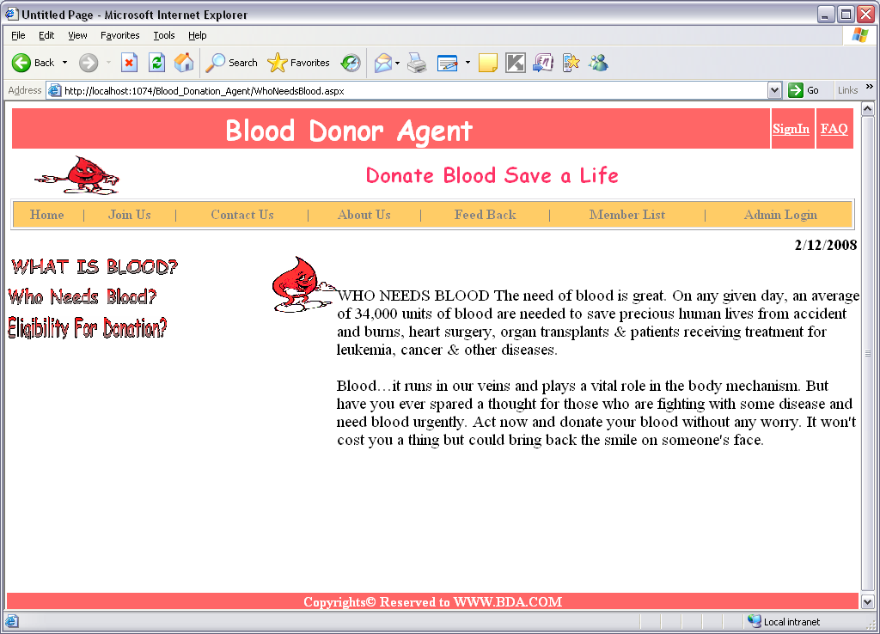

Admin Login
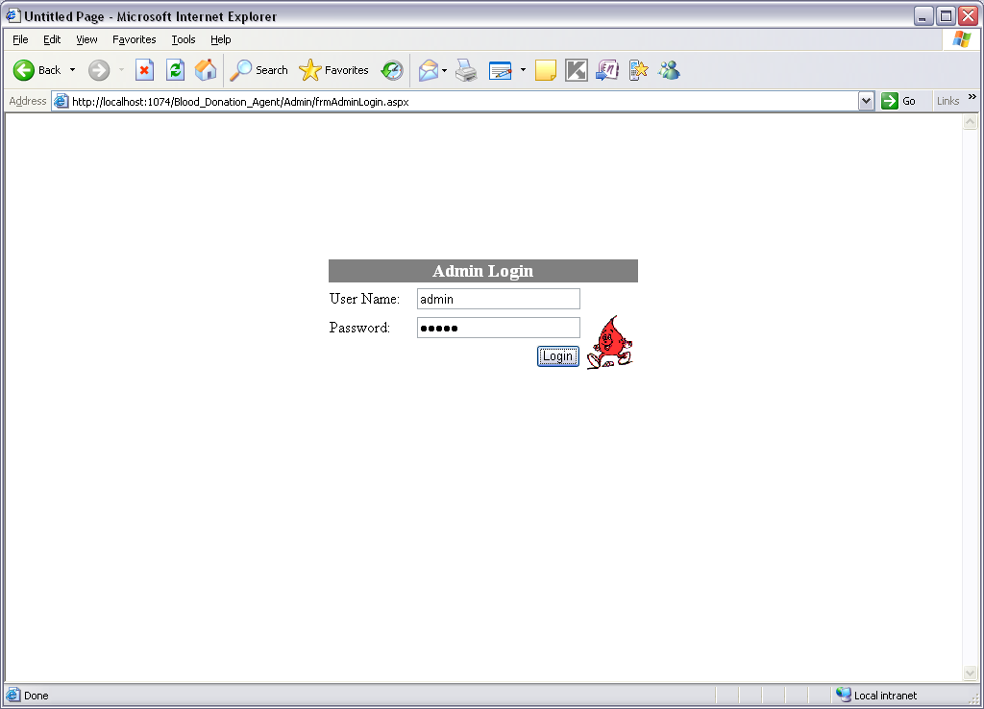
Admin Home
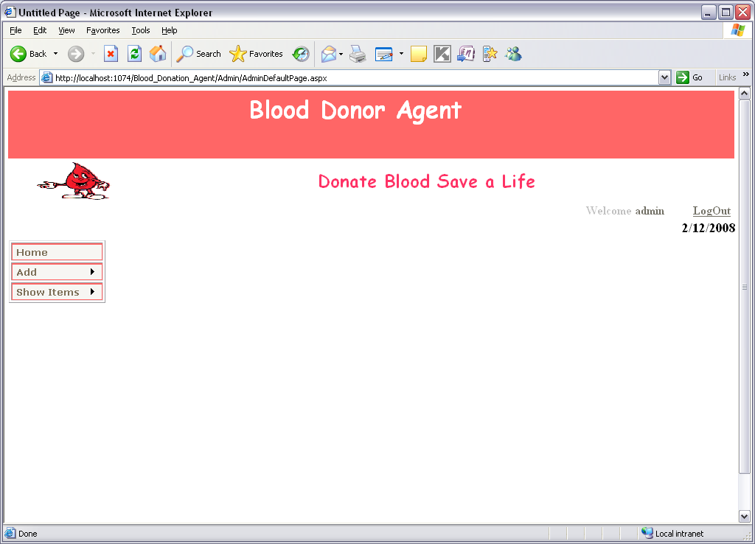

Add new Organization

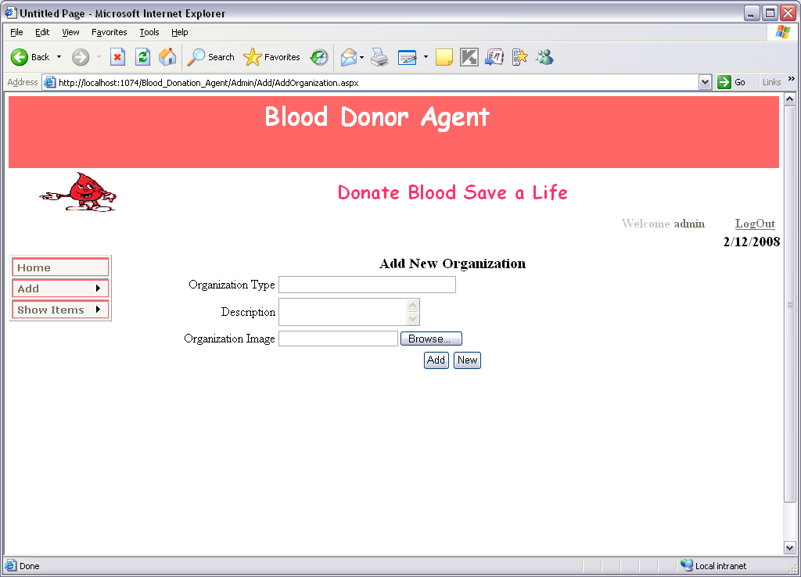
Retrieving Organization information
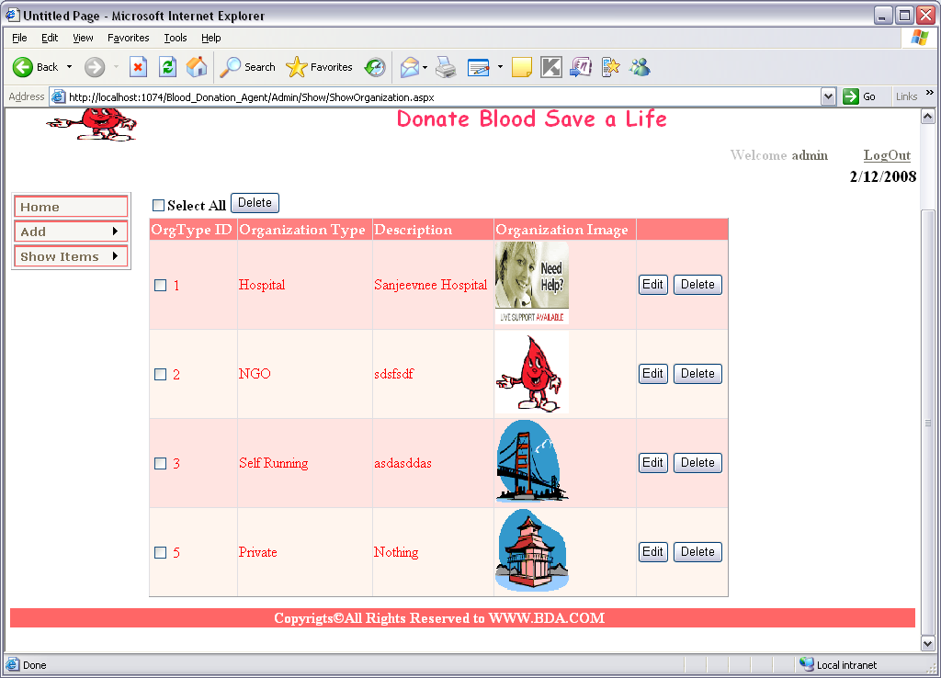

ADD NEW COUNTRY
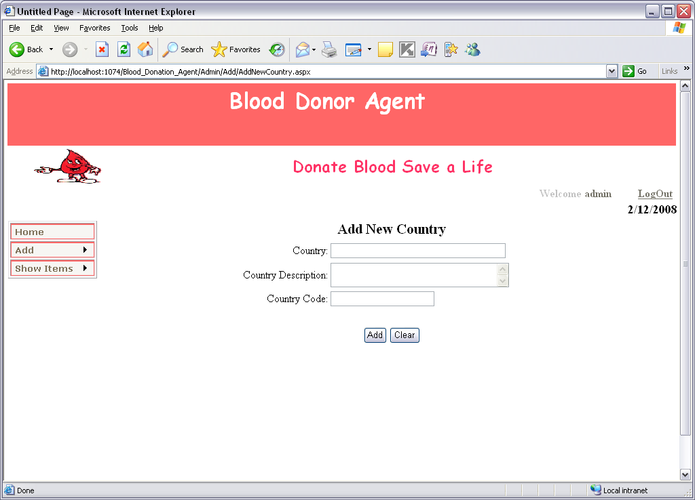
Country Information
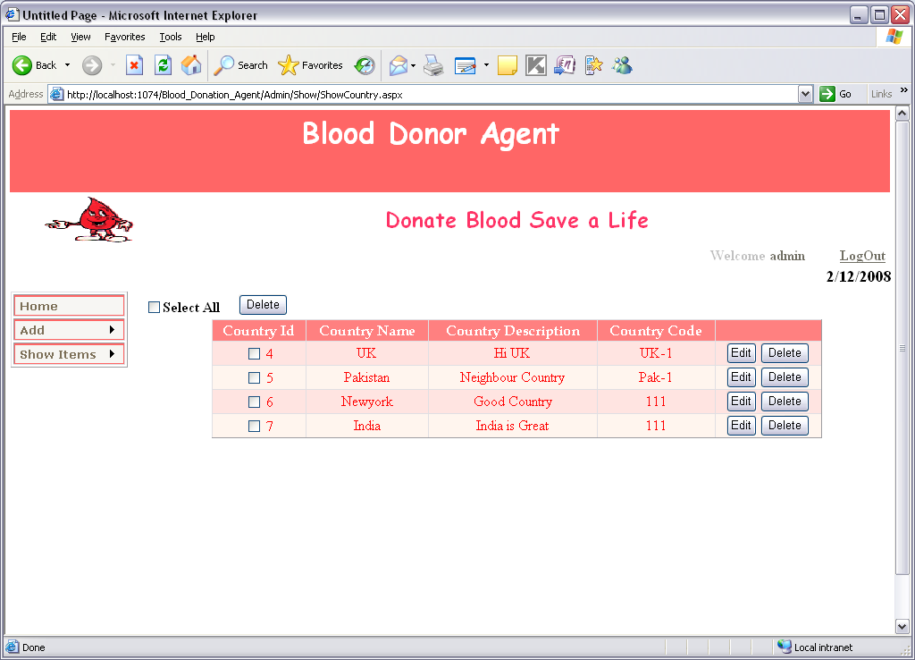

ADD NEW STATE
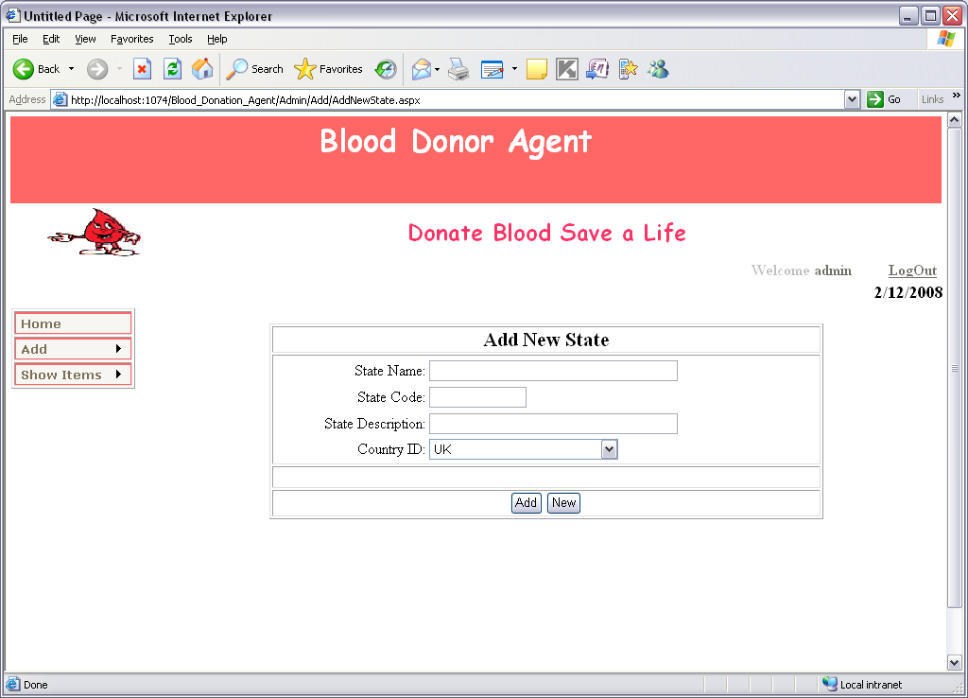
State Information
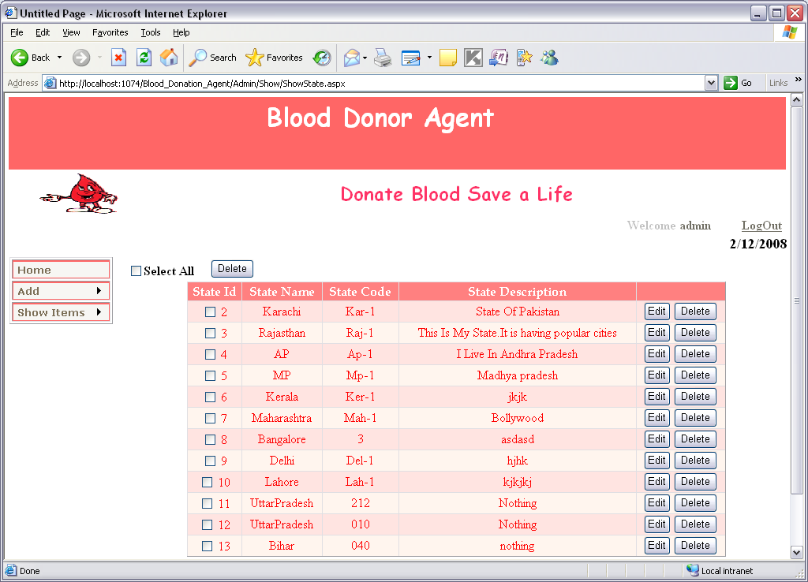

ADD NEW CITY
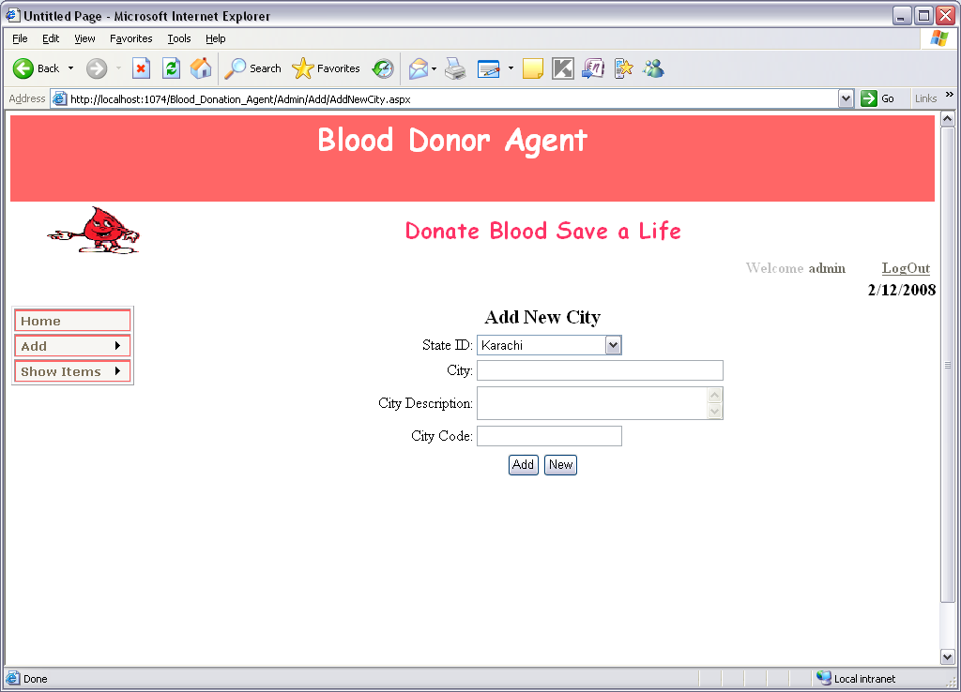
City Information
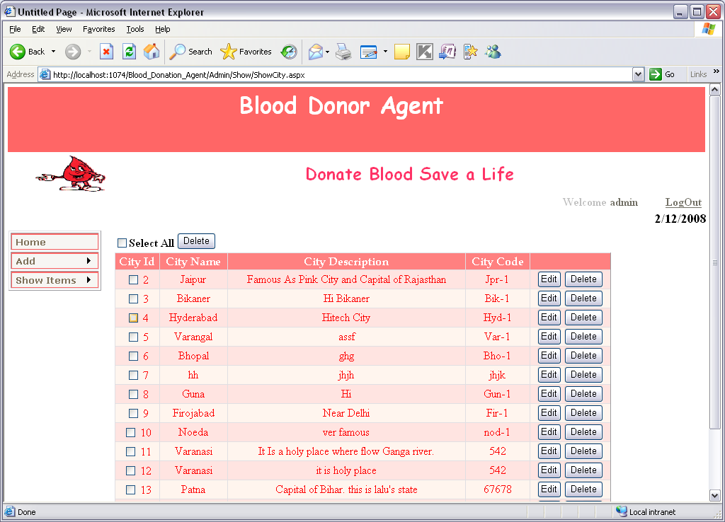

ADD NEW LOCATION
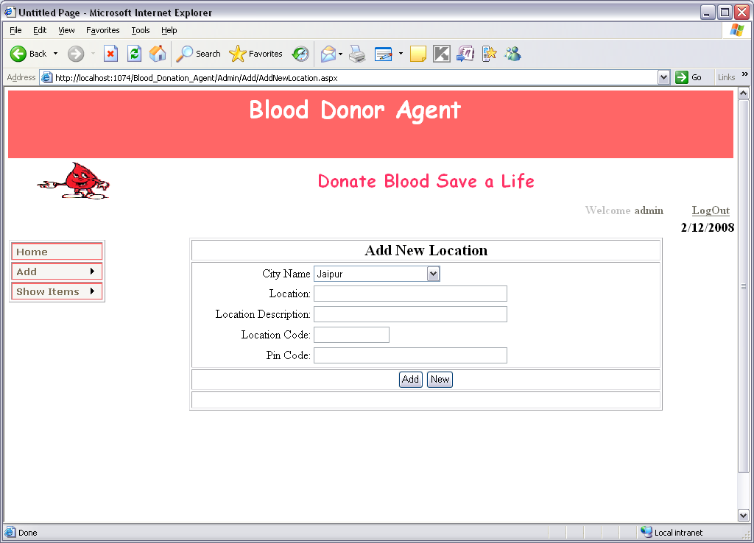
Location Information
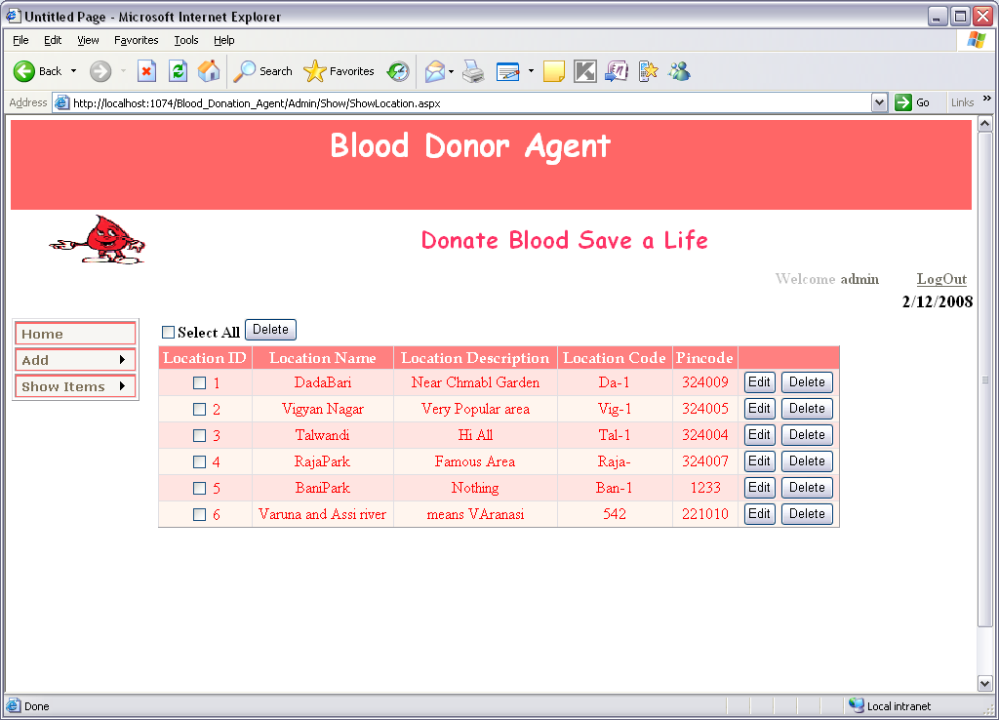

Registration Form For All Users
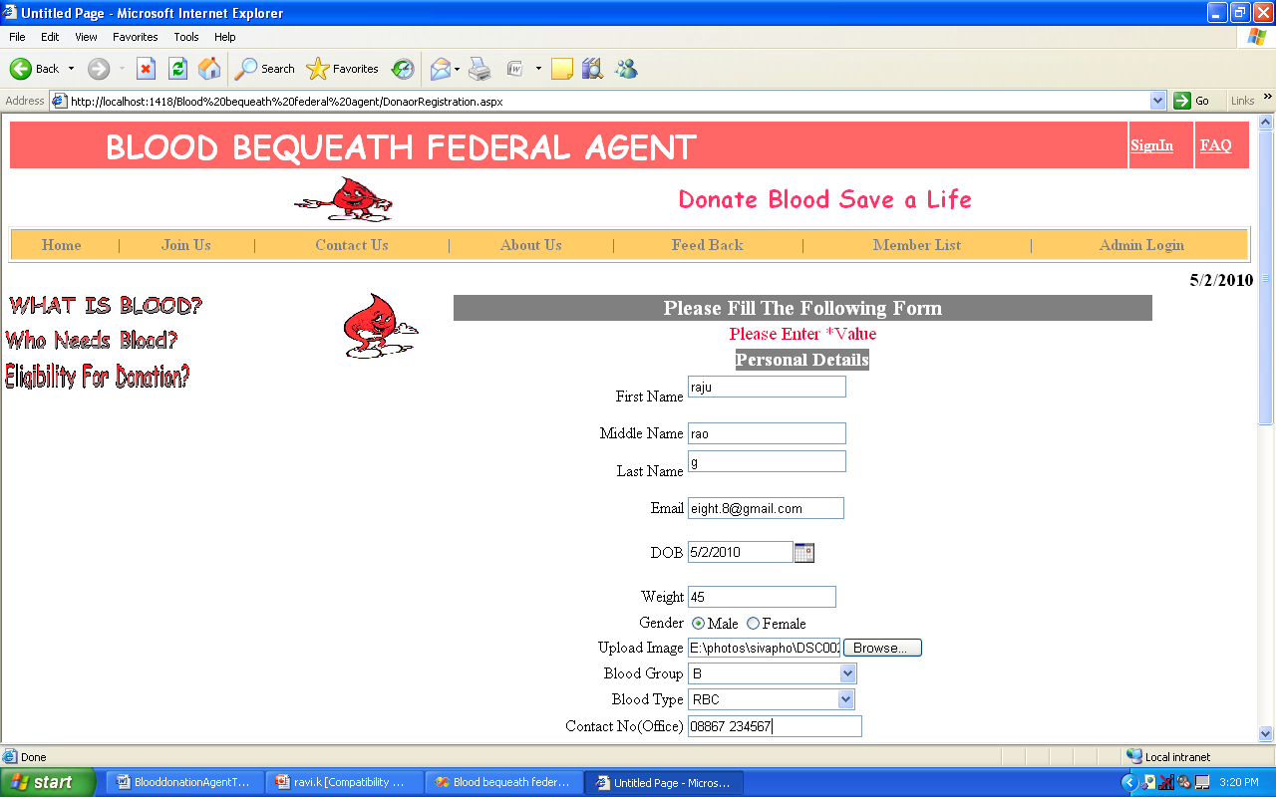
Login form
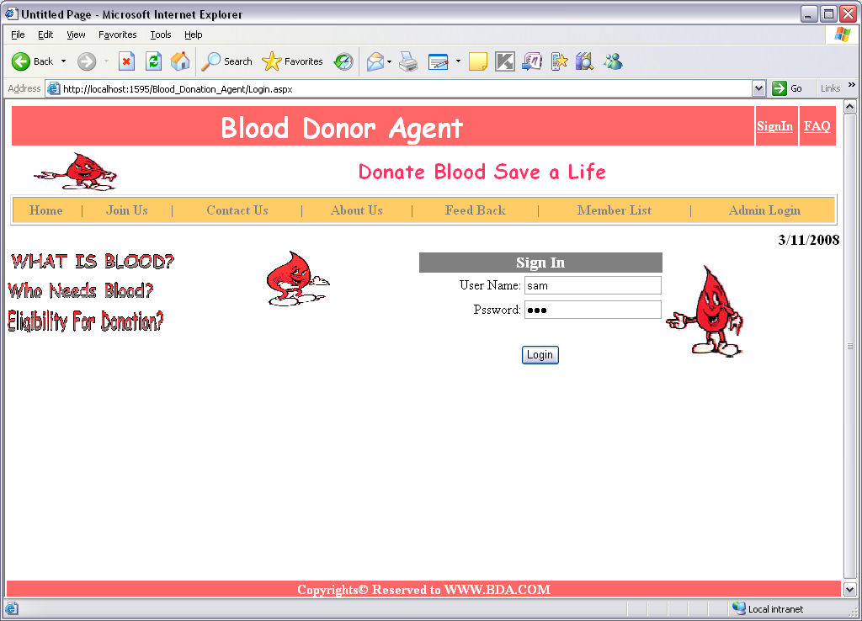

User Home
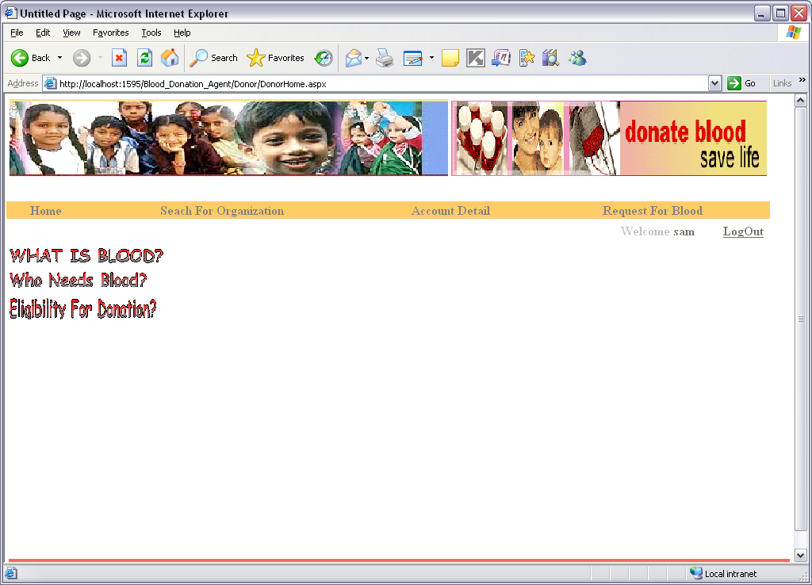

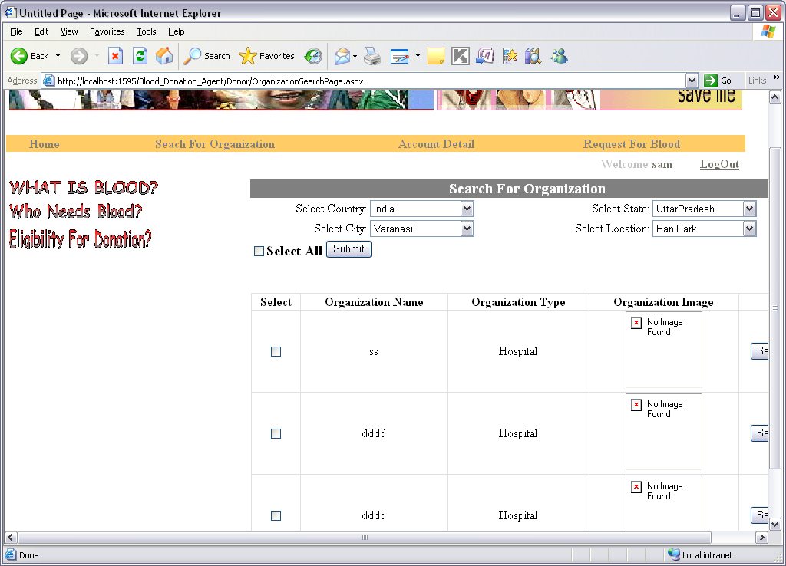
SearchForDonor

Update Account Details

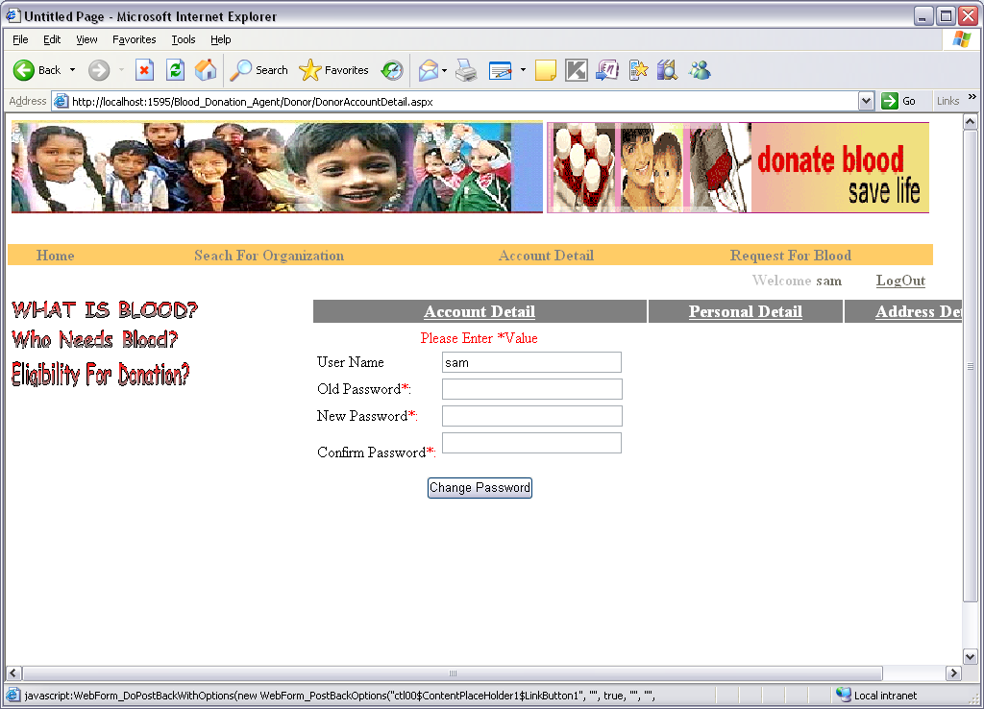

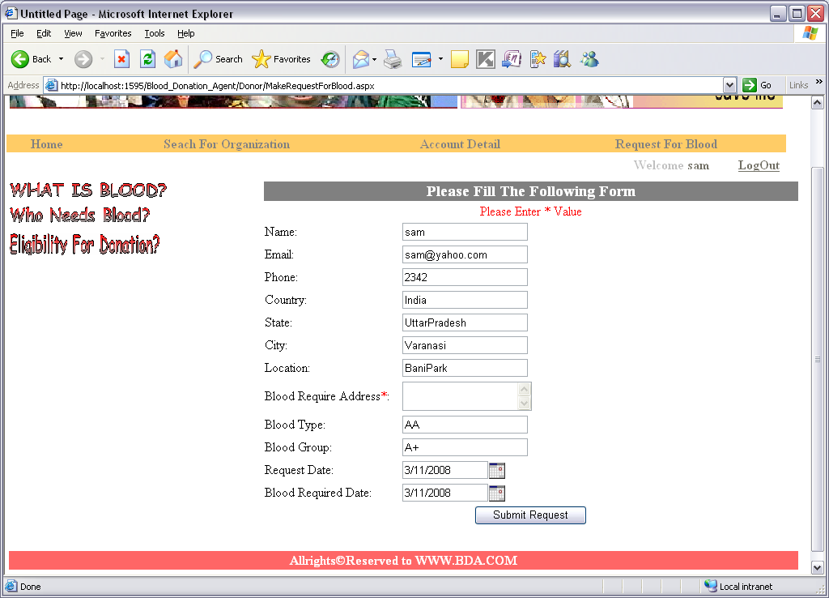
Request for blood

CONCLUSION
It has been a great pleasure for me to work on this exciting and challenging project. This project proved good for me as it provided practical knowledge of not only programming in ASP.NET and VB.NET web based application and no some extent Windows Application and SQL Server, but also about all handling procedure related with “Blood Bequeath Federal”. It also provides knowledge about the latest technology used in developing web enabled application and client server technology that will be great demand in future. This will provide better opportunities and guidance in future in developing projects independently.

BENEFITS:
The project is identified by the merits of the system offered to the user. The merits of this project are as follows: -
- It’s a web-enabled project.
- This project offers user to enter the data through simple and interactive forms. This is very helpful for the client to enter the desired information through so much simplicity.
- The user is mainly more concerned about the validity of the data, whatever he is entering. There are checks on every stages of any new creation, data entry or updation so that the user cannot enter the invalid data, which can create problems at later date.
- Sometimes the user finds in the later stages of using project that he needs to update some of the information that he entered earlier. There are options for him by which he can update the records. Moreover there is restriction for his that he cannot change the primary data field. This keeps the validity of the data to longer extent.
- User is provided the option of monitoring the records he entered earlier. He can see the desired records with the variety of options provided by him.

- From every part of the project the user is provided with the links through framing so that he can go from one option of the project to other as per the requirement. This is bound to be simple and very friendly as per the user is concerned. That is, we can sat that the project is user friendly which is one of the primary concerns of any good project.
- Data storage and retrieval will become faster and easier to maintain because data is stored in a systematic manner and in a single database.
- Decision making process would be greatly enhanced because of faster processing of information since data collection from information available on computer takes much less time then manual system.
- Allocating of sample results becomes much faster because at a time the user can see the records of last years.
- Easier and faster data transfer through latest technology associated with the computer and communication.
- Through these features it will increase the efficiency, accuracy and transparency,

9.1 LIMITATIONS:
- The size of the database increases day-by-day, increasing the load on the database back up and data maintenance activity.
- Training for simple computer operations is necessary for the users working on the system.

BIBLIOGRAPHY

- FOR .NET INSTALLATION
www.support.mircosoft.com
- FOR DEPLOYMENT AND PACKING ON SERVER
www.developer.com
www.15seconds.com
- FOR SQL
www.msdn.microsoft.com
- FOR ASP.NET
www.msdn.microsoft.com/net/quickstart/aspplus/default.com
www.asp.net
www.fmexpense.com/quickstart/aspplus/default.com
www.asptoday.com
www.aspfree.com
www.4guysfromrolla.com/index.aspx

