**PROGRESS TEST**

**Student’s name: Phạm Tuấn Kiệt**

**Student ID: SE171248**

**Components**:

**Task**:

**Description**:

**Reference:**

**ANSWER**

**Picture of your design:**

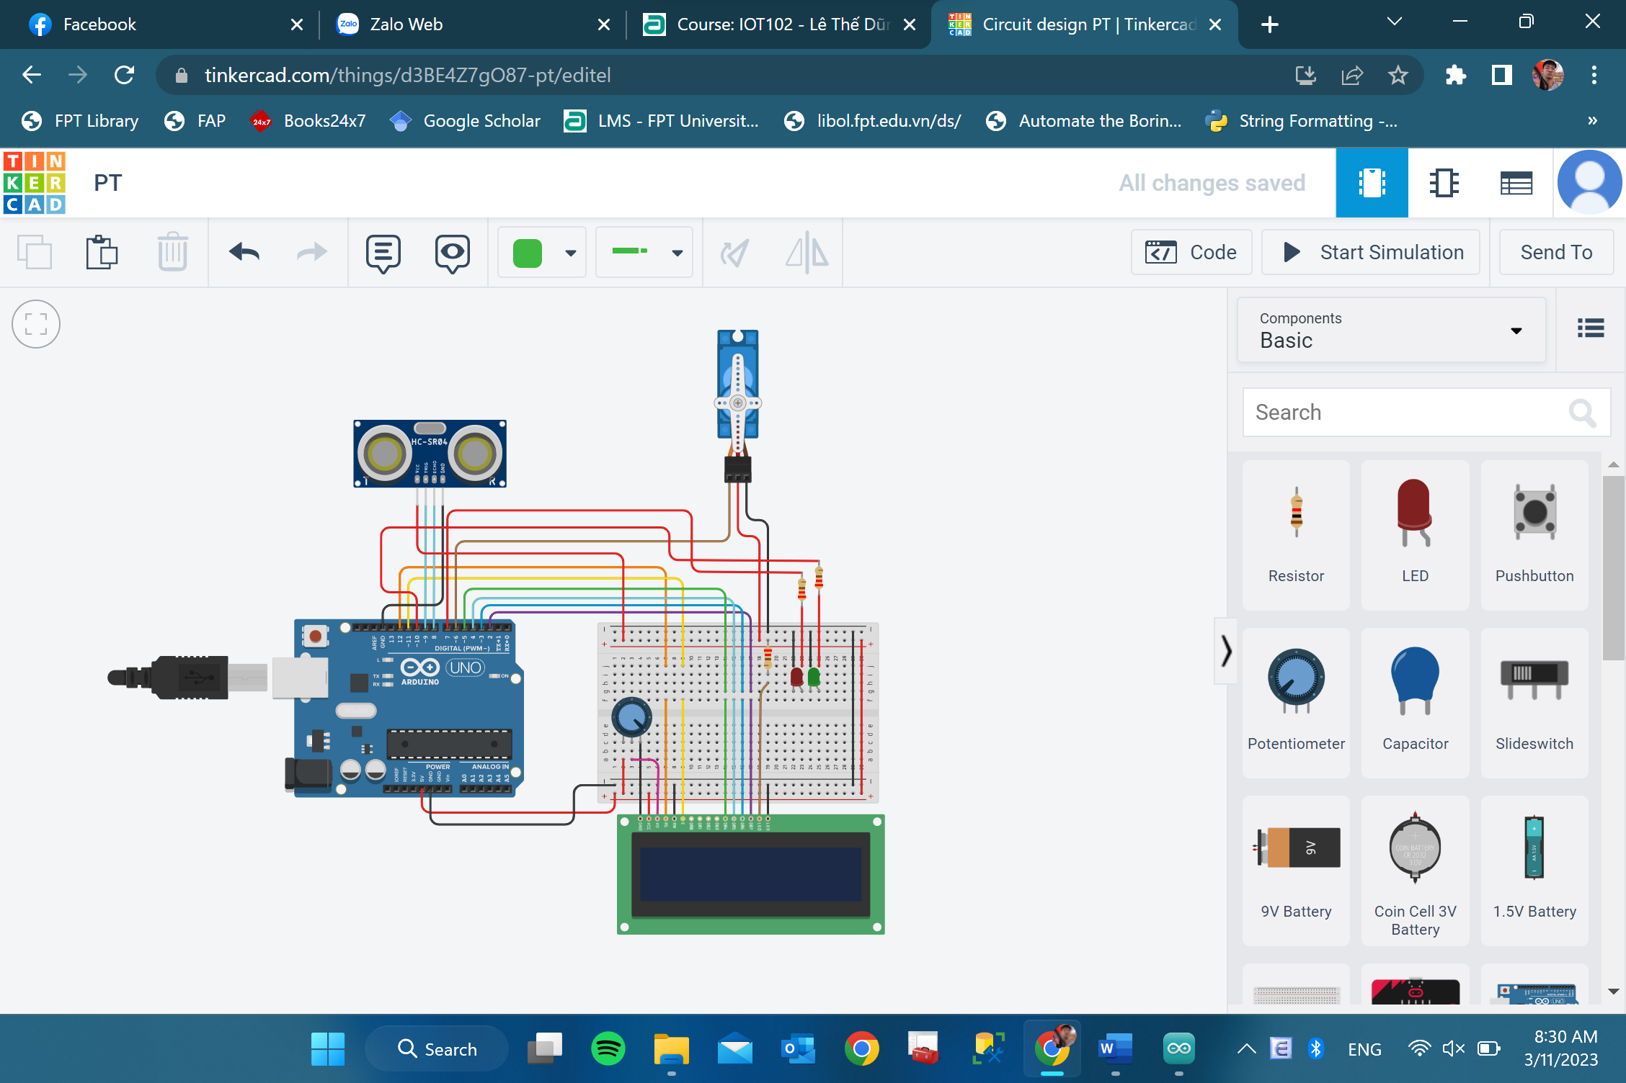

**Code:**

**#include <LiquidCrystal.h>**

**#include <Servo.h>**

**Servo myservo;**

**const int rs = 12, en = 11, d4 = 5, d5 = 4, d6 = 3, d7 = 2;**

**const unsigned int TRIG_PIN=9;**

**const unsigned int ECHO_PIN=8;**

**const unsigned int BAUD_RATE=9600;**

**int pos = 0; // variable to store the servo position**

**int redLed = 7, greenLed = 10;**

**int check = 0;**

**const int dis_th = 150;**

**const int delay_th = 2000;**

**LiquidCrystal lcd(rs, en, d4, d5, d6, d7);**

**void setup() {**

**pinMode(TRIG_PIN, OUTPUT);**

**pinMode(ECHO_PIN, INPUT);**

**Serial.begin(BAUD_RATE);**

**myservo.attach(6); // attaches the servo on pin 6 to the servo object**

**lcd.begin(16, 2);**

**pinMode(redLed, OUTPUT);**

**pinMode(greenLed, OUTPUT);**

**}**

**void loop() {**

**//sonic**

**digitalWrite(TRIG_PIN, LOW);**

**delayMicroseconds(2);**

**digitalWrite(TRIG_PIN, HIGH);**

**delayMicroseconds(10);**

**digitalWrite(TRIG_PIN, LOW);**

**const unsigned long duration= pulseIn(ECHO_PIN, HIGH);**

**int distance= duration/29/2;**

**if(duration==0){**

**Serial.println("Warning Error");**

**}**

**else{**

**if (distance <= dis_th && distance >= 80) {**

**Serial.print("Distance Barrier Open: ");**

**Serial.println(distance);**

**Serial.println(" cm");**

**lcd.setCursor(0, 0);**

**lcd.print("Barrier Opened");**

**digitalWrite(redLed, HIGH);**

**digitalWrite(greenLed, LOW);**

**for (pos = 0; pos <= 90 && !check; pos += 1) { // goes from 0 degrees to 180 degrees**

**// in steps of 1 degree**

**if (pos == 90) {**

**check = 1;**

**}**

**myservo.write(pos); // tell servo to go to position in variable 'pos'**

**delay(15); // waits 15ms for the servo to reach the position**

**}**

**} else {**

**delay(delay_th);**

**digitalWrite(redLed, LOW);**

**digitalWrite(greenLed, HIGH);**

**for (pos = 90; pos >= 0 && check; pos -= 1) { // goes from 0 degrees to 180 degrees**

**// in steps of 1 degree**

**if (pos == 0) {**

**check = 0;**

**}**

**myservo.write(pos); // tell servo to go to position in variable 'pos'**

**delay(15); // waits 15ms for the servo to reach the position**

**}**

**lcd.setCursor(0, 0);**

**lcd.print("Barrier Closed");**

**}**

**}**

**delay(100);**

**//servo**

**}**

**Link:** [**https://www.tinkercad.com/things/d3BE4Z7gO87-pt/editel?sharecode=nzcQI3R6gZLbhpYDRHylUAD3F7SdGjEkPA04kG1u_e4**](https://www.tinkercad.com/things/d3BE4Z7gO87-pt/editel?sharecode=nzcQI3R6gZLbhpYDRHylUAD3F7SdGjEkPA04kG1u_e4)