**PROGRESS TEST**

**Student’s name:**

**Student ID:**

**Components**:

**Task**:

**Description**:

**Reference:**

**ANSWER**

**Picture of your design:**

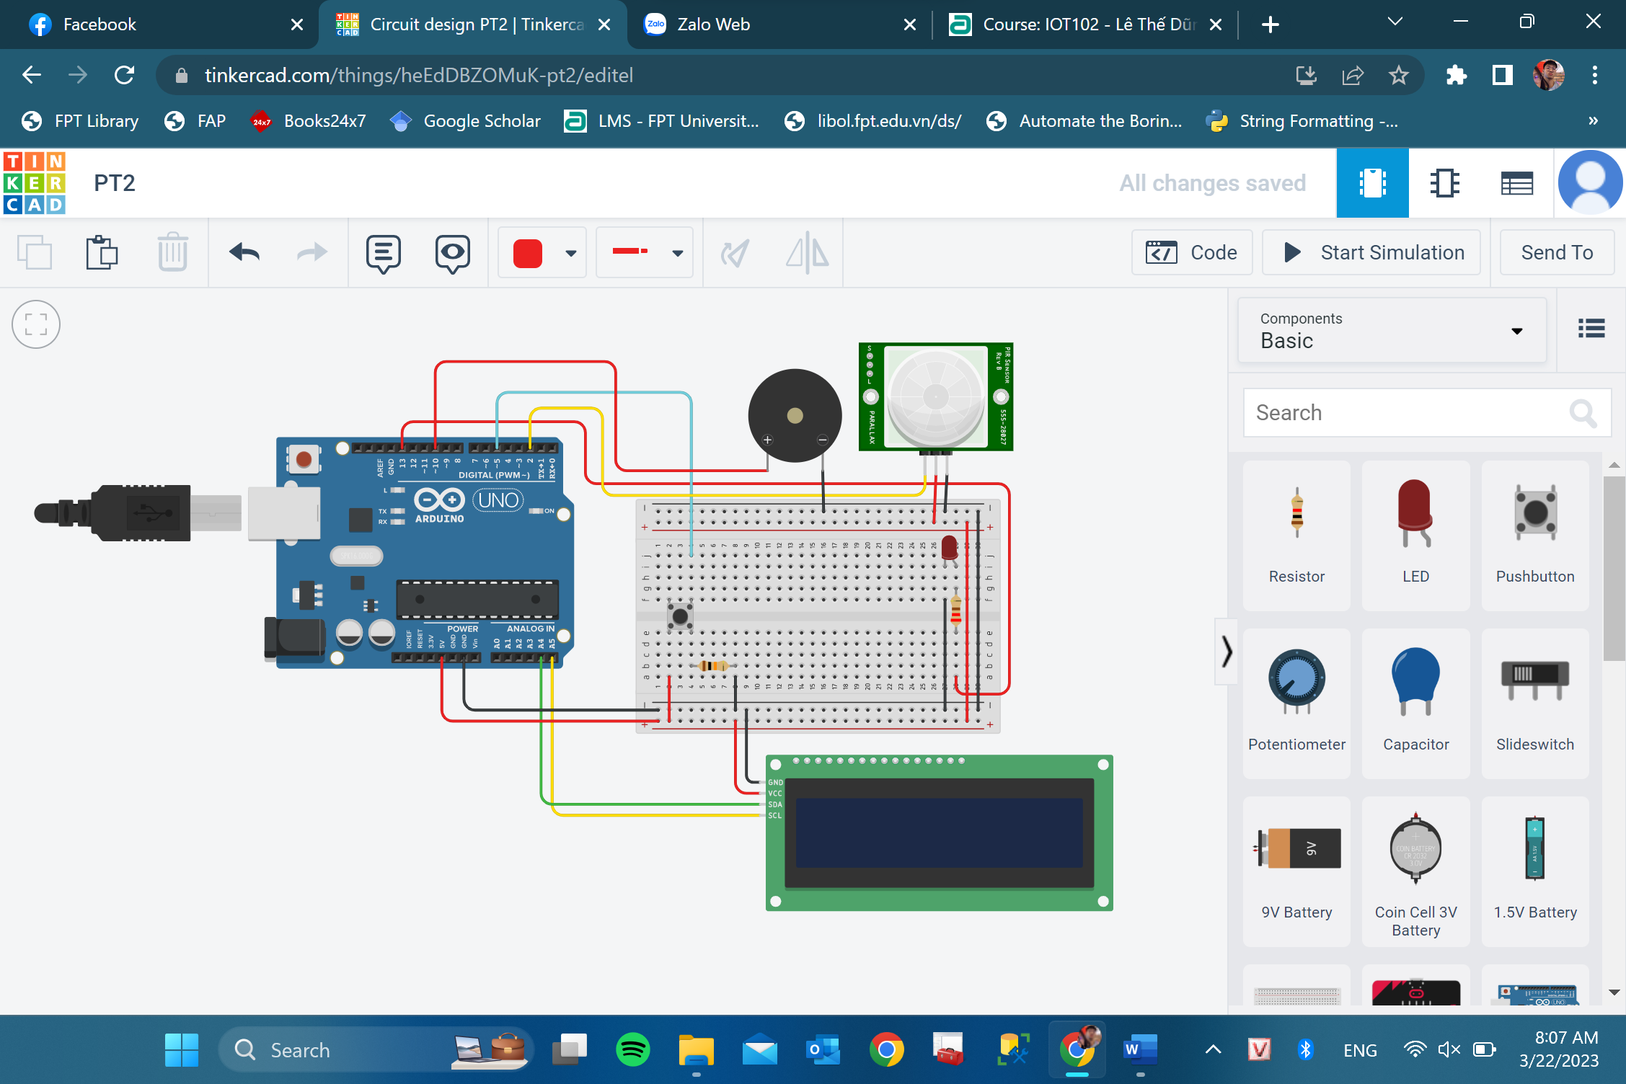

**Code:**

**#include <LiquidCrystal_I2C.h>**

**int but = 5;**

**int ledPin = 13;**

**int inputPin = 2;**

**int pirState = LOW;**

**int valPIR = 0;**

**int valButton = 0;**

**int pinSpeaker = 10;**

**LiquidCrystal_I2C lcd(0X27,16,2);**

**bool checkMotion = false;**

**void setup()**

**{**

**pinMode(but, INPUT);**

**pinMode(ledPin, OUTPUT);**

**pinMode(inputPin, INPUT);**

**pinMode(pinSpeaker, OUTPUT);**

**lcd.init();**

**lcd.backlight();**

**Serial.begin(9600);**

**}**

**void loop()**

**{**

**valPIR = digitalRead(inputPin);**

**if (valPIR == HIGH) {**

**checkMotion = true;**

**}**

**if (checkMotion) {**

**digitalWrite(ledPin, HIGH);**

**digitalWrite(pinSpeaker, HIGH);**

**lcd.setCursor(0, 0);**

**lcd.print("Motion detected!");**

**} else {**

**digitalWrite(ledPin, LOW);**

**digitalWrite(pinSpeaker, LOW);**

**}**

**valButton = digitalRead(but);**

**if (valButton == HIGH) {**

**checkMotion = false;**

**valPIR = LOW;**

**lcd.clear();**

**lcd.setCursor(0, 0);**

**lcd.print("Motion ended!");**

**}**

**delay(500);**

**}**

**Link:** [**https://www.tinkercad.com/things/heEdDBZOMuK-pt2/editel?sharecode=oDBWIY1Oq9a-oaRGih6uz0K8fCNTIeeXbp5BmVyivuU**](https://www.tinkercad.com/things/heEdDBZOMuK-pt2/editel?sharecode=oDBWIY1Oq9a-oaRGih6uz0K8fCNTIeeXbp5BmVyivuU)