  L1 Su23

Q1:

Software Requirements Specification

for

FU Library Management System (FULIBOL)

Version 1.0 approved

Prepared by

Pham Tuan Kiet – SE171248

Organization: FU Campus HCM

Date Created: Jul-24-2023

Q2:

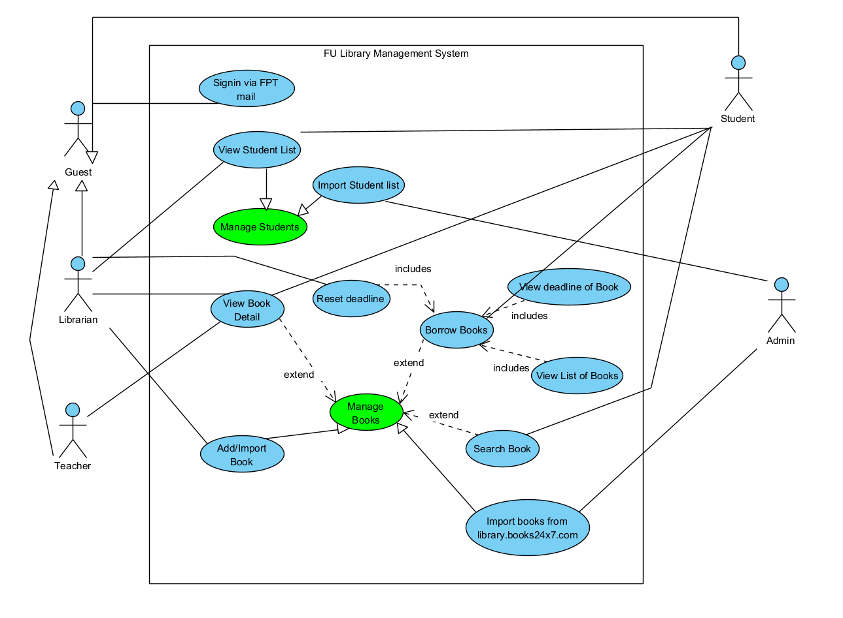

Q3:

|  |  |  |  |
| --- | --- | --- | --- |
| UC ID and Name: | **UC – 1 Borrow Book Management** | | |
| Created By: | **KietPTSE171248@fpt.edu.vn** | Date Created: | **Jul-24-2023** |
| Primary Actor: | **Student** | Secondary Actors: | **Librarian** |
| Trigger: | **Student wants to borrow book for studying.** | | |
| Description: | **This feature allows Student to borrow books from FU Library.** | | |
| Preconditions: | **1. Actor must sign in FPT email (@fpt.edu.vn)** | | |
| Postconditions: | **1. Success: The system show borrow message success**  **2. Fail: The system shows error message corresponding to error code** | | |
| Normal Flow: | |  |  |  | | --- | --- | --- | | Step | Actor Action | System Response | | **1** | **Student clicks the “Detail” button of the book that he/she wants to borrow** | **System redirects to book detail**  **screen** | | **2** | **Student clicks the “Borrow” button** | **System show borrow success**  **message** | | | |
| Alternative Flows: | 1. **The book of student not avaiblable in current:**  |  |  |  | | --- | --- | --- | | Step | Actor Action | System Response | | **1** | **Student clicks the “Detail” button of the book that he/she wants to borrow** | **System redirects to book detail**  **screen** | | **2** | **Student clicks the “Borrow” button** | **System show invalable message and as**  **ask student to request borrow this**  **book to the librarian.** |   **2. Student reset the deadline of the book:**   |  |  |  | | --- | --- | --- | | Step | Actor Action | System Response | | **1** | **Student clicks “Reset” button in the book detail** | **System show the reset form and ask**  **student to fill in.** | | **2** | **Student fill in the form and clicks “Send” button** | **System show sending success and send the form to the librarian.** | | | |
| Exceptions: | 1. **The reset form is empty** 2. **Student request reset deadline day in the past** | | |
| Priority: | **High** | | |
| Frequency of Use: | **Medium** | | |
| Business Rules: | **BR-01: Student can borrow from 7AM – 11:30AM and 13PM – 17PM from Monday to Saturday**  **BR-02: Student come to the FU Library to get books after requesting borrow**  **BR-03: Student must paid the penalty money for the books they borrow before learning next course.** | | |
| Other Information: | **Student can request borrow other books from the outsourcing by sending request to the library.** | | |
| Assumptions: | **Student must have FPT account and have internet connection to access the system** | | |

**Q4:**

**Non-functional 1: System must accept more than 500 students per hours**

**Non-functional 2: Only Student with mail FPT can see the books list**