EVENT INFORMATION

Journey to the Planets
Starlight Science Center – Ho Chi Minh City

Date | Saturday, 17 October 2026
Time | 8:00 - 17:00
Venue | Main Hall, Starlight Science Center
Contact | info@starlightsciencecenter.vn

Exhibition Overview
Starlight Science Center presents a new exhibition that takes visitors on a journey through the solar system.
Interactive screens, models, and a planetarium show help visitors learn about each planet.

The Inner Planets
Mercury, Venus, Earth, and Mars are rocky planets close to the Sun.
Mars is the most explored planet after Earth, with several rovers still working on its surface.

The Outer Planets
Jupiter, Saturn, Uranus, and Neptune are giant planets made mostly of gas and ice.
Tip: Mercury is one of our key topics this year.
Saturn's rings are made of billions of pieces of ice and rock.

Planetarium Shows
The planetarium dome shows the night sky as it appears from different places on Earth.
Shows start every hour and last thirty minutes.
Planet | Type | Moons
Mercury | Rocky | 0
Jupiter | Gas giant | 95
Earth | Rocky | 1
Saturn | Gas giant | 146
Mars | Rocky | 2
Neptune | Ice giant | 16

Space Missions
The exhibition describes famous missions such as Apollo 11, Voyager, and the James Webb Space Telescope.
Visitors can sit inside a model of a space capsule.

School Visits
Starlight Science Center offers guided tours and worksheets for school groups.
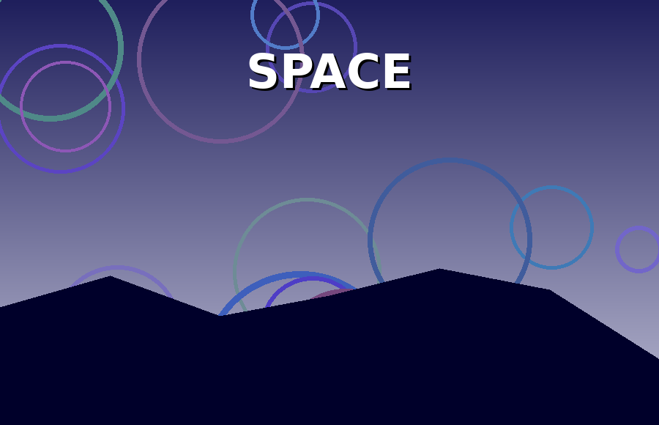
Above: Starlight Science Center
Teachers can download lesson plans from our website.

