ANNUAL REPORT 2026

Weekly Vegetable Box Report
Delta Organic Farm – Hanoi

Organization | Delta Organic Farm
Prepared by | Nguyen Van An
Date | September 2026
Status | Final draft

About the Farm
Delta Organic Farm grows vegetables without chemical pesticides on twenty hectares in Tien Giang province.
We deliver fresh boxes to more than one thousand families every week.

How the Subscription Works
Customers choose a small, medium, or large box and receive it every Friday.
Delta Organic Farm changes the vegetables each week based on the season.
Vegetable | Group | Weight (kg)
Morning glory | Leafy | 1.0
Sweet potato | Root | 2.0
Bok choy | Leafy | 0.8
Carrot | Root | 1.5
Basil | Herb | 0.2
Coriander | Herb | 0.2

This Season's Harvest
The current harvest includes morning glory, bok choy, sweet potatoes, and herbs.
Dragon fruit and pomelo will be added next month.

Farming Methods
We use compost, crop rotation, and natural predators to keep the soil healthy.
Remember: Morning glory is one of our key topics this year.
Drip irrigation saves water during the dry season.

Farm Visits
Families can visit the farm on the first Sunday of every month to pick vegetables and learn about organic farming.
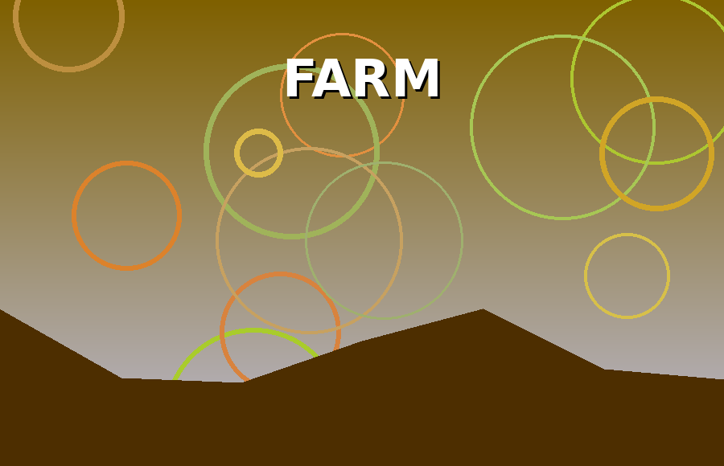
Above: Delta Organic Farm
Children especially enjoy feeding the ducks and planting seeds.
- Morning glory
- Bok choy
- Sweet potatoes
- Carrots
- Basil

Customer Feedback
Customers say the vegetables taste fresher and last longer than supermarket products.
Delta Organic Farm welcomes suggestions for new products.

Source: internal survey.
Figures rounded to the nearest whole number.

