EVENT INFORMATION

Recycling Made Simple
Clean City Initiative – Ho Chi Minh City

Date | Friday, 20 November 2026
Time | 18:00 - 21:30
Venue | Main Hall, Clean City Initiative
Contact | info@cleancityinitiative.vn

Why Recycle?
Recycling reduces waste, saves energy, and protects natural resources. Clean City Initiative wants every household to recycle.
Each ton of recycled paper saves about seventeen trees.

What Can Be Recycled?
Paper, cardboard, glass bottles, metal cans, and many plastic containers can be recycled.
Items should be clean and dry before they are placed in the recycling bin.

What Cannot Be Recycled?
Food waste, dirty tissues, and broken ceramics should not be placed in recycling bins.
Remember: Paper is one of our key topics this year.
Batteries and electronics must be taken to special collection points.

Collection Schedule
Recycling is collected once a week in every district. Check the schedule for your street.
Bins should be placed outside before 7:00 on collection day.
Material | Bin color | Recycling rate (%)
Paper | Blue | 68
Glass | Green | 45
Plastic | Yellow | 30
Metal | Yellow | 55
Cardboard | Blue | 72
Food waste | Brown | 20

Composting at Home
Food scraps and garden waste can be turned into compost for plants.
Clean City Initiative gives free compost bins to families who attend a short workshop.

Get Involved
Join a neighborhood clean-up day or become a recycling volunteer.
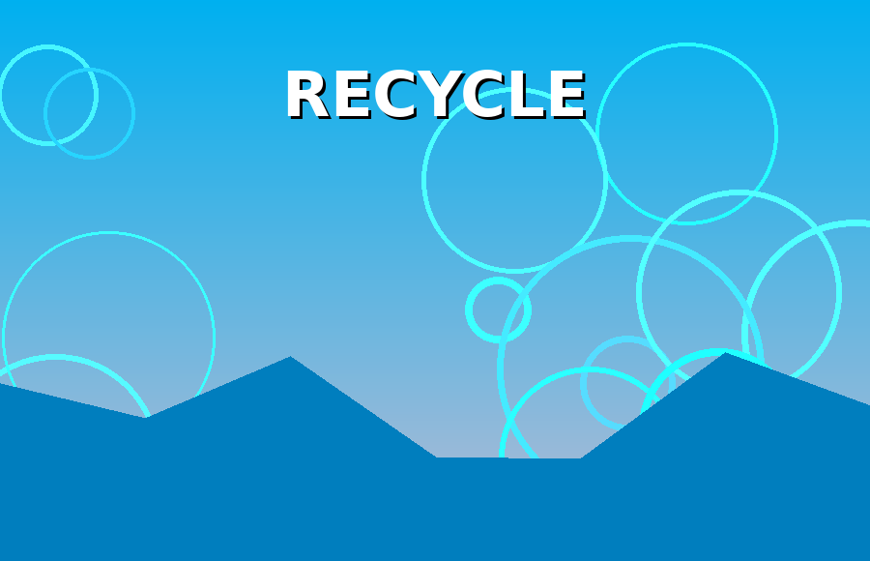
Above: Clean City Initiative
Together we can make our city cleaner and greener.

