TRAINING MANUAL · 2026

Computer
TechStart Academy – Can Tho

Department | TechStart Academy Training Team
Version | 3.0
Last updated | September 2026

History of the Computer
The first electronic computers were built in the 1940s and filled entire rooms.
The invention of the microchip made computers smaller, faster, and cheaper.

What Parts Are Needed for a Computer to Work?
A computer needs several basic parts to work. TechStart Academy students learn to identify each part.
The list below shows common parts and their functions.

How Are Computers Used Today?
Computers are used in schools, hospitals, banks, factories, and homes.
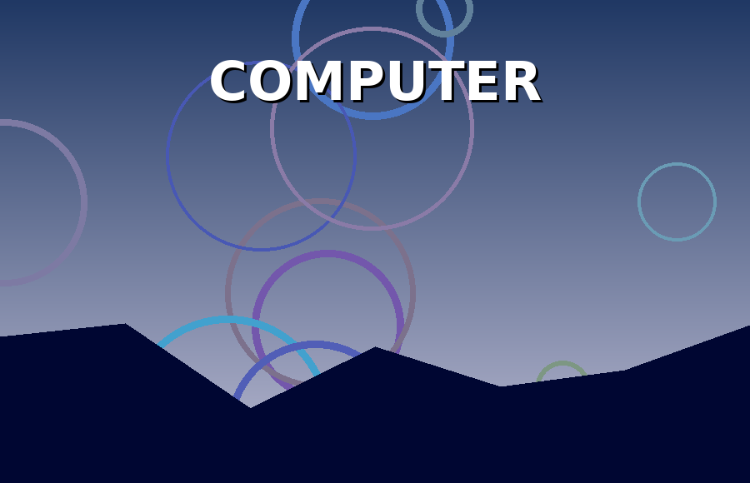
Above: TechStart Academy
Smartphones and tablets are also small computers that people carry every day.

Computer Connections
Computers connect to the internet through cables, Wi-Fi, or mobile networks.
TechStart Academy teaches students how to stay safe online.
Part | Type | Price ($)
Processor | Internal | 250
Monitor | External | 180
Keyboard | External | 25
Memory | Internal | 80
Mouse | External | 15
Hard drive | Internal | 90

Software
Software includes operating systems, office programs, games, and web browsers.
Did you know? Processor is one of our key topics this year.
Students practice with word processing and spreadsheet programs every week.

Careers in Technology
Technology careers include programming, network administration, graphic design, and data analysis.
TechStart Academy helps students find internships with local companies.

