TRAINING MANUAL · 2026

Urban Gardening Guide
Green Thumb Garden Center – Can Tho

Department | Green Thumb Garden Center Training Team
Version | 2.1
Last updated | September 2026

Getting Started
Urban gardening lets city residents grow vegetables, herbs, and flowers on balconies and rooftops.
Green Thumb Garden Center offers everything you need to start your own garden.

Choosing Containers
Pots, grow bags, and recycled boxes can all be used as containers. Make sure each container has drainage holes.
Larger containers hold more water and need less frequent watering.
Plant | Type | Days to harvest
Basil | Herb | 30
Cherry tomato | Vegetable | 65
Mint | Herb | 25
Chili pepper | Vegetable | 80
Marigold | Flower | 50
Lettuce | Vegetable | 40
Total

Soil and Compost
Use light potting soil mixed with compost to give plants the nutrients they need.
Kitchen waste such as vegetable peels can be turned into compost at home.

Basil
Mint
Lemongrass
Cherry tomato
Chili pepper

Watering
Water plants early in the morning or late in the afternoon to reduce evaporation.
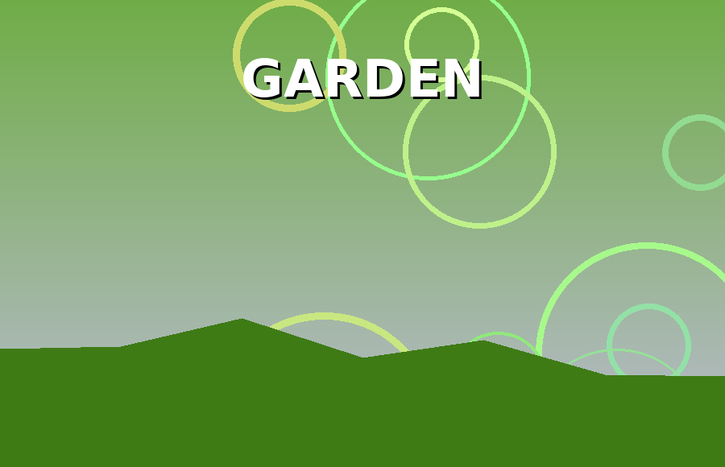
Photo: Green Thumb Garden Center
Self-watering pots are useful for people who travel often.

Easy Plants for Beginners
Herbs such as basil, mint, and lemongrass grow quickly and need little care.
Cherry tomatoes and chili peppers are also good choices for sunny balconies.

Workshops
Green Thumb Garden Center holds free workshops every Sunday morning.
Tip: Basil is one of our key topics this year.
Topics include composting, pest control, and growing plants from seeds.

