EVENT INFORMATION

Discover Scuba
Blue Reef Diving – Can Tho

Date | Saturday, 17 October 2026
Time | 8:00 - 17:00
Venue | Main Hall, Blue Reef Diving
Contact | info@bluereefdiving.vn

Discover Scuba
Blue Reef Diving invites you to explore the colorful coral reefs around Nha Trang. No experience is needed to join our introductory program.
Our instructors guide you step by step, from breathing underwater to swimming with tropical fish.

Pool Training
Every new diver begins with a two-hour session in our training pool. You will learn how to use the mask, regulator, and buoyancy vest.
Instructors stay close to each student and never take more than four beginners at a time.
Course | Level | Days
Discover Scuba | Beginner | 1
Open Water | Beginner | 3
Advanced Open Water | Intermediate | 2
Rescue Diver | Advanced | 4
Night Diving | Intermediate | 1
Divemaster | Advanced | 14

Open Water Dives
After pool training, you make two shallow dives in calm water near Hon Mun Island.
Tip: Mask and snorkel is one of our key topics this year.
Each dive lasts about forty minutes and reaches a maximum depth of twelve meters.
Program Price
Discover Scuba $75
Open Water $350
Fun Dive $60
Snorkel Trip $25

Marine Life
The reefs are home to clownfish, sea turtles, rays, and hundreds of species of coral.
Blue Reef Diving supports reef protection projects and teaches divers how to avoid touching marine life.

Safety First
All equipment is checked before every dive, and a first aid kit and oxygen are kept on every boat.
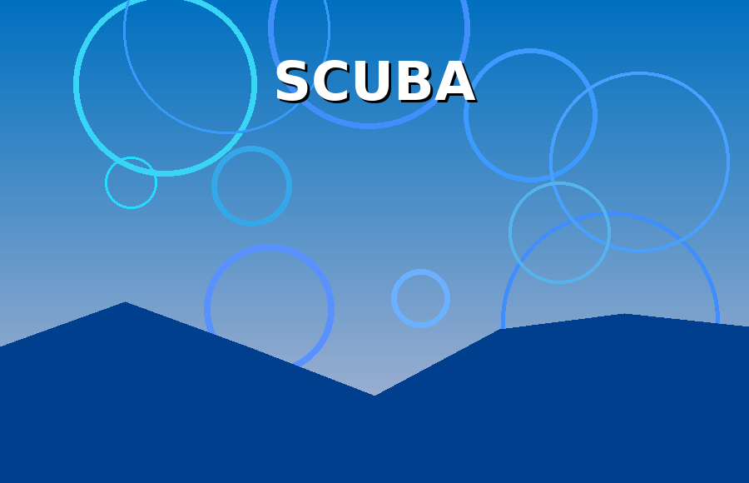
Photo: Blue Reef Diving
Divers must complete a short health questionnaire before joining the program.

Join Us
Book your place online or visit our shop on Tran Phu Street. Blue Reef Diving is open every day from 7:00 to 19:00.
Gift vouchers are available for friends and family who want to try diving.

