NEWSLETTER · ISSUE 19 · SEPTEMBER 2026

Dinosaurs Through Time
Lotus Museum – Ho Chi Minh City

When and Where Dinosaurs Lived
Dinosaurs lived on every continent for more than 160 million years. At Lotus Museum, visitors learn how the climate changed during this long period and how those changes shaped the animals.
The earliest dinosaurs were small and fast. Later species became enormous, and some developed feathers, horns, or armored plates that helped them survive.

Geologic Eras
Scientists divide the age of dinosaurs into three periods: the Triassic, the Jurassic, and the Cretaceous. Each period had different plants, seas, and continents.
The table in this section lists several well-known dinosaurs together with the period in which they lived and their estimated length.

Ornithischian Dinosaurs
Ornithischian dinosaurs were plant eaters with a bird-like hip structure. Many of them lived in herds and moved slowly across open plains.
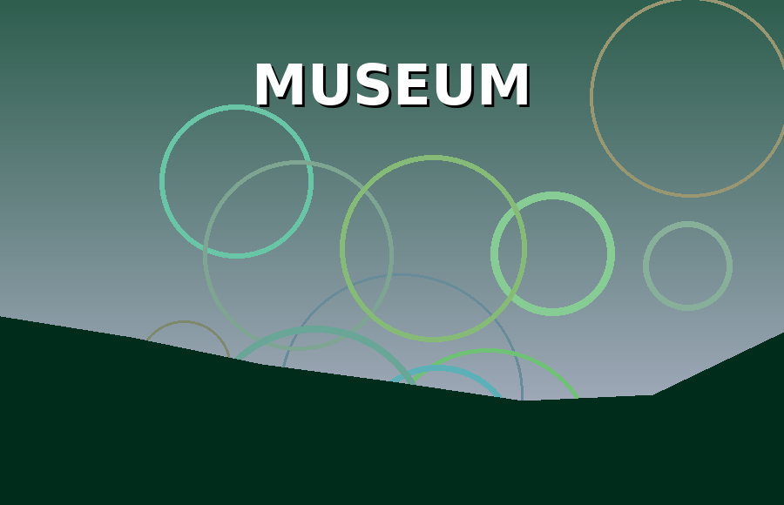
Photo: Lotus Museum
Researchers at Lotus Museum study their teeth and jaws to understand what these animals ate and how they chewed tough plants.

Theropod Dinosaurs
Theropods were mostly meat eaters that walked on two legs. The group includes famous hunters such as Tyrannosaurus and Velociraptor.
Modern birds are the living descendants of small feathered theropods, which makes this group especially important for scientists.
Dinosaur | Geologic period | Length (m)
Stegosaurus | Jurassic | 9
Triceratops | Cretaceous | 8
Coelophysis | Triassic | 3
Brachiosaurus | Jurassic | 22
Velociraptor | Cretaceous | 2
Plateosaurus | Triassic | 8

Fossil Discoveries
Fossils form when bones are buried quickly by mud or sand. Over millions of years, minerals replace the original material and preserve the shape of the bone.
Highlight: Walked on two legs is one of our key topics this year.
Every year, field teams uncover new specimens that change our understanding of how dinosaurs looked and behaved.

Kids Love Dinosaurs
Our family gallery offers touchable fossil casts, drawing stations, and a digging pit where young visitors can become paleontologists for a day.
Teachers can book guided tours that connect the exhibits with science lessons taught in primary schools.

