|  |  |  |
| --- | --- | --- |
| **ID** | **Name** | Introduction to Aritificial Intelligence  18CLC1  **Project: Wumpus World** |
| **18127259** | Kiều Công Hậu |
| **18127267** | Trần Đình Sang |

**REPORT**

1. Assignment plan:
2. Estimating the degree of completion level for each requirement:
3. Directories structure:

* ***Assets***: this folder contains images for GUI, map’s inputs (text file), map’ outputs (text file).
* ***Source***: this folder contains the source code.
* ***Report.pdf***: report.

1. **Enviroment:**

* Language: Python (3.7.6).
* Library:
  + pygame
  + pysat.solvers
  + enum
  + copy
  + sys

1. **Instruction:**

* Step 1: Compile and build the program at file ***Main.py*** in folder ***Source***.
* Step 2: Choose 1 of 5 maps.

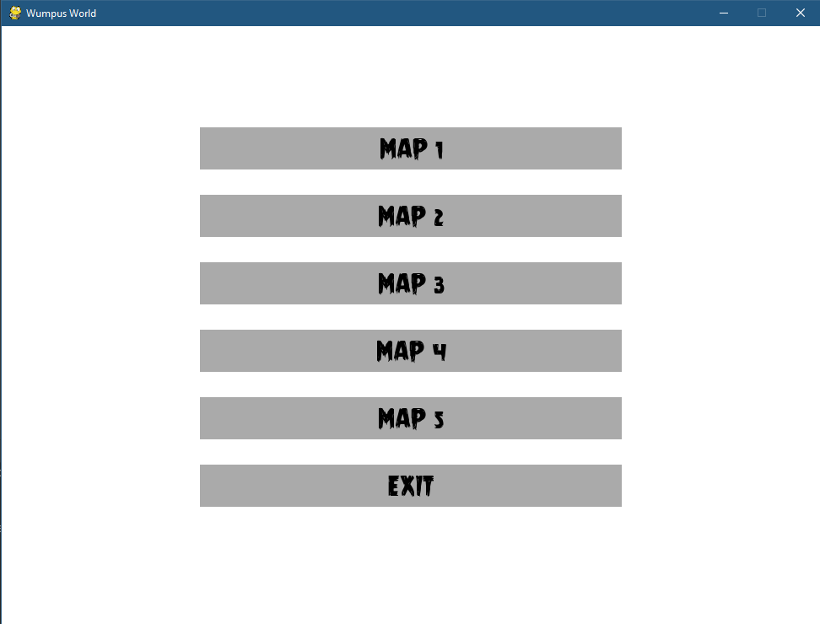

* Step 3: The Agent will automatically explore the cave, kill the Wumpus and grab Gold.

1. **References:**

* Source code of Problem 3 – Homework 03 (Puzzle game board) of this course.