2033210593_Cao Nguyễn Kiều Duyên

Binary_Search

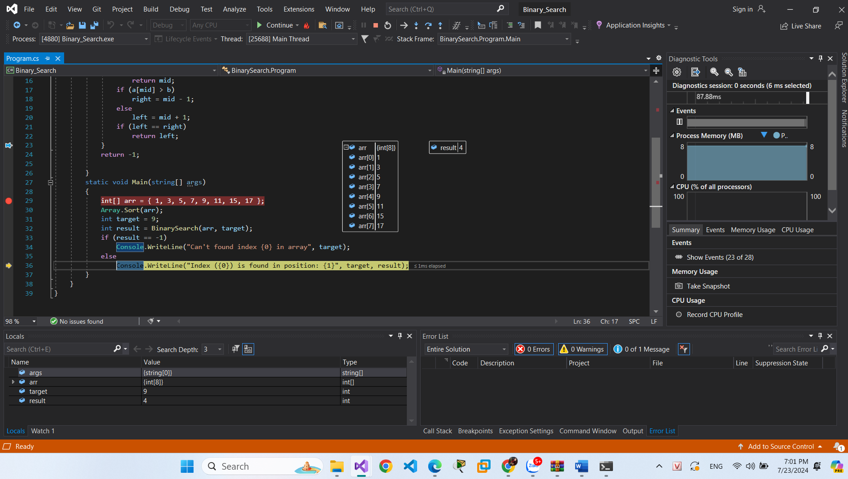

Merge_Sort

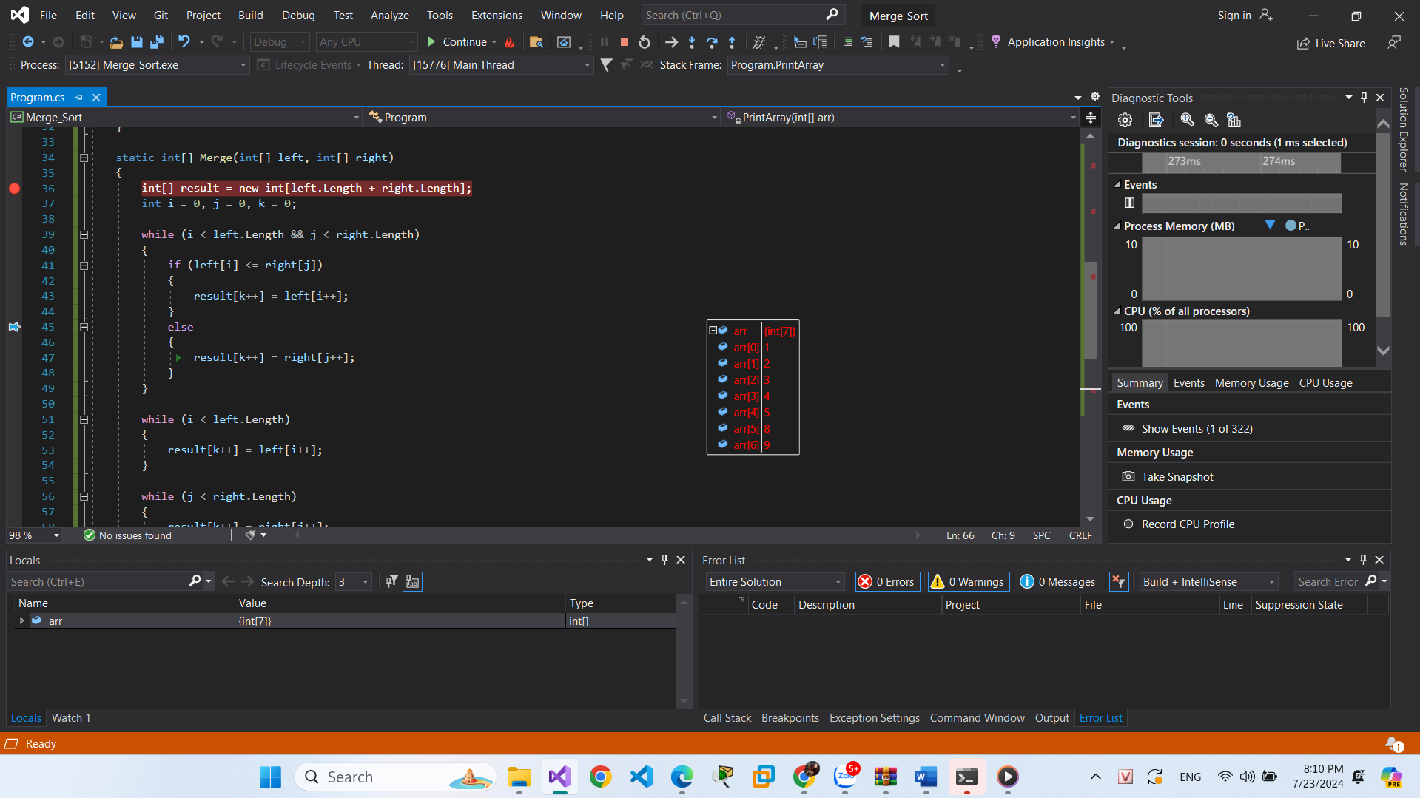

Big_Number_Multi

