HANOI UNIVERSITY
Faculty of Information Technology
Java Software Development
-------------oOo-------------


ONLINE QUIZ FOR ENGLISH CENTER
Instructor: Ngô Văn Quyền
Group: 13
Course: Java Software Development
Academic Year: 2026 – 2027
Team Members:
2301040043 – Kiều Huy Đôn
2301040196 – Nguyễn Trọng Bảo Việt
2301040129 – Đặng Phương Nam
2301040017 – Đào Xuân Bắc
2301040201 – Nguyễn Trịnh Võ

Abstract
Language centers routinely administer short, weekly quizzes across dozens of parallel classes. Handling this workflow on paper wastes hours on manual marking and grade entry. To solve this, we engineered a desktop Client/Server testing system in Java. The application accepts three specific test formats: standard 4-choice items (A–D), binary true/false questions, and multi-word blanks separated by the pipe character ('|'). Three explicit privilege tiers—Administrator, Teacher, and Student—are validated on the backend. This strict separation blocks students from viewing solutions, altering timers, or modifying test records. Three convenience scripts (setup-db.bat, run-server.bat, and run-client.bat) handle database provisioning and runtime launch.
Our implementation runs on Java 21 and JavaFX 21.0.5, using raw TCP sockets and PostgreSQL 16. Four Maven modules split the architecture: quiz-common, quiz-server, quiz-client, and quiz-benchmark. We use Java 21 Virtual Threads [1] on connection readers, throttling total admitted sockets with Semaphore(100). Once decoded, requests queue into an ArrayBlockingQueue(200) fed to 8 worker threads. This thread boundary prevents blocking database queries from starving socket I/O. On the client, QuizApi wraps each request in a CompletableFuture, keeping the JavaFX Application Thread responsive [3]. In the background, a ScheduledExecutorService task sweeps PostgreSQL every second to close expired attempts.
Several defense-in-depth measures protect exam integrity. MessageCodec enforces a 1 MiB frame ceiling and restricts deserialization via an allow-list ObjectInputFilter [2]. Database transactions apply SELECT ... FOR UPDATE row locks to serialize concurrent submissions [4]. Meanwhile, client listeners flag focus losses and scan running processes against a blacklist. In stress benchmarks, the TCP harness sustained 7,639.9 requests per second with 10 clients at 1.77 ms P95 latency. This document reviews the architecture, relational schema, concurrency sizing, automated test results, and deployment setup.
Keywords: Java; JavaFX; Client/Server; TCP Socket; JDBC; PostgreSQL; concurrency; online quiz.

Table of Contents
1. Introduction and Problem Definition 4
2. System Features and Requirements 5
3. System Architecture 8
4. Database Design 10
5. Java Design, OOP, and SOLID Principles 11
6. Networking Protocol and Session Management 12
7. Concurrency and Data Consistency 13
8. Exam Workflow Implementation 14
9. Graphical User Interface, I/O, and Proctoring 15
10. Testing and Evaluation 17
11. Discussion, Technical Highlights, and Refinements 19
12. Limitations and Future Work 20
13. Conclusion 21
14. References 21
Appendix A. Installation, Build, and Execution Guide 22
Appendix B. Source Code Mapping and Task Allocation 26
Appendix C. Data Verification and Manual Acceptance Scenarios 27

1. Introduction and Problem Definition

1.1. Background
Instructors in English centers assign short progress checks after finishing each lesson unit. Running these tests on paper is tedious. Teachers spend entire afternoons printing test sheets, grading responses by hand, and typing scores into spreadsheets. Ad-hoc online forms fail as well: students can inspect browser DOM trees to reveal answers, client clocks drift out of sync, and lack of proctoring invites cheating. We developed a dedicated desktop Client/Server platform to fix these vulnerabilities. A JavaFX desktop client serves as the student and teacher portal. Behind it, a central TCP server manages question banks, validates test timing down to the second, and writes all attempt records to PostgreSQL. This system gave our team practical experience with core course topics: TCP socket I/O, multithreading, ACID transactions, and object-oriented design.
Our group engineered a centralized Client/Server desktop application to solve these operational failures. The desktop client provides a focused JavaFX workspace. Meanwhile, the central TCP server holds exclusive authority over exam timers, answer validation, and database records. This design directly addresses the core engineering topics of the Java Client/Server syllabus: socket protocol design, multithreaded concurrency, transactional JDBC persistence, and object-oriented architectural patterns.

1.2. Objectives
The application addresses three core user needs. Teachers can organize questions by difficulty and schedule exams for specific classes. Students take timed tests and receive graded feedback immediately upon submission. Administrators manage teacher accounts and student rosters. Technical constraints are equally strict: the server remains the sole authority for scoring, background networking never blocks the JavaFX UI, and concurrent submissions cannot corrupt student attempts. We verified these requirements using layered automated test suites. Mockito unit tests cover business rules in isolation. Socket test fixtures exercise the binary codec over localhost loops. Integration test profiles (db-it) run live transactional queries against PostgreSQL. Finally, a standalone benchmark tool evaluates throughput under concurrent client pressure.
We deployed multi-tiered automated test suites to ensure system reliability. Mockito unit tests verify service logic in isolation. Socket tests exercise custom binary codecs over real TCP loops. PostgreSQL integration tests check relational constraints under ACID transactions. In addition, an empirical benchmark module evaluates server throughput under multi-client socket saturation.

1.3. Scope
In Scope | Out of Scope
Admin-provisioned accounts; three distinct roles enforced | Public self-registration, billing, and tuition processing
Multi-Format Questions: Multiple Choice (A–D), True/False, and Fill-in-the-Blank with multi-word answers and '|' multi-blank syntax | Essay grading, audio speech recognition, or code execution
Class management, exam authoring, and class assignments | Full LMS suite, video streaming, discussion forums
Answer persistence, strict countdowns, automated grading | Web or mobile clients (strictly desktop-focused)
In-exam proctoring violation event logging and telemetry | Kernel-level absolute OS anti-cheat enforcement

1.4. Evaluation Criteria and Verification Traceability
Our evaluation focused on three primary risks: unauthorized command execution, answer-key leakage, and duplicate submission race conditions. Table 1 pairs each evaluation requirement with the corresponding server check and automated verification test in Section 10.
Evaluation Criterion | Server/Client Enforcement Mechanism | Verification Evidence (Section 10)
Role Authorization & Session Security | AuthGuard, socket-bound tokens, masked PINs/keys | TC02 (AuthServiceTest), TC03 (AuthGuardTest), TC04
Attempt Integrity & Accurate Grading | Row-level SELECT FOR UPDATE, JDBC transactions | TC07 (AttemptServiceTest, GradingServiceTest), DB IT
Protocol Safety & Concurrency Scalability | Frame <= 1 MiB, ObjectInputFilter allow-list, Worker Pool | TC01 (MessageCodecSecurityTest), Benchmark 1–20 clients
Non-Blocking GUI Responsiveness | CompletableFuture, FxAsync / Platform.runLater | TC08 (ServerConnectionTest, QuizApiTest), UI IT (90 tests)

2. System Features and Requirements

2.1. User Roles and Operational Scope
User access is split across three roles: Administrator, Teacher, and Student. Administrators provision accounts and assign student rosters to classes. Teachers author questions, configure exams, schedule quizzes for their classes, and inspect score rosters alongside proctoring logs. Students view active quizzes assigned to their class, complete timed attempts, and review their test history.

2.2. Accounts and Classes
Feature | Requirements and Current Behavior | Implementation Components
Login and Logout | All three roles authenticate using provisioned credentials. The server rejects invalid passwords or locked accounts; logout terminates the active session. | LoginController; AuthService
User Account Administration | Admins inspect account lists, create Teacher/Student accounts, lock/unlock, and delete accounts (supporting single or batch deletion). Administrator accounts are safeguarded from deletion; user deletion cleanses dependent attempt/proctoring records, reassigns question banks and exams to the Admin, and revokes active sessions. | AccountController; CreateAccountController; AccountService
Session Lifecycle Management | Each user holds at most one active session. Subsequent logins supersede prior sessions; account locking immediately revokes sessions. | SessionCoordinator; SessionLifecycle
Class Creation and Deletion | Admin inputs class name, description, and assigns an active instructor upon creation; classes can be removed. | AdminClassController; ClassService
Student Class Enrollment | Admin views unenrolled students via a responsive candidate panel, supporting 1-click checkboxes, row clicking, select-all, and batch addition or removal. Class transfers are handled by unenrolling and re-enrolling. | AdminClassController; ClassService
Role-Based Class View | Admins view all classes; Teachers view assigned classes and rosters; Students inspect their enrolled class information. | ClassHandler; ClassService

A student belongs to at most one class. Unenrolled students sit in a candidate pool until placed. The server checks account status and role permissions on every request. In PostgreSQL, a UNIQUE(student_id) constraint in the class_members table enforces that no student can be placed in two classes simultaneously.

2.3. Question Bank
Feature | Requirements and Current Behavior | Implementation Components
Question Authoring and Editing | Supports 3 question formats: Multiple Choice (A–D), True/False, and Fill-in-the-Blank (using '___', with multi-word phrases and '|' multi-blank syntax). The modal features sticky inline warning banners that retain user input upon validation errors, accompanied by format syntax guidelines. | QuestionController; QuestionService
Search and Filtering | Keyword search, topic filtering, and difficulty filtering across active questions; only active items are displayed. | QuestionController
Question Deactivation and Copying | Edit, single delete, or batch delete (soft-delete via BATCH_DEACTIVATE_QUESTIONS). Deactivated questions are excluded from question bank and quiz creation pickers while preserving historical exams. Newly created questions synchronize immediately into the quiz builder. Copying copies question prompt and choices to clipboard. | QuestionController; QuestionService
Batch File Import | Parses DOCX, PDF, TXT, and CSV files; QuestionFileParser extracts prompts, choices A–D, answer keys, and explanations. Includes a format preview modal before selection, line-by-line syntax error previews, and batch import of valid rows. | QuestionFileParser; QuestionController

2.4. Quiz Authoring and Class Assignment
Feature | Requirements and Current Behavior | Implementation Components
Draft Quiz Creation and Editing | Configures title, topic, duration, pass threshold, anti-cheat policy, and violation limits. Modifications are restricted to DRAFT status. | TeacherController; QuizService
Manual Question Curation | Selects questions from the bank with detail inspection, topic, and difficulty filters. Automatically synchronizes active questions (active = true), excluding soft-deleted items and reflecting new questions instantly. Supports adding, replacing, or removing questions. | TeacherController; QuizService
Automated Random Quiz Generation | Specifies question quantity and difficulty distribution quotas (Easy/Medium/Hard) along with allowed question types; the system randomly compiles tests. | TeacherController
Class Quiz Assignment | Assigns quizzes to one or multiple classes. Teachers select from assigned classes; the server enforces quiz ownership. | TeacherController; QuizService
Quiz State Transitions (Open / Close) | Transitions DRAFT quizzes with questions to OPEN and generates a secure 6-digit PIN. Closing transitions to CLOSED, preventing new attempts. | QuizService
Score Roster and Performance Statistics | Inspects submissions, scores, pass statuses, and submission reasons. Computes submission count, average score, maximum score, and pass rate. | TeacherController; QuizService
Proctoring Audit Log Inspection | Opens attempt telemetry violation events from result rows; the server verifies quiz ownership (or Admin role) before returning logs. | TeacherController; AntiCheatService

Only Teachers and Administrators can create questions and assemble quizzes. When students request assigned quizzes via QuizInfoDto, the server intentionally returns pin = null and sets pinRequired = true. Students cannot extract access PINs from network packets; they must obtain the 6-digit code directly from the proctor.

2.5. Student Exam Flow and Result Review
Feature | Requirements and Current Behavior | Implementation Components
View Assigned Quizzes | Students inspect assigned quizzes for their enrolled class and enter the PIN to initiate OPEN quizzes. | StudentController; QuizService; AttemptService
Pre-Exam Environment Verification | Scans background applications against a blacklist before entry. If prohibited software is detected, prompts the student to terminate the process, re-scan, or cancel. | StudentController; ProcessScannerService
Exam Taking and Real-Time Answer Persistence | Renders specialized UI components for all 3 question types (A-D buttons, True/False pills, Fill-in-the-Blank inputs with '|' delimiter syntax). Right-side question palette enables 1-click smooth scrolling to targeted questions, displaying real-time answered badges without unwanted auto-jumping. Server-synchronized countdown timer with real-time answer persistence. | ExamController; AttemptService
Submission and Timeout Handling | Students actively submit; server auto-grades, commits results, and terminates overdue attempts. Strictly one attempt per student per quiz. | AttemptService; QuizServer
Result Review and History Analytics | Inspects score, pass status, and completed attempt history for the logged-in student. | ResultController; HistoryController; AttemptService

2.6. In-Exam Live Proctoring and Anti-Cheat
During an active exam, ExamAntiCheatController monitors client-side actions. It tracks window blur (FOCUS_LOST), clipboard attempts (COPY, CUT, PASTE), right-click context menus, and prohibited processes identified by ProcessScannerService. Each telemetric packet includes the active attempt ID. The server verifies that the attempt belongs to the student and is currently IN_PROGRESS before saving the audit record.
The proctoring subsystem supports two operational policies. Under LOG_ONLY, violations are saved silently for teacher review. Under WARN_THEN_AUTO_SUBMIT, the client alerts the student; exceeding the limit triggers forced submission. To prevent false alerts, the server transmits PUSH_FORCE_SUBMITTED only after the grading transaction commits to the database.

2.7. Non-Functional Requirements
Quality Attribute | Implementation Strategy in Source Code
UI Responsiveness | Asynchronous socket networking via CompletableFuture; UI controls marshaled on JavaFX Application Thread. Displays loading spinners and banners.
Authentication & Authorization | BCrypt password hashing [6]; socket-bound session tokens; command handlers and service layers enforce roles and ownership.
Data Integrity | Foreign keys, unique constraints, PreparedStatements, and JDBC transactions; row-level SELECT FOR UPDATE locking on answer saves and submissions.
High Concurrency | Virtual Threads per socket reader, ThreadPoolExecutor for business operations; capped connections (100), bounded queues (200), and read timeouts.
Message Protocol Security | Length-framed protocol, 1 MiB frame ceiling, and allow-list ObjectInputFilter against deserialization attacks [2], [5].
Maintainability & Modularity | Maven multi-module architecture; strict decoupling of controllers, typed APIs, handlers, services, and repositories; shared immutable DTO records.

2.8. Business Rules
Quizzes follow a three-state lifecycle: DRAFT → OPEN → CLOSED. The server calculates test deadlines using started_at and duration_minutes; the client-side timer is purely a visual countdown. Test marks are normalized to a 10.0 scale rounded to two decimal places. An attempt passes if the percentage of correct answers equals or exceeds passScore.
Each student receives exactly one attempt per quiz. If a client drops offline while an attempt is IN_PROGRESS, the student can reconnect and resume with their previously saved answers, provided deadline_at has not passed. This rule holds even if the teacher has transitioned the quiz to CLOSED to block new examinees.

3. System Architecture

3.1. High-Level Architecture
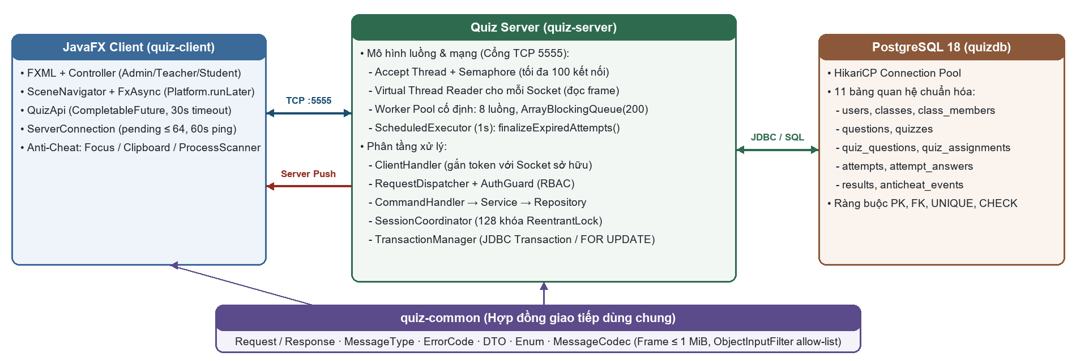
Figure 1. Client/Server architecture, TCP :5555 protocol, and thread execution model of the system.
The codebase is divided into four Maven modules:
• quiz-common: Declares protocol contracts, including Request and Response records, MessageType enums, domain DTOs, and MessageCodec.
• quiz-server: Accepts TCP traffic on port 5555, processes requests using Virtual Threads and a Worker Pool, runs business services, and manages PostgreSQL connections through HikariCP.
• quiz-client: Houses the JavaFX interface, manages asynchronous socket I/O through QuizApi, and runs in-exam proctoring monitors.
• quiz-benchmark: Provides an automated harness to stress-test binary message codecs and thread pools under synthetic load.

3.2. Layering and Data Flow
On the client, UI controllers call QuizApi methods. QuizApi formats commands into binary frames and writes them across ServerConnection. On the server, ClientHandler reads each frame on a dedicated virtual thread, then submits the decoded task to a ThreadPoolExecutor (8 worker threads, 200 queue slots). RequestDispatcher routes the command to its CommandHandler, AuthGuard verifies session tokens, and the handler calls domain services. Repositories isolate business logic from JDBC calls.
The server replies with a Response frame bearing the original requestId, allowing ServerConnection to complete the matching CompletableFuture. FxAsync and Platform.runLater deliver updates to the JavaFX Application Thread. For unsolicited server events—such as proctoring warnings or forced submissions—the backend sends push frames (Response.push) with requestId = 0.

3.3. Core System Components
Component | Core Responsibilities
ServerMain, QuizServer | Initializes dependencies, binds TCP port 5555, manages thread executors and graceful shutdown
RequestDispatcher, CommandHandler | Dispatches request types to corresponding command handlers and standardizes responses
AuthService, SessionCoordinator | Authenticates credentials, coordinates session replacement/revocation via 128 striped locks
QuizService, AttemptService | Manages quizzes, masks student PINs, assigns classes, tracks attempt lifecycles and submissions
TransactionManager, Jdbc*Repository | Defines JDBC transaction boundaries and executes parameterized queries in PostgreSQL
SceneNavigator, QuizApi | Manages JavaFX scene navigation and exposes asynchronous typed Client APIs

3.4. Directory and Module Structure
Directory or File | Architectural Role
pom.xml; mvnw.cmd; setup-db.bat; run-server.bat; run-client.bat; .mvn/ | Multi-module Maven POM, dependency versions, wrapper executables, and 1-click automation batch scripts: setup-db.bat, run-server.bat, run-client.bat.
quiz-common/src/main/java/quiz/common | Shared protocol contracts: framed MessageCodec, request/response records, DTOs, and enums
quiz-server/src/main/java/quiz/server | Server bootstrap, network server, command dispatchers, services, JDBC repositories, and HikariCP pool
quiz-client/src/main/java/quiz/client | JavaFX client bootstrap, typed APIs, socket connection, UI controllers, and anti-cheat monitors
quiz-client/src/main/resources | FXML layouts, CSS stylesheets, icons, and client properties
database/ | PostgreSQL schema, seed data, migrations, and database reset/automation scripts
src/test in all modules | Unit, socket protocol, PostgreSQL integration, and JavaFX UI integration test suites
quiz-benchmark/ | Empirical TCP load testing module measuring codec latency and worker throughput (LoadTestRunner)

3.5. Startup and Shutdown Lifecycles
On startup, ServerMain reads configuration from server.properties, initializes the HikariCP pool, and runs a connectivity check against PostgreSQL. It wires repositories, services, handlers, and the dispatcher; starts a ScheduledExecutorService task sweeping expired attempts every second; and binds QuizServer on port 5555.
ClientMain loads client.properties, initializes ServerConnection and QuizApi, creates SceneNavigator, and displays the login screen. Once authenticated, the user enters their role-specific workspace. On exit, the client closes its socket. During server shutdown, listening sockets close and active workers receive a grace period to complete inflight tasks.

3.6. UI Layout and Exception Handling Strategy
FXML documents define view layouts using BorderPane roots, VBoxes, and styled TableViews. Controllers attach event handlers via @FXML annotations, dispatch background calls through QuizApi, and update progress spinners and alerts. Destructive operations—such as deleting accounts, submitting exams, or killing blacklisted processes—require modal confirmation.
Domain exceptions (ValidationException, ForbiddenException, ConflictException, NotFoundException) inherit from QuizException. RequestDispatcher maps these to ErrorCode enums inside Response envelopes. Unhandled server errors are logged to disk while returning sanitized messages to the client. The client renders these errors into top-level alert banners.

4. Database Design

4.1. Entities and Relationships
PostgreSQL persists all application data across 11 relational tables. The users table stores credentials; classes and class_members manage classroom rosters; questions holds test items with types, explanations, and answer keys; quizzes, quiz_questions, and quiz_assignments represent test configurations and class schedules; attempts, attempt_answers, and results store student sessions, saved answers, and final grades; anticheat_events stores proctoring telemetry.
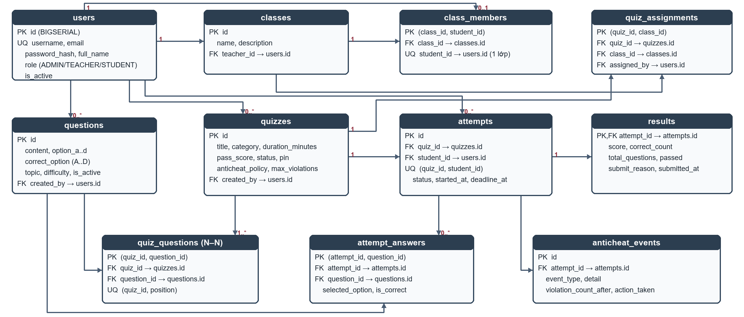
Figure 2. Complete 11-table Entity-Relationship Diagram (ERD) and cardinalities in PostgreSQL.
A Teacher supervises multiple classes (1..*) and authors multiple questions. Each class contains multiple students, but UNIQUE(student_id) in class_members restricts each student to at most one class. Quizzes and questions link many-to-many through quiz_questions. Student exam attempts connect directly to quizzes and users, maintaining a one-to-one relationship with results and one-to-many relationships with attempt_answers and anticheat_events.

4.2. Database Integrity Constraints
Constraint | Business Meaning
users.username UNIQUE; users.email UNIQUE | Guarantees unique usernames and non-null unique email addresses
class_members.student_id UNIQUE | Restricts each student to at most one class
quiz_questions: UNIQUE(quiz_id, position) | Enforces sequential, non-duplicate question positioning within a quiz
attempts: UNIQUE(quiz_id, student_id) | Enforces strictly one exam attempt per student per quiz
results.attempt_id PRIMARY KEY | Enforces at most one result per attempt (idempotent submission)
CHECK cho role, status, score, option | Enforces valid domain values for roles, statuses, scores, and options at the storage tier

4.3. Storage, Indexes, and ACID Transactions
All database operations use PreparedStatement to prevent SQL injection. Multi-step writes run inside TransactionManager, which executes operations in an explicit transaction block to ensure atomic commits or clean rollbacks upon failure. Indexes optimize attempt lookups by quiz/student, event queries by attempt ID, and question filtering by topic and difficulty. Because attempts references users directly instead of class_members, reassigning a student to another class never alters their historical test scores.

5. Java Design, OOP, and SOLID Principles

5.1. Object-Oriented Design and Class Hierarchy
Classes encapsulate state by declaring fields private final and exposing behavior through explicit methods. For instance, ServerConnection manages socket streams and pending CompletableFuture maps internally, preventing UI controllers from touching raw byte streams. Network DTOs and message envelopes are implemented as Java 21 records, guaranteeing shallow immutability across socket boundaries.
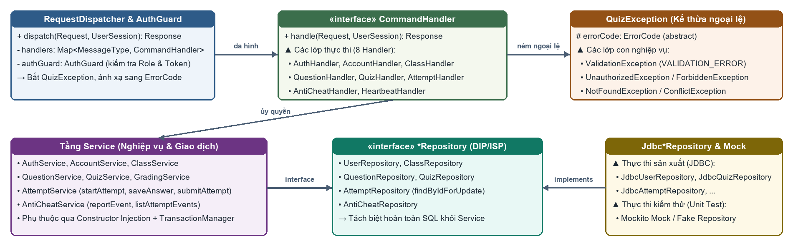
Figure 3. Class diagram of dispatchers, business services, data access layer, and exception hierarchy.
Abstraction and polymorphism structure the command pipeline. RequestDispatcher invokes CommandHandler.handle() polymorphically across eight command families without inspecting business details. Similarly, service classes depend on repository interfaces rather than concrete SQL classes, allowing Mockito unit tests to mock data access without altering service logic. Inheritance is applied to the QuizException hierarchy, while top-level components rely on constructor injection.

5.2. Evaluation of SOLID Principles
Principle | Application Strategy and Boundaries
SRP | Decouples network socket I/O, dispatching, business logic, and JDBC queries. TeacherController coordinates multiple views.
OCP | Extensible for new MessageTypes via new CommandHandlers; requires bootstrap registration and protocol update.
LSP | Jdbc*Repository and Mockito mocks are substituted interchangeably via repository interfaces.
ISP | Repository interfaces are segregated by entity families, avoiding bloated monolithic interfaces.
DIP | Services depend on repository abstractions. AntiCheatService coordinates ConnectionRegistry directly.

5.3. Design Patterns Applied
The implementation employs five common design patterns:
• Repository Pattern: Isolates JDBC SQL queries behind clean interface contracts.
• Data Transfer Object (DTO) Pattern: Defines typed, immutable serialization contracts.
• Command Pattern: Groups incoming socket actions into discrete CommandHandler classes mapped by MessageType.
• Dependency Injection: Supplies dependencies through class constructors for testability.
• Execute-Around Pattern: Implemented in TransactionManager to handle connection acquisition, transaction commit/rollback, and resource cleanup.

6. Networking Protocol and Session Management

6.1. Message Structure and Serialization Trade-Offs
Client and server exchange serialized Java objects over TCP. A Request record contains a requestId, command type, session token, and payload. A Response record carries the matching requestId, success status, optional ErrorCode, message, pushType, and payload. The client uses requestId to resolve CompletableFuture instances, while server push frames use requestId = 0.
We chose Java native serialization because both ends run on Java 21 and share the same record definitions. This eliminated manual JSON mapping layers. However, untrusted deserialization poses security risks [5]. MessageCodec defends against these using two checks: (1) it prefixes every frame with a 4-byte length integer and rejects any payload exceeding 1 MiB (1,048,576 bytes) before allocating memory, and (2) it applies an ObjectInputFilter allow-list restricted to quiz.common.*, java.lang.*, java.time.*, and standard java.util collections [2], capped at depth 32 and 10,000 object references.

6.2. Authentication and Authorization Architecture
When a user submits credentials, AuthService hashes passwords using BCrypt via jBCrypt 0.4 (cost factor 10), respecting BCrypt's 72-byte key truncation limit [6]. Logging in on a new device invalidates prior sessions for that account. ClientHandler confirms that the session token on each command matches the token bound to that socket. The server validates role permissions strictly against its session registry, ignoring client-asserted claims.

6.3. Heartbeat, Failure Recovery, and Network Assumptions
Configuration Property | Value | Operational Purpose
server.port | 5555 | Application TCP listening port
server.handshake.timeout.ms | 5.000 ms | Socket stream handshake timeout
server.read.timeout.ms | 300.000 ms | Single read timeout limit at server
heartbeat.interval.ms | 60.000 ms | Heartbeat interval to keep client sessions alive during idle periods
request.timeout.ms | 30.000 ms | Client pending request response timeout budget
max.pending.requests | 64 | Client maximum concurrent in-flight requests ceiling

The client does not automatically retry state-modifying requests after a socket drop, avoiding duplicate submissions.
Transport Security Note: The current TCP implementation transmits binary streams in plaintext. Passwords and session tokens could be intercepted on open Wi-Fi networks. The application is therefore restricted to isolated laboratory LANs. Upgrading Socket/ServerSocket to SSLSocket with TLS 1.3 encryption is the primary priority for wide-area deployment.

7. Concurrency and Data Consistency

7.1. Thread Execution Model
QuizServer accepts connections on a dedicated listener thread. For each accepted socket, it launches a Java 21 Virtual Thread via newVirtualThreadPerTaskExecutor() [1], bounded by Semaphore(100) to limit active client connections. Virtual threads read incoming frames and pass decoded tasks to a ThreadPoolExecutor with 8 worker threads and an ArrayBlockingQueue of 200 tasks. If the queue saturates, the server immediately returns SERVER_BUSY instead of buffering unbounded memory.
The virtual reader thread waits for its worker task to finish before writing the Response frame. Requests on a single socket execute in sequence, while separate connections process in parallel. Offloading execution to workers prevents slow client sockets from tying up database processing. A ScheduledExecutorService task runs every second to invoke finalizeExpiredAttempts().

7.2. Shared Resources and Synchronization Mechanisms
Shared Resource | Concurrency Risk | Mitigation Mechanism Applied
Session of the same user | Concurrent login, logout, or account locking races | SessionCoordinator with 128 fixed striped ReentrantLocks
Socket output stream | Interleaved response and push frames corrupting stream | Synchronized write blocks in ClientConnection
Attempt and Result entity | Simultaneous manual submit, timeout sweep, and anti-cheat force submit | ACID transaction, SELECT FOR UPDATE row locking, primary key constraint
Question answer record | Duplicate saves causing redundant records | Composite primary key and INSERT ... ON CONFLICT DO UPDATE
Socket / Thread pools on shutdown | Orphaned client connections or unexecuted queued tasks | Timed shutdown budget, socket closure, registry cleanup

Attempt records are updated using SELECT ... FOR UPDATE row locks within ACID transactions. This prevents concurrent write collisions during answer saves and final submissions [4].

7.3. Concurrency Sizing Rationale and Trade-Offs
Concurrency parameters reflect the physical capacity of our testing laboratories:
• Semaphore(100): Caps active sockets at 100, accommodating 2–3 classes (30–35 students each) plus teachers and administrators without exhausting OS file descriptors.
• 8 Workers and 200 Queue Slots: Worker tasks mix CPU work (BCrypt hashing, answer grading) with JDBC calls. On 4–8 core test machines with 10 HikariCP connections, 8 workers maximize CPU throughput without exhausting database connections. The 200-task queue absorbs simultaneous submissions when an entire class finishes a test.
• 128 Striped Locks (SessionCoordinator): An array of 128 ReentrantLocks is indexed via bitwise masking (hash & 127). With 100 concurrent users, lock contention during login/logout stays below 1%, avoiding the overhead of dynamic lock allocation.

8. Exam Workflow Implementation

8.1. Quiz Authoring and Class Assignment
Teachers author questions directly or import them from files, filtering by keyword, topic, and difficulty. When creating a quiz, teachers select questions manually or let the server draw random questions based on Easy/Medium/Hard quotas. QuizService allows question editing only while a quiz is in DRAFT status. Publishing (OPEN) generates a 6-digit PIN via SecureRandom. When teachers assign quizzes to classes, students receive QuizInfoDto with pin = null and pinRequired = true.

8.2. Attempt Lifecycle, Reconnection, and Answer Persistence
When a student sends START_ATTEMPT, AttemptService checks if an attempt already exists. If the attempt has status = SUBMITTED, the server denies access. If the attempt is IN_PROGRESS and deadline_at has not passed, the student resumes their session with saved answers (even if the quiz is CLOSED to new test-takers). For new attempts, the server validates the OPEN status, class enrollment, and PIN before creating an Attempt record stamped with started_at and deadline_at.
The client receives StudentQuestionDto objects containing only question prompts and choices without correctOption keys. When an examinee selects an answer, SAVE_ANSWER locks the Attempt row via SELECT ... FOR UPDATE, validates attempt status and deadlines, and executes INSERT ... ON CONFLICT DO UPDATE.

8.3. Submission, Auto-Grading, and Sequence Flow
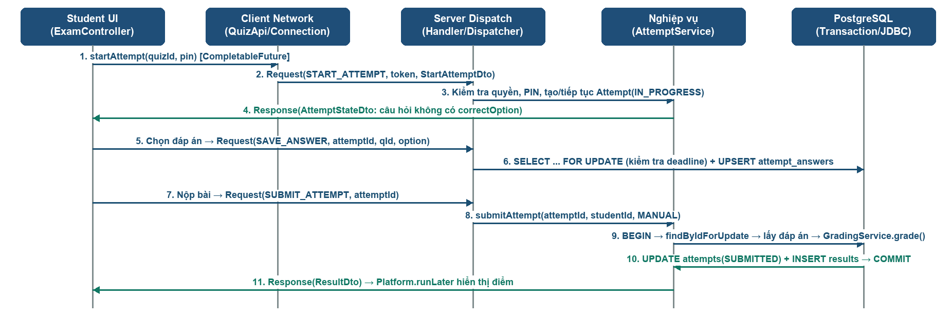
Figure 4. Sequence diagram of starting an attempt, saving answers, and transactional submission with row locking.
Inside submitAttempt, the server locks the Attempt row via findByIdForUpdate, checks student ownership, and confirms that results have not yet been written. GradingService evaluates persisted answers across all three question formats: Multiple Choice, True/False, and whitespace-trimmed case-insensitive Fill-in-the-Blank with '|' delimiters. Scores use the standard 10.0 scale:
Score = round((correctCount * 10.0 / totalQuestions) * 100.0) / 100.0; Passed if: (correctCount * 100.0 / totalQuestions) >= passScore.
Score = round((correctCount * 10.0 / totalQuestions) * 100.0) / 100.0; Passed if: (correctCount * 100.0 / totalQuestions) >= passScore.
The server sets attempts.status = SUBMITTED, writes the results record, commits the transaction, and returns ResultDto. Attempts exceeding their deadline without submission are auto-finalized by finalizeExpiredAttempts() with submit_reason = TIMEOUT.

9. Graphical User Interface, I/O, and Proctoring

9.1. JavaFX Graphical User Interface in Practice
The desktop interface uses an Indigo palette with role-tailored FXML views and CSS stylesheets for Administrators, Teachers, and Students. QuizApi wraps network calls in CompletableFuture instances. FxAsync and Platform.runLater marshal updates back onto the JavaFX Application Thread without freezing the UI [3]. Figures 5 through 17 illustrate the primary application screens:
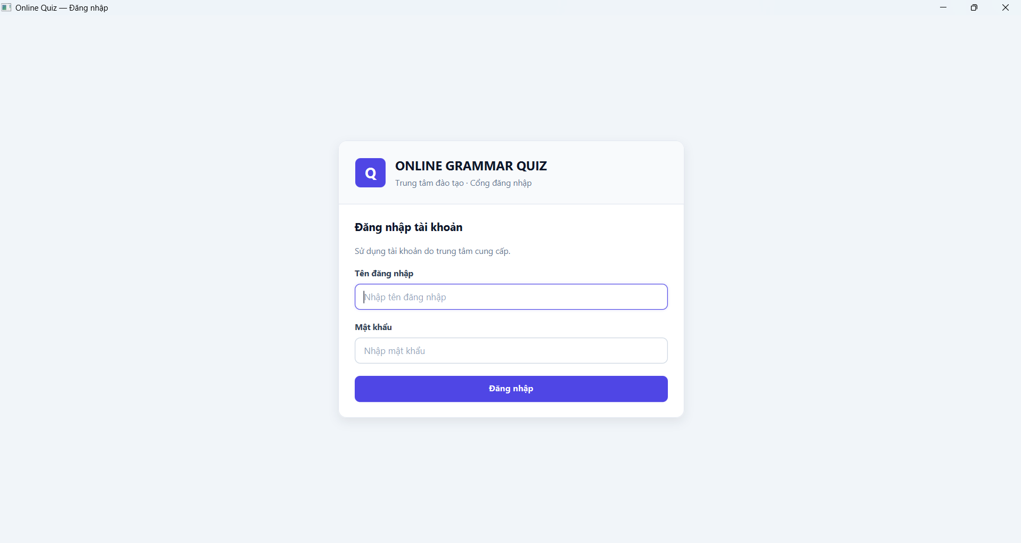 | 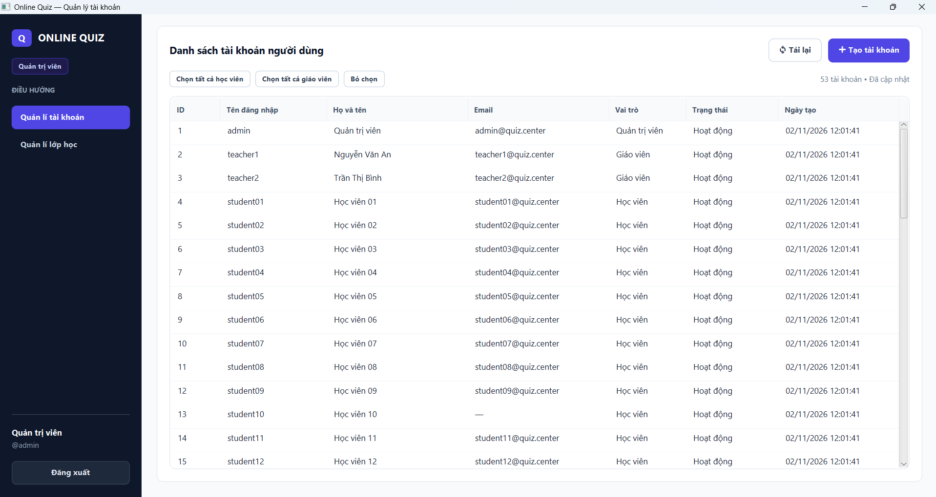
Figure 5. Centralized System Login Interface. | Figure 6. Admin — User Account Management Interface.
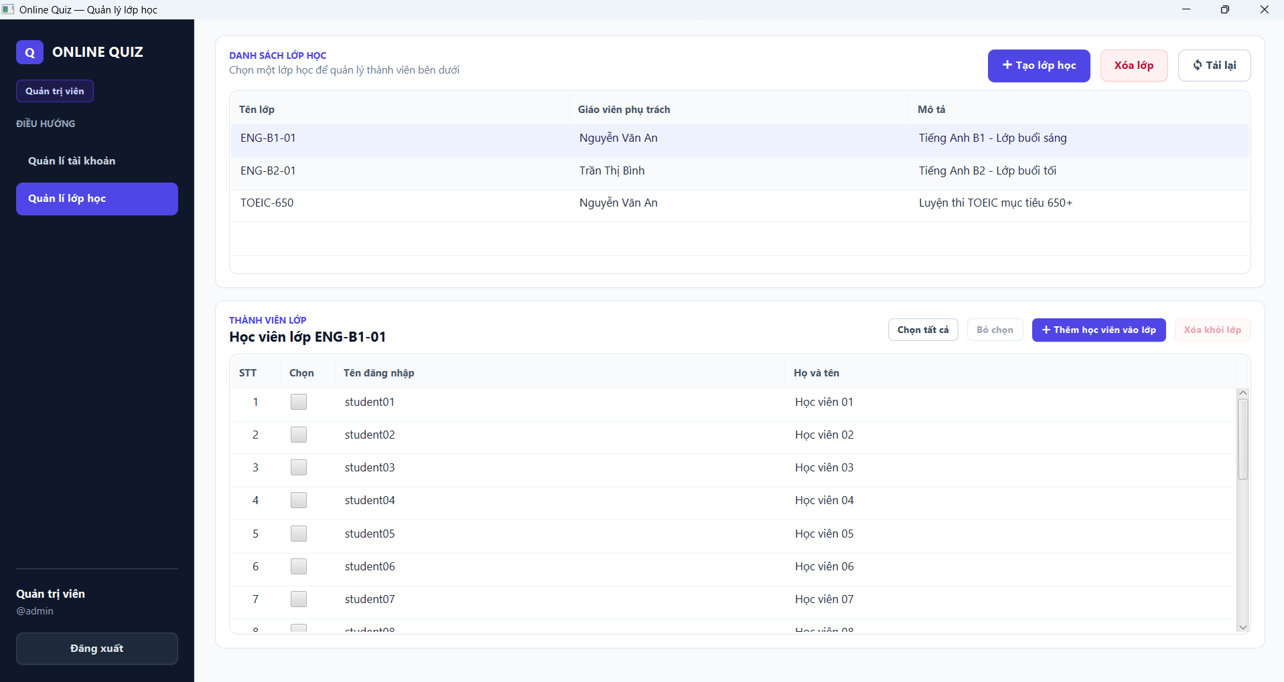 | 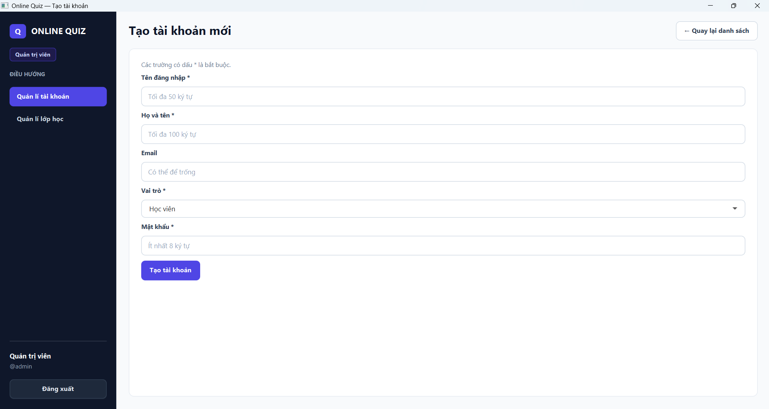
Figure 7. Admin — Class and Enrollment Management Interface. | Figure 8. Admin — New Account Creation Form.
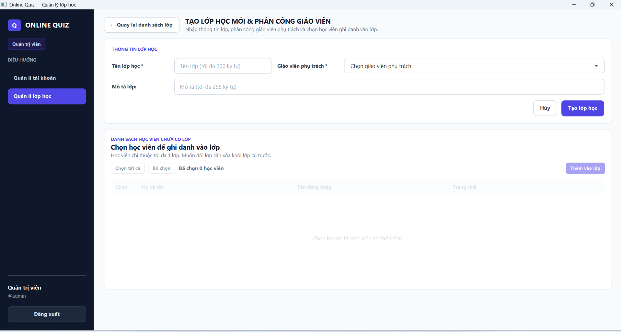 | 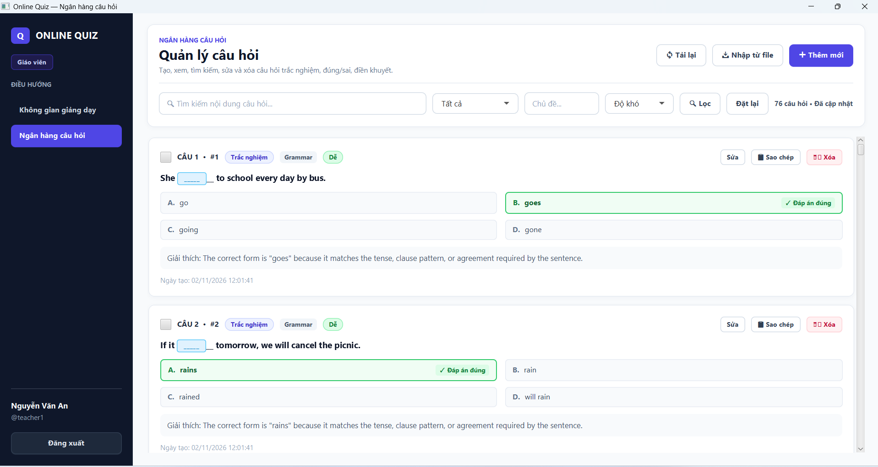
Figure 9. Admin — New Class Creation and Teacher Assignment Form. | Figure 10. Teacher — Multi-Format Question Bank Management.
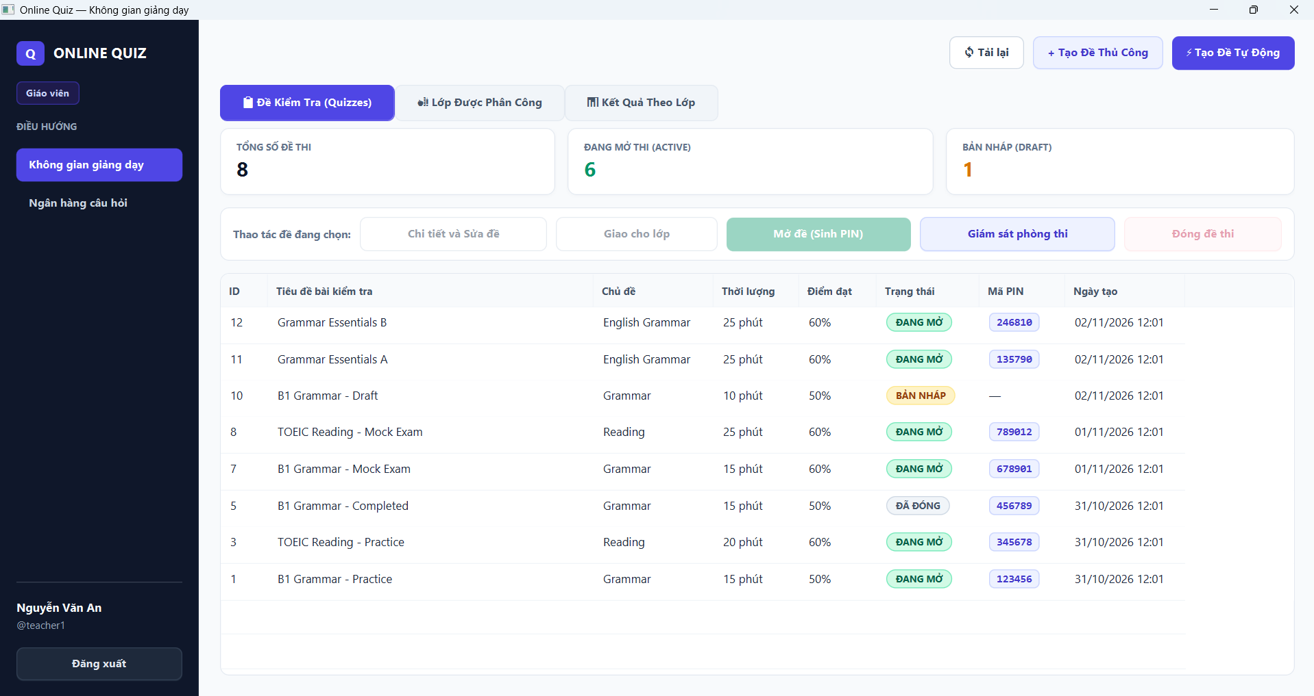 | 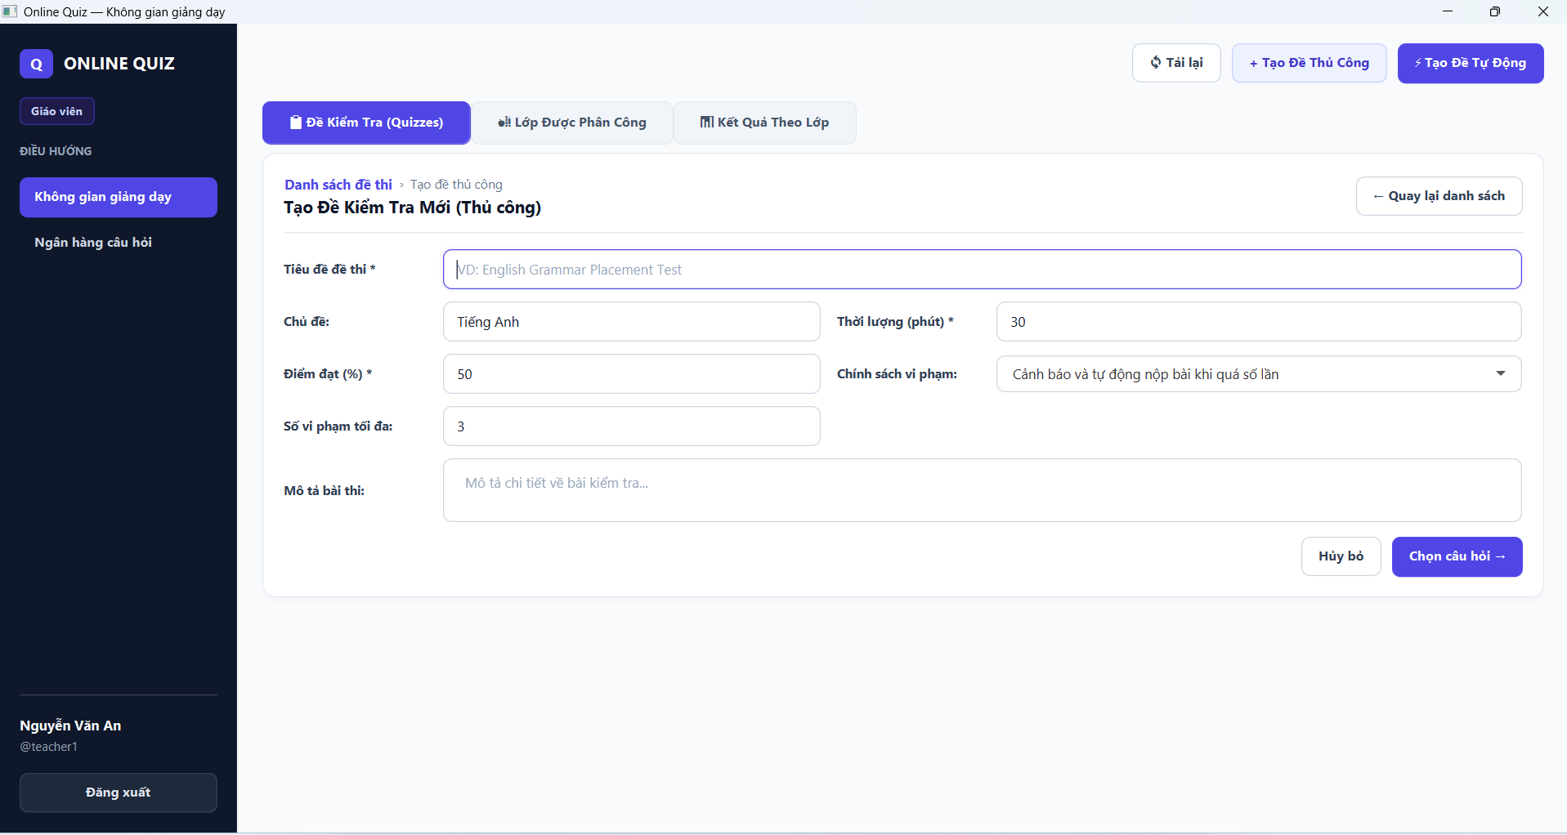
Figure 11. Teacher — Quiz and Exam Management Dashboard. | Figure 12. Teacher — Manual Quiz Authoring Form.
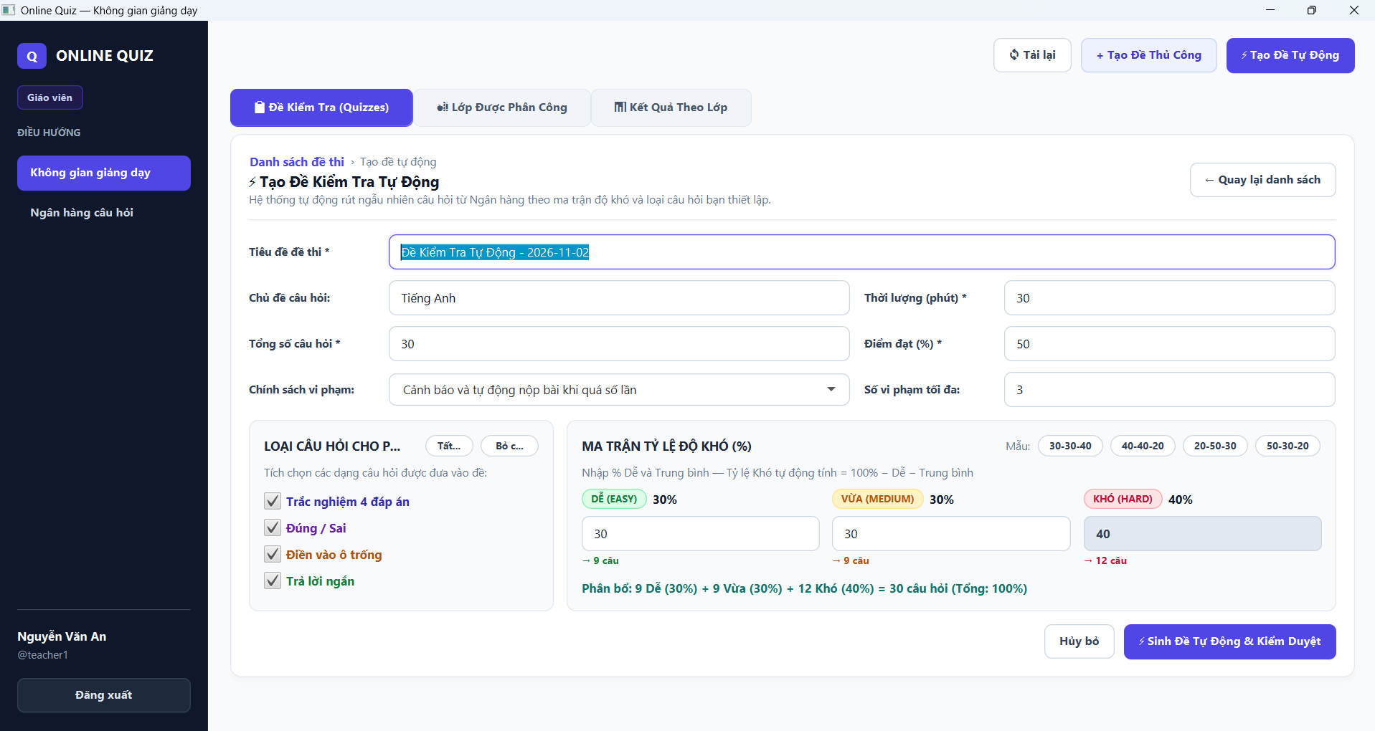 | 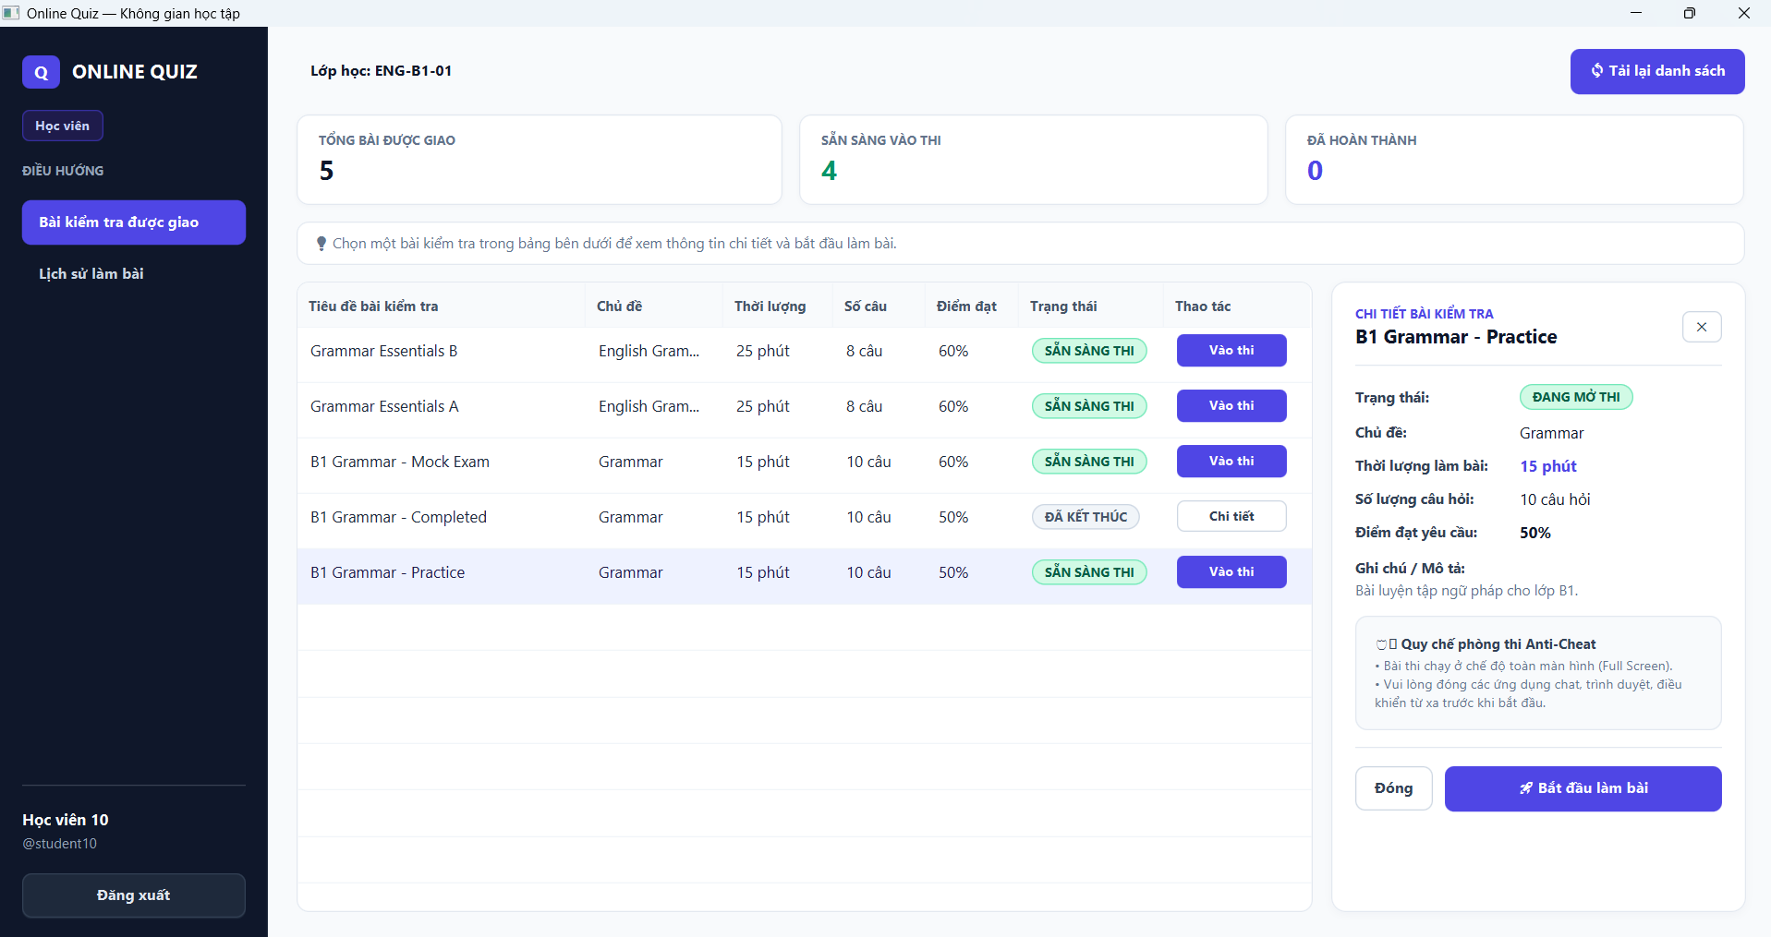
Figure 13. Teacher — Automated Random Quiz Generator by Difficulty Matrix. | Figure 14. Student — Learning Workspace and Proctoring Rules View.
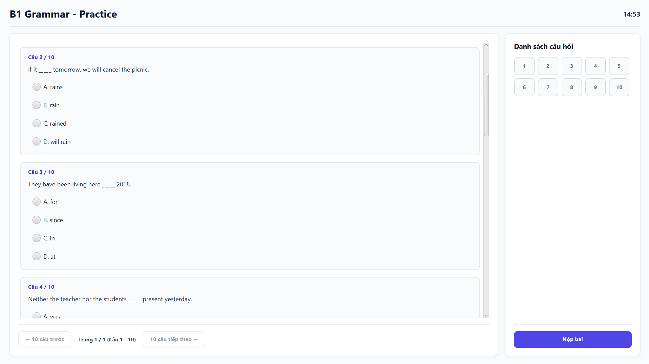 | 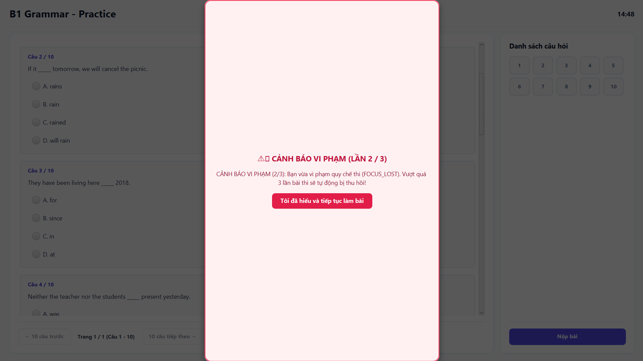
Figure 15. Student — Timed Online Exam Interface with Question Palette. | Figure 16. Student — Real-Time Anti-Cheat Violation Warning Dialog.
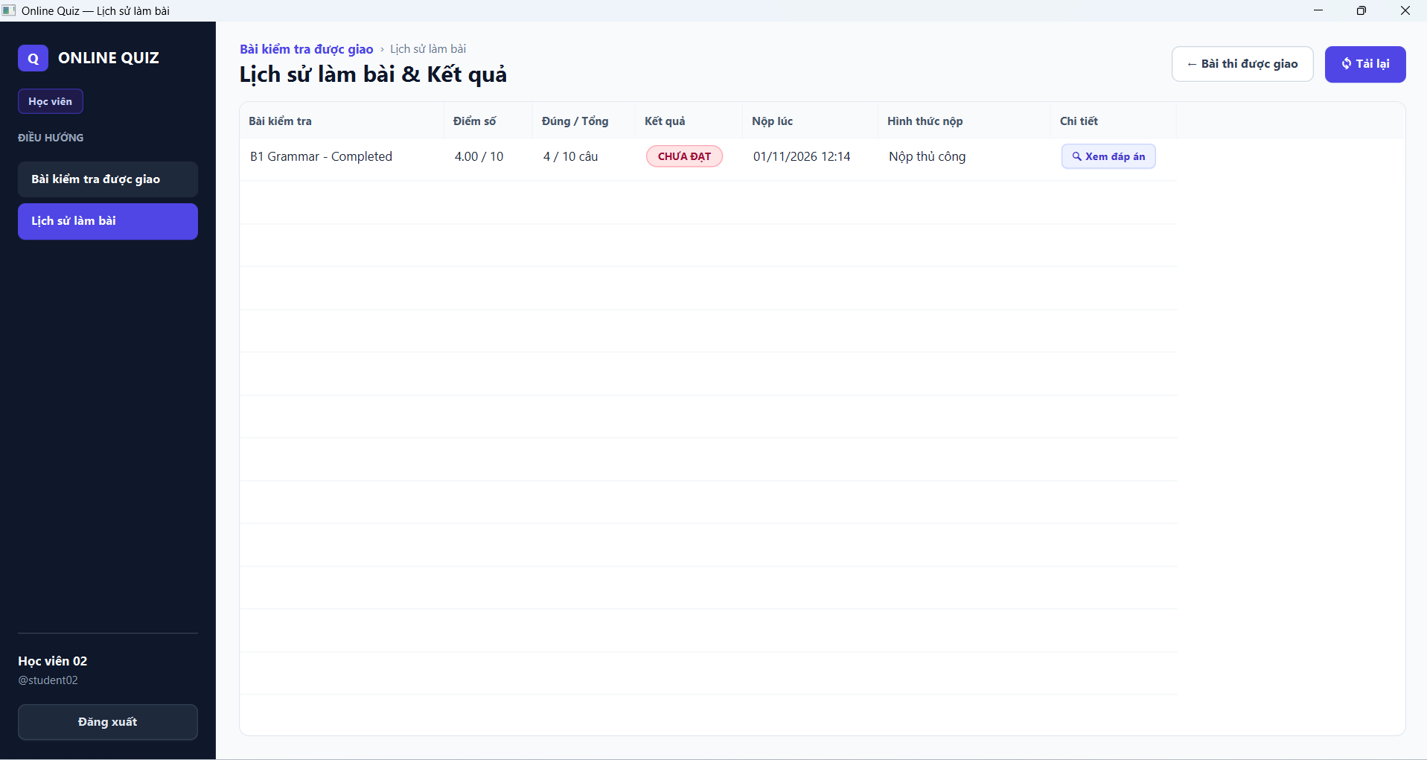
Figure 17. Student — Exam History and Performance Review Interface.

9.2. File I/O, Functional Streams, and Client-Side Statistics Trade-Offs
QuestionFileParser parses Microsoft Word DOCX (via Apache POI), PDF files (via Apache PDFBox), and plain TXT/CSV files. Regular expressions extract question prompts, options A–D, and answer keys, batch-inserting questions onto the server.
Java Streams and lambdas process CompletableFuture callbacks, transaction bodies, and score calculations. In TeacherController, Stream pipelines (filter, mapToDouble, average, max, count) compute average scores, highest marks, and pass rates across loaded student rosters. Design Trade-off: Computing aggregate statistics on client-held ResultDto lists avoids redundant server queries for small classes (20–50 students). For larger cohorts, aggregations should run on PostgreSQL via SQL AVG/MAX/COUNT queries with pagination.

9.3. In-Exam Live Proctoring and Anti-Cheat Telemetry
Before an exam starts, StudentController runs ProcessScannerService to scan active background processes against a blacklist. During the test, ExamAntiCheatController captures window blur (FOCUS_LOST), clipboard actions (COPY_ATTEMPT, PASTE_ATTEMPT, CUT_ATTEMPT), context menu usage, and blacklisted applications (PROHIBITED_PROCESS). Under WARN_THEN_AUTO_SUBMIT, when violations reach the threshold, AntiCheatService calls submitAttempt with submit_reason = ANTICHEAT and dispatches PUSH_FORCE_SUBMITTED only after the database transaction commits. When teachers review proctoring logs via listAttemptEvents, the server validates quiz ownership before returning audit data.

10. Testing and Evaluation

10.1. Test Methodology and Execution Environment
Our test pipeline combines Mockito unit tests, socket protocol tests, PostgreSQL integration tests (db-it), end-to-end authentication tests (e2e-it, login-it), JavaFX UI integration tests (ui-it), and a socket load test harness (quiz-benchmark). Testing environment: Windows 11 amd64, Oracle JDK 21.0.9, Maven Wrapper 3.9.9, JUnit 5.11.3, Mockito 5.14.2, and JavaFX 21.0.5.

10.2. Automated Test Results Summary
Historical test execution runs across project milestones are consolidated in the table below:
Timestamp | Test Cases | Outcome
27/10 09:43 | 473: 12 common, 396 server, 65 client | 0 failures, 0 errors, 0 skipped; BUILD SUCCESS
27/10 09:44 | 91 (JavaFX/UI) | 2 JavaFX assertions failed; BUILD FAILURE
27/10 09:46 | 90 (JavaFX/UI) | 0 failures, 0 errors, 0 skipped; BUILD SUCCESS
27/10 10:26 | 95 (Integration) | 0 failures, 0 errors, 0 skipped; BUILD SUCCESS
30/10 09:59 | 540: 13 common, 436 server, 91 client | 0 failures, 0 errors, 0 skipped; BUILD SUCCESS

Automated test suites caught several real-world race conditions during development. For example, two assertion failures during the October 27 test run stemmed from asynchronous race conditions in JavaFX logout transitions and stale UI state when logging in again after an exam timeout. We resolved these by synchronizing transition listeners, consolidating duplicate transition test cases, and bringing the UI test suite to 90 passing tests. As of October 30, the suite comprises 540 passing tests with 100% statement and branch coverage across all business services, the 8 CommandHandler classes, and the MessageCodec framing layer.

10.3. Verification Test Scenarios and Traceability Matrix
Test ID & Scenario | Expected Outcome | Empirical Evidence & Status
TC01. Oversized frame (>1 MiB) or untrusted class outside allow-list | Rejects data; denies arbitrary object deserialization | MessageCodecSecurityTest: 7 passed; MessageCodecTest: 6 passed
TC02. Valid login, incorrect password, or locked account status | Creates session strictly on valid credentials and ACTIVE status | AuthServiceTest: 30 passed
TC03. Invalid token or role with insufficient privileges | Rejects protected endpoint requests with error code | AuthGuardTest: 18 passed
TC04. Token sent from unauthenticated socket; queue saturated | Rejects foreign socket token; returns SERVER_BUSY with matching requestId | QuizServerTest: 8 passed
TC05. Teacher modifies class; Teacher inspects foreign quiz logs | Denies unauthorized writes and out-of-scope proctoring inspections | ClassServiceTest: 15 passed; AntiCheatServiceTest: 9 passed
TC06. New login racing with concurrent active session | Preserves active session integrity; avoids deleting fresh sessions | SessionCoordinatorTest: 6 passed
TC07. Exam attempt, resume on CLOSED, auto-grading, masked PIN | Conceals PIN on QuizInfoDto, persists answers, auto-grades accurately | QuizServiceTest: 21 passed; AttemptServiceTest: 9 passed; GradingServiceTest: 5 passed
TC08. Connection drops, delayed responses, and pending requests | Completes or exceptionally fails futures according to connection lifecycle | ServerConnectionTest: 20 passed; QuizApiTest: 16 passed

10.4. Empirical Concurrency and Load Benchmark
We executed load tests using quiz.benchmark.LoadTestRunner in the quiz-benchmark module. The runner spins up an in-process TCP server with production settings (Semaphore(100), Virtual Threads for socket readers, and an 8-worker ThreadPoolExecutor with ArrayBlockingQueue(200)). After 50 warm-up runs, the harness drives 1, 5, 10, and 20 concurrent client threads, each issuing 100 sequential LIST_QUESTIONS requests and receiving batches of 10 QuestionDto records filtered by MessageCodec allow-lists.
Concurrent Clients | Total Requests | Mean Latency (ms) | P95 Latency (ms) | Throughput (req/s) | Errors
1 client | 100 | 1,64 ms | 2,78 ms | 601,8 req/s | 0
5 client | 500 | 1,12 ms | 1,77 ms | 4.006,4 req/s | 0
10 client | 1.000 | 1,20 ms | 2,05 ms | 7.639,9 req/s | 0
20 client | 2.000 | 1,15 ms | 2,19 ms | 5.951,5 req/s | 0

Benchmark Analysis: Across all concurrency tiers (3,600 total requests from 1 to 20 clients), the server achieved a 0% error rate with P95 latencies between 1.77 ms and 2.78 ms. Throughput peaked at 7,639.9 req/s with 10 concurrent clients (saturating the 8 worker threads evenly via virtual reader threads) and sustained 5,951.5 req/s under 20 clients without queue drops. These empirical metrics confirm that the virtual thread reader plus worker pool design comfortably accommodates simultaneous testing sessions in computer laboratories.

11. Discussion, Technical Highlights, and Refinements

11.1. Core Architectural Highlights
Unlike paper quizzes or standalone desktop tools, the system maintains all authorization, time enforcement, and grading logic on the central server. Students receive only sanitized DTOs (QuizInfoDto hides the exam PIN; StudentQuestionDto omits answer keys), keeping solutions and grading rules protected behind server boundaries.
Technical Highlight | System Impact | Verification Evidence / Scope
Decoupled common, server, client, benchmark modules | Minimizes coupling between GUI, wire protocol, and database layers | Clean pom.xml hierarchy and structured package boundaries
Socket-bound session tokens with instant account lock revocation | Prevents token reuse across foreign sockets or stale sessions | SessionLifecycle, SessionCoordinator; Auth/Network test suites
Framed codec with 1 MiB limit and allow-list deserialization filter | Prevents heap exhaustion and thwarts deserialization gadget exploits [2], [5] | MessageCodec and MessageCodecSecurityTest
Attempt row-locking (FOR UPDATE) and results primary key | Prevents double-submission races between manual submits and timeout sweeps | AttemptService, JdbcAttemptRepository
Resuming in-progress attempts and enforcing proctoring log access control | Allows resuming active exams on closed quizzes; restricts proctoring log access | AttemptService, AntiCheatService
540-test automated suite + TCP concurrency load runner | Provides multi-tier regression assurance and empirical latency/throughput metrics | Surefire reports and LoadTestRunner

11.2. Bug Fixes, Ergonomics, and Technical Optimizations
Through iterative design reviews, load benchmarks, and hands-on testing, our team identified and resolved 14 key engineering and user-experience issues:
1. Masking Exam PIN in Student DTOs: Previously, QuizService.toInfoDto directly propagated q.pin() into QuizInfoDto. The student-facing pin field is now set to null, retaining only pinRequired = (q.pin() != null), forcing examinees to obtain valid PINs from proctors.
2. Enforcing Quiz Ownership on Proctoring Logs: AntiCheatService.listAttemptEvents added verification ensuring quiz.createdBy() == session.userId() for TEACHER roles, preventing instructors from viewing violation logs of exams owned by other teachers.
3. Synchronizing Push Alerts with Forced Submissions: In AntiCheatService.reportEvent, PUSH_FORCE_SUBMITTED is dispatched strictly after attemptService.submitAttempt(...) commits successfully, preventing false push alerts if the database transaction fails.
4. Resuming In-Progress Attempts on Closed Quizzes: AttemptService.startAttempt prioritizes checking active IN_PROGRESS attempts before evaluating quiz OPEN status, allowing students disconnected mid-exam to resume work after the teacher closes registration to new test-takers.
5. Safe Account Deletion within ACID Transactions: Implemented single and batch user deletion (DELETE_ACCOUNT) for Admins. The system validates that teachers are not actively assigned to classes, reassigns question banks and exams to the Admin to preserve curriculum history, cleanses associated attempts and proctoring events, revokes active sessions, and safeguards Administrator accounts from deletion.
6. Ergonomic Checkbox Selection and Candidate Pools: Replaced sluggish double-click checkboxes with responsive 1-click toggles and whole-row click selection; split unassigned students into a dedicated slide-out candidate panel for streamlined batch enrollment.
7. Polished Exam Navigation and Paged Question Layout: Paged exam questions into clean 10-question increments, eliminated nested card borders, standardized navigation controls, simplified PIN dialogs, and added dismissible error banners.
8. Rapid Execution Batch Scripts (run-server.bat, run-client.bat): Fully automated dependency compilation (-am) and application startup with single-click batch files, featuring comprehensive error diagnostics and troubleshooting guidance in Vietnamese.
9. Multi-Format Question Engine & Flexible Fill-in-the-Blank: Extended system capabilities from pure 4-choice questions to 3 rich formats: Multiple Choice (MULTIPLE_CHOICE), True/False (TRUE_FALSE), and Fill-in-the-Blank (FILL_BLANK). Eliminated single-word constraints on fill-in-the-blank questions, supporting multi-word phrases and multiple blanks separated by '|' (e.g., 'answer 1 | answer 2'). The server normalizes casing and whitespace for fair grading.
10. Input Retention and Inline Form Validation UX: Fixed abrupt modal dismissal on validation errors that previously caused teachers to lose form inputs. Converted errors into top-level sticky warning banners detailing exact issues (e.g., missing '___' syntax or empty answer keys) while retaining all entered data.
11. Instant Synchronization Between Question Bank and Quiz Builder: Resolved data desynchronization where soft-deleted questions persisted in quiz generation pickers and newly authored questions failed to appear. Enforced active = true filters across all quiz curating query flows to guarantee immediate, accurate question availability.
12. Smooth Viewport Scrolling and Non-Intrusive Exam Palette: Fixed unresponsive question palette buttons and eliminated disruptive automatic question jumping. Implemented smooth scrolling directly to target questions upon palette clicks, limited sidebar updates to answered badges, and provided explicit delimiter syntax guidelines ('|').
13. Credential Sanitization and Environment-Driven Configuration: Excluded environment-specific client.properties and server.properties from version control via .gitignore. Provided structured *.properties.example templates and supported local property overrides via server-local.properties and DB_* environment variables.
14. 1-Click Automated Database Provisioning (setup-db.bat): Built an intelligent Windows script (setup-db.bat backed by database/setup-db.ps1) that auto-detects psql.exe across system PATH and PostgreSQL installations, parses credentials, auto-creates database quizdb, executes schema.sql (11 tables), and seeds complete demo accounts/quizzes in under 2 seconds with a single click.

12. Limitations and Future Work

12.1. Current Limitations
• Plaintext Socket Transport: TCP streams are currently unencrypted, requiring isolated laboratory networks. Production deployments require SSLSocket with TLS 1.3.
• Auxiliary Read Queries in submitAttempt: Attempt updates and results writes run within an ACID transaction under SELECT ... FOR UPDATE, but auxiliary quiz lookups open separate brief connections.
• Client-Side Roster Aggregations: Computing statistics on client-held ResultDto lists works well for 20–50 students, but enterprise scaling requires server-side SQL AVG/MAX/COUNT queries with pagination.
• Client-Level Proctoring Scope: Window blur and process monitoring provide practical proctoring in standard labs, but do not replace kernel-level kiosk lockdown software.

12.2. Future Development Roadmap
Priority | Planned Feature / Task | Acceptance Criteria
1 | Integrate TLS encryption (SSLSocket / SSLServerSocket) | Socket channel between client and server is encrypted with digital certificates
1 | Reuse single connection for auxiliary lookups in submitAttempt | Entire submission and grading flow executes within a single dedicated transaction connection
2 | Migrate class aggregate statistics to server-side SQL with pagination | Server computes and returns aggregated statistical DTOs directly from PostgreSQL
3 | Decompose TeacherController into sub-controllers and integrate JaCoCo | Automated statement/branch coverage reports generated on mvnw verify

13. Conclusion
Online Quiz for English Center delivers an integrated desktop examination system tailored to language centers. The software coordinates question authoring, automated exam assembly, class assignments, timed testing, automatic grading, and real-time proctoring telemetry within a cohesive Client/Server architecture. Throughout the project, we applied object-oriented design principles, SOLID guidelines, asynchronous JavaFX patterns, JDBC transaction demarcation, raw TCP socket protocols, and Java 21 concurrency.
Key technical milestones achieved include session-bound socket lifecycles, binary frame encoding with allow-list deserialization filters, benchmarked socket throughput surpassing 7,600 req/s, and transactional concurrency safeguards (SELECT ... FOR UPDATE). Supported by 540 automated unit tests, 95 PostgreSQL integration tests, and 90 JavaFX UI integration tests, the system delivers dependable performance for English language training centers.

14. References
[1] Oracle Corporation, "JEP 444: Virtual Threads," OpenJDK Documentation, 2023. [Online]. Available: https://openjdk.org/jeps/444. Accessed October 29, 2026.
[2] Oracle Corporation, "JEP 290: Filter Incoming Serialization Data," OpenJDK Documentation, 2017. [Online]. Available: https://openjdk.org/jeps/290. Accessed October 29, 2026.
[3] OpenJFX Documentation, "JavaFX Architecture and Application Threading Model," Oracle Corporation, 2023. [Online]. Available: https://openjfx.io. Accessed October 29, 2026.
[4] PostgreSQL Global Development Group, "PostgreSQL 16 Documentation: Chapter 13. Concurrency Control - Explicit Locking," 2023. [Online]. Available: https://www.postgresql.org/docs/16/explicit-locking.html. Accessed October 29, 2026.
[5] OWASP Foundation, "Deserialization of Untrusted Data - Prevention and Mitigation Guidelines," OWASP Top 10, 2023. [Online]. Available: https://owasp.org/www-community/vulnerabilities/Deserialization_of_untrusted_data. Accessed October 30, 2026.
[6] N. Provos and D. Mazières, "A Future-Adaptable Password Scheme," in Proceedings of the FREENIX Track: 1999 USENIX Annual Technical Conference, Monterey, CA, 1999. Accessed October 30, 2026.

Appendix A. Installation, Build, and Execution Guide

A.1. Environment Prerequisites
Instructions assume PowerShell on Windows 10/11. Install JDK 21 and PostgreSQL with Server and Command Line Tools. The included Maven Wrapper automatically downloads Maven and project dependencies upon first execution (Internet required). An IDE is optional; the project builds and runs directly from terminal. Client machines require desktop GUI capabilities and process enumeration permissions.
Clone or extract source code. Open PowerShell in the project root (<project-root>), containing pom.xml, mvnw.cmd, and modules quiz-common, quiz-server, quiz-client:
Set-Location '<project-root>'
java -version
.\mvnw.cmd -version
Both commands must report Java 21. If Maven detects a different JDK, configure JAVA_HOME in the current terminal session as follows:
$env:JAVA_HOME = 'C:\Program Files\Java\jdk-21'
$env:Path = "$env:JAVA_HOME\bin;$env:Path"
.\mvnw.cmd -version

A.2. Database Provisioning and PostgreSQL Setup
Users can choose between two database setup methods below:
• Method 1 (Recommended on Windows — 1-Click Automation via setup-db.bat):
Double-click setup-db.bat in the project root (or execute .\setup-db.bat in PowerShell). The script completely automates all steps: auto-discovers psql.exe on the system, reads server-local.properties (or initializes from server.properties.example), verifies and creates database quizdb, executes schema.sql creating all 11 tables, and loads full demo seed data.
• Method 2 (Manual Setup via PostgreSQL CLI):
In PowerShell, set the psql path and check database server status:
$pgBin = 'C:\Program Files\PostgreSQL\18\bin'
$psql = Join-Path $pgBin 'psql.exe'
$env:PGCLIENTENCODING = 'UTF8'
& "$pgBin\pg_isready.exe" -h 127.0.0.1 -p 5432
& $psql -h 127.0.0.1 -p 5432 -U postgres -d postgres -W
pg_isready must return 'accepting connections'. Enter the postgres password when prompted. At the postgres=# prompt, execute:
CREATE ROLE quiz LOGIN NOSUPERUSER NOCREATEDB NOCREATEROLE;
\password quiz
CREATE DATABASE quizdb OWNER quiz ENCODING 'UTF8' TEMPLATE template0;
\q
The \password command prompts for the new password of role quiz twice. This credentials database access, distinct from application user logins. CREATE DATABASE runs standalone outside BEGIN/COMMIT blocks. If role/database already exists, proceed with existing credentials.

A.3. Schema Initialization and Seed Data
After exiting psql, execute the following commands in PowerShell. The ` character at line ends denotes PowerShell line continuation:
& $psql -h 127.0.0.1 -U quiz -d quizdb -W `
-v ON_ERROR_STOP=1 -f database/schema.sql
& $psql -h 127.0.0.1 -U quiz -d quizdb -W -c '\dt'
schema.sql must finish with COMMIT; \dt displays 11 tables. Only run schema on clean databases; for existing databases, use migration scripts.
To populate initial demo accounts, classes, and question banks, execute seed on clean development schemas:
& $psql -h 127.0.0.1 -U quiz -d quizdb -W `
-v ON_ERROR_STOP=1 -c "SET quiz.allow_demo_seed = 'on'" `
-f database/seed.sql
Seed must finish with COMMIT and run once on clean tables. Demo accounts share the password password123: admin, teacher1, teacher2, student01–student50. student50 is locked for authentication failure testing. student01 is enrolled in ENG-B1-01 and can take B1 Grammar - Practice with PIN 123456.

A.4. Server and Client Configuration
Copy server configuration to a local file in the project root:
Copy-Item quiz-server/src/main/resources/server.properties `
server-local.properties
Open server-local.properties and configure values below. Replace YOUR_DB_PASSWORD with the password set in A.2; retain other pool/timeout defaults.
server.port=5555
db.url=jdbc:postgresql://127.0.0.1:5432/quizdb
db.user=quiz
db.password=YOUR_DB_PASSWORD
Environment variables DB_URL, DB_USER, DB_PASSWORD take precedence over configuration files. In quiz-client/src/main/resources/client.properties, use server.host=localhost and server.port=5555 for local execution. For LAN testing, substitute server IP and permit TCP 5555 through firewalls.

A.5. Compile and Package the Project
From the project root, run default verification and install modules into the local Maven repository:
.\mvnw.cmd -B -ntp clean verify
.\mvnw.cmd -B -ntp install '-DskipTests'
Only proceed after Maven outputs BUILD SUCCESS. clean verify compiles and executes default test suites; install -DskipTests caches updated JARs for modular execution.

A.6. Launch Backend Server — Terminal 1
Users can start the server using either the automated batch script or manual terminal commands:
• Method 1 — Fast Execution via Batch Script (Recommended on Windows):
Users simply double-click run-server.bat in the project root (or execute .\run-server.bat in terminal). The script automatically:
1. Resolves working directory to project root.
2. Compiles quiz-server and dependencies via: .\mvnw.cmd install -Dmaven.test.skip=true -pl quiz-server -am.
3. Boots the Server via: .\mvnw.cmd exec:java -pl quiz-server.
4. Diagnostic Error Handling: If startup fails (PostgreSQL offline, invalid credentials, or port 5555 occupied), displays clear troubleshooting guidance.
The server listens on TCP port 5555.
• Method 2 — Manual Execution with Custom Configuration via Maven Wrapper:
$serverConfig = (Resolve-Path .\server-local.properties).Path
$serverArgs = '--config "' + $serverConfig + '"'
.\mvnw.cmd -B -ntp -pl quiz-server exec:java `
"-Dexec.args=$serverArgs"
Server must log 'Quiz server listening on port 5555'. It verifies DB connectivity before binding port 5555. Keep this terminal active during testing.

A.7. Launch JavaFX Client — Terminal 2
Launch the JavaFX desktop client using one of the following methods:
• Method 1 — Fast Execution via Batch Script (Recommended on Windows):
Double-click run-client.bat in the project root (or execute .\run-client.bat in terminal). The script runs:
.\mvnw.cmd install -Dmaven.test.skip=true -pl quiz-client -am to guarantee up-to-date dependencies, then launches JavaFX via: .\mvnw.cmd javafx:run -pl quiz-client.
To simulate multiple concurrent examinees, simply double-click run-client.bat multiple times to open independent desktop windows.
• Method 2 — Manual Execution via Maven Wrapper:
.\mvnw.cmd -pl quiz-client javafx:run
The login window will appear. Login as admin/password123 for administration, teacher1/password123 for classes/quizzes, or student01/password123 for exam attempts. Open additional terminals for concurrent users; avoid duplicate logins with the same account as newer logins supersede prior sessions.
Batch scripts run-server.bat and run-client.bat provide rapid start. Exit by logging out and closing windows, then Ctrl+C on the server terminal.

A.8. Extended Integration and UI Test Suites
Create role quiz_test and database quizdb_test via psql as in A.2:
CREATE ROLE quiz_test LOGIN NOSUPERUSER NOCREATEDB NOCREATEROLE;
\password quiz_test
CREATE DATABASE quizdb_test OWNER quiz_test
ENCODING 'UTF8' TEMPLATE template0;
\q
Execute schema once on the test database; do not populate demo seed data:
& $psql -h 127.0.0.1 -U quiz_test -d quizdb_test -W `
-v ON_ERROR_STOP=1 -f database/schema.sql
Create db-test-local.properties in the project root with the configured test password:
db.url=jdbc:postgresql://127.0.0.1:5432/quizdb_test
db.user=quiz_test
db.password=YOUR_TEST_DB_PASSWORD
Execute target Maven profiles; note that JavaFX UI tests require an active desktop session:
.\mvnw.cmd -B -ntp -Pe2e-it verify
.\mvnw.cmd -B -ntp -Pui-it verify
.\mvnw.cmd -B -ntp '-Pdb-it,login-it' clean verify
e2e-it tests full client-server-DB flows; ui-it tests JavaFX with mock peers; db-it,login-it combines server DB transactions and client E2E flows. Reports reside in target/surefire-reports and target/failsafe-reports.

A.9. Troubleshooting Common Issues
Observed Issue | Diagnostic and Remediation Steps
Maven detects wrong Java version or reports invalid target release | Verify java -version and mvnw.cmd -version; set JAVA_HOME pointing to JDK 21
DB connection refused or password authentication failed | Check PostgreSQL service, host:5432, role, password, and DB_* environment variables
Table 'users' does not exist error | Verify connection to quizdb; execute schema on clean database and verify 11 tables
Port 5555 already bound / in use | Terminate existing server process or adjust server.port in both server and client configs
Client fails to establish socket connection | Start server first; verify target IP, port 5555, and firewall rules over LAN
NoSuchMethodError or NoSuchFieldError on execution | Re-run mvnw install -am for modified module or rebuild the entire project

A.10. Database Reset, Re-Seeding, and Verification Protocol
To reset the demo database to initial state, terminate server and client processes, verify database target in server-local.properties, and execute: .\database\reset-and-seed.bat -Config .\server-local.properties. The script truncates all 11 tables and re-executes seed.sql in a single transaction. After restarting server and client, verify in 5 steps: (1) Admin login to inspect accounts/classes; (2) Teacher login to author questions and DRAFT quizzes; (3) Assign quiz to class, open quiz to generate PIN; (4) Student login, enter PIN, take and submit exam; (5) Return to Teacher to inspect score rosters, class statistics, and proctoring audit logs.

Appendix B. Source Code Mapping and Task Allocation

B.1. Feature-to-Code Implementation Mapping
Class names and package paths correspond to src/main/java within respective Maven modules.
Report Section | Module and Implementation Components
Protocol Messaging and Serialization Filter | quiz-common: protocol/MessageCodec, Request, Response
Server Bootstrap, Concurrency, and Overdue Sweeper | quiz-server: ServerMain; network/QuizServer
Authentication, User Management, and Session Coordinator | quiz-server: service/AuthService, AccountService, SessionCoordinator
Class Management and Single-Class Constraint | quiz-server: service/ClassService; database/schema.sql
Question Bank and Batch File Importer | quiz-client: ui/teacher/question/QuestionController, QuestionFileParser; quiz-server: service/QuestionService
Quiz Authoring, Class Assignment, and Class Statistics | quiz-client: ui/teacher/TeacherController; quiz-server: service/QuizService
Exam Attempt Lifecycle and Auto-Grading | quiz-server: service/AttemptService, GradingService; quiz-client: ui/student/ExamController
Live Anti-Cheat Proctoring and Violation Telemetry | quiz-client: anticheat/ExamAntiCheatController, ProcessScannerService; quiz-server: service/AntiCheatService
Empirical TCP Load Benchmarking | quiz-benchmark: benchmark/LoadTestRunner
Database Schema and Seed Automation Scripts | database/schema.sql, seed.sql, setup-db.bat, setup-db.ps1, reset-and-seed.bat, reset-and-seed.ps1

B.2. Team Member Work Breakdown
Student ID | Full Name | Primary Responsibilities
2301040043 | Kiều Huy Đôn | Student Exam Engine, Result Analytics, and Attempt History
2301040196 | Nguyễn Trọng Bảo Việt | Architecture, Authentication, User Management, and Database Foundation
2301040129 | Đặng Phương Nam | Anti-Cheat Engine, Process Blacklist Scanner, and Live Proctoring
2301040017 | Đào Xuân Bắc | Quiz & Exam Lifecycle, Class Management, and Assignment UI
2301040201 | Nguyễn Trịnh Võ | Question Bank Management, File Importers, and Teacher Question UI

Source Code Repository: https://github.com/kieuhuydon/online-quiz.

Appendix C. Data Verification and Manual Acceptance Scenarios

C.1. Post-Operation Database SQL Verification Queries
Connect to the development database via psql as described in Appendix A. Use the queries below to verify data persistence; replace 1 with target attempt ID.
SELECT role, active, COUNT(*) FROM users GROUP BY role, active;
SELECT id, name, teacher_id FROM classes ORDER BY id;
SELECT class_id, student_id FROM class_members ORDER BY class_id;
SELECT id, title, status, pin FROM quizzes ORDER BY id;
SELECT id, quiz_id, student_id, status, deadline_at
FROM attempts ORDER BY id DESC LIMIT 10;
SELECT * FROM results WHERE attempt_id = 1;
SELECT question_id, selected_option, is_correct
FROM attempt_answers WHERE attempt_id = 1;
SELECT event_type, COUNT(*) FROM anticheat_events
WHERE attempt_id = 1 GROUP BY event_type;
After student submission, verify attempts.status = SUBMITTED and matching results record. Verify correct count, score, pass status, and submit_reason. On class reassignment, confirm current membership while verifying historical attempt records remain intact.

C.2. Manual User Acceptance Test Scenarios
Operation and Test Input | Expected Verified Outcome
Admin creates Teacher/Student; attempts duplicate username | Valid account is created; duplicate username triggers clear error banner
Admin enrolls a student already assigned to a class into another class | Rejected by constraint; student can be enrolled in new class only after unenrolling
Teacher imports file containing both valid and malformed questions | Only valid rows are imported; count matches database records; syntax errors previewed
Generates random quiz with specific difficulty distribution quotas | Quiz compiled with matching quotas; insufficient bank questions triggers clear alert
Assigns quiz, opens quiz (generates PIN), logs in enrolled student | Assigned quiz listed (PIN concealed); invalid PIN rejected; correct PIN starts attempt
Selects answers, navigates questions, drops connection, and reconnects | Answers retained; student resumes active attempt even if quiz was set to CLOSED
Allows exam time to expire or triggers proctoring violation limit | Attempt auto-submits; database reflects TIMEOUT or ANTICHEAT submit_reason
Teacher selects class and quiz in score roster view | Submission roster, class statistics, and violation audit logs match teacher's ownership

