
MINISTRY OF EDUCATION AND TRAINING

FPT UNIVERSITY

Capstone Project Document
The Roll System using Mobile Device
Group 1
Group member | Pham Huy Hoang – Team Leader – 60740  Nguyen Thanh Binh – Team Member - 60321  Nguyen Quoc Huy – Team Member - 60551  Do Minh Dat – Team Member - 60545
Supervisor | Mr. Kieu Trong Khanh
Ext. Supervisor | N/A
Capstone Project code | RSM

-Ho Chi Minh City, 09/2013-

This page is intentionally left blank

ACKNOWLEDGEMENTS
We wish to thank various people for their contribution to this project: Our teachers for their advices and participant in the final review, our friend for the valuable technical support.
Special thanks should be given to Mr.Kiều Trọng Khánh, our research supervisor for his professional guidance and the useful, constructive recommendations throughout the course of this project.

Table of Contents
Table of Contents 4
List of Tables 5
List of Figures 6
Definitions, Acronyms, and Abbreviations 7
Report No.4 Software Desgin Description 8
1. Design Overview 8
2. System Architectural Design 9
3. Component Diagram 10
4. Detailed Description of Components 11
4.1 Class Diagram 11
4.2 Class Diagram Explanation 11
4.3 Sequence Diagram 13
5. Database Design 16
5.1 Logical Diagram Error! Bookmark not defined.
5.2 Data Dictionary 17
6. Algorithms 20
6.1 Face Detection 20
6.2 Face Recognition Error! Bookmark not defined.

List of Tables
Table 1: Entity Data Dictionary 17
Table 2: Attribute Data Dictionary 19

List of Figures
Figure 1: MVC Architecture 9
Figure 2: Component Diagram 10
Figure 3: Class Diagram 11
Figure 4: Add Image for Singe Student Sequence Diagram 13
Figure 5: Add Image for Many Students Sequence Diagram 13
Figure 6: Delete Student Image Sequence Diagram Error! Bookmark not defined.
Figure 7: Create Account Sequence Diagram Error! Bookmark not defined.
Figure 8: Configure System Sequence Diagram Error! Bookmark not defined.
Figure 9: Face Detection Sequence Diagram Error! Bookmark not defined.
Figure 10: Face Recognition Sequence Diagram Error! Bookmark not defined.
Figure 11: Auto Free Storage Space Sequence Diagram Error! Bookmark not defined.
Figure 12: Auto Active Roll Call Sequence Diagram Error! Bookmark not defined.
Figure 13: Add Roll Call Sequence Diagram Error! Bookmark not defined.
Figure 14: Edit Roll Call Sequence Diagram Error! Bookmark not defined.
Figure 15: Import Student List Sequence Diagram Error! Bookmark not defined.
Figure 16: Export Report Sequence Diagram Error! Bookmark not defined.
Figure 17: Add Student Sequence Diagram Error! Bookmark not defined.
Figure 18: Add Class Sequence Diagram Error! Bookmark not defined.
Figure 19:Edit Class Sequence Diagram Error! Bookmark not defined.
Figure 20: Add Subject Sequence Diagram Error! Bookmark not defined.
Figure 21: Edit Subject Sequence Diagram Error! Bookmark not defined.
Figure 22: Take Attendance Auto Sequence Diagram Error! Bookmark not defined.
Figure 23: Take Attendance Manual Sequence Diagram Error! Bookmark not defined.
Figure 24: View Roll Call Detail Sequence Diagram Error! Bookmark not defined.
Figure 25: Report Attendance by Class Sequence Diagram Error! Bookmark not defined.
Figure 26: Check Present Rate Sequence Diagram Error! Bookmark not defined.
Figure 27: Logical Diagram 16
Figure 28: Example of Haar Future 20
Figure 29: Apply Haar future to sub-window 21
Figure 30: Classifier Cascade 21
Figure 31: Viola-Jones method flowchart 23
Figure 32: Face Recognition Process Error! Bookmark not defined.
Figure 33: Face Recognition Algorithm Flowchart Error! Bookmark not defined.

Definitions, Acronyms, and Abbreviations
RSM | Roll System Mobile
Face Detection | Face detection is a computer technology that determines the locations and sizes of human faces in arbitrary (digital) images. It detects facial features and ignores anything else, such as buildings, trees and bodies.  http://en.wikipedia.org/wiki/Face_detection
Face Recognition | Face recognition is the task of identifying an already detected object as a KNOWN or UNKNOWN face, and in more advanced cases, telling EXACTLY WHO'S face it is!

Report No.4 Software Design Description

Design Overview
- This document describes the technical and user interface design of The Roll System using mobile device. It includes the architectural design, the detailed design of common functions and business functions and the design of database model.
- The architectural design describes the overall architecture of the system and the architecture of each main component and subsystem.
- The detailed design describes static and dynamic structure for each component and functions. It includes class diagrams, class explanations and sequence diagrams for each use cases.
- The database design describes the relationships between entities and details of each entity.
- Document overview:
- Section 2: gives an overall description of the system architecture design.
- Section 3: gives component diagrams that describe the connection and integration of the system.
- Section 4: gives the detail design description include class diagram, class explanation, and sequence diagram to details the application functions.
- Section 5: describe an ERD with logical diagram.

System Architectural Design
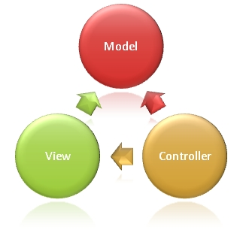
Figure 1: MVC Architecture
(http://www.w3schools.com/aspnet/mvc_intro.asp)

The Model is the part of the application that handles the logic for the application data.
Often model objects retrieve data (and store data) from a database.
The View is the parts of the application that handles the display of the data.
Most often the views are created from the model data.
The Controller is the part of the application that handles user interaction.
Typically controllers read data from a view, control user input, and send input data to the model.

Component Diagram

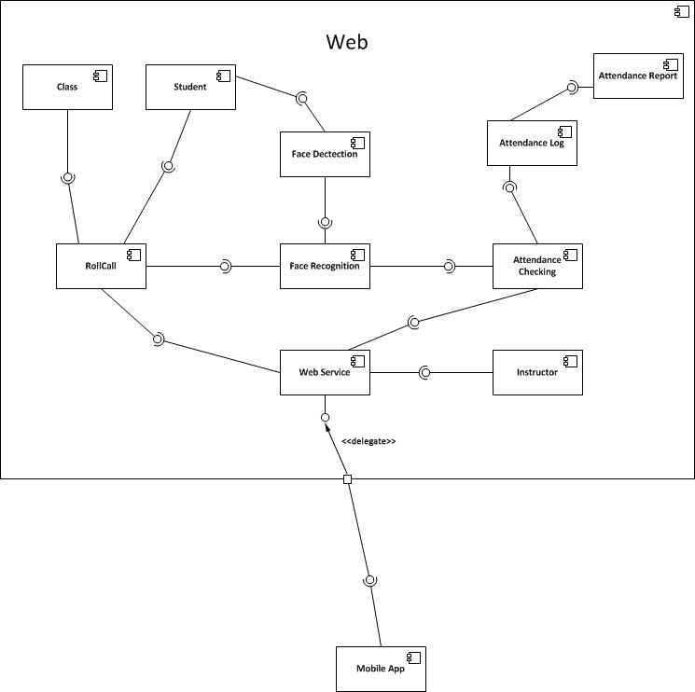
Figure 2: Component Diagram

Detailed Description of Components

Class Diagram
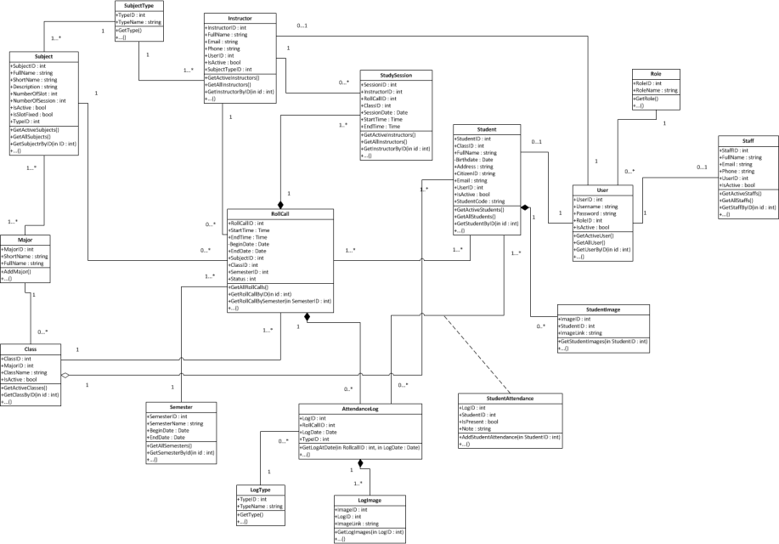
Figure 3: Class Diagram

Class Diagram Explanation

Roll Call
Attribute
Attribute | Type | Visibility | Description
RollcallID | Int | Public | Unique id of each roll call
StartTime | Time | Public | Start time of roll call
EndTime | Time | Public | End time of roll call
BeginDate | Date | Public | Begin date of roll call
EndDate | Date | Public | End date of roll call
SubjectID | Subject | Public | Subject of roll call
ClassID | Class | Public | Class of roll call
SemesterID | Semester | Public | Semester of roll call
Status | Int | Public | Status of roll call
Method
Method | Return Type | Visibility | Description
getAllRollcalls | Void | Public | Get all roll call in system
getRollcallbyID | Rollcall | Public | Get roll call in system by id
getRollcallBySemester | Rollcall | Public | Get roll call in system by semester

Subject
Attribute
Attribute | Type | Visibility | Description
SubjectID | Int | Public | Unique id of each subject
FullName | String | Public | Full name of subject
ShortName | String | Public | Short name of subject
Description | String | Public | Description of subject
NumberOfSlot | Int | Public | Number of slot of subject
NumberOfSession | Int | Public | Number of slot of subject
IsActive | Boolean | Public | Status active of subject
IsSlotFixed | Booean | Public | Number of slot of special subject

Method
Method | Return Type | Visibility | Description
GetActiveSubjects | Void | Public | Get subject are active.
GetAllSubjects | Void | Public | Get all subject in system
GetSubjectByID | Subject | Public | Get subject in system by id

…………………….

Sequence Diagram

Add Image for Singe Student
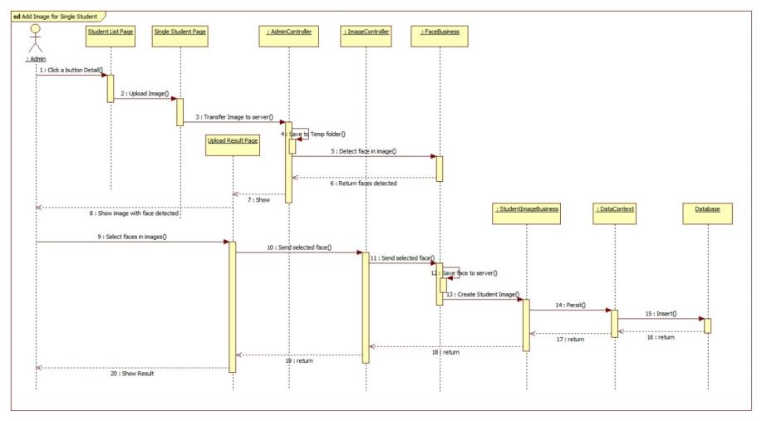
Figure 4: Add Image for Singe Student Sequence Diagram

Add Image for Many Students
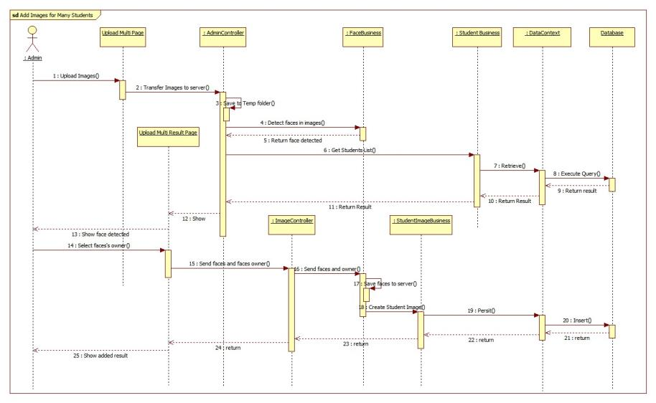
Figure 5: Add Image for Many Students Sequence Diagram

…..

5. User Interface Design

Instructor Interface Design

Instructor Home Page
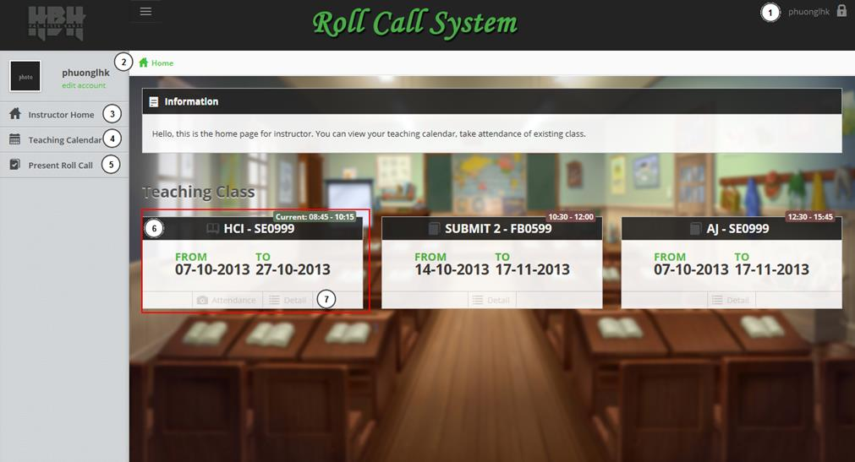
Figure 6: Instructor Home Page
Fields
No | Field Name | Description | Read only | Mand-atory | Control Type | Data Type | Length
6 | Roll Call Info | Info of a roll call: Subject, class, time…. | Y | Y | Label | N/A | N/A
Fields
No | Field Name | Description | Read only | Mand-atory | Control Type | Data Type | Length
1 | txtSo1 | Input first number | N | Y | Text | String | 0…100
2 | txtSo2 | Input second number | N | Y | Text | String | 0…100
3 | txtKq | Result of addition | Y | N | Text | String | 0.100

Button/ Hyperlink
No | Function | Description | Validation | Outcome
1 | Account Info | Username of user | No | Account Info
2 | Home Page | Click to go to home page | No | Home Page
3 | Instructor Home | Click to go to home page | No | Home Page
4 | Teaching Calendar | Click to View Teaching Calendar | No | Teaching Calendar Page
5 | Present Roll Call | Click to view the roll call at present | No | Present Roll Call Page

Button/ Hyperlink
No | Function | Description | Validation | Outcome
4 | Add2Primes | Add two prime number | Yes (number must be prime) | Result of Addition

Instructor – Teaching Calendar
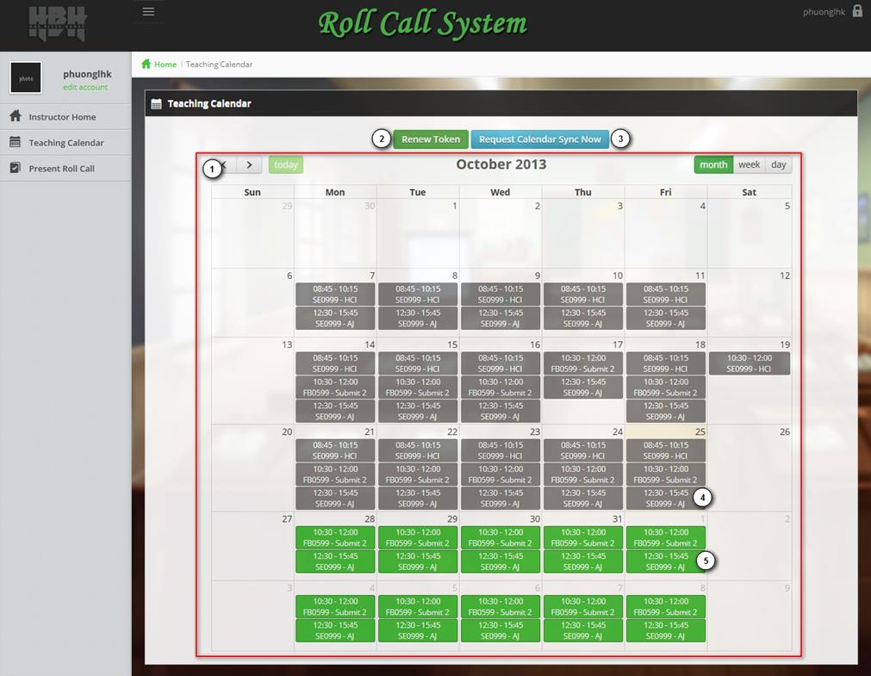
Figure 7: Instructor – Teaching Calendar
Fields
No | Field Name | Description | Read only | Mand-atory | Control Type | Data Type | Length
1 | Traching Calendar | The teaching calendar of instructor | Y | Y | Calendar | N/A | N/A
4 | Past event | Event of the days before today | Y | N | Label | N/A | N/A
5 | Future Event | Event of the days after today | Y | N | Label | N/A | N/A
Button/ Hyperlink
No | Function | Description | Validation | Outcome
2 | Renew Token | Click to get a new token from Google Calendar | No | Get Token from Google
3 | Request Calendar Sync now | Click to go to sync the calendar to Google Calendar | No | Calendar is synced

Instructor – Present Roll Call
…..

Database Design

Entity Relationship Diagram
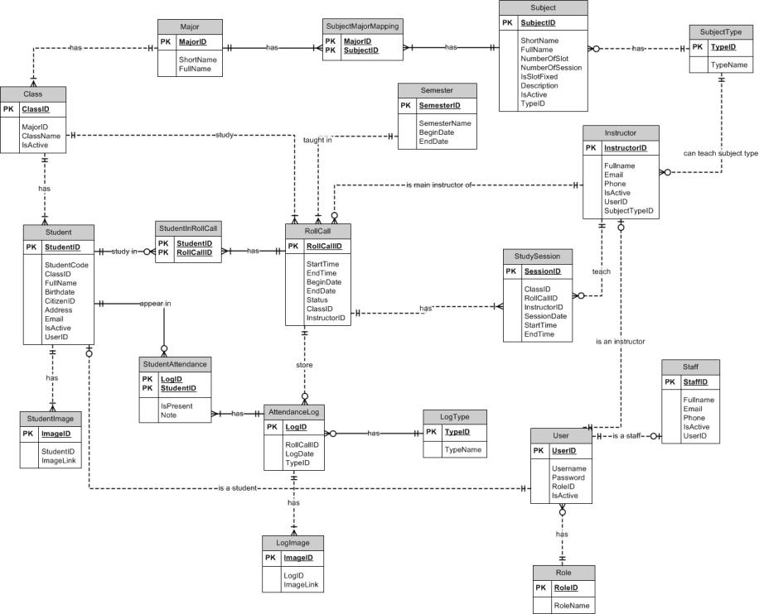
Figure 8: Logical Diagram

Data Dictionary
Entity Data dictionary: describe content of all entities
Entity Name | Description
Semester | Describe all semesters in school system.
Major | Describe all majors in school system.
SubjectMajorMapping | Describe relationship between table subject and table major. One subject belongs to one or a lot of major, one major has one or a lot of subject.
Subject | Describe all subjects in school system.
SubjectType | Describe type of subject (IT, economic, language ...)
Class | Describe all class in school system.
Student | Describe all students in school system.
StudentImage | Describe all images of each student.
Instructor | Describe all instructors in school system.
StudySession | Describe all study session of roll call.
Rollcall | Describe all roll calls in school system.
StudentInRollcall | Describe student list of roll call.
StudentAttendance | Describe attendance of student.
AttendanceLog | Describe all attendance in roll call
LogImage | Describe all images of attendance log
LogType | Describe all type of attendance log
Staff | Describe all staffs in school system.
User | Describe account of user of system. User include: admin, staff, guest, student …
Role | Describe role of user. One user has one role.
Table 1: Entity Data Dictionary

Entity name | Attributes | Description | Domain | Nulls
Semester | SemesterID{PK}  SemesterName  BeginDate  EndDate | Uniquely identifies a semester, auto increment.  Name of semester.  The begin date of semester.  The end date of semester. | Int  15 nvar  Datetime  Datetime | No  No  No  No
Major | MajorID{PK}  ShortName  FullName | Uniquely identifies a major, auto increment.  Short name of major.  Full name of major. | Int  2 nvar  30 nvar | No  Yes  No
SubjectMajorMapping | MajorID {FK}  SubjectID {FK} | Foreign key references to table Major  Foreign key references to table Subject | Int  Int | No  No
Subject | SubjectID{PK}  ShortName  FullName  NumberOfSlot  NumberOfSession  IsSlotFixed  Description  IsActive  TypeID {FK} | Uniquely identifies a subject, auto increment.  Short name of subject.  Full name of subject.  Number of slot of subject (per day).  Number of session of subject.  This value shows that a slot can fixed or not.  Description of subject  This value shows that the subject is active or not.  Foreign key references to table Type | Int  10 nvar  50 nvar  Int  Int  Bit  10 char  Bit  Int | No  Yes  No  No  No  No  Yes  No  No
SubjectType | TypeID {PK}  TypeName | Uniquely identifies a type, auto increment.  Name of type. | Int  50 nvar | No  No
Class | ClassID {PK}  MajorID {FK}  ClassName  IsActive | Uniquely identifies a class, auto increment.  Foreign key references to table Major  Name of class  This value shows that the class is active or not. | Int  Int  6 char  Bit | No  No  No  No
…..
Table 2: Attribute Data Dictionary

Algorithms

Face Detection

Definition
Face detection is a computer technology that determines the locations and sizes of human faces in arbitrary (digital) images. It detects facial features and ignores anything else, such as buildings, trees and bodies.
References: http://en.wikipedia.org/wiki/Face_detection

Different method for face detection
There are many ways to detect a face in a scene - easier and harder ones. Here is a list of the most common approaches in face detection:
- Finding faces in images with controlled background
- Finding faces by color
- Finding faces by motion
- Using a mixture of the above
- Finding faces in unconstrained scenes:
- Neural Nets using statistical cluster information
- Neural Net approach
- Weak classifier cascades
- Model-based Face Tracking
References: http://www.facedetection.com/facedetection/techniques.htm

The method we chose
We chose the Viola-Jones method. Reason:
- Simple, fast and good accuracy.
- Already implemented in EmguCV.

Method Introduction
This approach to detecting objects in images combines four key concepts:
- Simple rectangular features, called Haar features
- An Integral Image for rapid feature detection
- The AdaBoost machine-learning method
- A cascaded classifier to combine many features efficiently
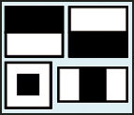
Figure 9: Example of Haar Future
The presence of a Haar feature is determined by subtracting the average dark-region pixel value from the average light-region pixel value. If the difference is above a threshold (set during learning), that feature is said to be present.
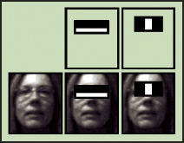
Figure 10: Apply Haar future to sub-window
To select the specific Haar features to use, and to set threshold levels, Viola and Jones use a machine-learning method called AdaBoost. AdaBoost combines many "weak" classifiers to create one "strong" classifier.
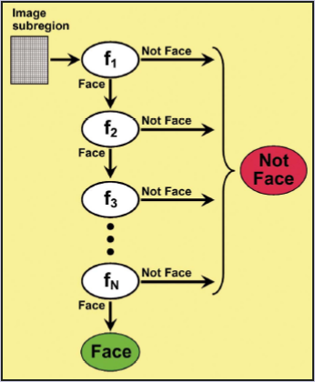
Figure 11: Classifier Cascade
During use, if any one of these filters fails to pass an image region, that region is immediately classified as "Not Face." When a filter passes an image region, it goes to the next filter in the chain. Image regions that pass through all filters in the chain are classified as "Face." Viola and Jones dubbed this filtering chain a cascade.
Reference: http://cognotics.com/opencv/servo_2007_series/part_2/sidebar.html
The basic principle of the Viola-Jones face detection algorithm is to scan the detector many times through the same image – each time with a new size. Pseudo code for the algorithm:
1) Opens an image and transforms to greyscale if needed.
2) Runs a sub-window through the image.
2a) Rescales the content of the sub-window to 24*24pixels (if needed). Check the Haar feature in each window. Move the sub-window if Haar feauture missing.
2b) Enlarges the sub-window by a given factor a goes back to 2).
2c) Continues until the sub-window size is equal to the least dimension of the image.
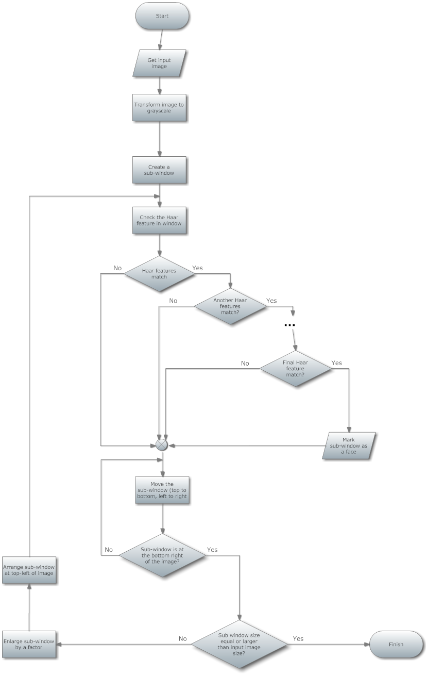
Figure 12: Viola-Jones method flowchart

………….

