
MINISTRY OF EDUCATION AND TRAINING

FPT UNIVERSITY

Capstone Project Document
The Roll System using Mobile Device
Group 1
Group member | Pham Huy Hoang – Team Leader – 60740  Nguyen Thanh Binh – Team Member - 60321  Nguyen Quoc Huy – Team Member - 60551  Do Minh Dat – Team Member - 60545
Supervisor | Mr. Kieu Trong Khanh
Ext. Supervisor | N/A
Capstone Project code | RSM

-Ho Chi Minh City, 09/2013-

This page is intentionally left blank

ACKNOWLEDGEMENTS
We wish to thank various people for their contribution to this project: Our teachers for their advices and participant in the final review, our friend for the valuable technical support.
Special thanks should be given to Mr.Kiều Trọng Khánh, our research supervisor for his professional guidance and the useful, constructive recommendations throughout the course of this project.

Table of Contents
Table of Contents 4
List of Tables 5
List of Figures 6
Definitions, Acronyms, and Abbreviations 8
Report No.3 Software Requirement Specification 9
1. User Requirement Specification 9
1.1 Guest Requirement 9
1.2 Instructor Requirement 9
1.3 Staff Requirement 9
1.4 Student Requirement 9
1.5 Admin Requirement 9
1.6 System Requirement 9
2. System Requirement Specification 9
2.1 External Interface Requirement 9
2.2 System Overview Use Case 10
2.3 List of Use Case 11
3. Software System Attribute 14
3.1 Usability 14
3.2 Reliability 14
3.3 Availability 14
3.4 Security 14
3.5 Maintainability 14
3.6 Portability 14
3.7 Performance 14
4. ERD 15

List of Tables
Table 1: <Admin> Add Image for Single Student 13
Table 2: <Admin> Add Image for Multi Students Error! Bookmark not defined.
Table 3: <Admin> Remove Student Images Error! Bookmark not defined.
Table 4: <Admin> Create Account Error! Bookmark not defined.
Table 5: <Admin> Active Account Error! Bookmark not defined.
Table 6: <Admin> Inactive Account Error! Bookmark not defined.
Table 7: <Admin> Config System Error! Bookmark not defined.
Table 8: <System> Face Detection Error! Bookmark not defined.
Table 9: <System> Recognize Student Error! Bookmark not defined.
Table 10: <System> Auto Free Storage Space Error! Bookmark not defined.
Table 11: <System> Auto Active Roll Call Error! Bookmark not defined.
Table 12: <System> Auto Inactive Roll Call Error! Bookmark not defined.
Table 13: <Staff>Add Roll Call Error! Bookmark not defined.
Table 14: <Staff>Edit Roll Call Error! Bookmark not defined.
Table 15: <Staff> Add Subject Error! Bookmark not defined.
Table 16: <Staff> Edit Subject Error! Bookmark not defined.
Table 17: <Staff> Active Subject Error! Bookmark not defined.
Table 18: <Staff> Inactive Subject Error! Bookmark not defined.
Table 19: <Staff> Add Student Error! Bookmark not defined.
Table 20: <Staff> Edit Student Error! Bookmark not defined.
Table 21: <Staff> Import Student List Error! Bookmark not defined.
Table 22: <Staff>Add Instructor Error! Bookmark not defined.
Table 23: <Staff> Edit Instructor Error! Bookmark not defined.
Table 24: <Staff> Add Class Error! Bookmark not defined.
Table 25 <Staff> Edit Class Error! Bookmark not defined.
Table 26: <Staff> Report Attendance by Class Error! Bookmark not defined.
Table 27: <Staff> Report Attendance by Student Error! Bookmark not defined.
Table 28: <Staff> Report Attendance by Block Error! Bookmark not defined.
Table 29: <Staff> Report Attendance by Semester Error! Bookmark not defined.
Table 30: <Instructor> Check Attendance by Taking Picture Error! Bookmark not defined.
Table 31: <Instructor> Check Attendance Manually Error! Bookmark not defined.
Table 32: <Instructor> View Roll Call List Error! Bookmark not defined.
Table 33: <Instructor> Report Attendance by Class Error! Bookmark not defined.
Table 34: <Student> CheckPresent Rate Error! Bookmark not defined.
Table 35: <Guest> Login Error! Bookmark not defined.
Table 36: < Authorized User> Change Password Error! Bookmark not defined.
Table 37: <User> Logout Error! Bookmark not defined.

List of Figures
Figure 1: System Overview Use Case 10
Figure 2: <Admin> Overview Use Case 11
Figure 3: <Admin> Add Image for Single Student 11
Figure 4: <Admin> Add Image for Multi Student Error! Bookmark not defined.
Figure 5: <Admin> Remove Student Image Error! Bookmark not defined.
Figure 6: <Admin> Create Account Error! Bookmark not defined.
Figure 7: <Admin> Active Account Error! Bookmark not defined.
Figure 8: <Admin> Inactive Account Error! Bookmark not defined.
Figure 9: <Admin> Config System Error! Bookmark not defined.
Figure 10: <System> Overview Use Case Error! Bookmark not defined.
Figure 11: <System> Face Detection Error! Bookmark not defined.
Figure 12: <System> Recognize Student Error! Bookmark not defined.
Figure 13: <System> Auto Free Storage Space Error! Bookmark not defined.
Figure 14: <System> Auto Active Roll Call Error! Bookmark not defined.
Figure 15: <System> Auto Inactive Roll Call Error! Bookmark not defined.
Figure 16: <Staff> Overview Use Case Error! Bookmark not defined.
Figure 17: <Staff>Add Roll Call Error! Bookmark not defined.
Figure 18: <Staff>Edit Roll Call Error! Bookmark not defined.
Figure 19: <Staff> Add Subject Error! Bookmark not defined.
Figure 20: <Staff> Edit Subject Error! Bookmark not defined.
Figure 21: <Staff> Active Subject Error! Bookmark not defined.
Figure 22: <Staff> Inactive Subject Error! Bookmark not defined.
Figure 23: <Staff> Add Student Error! Bookmark not defined.
Figure 24: <Staff> Edit Student Error! Bookmark not defined.
Figure 25: <Staff> Import Student List Error! Bookmark not defined.
Figure 26: <Staff>Add Instructor Error! Bookmark not defined.
Figure 27: <Staff>Edit Instructor Error! Bookmark not defined.
Figure 28: <Staff> Add Class Error! Bookmark not defined.
Figure 29: <Staff> Edit Class Error! Bookmark not defined.
Figure 30: <Staff> Report Attendance by Class Error! Bookmark not defined.
Figure 31: <Staff> Report Attendance by Student Error! Bookmark not defined.
Figure 32: <Staff> Report Attendance by Block Error! Bookmark not defined.
Figure 33: <Staff> Report Attendance by Semester Error! Bookmark not defined.
Figure 34: <Staff> Export Report Error! Bookmark not defined.
Figure 35: <Instructor> Overview Use Case Error! Bookmark not defined.
Figure 36: <Instructor> Capture and Show result attendance Error! Bookmark not defined.
Figure 37: <Instructor> Check Attendance Manually Error! Bookmark not defined.
Figure 38: <Instructor> View Roll Call List Error! Bookmark not defined.
Figure 39: <Instructor> Report Attendance by Class Error! Bookmark not defined.
Figure 40: <Student> Overview Use Case Error! Bookmark not defined.
Figure 41: <Student> CheckPresent Rate Error! Bookmark not defined.
Figure 42: <Guest> Overview Use Case Error! Bookmark not defined.
Figure 43: <Guest> Login Error! Bookmark not defined.
Figure 44: < Authorized User> Overview Use Case Error! Bookmark not defined.
Figure 45: < Authorized User> Change Password Error! Bookmark not defined.
Figure 46: < Authorized User> Logout Error! Bookmark not defined.
Figure 47: ERD - Conceptual Diagram 15

Definitions, Acronyms, and Abbreviations
RSM | Roll System Mobile
Face Detection | Face detection is a computer technology that determines the locations and sizes of human faces in arbitrary (digital) images. It detects facial features and ignores anything else, such as buildings, trees and bodies.  http://en.wikipedia.org/wiki/Face_detection
Face Recognition | Face recognition is the task of identifying an already detected object as a KNOWN or UNKNOWN face, and in more advanced cases, telling EXACTLY WHO'S face it is!

Report No.3 Software Requirement Specification

User Requirement Specification

Guest Requirement
Guest is a person who doesn’t have access to the system. To use system functions, guest must Login.

Instructor Requirement
Instructor is teacher of the university. Instructor’s account is created by admin?.Instructor can use mobile app or website, that can do functions:
- Check Attendance
- Report Attendance Rate

Staff Requirement
Staff is the employee of the university office. Staff’s account is created by admin. Staff can use website with these functions:
- Manage Subject: Add/ Edit/Active/ Inactive Subject
- Manage Class: Add/Edit /Active/ Inactive Class
- Manage Teacher: Add/Edit Teacher
- Manage Student: Add/Edit Student. Import Student List
- Manage Roll Call: Add/Edit Roll Call
- Report Attendance Rate: Report by Class, Block, Student. Export report

Student Requirement
Student is the student of the university. Student’s account is created by admin. . Staff can use website with function:
- Check Present Rate

Admin Requirement
Admin is the one who maintained and config the system. Admin can do functions:
- Manage Account: Create/Edit/Active/Inactive Account
- Manage Student Image: Add/Delete Student’s Image
- Config System

System Requirement
System is also an actor, run in the background to keep the system working. System can do functions:
- Auto free storage space
- Face Detection
- Face Recognition: Recognition Student/Store Result
- Manage Roll Call: Auto Active/Inactive Roll Call

System Requirement Specification

External Interface Requirement

User Interface
    - The interface of website is clear, do not annoy customer.
    - The interface of mobile app must be clear, compatibale with touch screen. The size of controls must be big enough to touch on smartphone.
    - The error, warning messages must be make clear, easy to understand. Error warning does not disturb customer.

Hardware Interface
- The system will use the standard hardware and data communications resources of a standard computer.

Software Interface
- Firefox Browser, Chromes with Resolution (1280*800) or bigger and support JavaScript and HTML5
- Smartphone with Android 4.1 or above. Screen size (70 x 120 mm) or bigger.

Communication Protocol
- Website using HTTP protocol for communication between the web browser and the web server.
- Mobile app using HTTP protocol for communicating between app and web service.

System Overview Use Case
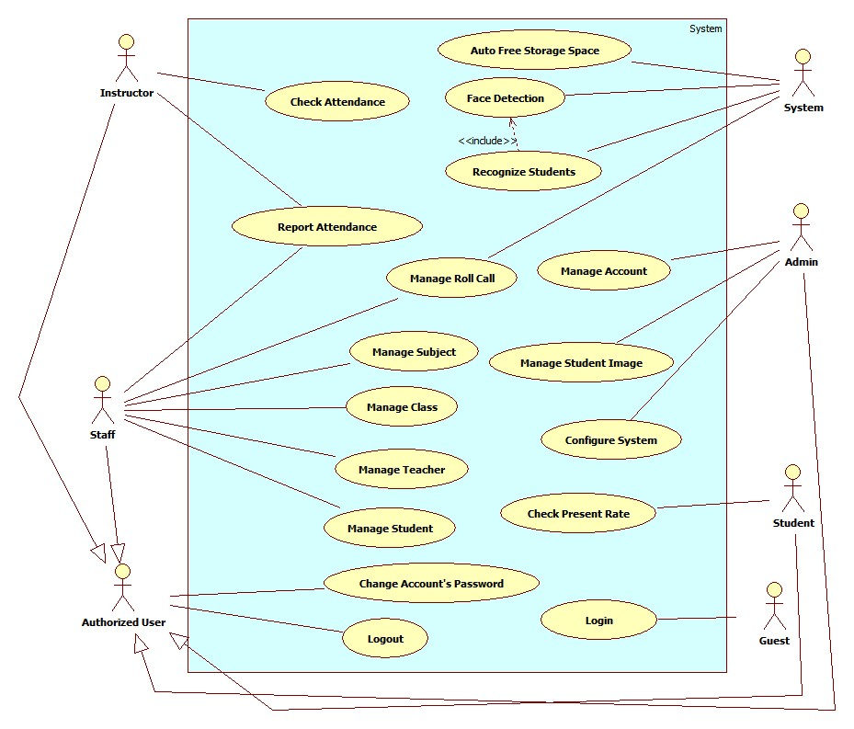
Figure 1: System Overview Use Case

List of Use Case

<Admin>Overview Use Case
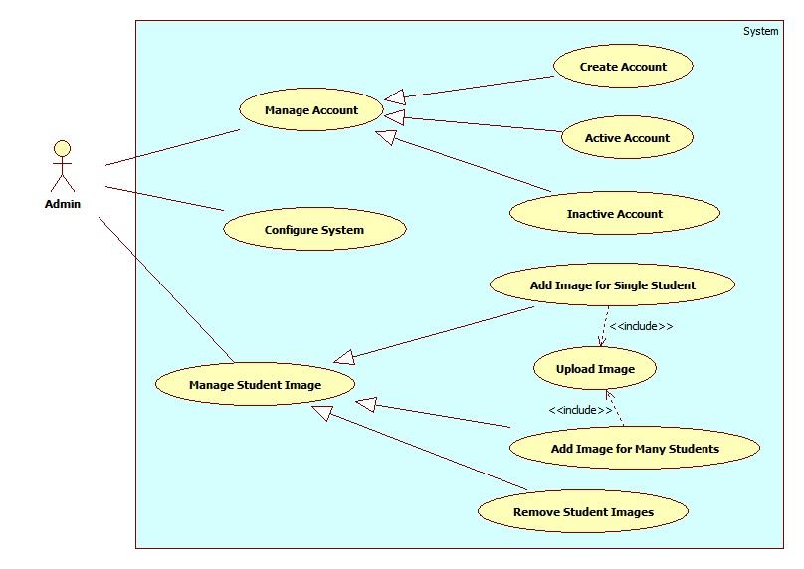
Figure 2: <Admin> Overview Use Case

<Admin> Add Image for Single Student
Use Case Diagram
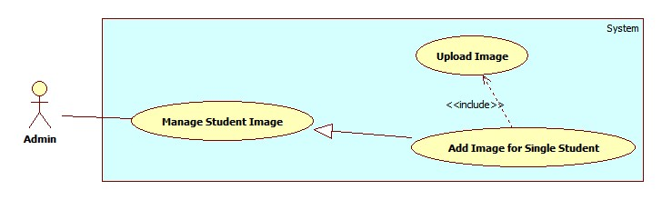
Figure 3: <Admin> Add Image for Single Student
Use Case Specification
USE CASE – AD005
Use Case No. | AD005 | Use Case Version | 2.0
Use Case Name | Add Image for Single Student
Author | Pham Huy Hoang
Date | 20/09/2013 | Priority | Normal
Actor: Admin
Summary:
This user case allow admin add image data for a student.
Goal:
Image of a students will be stored on server, the links to images is stored in database
Triggers:
- For face recognition, our system must store images of students face. With more images, we can have better recognition accuracy.
- To add new image for a single student, admin must:
- Click menu item“Manage Student Image” -> “Student List”.
- On the Student List Page, click Detail to view image data of a student.
- Upload images. System will detect human faces from uploaded images.
- Select the student faces from images.
- Press “Save” to save the images.
Preconditions:
- User must logged in the system with the role is admin.
- There must be at least one student in the student list.
- The admin has images contain the student’s face.
Post Conditions:
- Success: The images of a student will be stored on server and database
- Fail: No image added
Main Success Scenario:
Step | Actor Action | System Response
1 | - Click menu item “Manage Student Image”  - Click choose “Student List” menu.  [Alternative 1] | Redirect to Student List Page, contains :  - Table with 4 columns, record of 30 lastest students:  - Student Code: label  - Name: label  - Email: label  - Image Data: “Detail” button  - Class: Drop down list, data source: All active class in database.
2 | Click on “Detail” button. | Redirect to Student Detail Page, contains detail of Student Image Data, include:  - Student Current Image: A list of images  - File Upload Control  - Upload: button
2 | Select the student’s images from computer. | The selected images will be displayed as thumbnails.  [Exception 1]
3 | Click “Upload” button. | System will detect student faces from uploaded images, then display image full size with white face regions (See Use Case SY002)  [Exception 2, 3]
4 | Select student’s face from face region.  Click “Save” button. | The selected face region will be cropped from original picture, stored into server. Face’s owner and link will be stored in database. [Exception 4]  The pop-up is closed. The Student List Page is auto refresh.
Alternative Scenario:
No | Actor Action | System Response
1 | [Alternative 1]  - Select a class from Class drop down list.  - Press “Select” button. | A table show the records of all students in selected class.  Table with 4 columns:  - Student Code: label  - Name: label  - Email: label  - Image Data: “Detail” button
Exceptions:
No | Actor Action | System Response
1 | Select more than 20 images | Display error message: “ Too much images. Only process first 20 images”
2 | Not select image, click “Upload” button | Display error message: “Please choose images for uploading”
3 | - Upload images don’t contain human faces.  Or  -No faces detected from uploaded images | Display error message: “ No face found. Select another images”
4 | The selected face already in the database | Display message: “Face XXX existed in database”

Relationships: Manage Student Image
Business Rules:
- For saving storage space, only student’s face is stored. The face is saved as jpeg, resolution 100 x 100.
- The recommend number of image for a student is larger than 10 for acceptable accuracy.
- The original uploaded images will be stored on Temp folder on server. This Temp folder will be emptied at time interval (See Use Case SY001).
Table 1: <Admin> Add Image for Single Student
USE CASE – Name: Usecase name or function that describes in SRS
Use Case No. | Code | Use Case Version | 2.0
Use Case Name | Description
Author | Author’s name
Date | date | Priority | Level
Actor: Actor’ names
Summary:
Descript summaries.
Goal:
What does usecase for?
Triggers:
- Trigger actions
Preconditions:
- The requirement condition before the function is called/invoked
- The actor must have granted with particular permission or roles
Post Conditions:
- Success: output
- Fail: action for exceptions
Main Success Scenario:
Step | Actor Action | System Response
1 | - The Actor action interacts with System [exception no.] [alternative no.] | - The server/system react or response
Alternative Scenario:
No | Actor Action | System Response
1 | [Alternative 1]  - The alternative action alters the basic flow. | - The server/system react or response
Exceptions:
No | Actor Action | System Response
1 | Exception occurrences | The server/system react or response
Relationships: relation usecases that support this usecase
Business Rules:
- Constraints in processing above descript usecase

USE CASE – Add 2 Prime Numbers
Use Case No. | UC001 | Use Case Version | 2.0
Use Case Name | Add 2 Prime Numbers
Author | Kiều Trọng Khánh
Date | 12/12/2013 | Priority | High
Actor: Actor’ names
Summary:
Add 2 Prime Numbers
Goal:
To Add 2 Primes and show the result on screen
Triggers:
- Actor wants to get the result of add 02 prime numbers
- The actor click add button on current form.
Preconditions:
- The inputted values must be a Primes Numbers
- The actor must login to System as Students or Sciences
Post Conditions:
- Success: result of adding
- Fail: The message is shown “The numbers are very large!!!”
Main Success Scenario:
Step | Actor Action | System Response
1 | - The user press Enter or click the Add button [Alternative 1] | - The system get the parameters from the user’s request  - Convert the string value to numbers  - Call add function  - Return the value to response message  - The printer active the printer to print
Alternative Scenario:
[Alternative 1]
No | Actor Action | System Response
1 | - The user click close the window. | - The system show dialog “Are you exit?” with OK and Cancel Button
2 | - The user click OK | - The form is closed  - All temp information on form are saved in text file
Exceptions:
No | Actor Action | System Response
1 | The inputted value is very large or the result can be not executed because its value is a large number | The message is shown “The numbers are very large!!!””
Relationships: Check Prime Number, Store Number
Business Rules:
- Number is not more than 100 digits
- All information must be stored in text file .prop when the user click ok button on dialog box

Software System Attribute

Usability

Graphic User Interface
- All the text, label and image in staff, instructor and student page should be English.
- All the text, label and image in admin page should be English.

Usability
- Website admin, staff and instructor should need more than one week of training to be productive with the system.
- The student can use the system easily without training.

Installation
- The system must be easy to deploy. Customer can deploy successfully and learn to configure, maintain the system within one day of training.
- The mobile app must be easy to install. Compatible with almost Android Phone.
- The attached manual guide must be clear. User can read and do themselves without developer’s help.

Reliability
- N/A

Availability
- N/A

Security
- Privacy: Each role of user has a specific permission to interact with system.
- System always checks authorization and authenticated before doing anything.
- Only admin can grant permission to staff.

Maintainability
- N/A

Portability
- N/A

Performance
- Detect Faces From an Image: 3~4 seconds/image.
- Recognize Faces: 20~30 seconds/100 faces. With training set of 30 students, 600 images.
- The image upload speed depend on the speed of the network.

Conceptual Diagram
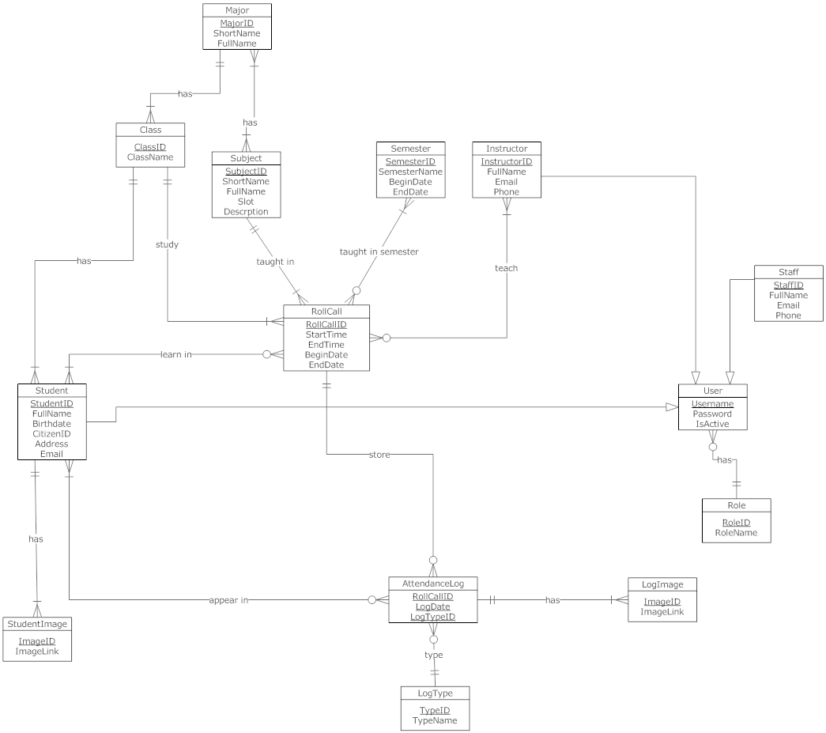
Figure 4: ERD - Conceptual Diagram

Data Dictionary
Entity Data dictionary: describe content of all entities
Entity Name | Description
Semester | Describe all semesters in school system. Each semester last 4-5 months.
Major | Describe all majors in school system. (Current major: Software Engineering, Financial Banking, Business Administrator …)
Subject | Describe all subjects in school system, A subject can be taught in many majors
SubjectType | Describe type of subject (IT, economic, language ...)
Class | Describe all class in school system. Each class belong to one major
Student | Describe all students in school system.
StudentImage | Describe all images of each student.
Instructor | Describe all instructors in school system. An instructor can teach many types of subject.
RollCall | Describe all roll calls in school system. A roll call contains info: Class, Subject, begin-end Time…..
StudySession | Describe all study session of roll call. A roll call has many study sessions.
AttendanceLog | Describe all all the attendance log of roll call. A log contains the present/absent students in a date of a roll call.
LogImage | Describe all images of attendance log.
LogType | Describe all type of attendance log (Auto, Manual).
Request | Describe all request send from admin to student.
RequestImage | Describe all images of request.
Staff | Describe all staffs in school system.
User | Describe account of user of system. User include: admin, staff, student …
Role | Describe role of user. One user has one role.

