SEMESTER PROJECT
Kieu Long

PART 1 - RESEARCH
The parking technology market currently offers various applications that let drivers find, reserve, and pay for parking. To understand the existing software ecosystem and identify opportunities for the Smart Parking Platform, we reviewed three solutions: ParkMobile, SpotHero, and ParkWhiz.
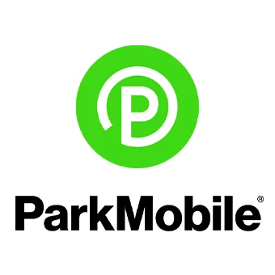

ParkMobile offers digital parking solutions that let users search for parking by destination, date, or event and reserve spots in advance. The service may display options such as pricing and availability, and supported locations could allow drivers to access parking using a QR code.

Strengths: ParkMobile offers an easy way to search for parking, make advance reservations, and access parking digitally. It caters to various parking needs, including events, commuting, garages, and transit hubs.

Opportunity for differentiation: The Smart Parking Platform will focus more on combining real-time parking availability with features like navigation, reservation, payment, occupancy tracking, and operator management within a single system.
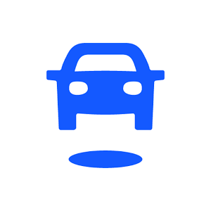

SpotHero is a parking reservation platform that lets drivers find parking spots, compare options and prices, pay in advance, and get a digital pass. It serves over 400 cities across the United States and Canada.

Strengths: SpotHero makes it easy to compare parking options and reserve a spot ahead of time. It also includes features such as managing reservations, saving favorite locations, buying parking passes, and rebooking.

Opportunity for differentiation: SpotHero mainly helps drivers reserve parking at partner garages and lots. The Smart Parking Platform will enhance this by highlighting real-time occupancy data and offering management and analytics tools for parking operators and stakeholders.


ParkWhiz lets drivers search for nearby garages or parking lots, compare options and prices, reserve parking, and pay digitally. After completing their reservation, users receive a parking pass.

Strengths: ParkWhiz features a simple reservation system and supplies details about parking facilities, such as location, amenities, and instructions.

Opportunity for differentiation: ParkWhiz primarily emphasizes booking and payment processes for parking facilities. The Smart Parking Platform aims to deliver a more comprehensive system that integrates parking discovery and reservation services with real-time availability updates, navigation assistance, occupancy tracking, and operator management.

Proposed Differentiation
Existing parking apps demonstrate that drivers gain from digital search, reservation, and payment options. Nonetheless, the Smart Parking Platform aims to build a more comprehensive parking ecosystem, moving beyond a reservation marketplace.
The platform integrates live parking status updates, interactive maps, reservation options, digital payment systems, navigation support, notifications, occupancy data analysis, and operator management features within both web and mobile apps. These features meet the project's original specifications.

PART 2 - VISION AND SCOPE
- Project Acquisition
The city transportation department recognized the need for a more efficient, centralized parking system and commissioned $oftware ¢orp. to develop a solution. Consequently, $oftware ¢orp. acquired the Smart Parking Platform project to enhance the parking experience for drivers and equip parking operators with improved tools for monitoring and managing parking facilities.

- Company Introduction
$oftware ¢orp. is a fictional company specializing in developing web, mobile, and data-centric applications. Its mission is to create technological solutions that improve daily services through accessible, efficient digital platforms. For the Smart Parking Platform project, $oftware ¢orp. has unlimited theoretical resources and budget, enabling the team to develop a comprehensive solution tailored to stakeholder needs.

- Project Overview
The Smart Parking Platform is a web and mobile application that helps drivers find, reserve, and pay for parking spaces in real time. It provides parking availability details, an interactive map of locations, navigation guidance, reservation options, cashless payments, and alerts. Additionally, the system supplies parking operators with tools to monitor occupancy levels and review parking activities.
The project aims to minimize the time drivers spend looking for parking and improve the monitoring and management of parking facilities. As the project advances, its vision and scope will be adjusted based on stakeholder feedback and new requirements identified over the semester.

PART 3 - SOFTWARE REQUIREMENTS SPECIFICATION (SRS)
- Purpose
This Software Requirements Specification (SRS) outlines the preliminary requirements for the Smart Parking Platform. The system aims to help drivers locate, reserve, and pay for parking spots in real time via web and mobile apps. It also provides parking operators with tools to monitor occupancy levels and oversee parking facilities. This document is the initial version of the SRS and will be further developed and refined throughout the semester as more requirements are identified.

- System Overview
The Smart Parking Platform offers a unified parking management system for drivers, parking operators, and system administrators. Users can check parking availability, find parking locations via an interactive map, reserve spots, complete digital payments, access reservation history and receipts, receive alerts, and get navigation help.
Parking operators will receive an administrative dashboard to oversee parking occupancy, generate reports, and analyze data. The platform will also connect with external mapping and navigation services. These features are outlined in the initial project requirements.

- Functional Requirements
FR1: The system shall allow users to rto create an account and securely log in.
FR2: The system shall show users which parking spaces are currently available.
FR3: The system shall show available parking locations on an interactive map.
FR4: The system shall allow users to reserve an available parking space.
FR5: The system shall allow users to pay for parking through the platform.
FR6: The system shall allow users to view their past reservations and payment receipts.
FR7: The system shall provide parking operators with a dashboard to manage parking facilities.
FR8: The system shall allow parking operators to view occupancy reports and parking data.
FR9: The system shall send users notifications and alerts about their parking activity.
FR10: The system shall connect with external mapping and navigation services to provide directions.

- Initial User Stories
- As a driver, I want to create an account so that I can save and manage my parking information.
- As a driver, I want to log into my account securely so that my personal information stays protected.
- As a driver, I want to see which parking spaces are available in real time so I don't waste time looking for an open spot.
- As a driver, I want to see nearby parking locations on a map so that I can choose one that is convenient for me.
- As a driver, I want to reserve a parking space ahead of time so that I know I will have a spot when I arrive.
- As a driver, I want to pay for parking through the app so I don't have to use a parking meter or payment machine.
- As a driver, I want to see my past reservations so that I can easily look back at where and when I parked.
- As a driver, I want to access my receipts so I can track what I paid for parking.
- As a driver, I want directions to my reserved parking location so I can find it without opening another app.
- As a driver, I want to receive reminders and updates about my reservation so I don't miss important parking information.
- As a parking operator, I want to see how many spaces are currently occupied so that I know how much parking is still available.
- As a parking operator, I want to view occupancy reports so that I can see how my parking facility is being used over time.
- As a parking operator, I want to see parking trends and data so that I can better understand when and how people use the facility.
- As a system administrator, I want to manage user and operator accounts so that I can keep the platform organized and secure.
- As a city transportation department employee, I want to see parking usage data so that I can better understand parking demand in different areas.

WORK BREAKDOWN STRUCTURE & PROJECT TIMELINE

PART 1 - WORK BREAKDOWN STRUCTURE (WBS)
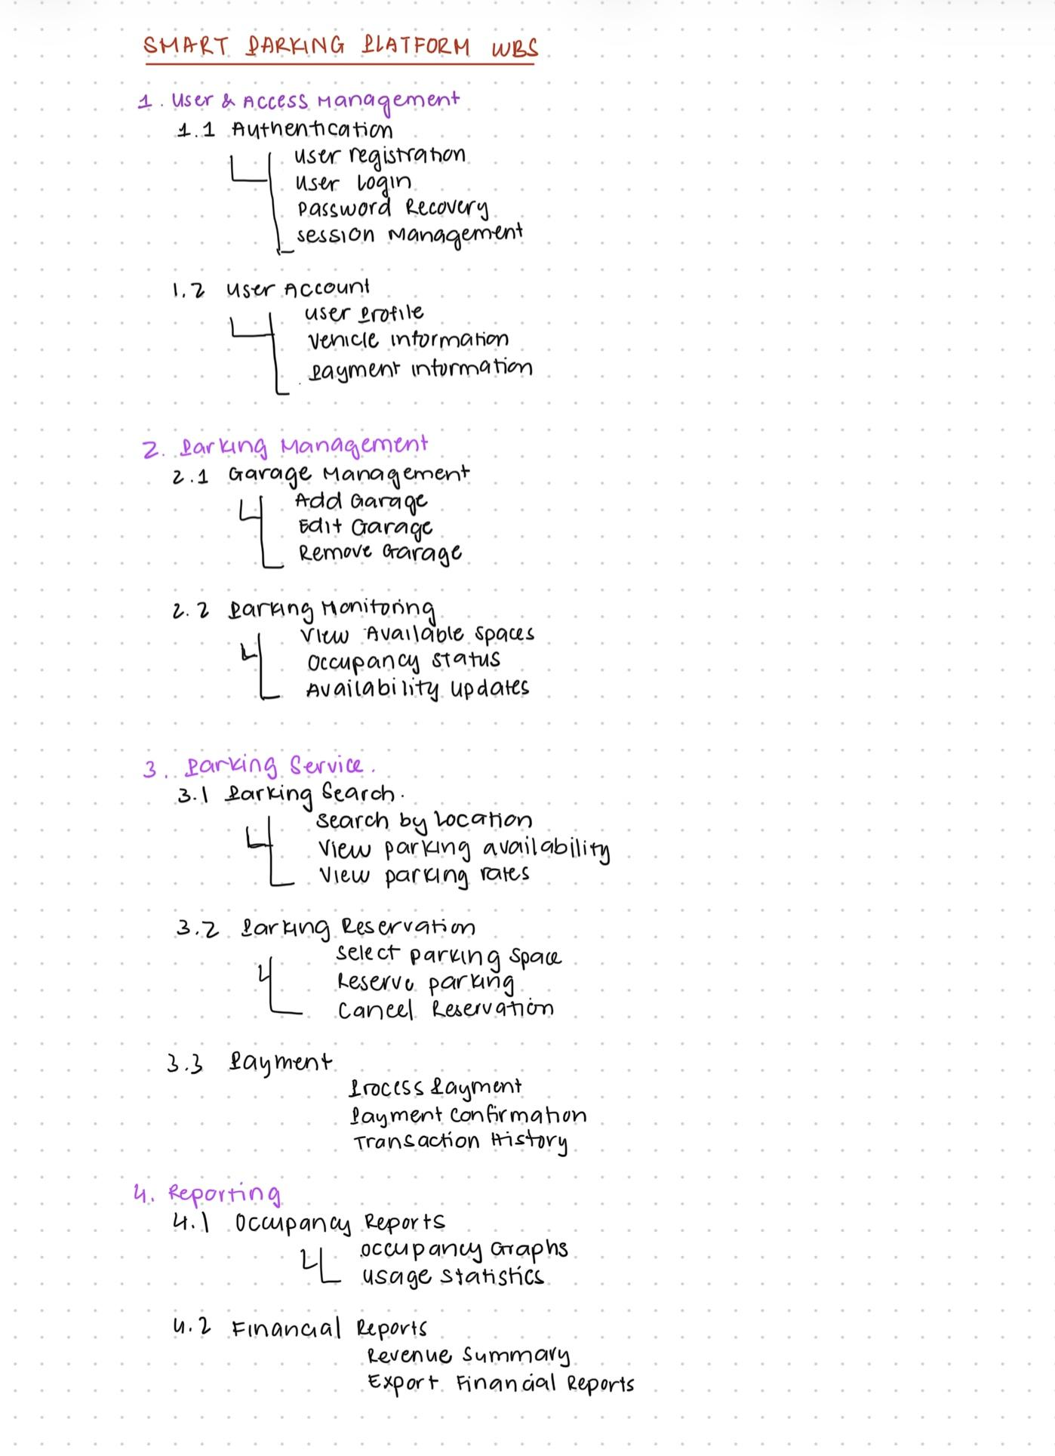
PART 2 - PROJECT TIMELINE

Phase | Duration | Dependecy | Milestone
Requirements & Planning | Week 1 | — | Requirements finalized
User & Access Management | Week 2 | Planning | Login & accounts ready
Parking Management | Week 3-4 | User Access | Garage system ready
Parking Services | Week 5-6 | Parking Management | Search & reservation ready
Payment Integration | Week 7 | Parking Services | Payment ready
Reporting | Week 8 | Parking Management | Reports ready
Integration & Testing | Week 9 | All core features | System integrated
Final Testing & Release | Week 10 | Integration & Testing | Final release

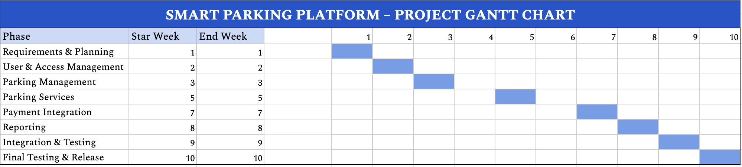

PRODUCT BACKLOG & SPRINT 1 PLANNING

The product backlog details the key features and requirements of the Smart Parking Platform. It comprises 45 items categorized into four groups: Login, User and Operator UI, Backend Processes, and Reporting. Trello labels distinguish each category, simplifying backlog organization and management.
Sprint 1 Goal:
Establish the core authentication and management functions needed to support the Smart Parking Platform.
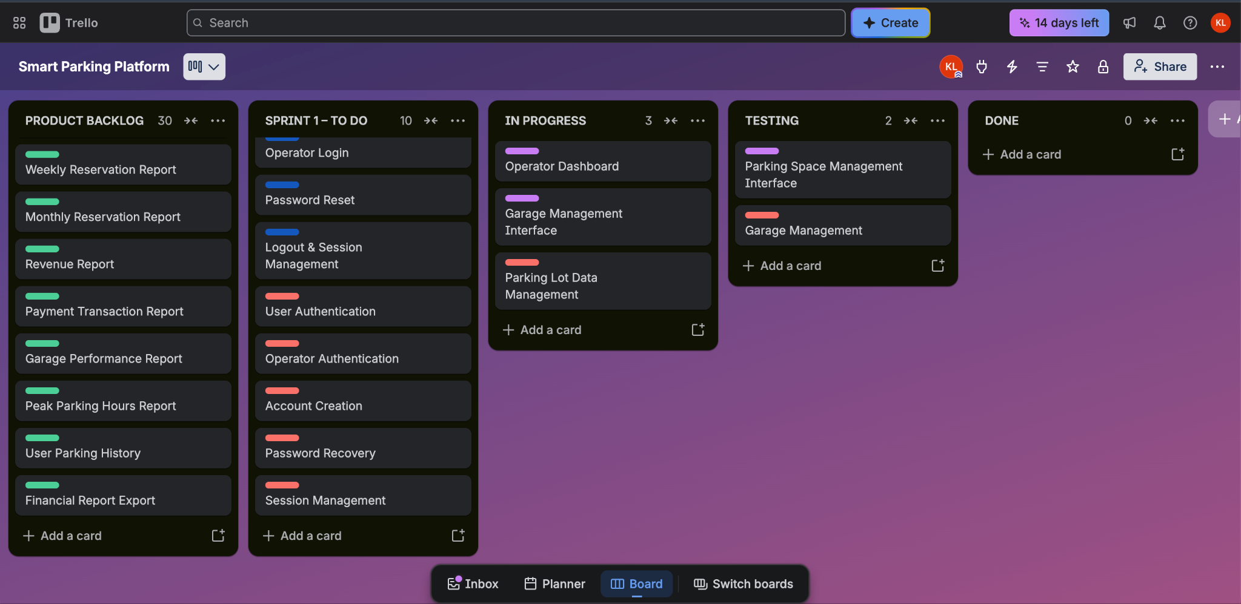
TRELLO LINK

