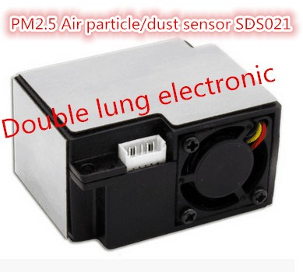
Item specifics
- Material: Mixture
- is_customized: Yes
- Model Number: SDS021
- Theory: Optical Sensor
- Output: Digital Sensor
- Type: Gas Sensor
- Usage: laser particle dust sensor
Product Description
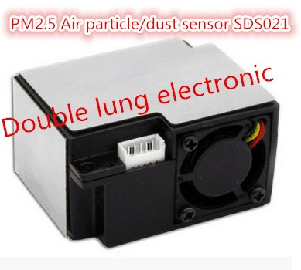
Overview
The SDS021 using principle of laser scattering,can get the particle concentration between 0.3 to 10μm in the air. It with digital output and built-in fan is stable and reliable. Product has passed the CE, FCC and RoHS certification.

Characteristics
1. Accurate and Reliable: laser detection, stable, good consistency;
2. Quick response: response time is less than 10 seconds when the scene changes;
3. Easy integration: UART output (or IO output can be customized), fan built-in;
4. High resolution: resolution of 0.3μg/m3;
5.Certification:CE,FCC,RoHS;
6.Cutter: professional internal spiral duct, cutting the small particles effectively;make the measurement more accurate;
7.Flocculant prevention design:with inlet which can calculate the space of the fence specially,effectively prevent the catkin floc etc;
8.Clean hole:independent design,convenient maintenance;
9.Smallest:the minimum volume of laser PM2.5 sensor.
Scope of application
Detector of PM2.5;Purifier;Fresh air system and other detection field.
Working principle
Using laser scattering principle:
Light scattering can be induced when particles go through the detecting area. The scattered light is transformed into electrical signals and these signals will be amplified and processed. The number and diameter of particles can be obtained by analysis because the signal waveform has certain relations with the particles diameter.
Technical Parameters
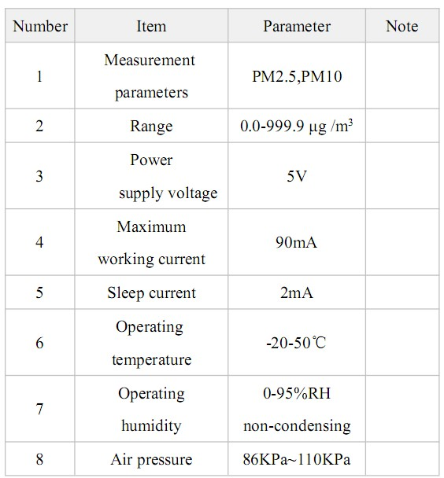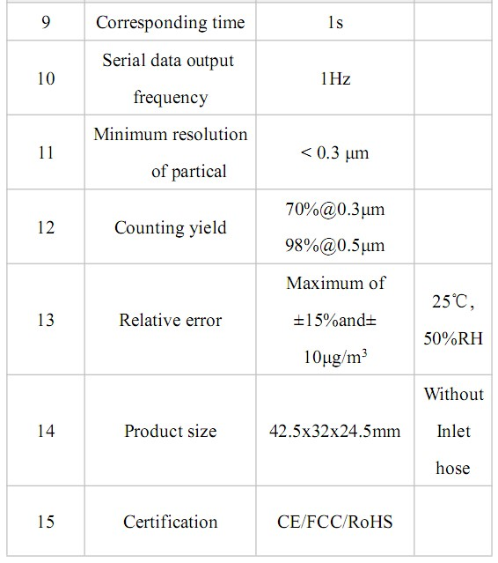
About service life
Service life is the key parameter of laser dust sensor. The laser diode in this sensor has high quality and its service life is up to 8000 hours. If you need real-time data (such as detector), you can use the default configuration that measures at the frequency of 1time per second. On the occasion of real-time demand is not high (such as filter, air quality monitoring, etc.), you can use the discontinuous working method to prolong the service life. For example, you can start the sensor for 30 seconds per minutes. If you have any other requirements, please contact us, we are willing to serve for manufacturers and developers.

Product specifications
1.Product size
L*W*H=42.5*32*24.5mm

2.Interface specification

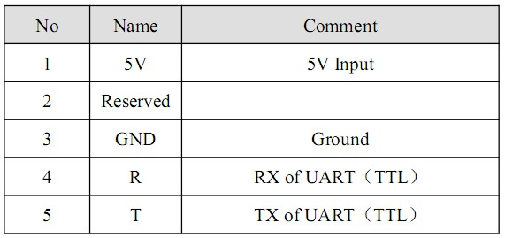
The UART communication protocol
Bit rate:9600
Data bit:8
Parity bit:NO
Stop bit:1
Data Packet frequency:1Hz
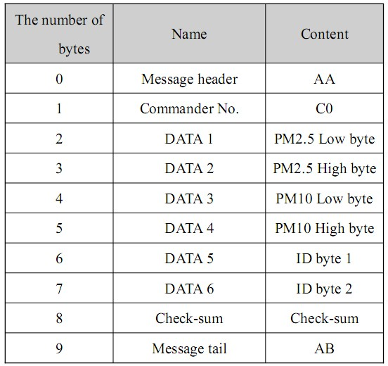

Check-sum: Check-sum=DATA1+DATA2+...+DATA6.
PM2.5 value: PM2.5 (μg /m3) = ((PM2.5 High byte *256) + PM2.5 low byte)/10
PM10 value: PM10 (μg /m3) = ((PM10 high byte*256) + PM10 low byte)/10

import serial
ser = serial.Serial('/dev/ttyUSB0') # open serial port
print(ser.name)
ser.read(10)
ser.read(10)
ser.read(10)
ser.read(10)
import numpy; ser.read(10)
numpy.fromstring(ser.read(10), dtype="uint16")
numpy.fromstring(ser.read(10), dtype="uint16")
numpy.fromstring(ser.read(10), dtype="uint16")
numpy.fromstring(ser.read(10), dtype="uint16")
numpy.fromstring(ser.read(10), dtype="uint16")
numpy.fromstring(ser.read(10), dtype="uint16")
numpy.fromstring(ser.read(10), dtype="uint16")
numpy.fromstring(ser.read(10), dtype="uint16")
numpy.fromstring(ser.read(10), dtype="uint16")
numpy.fromstring(ser.read(10), dtype="uint16")[1:2]/10
numpy.fromstring(ser.read(10), dtype="uint16")[1:3]/10.
numpy.fromstring(ser.read(10), dtype="uint16")[1:3]/10.
import time
time.time()
logfile = open("/scratch/jerome/dust1.txt","w")
while True:
pm2,pm10=numpy.fromstring(ser.read(10), dtype="uint16")[1:3]/10.
l = "%s %s %s"%(time.time, pm2, pm10)
print(l)
time.sleep(1)
while True:
pm2,pm10=numpy.fromstring(ser.read(10), dtype="uint16")[1:3]/10.
l = "%s %s %s"%(time.time(), pm2, pm10)
print(l)
time.sleep(1)
while True:
pm2,pm10=numpy.fromstring(ser.read(10), dtype="uint16")[1:3]/10.
l = "%s %s %s"%(time.time(), pm2, pm10)
print(l)
logfile.write(l+"\n")
if i%1000 == 0:
logfile.flush()
time.sleep(1)
i+=1
i=0
while True:
pm2,pm10=numpy.fromstring(ser.read(10), dtype="uint16")[1:3]/10.
l = "%s %s %s"%(time.time(), pm2, pm10)
print(l)
logfile.write(l+"\n")
if i%1000 == 0:
logfile.flush()
time.sleep(1)
i+=1
%hist

