Version 1.2
Chris Gray, 7 March 2016
Table of Contents
Keratoconus Assistant Build Manual 4
Conventions 2
Tooling up 2
Eclipse projects 2
Clearing the ground 3
Buiding the application 3
Creating the native launcher 3
Creating the Windows installer 4
Creating a USB stick 4
Preparing a new classification model 4
Testing the new model 6
Adding the new model to the build 6
Modifying the resource files 6
css directory 7
html directory 7
icon directory 7
load directory 7
preferences 8

Conventions
In this guide we sometimes use italics to indicate that you need to replace this text by something specific to your project: for example on page 5, if you create the Eclipse workspace in a folder called C:\Users\JoeBloggs\keratoconus-workspace then “your-keratoconus-workspace\Keratoconus-Installer\keratoconus.jar” means “C:\Users\JoeBloggs\keratoconus-workspace\Keratoconus-Installer\keratoconus.jar”.

Tooling up
You will need the following:
- Java 8 (at least version jre1.8.0_45 - earlier versions do not correctly export the javafx.* packages).
- Eclipse IDE for Java Developers. I used Luna Service Release 1 (4.4.1), Build id: 20140925-1800. Download site: https://eclipse.org/downloads/
- Bndtools (I used version 3.0.0.DEV-20150608-205409-gf28b98f, you should try to use this or a later version), this is a plug-in for Eclipse. Download site for the latest stable build: https://dl.bintray.com/bndtools/bndtools/latest/
- Launch4j, I used version 3.8. Download site: http://sourceforge.net/projects/launch4j/
- Advanced Installer (I used version 12.7.1), the Freeware Version is sufficient. Download site: http://www.advancedinstaller.com/download.html
I used Windows 8.1 to build, any recent version of Windows should be O.K..

Eclipse projects
Create a folder on your PC which wil be used to build Keratoconus Assistant, for example C:\Users\username\keratoconus-workspace. Clone the git repository at <https://github.com/kiffer580/keratoconus.git> into this directory. Launch Eclipse and tell it to use this folder as its “workspace”, and then open the menu item “File→Import ...→Existing projects into Workspace”. Select the workspace folder as the root directory and click on “Finish”.
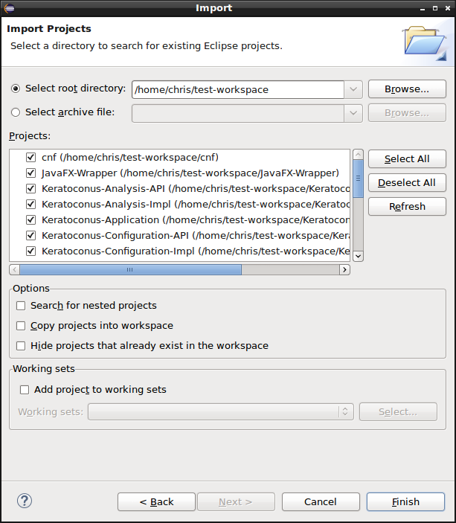
You should now see the following projects in the Project Explorer view:
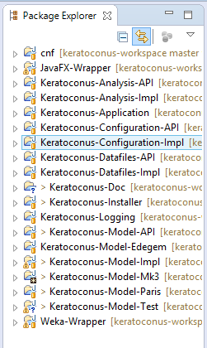
cnf
JavaFX-Wrapper
Keratoconus-Analysis-API
Keratoconus-Analysis-Impl
Keratoconus-Application
Keratoconus-Configuration-API
Keratoconus-Configuration-Impl
Keratoconus-Datafiles-API
Keratoconus-Datafiles-Impl
Keratoconus-Installer
Keratoconus-Logging
Keratoconus-Model-API
Keratoconus-Model-Edegem
Keratoconus-Model-Impl
Keratoconus-Model-Mk3
Keratoconus-Model-Paris
Weka-Wrapper

Alternatively, in Eclipse use File→Import ...→Git→Projects from Git→Clone URI to import the named projects from <https://github.com/kiffer580/keratoconus.git>.
The cnf project is a special project used by bndtools to store its settings, local repositories, etc.. All the other projects are bndtools projects.

Clearing the ground
Before performing any building or testing it is a good idea to stop the Keratoconus Assistant if it is already running (right-click on the KA icon and choose “Exit Kerataconus Assistant”). Use “Project→Clean ...” to re-build all projects. All should build with no errors and few warnings.
Open file production.bndrun in the Keratoconus-Installer project, and click on the “Resolve” button in the “Run” tab. This should result in a “Resolution results” window which lists all the modules which are used in the application; if no errors are reported then click on “Finish” and then (very important) save the result with either the Eclipse “File→Save” menu or control-S.
Still in the “Run” tab of production.bndrun, you can test the current build by clicking on the 'Run OSGi' button. This will launch Keratoconus Assistant in the Eclipse environment (KA icon appears in the task bar). After testing you should shut down Keratoconus Assistant again to prevent confusion when you test the installer later on.
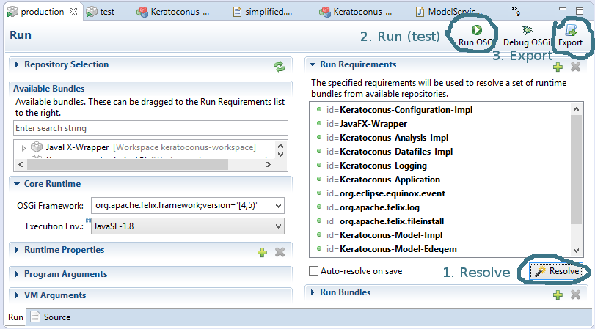

Building the application
If all appears to be well, create the keratonus.jar file as follows:
- Click on the “Export” button of production.bndrun.
- Select “Executable JAR”, “Next >”, “Export to JAR:”
- Set the path to “your-keratoconus-workspace\Keratoconus-Installer\keratoconus.jar”
- Click on “Finish”.
The resulting keratonus.jar file is a runnable jar file containing a launcher, the Keratoconus Assistant modules, and all required libraries. It does not however contain the configuration files, icons, html and css files; it expects these to be present in the directory from which it is launched. If your Windows installation is set up to run jar files by double-clicking on them, you should be able to verify the correctness of the keratoconus.jar file by opening the Keratoconus-Installer directory in Windows Explorer and double-clicking on the keratoconus.jar file.

Creating the native launcher
The native launcher is a very small program which effectively executes the command ./JRE32/jre1.8.0_45/bin/java -jar keratoconus.jar to launch the application with the correct JRE. It is created using the launch4j.exe executable.
- Click on the “open configuration” icon (folder, second from left), navigate to the Keratonus-Installer directory and choose keratoconus32.xml.
- Set the output file to your-keratoconus-workspace\Keratoconus-Installer\keratoconus32.exe.
- Click on the “build wrapper” icon (cogwheel, fourth from left). Wait for the message
Compiling resources
Linking
Successfully created your-keratoconus-workspace\Keratoconus-Installer\keratoconus32.exe

- At this point you can test the executable by clicking on the “test wrapper” icon (play-button, fifth from left).
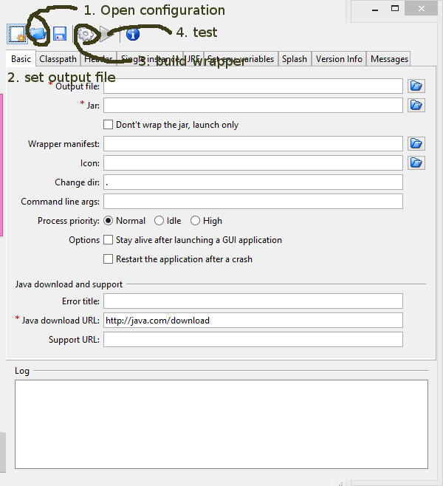

Creating the Windows installer
For this we use the freeware version of Caphyon's Advanced Installer application.

Open the project Keratoconus Assistant 32-bit.aip located in the Keratoconus-Installer directory. Click on the pile of bricks (Build) in the title bar, or hit F7. This will build the self-contained MSI installer. You can test the installer by clicking on the start button (Run) next to the pile of bricks, or by hitting F5.

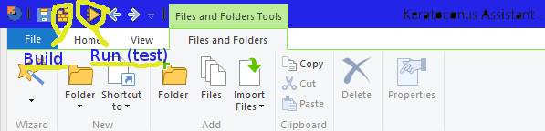

Creating a USB stick
To create a USB stick from which Keratoconus Assistant can be run directly, copy all of the following from the Keratoconus-Installer directory to the USB stick (all at the same level, i.e. in the root directory of the stick or all together in one directory):
- Directories css, html, icon, JRE32, and load
- Files keratoconus.jar, keratoconus32.exe.
The application can then be launched by double-clicking on keratoconus.exe.

Preparing a new classification model
This task is most conveniently performed using Eclipse/bndtools. Use one of the existing classification model projects (Keratoconus-Model-Edegem, Keratoconus-Model-Paris, Keratoconus-Model-Mk3) as an example.
- Create a new project using the menu “File→New→Bndtools OSGi Project”. Give it a name similar to the existing models. The checkbox “Use bnd workspace location” should be ticked, ensure that the correct JRE is selected (Java8), and choose Project Layout 'bnd'. Click on “Next >” and on the following page chooose the “Empty project” template; click on “Next >” once more and then on “Finish”.
- Within the new project, use menu “File→New→Folder” to create a new folder “resource”, with sub-folders “config” and “model” (all in lower case).
- Export your model from Weka explorer, copy it to the “model” sub-folder you just created, and rename it to shortname.model, where “shortname” will be the short name KA will use for your model. By convention this is all lower case and does not contain spaces.
- In the “config” sub-folder create a text file called “shortname.properties”, as follows:
  - config.format.version=1.2
  - pentacam.fields.common=Last Name,First Name,Pat-ID,D.o.Birth,Exam Date,Exam Time,Exam Eye,Exam Type,Exam Comment,Status,Error
  - pentacam.fields.key=Last Name,First Name,Pat-ID,Exam Date,Exam Time
(Do not change these first three lines)

  - model.name=shortname (must be same as used in the filenames!)
  - model.description=A longer name
  - pentacam.files=comma-separated list of the files used in the model.
The names must exactly match the names as they appear in the c:\Pentacam directory, e.g. CHAMBER, COR-PWR (all capitals) but Fourier (initial capital), without the -LOAD suffix or the .CSV extension.
For each of these files:
  - filename.field.separator=”;” (the field separator for this file)
  - pentacam.fields.used=see below

Save the file.

The pentacam.fields.used property is a comma-separated list of field descriptors, where every field descriptor has one of the following forms:
- the name of the field, exactly as it occurs in the Master File from which the model was derived, but without a trailing colon (:) if one was present; folowed by a colon (:); followed by one of the files listed in the pentacam.files property. Example:
Cor.Vol.:CHAMBER
- Some files (specifically COR_PWR) contain two lines of data for each examination; one line in which certain variables are measured at the front (exterior) face of the cornea, and one in which these variables are measured at the back (interior) face. In this case one column of the file serves to designate the face (FRONT/BACK) to which the current line refers; you can indicate this by including an field descriptor with theform fieldname;discriminator:filename in the list, e.g.
Surface;discriminator:COR-PWR
Then every field descriptor of the form fieldname;bifacial:filename will correspond to two variables in the Master file, namely fieldname FRONT and fieldname BACK. For example r0.0 0°;bifacial:COR-PWR
corresponds to columns r0.0 0° FRONT and r0.0 0° BACK of the MF. The “discriminator” variable does not itself form part of the model.
- If on the other hand you only need one of the two faces for one or more variables, you should add “ FRONT” or “ BACK” to the name of the variable, e.g.
Sag5mm BACK:COR-PWR
In all three cases it is important to be very precise in the naming, e.g. exactly one space between “Sag5mm” and “BACK”, three spaces between “r0.0” and “0°”. Try wherever possible to copy-paste the names rather than type them. Be careful also to distinguish between the “;” which goes before “discriminator” or “bifacial” and the “:” which goes before the file name.
- Open the file bnd.bnd in your project, go to the “Source” tab and paste in the following content:
Include-Resource: /resource
Bundle-Version: 1.0.0.${tstamp}
Fragment-Host: Keratoconus-Model-Impl
Import-Package: !*

javac.source: 1.8
javac.target: 1.8
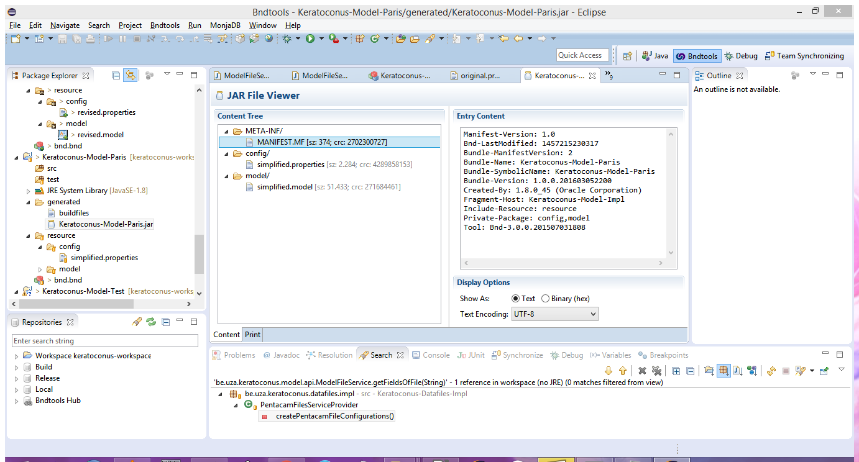
javac.compliance: 1.8
Save the file. A jar file will automatically be generated and placed in the “generated” folder. If you open this file in Eclipse you should see something like the following:

Testing the new model
The new model can be tested rather simply by dropping the Keratoconus-Model-Xxx.jar file into the load directory of an existing installation, e.g. to
C:\Program Files (x86)\Keratoconus Assistant\load.
From here it should automatically be picked up and be added to the “User preferences Classification model menu of KA.

Adding the new model to the build
To make a new version of Keratoconus Assistant which includes your model, you need to add your Keratoconus-Mode-Xxx project to the production.bndrun file. The easiest way is by clicking on the green “+” sign in the “Run requirements” panel; then select your project from the list of Available Bundles on the left-hand-side, click on “Add -->” to move it to the list of Selected Bundles, and then click on “Finish”. Now click on “Resolve” and proceed to build the application, jar file, launcher, and installer as explained above.
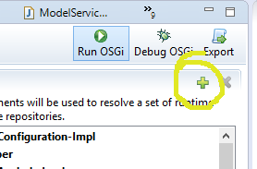

Modifying the resource files
Most of the important “resource” files are stored in the installation directory. This means that they can readily be edited within the Keratoconus-Installer directory, and the results can be tested
- by running the application within the Eclipse environment, using the “Run OSGi” menu of production.bndrun;
- by copying the new versions of the files to a USB stick which can then be tested in the field.
Once these tests have proved satisfactory a new MSI installer can be made as described in the section Creating the Windows installer.

css directory
This contains CSS stylesheets for both HTML and JavaFX components.
- about.css, manual.css - these contain stylesheets for the html documents about.html, manualx.html.
- graphical-patient-record.css - contains the stylesheet for the patient record document which is created as HTML and saved as a JPEG.
- popup.css, userprefs.css - contain stylesheets for the main pop-up display of the analysis results, and the user preferences dialogues, respectively. N. B. These are JavaFX stylesheets, as can be seen from the -fx- prefix in the property names. The styles are applied according to classes which are assigned to elements of the document in the Java code. In popup.css in particular, if there are definitions for .popup-xxxxx and .popup-xxxxx-yyyyy then the first applies to all xxxxx and the second only to category yyyyy, e.g. .popup-root applies to the root window and .popup-root-main applies additionally when the analysis result is for a “main” indication (keratoconus, post-refractive).

html directory
This contains the html sources for the pages “About Ketatoconus Assistant” and “User Manual” which can be accessed from the context menu (right-click on the task bar icon).

icon directory
This contains the icons used by the application. These should include icons which are used when the Pentacam software indicates a “warning” or an “error” condition (location defined in load/be.uza.keratoconus.systemtrayapp.MainPopup.cfg, see next section), and a set of icons which are used to indicate the category of the analysis result. The “base” icon is defined in load/be.uza.keratoconus.configuration.impl.PentacomConfigurationServiceProvider.cfg, e.g. icon.path.base=icon/JR2.png; the application will then expect to also find files called JR2-ambiguous.png, JR2-bad.png, JR2-main.png, JR2-normal.png, JR2-side.png, JR2-large.png, in the same directory. The first five of these are used to vary the icon in the task bar, the last is used whenever a larger icon is required (48x48; the other icons are 16x16).

load directory
This contains configuration files for some components of the application. These files are read in and interpreted during program start-up.
be.uza.keratoconus.configuration.impl.PentacamConfigurationServiceProvider.cfg
Contains settings which are used in several places, such as the names of the classifications and the location of the preferences and logging files.
be.uza.keratoconus.systemtrayapp.GraphicalPatientRecord.cfg
Defines the fields to be used on each line of the graphical patient record, the image dimensions, and the stylesheet to be used. Property patient.record.date.format defines how the fields 'Exam Date' 'Exam Time' of the common fields can be used to derive a timestamp, which is then used in the name of the created file.
be.uza.keratoconus.systemtrayapp.MainPopup.cfg
Contains settings which determine the contents of the main pop-up window.

You can also add classification models to this directory in the form of jarfiles, see section “Keratoconus Assistant Build Manualˮ on page 9.

