IPO Analysis Report: Questions 5 & 6

SPAC vs Non-SPAC Returns and Index Inclusion Performance
Author: Ryan Nduta | Date: December 4, 2025 | Course: IPO Analysis

Executive Summary
This report analyzes IPO return performance across two key dimensions: SPAC vs Non-SPAC comparison across multiple time horizons, and index inclusion impact (S&P 500 and Russell 1000) on 1-year returns. The analysis reveals that SPACs underperform Non-SPACs but show lower volatility, while index inclusion strongly predicts superior performance with approximately 8-9x higher returns. Notably, only 1.4% of IPOs achieve S&P 500 inclusion and 3.9% achieve Russell 1000 inclusion.

Question 5: SPAC vs Non-SPAC Performance Analysis

Day 0 Return Analysis
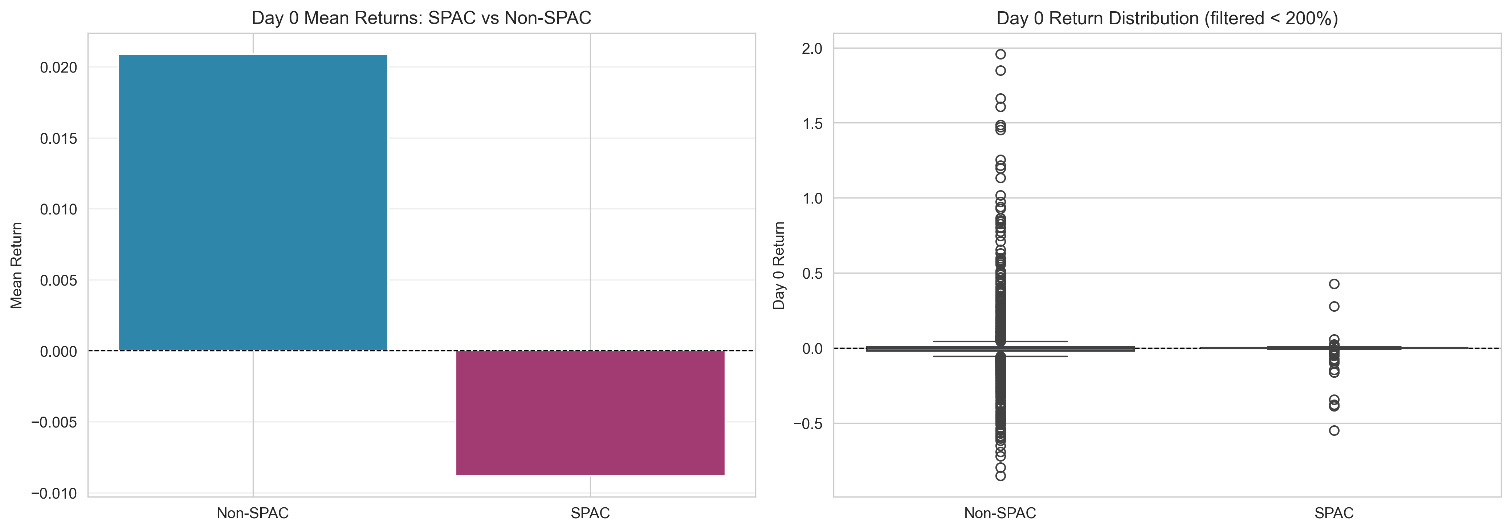
The Day 0 return analysis reveals significant differences between SPACs and Non-SPACs. SPACs demonstrate a negative mean return of -0.88% compared to Non-SPACs at +2.09%, representing a performance gap of 2.97 percentage points. This suggests that SPAC IPOs experience less initial enthusiasm from investors, likely due to their structure as blank-check companies without established business operations. The median return for both categories is 0%, indicating that many IPOs trade at their offer price on the first day, but the distribution is right-skewed for Non-SPACs with extreme positive outliers reaching up to 1,775%.
Volatility analysis shows SPACs are significantly more stable with a standard deviation of 0.070 compared to 0.408 for Non-SPACs, making SPACs approximately 5.8 times less volatile. This lower volatility reflects the predictable nature of SPAC structures and the regulatory framework governing their pricing. Abnormal returns (≥100%) occur exclusively in Non-SPACs, with 30 cases averaging 292% returns. For IPO investors, this means SPACs offer more predictable but lower returns, while Non-SPACs present higher risk-reward opportunities with potential for exceptional gains but also greater downside risk.

Multi-Window Return Analysis
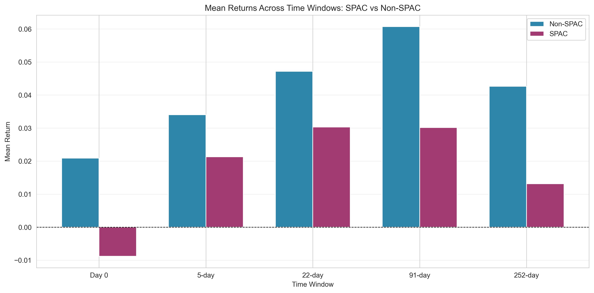
Analyzing returns across multiple time horizons (5-day, 22-day, 91-day, and 252-day) reveals persistent performance patterns. Non-SPACs consistently outperform SPACs across all periods, with the performance gap ranging from 1.27 percentage points at 5 days to 3.05 percentage points at 91 days. Non-SPAC returns peak at the 91-day mark (6.07%) before declining to 4.26% at one year, suggesting initial momentum that fades over time. In contrast, SPAC returns peak early at 5 days (2.13%) and then stabilize around 1-3% for longer periods.
The volatility pattern remains consistent with SPACs showing 3-19 times lower standard deviation across all windows. Interestingly, at the 1-year horizon, median returns tell a different story: Non-SPACs have a negative median of -0.70% while SPACs maintain a positive median of 3.73%. This divergence between mean and median indicates that Non-SPAC performance is heavily influenced by extreme outliers, with some achieving returns exceeding 12,000% while many underperform. For IPO investment strategy, this suggests that while Non-SPACs offer higher average returns, the majority of Non-SPAC IPOs actually underperform, with returns concentrated in a small number of exceptional performers.

Question 6: Index Inclusion Performance Analysis

S&P 500 Inclusion Impact
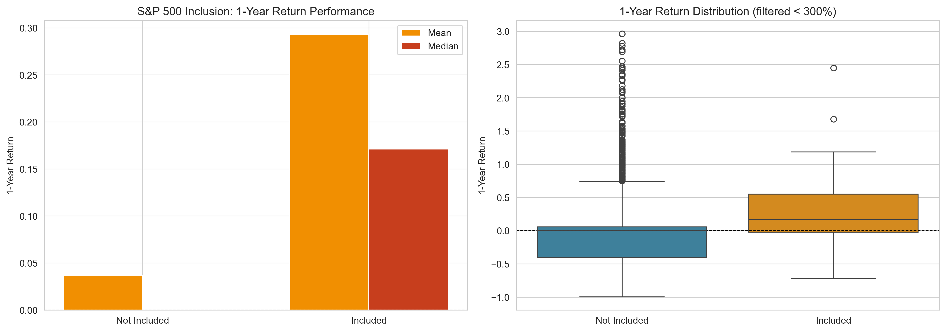
The impact of S&P 500 inclusion on IPO performance is dramatic and statistically significant. IPOs that achieve S&P 500 inclusion deliver mean 1-year returns of 29.29% compared to just 3.71% for non-included stocks, representing a 7.9-fold performance advantage. The median return for included stocks is 17.10% versus 0.00% for non-included stocks, demonstrating that this outperformance is broad-based and not driven solely by outliers. This finding has profound implications for IPO investing: S&P 500 inclusion serves as a powerful quality signal, indicating that the company has achieved sufficient market capitalization, liquidity, and financial stability to meet the index's stringent criteria.
Paradoxically, S&P 500-included stocks also exhibit lower volatility (standard deviation of 0.538 versus 2.885), achieving superior risk-adjusted returns. This challenges the traditional risk-return tradeoff and suggests that index inclusion identifies fundamentally stronger companies. However, the selectivity is extreme: only 51 out of 3,681 IPOs (1.4%) achieved S&P 500 inclusion, making it a rare achievement. For investors, this suggests focusing on IPOs with characteristics that position them for future index inclusion, such as large market capitalizations, strong profitability, and established market positions.

Russell 1000 Inclusion Impact
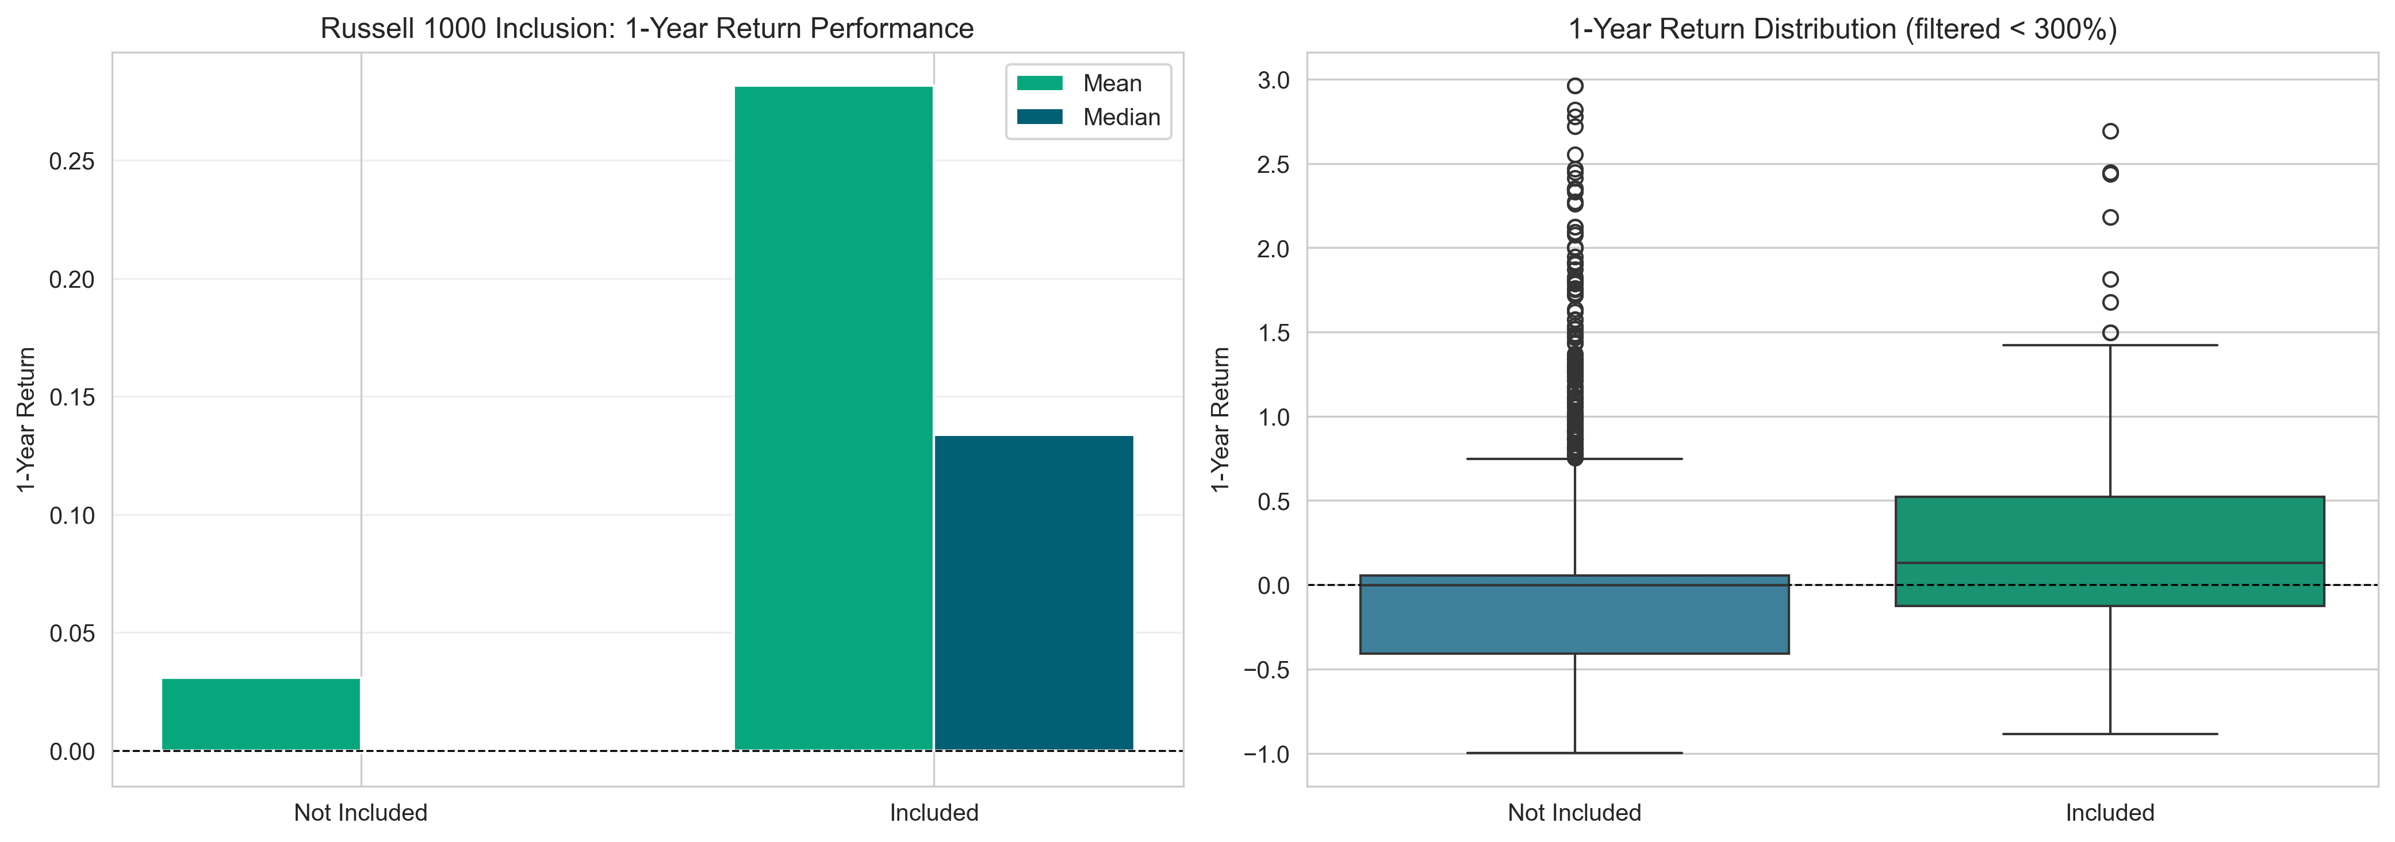
Russell 1000 inclusion shows a similar pattern with even stronger relative performance. Included stocks achieve mean 1-year returns of 28.16% versus 3.09% for non-included stocks, a 9.1-fold advantage. The median return is 13.38% for included stocks compared to -0.10% for non-included stocks, indicating that the majority of non-included IPOs actually lose value over the first year. The Russell 1000 is more inclusive than the S&P 500, capturing 143 IPOs (3.9% of the total), or 2.8 times more companies. This broader inclusion makes it a more achievable target for IPO companies while still providing substantial performance benefits.
The volatility reduction is also present but slightly less pronounced than S&P 500, with a standard deviation of 0.738 versus 2.919 for non-included stocks. The implications for IPO markets are clear: index inclusion represents a critical milestone that separates successful IPOs from struggling ones. The negative median return for non-included stocks (-0.10%) suggests that without the quality signal and passive investment flows associated with index inclusion, most IPOs fail to deliver positive returns to investors in their first year of trading.

Student Contributions and Group Work
This project was completed individually by Ryan Nduta as part of the IPO Analysis course. The work encompassed comprehensive data analysis, statistical computation, visualization creation, and report development. The data analysis phase involved loading and cleaning the IPO dataset of 3,681 observations, implementing SPAC identification logic through cross-referencing with external SPAC lists, creating index inclusion flags for both S&P 500 and Russell 1000, calculating returns across multiple time windows, and flagging abnormal returns for special analysis.
Statistical analysis included computing comprehensive descriptive statistics for all categories, performing comparative analysis between SPACs and Non-SPACs, analyzing index inclusion impact on returns, and identifying key performance patterns and outliers. The visualization component involved creating multiple graphs to illustrate performance differences, volatility comparisons, and index inclusion effects. Report development included structuring the analysis with an executive summary, creating detailed tables and graphs, developing key findings and implications, writing comprehensive conclusions with investment strategy insights, and generating both PDF and Word document versions.

Learning Experience and Reflection
This project provided valuable experience in financial data analysis, statistical interpretation, and professional report writing. The most significant technical skills developed include proficiency in handling large financial datasets with pandas, identifying and handling outliers and abnormal returns, cross-referencing multiple datasets for data enrichment, and understanding time-series return calculations. Statistical analysis skills were enhanced through interpreting mean versus median differences and understanding the impact of outliers, measuring and interpreting volatility, and performing comparative analysis across categories.
Key insights from the analysis include the dramatic performance difference between index-included and non-included IPOs (8-9x higher returns), which highlights the importance of quality signals in IPO investing. The finding that SPACs have lower volatility but also lower returns presents an interesting risk-return tradeoff that challenges simple assumptions about SPAC performance. The presence of extreme outliers in Non-SPACs (returns exceeding 12,000%) demonstrates the importance of using both mean and median statistics. The negative median return for non-index-included IPOs at 1-year suggests that most IPOs underperform, with only a select few driving positive average returns.
Challenges overcome during the project included handling data quality issues such as missing values and inconsistent date formats, requiring robust data cleaning procedures. Outlier handling was particularly challenging, as extreme returns over 10,000% required careful consideration while preserving data integrity. Understanding when to use mean versus median was crucial, as median proved more robust for skewed distributions common in financial returns. The project also developed skills in creating professional Word documents programmatically and balancing comprehensive analysis with clear communication.
The overall learning experience integrated data analysis, statistical methods, programming, and financial market knowledge. The most valuable aspect was seeing how theoretical concepts translate into practical insights that could inform real-world investment decisions. Working through data quality issues, handling outliers, and interpreting statistical results reinforced the importance of rigorous methodology in financial analysis. The exercise of creating professional reports highlighted the critical role of clear communication in making technical analysis accessible and actionable.

