Assignment #4: Resource Allocation & Constrained Optimization
Heckscher-Ohlin Model

Part 5: Analytical Questions
Question 1: Regression Critique - Unit Roots and Spurious Correlation
Is this regression sensible?
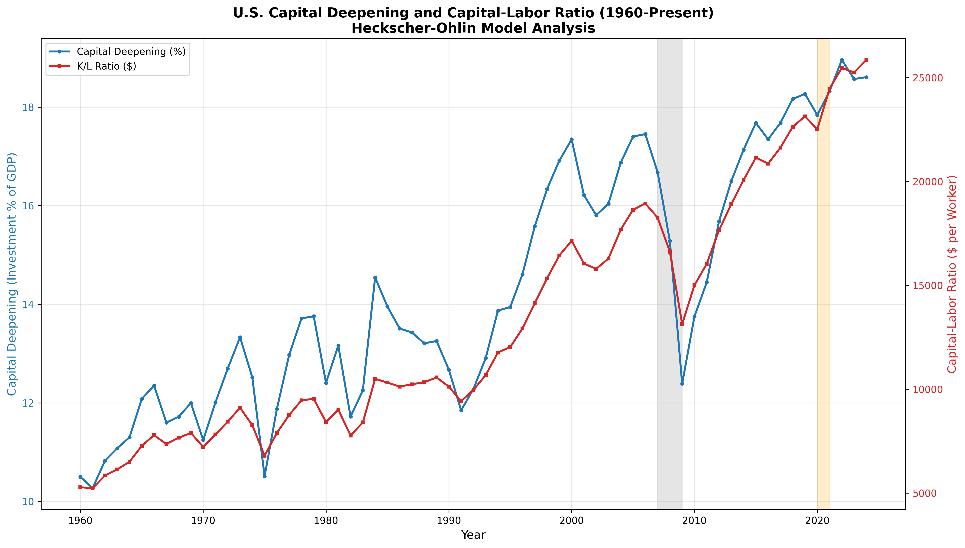
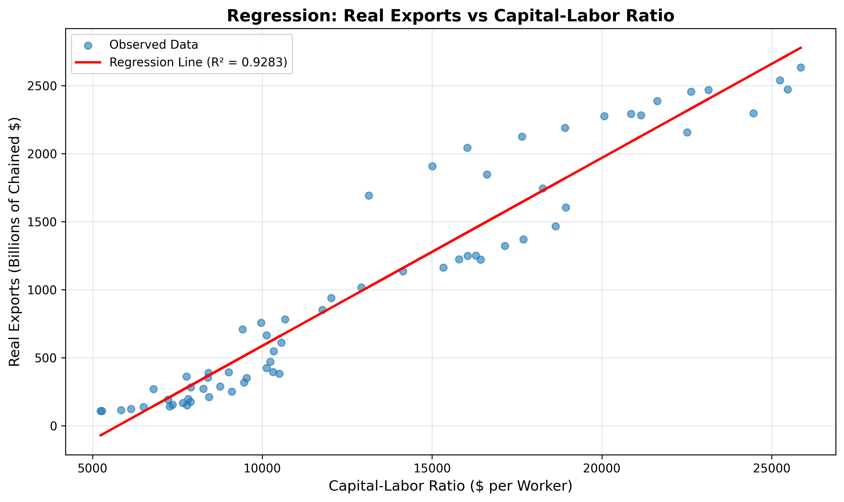
No, this regression will most likely result in spurious correlations due to the existence of unit roots in the time series.
What is a Unit Root?
A unit root exists in a time series when:
The time series is non-stationary, i.e., it has changing properties over time.
The time series has permanent effects, i.e., the effect of a change in the time series will not die out.
The time series has a tendency to wander and will not return to a mean value.
Mathematically, a time series has a unit root when it can be described by the following equation:
Y_t = Y_{t-1} + \epsilon_t
The term "unit" refers to the coefficient of 1 on the lagged term.
Why is Regressing Two Trending Variables Problematic?
- Spurious Correlation: When two variables both trend upward over time (like Exports and K/L ratio), they will appear highly correlated even if there's no causal relationship. You could get an R² of 0.90+ simply because both variables grew over the same period.
- Misleading T-Statistics: Standard regression assumes residuals are independent and identically distributed (i.i.d.). With non-stationary data, residuals inherit the unit root, making t-statistics unreliable and confidence intervals meaningless.
- Non-Constant Variance: The variance of a unit root process grows without bound over time, violating the homoskedasticity assumption.
- Granger-Newbold (1974) Finding: Two independent random walks will appear significantly related in ~75% of regressions at the 5% level – a dramatic over-rejection of the null.

Proper Approaches Include:
First-Differencing: Regress ΔExports on ΔK/L to remove trends
Cointegration Analysis: Test if a stable long-run relationship exists (Engle-Granger or Johansen tests)
Error Correction Models: If cointegrated, model both short-run dynamics and long-run equilibrium
Augmented Dickey-Fuller Test: Formally test for unit roots before regression
Interpretation Warning: Any high R² or significant coefficients from this regression should be viewed skeptically. The apparent relationship may be entirely due to both variables trending upward with U.S. economic growth rather than any causal link predicted by H-O theory.
Question 2: Future Outlook - Generative AI and Capital-Labor Dynamics
Projected Evolution of Capital/GDP and K/L Ratio (2025-2035)
Capital as % of GDP: Expected to INCREASE
Massive Infrastructure Investment: Goldman Sachs predicts 1+ trillion dollars of AI infrastructure investment worldwide by 2027, including:
Data centers (200B+)
Semiconductor fabs (300B+ with CHIPS Act)
Energy grid investments to support AI power consumption
Networking infrastructure
Corporate AI Adoption: Companies in all industries are now spending more capital on:
Cloud computing capacity
AI-integrated equipment and machinery
Automation systems and robotics
Historical Context: Capital/GDP has historically averaged 15-18% since 1960. AI investment could temporarily boost this to 20%+ during the investment phase.
Capital-Labor Ratio: Expected to ACCELERATE Upward
The K/L ratio is likely to rise sharply because of both numerator changes AND possible denominator changes:
Numerator Effect (Capital Accumulation):
AI infrastructure investment will require enormous upfront capital outlays
AI scaling will require exponentially more computing power
Capital is invested upfront, but productivity gains are realized later
Denominator Effect (Labor Dynamics):
This is where "Capital Deepening" vs "Labor Displacement" becomes important:
Scenario | Mechanism | K/L Impact
Capital Deepening | AI augments workers, making them more productive | Moderate K/L increase (numerator grows faster)
Labor Displacement | AI replaces certain job categories | Rapid K/L increase (denominator shrinks)
Mixed Effect | Some jobs displaced, new jobs created | Depends on transition speed

My Assessment: BOTH Effects Will Occur
Near-Term (2025-2030): Capital Deepening Dominates
AI primarily augments, versus replaces, most knowledge workers
Productivity increases in current job types (coding, analysis, customer service)
The workforce may even increase as productivity increases allow more flexible work arrangements
New job types emerge (AI trainer, prompt engineer, AI safety expert)
Medium-Term (2030-2035): Labor Displacement Accelerates
Autonomous agents increasingly begin replacing routine cognitive work
Manufacturing and logistics become more automated
Service industry disruptions begin (call centers, basic legal and accounting services)
Structural unemployment risk within those sectors
Key Variables to Watch:
AI Capability Curve: How quickly do AI systems begin matching human performance on specific tasks?
Adoption Speed: The speed at which enterprises adopt and implement AI technology is 3-5 years behind availability
Policy Response: How governments address job retraining, universal basic income, and an automation tax
New Industry Creation: Historically, technology creates more jobs than it eliminates, but at significant transition costsQuantitative Projections:
Metric | 2024 Baseline | 2030 Projection | 2035 Projection
Capital/GDP | ~17% | 19-21% | 18-20% (normalizing)
K/L Ratio | ~$30,000/worker | ~$40,000/worker | ~$50,000/worker
Labor Force Growth | 0.5%/year | 0.3%/year | 0.1-0.5%/year

H-O Model Implications:
If the U.S. becomes relatively more capital-abundant, (K/L rises):
More exports of capital-intensive products
Increased specialization in high-tech, semiconductors, aerospace, and advanced manufacturing industries for the U.S.
Labor-intensive manufacturing will continue to move to labor-abundant countries
However, AI could challenge traditional notions of factor intensities (software is capital-intensive in production but nearly free to copy)

