SECTION 1: VALIDATED DIRECTED-ARC MODEL

1) Base relation and subtypes

- EMPLOYEE is a supertype.
- MANAGER is a subtype of EMPLOYEE.
- PROJECT is a supertype.
- INTERNAL_PROJECT and EXTERNAL_PROJECT are disjoint subtypes of PROJECT.

Directed arcs (validated):

EMPLOYEE(emp_id) ---> MANAGER(mng_emp_id)
PROJECT(prj_num) ---> INTERNAL_PROJECT(int_prj_num)
PROJECT(prj_num) ---> EXTERNAL_PROJECT(ext_prj_num)

2) Relationship-derived arcs

INTERNAL_PROJECT(int_prj_num) ---> ASSIGNMENT(asg_int_prj_num)
EMPLOYEE(emp_id) ---> ASSIGNMENT(asg_emp_id)
MANAGER(mng_emp_id) ---> INTERNAL_PROJECT(int_mng_emp_id)
VENDOR(ven_name) ---> EXTERNAL_PROJECT(ext_ven_name)

3) Directed-arc design issues found and validation decisions

Issue A: Repeating/composite name and address structures can hide dependencies.
Validation decision: flatten into atomic attributes in each relation:
- employee: emp_first, emp_middle, emp_last
- vendor: ven_first, ven_middle, ven_last, ven_street, ven_city, ven_state, ven_zip

Issue B: Supertype/subtype enforcement can be lost if subtype tables are not PK=FK.
Validation decision: use identical subtype key as PK and FK to supertype:
- manager.mng_emp_id PK/FK -> employee.emp_id
- internal_project.int_prj_num PK/FK -> project.prj_num
- external_project.ext_prj_num PK/FK -> project.prj_num

Issue C: Assignment cardinality can allow invalid hours.
Validation decision: semantic constraint on assignment hours > 1.

Issue D: Business rule “manager is assigned to internal project he/she manages” is not guaranteed by FK-only design.
Validation decision: enforce with a procedural rule (trigger/assertion/business transaction rule).

4) Assumptions added to semantic integrity constraints

- Manager is an EMPLOYEE subtype (every manager must be an employee).
- Internal and External project subtypes are disjoint.
- ASSIGNMENT references only INTERNAL_PROJECT (not EXTERNAL_PROJECT).
- VENDOR is identified by ven_name in this model version.

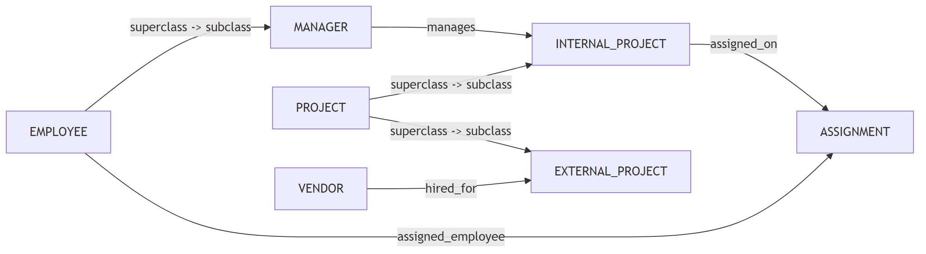

SECTION 2: DEPENDENCY DIAGRAMS (VALIDATED)

Notation:
- PK attributes are marked [PK].
- Partial and transitive dependency checks are stated under each relation.

A) EMPLOYEE
EMPLOYEE([PK] emp_id, emp_first, emp_middle, emp_last, emp_gender, emp_salary)
FDs:
- emp_id -> emp_first, emp_middle, emp_last, emp_gender, emp_salary
Normalization note:
- No partial dependency (single-attribute PK).
- No transitive dependency among non-key attributes in the validated model.

B) MANAGER
MANAGER([PK] mng_emp_id, mng_bonus)
FDs:
- mng_emp_id -> mng_bonus
Normalization note:
- BCNF/3NF compliant in validated form.

C) VENDOR
VENDOR([PK] ven_name, ven_street, ven_city, ven_state, ven_zip, ven_first, ven_middle, ven_last)
FDs:
- ven_name -> ven_street, ven_city, ven_state, ven_zip, ven_first, ven_middle, ven_last
Normalization note:
- 3NF compliant based on assumed natural key ven_name.
- If business uses duplicate vendor names, replace with surrogate vendor_id.

D) PROJECT
PROJECT([PK] prj_num, prj_desc, prj_startdt, prj_budget, prj_actcst)
FDs:
- prj_num -> prj_desc, prj_startdt, prj_budget, prj_actcst
Normalization note:
- 3NF compliant.

E) EXTERNAL_PROJECT
EXTERNAL_PROJECT([PK] ext_prj_num, ext_contcost, ext_ven_name)
FDs:
- ext_prj_num -> ext_contcost, ext_ven_name
Normalization note:
- 3NF compliant; ext_ven_name is FK to vendor.

F) INTERNAL_PROJECT
INTERNAL_PROJECT([PK] int_prj_num, int_rating, int_mng_emp_id)
FDs:
- int_prj_num -> int_rating, int_mng_emp_id
Normalization note:
- 3NF compliant; int_mng_emp_id is FK to manager.

G) ASSIGNMENT
ASSIGNMENT([PK] asg_int_prj_num, [PK] asg_emp_id, asg_hours)
FDs:
- (asg_int_prj_num, asg_emp_id) -> asg_hours
Normalization note:
- No partial dependency (asg_hours depends on full composite key).
- 3NF compliant.

Potential problems inferred (and fixes)
- Problem 1: Constraint typo in source (“Assignment.Gender”) is ambiguous.
Fix: apply gender constraint to EMPLOYEE.emp_gender IN ('M','F','O').
- Problem 2: Business rule requiring manager participation cannot be fully expressed by static FK constraints.
Fix: implement trigger/transaction rule to auto-insert/validate assignment row.

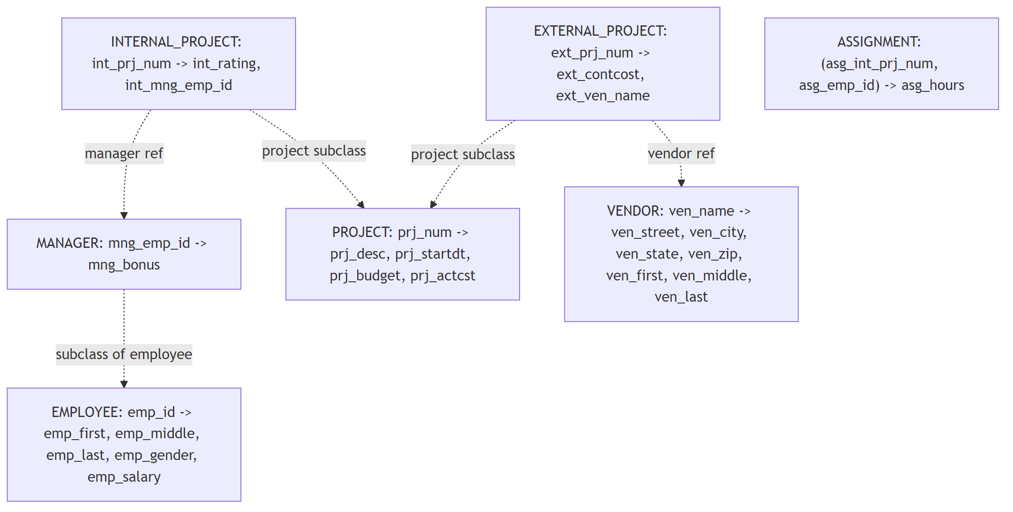

SECTION 3: VALIDATED INFORMATION-PRESERVING LOGICAL MODEL
Validated relation set (final):

EMPLOYEE(
emp_id PK,
emp_first,
emp_middle,
emp_last,
emp_gender CHECK IN ('M','F','O'),
emp_salary
)

MANAGER(
mng_emp_id PK FK -> EMPLOYEE(emp_id),
mng_bonus
)

VENDOR(
ven_name PK,
ven_street,
ven_city,
ven_state,
ven_zip,
ven_first,
ven_middle,
ven_last
)

PROJECT(
prj_num PK,
prj_desc,
prj_startdt,
prj_budget,
prj_actcst
)

EXTERNAL_PROJECT(
ext_prj_num PK FK -> PROJECT(prj_num),
ext_contcost,
ext_ven_name FK -> VENDOR(ven_name)
)

INTERNAL_PROJECT(
int_prj_num PK FK -> PROJECT(prj_num),
int_rating,
int_mng_emp_id FK -> MANAGER(mng_emp_id)
)

ASSIGNMENT(
asg_int_prj_num PK FK -> INTERNAL_PROJECT(int_prj_num),
asg_emp_id PK FK -> EMPLOYEE(emp_id),
asg_hours CHECK > 1
)

Information-preserving rationale
- All original ER entities are represented by relations.
- Subtype/supertype semantics are preserved with PK=FK subtype pattern.
- Relationship semantics are preserved via foreign keys and associative relation ASSIGNMENT.
- Business rule constraints are preserved via CHECK constraints + procedural enforcement for manager assignment rule.
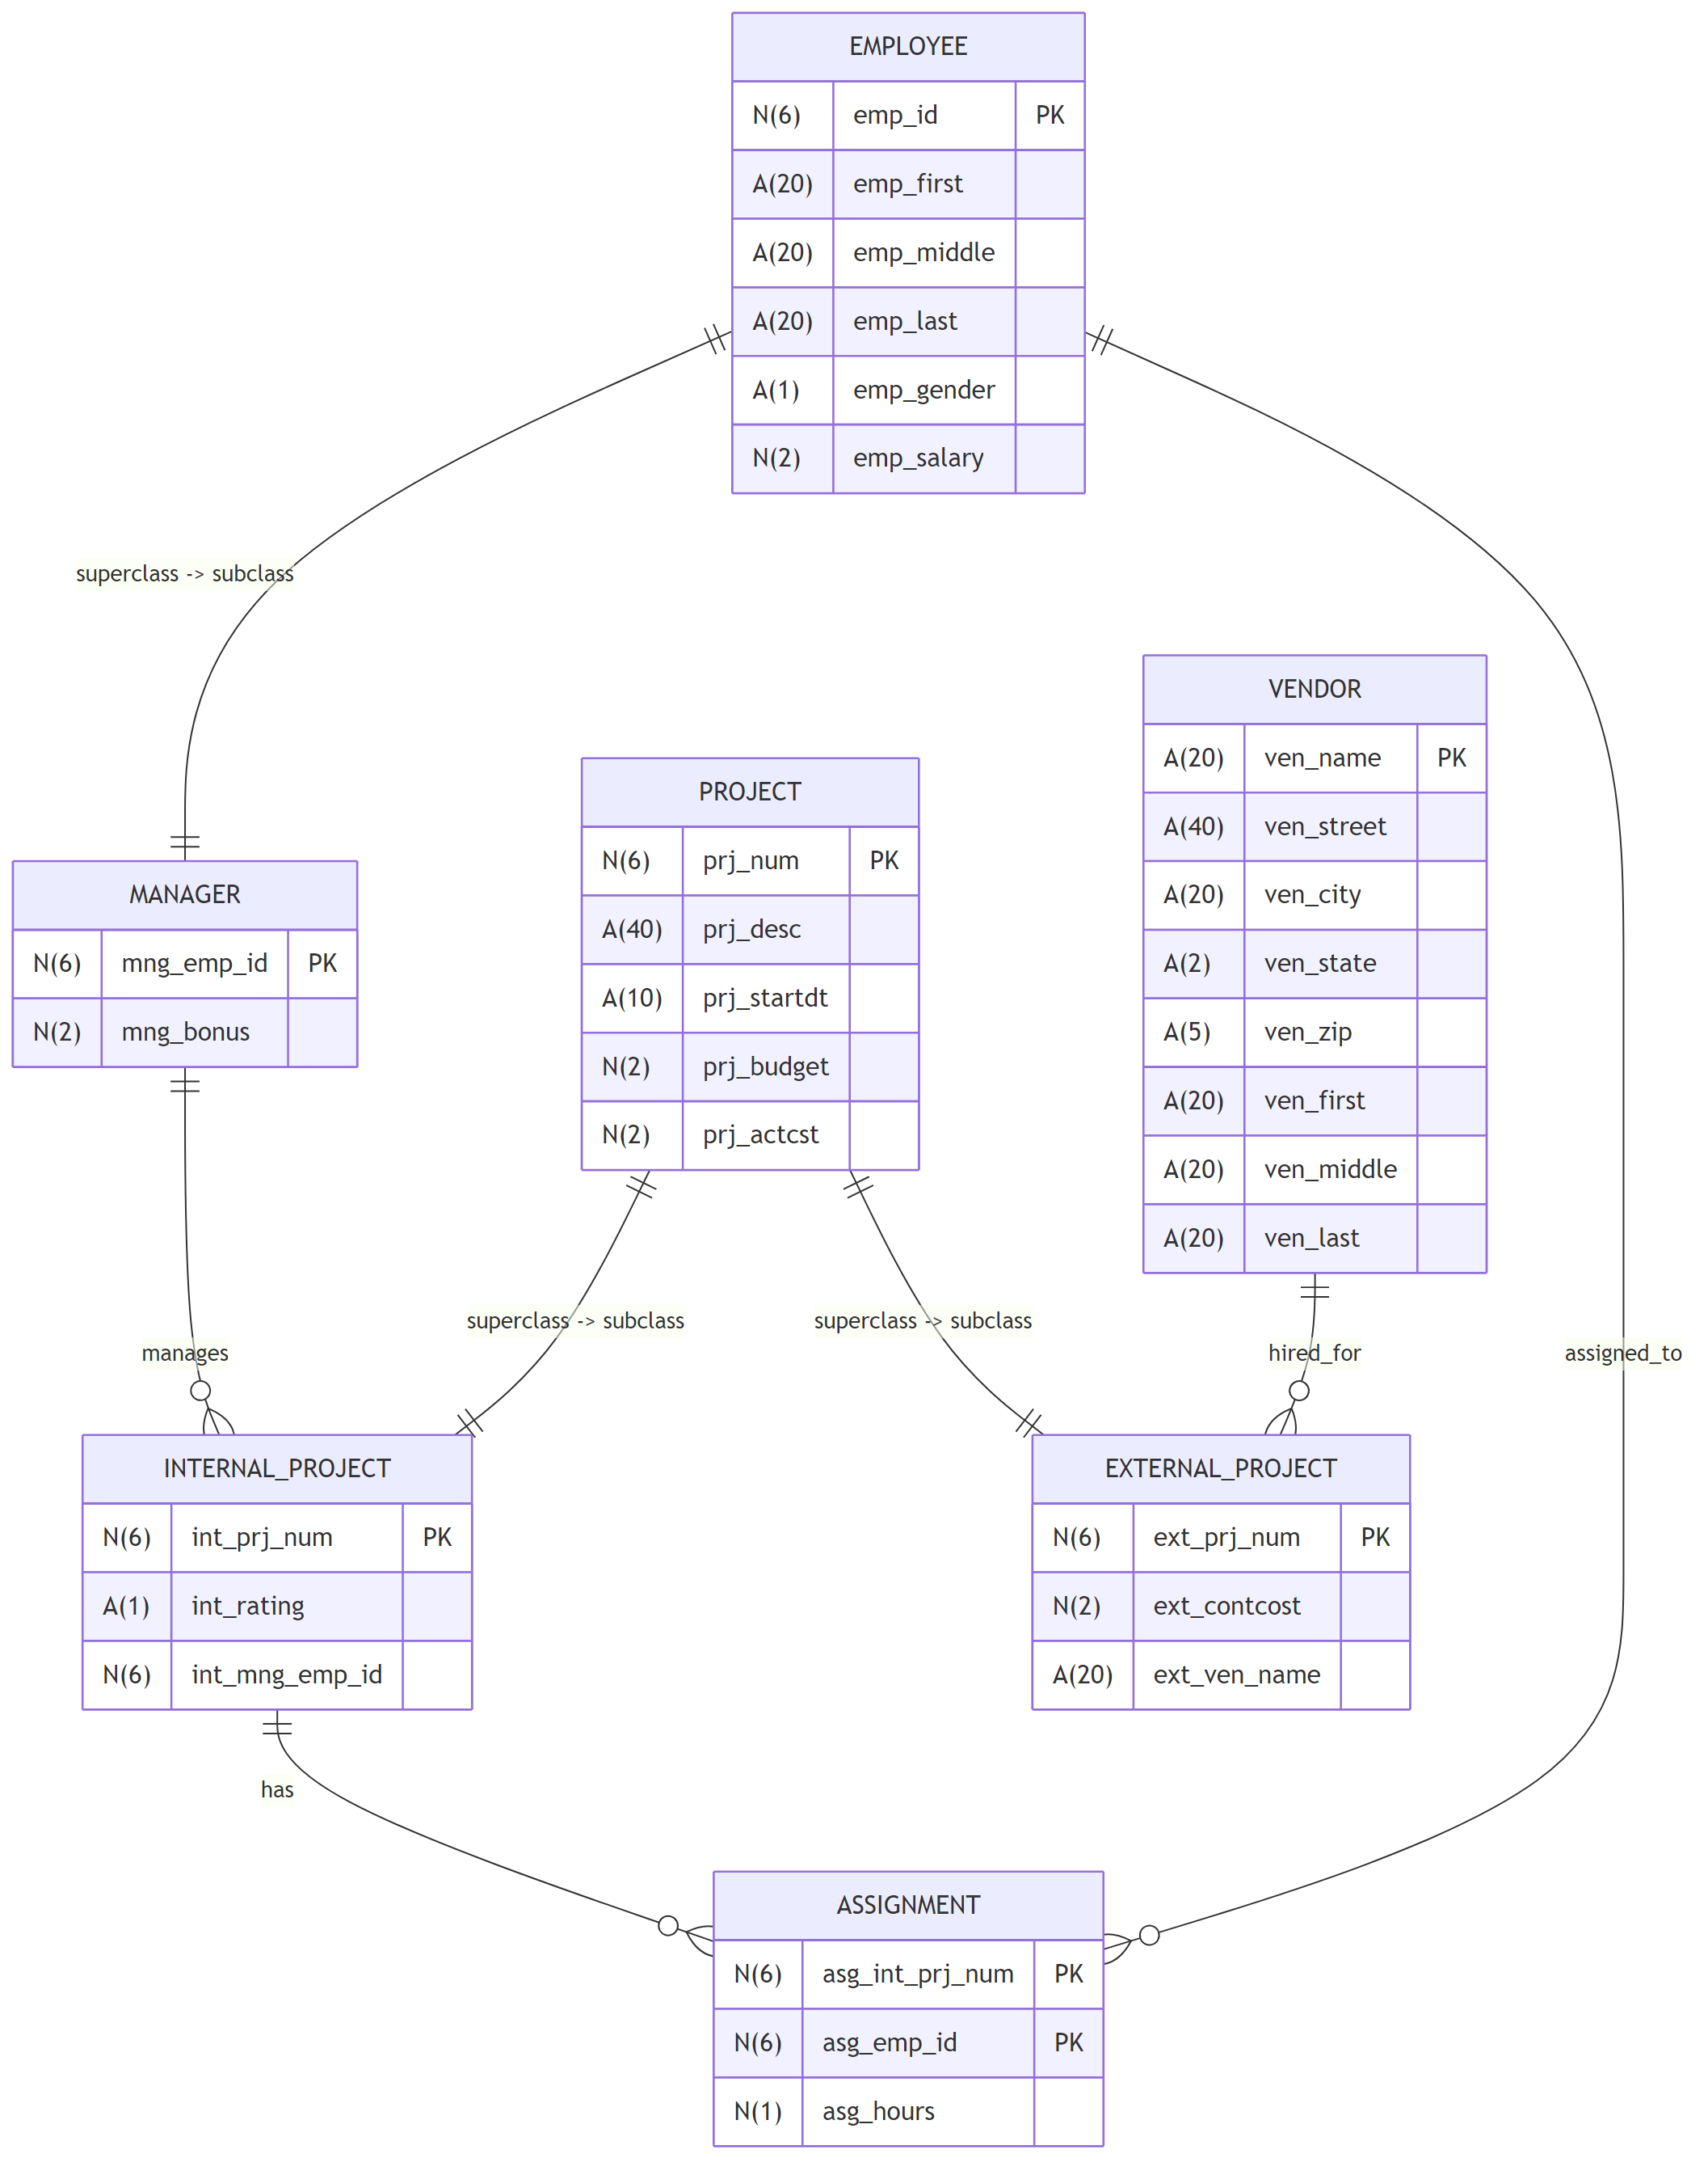

SEMANTIC INTEGRITY CONSTRAINTS (FINAL LIST)

1) EMPLOYEE.emp_gender IN ('M','F','O')
2) ASSIGNMENT.asg_hours > 1
3) A manager will be assigned to any internal project that he/she also manages.
4) Every MANAGER must exist in EMPLOYEE.
5) Every INTERNAL_PROJECT and EXTERNAL_PROJECT row must correspond to an existing PROJECT row.

