Database Platform Used: PostgreSQL

SECTION 1: SQL CODE TO CREATE TABLES, CONSTRAINTS, AND RELATIONSHIPS

1) MANAGER is a subtype of EMPLOYEE (1:1 via mng_emp_id = emp_id).
2) INTERNAL_PROJECT and EXTERNAL_PROJECT are subtypes of PROJECT.
3) ASSIGNMENT links EMPLOYEE to INTERNAL_PROJECT.
4) VENDOR is identified by ven_name in this model.
5) Rule enforcement for manager assignment to managed internal project is implemented with a trigger.

SQL DDL/Constraints:

DROP TABLE IF EXISTS assignment CASCADE;
DROP TABLE IF EXISTS external_project CASCADE;
DROP TABLE IF EXISTS internal_project CASCADE;
DROP TABLE IF EXISTS manager CASCADE;
DROP TABLE IF EXISTS vendor CASCADE;
DROP TABLE IF EXISTS project CASCADE;
DROP TABLE IF EXISTS employee CASCADE;

CREATE TABLE employee (
emp_id NUMERIC(9,0) PRIMARY KEY,
emp_first VARCHAR(20) NOT NULL,
emp_middle VARCHAR(20),
emp_last VARCHAR(20) NOT NULL,
emp_gender CHAR(1) NOT NULL,
emp_salary NUMERIC(6,0),
CONSTRAINT chk_employee_gender
CHECK (emp_gender IN ('M', 'F', 'O'))
);

CREATE TABLE manager (
mng_emp_id NUMERIC(9,0) PRIMARY KEY,
mng_bonus NUMERIC(6,0) NOT NULL,
CONSTRAINT fk_manager_employee
FOREIGN KEY (mng_emp_id)
REFERENCES employee(emp_id)
ON DELETE CASCADE
);

CREATE TABLE vendor (
ven_name VARCHAR(60) PRIMARY KEY,
ven_street VARCHAR(50),
ven_city VARCHAR(20),
ven_state CHAR(2),
ven_zip CHAR(5),
ven_first VARCHAR(20) NOT NULL,
ven_middle VARCHAR(20),
ven_last VARCHAR(20) NOT NULL
);

CREATE TABLE project (
prj_num NUMERIC(9,0) PRIMARY KEY,
prj_desc VARCHAR(120) NOT NULL,
prj_startdt DATE,
prj_budget NUMERIC(8,2) NOT NULL,
prj_actcst NUMERIC(8,2)
);

CREATE TABLE external_project (
ext_prj_num NUMERIC(9,0) PRIMARY KEY,
ext_contcost NUMERIC(8,2),
ext_ven_name VARCHAR(60),
CONSTRAINT fk_external_project_project
FOREIGN KEY (ext_prj_num)
REFERENCES project(prj_num)
ON DELETE CASCADE,
CONSTRAINT fk_external_project_vendor
FOREIGN KEY (ext_ven_name)
REFERENCES vendor(ven_name)
ON DELETE SET NULL
);

CREATE TABLE internal_project (
int_prj_num NUMERIC(9,0) PRIMARY KEY,
int_rating CHAR(1),
int_mng_emp_id NUMERIC(9,0) NOT NULL,
CONSTRAINT fk_internal_project_project
FOREIGN KEY (int_prj_num)
REFERENCES project(prj_num)
ON DELETE CASCADE,
CONSTRAINT fk_internal_project_manager
FOREIGN KEY (int_mng_emp_id)
REFERENCES manager(mng_emp_id),
CONSTRAINT chk_internal_rating
CHECK (int_rating IN ('A','B','C','D','F'))
);

CREATE TABLE assignment (
asg_int_prj_num NUMERIC(9,0) NOT NULL,
asg_emp_id NUMERIC(9,0) NOT NULL,
asg_hours NUMERIC(5,2) NOT NULL,
CONSTRAINT pk_assignment
PRIMARY KEY (asg_int_prj_num, asg_emp_id),
CONSTRAINT fk_assignment_internal_project
FOREIGN KEY (asg_int_prj_num)
REFERENCES internal_project(int_prj_num)
ON DELETE CASCADE,
CONSTRAINT fk_assignment_employee
FOREIGN KEY (asg_emp_id)
REFERENCES employee(emp_id)
ON DELETE CASCADE,
CONSTRAINT chk_assignment_hours
CHECK (asg_hours > 1)
);

-- Trigger rule for Section 4
CREATE OR REPLACE FUNCTION fn_assign_manager_to_internal_project()
RETURNS TRIGGER
LANGUAGE plpgsql
AS $$
BEGIN
INSERT INTO assignment (asg_int_prj_num, asg_emp_id, asg_hours)
VALUES (NEW.int_prj_num, NEW.int_mng_emp_id, 2)
ON CONFLICT (asg_int_prj_num, asg_emp_id)
DO NOTHING;

RETURN NEW;
END;
$$;

DROP TRIGGER IF EXISTS trg_assign_manager_to_internal_project ON internal_project;

CREATE TRIGGER trg_assign_manager_to_internal_project
AFTER INSERT OR UPDATE OF int_mng_emp_id
ON internal_project
FOR EACH ROW
EXECUTE FUNCTION fn_assign_manager_to_internal_project();
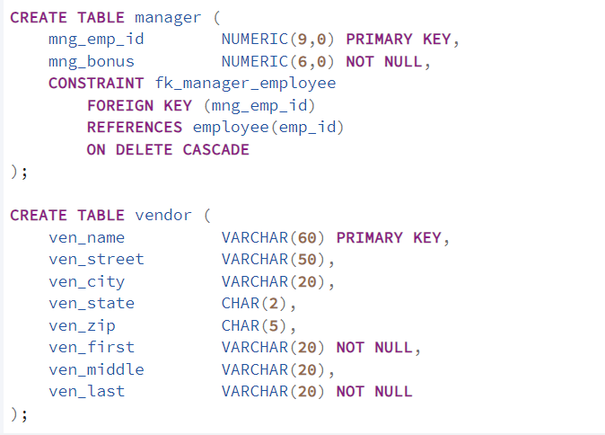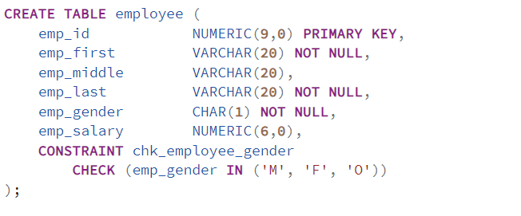

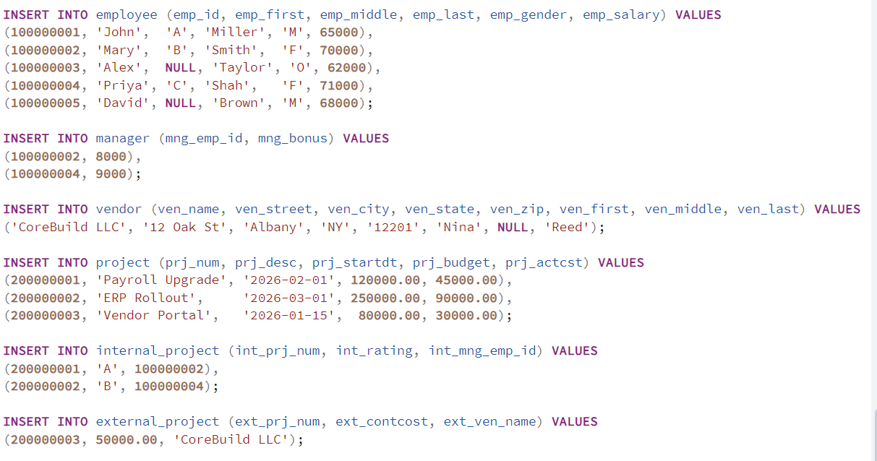

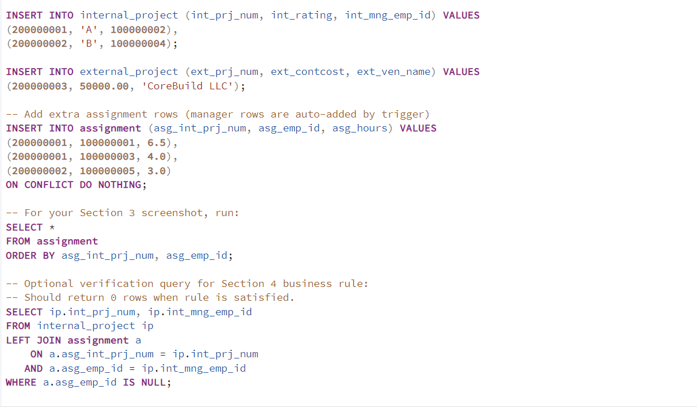

SECTION 2: SCREENSHOT OF REFRESHED TABLE LIST

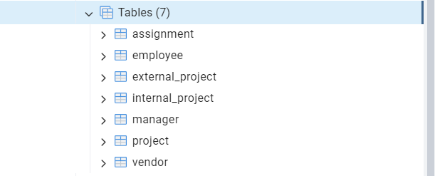

SECTION 3: INSERT 5+ RECORDS AND SHOW SELECT * RESULTS

Sample insert SQL used:

INSERT INTO employee (emp_id, emp_first, emp_middle, emp_last, emp_gender, emp_salary) VALUES
(100000001, 'John', 'A', 'Miller', 'M', 65000),
(100000002, 'Mary', 'B', 'Smith', 'F', 70000),
(100000003, 'Alex', NULL, 'Taylor', 'O', 62000),
(100000004, 'Priya', 'C', 'Shah', 'F', 71000),
(100000005, 'David', NULL, 'Brown', 'M', 68000);

INSERT INTO manager (mng_emp_id, mng_bonus) VALUES
(100000002, 8000),
(100000004, 9000);

INSERT INTO vendor (ven_name, ven_street, ven_city, ven_state, ven_zip, ven_first, ven_middle, ven_last) VALUES
('CoreBuild LLC', '12 Oak St', 'Albany', 'NY', '12201', 'Nina', NULL, 'Reed');

INSERT INTO project (prj_num, prj_desc, prj_startdt, prj_budget, prj_actcst) VALUES
(200000001, 'Payroll Upgrade', '2026-02-01', 120000.00, 45000.00),
(200000002, 'ERP Rollout', '2026-03-01', 250000.00, 90000.00),
(200000003, 'Vendor Portal', '2026-01-15', 80000.00, 30000.00);

INSERT INTO internal_project (int_prj_num, int_rating, int_mng_emp_id) VALUES
(200000001, 'A', 100000002),
(200000002, 'B', 100000004);

INSERT INTO external_project (ext_prj_num, ext_contcost, ext_ven_name) VALUES
(200000003, 50000.00, 'CoreBuild LLC');

INSERT INTO assignment (asg_int_prj_num, asg_emp_id, asg_hours) VALUES
(200000001, 100000001, 6.5),
(200000001, 100000003, 4.0),
(200000002, 100000005, 3.0)
ON CONFLICT DO NOTHING;

Use select * from employee
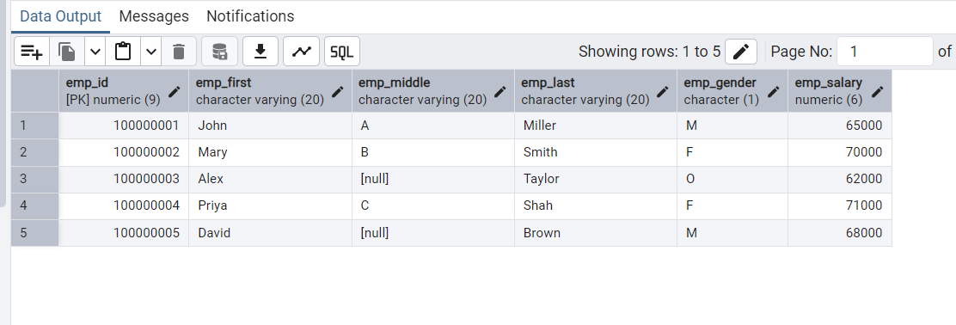

Query used for screenshot:
SELECT *
FROM assignment
ORDER BY asg_int_prj_num, asg_emp_id;

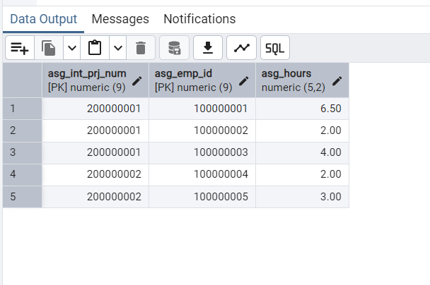

SECTION 4: HOW TO ENSURE MANAGER IS ASSIGNED TO INTERNAL PROJECT

To ensure a manager is assigned to any internal project he/she manages, I implemented a database trigger on INTERNAL_PROJECT.

When a new internal project is inserted (or manager is updated), the trigger inserts a row into ASSIGNMENT for:
(asg_int_prj_num = internal project number, asg_emp_id = internal manager employee id, asg_hours = 2).
If that assignment row already exists, ON CONFLICT DO NOTHING prevents duplicates.
This enforces the business rule at the database level consistently.

Verification query used:
SELECT ip.int_prj_num, ip.int_mng_emp_id
FROM internal_project ip
LEFT JOIN assignment a
ON a.asg_int_prj_num = ip.int_prj_num
AND a.asg_emp_id = ip.int_mng_emp_id
WHERE a.asg_emp_id IS NULL;

Expected result: 0 rows.

INSERT/UPDATE internal_project
↓
Is int_mng_emp_id NOT NULL?
↙ ↘
NO YES
↓ ↓
SKIP Check if assignment exists?
↙ ↘
NO YES
↓ ↓
INSERT row SKIP
in ASSIGNMENT (avoid duplicate)
↓
RETURN success

SEMANTIC INTEGRITY CONSTRAINTS

1) EMPLOYEE.emp_gender IN ('M','F','O')
2) ASSIGNMENT.asg_hours > 1
3) A manager will be assigned to any internal project that he/she also manages.

